Customer Data Application

Development team:
Prashant Sharma

Customer Application is an application to store, retrieve edit and delete customer data to and from database.

This application uses these components:

- AngularJS – AngularJS is used for the front end. The communication with the server side is done using angularjs and the UI is designed in angularJS.
- NodeJS – NodeJS is the server side environment to connect to to database write rest services for the database conection.
- MongoDB – MongoDB is the database used for the application. It stores only JSON data and it is not a relational database.
- Bootstrap – Bootstrap is the css framework used for beautification of the application.

Using MongoDB.

- Download zip file of mongodb from https://www.mongodb.org/
- Unzip it and then create a folder for the data to be stored.
- In the bin folder create a bat file with the command
mongod --dbpath d:\DevMongoDB\MongoData.
Here d:\DevMongoDB\MongoData is the db path where data needs to be stored.
- The go to command prompt and run the bat file, This creates a connection with the database.
- Then open another command prompt and run the command mongo.
- This opens the shell for mongodb.
- Here create the database called test using the command use test in the mongo shell.

Using node.

- Here the node is used to create a server environment, to create a connection with the database and to use rest services.
- A package.json file has been created to download all dependencies.
- Go to the node package using command prompt.
- Run npm install to download the dependencies.
- Then to start the server run npm start, this will start the server as in package.json I have mentioned the command to run the server.
- This command will start the server.

The Application.

There are four links for add, delete, view and update. On click of each link it goes to partilcular view.
The Application comprises of four views.

    - View Customer – This view displays all the customer details that are in the db.
    - Add Customer – This view has the input fields to enter new values into database.
    - Delete Customer – This view has a field to search a customer by Id. It then displays the customer details, then on click of delete, it deletes the customer from database.
    - Update Customer – This view has a field to search a customer by Id. It then provides fields to update details of a customer except the id. On click of update it updates the details to database.

View Customer:

Add Customer:

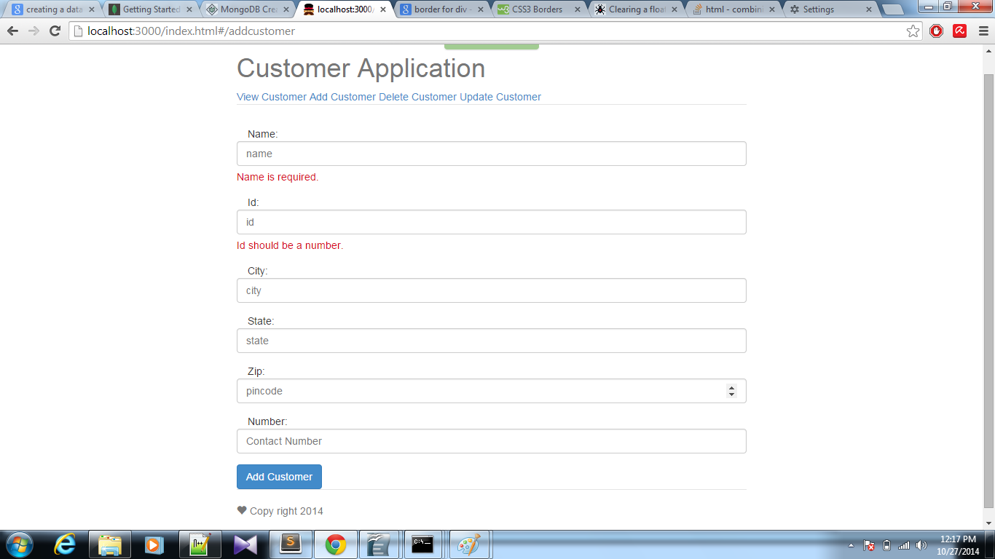

Delete Customer:

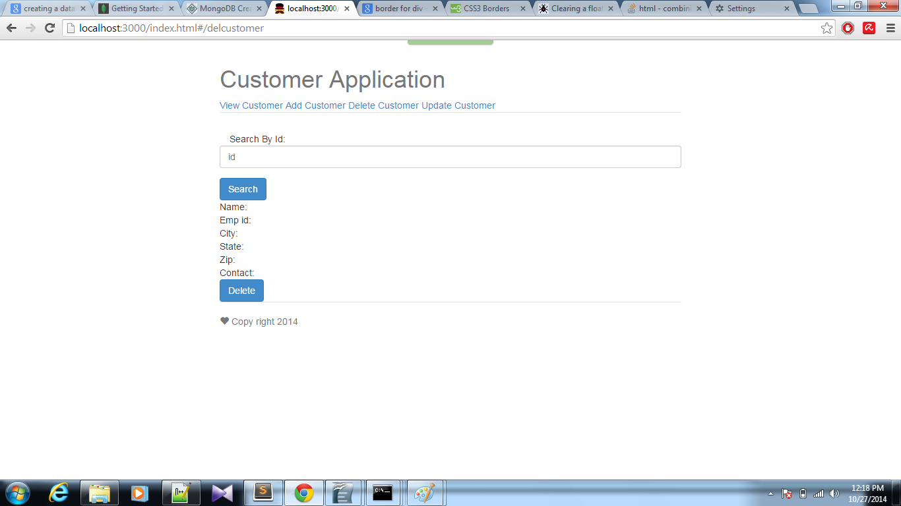

'

Update Customer:

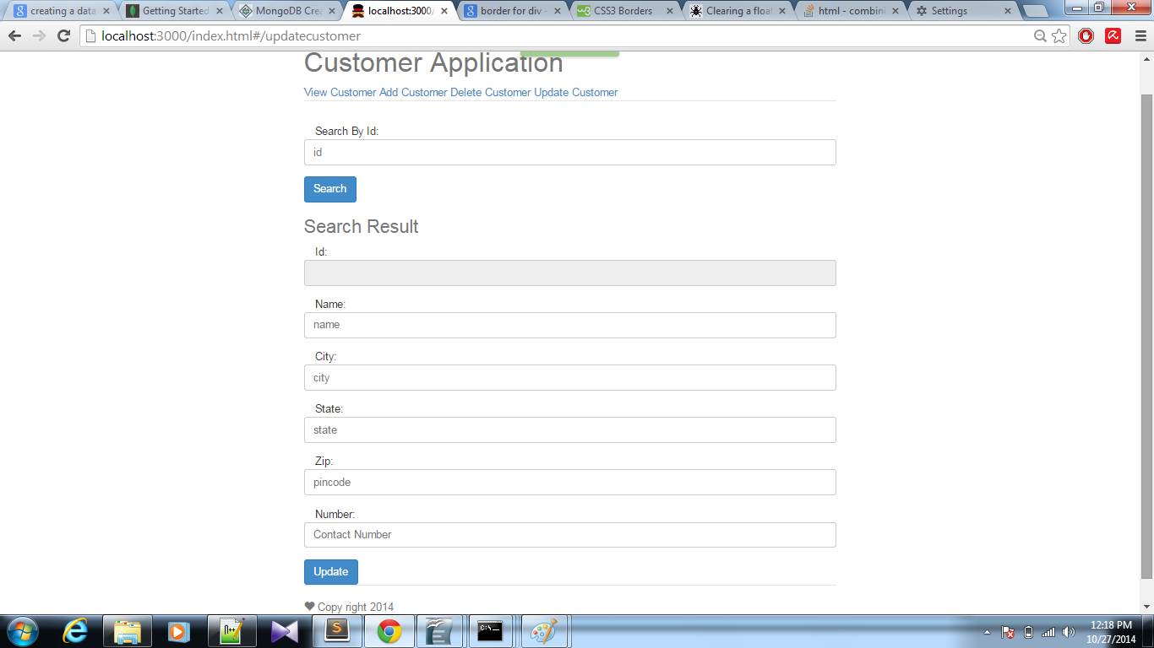

These are the screens of the pages.

Add Customer:

