ONLINE ASSET MANAGEMENT SYSTEM

PRAFULL DHIMAN
PRASHANT GUPTA
LALIT YADAV

A PROJECT REPORT SUBMITTED TO THE FACULTY OF NPCIL INFORMATION TECHNOLOGY IN PARTIAL FULFILMENT OF THE REQUIREMENTS FOR THE INTERNSHIP CERTIFICATE OF NPCIL RR SITE.

May, 2017

DECLARATION AND APPROVAL
STUDENT`S DECLARATION
I declare that this work has not been previously submitted and approved for the award of a trainee certificate by this or any other University. To the best of my knowledge and belief, the dissertation contains no material previously published or written by another person except where due reference is made in the dissertation itself.
Prafull Dhiman.
National Institute of Technology, Hamirpur (H.P.).

Sign: ………………………………… Date: ………………………………...

SUPERVISOR’S APPROVAL
This project report has been submitted for examination with my approval as university supervisor

Mr. Rakesh Badiga.

Faculty of Information Technology Department, NPCIL Rawatbhata, Rajasthan.

Sign: …………………………………. Date: …………………………………

ACKNOWLEDGMENT
I would like to take this opportunity to thank the Almighty God for His guidance and the far He has taken me and also to acknowledge my supervisor Mr. Rakesh Badiga for his continuous, tireless guidance and supervision throughout the entire project report writing period. I also acknowledge my parents for boosting me financially to cater for the all costs incurred. May God bless you all.

ABSTRACT
With the advent of ever evolving technology, every institution, organization, government agency and state corporation needs a proper way of managing its asset information efficiently, and managing it the right way cuts down maintenance costs and also saves time. There emerged the need to automate the asset management process to eliminate asset loss due to unaccountability thus there was the need to develop an Online Asset Management System to maintain and keep asset records. The specific objectives of this proposed system were: to asses and analyze the ways used to maintain and keep asset records using interviews and observation, to design an online system with two modules, that is, administrator and the workers, to implement the system using the available technology, to deploy and test the system for integration. The methodology involved was incremental methodology since it is generally easier to test and debug than other methods of software development because relatively smaller changes are made during each iteration. This allows for more targeted and rigorous testing of each element within the overall system. The Online Asset Management System makes used the modelling tools such as use case diagrams and activity diagrams. The Online Asset Management System was achieved using Hyper Text Markup Language (HTML), Java Script, JQUERY, and Preprocessor Hypertext (PHP), and MySQL as database. Testing of the system was conducted through reviews, walkthroughs and integration testing which was conducted in three stages development, system and acceptance testing. The concept of Online Asset Management System was to make the asset information easily accessible and reliable at any moment and to eliminate the challenge of monitoring asset information.

Table of Contents
DECLARATION AND APPROVAL ii
DEDICATION iv
ACKNOWLEDGMENT v
ABSTRACT vi
Table of Contents vii
List of Figures ix
CHAPTER ONE 1
1.1 Background of the Study 1
1.2 Statement of The Problem 2
1.3 Objectives 3
1.3.1 General Objective 3
1.3.2 Specific Objectives 3
1.4 Scope of The Research 3
1.5 Justification 3
1.6 Operational Definition of Terms 4
CHAPTER TWO 5
2.1 Introduction 5
2.2 ICT and Devolution 6
2.3 Overview of the existing System. 7
2.4 Related Systems. 7
2.4.1 Nimbus Software 7
2.4.2 ManageSoft 7
2.4.3 Syslist 7
2.5 The Proposed System 7
CHAPTER THREE 9
3.1 System Development and Methodology 9
3.2 System Analysis and Design Tools 10
3.2.1 System Analysis Tools 10
3.2.2 System Design Tools 10
3.3 System Implementation and Testing 11
3.3.1 System development tools 11
3.3.2 Testing 11
CHAPTER FOUR 13
4.1 System Analysis 13
4.1.1 Data Gathering 13
4.1.2 Data Analysis 13
4.2 Requirement Specification 14
4.2.1 Functional requirements 14
4.2.2 Non-functional Requirements 15
4.2.3 Application Hardware and Software Requirements 15
4.3 System Design 16
4.3.1 Use Case Diagrams for the System 16
4.3.2 Activity Diagrams for the system 19
4.3.3 Entity Relationship Diagrams for the system’s database 24
CHAPTER FIVE 25
5.1 Introduction 25
5.2 Snapshots of the Major Activities of the Application 25
5.2.1 A snapshot of the login user interface 25
5.2.2 A snapshot of the administrator’s dashboard 28
5.3. Code Snippets 28
5.3.1. PHP Code Snippet for user login 28
5.3.2. PHP Code Snippet for redirecting users 30
5.3.3 JQUERY Code Snippet for Validating Asset 31
5.4 Usability 32
5.5 Testing of the Application 33
CHAPTER SIX 35
6.1 Summary 35
6.2 Conclusions 35
6.3 Recommendations 35
REFERENCES 36
APPENDICES 37
Appendix (I): Project Gant Chart 37
Appendix (ii): Estimated study for the project 38

List of Figures
Figure 1 - Incremental Life Cycle Model 9
Figure 2 - West Pokot County Headquarters 14
Figure 3 - Senior Administrator Case Diagram 16
Figure 4 - Junior Administrator Case Diagram 18
Figure 5 - Office User Case Diagram 19
Figure 6 - Senior Administrator Activity Diagram 21
Figure 7- Junior Administrator Activity Diagram 22
Figure 8- Office User Activity Diagram 23
Figure 9 - Entity Relationship Diagram 24
Figure 10 - User Login Screen 25
Figure 11 - User Login with wrong input 26
Figure 12 - Login Screen for user with an unconfirmed account 26
Figure 13 - Login screen for user with a suspended account 27
Figure 14 - Administrator's dashboard 28
Figure 15 - PHP snippet for user login 30
Figure 16 - PHP Code snippet for redirecting users 30
Figure 17 - JQUERY code snippet for validating user input 31
Figure 18 - User menu and navigation 32
Figure 19 - Export options 32
Figure 20 Input Validation 33
Figure 21 - Confirm dialog 33

CHAPTER ONE
Introduction

1.1 Background of the Study
Assets are generally brought in businesses to benefit from them and to increase the value of a business. Assets are classified into different types based on their convertibility to cash; use in business or on basis of their physical existence.
Asset Management is a systematic approach of maintaining, upgrading, and operating physical assets cost effectively. It combines engineering principles with sound business practices and economic theory, and it provides tools to facilitate a more organized, logical approach to decision making. Thus, asset management provides a framework for handling both short- and long-range planning. (FHWA 1999). It is a systematic process of deploying, operating, maintaining, upgrading, and disposing of assets cost-effectively. Managing assets allows one to get maximum value from the use of the assets, right-size IT inventory, and optimize inventory purchase decisions and strategies. Asset management provides one the means to achieve complete visibility into his or her IT infrastructure inventory, helping him or her gain an in-depth understanding of: what systems and equipment exist where components reside, how they are used, what they cost, when were they added to the inventory, when their warranty expires, whether they have an expiry date, and how they impact IT and business services (Vinod Mohan, 2013). This level of visibility into asset details will help organizations improve infrastructure efficiency and performance, and minimize related overhead expenses. All organizations, in one way or the other, perform Asset Management. It’s important to implement Asset Management practices intelligently, in order to achieve IT operational efficiency, financial accountability of asset purchase, simpler auditing and compliance, and long-term asset manageability and maintenance. Every business, institution or organization therefore needs a proper way of keeping its asset records as they play a key role in the business or organization’s success.
According to a survey by an author (Brianna Aris, 2016) on local government professionals on the state of their organization’s asset management, Aris says her findings reveal that a poor asset management culture is systemic throughout many councils.
In Kenya, institutions, organizations and government parastatals are facing a difficult time in identifying and tracking of their assets. For instance, during my attachment period at West Pokot County government, I noticed that the County government did not have a proper record keeping system for monitoring and managing its assets. The records on the asset information are still being kept as physical documents then stored in files. This makes it difficult to retrieve information about a specific asset due to the technical manner in which the information is stored.
West Pokot County is also incurring a lot of losses in terms of assets which are being embezzled by some of the officers working at the county. Some officers at the county are misusing the county’s assets for their own personal good. Some use the devices assigned to them for office use for their own personal gain, for example, some use the camera meant for the media team to take photos of their families and friends during vacation.
West Pokot County is also losing its assets due to fraud as some assets are assigned to users or leased for use without the records being noted. Assets assigned wrongfully this way cannot be accounted for in case they get lost or get damaged when being used, thus being losses to the county.
West Pokot County also faces a challenge during inventory taking, the inventory is taken manually, the asset information is recorded on printed papers then after all the inventories have been taken, the information is then fed into MS Excel manually then printed. This process is tiresome and also prone to entry errors such as spelling errors and wrong entries.
West Pokot County also faces a challenge of keeping history of the asset’s information such as the asset’s repair history and warranty information, asset’s repair history and warranty information.

1.2 Statement of The Problem
During the study, it was discovered that the current system being used at West Pokot County was inefficient as it led to a significant loss of the county’s funds in terms of assets lost through fraud and corruption. The asset records are also vulnerable to getting damaged or getting lost as they were kept as physical documents in physical files. A lot of time was also wasted in retrieving the asset records especially when the records are poorly kept. The system in place also did not provide asset reporting and alerting for example being able to receive alerts on asset warranty and lease expiration, and this led to some warranties expiring unused or a lease expiring without being notified. The system also did not provide asset tracking as one should be able to identify and track change in the location of assets, increase or decrease of the number of assets, track assignment status and user information. A remedy to this was to design and develop an online asset management system to keep the asset records.

1.3 Objectives

1.3.1 General Objective
The main objective of this project was to develop an online asset management system to keep and maintain asset records for assets available in an institution.

1.3.2 Specific Objectives
- To investigate the existing system so as to determine the system requirements.
- To design and develop a user friendly online asset management system.
- To test and validate the developed system

1.4 Scope of The Research
This project targets West Pokot county government’s ICT department, in particular the asset information management system.

1.5 Justification
A variety of Asset management software products exist in the market which can be used to manage IT equipment efficiently. But often these Asset management software products do not always fulfill all the IT requirements of an organization. For example, most of the Asset management software products available in the market manage hardware and software assets quite well but fail to offer real time access to the asset information, offer real time tracking of an asset’s location, fail to keep properly inventory records about the assets’ condition.
The proposed online Asset management system addresses the core aspects surrounding the overall management of asset records in institutions. It is not only designed to simplify the process but also to provide an avenue in which accountability, efficiency, reliability, availability and security can be achieved in the management process. Efficiency and effectiveness is in regard to speed in generation of reports, file organization, editing of recorded information, utilizing the available resources like printing and storage of data at centralized database hence ease retrieval of data. Security is enhanced by use of password and privileges allocation which is assigned to each user of the system. Reliability is upheld by making information available online for easy retrieval and access at any given time from anywhere.

1.6 Operational Definition of Terms
- Asset - An asset is a resource or property having a monetary or economic value, possessed by an individual or entity, which is capable of producing some future economic benefit.
- User- all those who use the system, it may include administrator and the county workers.
- Administrator – an administrator is a user of the asset management system who has more privileges in the system than an ordinary user.
- Asset Manager – The online Asset Management System.

CHAPTER TWO
LITERATURE REVIEW

2.1 Introduction
Technology is advancing very fast and due to these advancements, there is need to cope up with them. ICT plays a key role in every country’s economic development.
Over the last decade, Kenya has experienced substantial growth in ICT, with the period between 2013 and 2014 seeing up to 8.4 percent improvement in this sector (Ogutu, 2015).
“Since 2000, Kenya’s economy has grown at an average of 3.7 percent. Without I CT, this growth would have been at 2.8% and per capita income would have stagnated” (Ogutu, 2015). During the first decade of the 21st century, ICT was responsible for the growth of approximately one-quarter of Kenya’s GDP.
Kenya has been ranked among the top 5 African countries with the fastest growth in telecommunications, infrastructure and mobile money innovations (Ogutu, 2015). The engine behind the rapid growth has been mobile telephony which has caused a mobile revolution in the country. Mobile penetration in Kenya is currently at 82.6 per cent with 33.6 million subscribers, proving that the mobile phone is an important tool in transforming lives.
ICT plays a large role in our day-to-day lives, addressing challenges facing Kenyans in general. Particular sectors such as finance, health, education, agriculture and the government are quickly embracing technology for dissemination of information, enhancement of service delivery and to reach their customers more effectively and efficiently.
The financial inclusion agenda in Kenya has borne positive results with 2 out of 3 adult Kenyans being part of the formal financial ecosystem. The growth of MPESA in the country has driven change in the business model of most financial institutions in the country. Mobile money agents represent three quarters of the total financial access points in Kenya and are a major driver in bringing financial access points closer to the population.
In the health sector, ICT is used to provide health tips and improve access by the general public to quality health care. ICT is also used to improve procurement and distribution of medicine and medical supplies, as well as monitor and encourage attendance of mothers at ante-natal and post-natal clinics, particularly among pastoral communities.
In education, ICT enables more children to affordably access learning content. This area has huge potential for growth in enabling online education and facilitating massive and open online content.
The agriculture sector is also rapidly adopting the use of ICT. Already, ICT is being used to monitor distribution of fertilizers and to disseminate information to farmers on how to increase yields and access markets through the use of mobile devices (Cespedes, 2013). The government has identified the potential of ICT in deriving the economy and has embarked on several transformative ICT initiatives. The launch of Huduma Centers as one-stop shops that aim to provide a wide range of services demonstrate how ICT can be leveraged to substantially improve public service delivery.
The private sector in partnership with the government has also played a critical role in driving some of the projects including use of mobile payment platforms to collect government revenue such as e-citizen and e-jiji payments. The digital economy holds huge potential for growth, so ICT will be expected to play an increasing role in affording opportunities to the youth of the country to play an active role in the sector.

2.2 ICT and Devolution
The devolved system of government that Kenya adopted after the March 2013 general election holds a lot of promise to unlock the country’s economic, social and political fortunes which have been stifled by a centralized system of government since independence. Devolution main goal is to result in equitable development in all parts of Kenya, and has in the last two years delivered encouraging results in many counties.
Each of the 47 county governments in Kenya is one way or another embracing ICT in its day to day activities and this is aimed at improving services rendered to the common Kenyan. The Meru County government for instance, has embarked on a programme of integrating ICT in delivery of services, through installation of ICT infrastructure in the departments and this is aimed at faster delivery of services such as business licensing, payments and land management.
ICT is being embraced by some county governments to improve service delivery to the citizens, fight corruption and mange resources.

2.3 Overview of the existing System.
West Pokot County government has yet to fully embrace ICT in its day to day operations despite having appropriate ICT infrastructure in place. A manual record keeping system currently exists. A lot of time is used in retrieval of records, it’s hard to maintain and update information in this system too.

2.4 Related Systems.

2.4.1 Nimbus Software
Nimbus software is suited to managing a wide variety of IT equipment like servers, network services, switches, routers, emails and graphical display. Nimbus software is rather sophisticated. At West Pokot County government, the IT-maintenance need is more on hardware like CPU, memory, monitors, drives, printers etc and software like operating system, Microsoft office, antivirus etc.

2.4.2 ManageSoft
ManageSoft tracks and analyzes software and hardware assets with reduced IT costs and improved IT service levels. ManageSoft however lacks the ability to support heterogeneous networking in Mac environment and input non-PC data such as information on telephone system, office material manually into the inventory database.

2.4.3 Syslist
Syslist can quickly search the organization’s inventory for useful information such as serial numbers, IP addresses or a list of PCs with a given software type installed. Unlike ManageSoft, Syslist is uniquely built to accommodate non-PC data such as, information on telephone system, office material manually into the inventory database. While Syslist does support Unix and Linux environment, it does not support heterogeneous networking in Mac environment.

2.5 The Proposed System
Online Asset Management System is a web based asset management aimed at solving the asset management problem at West Pokot County.
It combines all the concepts of the above related systems and fill in all the gaps had been created
by the present manual system. How does it fill?
- It is a responsive web based application thus will be accessed by any device (Smartphone, tablet or computer) with internet connectivity from anywhere at any given time of day or night.
- Storing, tracking, modifying and maintenance of the asset records will be simple.
- Cases of corruption will reduce drastically as the asset management process is automated handled by a system and everything is recorded, analyzed and stored in databases for future reference.
- The asset records will be secure and readily available as they will be stored online.

CHAPTER THREE
METHODOLOGY

3.1 System Development and Methodology
The Asset Management system used the incremental build methodology, where the system was designed, implemented and tested incrementally (a little more was added each time) until the system was finished. It involved both development and maintenance. The system was defined as finished when it satisfied all of its requirements. This model combines the elements of the waterfall model with the iterative philosophy of prototyping. The system was decomposed into a number of components, each of which is designed and built separately (termed as builds).

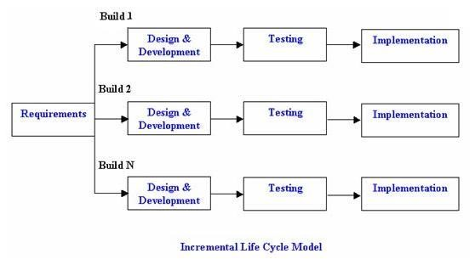
Figure 1 - Incremental Life Cycle Model
Benefits of using incremental model included: Core product was developed first i.e. main functionality is added in the first increment.
After each iteration, regression testing was being conducted. During this testing, faulty elements of the system were quickly identified because few changes a were made within any single iteration.
It was generally easier to test and debug than other methods of software development because relatively smaller changes were made during each iteration. This allowed for more targeted and rigorous testing of each element within the overall product.
With each release a new feature was added to the system.

3.2 System Analysis and Design Tools

3.2.1 System Analysis Tools
The system analysis of this system was conducted was carried through a number of tools.

3.2.1.1 Observation
This method included reviewing of the current system and their functionalities they offer as well as the problem they solve. It involved installation the applications in our devices and examining their operations.

3.2.1.2 Interviews
The researcher did a site visit and carried samples of questions that were used to interview the users of the existing system.

3.2.2.3 Reviewing journals and documents
The researcher reviewied articles, journals and other documents about the current automated systems. How they achieved their specified functionality.

3.2.2 System Design Tools

3.2.2.1 Use-case Diagrams
Use case diagrams were used to show the tasks of the administrators a well as the system users.

3.2.2.2 Activity Diagrams
Activity diagram were used to show the flow of activities of the entire system which include the activities of each of the administrator, supervisors as well as the database interactions.

3.2.2.3 Entity Relationship Diagrams
Entity relationship diagrams were used to illustrate the logical structure of my database.

3.3 System Implementation and Testing

3.3.1 System development tools
The system used both hardware and software tools to accomplish the development of the system.
Hardware Tools
- A laptop for development purposes.
Software Tools
- Front End Development Languages which are HTML5, CSS3, JQUERY, JavaScript.
- Back End Scripting language which is PHP
- Atom Editor
- Adobe Dreamweaver CC 2015.

3.3.2 Testing
Generally, all programs were tested before system conversion.

3.3.2.1 White box testing
It concentrated on internal construction of a program. It was carried out on the following:
- Cyclomatic complexity - measures of logical complexity of a program
- Data flow testing – commonly associated with SSADM. It was used to select paths of a program according to location and definition of variables.
- The loop testing – it focused on exclusive validity of loops within a program

3.3.2.2 Black box testing
Focused on functional requirements of software. It attempted to find errors in the following categories:
- Incorrect or missing functions
- Interface errors
- Data structure errors
- Performance errors
- Initialization and termination errors
Major stages of testing that were carried out to the Asset Management System included:
- Unit testing: testing of program segments that do specific functions. It emphasized on the local data structure, boundaries, interfaces etc.
- Module testing: involved testing of interrelated units within a program, which perform a specific task. It emphasized on local data structure, error handling and independent program parts. Debugging and correction of errors during each individual program segment were part of module testing.
- Recovery testing: It was conducted to force software to fail in a number of ways and verify that recovery was properly performed.
- Security testing: It attempted to verify that protection mechanism built into the system works.
- Stress testing: It was designed to confront a program with abnormal structure and abnormal quantity of resources e.g. a large volume of transaction inputs to see how the program can cope up with such abnormally.
- Performance testing: It was conducted to evaluate the software performance e.g. run time, response time, quality of output etc.
- Acceptance testing: This was carried out by software users and management representation for the following reasons:
  - To discover software errors not yet detected
  - To discover the actual and exact demands of the system
  - To discover if any major changes required by the system were being adopted.

CHAPTER FOUR
SYSTEM ANALYSIS & DESIGN

4.1 System Analysis

4.1.1 Data Gathering
Data was collected from interviewing ICT department personnel and staff about the major issues affecting asset records management at West Pokot County and online articles about the major issues affecting asset records management in general. Data collection also involved observation, where the techniques were observed.

4.1.2 Data Analysis
Following the data collection, it was observed that the process of asset management at West Pokot County is not properly handled as the records are kept in MS excel files in computer hard drives, which makes it complicated to retrieve the information with ease and in real time, and updating the asset information and keeping track of critical asset information such as warranty expiry dates.
It was also observed that the county is also losing its assets due to fraud as some assets are assigned to users or leased for use without the records being noted. Assets assigned wrongfully this way cannot be accounted for in case they get lost or get damaged when being used, thus being losses to the county. Some staff for instance were using antivirus keys meant for the county offices to activate antivirus programs on their personal computers.
It was also observed that the county faces a challenge during inventory taking, the inventory is taken manually, the asset information is recorded on printed papers then after all the inventories have been taken, the information is then fed into MS Excel manually then printed. This process is tiresome and also prone to entry errors such as spelling errors and wrong entries.
The information gathered led to the conclusion that the county needed a proper way of managing these records, that would offer real time access to asset information and ease the process of inventory management and asset record keeping as a whole.

Figure 2 - West Pokot County Headquarters

4.2 Requirement Specification

4.2.1 Functional requirements
- Validate the user of the system, the user will be required to login and provide the correct username and passwords.
- Allow administrators to add assets the asset manager.
- Allow the administrators to view notifications on expired license keys, expired warranties, expired leases and unconfirmed sign up requests.
- Allow administrators to view messages from users in different offices and departments.
- Allow administrators to fully manage assets, including adding an asset to the system, updating or deleting assets from the system, viewing existing assets in the system.
- Allow the administrators to take inventories of the assets available in the system and updating the asset’s working condition and location.
- Allow the administrators to add vendors to the system
- Calculate asset depreciation

4.2.2 Non-functional Requirements
Security: The system is secure as it provides authentication to every user senior administrators, junior administrators or office users. The senior administrator can control the system access by either blocking all users or an individual user.
Availability: Information is readily available to the users once they are connected to the internet and logged into their system accounts at any hour of the day.
Usability: The user is able to navigate through different modules by the use of a navigation menu.
Portability: The system was developed using HTML5 which is platform independent thus it can be accessed from any device with a web browser.

4.2.3 Application Hardware and Software Requirements
- A web browser with HTML5 support.
- Internet Connection: - Mobile Data Network or Wi-Fi Network

4.3 System Design

4.3.1 Use Case Diagrams for the System

4.3.1.1 Senior Administrator use case diagram
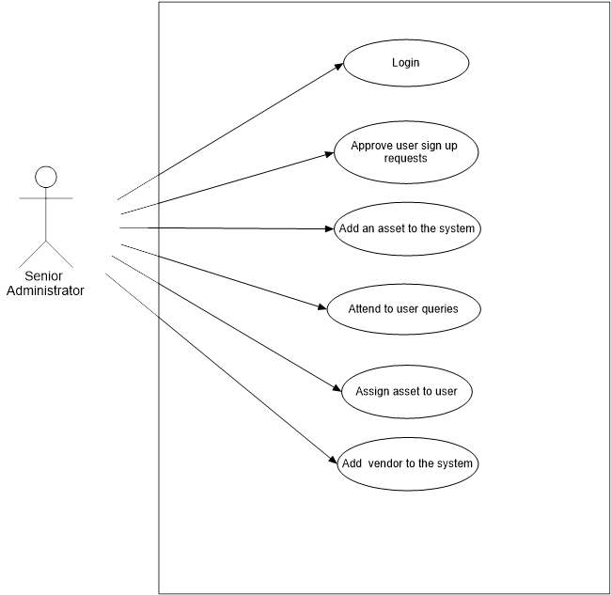
Figure 3 - Senior Administrator Case Diagram
The senior system administrator handles a number of responsibilities in the system. The senior administrator has higher privileges in the system as compared to the junior administrator and office users of the system as the senior administrator can: -
- Manage system users - Approve sign up requests from office users who have signed up to the asset manager, view existing users in the asset manager, suspend a user from using the asset manager and delete a user permanently from the asset manager.
- Manage assets - Add new assets or existing assets to the asset manager, edit and update asset information, take inventories of the assets, view the assets and their depreciation information, delete an asset from the asset manager and assign an asset to an office user for long term or short use.
- Manage offices and departments – Add an office/department to the asset manager, edit and update offices and departments information, view existing offices and departments and delete offices from the asset manager.
- Manage vendors and technicians - Add a vendor or technician to the system, view existing vendors and technicians, edit and update the vendors and technicians’ information, delete the vendors or technicians from the asset manager.
- User Feedback Management - Attend to/respond to queries by office users sent to the administrators through the asset manager Queries service.

4.3.1.2 Junior Administrator use case diagram
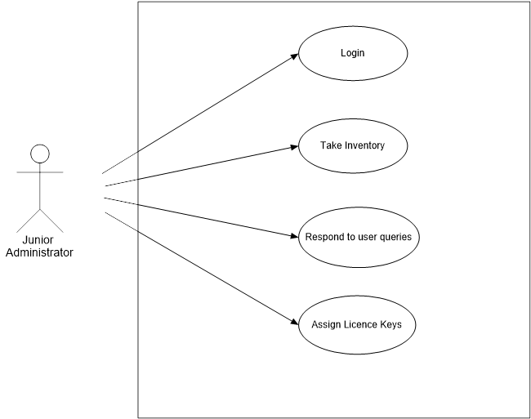
Figure 4 - Junior Administrator Case Diagram
The junior system administrator has a number of responsibilities in the system and has higher privileges in the system than an office user, but less than the senior administrator. The junior administrator can: -
- Take inventories of the assets existing the asset manager.
- Respond/attend to office user queries sent to the administrators.
- Assign license keys to assets(computers) which include anti-virus activation keys and software activation keys.

4.3.1.3 Office user use case diagram
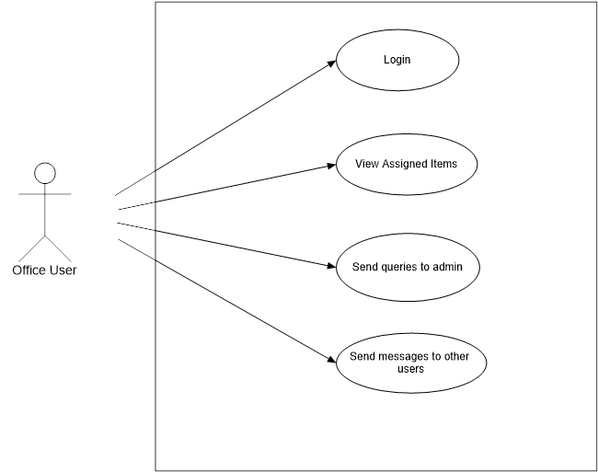
Figure 5 - Office User Case Diagram

An office user has the least number of responsibilities in the asset manager. An office user can only view items assigned to him/her, send queries/feedback to the administrators or send messages to other users of the asset manager.

4.3.2 Activity Diagrams for the system
Activity diagrams are one of the tools that were used in the fulfilment of the projects objectives. Various activity diagrams were used to illustrate the flow of activities of given subsystem and the flow of activities of the entire application.

4.3.2.1 Senior Administrator Activity Diagram
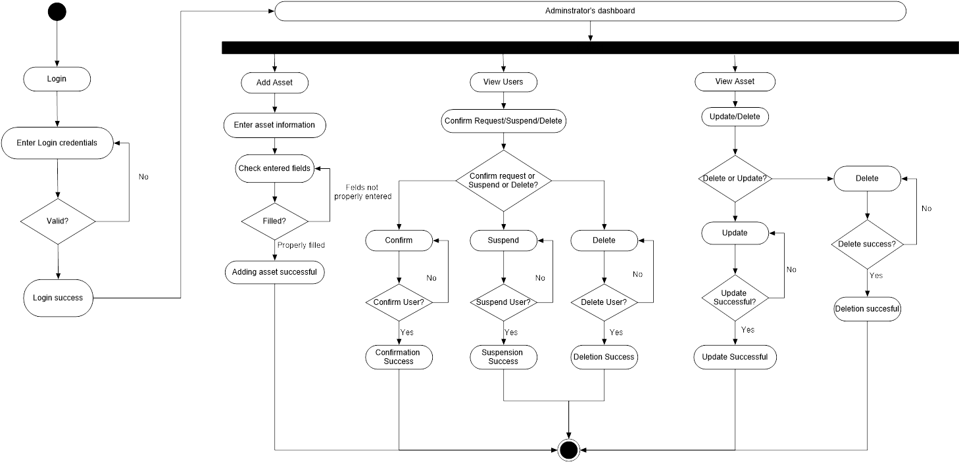
Figure 6 - Senior Administrator Activity Diagram
The administrator first starts by logging into the system using his email address and chosen password to get access to his profile. The system checks if the email and password are valid. If they are valid, the administrator is logged in the system successfully and can access his dashboard. If they are incorrect, the system prompts the administrator to re-enter the email and password.
After a successful login, the administrator can perform a number of operations availed on the dashboard like adding an asset to the system, performing actions to the system users, adding offices, adding departments, adding vendors, adding technicians and responding to office user queries.
In the assets module, the administrator can add an asset to the system by first entering the asset information, then when he clicks save, the information entered is validated whether entered correctly or not. If the information was entered correctly the information is saved successfully. If the information was not correctly entered, the administrator will have to enter the information correctly before saving.
In the Users module, the administrator can perform various actions to the users existing in the system like confirming the user sign up request, suspending a user from the system and deleting a user from the system. When confirming a user to the system, the administrator first selects a user, then clicks on a confirm request button which then prompts the administrator to confirm his action first. If he confirms the action, the system will confirm the user to the system and simultaneously send the user a confirmation email with a link to complete his registration. If he cancels the action, the intended action of confirming the account is not executed. When suspending a user from the system, the administrator first selects a user, then clicks on a suspend user button that will also prompt the administrator to confirm his action. If the administrator confirms this action, the system will suspend the user and also simultaneously send the user an email to notify him of his suspension. If he cancels the action, the intended action of suspending the user account is not executed When deleting a user, the administrator will first select a user then click on a delete user button which will then prompt the administrator to confirm the action. If he confirms the action, the system will permanently delete the user. If he cancels the action, the intended action of deleting the user account is not executed.

4.3.2.2 Junior Administrator Activity Diagram
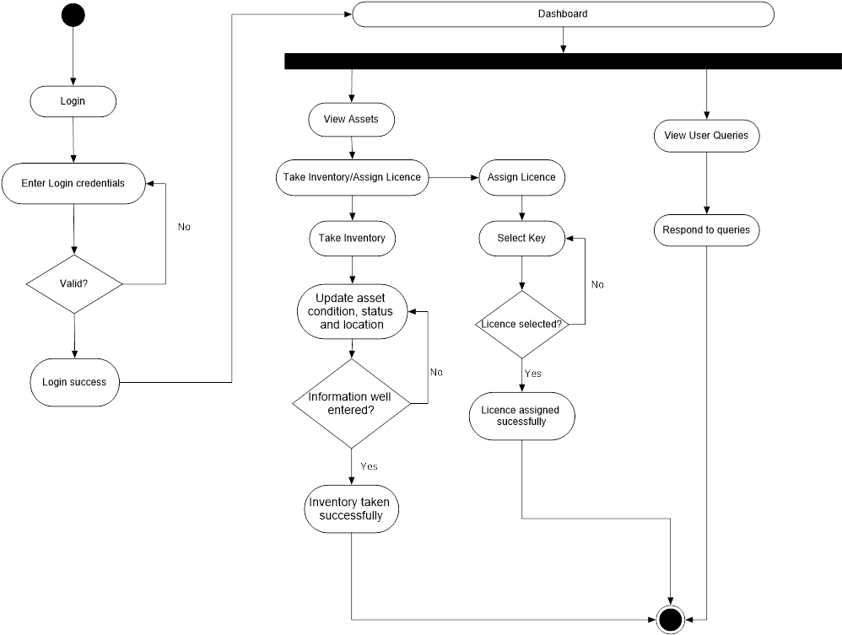
Figure 7- Junior Administrator Activity Diagram
The junior administrator first starts by logging into the system using his email address and chosen password to get access to his profile. The system checks if the email and password are valid. If they are valid, the administrator is logged in the system successfully and can access his dashboard. If they are incorrect, the system prompts the administrator to re-enter the email and password.
After a successful login to the system, the junior admin can perform various operations using his menu including taking inventory of the assets or assigning licenses to assets that have programs that require license keys installed in them for example computers and laptops and viewing user queries and responding to them.
In the Inventory taking module, the junior administrator first selects the asset then click on the ‘Take Inventory’ icon, which will open a new page with details of the chosen asset information. The asset junior administrator will now have to update the asset’s office in which it exists, department, custodian, status and condition before saving the information.
In the assigning license module, the junior administrator first selects the item to assign a license then clicks on the assign license icon which will open a new page which has information about the asset being assigned a license. The junior administrator will then select the license key then assign it to the asset by clicking the save button.

4.3.2.3 Office User Activity Diagram
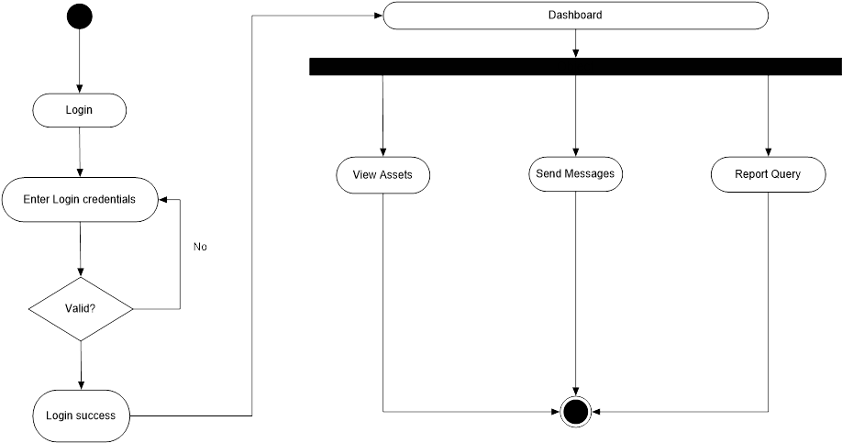
Figure 8- Office User Activity Diagram
The office user first starts by logging into the system using his email address and chosen password to get access to his profile. The system checks if the email and password are valid. If they are valid, the administrator is logged in the system successfully and can access his dashboard. If they are incorrect, the system prompts the administrator to re-enter the email and password.
After a successful login to his account, an office user has a number of operations he/she can perform and they include viewing the assets he/she is assigned, send messages to his/her fellow colleagues or report queries to the administrators.

4.3.3 Entity Relationship Diagrams for the system’s database
An entity relationship diagram (ERD) represents the entities, or groups of information, and their relationships maintained for an application. Entity Relationship Diagrams were used in both the logical and physical modelling of the system’s database which is used to store data and to produce the desired information requested by queries to the database.
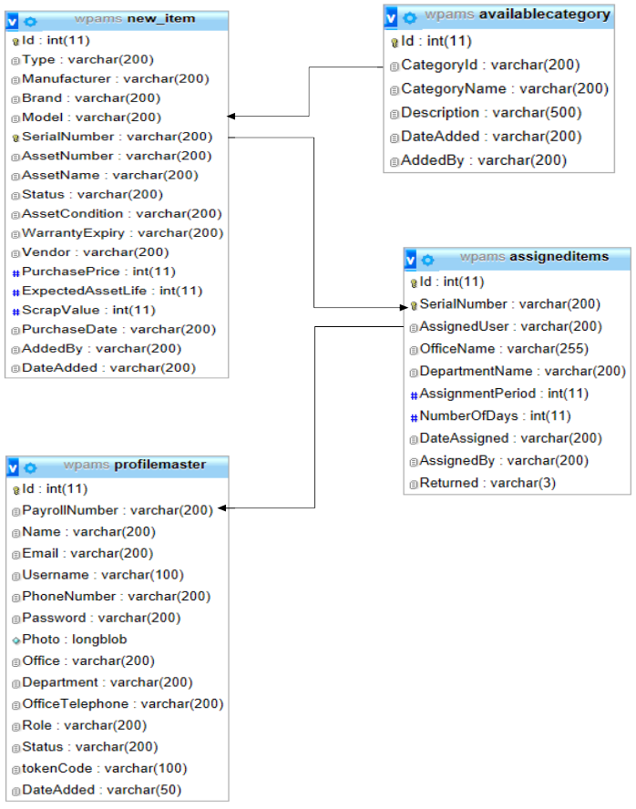
Figure 9 - Entity Relationship Diagram

CHAPTER FIVE
SYSTEM IMPLEMENTATION, TESTING AND VALIDATION

5.1 Introduction
After the analysis and design of the application, the next phase was implementation where coding was done. HTML 5, CSS3, jQUERY and Bootstrap Framework were used to design the layout of the application, and PHP was used to implement the system’s functionality. jQUERY and JavaScript libraries and plugins were used to validate and animate the application. PHP was used to pass information to and from the server.

5.2 Snapshots of the Major Activities of the Application

5.2.1 A snapshot of the login user interface
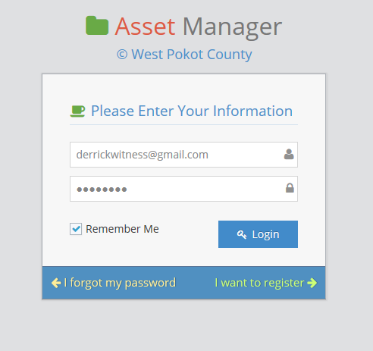
Figure 10 - User Login Screen
The figure above illustrates the user login screen with sample input in the fields.
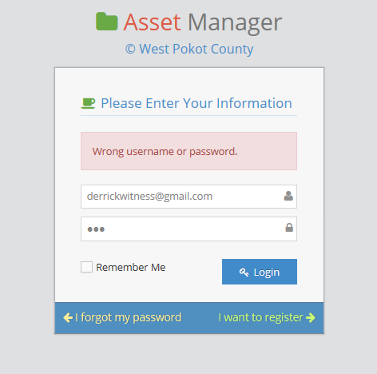
Figure 11 - User Login with wrong input
The figure above illustrates the user login window when a user enters wrong username or password.

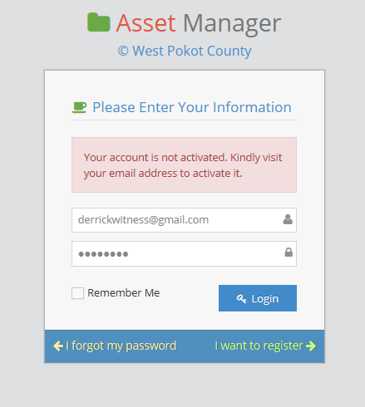
Figure 12 - Login Screen for user with an unconfirmed account
The figure above illustrates the user login window when a user provides the right login credentials but has not activated his or her account
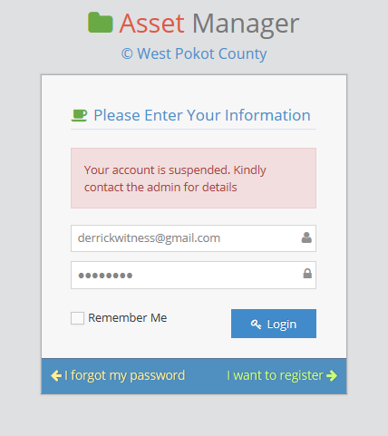
Figure 13 - Login screen for user with a suspended account
The figure above illustrates the user login window when a user provides the right login credentials but his or her account is suspended by the admin

5.2.2 A snapshot of the administrator’s dashboard
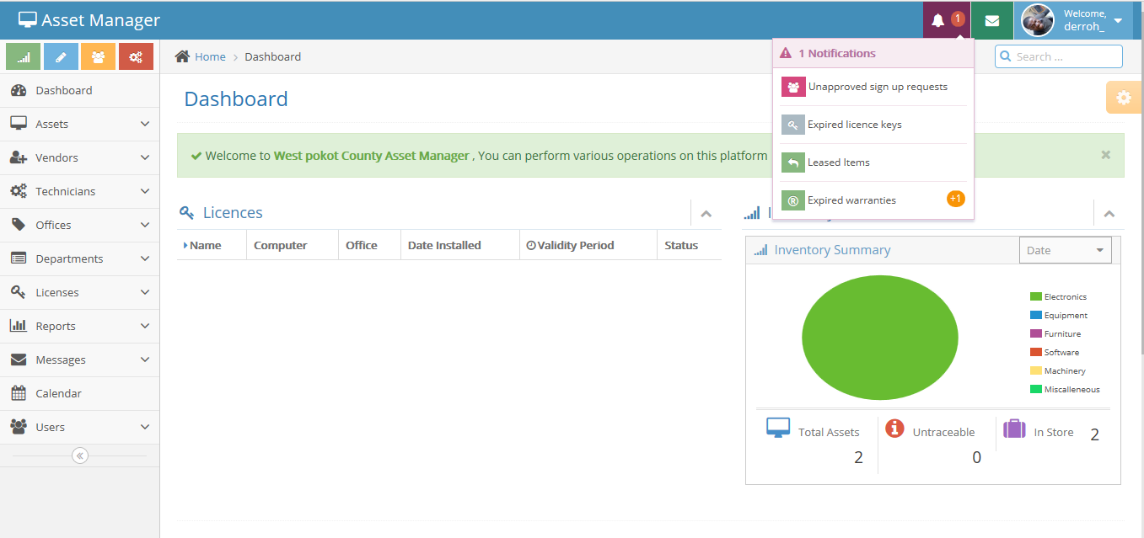
Figure 14 - Administrator's dashboard

5.3. Code Snippets
Below are code snippets of the system which include PHP scripts for database sourcing and JQUERY scripts for validating user input.

5.3.1. PHP Code Snippet for user login
<?php
//process login form if submitted
if(isset($_POST['submit']))
{
$user_email = trim($_POST['user_email']);
$password = trim($_POST['password']);
if($user->login($user_email, $password))
{
//check if account is activated
$stmt = $db->prepare('SELECT * FROM profilemaster WHERE Email =
:user_email');
$stmt->execute(array(':user_email' => $user_email));
while($row=$stmt->fetch(PDO::FETCH_ASSOC))
{
$status = $row['Status'];
$_SESSION["username"] = $row['Username'];
$_SESSION['usersfullname'] = $row['Name'];
$_SESSION["profilephoto"] = $row['Photo'];
$_SESSION["Role"] = $row['Role'];
$_SESSION["Id"] = $row['Id'];
}
if( $status=="Y")
{
if(!empty($_POST["remember"]))
{
setcookie ("member_login",$_POST["user_email"],time()+ (10 * 365 * 24 * 60 * 60));
setcookie ("member_password",$_POST["password"],time()+ (10 * 365 * 24 * 60 * 60));
} else {
if(isset($_COOKIE["member_login"]))
{
setcookie ("member_login","");
}
if(isset($_COOKIE["member_password"]))
{
setcookie ("member_password","");
}
}
header('Location: index');
exit;
}else if ( $status=="N") {
$user-> logout();
$message = '<div class="alert alert-danger"> Your account is not activated. Kindly visit your
email address to activate it. </div>';
}else if ( $status=="P") {
$user->logout();
$message = '<div class="alert alert-danger"> Your account is not approved. Kindly be patient
till the procces is complete. You will receive an email with a confirmation</div>';
}else if ( $status=="S") {
$user->logout();
$message = '<div class="alert alert-danger">Your account is suspended. Kindly contact the
admin for details</div>';
}
} else {
$message = '<div class="alert alert-danger">Wrong username or password.</div>';
}
}//end of submit
//echo errors here
if(isset($message)){ echo $message; }
?>
Figure 15 - PHP snippet for user login
The above snippet is for the user login functionality. It first checks if the form is submitted or not. If the form is submitted, it then gets the user input i.e. the email and passwords. The email and password are passed to another function login which checks if the email and password provided exists or not. If they exist, the user’s details: Username, Name, Photo, Role and Id are fetched from the database and each is assigned to session variables. After that it then checks if the user’s account is activated or suspended. If it is activated, and the user has checked the ‘Remember Me’ checkbox, the user’s password and email are stored as cookies. If the account is not activated, the system will output a message informing the user that the account is not activated. If the account is suspended, the system will tell the user that his/her account is suspended and he can contact the administrator for more information about it.

5.3.2. PHP Code Snippet for redirecting users
Figure 16 - PHP Code snippet for redirecting users
The above code snippet checks if a user visiting a page is logged into his or her account. If the user is not logged in his or her account, the system redirects him or her to the user login page, login.php.

5.3.3 JQUERY Code Snippet for Validating Asset
$('#asset-information').validate({
errorElement: 'div',
errorClass: 'help-block',
focusInvalid: false,
ignore: "",
rules: {
assetName: {
required: true
},
assetSerial: {
required: true
},
assetNumber: {
required: true
},
assetStatus: {
required: true
},
assetCondition: {
required: true
},
warrantyExpiry: {
required: true
}
},
messages: {
assetName: {
required: "Please specify the asset's name"
},
assetSerial: {
required: "Please specify the asset's serial number"
},
assetNumber: "Please specify the asset's number",
assetStatus: "Please specify the asset's status",
assetCondition: "Please choose the asset's condition",
warrantyExpiry: "Please choose the asset's warranty expiry date"
}
Figure 17 - JQUERY code snippet for validating user input
The above JQUERY code snippet first declares the rules for validating the form elements in the form with the id 'asset-information'. Each form element is represented by its id and the error message for each element is also defined.

5.4 Usability
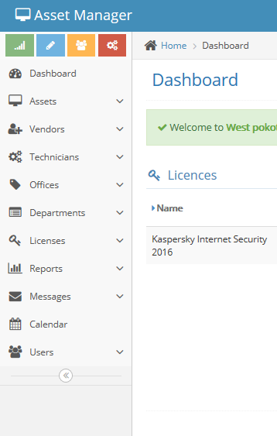
Figure 18 - User menu and navigation
The figure above represents the asset manager’s navigation menu that helps the user access the different modules and submodules of the system with ease.
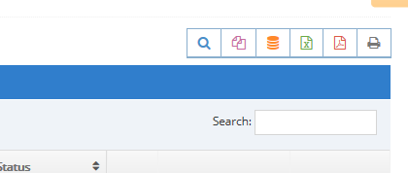
Figure 19 - Export options
The figure above figure shows the different export options a user can export his/her data to i.e. excel, pdf

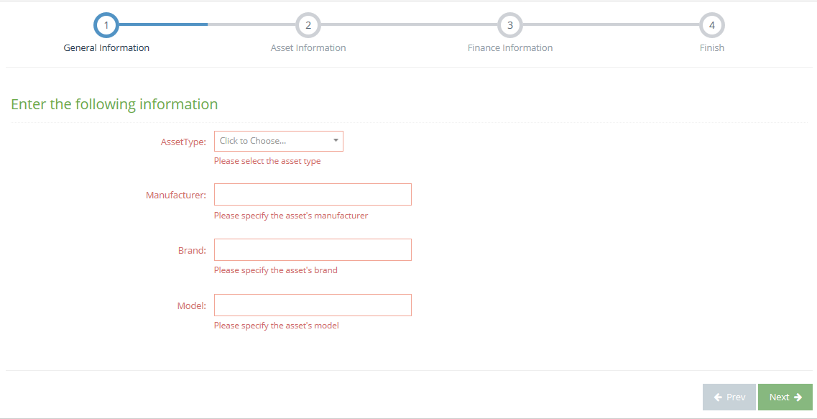
5.5 Testing of the Application
Figure 20 Input Validation
The figure above illustrates the error messages provided by the system when a user submits data without entering all the information required.
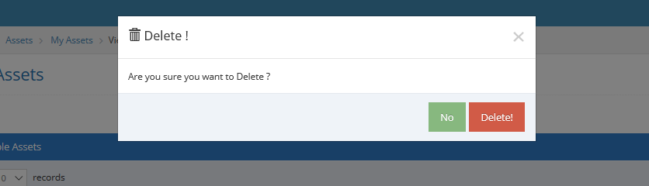
Figure 21 - Confirm dialog
The figure above shows a confirm action modal dialog which shows when a user tries to manipulate a functionality that will modify the system’s data.

CHAPTER SIX
SUMMARY, CONCLUSIONS AND RECOMMENDATIONS

6.1 Summary
The online asset management system was developed using HTML5, Bootstrap, CSS3, JavaScript and JQUERY. It has three modules, the senior administrator’s, the junior administrator’s and the office user’s. The senior administrator can add assets, vendors, suppliers, offices and departments to the system and manage their information. The junior administrator can only view the asset information, the inventories and respond to user queries. The office user can only view assets he/she is assigned and submit queries to the administrators. The application is hosted online so users can access it at any time at their convenience.

6.2 Conclusions
The online asset management system was developed to solve the problem of asset information management at West Pokot county as it will ease access to information such as inventory reports. The system will eliminate time consumption and resources used in taking inventories and also help a user keep track of his/her assets. The system will also manage antiviruses and licenses information; thus no asset will miss an active antivirus license.

6.3 Recommendations
There are many recommendations that can make this project even much better despite its success, recent technological changes:
- The system to be linked directly to the county’s payroll so that a user can be fined or surcharged when he/she mishandles the county’s assets.
- The system to have an e-commerce module where users can buy scrap and unrepairable computer parts.

REFERENCES
Brianna Aris (2016). Quantifying Major Barriers to Good Asset Management Practice in Local
Government
Keziah Wangui Mugambi and Ms. Fridah Simba Theuri (2014). The Challenges Encountered by
County Governments in Kenya.
Vinod Mohan (2013) IT Asset Management Benefits & Best Practices
Joel Ogutu (2015) How ICT drives Kenya’s Economic growth
Lisa M. Cespedes (2013) How ICT tools are improving efficiency of Agricultural development
J.Kreutzkaamp, L. Hagge, E. Deffur, A. Gellrich, B. Schulz (2003), Experience with an IT Asset
Management System (pdf), Electronic Report, Desy, Hamburg, Accessed October 2016.
ManageSoft Corporation (2004), ManageSoft, The Software Management Company,
http://www.managesoft.com, Accessed September 2016
Syslist.com Company (2004), Syslist Software, A Hardware and Software Inventory Management,
http://www.syslist.com/, Accessed September 2016.
http://www.investopedia.com/terms/d/depreciation.asp . Accessed February 18th 2017.
http://www.accountingcoach.com/terms/D/depreciable-cost. Accessed February 18th 2017.
How to Calculate Depreciation on Fixed Assets, http://www.wikihow.com/Calculate-Depreciation-on-Fixed-Assets. Accessed February 18th 2017.

APPENDICES

Appendix (I): Project Gant Chart

Length in days | 5 | 30 | 1 | 23 | 30 | 31 | 14 | 1
Idea generation
Proposal writing
Proposal Presentation
Requirement collection and analysis
Design
Coding and unit testing
Prepare documentation
Final presentation

Appendix (ii): Estimated study for the project

ITEM | COST(KES)
Materials, Services and Expendables  Printing (Proposal)  Stationery (3 Pens and Papers)  Photocopying cost  1 Flash Disk and 5 CDs  Modem  Bundles | 1000.000  200.00  200.00  700.00  2000.00  2000.00
Laptop | 45,000.00
Miscellaneous | 1000.00
TOTALS | 52,100.00

