 

Camp Education Society’s

Dr. Arvind B. Telang Senior College

Nigdi, Pune – 411 044

A

PROJECT REPORT ON

**“Blood Bank Management System”**

**Developed By**

|  |  |
| --- | --- |
| **Name** | **Roll No** |
| **Dhananjay M. Bhagat** | **2912** |

**Submitted to**

**Savitribai Phule Pune University**

**In Fulfillment Of**

**T.Y.B.Sc. (Computer Science) Sem-VI**

**Academic Year**

**2021-22**



Roll. No. -2912

Camp Education Society’s

**Dr. Arvind B. Telang Senior College, Pune - 44**

DEPARTMENT OF COMPUTER SCIENCE

***CERTIFICATE***

This is to certify that **Mr. Dhananjay M. Bhagat**. of class T.Y.B.Sc.(Comp. Sci.) SEM -VI has satisfactorily completed the Project entitled **“Blood Bank Management System”** in Computer Science during the year 2021-2022 as per requirements of the Savitribai Phule University of Pune.

**Project Guide Head of Dept**

**(Prof. Midgule Vinayak E.) (Prof.Midgule Vinayak E.)**

**Internal Examiner External Examiner**

**ACKNOWLEDGMENT**

I would like to express my gratitude and sincere regards to the following people to whom I am grateful for the support and help. Without their guidance I have been not able to do this project **“Blood Bank Management System”**.

I would like to thanks my Project In-charge and **H.O.D. (Comp.Sci.) Department** **Prof. Midgule Vinayak**  for providing his guidance during development of this project **.**

I sincerely thanks to all the faculty members of Computer Science department for their guidance and support throughout the Project.

**Mr. Dhananjay M. Bhagat.**

**INDEX**

|  |  |  |
| --- | --- | --- |
| **Sr no** | **Contents** | **Page No** |
| 1 | **Introduction**   * Problem Statement * Purpose/Objectives and goals * Project Scope and Limitation | 6  6  6  7 |
| 2 | **System Analysis**   * Existing System * Scope and Limitations of Existing System * Project prespective ,Features * Requirement Analysis , Functional Requirement, Performance Requirement & Security Requirement * Functional Requirement Performance Requirement | 8  8  8  8  9  9 |
| 3 | **System Design**   * Class Diagram * E-R diagram * Use case diagram * Activity Diagram * Sequence diagram * Deployment diagram * Database Dictionary * User interfaces | 10  10  11  12  13  14  15  16  19 |
| 4 | **Outputs and Reports Testing** | 26 |
| 5 | **Conclusion And Recommendation** | 28 |
| 6 | **Bibliography** | 29 |

**Abstract :-**

**Abstract of Blood Bank Management System**

Help Line is an voluntary and non-governmental organization.It maintains Online library of blood donors in India. Sometimes Doctors and Blood bank project have to face the difficulty in finding the blood group Donors at right time. Help Line has attempted to provide the answer by taking upon itself the task of collecting Blood bank project nationwide for the cause and care of people in need.

At any point of time the people who are in need can reach the donors through our search facility. By mobilizing people and organization who desire to make a difference in the lives of people in need. On the basis of humanity, Everyone is welcome to register as a blood donor.

Blood Bank Management System (BBMS) is a browser based system that is designed to store, process, retrieve and analyze information concerned with the administrative and inventory management within a blood bank. This project aims at maintaining all the information pertaining to blood donors, different blood groups available in each blood bank and help them manage in a better way. Aim is to provide transparency in this field, make the process of obtaining blood from a blood bank hassle free and corruption free and make the system of blood bank management effective.

**Introduction :-**

* **Problem** **Statement**

Existing system is a manual one in which users need either to call a service centre or need to find a nearby shopand admins needs to maintaining books to store the information like Donor details, blood group details. It is very difficult to maintain historical data.

**The following are the disadvantages of the existing system:**

* It is difficult to maintain important information in books.
* It is tedious to manage historical data which needs much space to keep all the previous year data.
* Daily services details must be entered into books are very difficult to maintain**.**
* Difficult to update the information.
* **Purpose/Objectives** **and** **goals**

The main objective of this application is to automate the complete operations of the blood bank. They need maintain hundreds of thousands of records. Also searching should be very faster so they can find required details instantly.

To develop a web-based portal to facilitate the co-ordination between supply and demand of blood . This system makes conveniently available good quality, safe blood and other blood components, which can be provided in a sound, ethical and acceptable manner, consistent with the long-term well being of the community. It actively encourage voluntary blood donation, motivate and maintain a well-indexed record of blood donors and educate the community on the benefits of blood donation. This will also serve as the site for interaction of best practices in reducing unnecessary utilization of blood and help the state work more efficiently towards self-sufficiency in blood.

The system will provide the user the option to look at the details of the existing Donor List, Blood Group and to add a new Donor. It also allows the user to modify the record. The administrator can alter all the system data.

* **Project** **Scope** **and** **Limitation** **:-**

**Scope:**

This research study covers the three (3) basic operations of blood banks, namely:

donor registration, monitoring of blood bags or products’ inventories, and monitoring of blood bags or products’ issuance. In addition, the study considers three (3) possible users of the system, namely:

hospital administrator, doctors, and blood receptionists.

**Limitation:**

This research study does not cover the actual blood collection activity, and actual blood transfusion operation. Blood donors and patients or recipients of blood donation are not system users, their registration or information will be encoded by the blood bank receptionists.

**System Analysis :-**

* **Existing System :-**
* The existing system for this project is the data is not secure properly . Currently we cant provide that much security. Service provider’s today have multiple channels to connect with system for best opportunity .
* The first impression of provider’s that will they can set all their facilities. User can also receive the service nearby.
* Streamlining all the interactions across multiple channels like website, email. under a single platform.
* Highlighting the common FAQs : customers will be able to find the answer easily in your service providers portal.
* **Scope and Limitations of Existing System :-**
* Day by day problems are increasing to manage these problems our project will help the common man.
* This system increases quality and speed of service as compared to existing system.
* **Project prespective,Features :-**
* Blood Camp Management and Reporting. ...
* DonorManagement. ...
* Donor Test Results Management & Adverse Reaction Data Management
* Search based on Component ID, Donor Registration ID, Donor Blood Bag Number and Donor Name. ...
* Blood Components Management. ...
* Patient Management System. ...
* **Requirement Analysis , Functional Requirement, Performance Requirement & Security Requirement :-**

**Requirement Analysis :-**

Requirement analysis is a process of understanding the user needs and exceptions from proposed system or application and is a well- defined stage in software development lifecycle model. By using this application the user can easily enter his data.

* **Functional Requirement :-**

|  |  |
| --- | --- |
| Processor | Pentium IV (Atleast) |
| Memory | 2 GB RAM and above |
| Screen Resolution | Monitor with screen resolution min.1366×768 |
| Hard disk space | Minimum520 MB to include data base usage for future |

* **Performance Requirement :-**

|  |  |
| --- | --- |
| Operating System | Linux |
| Front End | HTML, CSS , PHP |
| Back End | PostgresSQL |
| Technology | XAMMP Server |

**System Design :-**

* **System Model: Using OOSE**
* **Class Diagram**

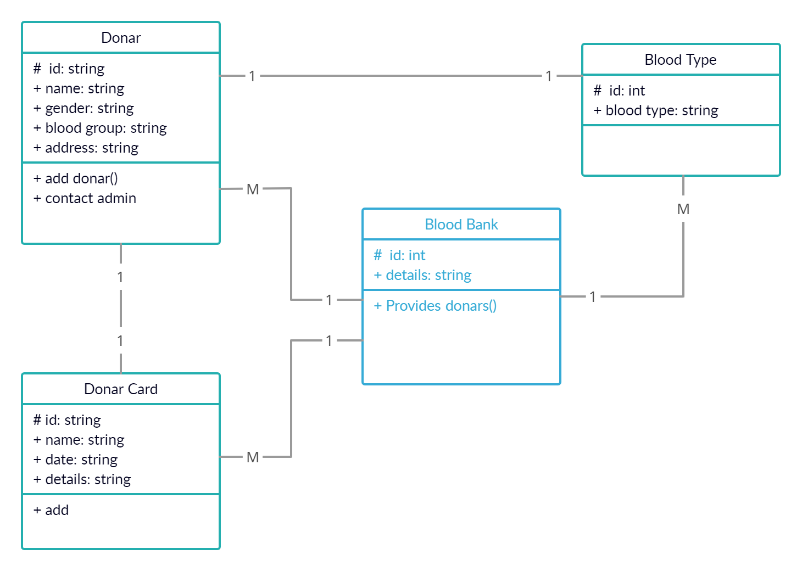

Admin

#id:string

+ username:string

+password:string

**E-R diagram**:-

Webpage info

Update

BDMS

Contact info

add

Admin

add

Blood Group

Register

has

Blood Donarar

**1 1**

**M 1**

**M 1 1**

**M**

**1**

**1**

**M**

* **Use case diagram**:-

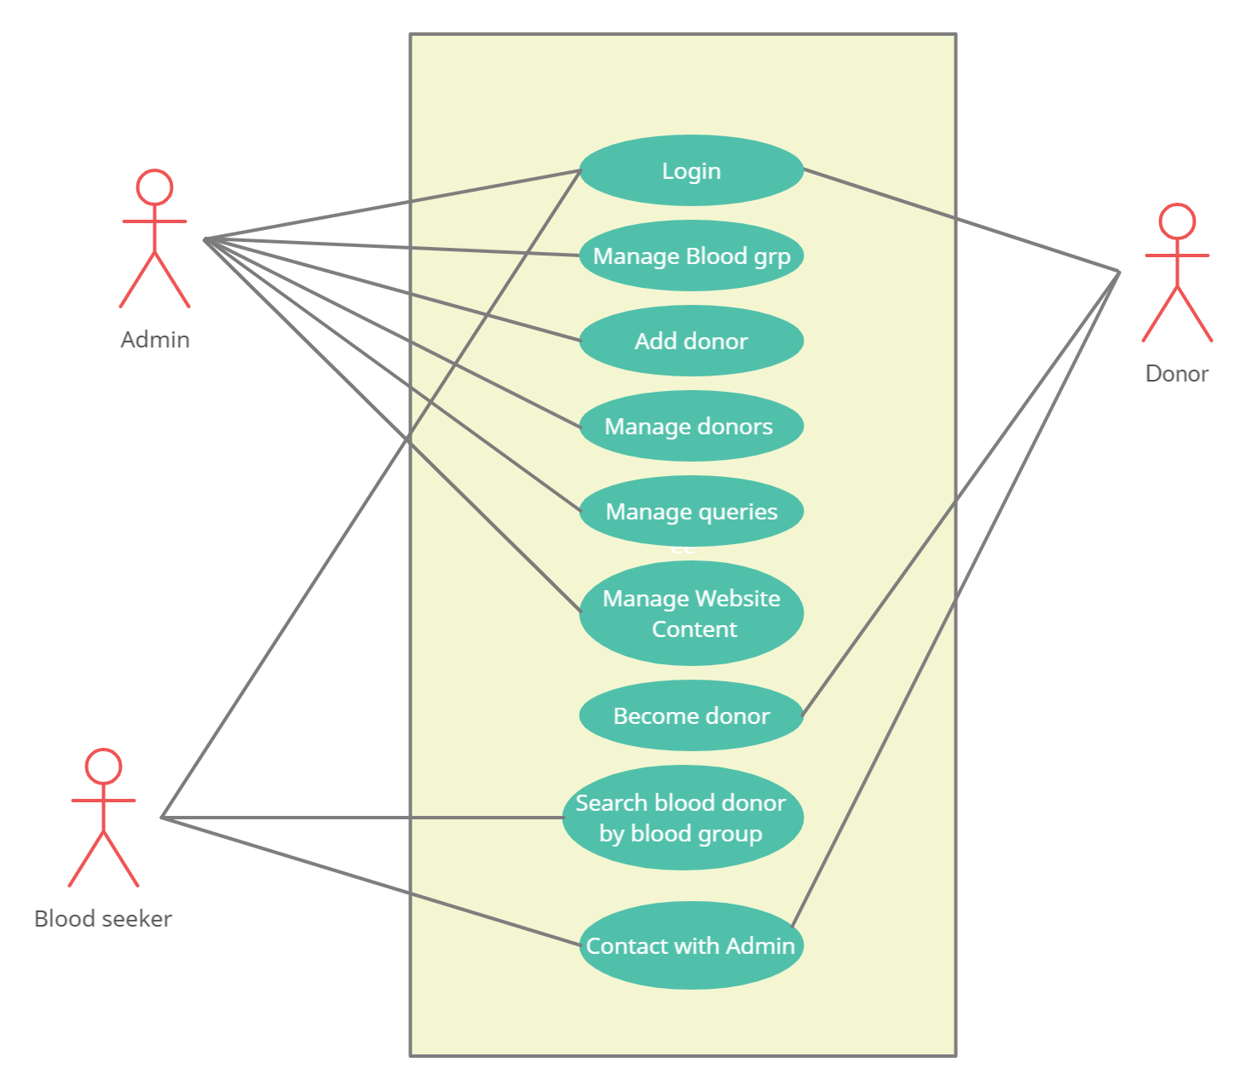

* **Activity Diagram :-**

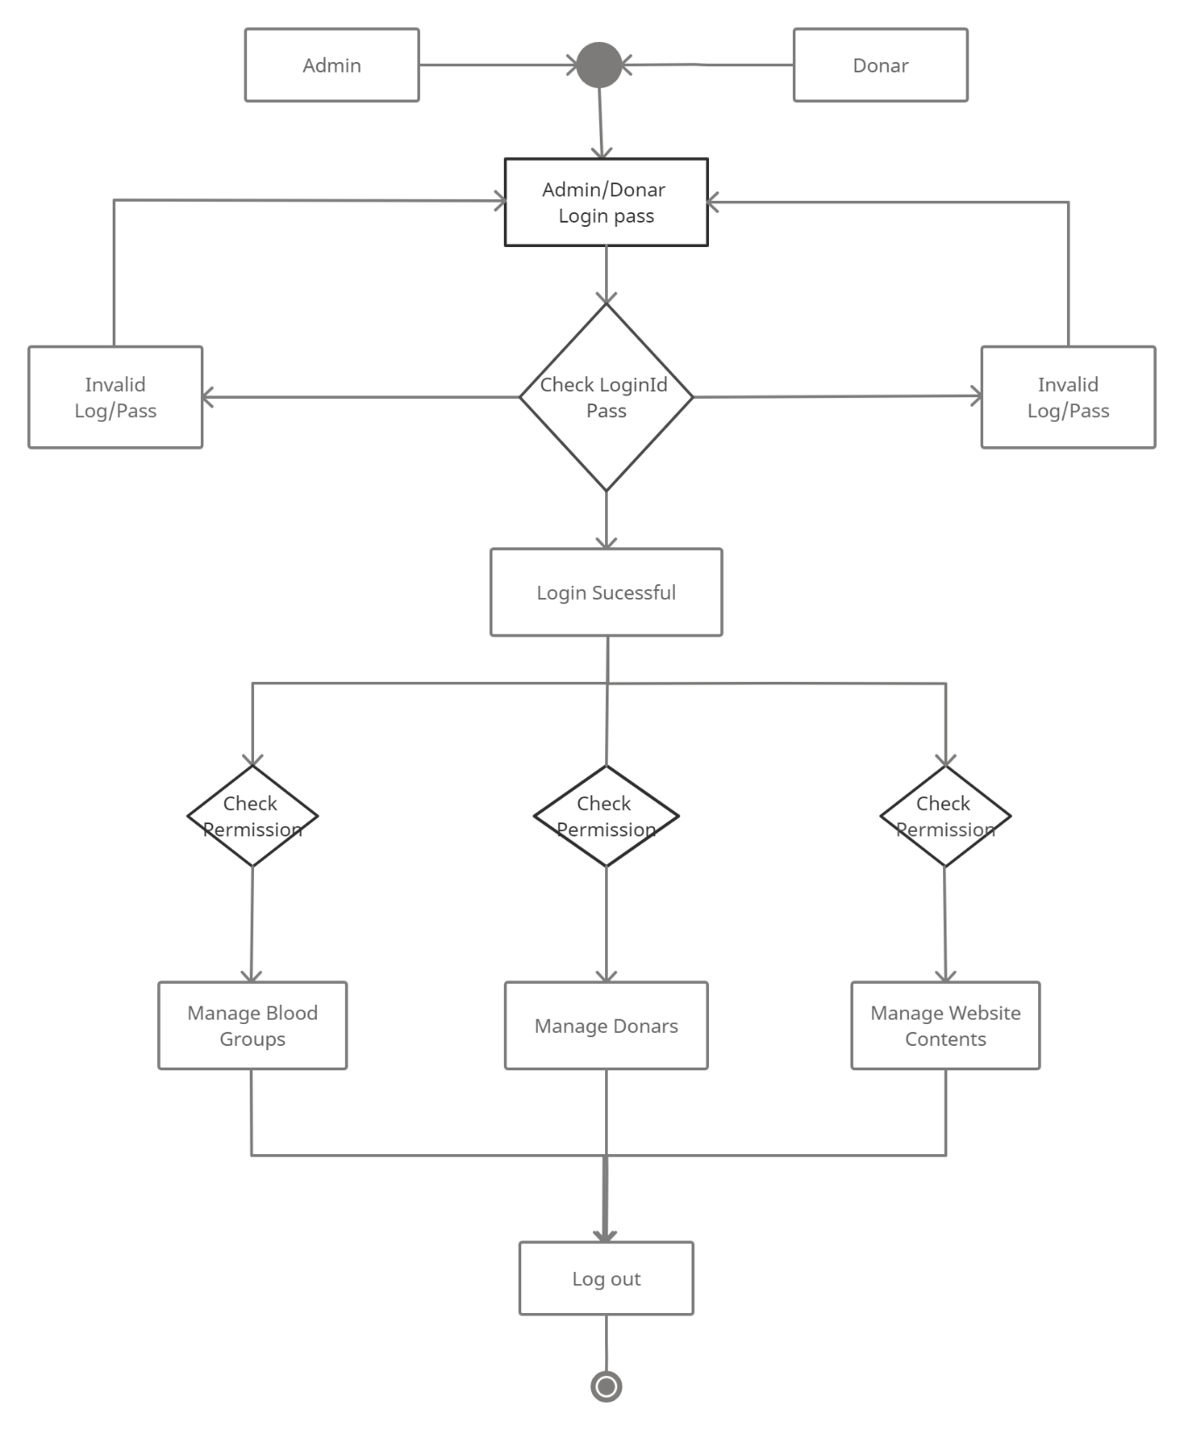

* **Sequence diagram :-**

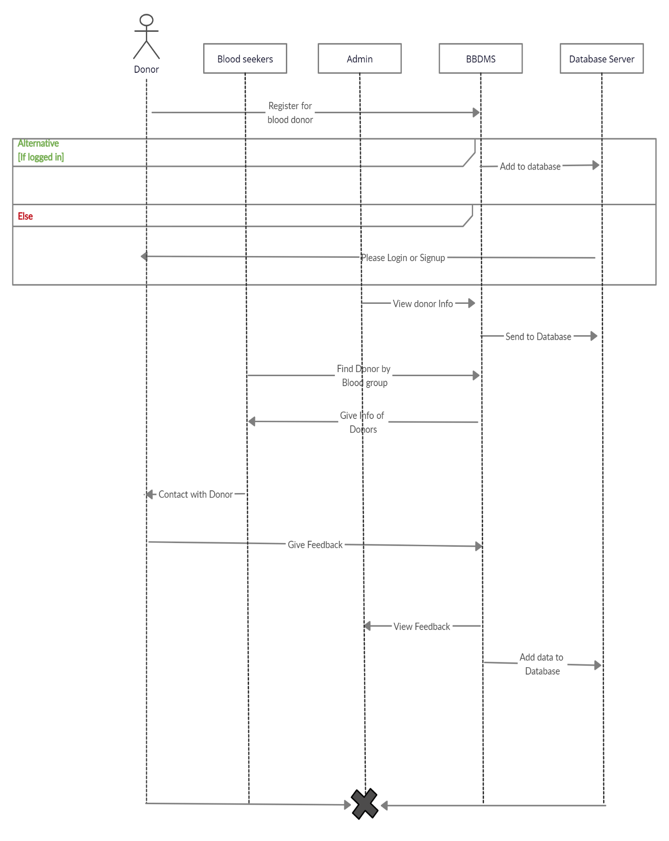

* **Deployment diagram** :-

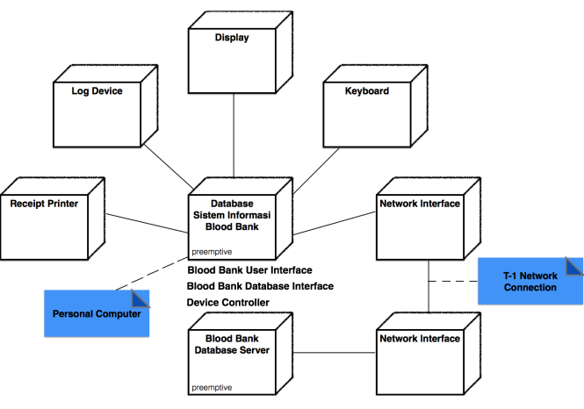

* **Database Dictionary:**

Table Name: admin

Description: - This Table is store info about admin login details.

**Admin:**

|  |  |  |  |  |
| --- | --- | --- | --- | --- |
| **Field name** | **DataType** | **Constraints** | **Size** | **Description** |
| admin_id | Int | Primary key | 15 | Unique id of admin |
| admin_name | Char | Not null | 30 | Name of admin |
| admin_password | Varchar | Not null | 15 | Password of admin |

Table Name: bloodgroup

Description: - This Table is store type of blood group info.

**Blood group:**

|  |  |  |  |  |
| --- | --- | --- | --- | --- |
| **Field name** | **Data Type** | **Constraints** | **Size** | **Description** |
| Donor_id | Int | Primary key | 30 | Donor id |
| Blood group | Varchar | Not null | 20 | Blood group of donor |
| Posting date | Date | Not null |  | Date of posting |

Table Name:  blooddonors

Description: - This Table is store blood donor’s information.

**Blood Donor:**

|  |  |  |  |  |
| --- | --- | --- | --- | --- |
| **Field name** | **DataType** | **Constraints** | **Size** | **Description** |
| Donor_id | Int | Primary key | 30 | Donor id |
| Donor_name | Varchar | Not null | 20 | Name of Donor |
| Donor_email | Varchar | Not null | 20 | Email id of donor |
| phoneNo | Numeric | Not null | 10 | Phone number |
| Gender | Varchar | Not null | 20 | Donor gender |
| Age | Int | Primary key | 11 | Age of donor |
| Blood group | Varchar | Not null | 20 | Blood group of donor |
| Address | Varchar | Not null | 255 | Address of donor |
| Message | Varchar | Not null | 100 | Message |
| Posting date | Date | Current time |  | Date of posting |
| Status | Int | Foreign key | 1 |  |

Table Name: contactusinfo

Description: - This Table is store contact information.

**Contact Us Info:**

|  |  |  |  |  |
| --- | --- | --- | --- | --- |
| **Fieldname** | **DataType** | **Constraints** | **Size** | **Description** |
| Id | Int | Primary key | 15 | User  id |
| Name | Varchar | Not null | 20 | Name of User |
| Contact No | Numeric | Not null | 10 | Phone number |
| Email | Varchar | Not null | 20 | Email of user |
| Address | Varchar | Not null | 30 | Address of user |

Table Name: contactusquery

Description: - This Table is store enquiry info.

**Contact Us enquiry:**

|  |  |  |  |  |
| --- | --- | --- | --- | --- |
| **Fieldname** | **DataType** | **Constraints** | **Size** | **Description** |
| Id | Int | Primary key | 15 | Donor  id |
| Name | Varchar | Not null | 20 | Name of donor |
| Contact No | Numeric | Not null | 10 | Phone number |
| Email | Varchar | Not null | 20 | Email of donor |
| Address | varchar | Not null | 30 | Address of donor |
| Posting date | Date | Current time |  | Date of posting |
| Status | Int | Foreign key | 1 |  |

* **User interfaces :-**

**BLOOD DONATION**  is a website based on PHP. The purpose of this project was to develop a blood management information system to assist in the management of blood donor records and ease or control the distribution of blood in various part of country basing on the hospitals demand. . This project includes mainly two modules i.e. login and main page.

* **Login**

The page require user name and password to start the application. Login is a process by which individual access to a computer system is controlled by identifying and authenticating the user through the cardinalities presented by the user. Admin can add update or delete the user, city, state, camp etc.

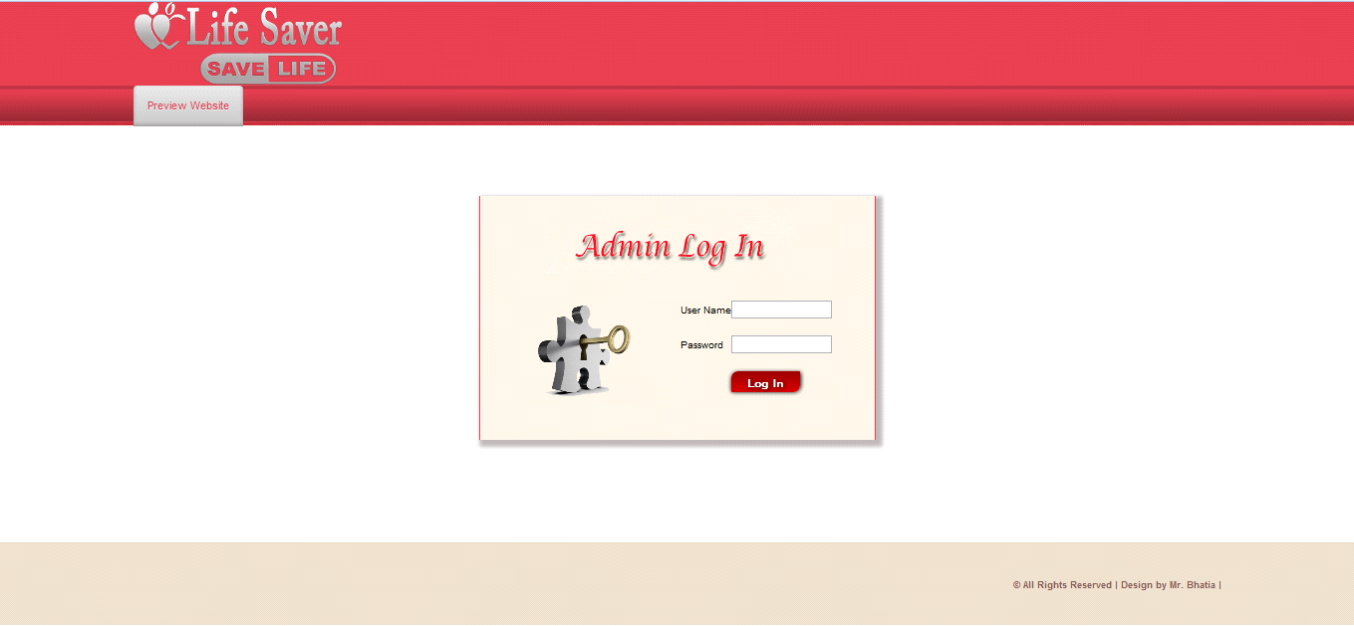

* **User**

User can register the account by fill the information about you and click on save button. He/she can add the account for the further enquiry of the blood donation. The user have to login to get more information about the blood bank.

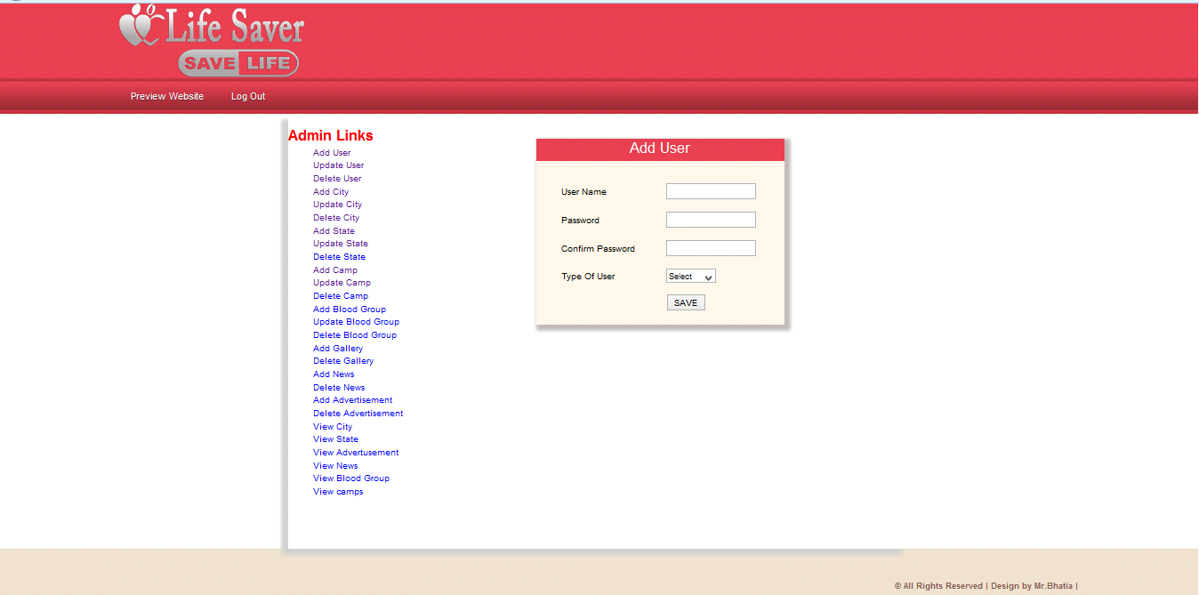

**Main Window:-** The BLOOD BANK MANAGEMENT SYSTEM is great project. this project is designed for successful completion of project on blood bank management system. the basic building aim is to provide blood donation service to the city recently. Blood Bank Management System (BBMS) is a browser based system that is designed to store, process, retrieve and analyze information concerned with the administrative and inventory management within a blood bank.

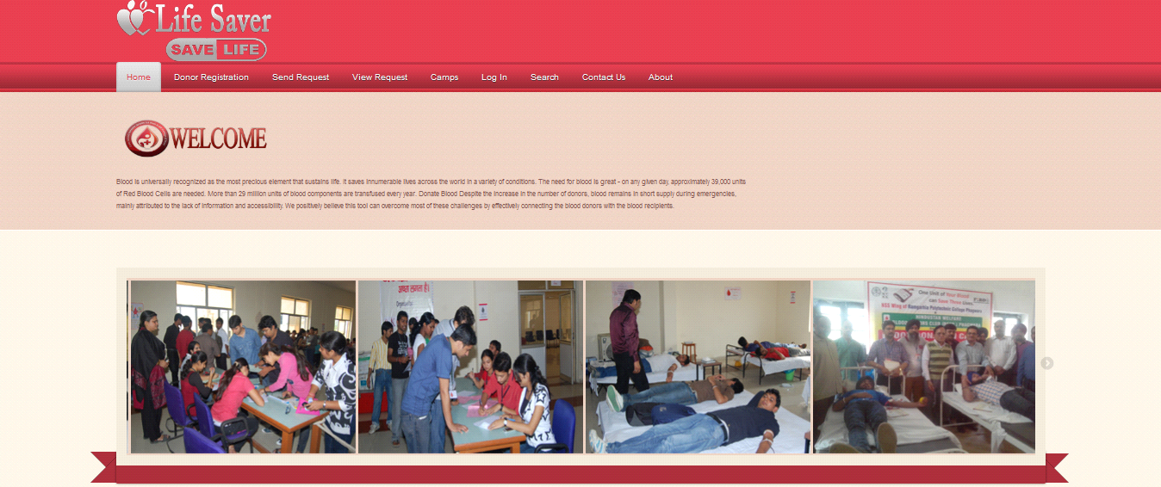

**Registration Page:** Registration page includes the information of the donor who want to register. Donor can register the account by clicking on new register. He/she can add the account for the further enquiry of the blood donation.

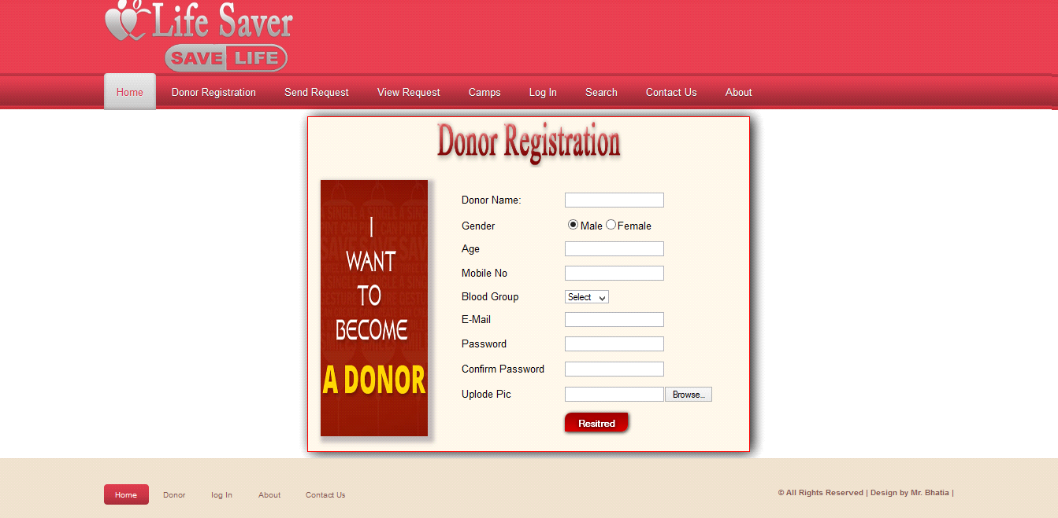

**Donor login:-** The page require donor id and password to open the donor pannel. Login is a process by which individual access to a computer system is controlled by identifying and authenticating the user through the cardinalities presented by the user. Donor can change password, update profiile or view donations etc.

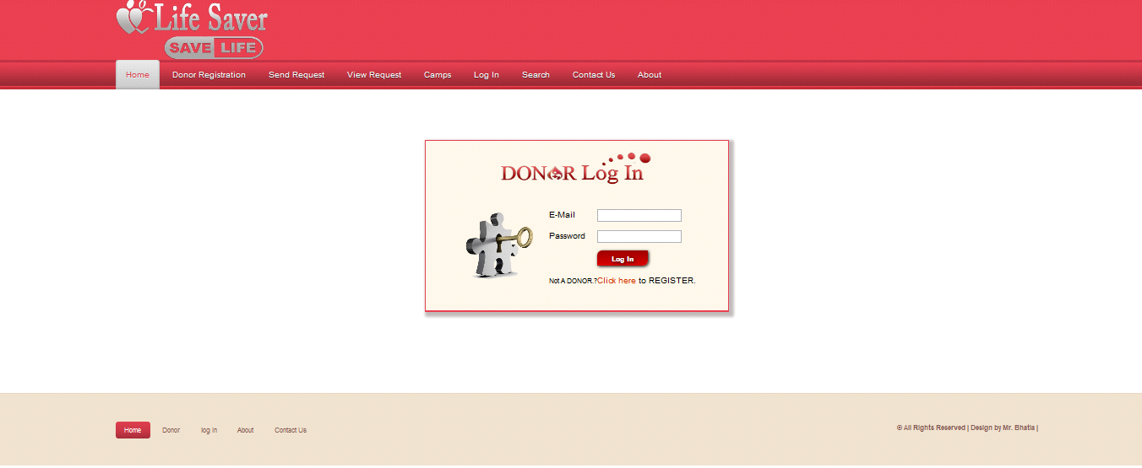

**Blood Donated**

Above snap short describe about donation from donor.This is only used by a donor.

Person will get the blood immediately he/she requested for the particular blood group he/she has requested.

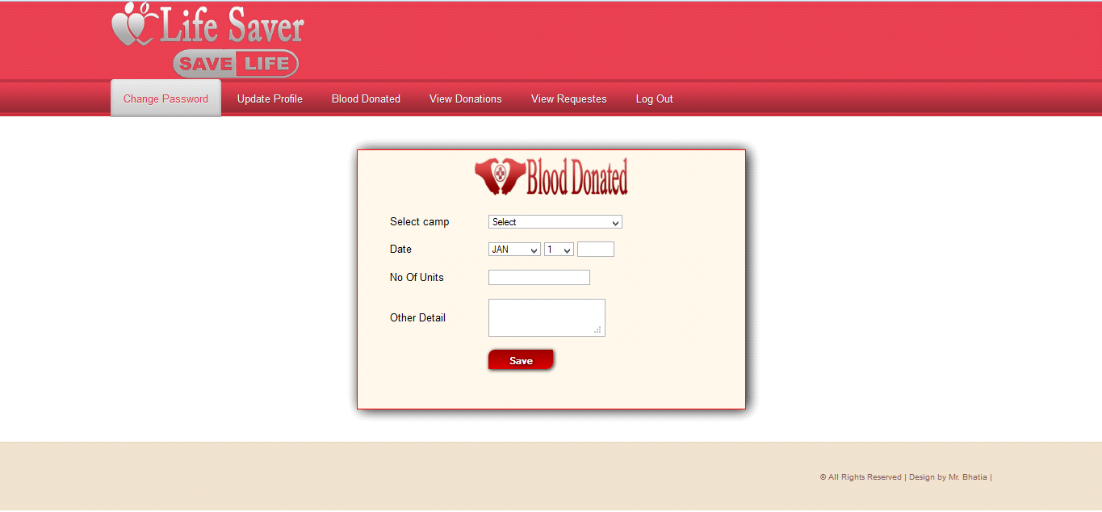

**Figure :- Blood Donated**

**Donor Pannel**

This page is the the welcome page of the donor panel. In this page include all the module related to Donor like :

Change password

Update profile

Blood donated

View donation

View requested

Logout

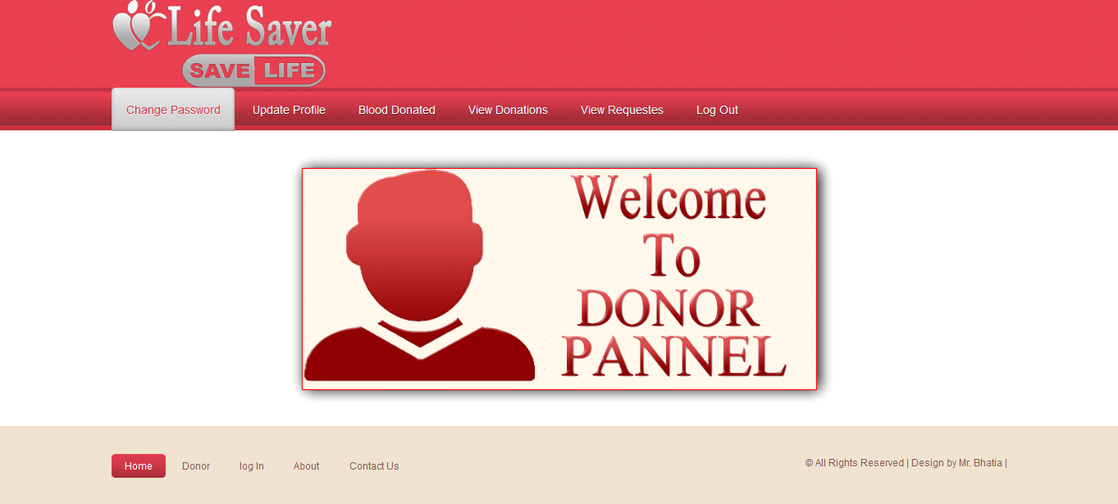

**Figure 7.8:Welcome To Donor Pannel**

**Admin Pannel**

This is the admin side of the project, shows all the admin page like addition , updation, deletion of the user, city,state,camps etc.

Person will get the blood immediately he/she requested for the particular blood group he/she

has requested.

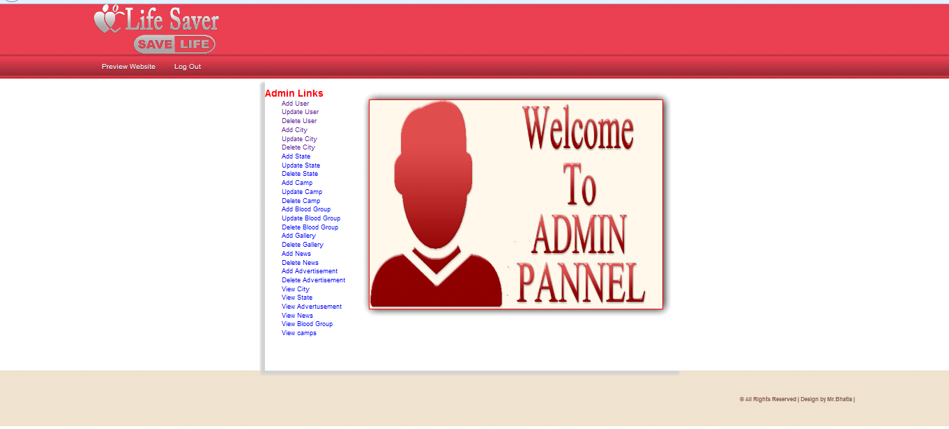

**Figure 7.12:Admin Pannel**

**Outputs and Reports Testing**

* **Test cases:**

**To Verify Login Page :**

|  |  |  |  |  |  |  |
| --- | --- | --- | --- | --- | --- | --- |
| **Test Case ID** | **Test Case Name** | **Sub Test Case ID** | **Steps to Execute** | **Expected Result** | **Actual Result** | **Pass/Fail** |
| TC_1 | To Verify Login Page | TC_001 | Keep username and password blank and click login | Display error message for entering username and password | Displays error message | **Pass** |
|  |
|  |
|  |  | TC_002 | Enter username ,blank password and click login | Display error message for entering password | Displays message to enter password | **Pass** |  |
|  |  | TC_003 | Enter password and blank username and click login | Display error for entering username | Displays to enter username | **Pass** |  |
|  |  | TC_004 | Enter username correct password incorrect and click  Login | Display error invalid login details & Capture image | Displays error message | **Pass** |  |
|  |  | TC_005 | Enter username incorrect and password correct and click login | Display error message invalid login details & Capture image | Displays error message | **Pass** |  |
|  |  | TC_006 | Enter username and password correct | Display the homepage | Displays the homepage | **Pass** |  |
|  |  | TC_007 | Click forgot password link | Display forgot password page | Display forgot pw window | **Pass** |  |

**Conclusion And Recommendation**

In this project, **“BLOOD BANK MANAGEMENT SYSTEM”** we have tried to computerize various processes of Blood Bank.Blood Bank Management System is very flexible software and can be used in any branch of BLOOD BANK for keeping record. In this software we have tried to provide all the Blood bank management system related record keeping facilities which helps to keep record and employees who belongs to it.

The main focus of this project is to less in human efforts. The maintenance of the record is made efficient, as all the records are stored in the SQL database.

It is user interactive and effective than the existing system. The flexibility of visual basic helps to maintain the **“BLOOD BANK MANAGEMENT SYSTEM”** more efficiently.

Finally, we are thankful to all the people who have given us their hearty support in this endeavour.

**Bibliography**

The following are the books that have been referred for the successful completion of our project work:

**Software Engineering** –

Website References:-

[www.w3schools.com](http://www.w3schools.com)

Killerphp.com

Learn-php.org

**Book References:-**

PHP and Postgresql Novice to Ninja – by Kevin Yank.

Head First PHP & Postgresql – by Lynn Beighley & Michael Morrison.

PHP : A Beginner’s Guide – by Vikram Vaswani.