Enterprise IT Support Agent
Use Case: Policy Q&A + Ticket Status + SLA Escalation
Tech Stack: AWS Bedrock Agent, Knowledge Base, Action Group, Guardrails, LangChain, LangGraph, MCP, Lambda, API Gateway, OpenSearch/Aurora pgvector, CloudWatch

Hum pehla practical step Bedrock Knowledge Base ke liye demo policy document se start kar rahe hain, kyunki RAG/Agentic AI ka base wahi hota hai: document → chunking → embeddings → vector search → answer generation. Amazon Bedrock Knowledge Bases ingestion ke time documents ko chunks mein split karta hai, embeddings generate karta hai, aur vector index mein store karta hai.

Bhai screenshot sahi page ka hai — S3 Create bucket page. Abhi is step mein hume sirf bucket create karni hai jisme policy document upload hoga.

1. “Choose bucket” par click karna hai kya?
Nahi bhai, abhi “Choose bucket” par click nahi karna hai.
Screenshot mein jo “Copy settings from existing bucket – Choose bucket” option hai, woh optional hai. Iska use tab hota hai jab aap kisi existing bucket ki settings copy karna chahte ho.
Hum naya demo bucket bana rahe hain, isliye:
Choose bucket → mat click karo

2. Screenshot ke fields kya select rehne chahiye?

Screenshot 1 — General configuration

AWS Region
Asia Pacific (Mumbai) ap-south-1
Ye sahi hai. Aap Mumbai region mein project kar rahe ho.

Bucket type
General purpose
Ye sahi hai. Demo aur normal S3 storage ke liye General purpose bucket use karte hain.

Bucket namespace
Global namespace
Ye default sahi hai.

Bucket name
Aapne likha hai:
it-support-policy-demo
Ye name theek hai, but S3 bucket name globally unique hona chahiye. Agar create karte time error aaye ki bucket already exists, toh name change kar dena:
it-support-policy-demo-prashant-2026
ya
it-support-policy-demo-628479575897

Screenshot 1 — Object Ownership

ACLs disabled recommended
ACLs disabled (recommended)
Ye bilkul sahi hai. Iska matlab access control ACL se nahi, bucket policy/IAM policy se manage hoga. Production best practice bhi yahi hoti hai.

Screenshot 2 — Block Public Access

Block all public access
Checked / enabled
Ye enabled hi rehne do.
Iska matlab bucket public internet se accessible nahi hogi. Bedrock Knowledge Base ko access IAM role se milega, public access ki zaroorat nahi hai.
Interview line:
“For enterprise RAG source documents, S3 bucket should remain private. Bedrock accesses it using IAM role, not public access.”

3. Bucket Versioning kya hota hai?
Bucket Versioning ka matlab hai S3 same file ke multiple versions save rakhta hai.
Example:
Aapne upload kiya:
it-support-policy-demo.txt version 1
Baad mein same file update karke upload ki:
it-support-policy-demo.txt version 2
Agar versioning enabled hai, S3 dono versions store karega:
version 1
version 2
Iska benefit:
- Galti se file overwrite ho gayi toh old version restore kar sakte ho
- Galti se delete ho gayi toh recover kar sakte ho
- Audit/history maintain hoti hai

Demo ke liye kya select karein?
Abhi screenshot mein:
Bucket Versioning: Disable
Demo ke liye Disable theek hai. Cost aur simplicity ke liye abhi disable rakho.

Production mein kya karte?
Production mein, especially enterprise policy documents ke liye, main recommend karunga:
Bucket Versioning: Enable
Kyunki RAG documents ka history important hota hai. Agar wrong policy upload ho gayi toh old version restore kar sakte ho.
Interview line:
“For demo I kept versioning disabled to reduce complexity, but in production I would enable S3 versioning for recovery, auditability and rollback of knowledge base documents.”

Screenshot 3 — Default encryption

Server-side encryption with Amazon S3 managed keys SSE-S3
Selected
Ye demo ke liye sahi hai.

Bucket Key
Screenshot mein Enable selected hai. Theek hai.
Production mein agar customer compliance high hai, toh SSE-KMS choose kar sakte hain:
SSE-S3 → demo/simple use case
SSE-KMS → production/compliance/customer managed key

4. Abhi final kya karna hai?
Aapki current screen par settings mostly sahi hain.
Abhi ye rakho:
Bucket type: General purpose
Bucket namespace: Global namespace
Bucket name: it-support-policy-demo
Copy settings: skip
Object Ownership: ACLs disabled
Block Public Access: enabled
Bucket Versioning: Disable
Encryption: SSE-S3
Advanced settings: default
Phir:
Create bucket
Agar bucket name error de, toh name change kar dena:
it-support-policy-demo-prashant-2026

5. Policy document real project mein aisa hi hota hai kya?
Short answer: Conceptually haan, lekin real project mein document zyada detailed aur official hota hai.
Maine jo document diya hai woh demo/training document hai taaki Knowledge Base quickly ban sake aur RAG flow test ho sake.
Real project mein source documents usually aise hote hain:
HR policy PDFs
IT support SOPs
Laptop replacement policy
Security policy
Runbooks
Confluence pages
SharePoint documents
Product manuals
Knowledge articles
Incident response guides
Legal/compliance documents
FAQ documents
Real documents mein ye cheezein hoti hain:
Document owner
Version
Effective date
Approval authority
Policy scope
Definitions
Detailed rules
Exceptions
SLA matrix
Escalation matrix
Compliance notes
Interview mein bol sakte ho:
“For the demo I used a simplified IT policy document, but in real enterprise projects we ingest official policy documents, SOPs, runbooks, FAQs, SharePoint/Confluence content, PDF manuals and structured business documents into the knowledge base.”

6. Kya Excel file bhi ho sakti hai?
Haan, Excel file bhi ho sakti hai.
Amazon Bedrock Knowledge Bases supported document formats mein .txt, .md, .html, .doc/.docx, .csv, .xls/.xlsx, and .pdf include hote hain. Source files ke liye 50 MB file size limit bhi documented hai. [docs.aws.amazon.com]
Lekin practical point important hai:

Excel kab use karna sahi hai?
Excel useful hai jab data tabular ho:
SLA matrix
Department-wise policy rules
Asset inventory
Ticket categories
Priority matrix
Escalation contacts
FAQ rows
Product catalog
Example:
Ticket Type | Priority | SLA Days | Escalation Team
Laptop Replacement | P2 | 7 | Hardware Support Lead
Password Reset | P3 | 1 | Service Desk

Excel ke saath challenge kya hota hai?
Excel structured/tabular data hota hai. RAG semantic search ke liye kabhi-kabhi Excel se exact analytical query answer weak aa sakta hai.
Example:
“Show all tickets where SLA > 7”
Ye semantic search se better SQL/database query se solve hota hai.
AWS re:Post discussion mein bhi Excel supported hone ke bawajood tabular queries ke liye CSV conversion, metadata filtering, ya structured retrieval approach consider karne ki guidance milti hai. [repost.aws]

Best practice
Narrative policies / SOPs → PDF, DOCX, TXT
Tabular rules / matrix → CSV or Excel
Analytical filtering/query → Database / structured RAG / SQL
Interview line:
“Excel files are supported, but for RAG I prefer converting important tabular data into clean CSV or structured metadata. If the use case requires filtering, aggregation or exact calculations, I would use database/SQL-based retrieval rather than pure vector search.”

Current actionable step
Bhai abhi Create bucket button click karo.
Agar bucket successfully create ho jaaye toh mujhe bolo:
bucket created
Agar bucket name error aaye toh bucket name change karke:
it-support-policy-demo-prashant-2026
try karo.
Bhai screenshot mein upload successful hai ✅
Bucket: it-support-policy-demo-prashant-2026
File uploaded: HR-Notice explain.txt
Ab aapka question bahut important hai — S3 mein backup/recovery ka main mechanism “Versioning” hota hai.

1. Agar S3 file galti se delete ho jaaye toh recover kaise hoga?

Case A — Versioning disabled hai
Agar bucket mein Versioning disabled hai aur file delete ho gayi, toh S3 ke andar normally direct recovery possible nahi hoti. Fir recovery tabhi possible hai agar:
- AWS Backup configured ho
- Cross-region/account backup copy ho
- Same file local machine/Git/another system mein ho
- Replication/backup bucket mein copy ho
Isliye production mein S3 bucket ke liye versioning enable karna best practice hota hai.

Case B — Versioning enabled hai
Agar Versioning enabled hai, toh delete karne par S3 actual object ko immediately permanently remove nahi karta; S3 ek delete marker create karta hai, aur old version bucket mein preserved rehta hai. Deleted object recover karne ke liye delete marker remove kar sakte ho ya previous version download/copy kar sakte ho. [repost.aws], [docs.amazonaws.cn]
Recovery flow:
S3 Bucket
→ Object
→ Show versions ON
→ Delete marker dikhega
→ Delete marker remove karo
→ Old file wapas current object ban jaayegi
AWS documentation ke according previous version ko restore karne ke 2 common ways hain: previous version ko same bucket mein copy karke current version banana, ya current version/delete marker ko remove karke older version ko current banana. [docs.aws.amazon.com]

2. Agar file corrupt ho jaaye ya galat file overwrite ho jaaye?
Agar versioning enabled hai aur kisi ne same naam se corrupt file upload kar di:
HR-Notice explain.txt → good version
HR-Notice explain.txt → corrupt new version
Toh S3 old good version preserve rakhega. Aap Show versions ON karke old version select kar sakte ho aur usko download/copy karke restore kar sakte ho. AWS docs ke according versioning se previous versions retrieve/restore kiye ja sakte hain. [docs.aws.amazon.com]

3. Production mein S3 backup kaise design karte hain?

Level 1 — S3 Versioning
Yeh first protection hai.
Accidental delete → recover possible
Accidental overwrite → old version restore possible
Corrupt upload → previous version restore possible
Abhi aapke demo bucket ke liye bhi main suggest karunga:
S3 bucket → Properties → Bucket Versioning → Enable

Level 2 — AWS Backup for S3
Enterprise backup ke liye AWS Backup use kar sakte hain. AWS Backup S3 ke liye centralized backup and restore provide karta hai, continuous backups aur point-in-time restore support karta hai. AWS Backup for S3 use karne ke liye S3 Versioning enable hona required hai. [docs.aws.amazon.com]
AWS Backup se aap:
- Scheduled backup plan bana sakte ho
- Backup vault mein encrypted backup store kar sakte ho
- Point-in-time restore kar sakte ho
- Specific objects ya full bucket restore kar sakte ho
AWS Backup S3 restore mein all objects ya specific objects ko existing ya new bucket mein restore kiya ja sakta hai. [docs.aws.amazon.com]

Level 3 — Object Lock
Agar data bahut critical hai, jaise compliance/legal/financial records, toh S3 Object Lock use hota hai.
Object Lock objects ko fixed time ya indefinitely delete/overwrite hone se protect karta hai using WORM model — Write Once Read Many. Object Lock versioning-enabled buckets ke saath kaam karta hai. [docs.aws.amazon.com]
Use case:
Ransomware protection
Compliance archive
Legal records
Audit logs
Critical backups
Important:
Object Lock usually bucket creation time par enable karna hota hai.
Normal demo bucket ke liye zaroori nahi.
Production compliance bucket ke liye useful hai.

4. Is demo bucket mein abhi kya karna chahiye?
Aapka current bucket already create ho gaya aur file upload bhi ho gayi. Ab safe side ke liye Versioning enable kar do.

Console steps
S3
→ Buckets
→ it-support-policy-demo-prashant-2026
→ Properties
→ Bucket Versioning
→ Edit
→ Enable
→ Save changes
Versioning enable karne ke baad future delete/overwrite se recovery easy ho jaayegi.

5. Interview-ready answer
Aap interview mein bol sakte ho:
“For S3 data protection, I enable S3 Versioning as the first layer. If someone accidentally deletes a file, S3 creates a delete marker instead of permanently deleting the object, so we can remove the delete marker or restore a previous version. If a file is corrupted or overwritten, we can roll back to an older version. For enterprise backup, I use AWS Backup for S3 to create centralized scheduled or continuous backups and perform point-in-time restore. For compliance or ransomware protection, I use S3 Object Lock with WORM retention so objects cannot be deleted or overwritten during the retention period.”

Current actionable step
Bhai abhi sirf ye karo:
S3 bucket → Properties → Bucket Versioning → Enable
Enable ho jaaye toh mujhe bolo “versioning enabled”.
Perfect bhai ✅ Versioning enabled — ab aapka S3 bucket accidental delete/overwrite ke against safer ho gaya.
Ab hum next step start karte hain:

Step 2: Amazon Bedrock Knowledge Base Create Karna
Knowledge Base ka kaam hoga:
S3 document
→ Bedrock ingestion
→ Parsing
→ Chunking
→ Embedding generation
→ Vector store indexing
→ RAG query answering
Amazon Bedrock Knowledge Base raw documents ko parse karta hai, chunks mein split karta hai, embeddings generate karta hai aur vector store mein index karta hai, jisse user query ke time relevant context retrieve ho sake. [deepwiki.com]

Abhi Console mein yeh karo
AWS Console search bar mein type karo:
Bedrock
Phir open karo:
Amazon Bedrock
Left side menu mein jao:
Builder tools → Knowledge Bases
Phir click karo:
Create knowledge base

Agar first-time Bedrock open kar rahe ho
Agar Bedrock model access ka prompt aaye, toh model access enable karna padega. Usually RAG demo ke liye humein:
Embedding model
LLM model
chahiye hota hai.
But abhi pehle sirf Knowledge Base creation page tak pahunchna hai.

Interview mein is step ko kaise explain karna hai
Aap bol sakte ho:
“After uploading the source policy document to S3, I created an Amazon Bedrock Knowledge Base. The Knowledge Base connects to the S3 data source, parses the document, splits it into chunks, generates embeddings using an embedding model, and stores those vectors in a vector database. This becomes the retrieval layer for the RAG pipeline.”

Current actionable step
Bhai abhi sirf yeh karo:
Amazon Bedrock → Builder tools → Knowledge Bases → Create knowledge base
Jab Create knowledge base page open ho jaaye, screenshot bhej dena. Main wahi fields one-by-one bataunga kya select karna hai.
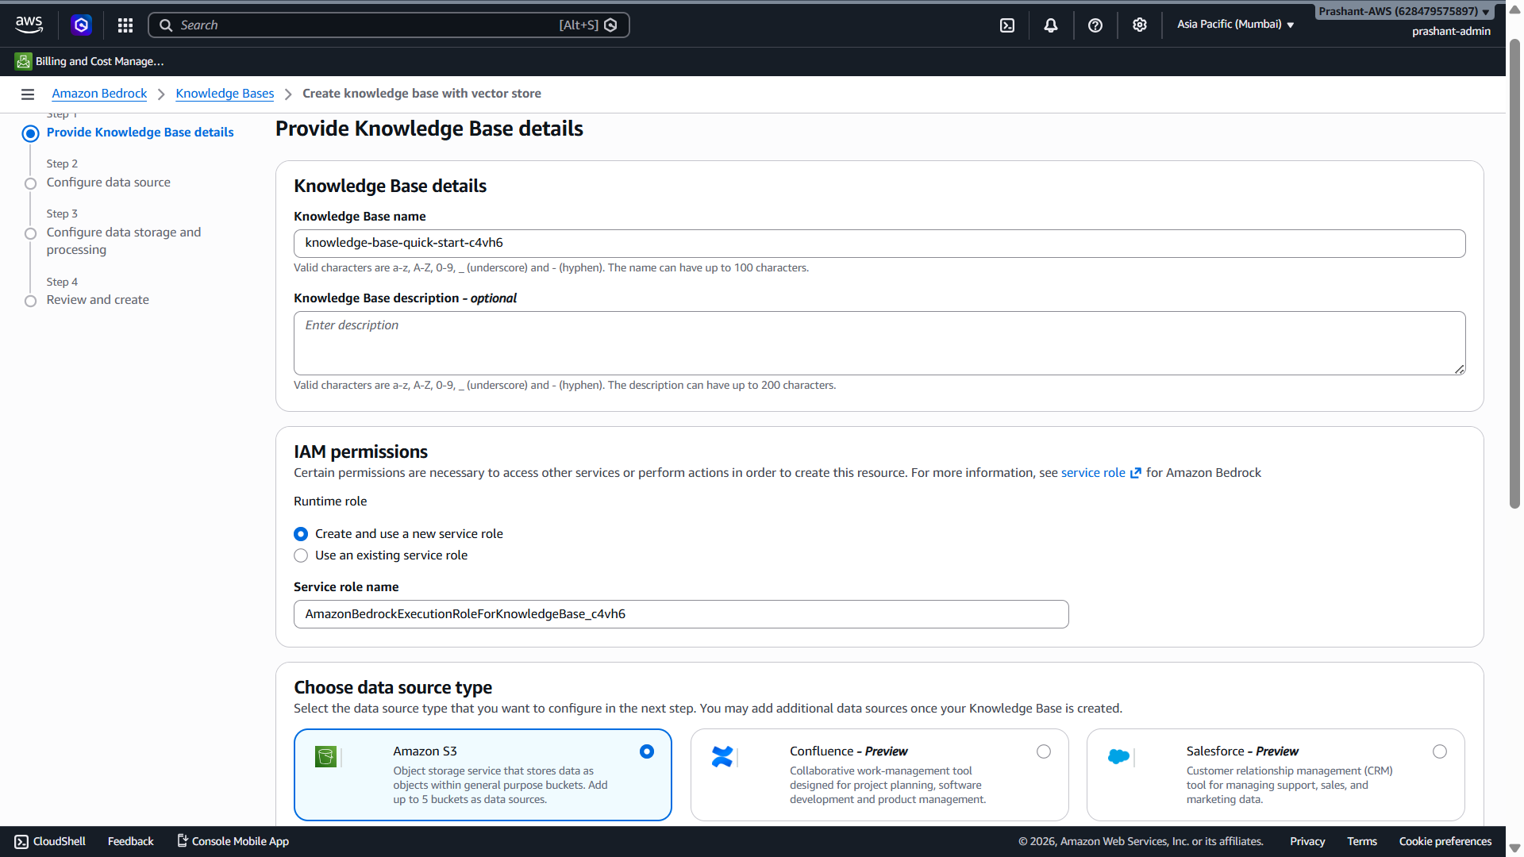
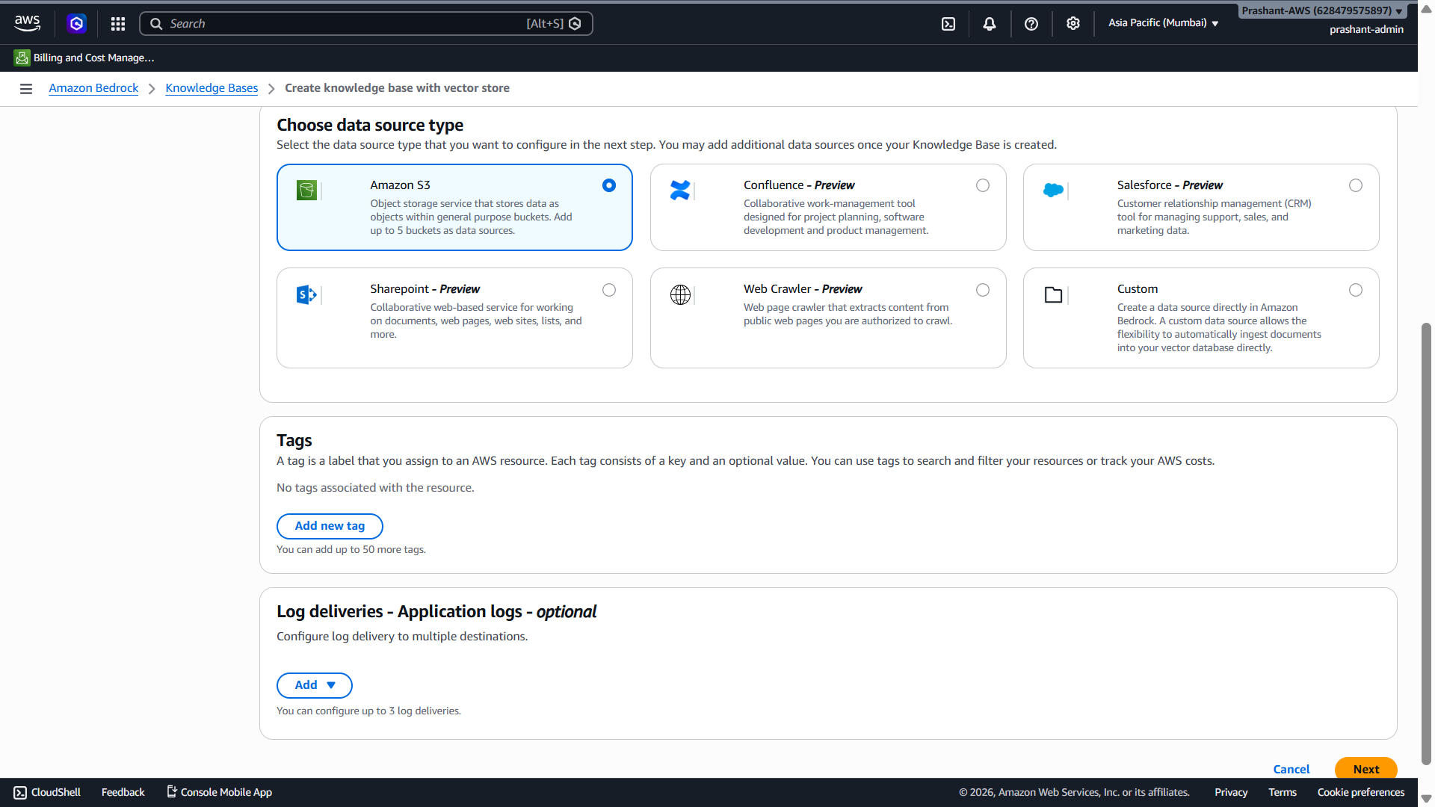
Perfect bhai ✅ Screenshot mein aap Amazon Bedrock → Knowledge Bases → Create knowledge base with vector store ke Step 1: Provide Knowledge Base details page par ho.
Abhi is page par sirf yeh fields set karo:

Is screen par kya fill/select karna hai?

1. Knowledge Base name
Current auto name hai:
knowledge-base-quick-start-c4vh6
Isko change karke meaningful naam de do:
it-support-policy-kb
Interview mein meaningful name better lagta hai.

2. Knowledge Base description — optional
Isme yeh paste kar sakte ho:
Knowledge base for enterprise IT support policies including laptop replacement SLA, ticket escalation rules, PII handling, and authorized support actions.

3. IAM permissions
Screenshot mein selected hai:
Create and use a new service role
✅ Isko selected rehne do.
Service role name auto aa raha hai:
AmazonBedrockExecutionRoleForKnowledgeBase_c4vh6
✅ Isko bhi as-is rehne do.
Is role ka kaam hoga Bedrock Knowledge Base ko S3 document read karne, embedding generation aur vector store operations ke liye required permissions dena. Bedrock Knowledge Base data source ko ingest karke vector embeddings banata hai aur vector store mein index karta hai. [deepwiki.com]

4. Choose data source type
Screenshot mein selected hai:
Amazon S3
✅ Ye bilkul sahi hai, kyunki humne document S3 bucket mein upload kiya hai.
Amazon Bedrock Knowledge Bases S3 data source se documents ingest kar sakta hai, aur supported file formats mein .txt, .pdf, .docx, .csv, .xls/.xlsx etc. supported hain. [docs.langchain.com]

5. Tags
Abhi optional hai. Demo ke liye skip kar do.
Agar add karna ho toh production style mein add kar sakte ho:
Project = Enterprise-IT-Support-Agent
Environment = Demo
Owner = Prashant
But abhi zaroori nahi hai.

6. Log deliveries — Application logs
Abhi optional hai. Isko skip kar do.
Production mein CloudWatch logs enable karte, but abhi demo setup fast rakhte hain.

Is screen par final selection summary
Knowledge Base name: it-support-policy-kb
Description: Knowledge base for enterprise IT support policies...
IAM permissions: Create and use a new service role
Data source type: Amazon S3
Tags: skip
Log deliveries: skip

Abhi kya click karna hai?
Bottom-right mein jo orange button hai:
Next
✅ Us par click karo.

Interview mein is screen ko kaise explain karna hai?
Aap bol sakte ho:
“In the Knowledge Base creation step, I created an IT support policy knowledge base, selected Amazon S3 as the data source, and allowed Bedrock to create a service role. This role gives Bedrock controlled access to ingest documents from S3, generate embeddings, and index them into the configured vector store.”

Current actionable step
Bhai abhi sirf:
Knowledge Base name = it-support-policy-kb
Description paste karo
Amazon S3 selected rehne do
New service role selected rehne do
Click Next
Next screen ka screenshot bhej dena — main wahi batata hoon S3 bucket aur file/prefix kaise select karna hai.
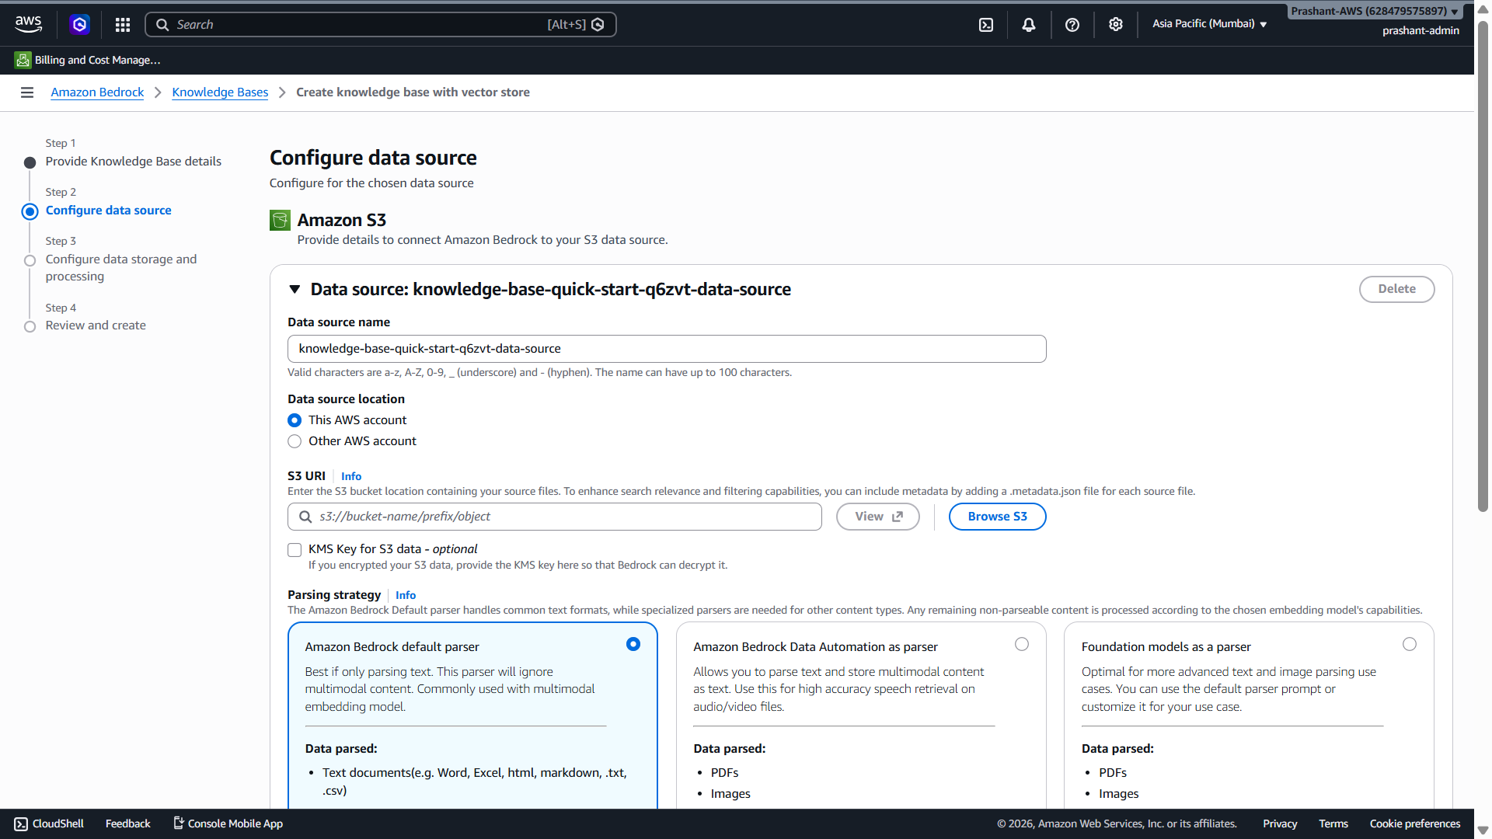
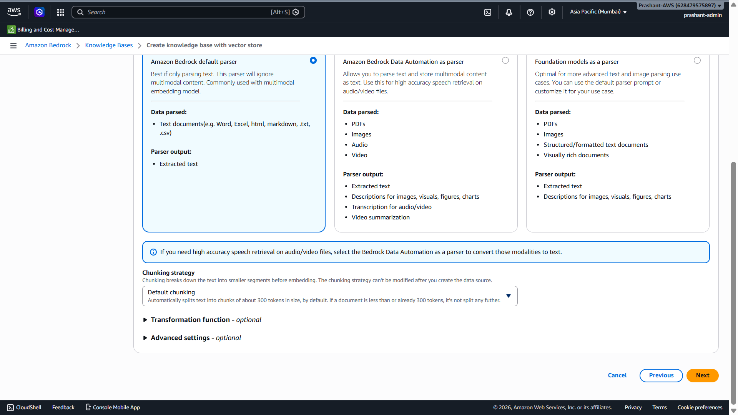
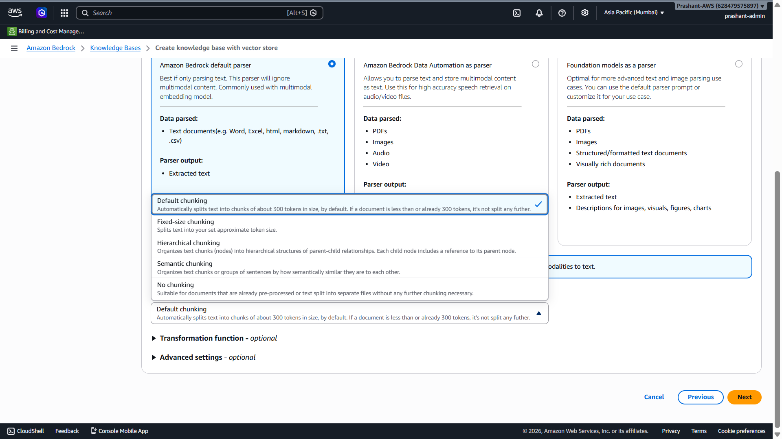
Haan bhai, mostly right ✅
Chunking, embedding generation, vector index mein store karna — yeh actual processing Bedrock internally karta hai, lekin aapko console mein kuch configuration choices select karni padti hain.
Simple line:
“Hum manually chunks create nahi karte, embeddings manually generate nahi karte, aur vector index mein manually insert nahi karte. Hum data source, parser, chunking strategy, embedding model aur vector store select karte hain; ingestion/sync ke time Bedrock processing internally karta hai.”
AWS docs ke according Bedrock Knowledge Base ingestion process mein document parse hota hai, chunks mein split hota hai, embedding model data ko vector embeddings mein convert karta hai, aur vector store mein index karta hai. [deepwiki.com]

Is screen par kya ho raha hai?
Aap abhi Step 2: Configure data source screen par ho.
Yahan Bedrock ko batana hai:
Source data kahan pada hai? → S3 bucket
Parser kaunsa use karna hai? → Default parser
Chunking kaise karni hai? → Default chunking

1. S3 URI kya bharna hai?
Screenshot mein S3 URI blank hai.
Aapka bucket name hai:
it-support-policy-demo-prashant-2026
Agar file bucket ke root mein upload hai, toh S3 URI mein yeh daalo:
s3://it-support-policy-demo-prashant-2026/
Agar kisi folder ke andar upload hoti, jaise docs/, toh URI hota:
s3://it-support-policy-demo-prashant-2026/docs/
Abhi root bucket use karo.

2. Parser strategy kya select karein?
Screenshot mein selected hai:
Amazon Bedrock default parser
✅ Isko selected rehne do.
Aapki file text-based hai, isliye default parser enough hai. Default parser common text formats ke liye suitable hai, jaise Word, Excel, HTML, Markdown, TXT, CSV. Bedrock supported source document formats mein TXT, MD, HTML, DOC/DOCX, CSV, XLS/XLSX aur PDF include hain. [docs.langchain.com]

3. Chunking strategy kya select karein?
Screenshot mein selected hai:
Default chunking
✅ Isko selected rehne do.
Default chunking automatically text ko approx 300 token chunks mein split karta hai. AWS docs ke according default chunking content ko approximately 300 tokens ke chunks mein split karta hai aur sentence boundaries preserve karta hai. [github.com]
Demo ke liye default chunking best hai.

4. Yeh options ka matlab kya hai?

Default chunking
Small/normal documents ke liye best.
Bedrock automatically chunks banata hai.

Fixed-size chunking
Aap token size aur overlap control karte ho.
Example: 500 tokens with 10% overlap.

Hierarchical chunking
Parent-child chunks banata hai.
Useful for large documents where section-level context important ho.

Semantic chunking
Meaning ke basis par chunks banata hai.
Useful when paragraphs/topics naturally separate karne hain.

No chunking
Jab document already small ya pre-processed ho.
Production mein chunking strategy retrieval quality ko directly affect karti hai. AWS docs ke according Bedrock first documents ko manageable chunks mein split karta hai, phir embeddings generate karke vector index mein write karta hai. [github.com]

5. Embedding aur vector store kab configure hoga?
Abhi Step 2 data source hai.
Next screen Step 3: Configure data storage and processing mein aapko usually yeh select karna hoga:
Embedding model
Vector store
Storage/index configuration
Yahin Bedrock embedding model aur vector store configure karega. AWS docs ke according Knowledge Base raw data ko vector embeddings mein convert karta hai using selected embedding model and stores those embeddings in selected vector store. [deepwiki.com]

6. Manual vs automatic — clear difference

Hum manually configure karte hain:
S3 data source
Parser strategy
Chunking strategy
Embedding model
Vector store
IAM role
Sync/ingestion trigger

Bedrock internally karta hai:
Document parsing
Text extraction
Chunk creation
Embedding generation
Vector index write
Retrieval during query
Citation/source mapping
Jab data source sync hota hai, Bedrock raw data ko embeddings mein convert karta hai based on selected embedding model and vector store configuration. Sync incremental hota hai, yani add/modify/delete files ke basis par only changed documents process hote hain. [github.com]

Interview-ready answer
Aap interview mein aise bolna:
“In Amazon Bedrock Knowledge Bases, we don’t manually create chunks, embeddings or vector records. We configure the S3 data source, parser, chunking strategy, embedding model and vector store. During the ingestion or sync job, Bedrock parses the documents, splits them into chunks, generates embeddings and indexes them into the vector store. At runtime, Bedrock retrieves relevant chunks and augments the LLM prompt for RAG-based response generation.”

Is screen par ab kya karo?
Abhi sirf yeh set karo:
Data source name: it-support-policy-s3-source
Data source location: This AWS account
S3 URI: s3://it-support-policy-demo-prashant-2026/
KMS key: unchecked
Parser strategy: Amazon Bedrock default parser
Chunking strategy: Default chunking
Transformation function: skip
Advanced settings: skip
Phir Next click karo.

Current actionable step
Bhai abhi S3 URI field mein yeh paste karo:
s3://it-support-policy-demo-prashant-2026/
Phir Next click karke next screen ka screenshot bhej do.
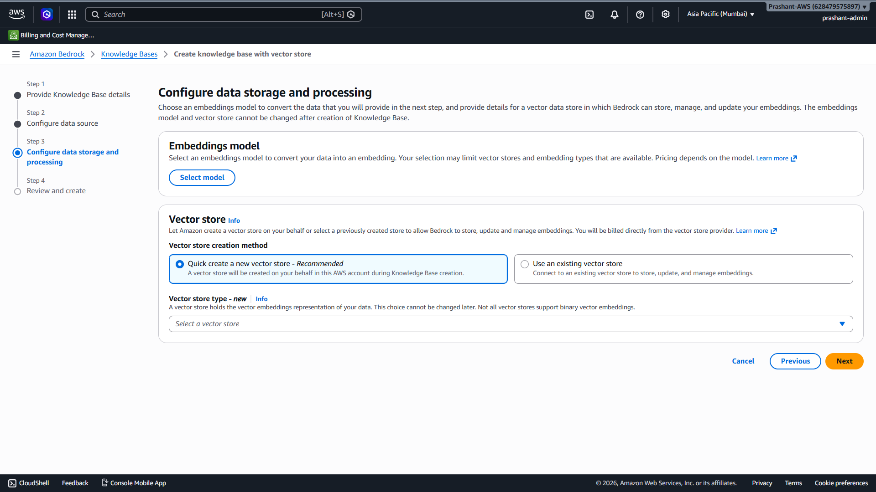
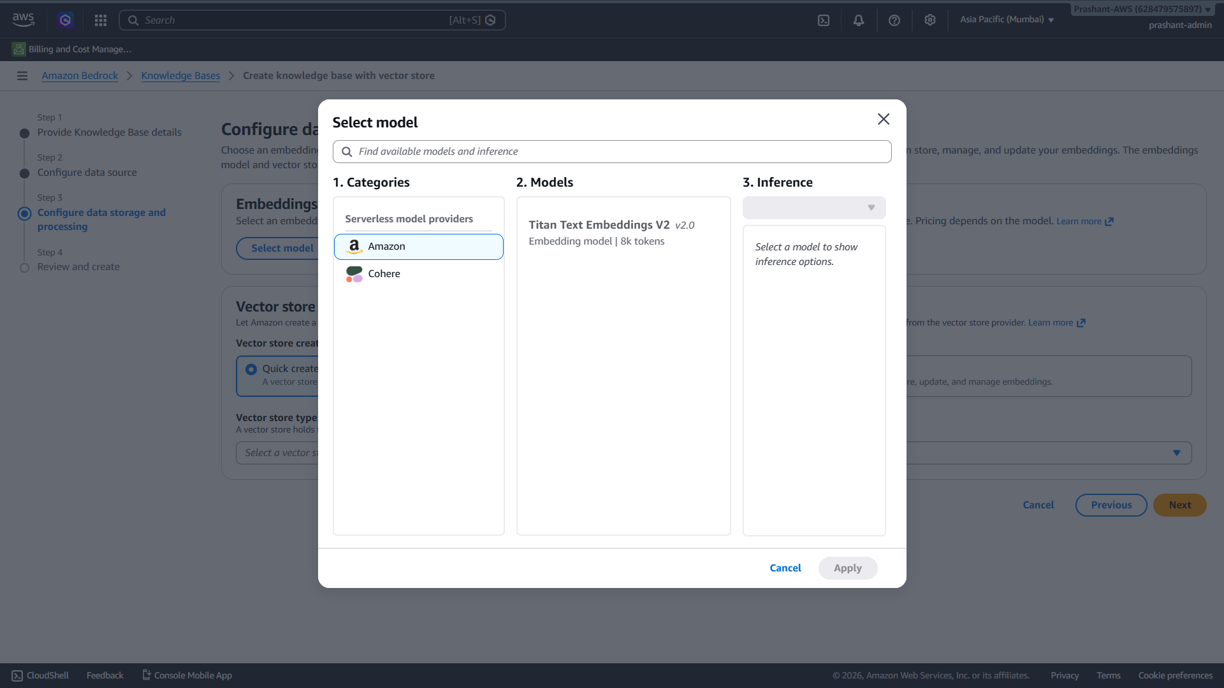
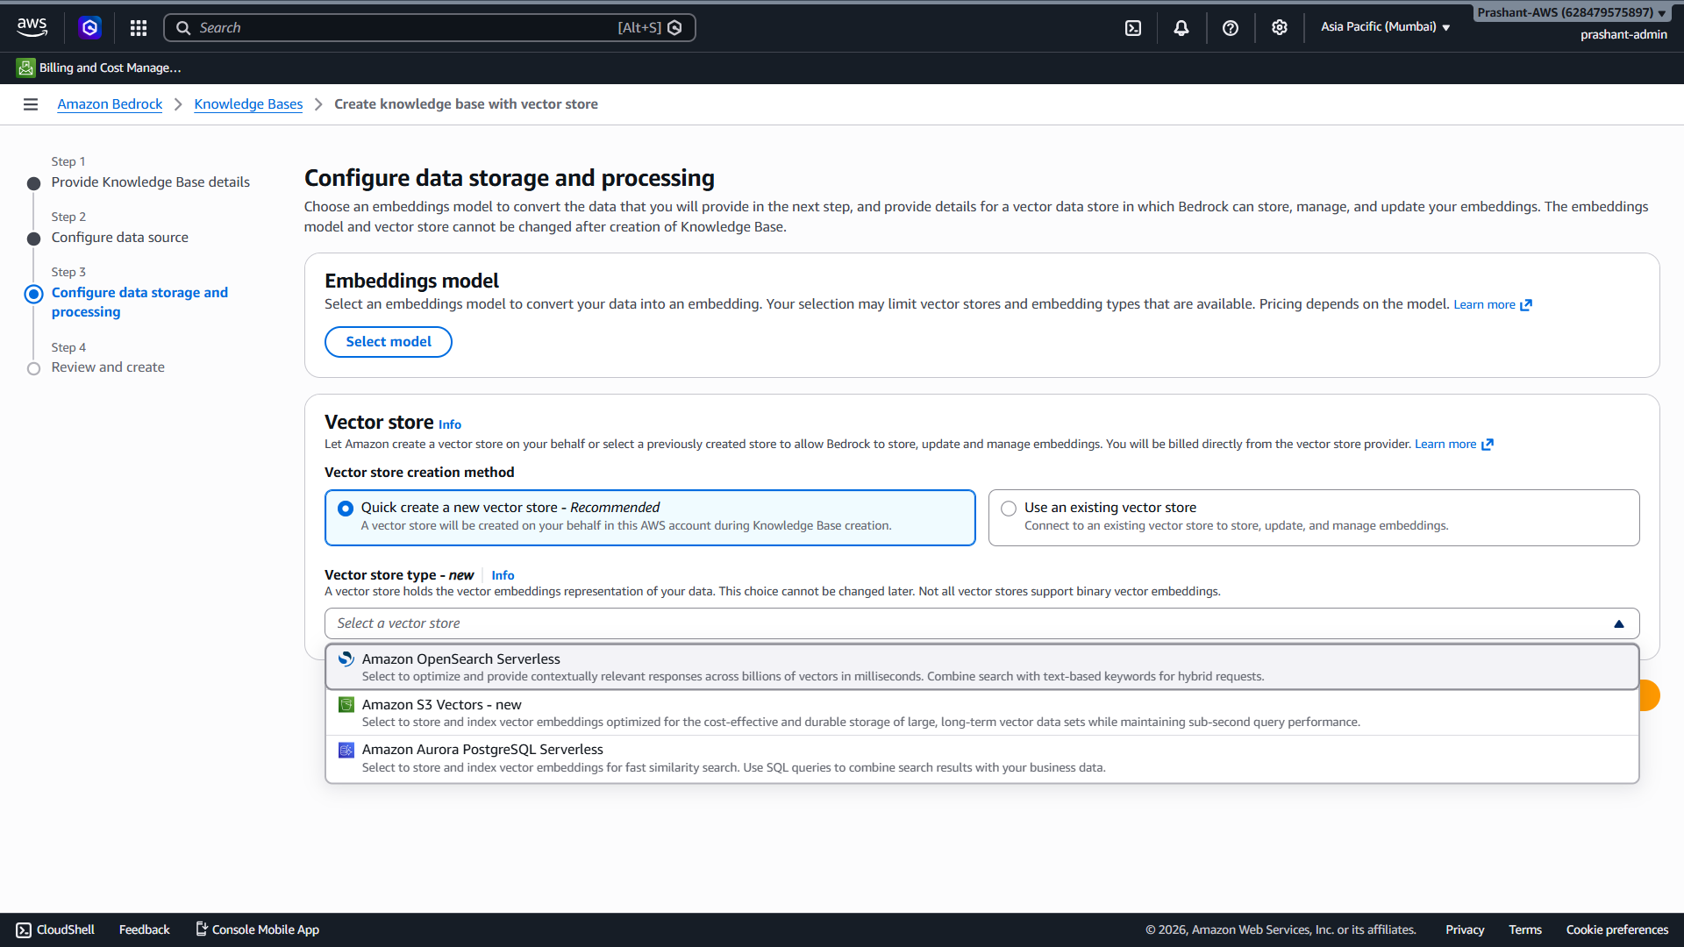
Haan bhai, mostly right ✅
Chunking, embedding generation, vector index mein store karna — yeh actual processing Bedrock internally karta hai, lekin aapko console mein kuch configuration choices select karni padti hain.
Simple line:
“Hum manually chunks create nahi karte, embeddings manually generate nahi karte, aur vector index mein manually insert nahi karte. Hum data source, parser, chunking strategy, embedding model aur vector store select karte hain; ingestion/sync ke time Bedrock processing internally karta hai.”
AWS docs ke according Bedrock Knowledge Base ingestion process mein document parse hota hai, chunks mein split hota hai, embedding model data ko vector embeddings mein convert karta hai, aur vector store mein index karta hai. [deepwiki.com]

Is screen par kya ho raha hai?
Aap abhi Step 2: Configure data source screen par ho.
Yahan Bedrock ko batana hai:
Source data kahan pada hai? → S3 bucket
Parser kaunsa use karna hai? → Default parser
Chunking kaise karni hai? → Default chunking

1. S3 URI kya bharna hai?
Screenshot mein S3 URI blank hai.
Aapka bucket name hai:
it-support-policy-demo-prashant-2026
Agar file bucket ke root mein upload hai, toh S3 URI mein yeh daalo:
s3://it-support-policy-demo-prashant-2026/
Agar kisi folder ke andar upload hoti, jaise docs/, toh URI hota:
s3://it-support-policy-demo-prashant-2026/docs/
Abhi root bucket use karo.

2. Parser strategy kya select karein?
Screenshot mein selected hai:
Amazon Bedrock default parser
✅ Isko selected rehne do.
Aapki file text-based hai, isliye default parser enough hai. Default parser common text formats ke liye suitable hai, jaise Word, Excel, HTML, Markdown, TXT, CSV. Bedrock supported source document formats mein TXT, MD, HTML, DOC/DOCX, CSV, XLS/XLSX aur PDF include hain. [docs.langchain.com]

3. Chunking strategy kya select karein?
Screenshot mein selected hai:
Default chunking
✅ Isko selected rehne do.
Default chunking automatically text ko approx 300 token chunks mein split karta hai. AWS docs ke according default chunking content ko approximately 300 tokens ke chunks mein split karta hai aur sentence boundaries preserve karta hai. [github.com]
Demo ke liye default chunking best hai.

4. Yeh options ka matlab kya hai?

Default chunking
Small/normal documents ke liye best.
Bedrock automatically chunks banata hai.

Fixed-size chunking
Aap token size aur overlap control karte ho.
Example: 500 tokens with 10% overlap.

Hierarchical chunking
Parent-child chunks banata hai.
Useful for large documents where section-level context important ho.

Semantic chunking
Meaning ke basis par chunks banata hai.
Useful when paragraphs/topics naturally separate karne hain.

No chunking
Jab document already small ya pre-processed ho.
Production mein chunking strategy retrieval quality ko directly affect karti hai. AWS docs ke according Bedrock first documents ko manageable chunks mein split karta hai, phir embeddings generate karke vector index mein write karta hai. [github.com]

5. Embedding aur vector store kab configure hoga?
Abhi Step 2 data source hai.
Next screen Step 3: Configure data storage and processing mein aapko usually yeh select karna hoga:
Embedding model
Vector store
Storage/index configuration
Yahin Bedrock embedding model aur vector store configure karega. AWS docs ke according Knowledge Base raw data ko vector embeddings mein convert karta hai using selected embedding model and stores those embeddings in selected vector store. [deepwiki.com]

6. Manual vs automatic — clear difference

Hum manually configure karte hain:
S3 data source
Parser strategy
Chunking strategy
Embedding model
Vector store
IAM role
Sync/ingestion trigger

Bedrock internally karta hai:
Document parsing
Text extraction
Chunk creation
Embedding generation
Vector index write
Retrieval during query
Citation/source mapping
Jab data source sync hota hai, Bedrock raw data ko embeddings mein convert karta hai based on selected embedding model and vector store configuration. Sync incremental hota hai, yani add/modify/delete files ke basis par only changed documents process hote hain. [github.com]

Interview-ready answer
Aap interview mein aise bolna:
“In Amazon Bedrock Knowledge Bases, we don’t manually create chunks, embeddings or vector records. We configure the S3 data source, parser, chunking strategy, embedding model and vector store. During the ingestion or sync job, Bedrock parses the documents, splits them into chunks, generates embeddings and indexes them into the vector store. At runtime, Bedrock retrieves relevant chunks and augments the LLM prompt for RAG-based response generation.”

Is screen par ab kya karo?
Abhi sirf yeh set karo:
Data source name: it-support-policy-s3-source
Data source location: This AWS account
S3 URI: s3://it-support-policy-demo-prashant-2026/
KMS key: unchecked
Parser strategy: Amazon Bedrock default parser
Chunking strategy: Default chunking
Transformation function: skip
Advanced settings: skip
Phir Next click karo.

Current actionable step
Bhai abhi S3 URI field mein yeh paste karo:
s3://it-support-policy-demo-prashant-2026/
Phir Next click karke next screen ka screenshot bhej do.
Haan bhai, screenshot bilkul sahi hai ✅
Aap ab Step 3: Configure data storage and processing par ho. Yahin embedding model aur vector store select hota hai.
Simple meaning:
Embedding model = text ko vector/number format mein convert karega
Vector store = un vectors ko store/index karega
Bedrock Knowledge Base ingestion ke time documents ko parse/chunk karta hai, embeddings generate karta hai, aur selected vector store mein store/index karta hai. [deepwiki.com]

Is screen par kya select karna hai?

1. Embeddings model
Popup mein dikh raha hai:
Amazon → Titan Text Embeddings V2
✅ Isko select karo.
Steps:
Select model
→ Amazon
→ Titan Text Embeddings V2
→ model row par click karo
→ Apply
Agar Apply disabled hai, toh model name par ek baar click karo; phir inference option enable ho sakta hai.
Interview explanation:
“I selected Amazon Titan Text Embeddings V2 to convert enterprise policy text into vector embeddings for semantic search.”

2. Vector store type kya select karein?
Dropdown mein options dikh rahe hain:
Amazon OpenSearch Serverless
Amazon S3 Vectors - new
Amazon Aurora PostgreSQL Serverless
Demo aur cost-safe practice ke liye main recommend karunga:
Amazon S3 Vectors - new
Reason: S3 Vectors Bedrock Knowledge Bases ke saath integrate hota hai, Bedrock automatically documents fetch karta hai, chunks/embeddings banata hai, aur vectors S3 vector index mein store karta hai; yeh RAG apps ke liye cost-effective vector storage option hai. [docs.aws.amazon.com]
AWS ne S3 Vectors ko production-grade scale/performance ke saath generally available announce kiya, aur S3 Vectors serverless architecture mein infrastructure provisioning ki zaroorat nahi hoti. [aws.amazon.com]

Options ka quick meaning

Amazon S3 Vectors
Best for:
Demo
Cost-safe RAG
Policy/manual/document search
Simple managed vector storage

Amazon OpenSearch Serverless
Best for:
Large enterprise search
Hybrid search
High-performance retrieval
Advanced search/filtering

Amazon Aurora PostgreSQL Serverless
Best for:
RAG + relational SQL use case
pgvector
Business data + vector search combine karna
Amazon Bedrock Knowledge Bases multiple vector stores support karta hai, including OpenSearch Serverless, Aurora/RDS, Pinecone, Redis, MongoDB Atlas and S3 Vectors. [deepwiki.com]

Abhi final selection summary
Is screen par yeh rakho:
Embeddings model:
Amazon Titan Text Embeddings V2

Vector store creation method:
Quick create a new vector store

Vector store type:
Amazon S3 Vectors - new
Phir:
Next

Important interview point
Screenshot ke top par likha hai ki embeddings model and vector store cannot be changed after creation. Iska matlab agar baad mein model/vector store change karna ho, toh normally new Knowledge Base create karna padta hai.
Interview mein bolna:
“Embedding model and vector store are key design decisions because they impact retrieval quality, cost, latency and scalability. In this demo I selected Titan Text Embeddings V2 and S3 Vectors for a managed, cost-effective RAG setup.”

Current actionable step
Bhai abhi:
1. Titan Text Embeddings V2 select karke Apply karo
2. Vector store type mein Amazon S3 Vectors - new select karo
3. Next click karo
Next screen ka screenshot bhej dena.
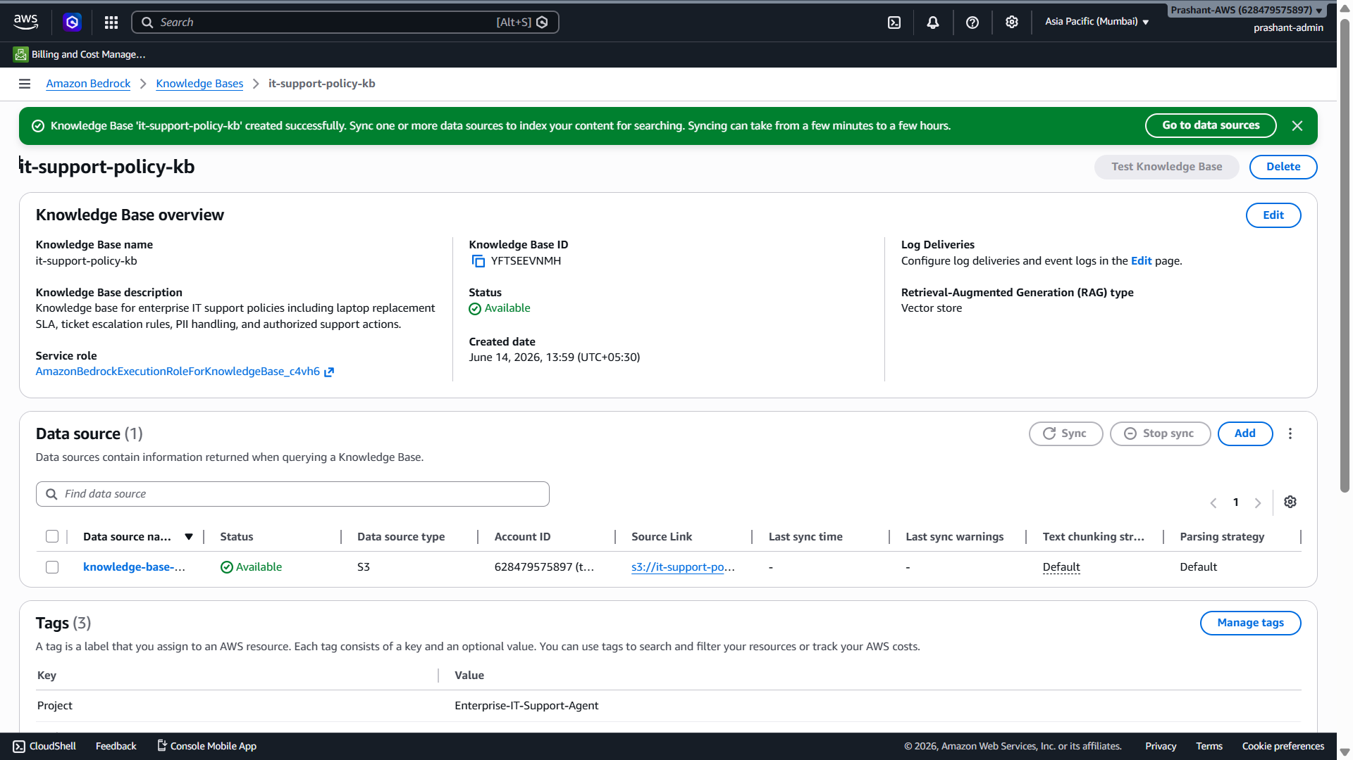
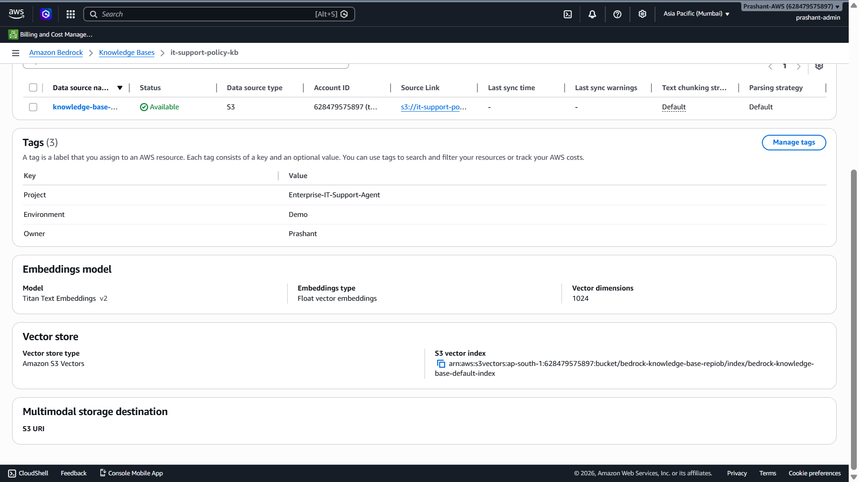
Perfect bhai ✅ Knowledge Base create ho gaya.
Screenshot se main clearly dekh raha hoon:
Knowledge Base name: it-support-policy-kb
Status: Available
Embedding model: Titan Text Embeddings v2
Vector dimensions: 1024
Vector store type: Amazon S3 Vectors
Data source type: S3
Last sync time: -
Text chunking strategy: Default
Parsing strategy: Default
Abhi important point: Knowledge Base create ho gaya hai, but document abhi index/sync nahi hua hai. Isliye top green message bhi bol raha hai: “Sync one or more data sources to index your content for searching.”

Abhi kya karna hai?

Current step: Data source sync karo
Data source table mein left side checkbox dikha raha hai. Usko select karo.
Data source row checkbox select karo
→ Sync button active ho jaayega
→ Sync click karo
Abhi Last sync time mein - aa raha hai, iska matlab abhi tak ingestion run nahi hua.
Amazon Bedrock Knowledge Base sync/ingestion ke time S3 source data ko parse karta hai, chunks mein split karta hai, embeddings generate karta hai, aur selected vector store mein index karta hai. [solved.scality.com]

Sync ke time internally kya hoga?
Aapne already configure kar diya:
Parser: Default
Chunking: Default
Embedding model: Titan Text Embeddings v2
Vector store: Amazon S3 Vectors
Sync click karne ke baad Bedrock internally karega:
S3 document read
→ text parse
→ default chunking
→ Titan Text Embeddings v2 se vector embeddings
→ Amazon S3 Vectors index mein store
→ Knowledge Base searchable ban jayega
S3 Vectors with Bedrock Knowledge Bases integration mein Bedrock automatically S3 data source se data fetch karta hai, content ko text blocks mein convert karta hai, embeddings generate karta hai, aur vector index mein store karta hai. [modelconte...tocol.info]

Sync baar-baar kab karna hota hai?
Sync har query ke liye nahi hota. Sync tab karte hain jab:
New file upload ho
Existing file update ho
File delete ho
Metadata change ho
AWS docs ke according data source sync incremental hota hai, yani Bedrock only added, modified, or deleted documents process karta hai since last sync. [langchain.com]

Test Knowledge Base button grey kyon hai?
Top-right mein Test Knowledge Base button grey/disabled dikh raha hai. Reason likely ye hai:
Knowledge Base created hai
but data source sync complete nahi hua
Sync complete hone ke baad Test Knowledge Base active ho jayega.

Interview mein is current stage ko kaise explain karna hai?
Aap bol sakte ho:
“At this stage, I created the Bedrock Knowledge Base with Titan Text Embeddings v2 and Amazon S3 Vectors as the vector store. The data source is S3, but after creation I need to run data source sync. During sync, Bedrock parses the S3 documents, chunks the text, generates embeddings, and indexes them into the S3 vector index. After sync, the Knowledge Base becomes searchable for RAG queries.”

Current actionable step
Bhai abhi sirf ye karo:
1. Data source row ka checkbox select karo
2. Sync button click karo
3. Sync complete hone ka wait karo
Sync complete hone ke baad screenshot bhej dena ya bolo “sync done”. Then hum Test Knowledge Base mein first RAG query run karenge.
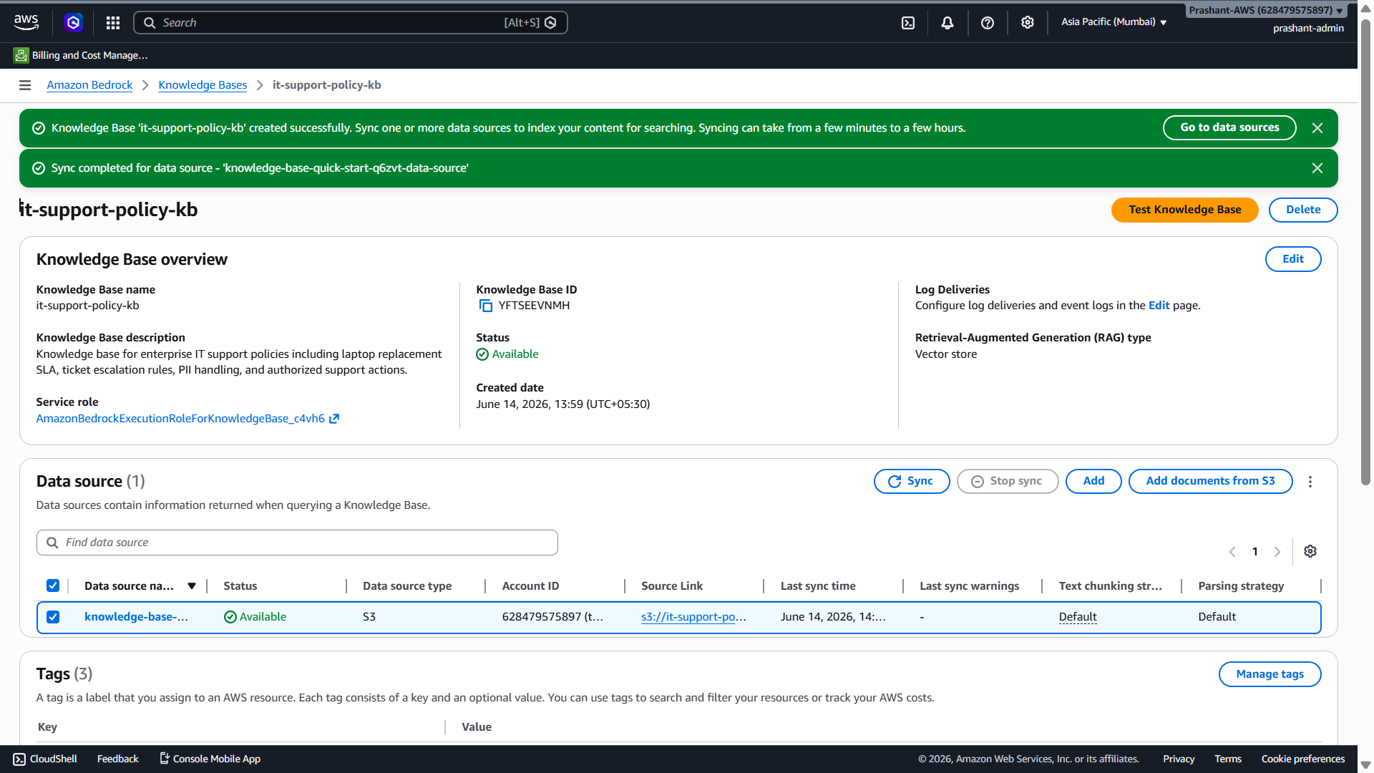

Perfect bhai ✅ Sync completed successfully — ab aapka RAG Knowledge Base ready hai.
Screenshot mein clearly dikh raha hai:
Knowledge Base: it-support-policy-kb
Status: Available
Data source status: Available
Sync completed
Last sync time: June 14, 2026
Text chunking strategy: Default
Parsing strategy: Default
Test Knowledge Base button: Enabled
Ab Bedrock ne internally ye process complete kar diya:
S3 document read
→ document se embeddings generate→ document parse
→ Amazon S3 Vectors index mein vectors store
→ Knowledge Base searchable ho gaya

→ text chunking
Amazon Bedrock Knowledge Bases ingestion flow mein source data parse hota hai, chunks mein split hota hai, embedding model data ko vector embeddings mein convert karta hai, aur vector store mein store/index karta hai. [solved.scality.com]

Ab Next Step: Test Knowledge Base
Ab top-right ka orange button click karo:
Test Knowledge Base
Uske baad right side ya testing panel open hoga jahan model select karke query pooch sakte ho.

Test ke liye pehle ye questions try karna

Query 1
What is the laptop replacement SLA?
Expected answer kuch aisa aana chahiye:
Laptop replacement SLA is 7 business days.

Query 2
When can a laptop replacement ticket be escalated?
Expected answer:
If a laptop replacement ticket remains unresolved for more than 7 business days, it qualifies for escalation.

Query 3
What personal information should not be exposed?
Expected answer:
The assistant must not expose mobile number, personal email, Aadhaar, PAN, salary, home address, or confidential employee records.

Agar model select karne ko bole
Agar Test Knowledge Base mein model select karna pade, toh koi available chat model choose karo, jaise:
Claude
Amazon Nova
Llama
Agar Claude available ho toh Claude choose karna, otherwise Amazon Nova bhi okay hai.

Interview mein is step ko kaise explain karna hai
Aap bol sakte ho:
“After creating the Knowledge Base, I ran a data source sync. During sync, Amazon Bedrock parsed the S3 document, applied default chunking, generated vector embeddings using Titan Text Embeddings v2, and stored those embeddings in Amazon S3 Vectors. Once sync completed, the Knowledge Base became available for RAG-based testing and semantic search.”

Current actionable step
Bhai abhi sirf:
Test Knowledge Base click karo
Phir query run karo:
What is the laptop replacement SLA?
Output ka screenshot bhej dena — main check karunga ki RAG correct answer de raha hai ya nahi.
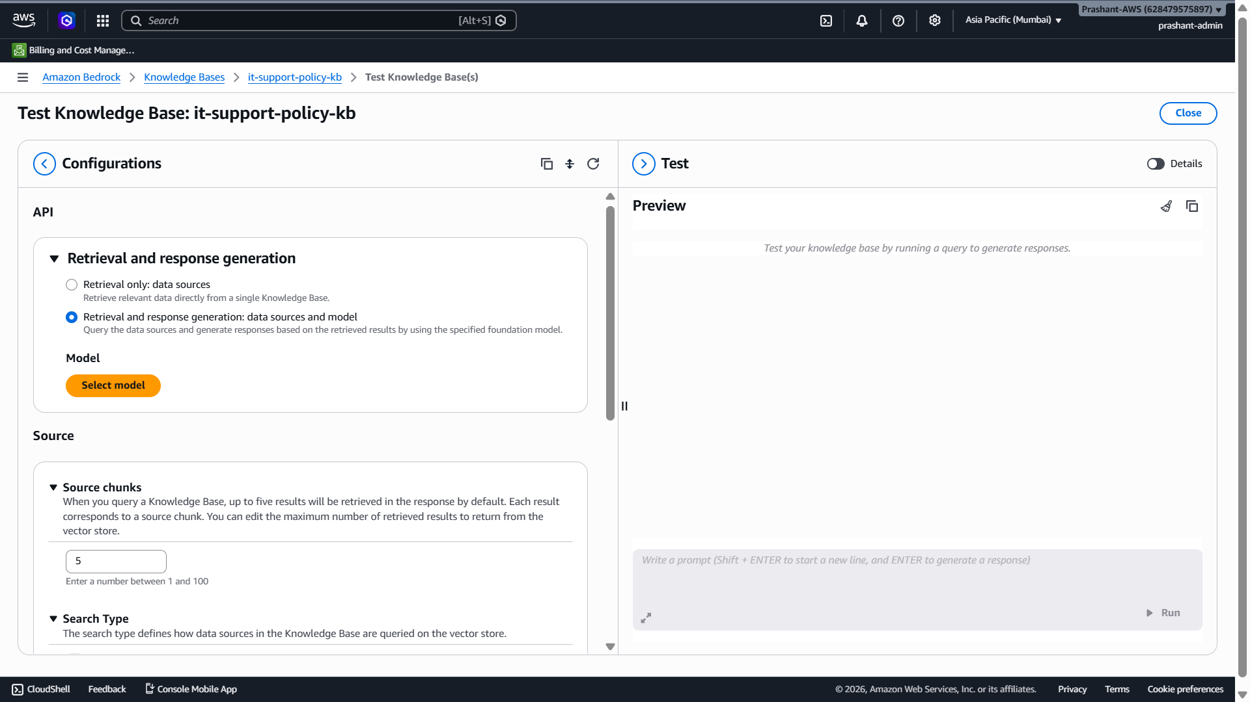

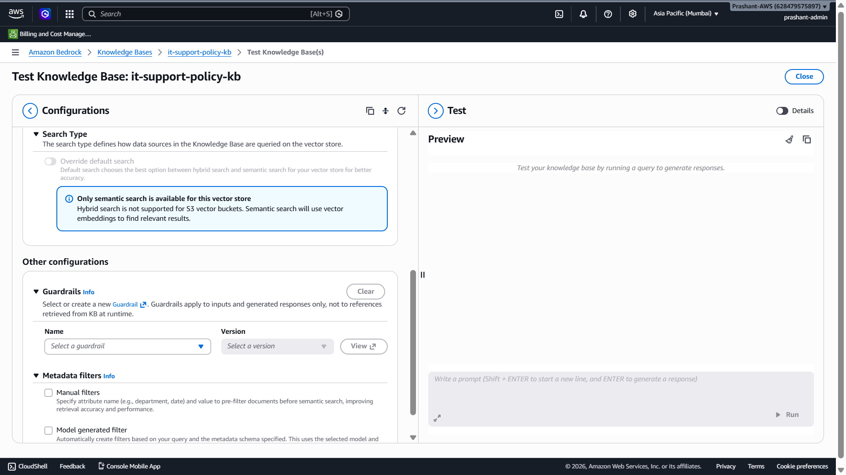

Perfect bhai ✅ Aap Test Knowledge Base screen par aa gaye ho.
Screenshot mein main dekh raha hoon:
Mode selected: Retrieval and response generation
Model select nahi huaModel: Not selected yet
Source chunks: 5
Search type: Only semantic search available for this vector store
Guardrails: Optional, not selected
Metadata filters: Optional, not selected
Abhi prompt run isliye nahi ho raha kyunki response generation model select nahi kiya hai.

Abhi kya karna hai?

Step 1: Select model click karo
Left side mein orange button hai:
Select model
Ispar click karo.
Agar options aayein toh koi available chat model select karo:
Preferred: Claude / Amazon Nova
Agar Claude available nahi hai toh Amazon Nova select kar lena.
Embedding model alag hota hai — Titan Text Embeddings v2 already ingestion ke liye use hua. Ab jo model select karna hai woh answer generate karne ke liye LLM model hai.

Retrieval and response generation ka matlab
Aapne jo option select kiya hai:
Retrieval and response generation: data sources and model
Ye sahi hai ✅
Iska matlab:
User query
→ Knowledge Base se relevant chunks retrieve honge
→ selected LLM model un chunks ke basis par answer generate karega
Agar aap Retrieval only select karte, toh sirf source chunks milte, generated answer nahi milta.
Amazon Bedrock Knowledge Bases retrieved data ko foundation model ke prompt mein use karke RAG response generate kar sakta hai. [solved.scality.com]

Source chunks = 5 ka matlab
Source chunks: 5
Iska matlab Bedrock query ke time maximum 5 relevant chunks retrieve karega.
Demo ke liye 5 sahi hai. Production mein use case ke hisaab se tune karte hain:
Small answer → 3 to 5 chunksSmallDetailed answer → 5 to 10 chunks
Large docs → threshold/reranking/hybrid search consider

Search type mein “Only semantic search” kyon aa raha hai?
Screenshot mein message dikh raha hai:
Only semantic search is available for this vector store.
Hybrid search is not supported for S3 vector buckets.
Ye normal hai. Aapne Amazon S3 Vectors select kiya tha, isliye yahan semantic vector search use ho raha hai. S3 Vectors Bedrock Knowledge Bases ke saath cost-effective managed vector storage ke liye integrate hota hai. [modelconte...tocol.info]
Interview mein bolna:
“For this demo I used S3 Vectors, so semantic search is available. For advanced hybrid search use cases, I can evaluate OpenSearch Serverless.”

Guardrails aur Metadata filters abhi use karna hai?
Abhi nahi bhai.

Guardrails
Skip for now. Baad mein add karenge.
Guardrails input/output safety, PII protection, denied topics aur compliance ke liye use hote hain. Bedrock Guardrails Knowledge Bases/RAG apps ke saath sensitive information protection and harmful content filtering mein help karte hain. [docs.aws.amazon.com]

Metadata filters
Skip for now. Ye tab use hota hai jab chunks ke saath metadata ho:
department = HR
country = India
document_type = policy
access_group = IT
Abhi simple demo document hai, so filters ki zaroorat nahi.

Model select hone ke baad ye query run karna
Prompt box mein ye type karo:
What is the laptop replacement SLA?
Expected response:
The laptop replacement SLA is 7 business days.
Phir second query:
When can a laptop replacement ticket be escalated?
Expected response:
If a laptop replacement ticket remains unresolved for more than 7 business days, it qualifies for escalation.

Interview mein is screen ko kaise explain karna hai?
Aap bol sakte ho:
“After syncing the Knowledge Base, I tested the RAG flow using the Test Knowledge Base screen. I selected retrieval and response generation mode, chose a foundation model for answer generation, kept source chunks as 5, and used semantic search over the S3 vector store. The Knowledge Base retrieves relevant chunks and the model generates a grounded answer from those chunks.”

Current actionable step
Bhai abhi sirf:
Select model → choose available LLM → Apply
Phir query run karo:
What is the laptop replacement SLA?
Output screenshot bhej do, main verify kar dunga ki RAG answer correct aa raha hai ya nahi.
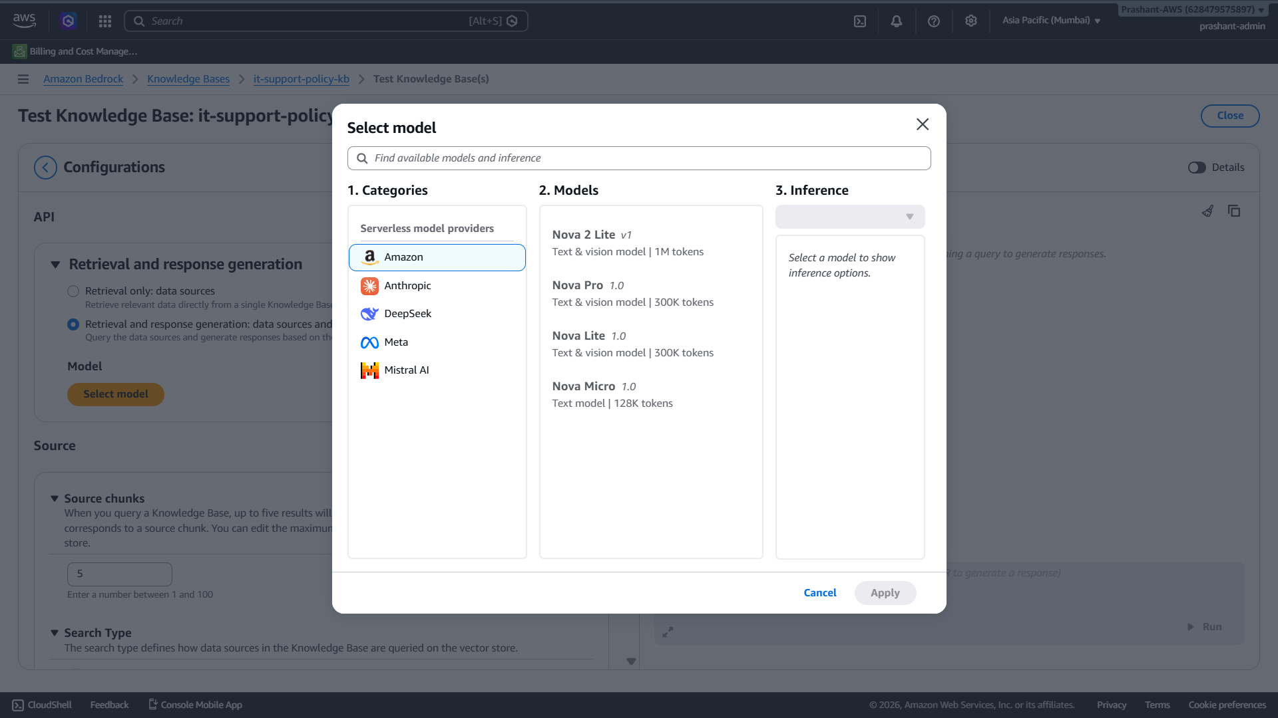

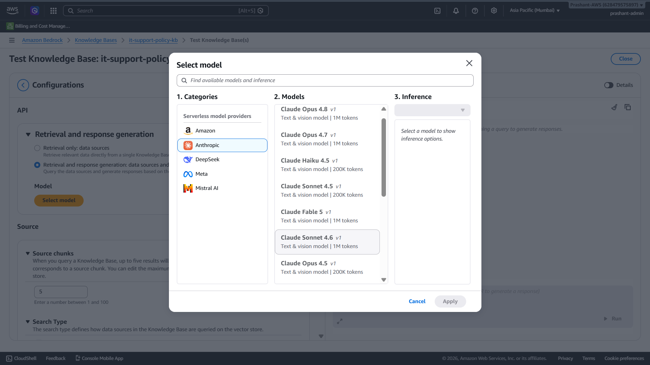

Bhai current demo ke liye Amazon → Nova Lite select karo ✅
Aapka use case simple RAG testing hai:
Question → Knowledge Base se chunks retrieve → model answer generate kare
Iske liye Claude Opus / Sonnet jaisa heavy model abhi zaroori nahi.

Best choice for current step

Select this:
Category: AmazonCategory: Amazon Lite 1.0
Agar Nova 2 Lite available and selectable hai, toh woh bhi okay hai. But simple rakho:
Nova Lite 1.0

Kyun?
- Cost-safe hai
- Simple RAG Q&A ke liye enough hai
- Fast testing ke liye suitable hai
- Demo/interview explanation ke liye AWS-native model choice bhi achhi lagegi

Kya Claude select kar sakte ho?
Haan, kar sakte ho, but abhi avoid karo.
Claude Sonnet → better reasoning, but comparatively expensive
Claude Opus → high-end, demo ke liye unnecessary
Agar interviewer-level final demo dikhana ho later, toh bol sakte ho:
“For cost-safe testing I used Amazon Nova Lite, and for advanced reasoning-heavy enterprise workloads I can switch to Claude Sonnet or Nova Pro depending on accuracy, latency and cost requirements.”

Abhi exact steps
- Left side mein Amazon select karo
- Middle list mein Nova Lite 1.0 select karo
  - Agar Nova 2 Lite selectable hai, toh woh bhi choose kar sakte ho
- Right side Inference mein jo default option aaye, usko select karo
- Apply button click karo
Phir prompt box active ho jayega.

Test query run karo
Model apply hone ke baad yeh query run karo:
What is the laptop replacement SLA?
Expected answer:
The laptop replacement SLA is 7 business days.

Current actionable step
Bhai abhi Amazon → Nova Lite 1.0 → Apply karo.
Agar Apply button enable na ho, toh model row par ek baar click karo aur right side inference dropdown mein available option select karo.

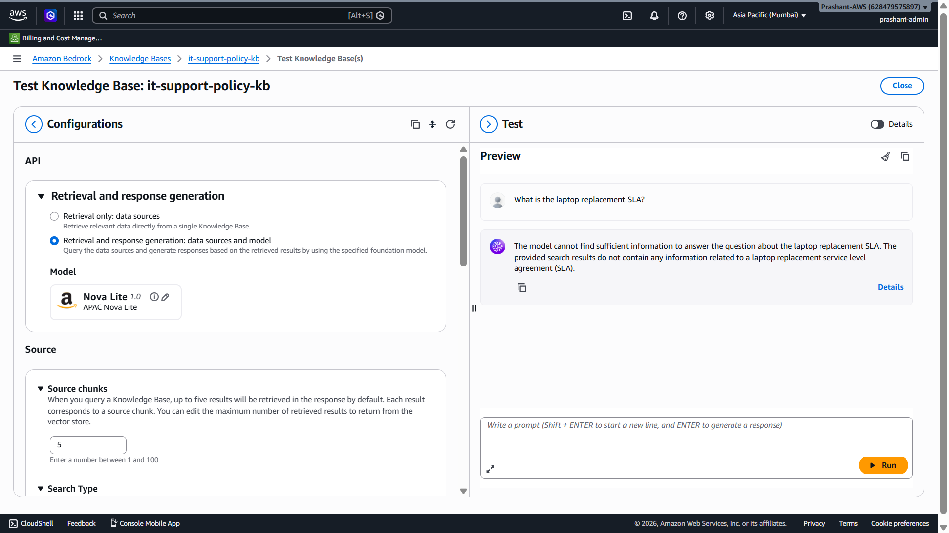

Bhai output bilkul expected hai — system galat nahi chal raha, issue data/document ka hai ✅
Screenshot mein model answer bol raha hai:
“The model cannot find sufficient information… source chunks do not contain laptop replacement SLA.”
Iska simple meaning:
Knowledge Base sync ho gaya hai,
retrieval bhi chal raha hai,
model bhi chal raha hai,
but retrieved document chunks mein laptop replacement SLA wali information nahi mili.

Main reason kya hai?
Mujhe screenshot se ek important clue mila: aapne S3 mein jo file upload ki thi uska naam dikh raha tha:
HR-Notice explain.txt
Lekin jo query aap pooch rahe ho:
What is the laptop replacement SLA?
Yeh answer tabhi milega jab Knowledge Base mein woh document ho jisme laptop replacement SLA written ho.
Maine jo demo document diya tha uska naam tha:
it-support-policy-demo.txt
``
Usme yeh line thi:
The standard laptop replacement SLA is 7 business days.
Agar aapne S3 bucket mein HR-Notice explain.txt upload kiya hai aur it-support-policy-demo.txt upload nahi kiya, toh Bedrock ko laptop SLA ka context milega hi nahi.

Kya Bedrock issue hai?
Nahi bhai. Bedrock correctly behave kar raha hai.
RAG ka rule hai:
LLM answer only from retrieved context.
Agar retrieved chunks mein required information nahi hai, toh model ko bolna chahiye:
Information not available.
Yeh actually good behavior hai, kyunki hallucination nahi kar raha.
Amazon Bedrock Knowledge Bases ingestion ke time source data parse, chunk, embed aur vector store mein index karta hai; query ke time relevant chunks retrieve hote hain aur model answer generate karta hai. Agar chunks mein information nahi hai, answer nahi milega. [solved.scality.com]

Ab kya karna hai?

Fix: correct policy document upload karo
Same S3 bucket mein yeh file upload karo:
it-support-policy-demo.txt
Jo maine pehle generate ki thi.
Agar file download nahi mil rahi toh aap simple ek new .txt file bana sakte ho with this content:
Enterprise IT Support Policy Demo Document

Laptop Replacement Policy:
Employees can request laptop replacement if the device is physically damaged, has repeated hardware failures, or is older than the approved lifecycle period. The standard laptop replacement SLA is 7 business days from the ticket creation date.

SLA Escalation Rule:
If a laptop replacement ticket remains unresolved for more than 7 business days, it qualifies for escalation to the hardware support queue lead.

PII Policy:
The assistant must not expose personal information such as mobile number, personal email, Aadhaar, PAN, salary, home address, or confidential employee records.
Upload this file to:
s3://it-support-policy-demo-prashant-2026/
Then come back to Knowledge Base and click:
Sync
AWS docs ke according jab S3 data source mein file add/modify/delete hoti hai, data source ko sync karna hota hai; sync incremental hota hai aur changed documents process karta hai. [langchain.com]

Test karne ke liye abhi ek quick check
Aap Details par click karke retrieved chunks dekh sakte ho. Wahan likely HR-Notice explain.txt ke chunks dikhenge, laptop SLA wali line nahi dikhegi.
Aap temporarily ek query pooch sakte ho jo HR-Notice explain.txt se related ho. Agar answer aa gaya, toh confirm ho jaayega ki Knowledge Base working hai but wrong document synced hai.

Interview learning point
Aap interview mein bol sakte ho:
“During RAG testing, if the model says information is not available, I first check the retrieved chunks. Most RAG issues are not model issues; they are usually data ingestion, wrong document, poor chunking, or retrieval mismatch issues. In this case, the Knowledge Base was working, but the uploaded source document did not contain laptop SLA content.”

Current actionable step
Bhai abhi sirf yeh karo:
S3 bucket mein it-support-policy-demo.txt upload karo
Upload ke baad Knowledge Base page par jaakar:
Sync
Phir same query run karo:
What is the laptop replacement SLA?

tumne "it-support-policy-demo.txt" waali file di thi kewal jisko humne s3 mai upload kar diya hai, aur kyonki humne aise tasks ko pehle bhi kai baar project mai kiya hai toh isliye abhi k liye kewal it-support-policy-demo.txt isi file ko use karo, kyonki humara target end to end flow banana aur langchain/langgraph/MCP ko sikhna hai

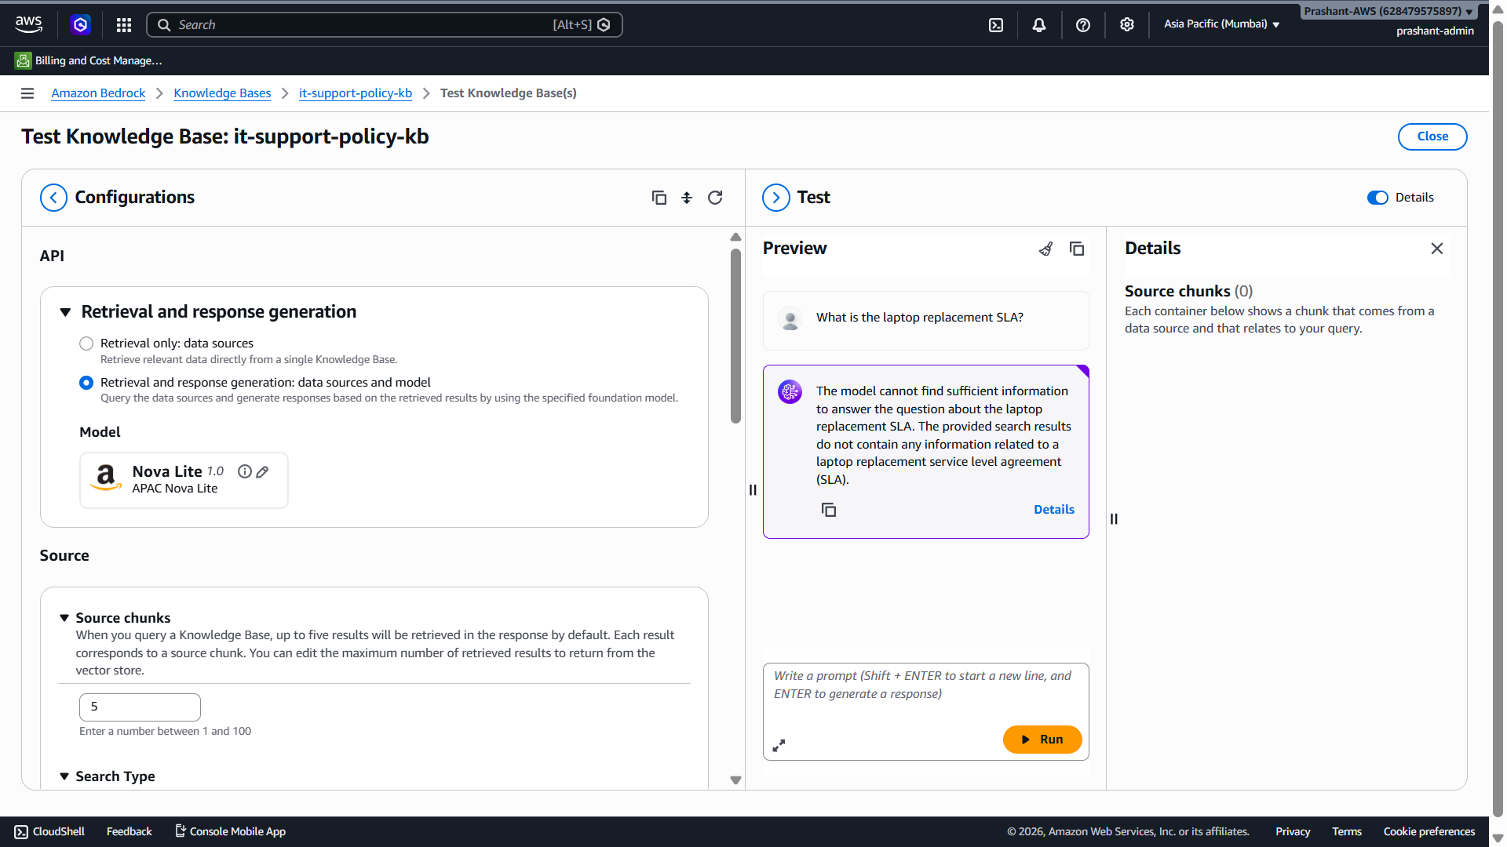

Bhai screenshot se clear hai ✅

Main finding
Right side Details panel mein clearly dikh raha hai:
Source chunks (0)
Iska matlab:
Query ke against Knowledge Base ne ek bhi relevant chunk retrieve nahi kiya.
So issue Nova Lite generation ka nahi hai. Issue abhi retrieval side par hai.
RAG flow mein answer tabhi generate hota hai jab Knowledge Base relevant chunks retrieve kare. Bedrock Knowledge Base ingestion ke time document parse/chunk/embed/index karta hai, aur query time par relevant chunks retrieve karke model ko context deta hai. Agar chunks retrieve hi nahi hue, model ke paas answer generate karne ke liye context nahi hota. [solved.scality.com]

Abhi kya samjho?
Aapka current flow:
Question:
What is the laptop replacement SLA?

Knowledge Base retrieval:
0 chunks

Model response:
Information not found
Yeh actually good RAG behavior hai, kyunki model hallucinate nahi kar raha. Lekin hume confirm karna hai ki indexed content searchable hai ya nahi.

Possible reasons
Abhi sirf 3 likely reasons hain:

1. Query semantic match nahi kar rahi
Kabhi-kabhi short query exact chunk retrieve nahi kar paati, especially small test document + S3 Vectors semantic-only search ke saath.
Screenshot mein bhi dikh raha tha:
Only semantic search is available for this vector store.Only semantic search is available forHybrid search is not supported for S3 vector buckets.
S3 Vectors Bedrock Knowledge Bases ke saath semantic vector retrieval ke liye use hota hai; hybrid search support vector store ke hisaab se vary karta hai. [modelconte...tocol.info]

2. Data source sync complete hua, but document chunks effectively retrieve nahi ho rahe
Sync successful hai, but hume query ko broader bana kar validate karna hoga.

3. S3 URI/prefix mein file indexed nahi hui
Aapne file upload ki hai, sync complete bhi hai, so abhi isko first assumption nahi banayenge. Pehle query-level validation karte hain.

Abhi current step: exact phrase query run karo
Prompt box mein yeh exact query run karo:
Laptop Replacement Policy
Agar still 0 chunks aaye, second query run karo:
7 business days
Agar in queries par chunks aa jaate hain, toh Knowledge Base indexed hai but original query semantic retrieval mein weak tha.
Agar in dono par bhi:
Source chunks (0)
aata hai, toh phir confirmed hai ki ingestion/indexing side par issue hai — then hum data source/prefix/sync history check karenge.

Interview learning point
Aap interview mein is situation ko aise explain kar sakte ho:
“In RAG debugging, I first check the retrieved source chunks. If source chunks are zero, then it is a retrieval/indexing problem, not an LLM generation problem. I validate by testing broader or exact phrase queries, checking sync status, source path, parsing warnings, chunking strategy, and whether the document was actually indexed.”

Current actionable step
Bhai abhi prompt mein sirf yeh run karo:
Laptop Replacement Policy
Phir Details panel mein Source chunks count dekho.
Agar screenshot bhej do, main turant bata dunga retrieval working hai ya indexing/prefix issue hai.

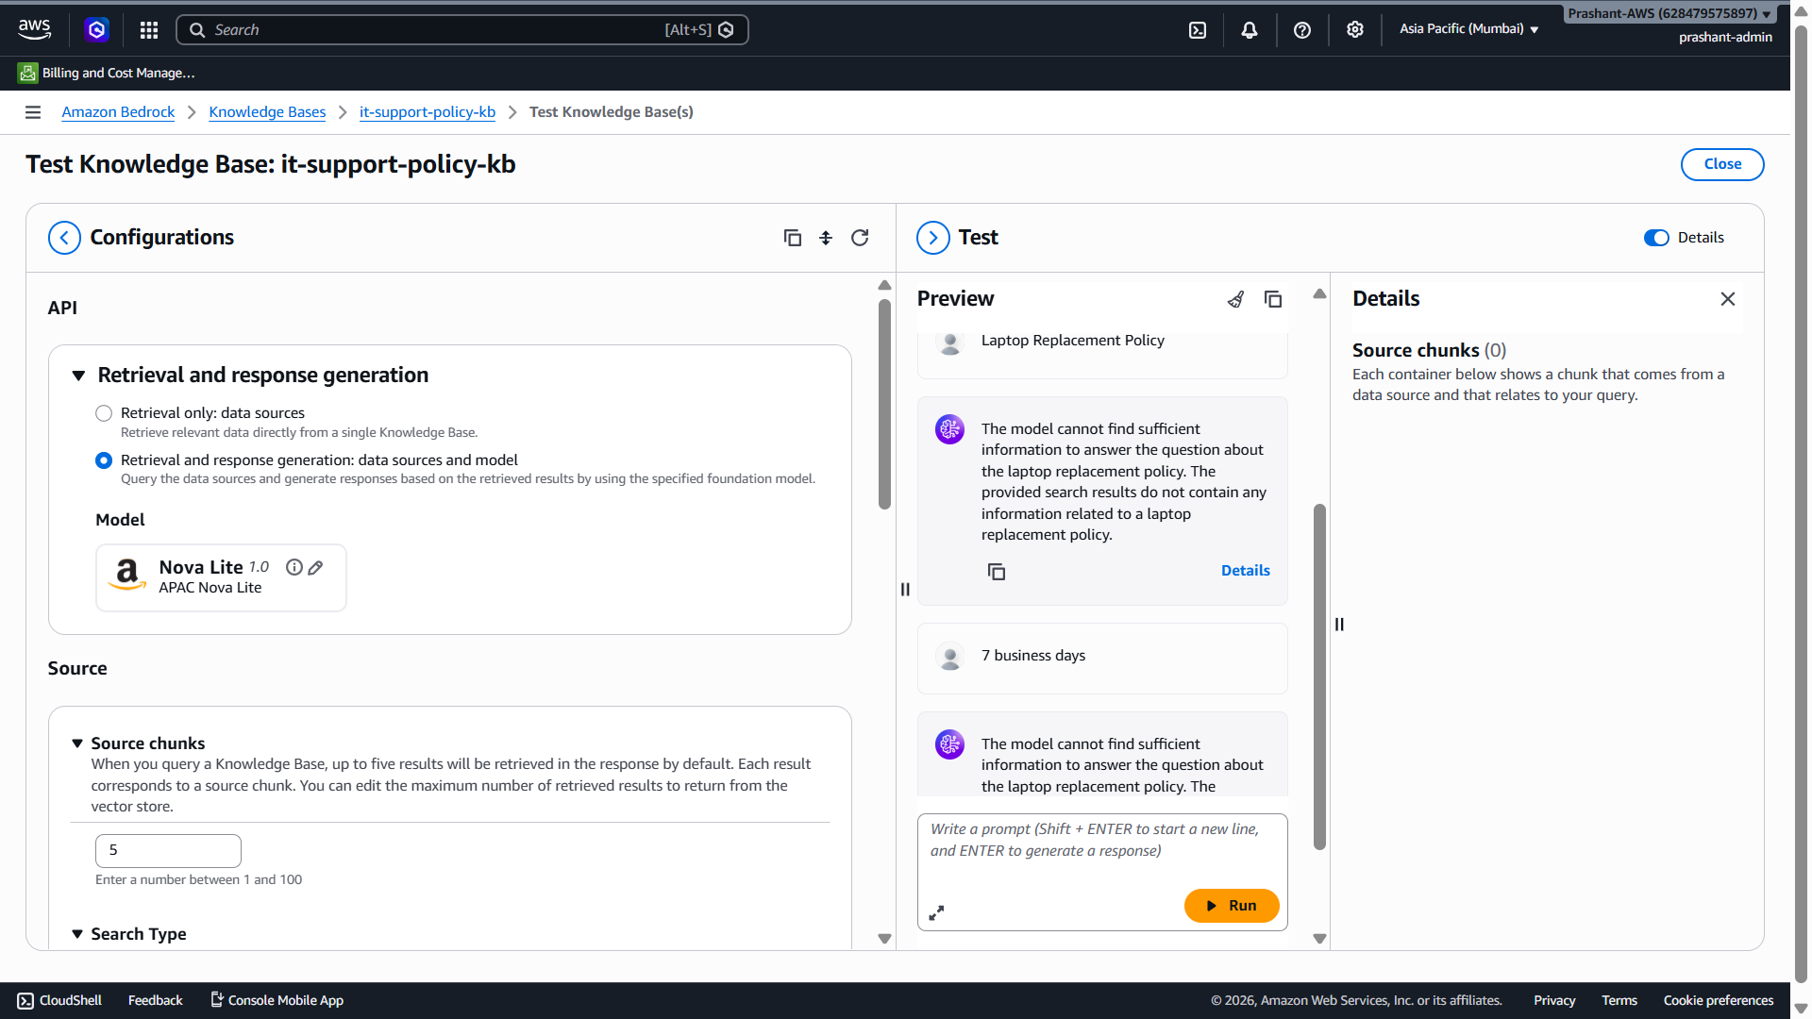

Bhai screenshot se final confirmation mil gaya:
Query: Laptop Replacement Policy
Query: 7 business days
Details panel: Source chunks (0)
Matlab retrieval layer ek bhi chunk return nahi kar rahi. Yeh ab model issue nahi hai. Nova Lite, Claude, kuch bhi select karo — jab Source chunks = 0, LLM ke paas answer generate karne ke liye context hi nahi hai.

Abhi issue kis layer mein hai?
RAG flow mein normally ye hota hai:
User query
→ Query embedding
→ Vector store search
→ Source chunks retrieve
→ LLM answer generate
Aapke case mein flow yahan fail ho raha hai:
User query
→ Query embedding
→ Vector store search
→ Source chunks = 0
Bedrock Knowledge Base ingestion mein data parse, chunk, embed aur vector store mein index hota hai; query ke time relevant chunks retrieve hote hain. Agar chunks retrieve nahi ho rahe, toh hume data source indexing/prefix/sync details check karni hongi. [solved.scality.com], [langchain.com]

Most likely issue
Abhi 90% chance hai ki Knowledge Base ne sync toh complete dikhaya, but actual document indexed nahi hua ya S3 source path/prefix mismatch hai.
Isliye ab hume S3 repeat upload nahi karna. Sirf yeh verify karna hai:
Data source ne actual file process ki ya nahi?

Abhi sirf yeh karo — Current Step

Test screen close karo
Top-right mein:
Close
click karo.
Phir Knowledge Base page par jo Data source table hai, usme data source name par click karo:
knowledge-base-quick-start-...-data-source
Us page par hume check karna hai:
Sync history
Ingestion job status
Documents scanned / indexed / failed
S3 URI / source path
Warnings / errors
Agar wahan documents processed = 0 hua, toh issue S3 URI/prefix ka hai.
Agar documents processed = 1 but chunks still 0, toh parsing/indexing issue hai.

Interview learning point
Aap isko interview mein aise explain kar sakte ho:
“When RAG response says information not found, I don’t directly blame the LLM. I first inspect source chunks. If source chunks are zero, it is a retrieval/indexing issue. Then I check data source sync history, documents processed, parsing warnings, S3 URI/prefix, chunking configuration and vector indexing status.”

Current actionable step
Bhai abhi sirf:
Close → Data source name click karo → Sync/ingestion details ka screenshot bhejo
Us screenshot se main exact bata dunga ki issue file processed nahi hui ya processed hui but retrieval nahi ho rahi.

Bhai ab screenshot se 100% root cause confirm ho gaya ✅
Aapke S3 bucket mein currently sirf 1 object hai:
HR-Notice explain.txt
Bucket mein it-support-policy-demo.txt present nahi hai. Isliye Bedrock Knowledge Base ne isi HR-Notice explain.txt ko index kiya, aur laptop replacement SLA query par Source chunks = 0 aa raha hai.

Abhi kya karna hai?
Maine correct file dobara bana di hai:
Download it-support-policy-demo.txt
Ab S3 mein sirf yeh current step karo:
Upload → Add files → it-support-policy-demo.txt → Upload
Upload ke baad bucket mein 2 files dikhengi:
HR-Notice explain.txt
it-support-policy-demo.txt
Agar aap only demo policy file use karna chahte ho, toh baad mein HR-Notice explain.txt delete kar sakte ho. But abhi safe approach:
Pehle it-support-policy-demo.txt upload karo

Upload ke baad Knowledge Base mein kya karna hai?
Amazon Bedrock → Knowledge Bases → it-support-policy-kb
→ Data source select
→ Sync
Sync ke baad Documents section mein ideally yeh dikhna chahiye:
s3://it-support-policy-demo-prashant-2026/it-support-policy-demo.txt
Status: INDEXED
Phir Test Knowledge Base mein query run karo:
What is the laptop replacement SLA?
Expected answer:
The standard laptop replacement SLA is 7 business days from the ticket creation date.

Interview learning point
Aap is issue ko interview mein confidently explain kar sakte ho:
“During RAG testing, the model returned no answer because the retrieved source chunks were zero. I debugged the pipeline by checking source chunks, sync history, indexed documents and S3 object list. The issue was not the LLM; the wrong source document was indexed. After uploading the correct IT policy document and re-syncing the Knowledge Base, retrieval should return the relevant chunk.”

Current actionable step
Bhai abhi sirf:
S3 bucket → Upload → it-support-policy-demo.txt
Upload ke baad screenshot bhej do ya bolo “uploaded”.
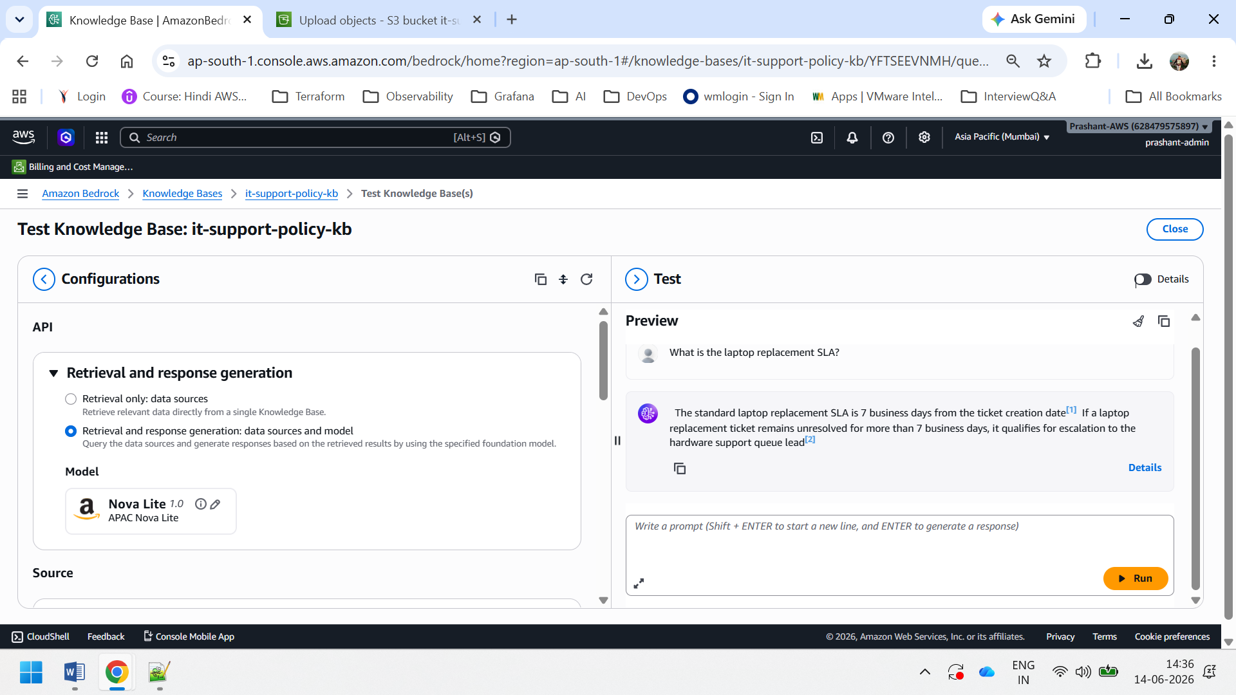
Perfect bhai ✅ RAG Knowledge Base ab correctly work kar raha hai.
Screenshot mein answer aa gaya:
“The standard laptop replacement SLA is 7 business days from the ticket creation date…”
Aur citations bhi aa rahe hain:
[1], [2]
Iska matlab:
S3 document indexed correctly
→ chunks retrieve ho rahe hain
→ Nova Lite model retrieved context se answer generate kar raha hai
→ citation/source grounding working hai
Ye exactly wahi RAG flow hai jo hume interview mein explain karna tha.

Abhi kya prove ho gaya?
Aapka current flow successfully complete ho gaya:
S3 policy document
→ Bedrock Knowledge Base
→ Default Text Embeddings v2→ Default parsing
→ Amazon S3 Vectors
→ Semantic retrieval
→ Nova Lite response generation
→ Source citations
→ Default chunking
Interview line:
“I created a Bedrock Knowledge Base using an S3 policy document. During sync, Bedrock parsed the document, chunked it, generated embeddings using Titan Text Embeddings v2, and stored them in Amazon S3 Vectors. In testing, the model retrieved relevant chunks and generated a grounded answer with citations.”

Important learning from debugging
Jo issue pehle aaya tha:
Source chunks = 0
Root cause tha:
Wrong source document indexed tha
Fix:
Correct it-support-policy-demo.txt upload kiya
→ Knowledge Base sync kiya
→ retrieval working ho gaya
Interview mein yeh strong debugging story ban sakti hai:
“When the RAG response failed, I checked source chunks, sync history, indexed documents, and S3 object list. I found the correct policy document was not indexed. After uploading and syncing the correct document, retrieval started returning grounded answers.”

Abhi 2 quick validation queries run karo
Same test box mein ye 2 queries run karo:
When can a laptop replacement ticket be escalated?
Expected:
If the ticket remains unresolved for more than 7 business days.
Second:
What personal information should not be exposed?
Expected:
Mobile number, personal email, Aadhaar, PAN, salary, home address, or confidential employee records.

Current actionable step
Bhai abhi sirf ye query run karo:
When can a laptop replacement ticket be escalated?
Output screenshot bhej do. Uske baad hum Bedrock Agent + Action Group start karenge, jahan agent ticket status/escalation tool call karega.

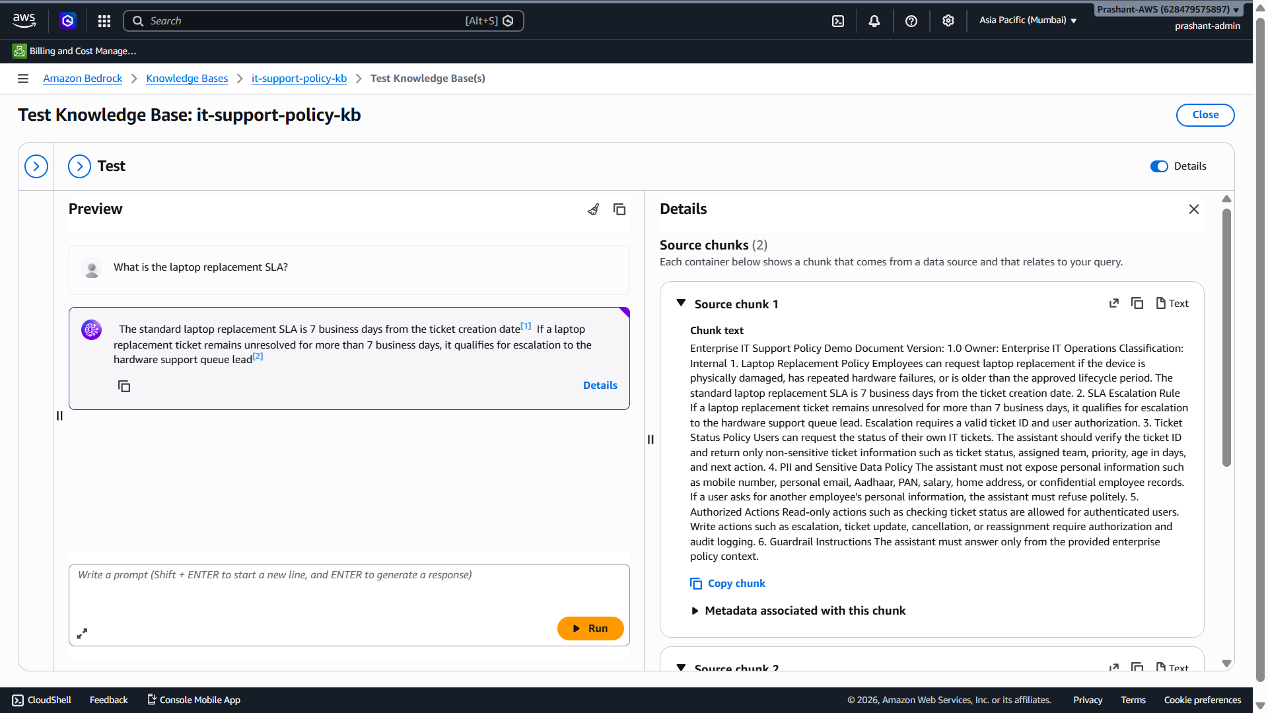

isme citations kya hai? aur humne Source chunks mai 5 diya tha toh yahan uska use case kaise pata chalega?

Bilkul bhai, screenshot mein jo aap dekh rahe ho woh RAG ka most important concept hai: citations + retrieved source chunks.

1. Citations kya hain?
Answer mein jo [1] aur [2] dikh raha hai, woh citations/source references hain.
Screenshot mein answer hai:
“The standard laptop replacement SLA is 7 business days from the ticket creation date [1]. If a laptop replacement ticket remains unresolved for more than 7 business days, it qualifies for escalation to the hardware support queue lead [2].”
Iska matlab:
[1] = answer ka pehla part Source chunk 1 se aaya
[2] = answer ka second part Source chunk 2 se aaya
Simple words mein:
Citation batata hai ki model ne answer ka particular sentence kis source chunk/document evidence ke basis par diya hai.
Amazon Bedrock Knowledge Bases retrieved data ke basis par generated answer ko ground karta hai aur citations/source references provide karta hai, jisse user verify kar sake ki response kis source text par based hai. [solved.scality.com]

2. Citation ka benefit kya hai?
Production RAG system mein citations bahut important hote hain because:
1. User verify kar sakta hai answer kahan se aaya.
2. Hallucination reduce hoti hai.
3. Auditability improve hoti hai.
4. Enterprise users ko trust milta hai.
5. Compliance teams dekh sakti hain ki AI ne source document ke basis par answer diya.
Interview line:
“Citations are source references attached to the generated answer. They show which retrieved document chunks were used to support the response. This improves trust, auditability, and hallucination control in enterprise RAG systems.”

3. Source chunks kya hote hain?
Right side Details panel mein dikh raha hai:
Source chunks (2)
Aur neeche:
Source chunk 1
Source chunk 2
Source chunk ka matlab hai document ka woh small text portion jo Knowledge Base ne query ke liye relevant samjha.
Aapke document mein Bedrock ne content ko chunk kiya tha. Query aayi:
What is the laptop replacement SLA?
Bedrock ne vector search karke relevant chunks retrieve kiye. Yahan 2 chunks relevant mile.
Flow:
User query
→ query embedding
→ vector search
→ relevant source chunks
→ LLM prompt mein chunks
→ final answer with citations
Amazon Bedrock Knowledge Base ingestion ke time documents parse karta hai, chunks mein split karta hai, embeddings banata hai, aur vector store mein index karta hai; runtime par relevant chunks retrieve karke response generation mein use karta hai. [objectfirst.com]

4. Humne Source chunks mein 5 diya tha, phir yahan 2 kyon aaye?
Bahut important point bhai.
Aapne left side mein jo value set ki hai:
Source chunks = 5
Iska matlab yeh nahi hai ki hamesha 5 chunks aayenge.
Iska matlab hai:
“Maximum 5 relevant chunks retrieve karo.”
Lekin agar query ke liye sirf 2 chunks relevant hain, toh Bedrock sirf 2 chunks return karega.
So:
Source chunks setting = maximum limit
Actual chunks returned = relevance ke basis par
Aapke case mein:
Configured max chunks: 5
Actual retrieved chunks: 2
Yeh normal and correct hai.

5. Iska use case kaise pata chalega?
Aapko use case Details panel se pata chalega.

Example from screenshot

Source chunk 1 mein kya dikh raha hai?
Right panel mein chunk text mein clearly ye lines hain:
The standard laptop replacement SLA is 7 business days from the ticket creation date.
Isliye final answer mein [1] citation laga.

Source chunk 2 kya likely support kar raha hai?
Answer ka second part:
If a laptop replacement ticket remains unresolved for more than 7 business days, it qualifies for escalation...
Iske liye [2] citation laga.
Matlab:
Answer sentence 1 → Source chunk 1
Answer sentence 2 → Source chunk 2

6. 5 chunks ka practical impact kya hota hai?
Agar aap Source chunks ko 5 rakhte ho:
Bedrock top 5 relevant chunks tak retrieve kar sakta hai.
Agar aap 2 rakhte:
Sirf top 2 chunks retrieve hote.
Agar aap 10 rakhte:
Zyada context mil sakta hai, but irrelevant noise bhi aa sakta hai.

Practical tuning
3 chunks → concise/simple answers
5 chunks → normal RAG Q&A, good default
10 chunks → detailed policy/manual answers
Too many → noise, cost, latency, confusion
Interview line:
“The source chunks value is the maximum number of chunks to retrieve. I usually start with 3 to 5 chunks, then tune based on answer quality, latency, token cost, and whether the response needs broader context.”

7. Citation aur Source chunk ka relation
Simple mapping:
Source chunk = raw retrieved evidence
Citation = reference number attached to generated answer
Example:
Source chunk 1:
“The standard laptop replacement SLA is 7 business days...”

Generated answer:
“The standard laptop replacement SLA is 7 business days [1].”
Yahan [1] bol raha hai ki yeh answer Source chunk 1 se supported hai.

8. Interview mein kaise explain karna hai?
Aap bol sakte ho:
“In the Test Knowledge Base screen, the answer included citations like [1] and [2]. These citations point to the retrieved source chunks used by the model to generate the answer. We configured source chunks as 5, which means Bedrock can retrieve up to 5 relevant chunks, but it returned only 2 because only 2 chunks were relevant to the laptop SLA query. This is expected behavior. Citations help validate that the answer is grounded in enterprise source documents rather than hallucinated.”

One-line yaad rakho
“Source chunks are the retrieved evidence, and citations show which evidence was used to generate each part of the answer.”

Current actionable step
Abhi isi screen par ek aur query run karo:
What personal information should not be exposed?
Phir dekho Source chunks count kitna aata hai aur answer mein citations [1], [2] kaise lagte hain.

Bilkul bhai, Bedrock Agent + Action Group start karte hain ✅
Ab hum RAG Knowledge Base ko ek Agentic AI flow mein convert karenge.

Target Flow
User Query
↓
Bedrock Agent
↓
If policy question → Knowledge Base se answer
If ticket status/escalation → Action Group / Lambda tool
↓
Final response
Amazon Bedrock Agent create karte time agent role, foundation model, instructions, aur at least ek Knowledge Base ya Action Group configure karna hota hai.
Action Group agent ke actions define karta hai, jaise Lambda/API business logic call karna. [docs.aws.amazon.com] [repost.aws]

Abhi hum kya banayenge?

Agent Name
it-support-agent

Agent ka kaam
1. IT policy questions answer karega using Knowledge Base1. IT policy questions answer karega using Knowledge karega using Action Group
3. SLA breached ho toh escalation suggest/perform karega
4. PII expose nahi karega
``

Step 1: Bedrock Agent Create karo
AWS Console mein jao:
Amazon BedrockAmazon Bedrock Builder tools
→ Agents
→ Create agent
Agar direct Agents menu dikhe:
Amazon Bedrock → Agents → Create agent

Agent create screen par fields

1. Agent name
it-support-agent

2. Description
Enterprise IT support agent for policy Q&A, ticket status check, SLA validation, and escalation workflow.

3. Agent resource role
Select karo:
Create and use a new service role
AWS Bedrock agent ko model invoke karne, Knowledge Base use karne, aur action tools call karne ke liye service role chahiye hota hai. [docs.aws.amazon.com]

4. Foundation model
Cost-safe demo ke liye select karo:
Amazon → Nova Lite
Agar Agent builder mein Nova Lite available na ho, toh:
Claude Haiku / Claude Sonnet
But pehle Nova Lite try karo because hum cost-safe rehna chahte hain.

5. Agent Instructions
Isko paste karna:
You are an enterprise IT support agent.

Your responsibilities:
1. Answer IT policy and authorized actions.1. Answer IT policy questions using the attached Knowledge Base.
3. Do not guess. If information is not available in the Knowledge Base, say that the information is not available.
4. Do not expose PII or confidential employee information such as mobile number, personal email, Aadhaar, PAN, salary, home address, or confidential employee records.
5. For ticket status or escalation requests, use the available action group tools.
6. Read-only ticket status checks are allowed for authenticated users.
7. Write actions such as escalation require authorization and audit logging.
8. If a laptop replacement ticket is unresolved for more than 7 business days, it qualifies for escalation according to policy.
9. Keep responses concise, professional, and grounded in enterprise policy.

Abhi Knowledge Base attach karna hai?
Agar same page par Knowledge Base section dikhe, toh attach karo:
Knowledge Base: it-support-policy-kbKnowledge Base: it-support-policy-k support policy questions, including laptop replacement SLA, escalation rules, PII policy, and authorized actions.
Instruction for agent:
Agar Knowledge Base attach option abhi na dikhe, koi problem nahi — agent create hone ke baad Agent Builder mein attach karenge.

Cost note
Abhi sirf agent create/configure karne se heavy cost nahi aayegi. Cost mainly tab aayegi jab:
Agent test/invoke hoga
Model response generate karega
Action/Lambda execute hogi
Isliye hum minimal tests hi karenge.

Interview line for this step
Aap bol sakte ho:
“After creating the Bedrock Knowledge Base, I created a Bedrock Agent for enterprise IT support. I configured the agent with a foundation model, service role, and clear instructions. The agent uses the Knowledge Base for RAG-based policy answers and will use Action Groups for ticket status and escalation workflows.”

Current actionable step
Bhai abhi sirf yeh karo:
Amazon Bedrock → Agents → Create agent
Fill:
Agent name: it-support-agent
Description: Enterprise IT support agent for policy Q&A, ticket status checkDescription: Enterprise IT support agent for policy Q&A, ticket status check, SLA validation, and escalation workflow.
Instructions: paste above instructions
Role: Create new service role
Create/Save ke baad screenshot bhej dena. Main next step mein Knowledge Base attach ya Action Group add karwaunga depending on screen.

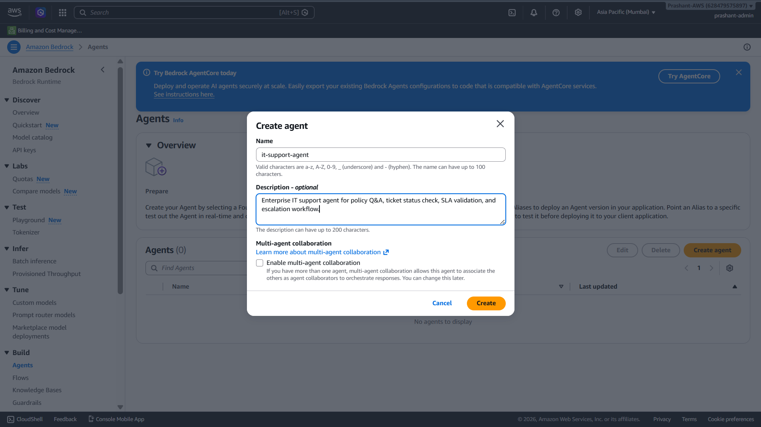

Perfect bhai ✅ Screenshot mein aap Create agent popup par ho.

Is screen par kya karna hai?

1. Name
Aapne correct bhar diya:
it-support-agent
✅ Sahi hai.

2. Description
Aapne likha hai:
Enterprise IT support agent for policy Q&A, ticket status check, SLA validation, and escalation workflow.
✅ Ye bhi sahi hai.

3. Multi-agent collaboration checkbox
Screenshot mein option hai:
Enable multi-agent collaboration
``
❌ Abhi isko enable mat karo.
Reason: Abhi hum single Bedrock Agent + Knowledge Base + Action Group bana rahe hain. Multi-agent collaboration later use hota hai jab supervisor agent ke niche multiple collaborator agents attach karne hote hain. AWS Bedrock multi-agent collaboration mein collaborator agents create/deploy karke supervisor agent ke saath associate kiye jaate hain. [docs.langchain.com]
Abhi humara flow simple rakhenge:
Single Agent
→ Knowledge Base for RAG
→ Action Group for ticket status/escalation

Abhi kya click karna hai?
Bottom-right orange button:
Create
✅ Is par click karo.

Create ke baad kya hoga?
Agent builder page open hoga. Wahan hum next fields configure karenge:
1. Agent resource role
2. Foundation model
3. Agent add3. Agent instructions
4. Knowledge Base attach
Amazon Bedrock Agent ko prepare/test/deploy karne ke liye minimum configuration mein agent resource role, foundation model, instructions, aur at least one action group ya knowledge base configure karna hota hai. [docs.aws.amazon.com]

Interview mein is screen ko kaise explain karna hai?
Aap bol sakte ho:
“I created a Bedrock Agent named it-support-agent for enterprise IT support use cases. I kept multi-agent collaboration disabled initially because this phase uses a single controlled agent with a Knowledge Base for RAG and an Action Group for ticket workflow automation. Multi-agent collaboration can be added later when we split responsibilities into policy agent, ticket agent, and compliance agent.”

Current actionable step
Bhai abhi sirf:
Multi-agent collaboration unchecked rakho
→ Create click karo
Create ke baad jo Agent Builder screen aaye, uska screenshot bhej dena.
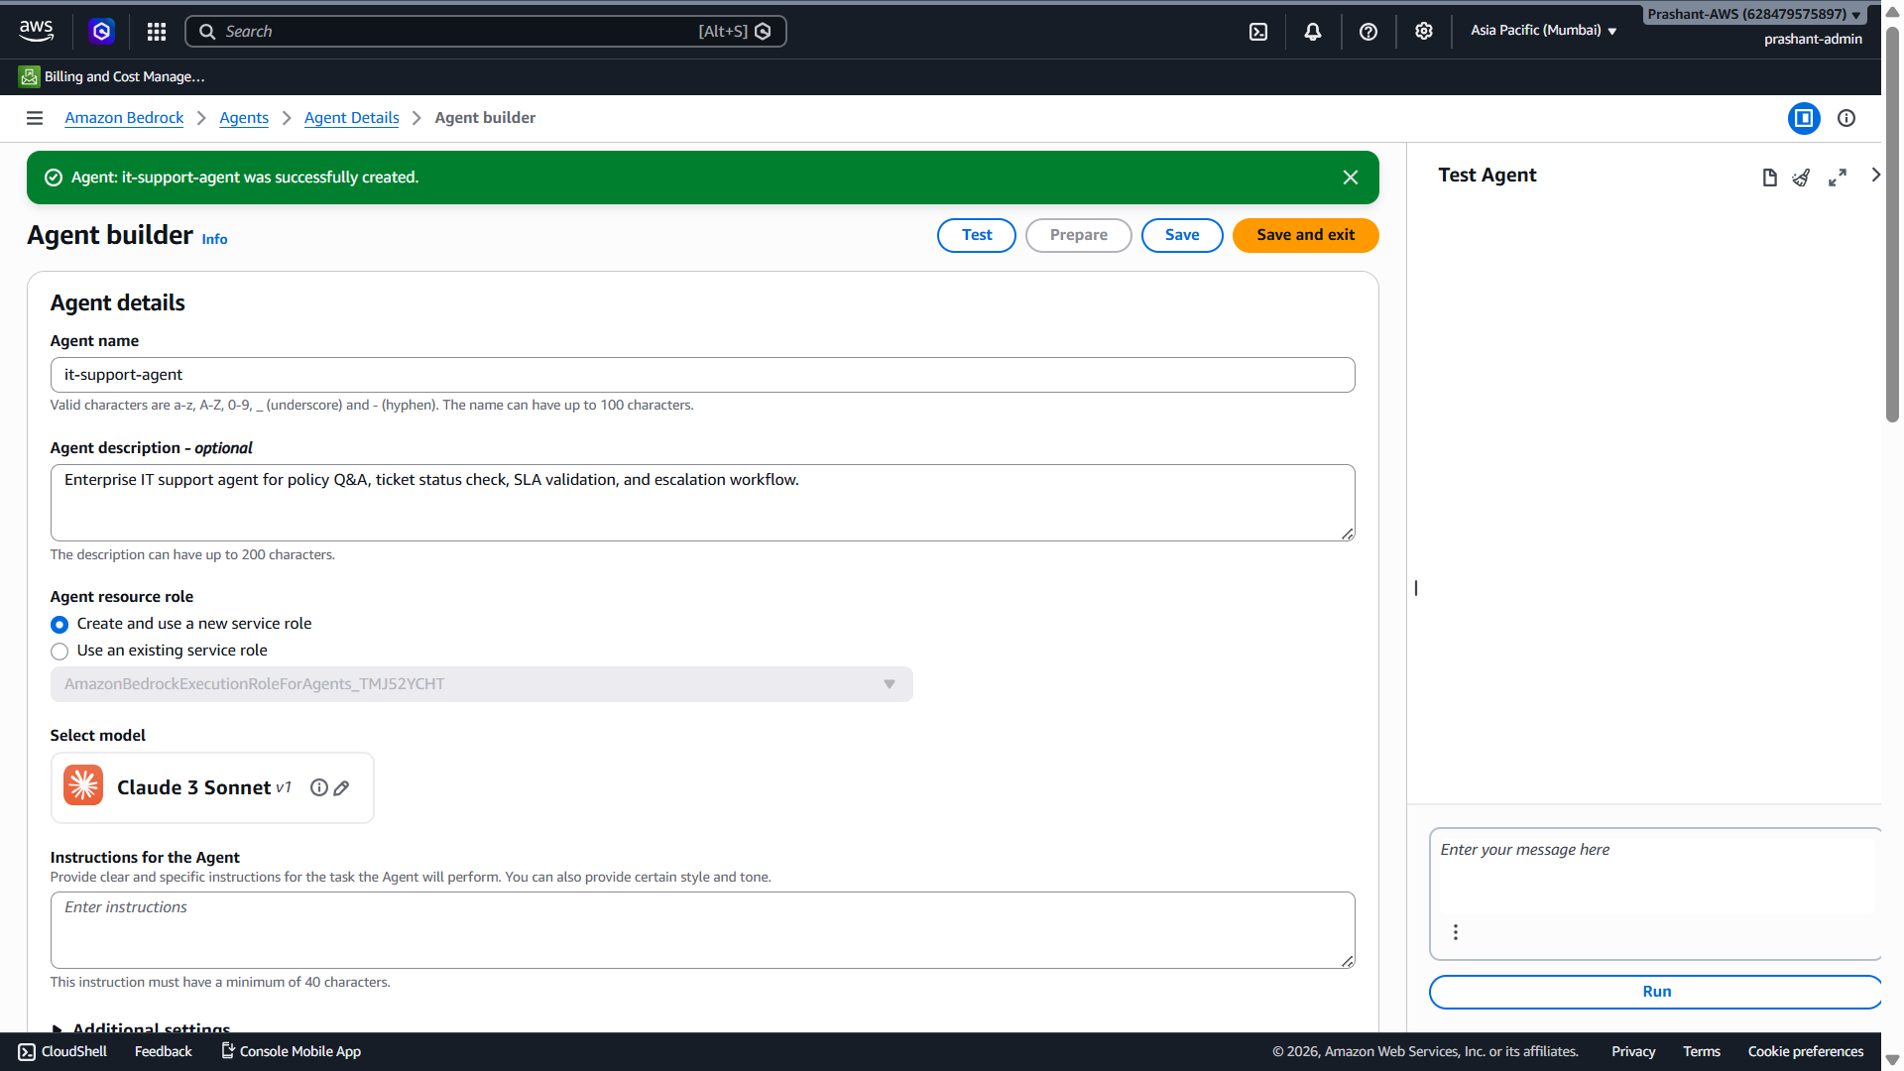
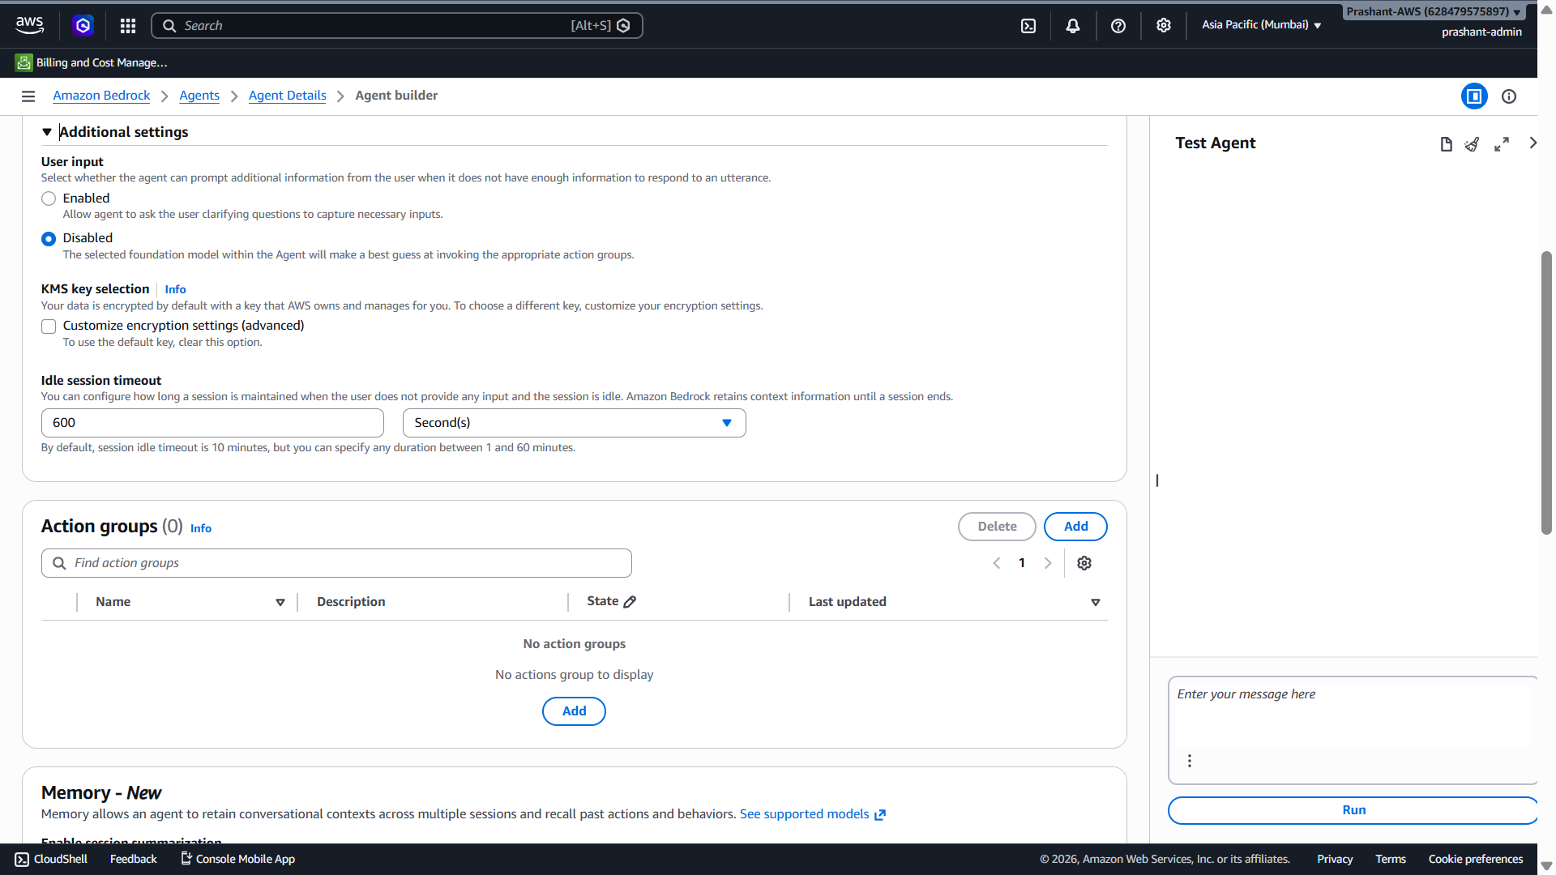
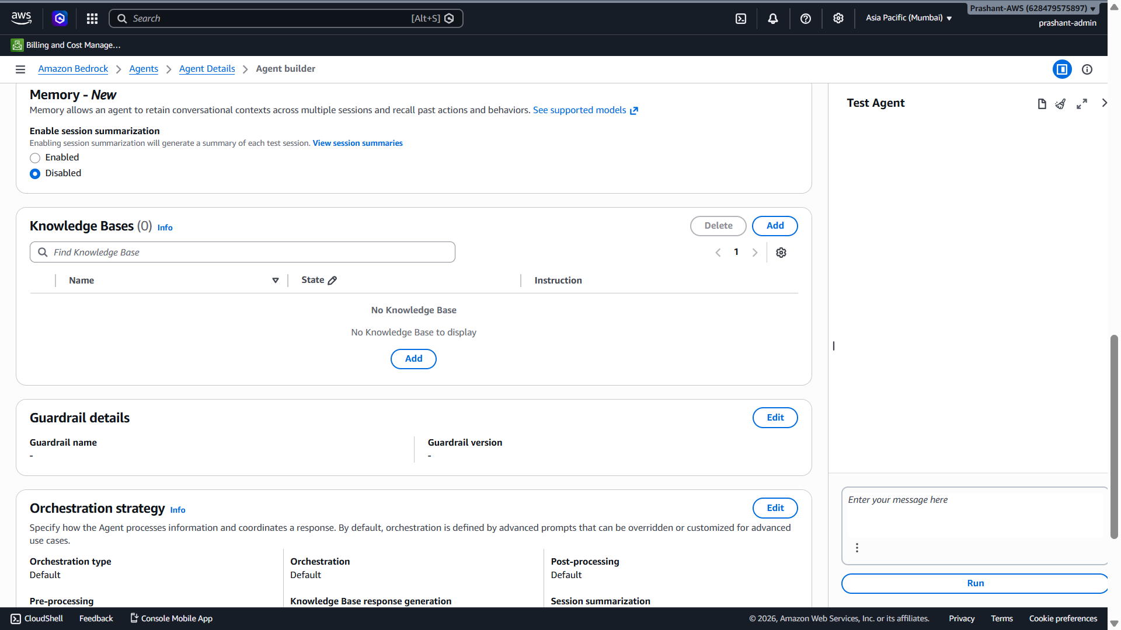

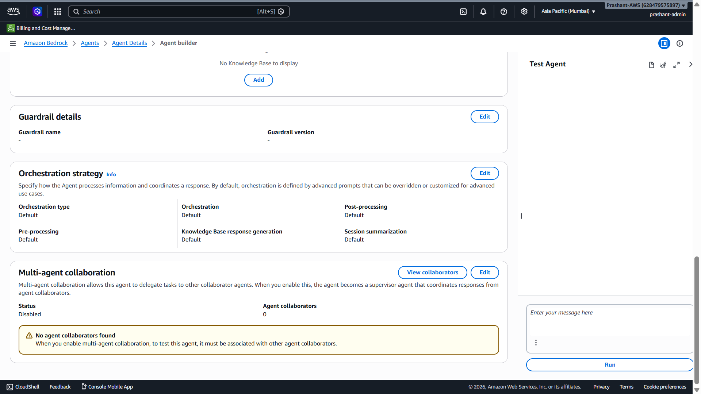

Perfect bhai ✅ Screenshot aur aapka note dono clear hain.

Multi-agent collaboration: Disabled, Agent collaborators: 0 — kya sahi hai?
Haan, bilkul sahi hai.
Abhi hum single Bedrock Agent bana rahe hain:
it-support-agent
→ Knowledge Base use karega
→ Action Group/Lambda tool use karega
``
Multi-agent collaboration tab enable karte hain jab hum supervisor + multiple agents banate hain:
Supervisor Agent
├── Policy Agent
├── Ticket Agent
├── Compliance Agent
└── Finance/HR Agent
Abhi Status: Disabled and Agent collaborators: 0 perfect hai. Isko change mat karo.

Ab current Agent Builder screen par kya karna hai?
Screenshot mein main dekh raha hoon:
Agent created successfully
Agent resource role: Create and use a new service role
Model: Claude 3 Sonnet v1
Instructions: empty
User input: Disabled
Action groups: 0
Knowledge Bases: 0
Memory: Disabled
Guardrail: not configured
Abhi sabse pehle Instructions for the Agent fill karni hai.

Step 1: Agent Instructions paste karo
Instructions for the Agent box mein ye paste karo:
You are an enterprise IT support agent.

Your responsibilities:
1. Answer IT support policy questions using the attached Knowledge Base.
2. Use the Knowledge Base for laptop replacement SLA, escalation rules, ticket status policy, PII policy, and authorized support actions.
3. Do not guess. If information is not available in the Knowledge Base, say that the information is not available.
4. Do not expose PII or confidential employee information such as mobile number, personal email, Aadhaar, PAN, salary, home address, or confidential employee records.
5. For ticket status or escalation requests, use available action group tools.
6. Read-only ticket status checks are allowed for authenticated users.
7. Write actions such as escalation, ticket update, cancellation, or reassignment require authorization and audit logging.
8. If a laptop replacement ticket remains unresolved for more than 7 business days, it qualifies for escalation according to policy.
9. Keep responses concise, professional, and grounded in enterprise policy.

Step 2: User input option kya rakhein?
Screenshot mein:
User input: Disabled
Isko main recommend karunga:
Enabled
Kyunki agar user bole:
Check my ticket status
Aur ticket ID na de, toh agent user se clarification pooch sake:
Please provide your ticket ID.
Agar disabled rahega, agent kabhi-kabhi guess kar sakta hai. Production mein user input enabled better hota hai.
So set:
User input: Enabled

Step 3: Model Claude 3 Sonnet sahi hai kya?
Haan, current screenshot mein model selected hai:
Claude 3 Sonnet v1
Ye agent reasoning ke liye good hai. Cost-safe testing ke liye hum baad mein minimum queries run karenge.
Agar aap cost aur kam rakhna chaho toh Nova Lite try kar sakte ho, but agent builder mein jo model already selected hai, usko abhi rehne do.

Step 4: Memory
Screenshot mein:
Memory: Disabled
Abhi disabled hi rehne do.
Reason: Demo ke liye hum simple stateless agent bana rahe hain. Production mein memory/session summarization baad mein enable kar sakte hain.

Step 5: Guardrail
Abhi guardrail configure mat karo. Pehle agent + KB + Action Group complete karte hain.

Step 6: Knowledge Base section
Screenshot mein Knowledge Bases section mein:
Knowledge Bases (0)
Add button
Ye hum next step mein add karenge.
Abhi pehle instructions + user input save karte hain.

Current actionable step
Bhai abhi sirf ye karo:
1. Instructions box mein above instructions paste karo
2. User input ko Enabled karo
3. Save click karo
Save ke baad screenshot bhej dena.
Uske baad main next step mein Knowledge Base: it-support-policy-kb attach karwaunga.

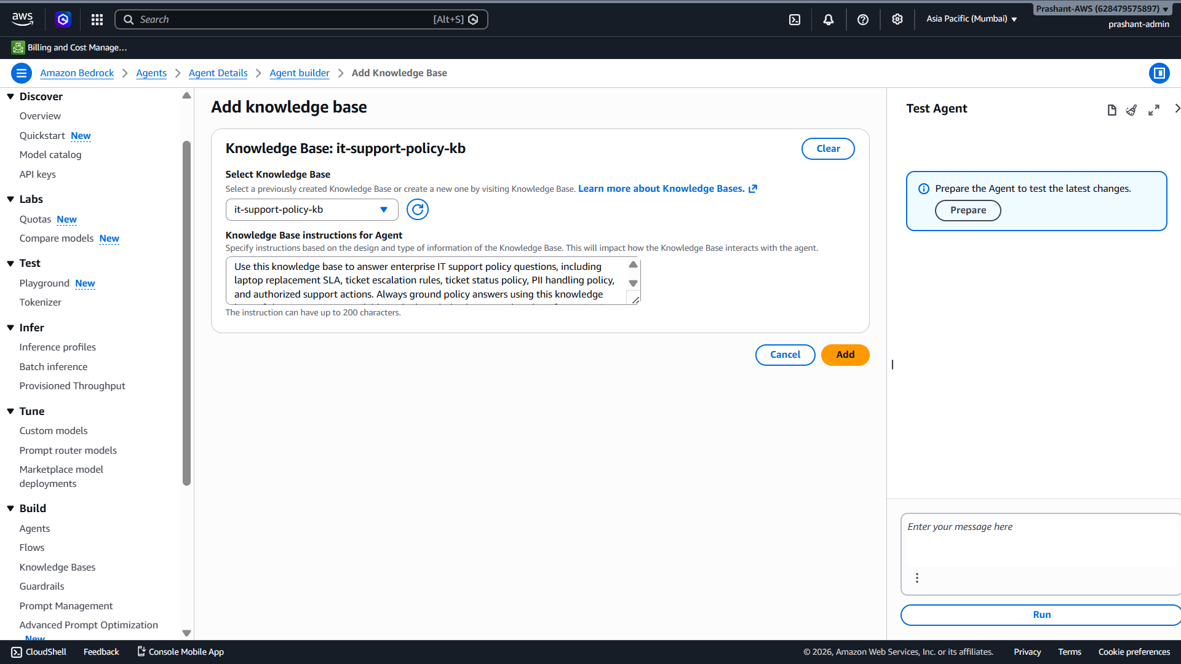

Perfect bhai ✅ screenshot se clear hai:
Agent created: Yes
Instructions saved/updated: Yes
Model: Claude 3 Sonnet v1
Agent role: Existing role selected
Right side: Prepare needed before testing
Abhi Prepare mat karo, kyunki agent mein abhi:
Knowledge Bases: 0
Action Groups: 0
Pehle Knowledge Base attach karte hain, phir Prepare karenge.

Next Step: Knowledge Base Attach karo
Aap page par thoda neeche scroll karo jahan section hai:
Knowledge Bases (0)
``
Wahan Add button click karo.
Phir values yeh select/fill karni hain:

1. Knowledge Base
Select karo:
it-support-policy-kb

2. Knowledge Base instruction
Yeh paste karo:
Use this knowledge base to answer enterprise IT support policy questions, including laptop replacement SLA, ticket escalation rules, ticket status policy, PII handling policy, and authorized support actions. Always ground policy answers using this knowledge base. If the answer is not available in the knowledge base, say that the information is not available.

3. Save / Add
Jo bhi button aaye:
Add / Save
click kar dena.

Abhi Prepare kyun nahi?
Prepare ka matlab agent ka latest configuration deploy/test-ready version mein compile/update karna hota hai. Lekin agar abhi Prepare kar diya, toh agent sirf instructions ke saath prepare hoga, Knowledge Base ke bina.
Correct sequence:
Instructions saved
→ Knowledge Base attach
→ Action Group add
→ Prepare
→ Test
Abhi hum sirf Knowledge Base attach karenge.

Interview mein is step ko kaise explain karna hai?
Aap bol sakte ho:
“After creating the Bedrock Agent, I attached the existing it-support-policy-kb Knowledge Base to the agent. This allows the agent to answer policy-related questions using RAG instead of relying only on the foundation model.”

Current actionable step
Bhai abhi sirf:
Knowledge Bases (0) → Add → select it-support-policy-kb → paste
Kar do, phir screenshot bhej dena.

Bhai error clear hai ✅
Screenshot mein red error aa raha hai:
ValidationException:
Value at 'description' failed to satisfy constraint:
Member must have length less than or equal to 200
Iska matlab Knowledge Base instructions for Agent field mein text 200 characters se zyada ho gaya hai. Is field ka limit screenshot mein bhi likha hai:
The instruction can have up to 200 characters.

Ab kya karna hai?
Is long instruction ko delete karo aur yeh short instruction paste karo:
Use this KB for IT policy, laptop SLA, ticket escalation, PII rules, and authorized actions. If not found, say information is not available.
Yeh 200 characters ke andar hai ✅

Then click
Add

Interview mein is field ka meaning
Aap bol sakte ho:
“While attaching the Knowledge Base to the Agent, I provided a short instruction telling the agent when to use this KB — for IT policy, laptop SLA, escalation rules, PII handling, and authorized actions.”

Current actionable step
Bhai abhi sirf:
Current KB instruction text delete karo
→ short instruction paste karo
→ Add click karo

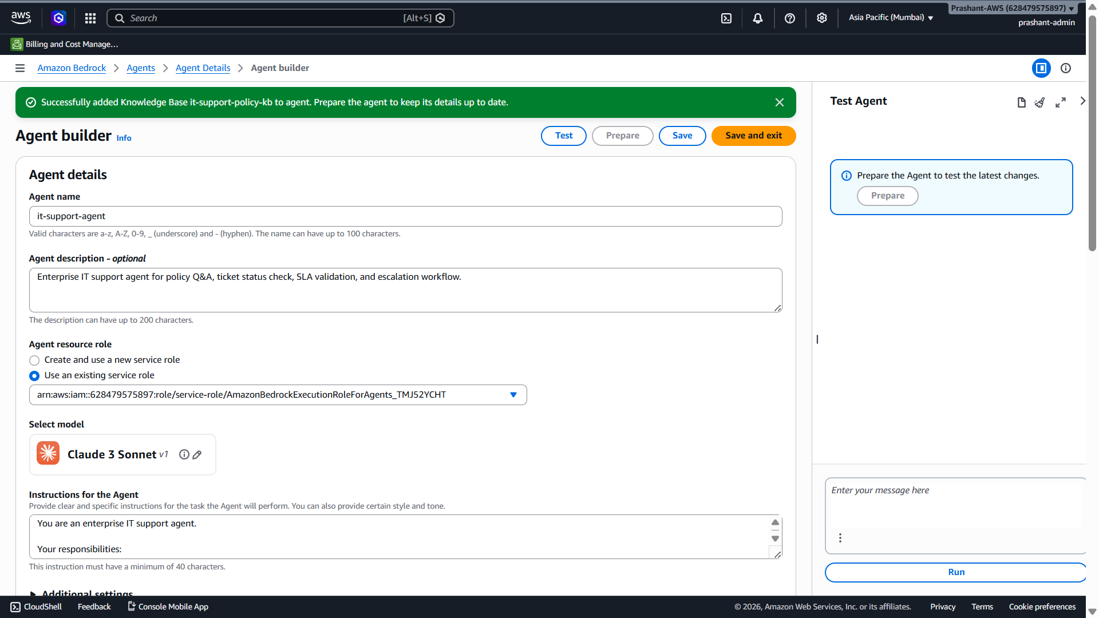

Perfect bhai ✅ Screenshot se confirm ho gaya:
Knowledge Base successfully added to agent: it-support-policy-kb
Agent: it-support-agent
Model: Claude 3 Sonnet v1
Agent role: existing service role selected
Prepare needed: Yes
Abhi Prepare mat karo, kyunki next hum Action Group add karenge. Prepare last mein karna hai.
Correct sequence:
Agent instructions ✅
Knowledge Base attached ✅
Action Group add ⏳
Prepare agent
Test minimal query

Next Step: Action Group Add Karna
Action Group se agent external tool/API call karega, jaise:
get_ticket_status(ticket_id)
escalate_ticket(ticket_id, reason)
Abhi demo ke liye hum mock Lambda/tool use karenge jisse interview mein aap explain kar pao ki agent ticket status check aur escalation action perform kar sakta hai.

Abhi kya karo?
Page ko thoda neeche scroll karo jahan section hai:
Action groups (0)
Wahan Add button click karo.
Aapke previous screenshot mein Action groups section dikh raha tha:
Action groups (0)
Add

Action Group ka interview meaning
Aap interview mein bol sakte ho:
“Knowledge Base gives the agent retrieval capability for policy questions, while Action Group gives the agent tool-calling capability. For example, policy questions go to RAG, but ticket status or escalation requests go to an Action Group backed by Lambda or enterprise APIs like ServiceNow/Jira.”

Current actionable step
Bhai abhi sirf:
Scroll down → Action groups (0) → Add
Click karo.
Jo Add Action Group screen open ho, uska screenshot bhej dena. Main uske exact fields fill karwaunga.

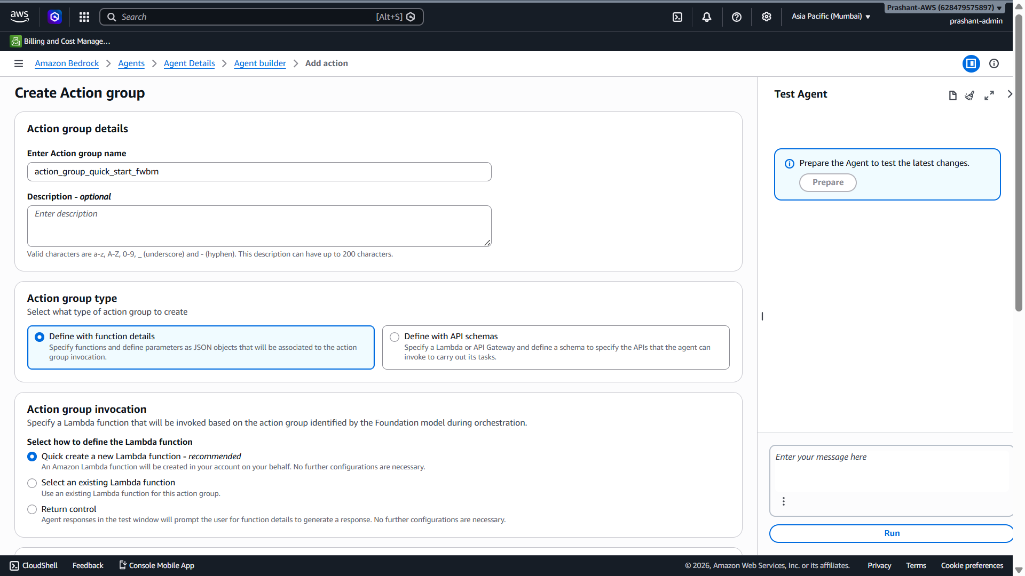
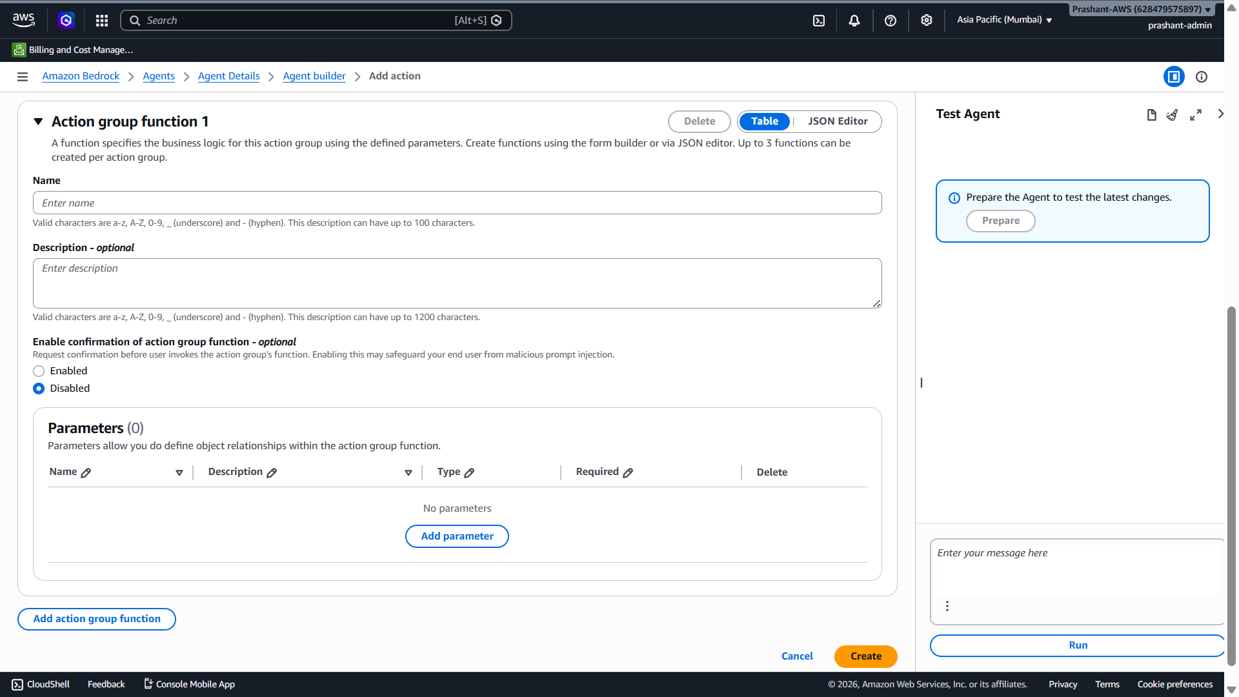

Perfect bhai ✅ Aap Create Action group screen par ho. Abhi hum pehla read-only tool banayenge:
get_ticket_status(ticket_id)
Escalation tool baad mein add karenge, kyunki escalation write action hai aur usme confirmation/authorization explain karna better rahega.
Action Group ka role hota hai agent ko external actions/tools dena, usually Lambda/API business logic ke through. [repost.aws]

Is screen par exact kya fill karna hai?

1. Action group details

Action group name
Current auto name ko replace karo:
it_ticket_actions

Description
Tools for IT ticket status check and support workflow actions.

2. Action group type
Selected rehne do:
Define with function details
✅ Ye simple demo ke liye best hai. Isme hum directly function name + parameters define karte hain.

3. Action group invocation
Selected rehne do:
Quick create a new Lambda function - recommended
✅ Isse Bedrock ek Lambda create karega. Baad mein hum us Lambda mein mock logic add karenge.

Action group function 1

Name
get_ticket_status

Description
Get IT ticket status, assigned team, priority, and ticket age in days for a given ticket ID.

Enable confirmation
For this function:
Disabled
✅ Kyunki ticket status check read-only action hai. Confirmation write actions ke liye useful hota hai, jaise escalation/update/delete.

Parameters section
Click karo:
Add parameter
Fill:

Parameter name
ticket_id

Description
IT ticket ID such as INC123.

Type
String

Required
Yes / checked

Final summary before Create
Screen par ye hona chahiye:
Action group name: it_ticket_actions
Description: Tools for IT ticket status check and support workflow actions.

Action group type: Define with function details
Invocation: Quick create a new Lambda function

Function name: get_ticket_status
Function description: Get IT ticket status, assigned team, priority, and ticket age in days for a given ticket ID.
Confirmation: Disabled

Parameter:
ticket_id | String | Required
Phir bottom-right:
Create
click karo.

Interview mein isko kaise explain karna hai?
Aap bol sakte ho:
“I created an Action Group for IT ticket operations. The first function is get_ticket_status, which accepts a ticket_id parameter. Since it is a read-only action, confirmation is disabled. The Action Group is backed by Lambda, where the actual ServiceNow/Jira integration or mock business logic runs.”

Current actionable step
Bhai abhi sirf:
Fill above fields → Add parameter ticket_id → Create
``
Create ke baad screenshot bhej do.

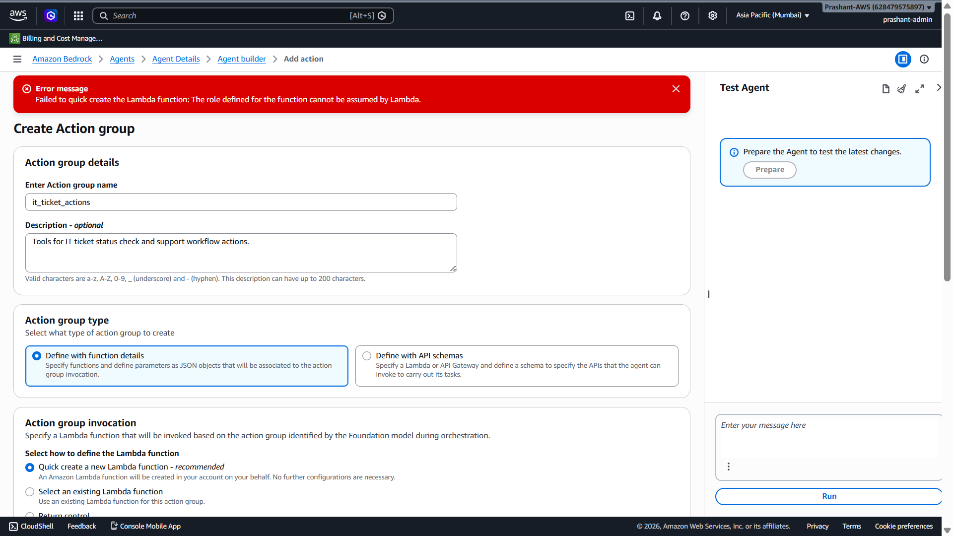

Bhai screenshot mein error clear hai:
Failed to quick create the Lambda function:
The role defined for the function cannot be assumed by Lambda.

Iska simple meaning
AWS Bedrock ne Quick create Lambda try kiya, but jo Lambda execution role ban/assign ho raha tha uski trust relationship Lambda service ke saath correct nahi bani.
Lambda function ko run hone ke liye IAM role chahiye jisme trust policy hoti hai:
lambda.amazonaws.com can assume this role
Agar yeh trust missing/blocked ho, toh Lambda create fail ho jaata hai. Action Group Lambda ya Return Control executor use kar sakta hai; Lambda executor mein business logic Lambda function mein hota hai, aur Return Control mein Lambda ki zaroorat nahi hoti. [repost.aws]

Fastest Fix for Our Demo: Return control use karo
Bhai abhi humara target hai:
End-to-end agent flow samajhna
BedrockChain/LangGraph/MCP later connect karnaBedrock Agent + KB + Action Group concept explain karna
IAM/Lambda trust policy mein abhi time waste nahi karte.

Abhi kya change karo?
Screenshot mein Action group invocation section mein currently selected hai:
Quick create a new Lambda function
Isko change karo:
Return control
Return control se Lambda create nahi hogi, isliye IAM role error avoid ho jaayega.

Kya Return control production-grade hai?
Interview mein distinction aise bolna:
“For quick demo, I used Return Control to validate the agent tool-calling flow without creating Lambda. In production, the same Action Group would be backed by Lambda or API Gateway integration calling ServiceNow/Jira APIs.”
Production flow:
Bedrock Agent
→ Action Group
→ Lambda Agent→ Lambda
→ ServiceNow/Jira API
Demo flow:
Bedrock Agent
→ Action Group
→ Return Control
→ App/Test layer handles tool response

Abhi exact steps

1. Action group details same rakho
Action group name: it_ticket_actions
Description: Tools for IT ticket status check and support workflow actions.

2. Action group type same rakho
Define with function details

3. Action group invocation change karo
Select:
Return control

4. Function details same rakho
Function name: get_ticket_status
Description: Get IT ticket status, assigned team, priority, and ticket age in days for a given ticket ID.
Parameter:
ticket_id | String | Required

5. Create click karo

Interview-ready explanation for this error
Aap bol sakte ho:
“While creating the Action Group, quick Lambda creation failed due to Lambda execution role trust relationship. The Lambda service must be able to assume the execution role. For demo speed, I used Return Control to validate tool-calling flow without Lambda. In production, I would create a dedicated Lambda execution role with correct trust policy, attach CloudWatch logging permissions and business API permissions, then select that Lambda in the Action Group.”

Current actionable step
Bhai abhi sirf:
Action group invocation → Return control select karo
→ Create click karo
Create successful ho jaaye toh screenshot bhej do.

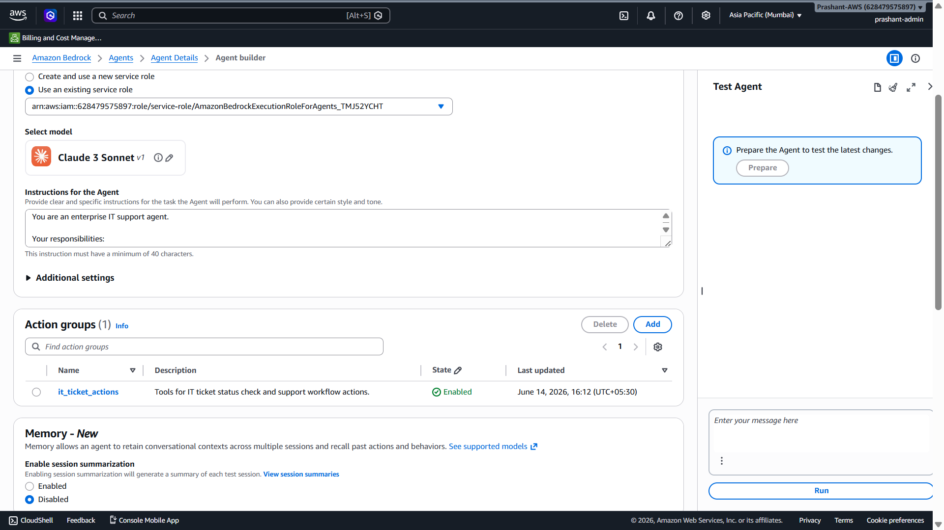

Nahi bhai — LangChain / LangGraph / MCP banane ke liye AWS Bedrock Agent create karna pehle mandatory nahi hota.
Ye do alag approaches hain:

1. Bedrock Agent approach — AWS Console managed agent
Jo aap abhi bana rahe ho:
Bedrock Agent
→ Knowledge Base
→ Action Group
→ Prepare→ Alias/Deploy→ Prepare
→ Test
Isme AWS Bedrock Agent khud orchestration karta hai:
User queryUser query use kare
→ Action Group call kare
→ Final response de
→ Agent decides
Is approach mein LangChain/LangGraph mandatory nahi hain.
Aapka current screenshot shows:
Action groups (1): it_ticket_actions
State: Enabled
Knowledge Base already attached
Model: Claude 3 Sonnet
Prepare required
Matlab Bedrock Agent wala managed flow almost ready hai.

2. LangChain / LangGraph / MCP approach — custom code-based agent
Isme AWS Bedrock Agent banana zaroori nahi hota.
Architecture aisi hoti hai:
React UI / API Gateway
↓
Lambda / ECS / FastAPI backend
↓
LangGraph Orchestrator
↓
LangChain RAG Chain
↓
MCP Tool Server
↓
Amazon Bedrock LLM
↓
Vector DB / APIs / ServiceNow / Jira
Yahan:
LangChain = RAG, prompt, retriever, tools
LangGraph = workflow control: nodes, edges, state, approval
MCP = external tools expose karne ka standard protocol
Bedrock = LLM provider, jaise Claude/Nova/Titan
Is architecture mein aap Bedrock Agent service use nahi karte. Aap Bedrock model APIs use karte ho.

3. Toh hum dono kyun kar rahe hain?
Bhai interview ke liye dono ka relation samajhna zaroori hai.
Hum abhi Bedrock Console UI se managed Agent bana rahe hain because:
- Fast demo ban jaata hai
- Console UI fields samajh aati hain
- Knowledge Base + Action Group ka managed flow clear hota hai
- Interview mein AWS-native Agentic AI confidently explain kar paoge
Baad mein same use case ko explain karenge:
Agar mujhe zyada custom control chahiye hota,
toh main LangGraph orchestration use karta.
LangChain RAG/tool layer ke liye use karta.
MCP external enterprise tools standardize karne ke liye use karta.

4. Interview mein best answer
Agar interviewer pooche:
“Do we need to create Bedrock Agent before using LangChain or LangGraph?”
Aap bolo:
“No, Bedrock Agent is not mandatory for LangChain or LangGraph. Bedrock Agent is AWS-managed agent orchestration where we configure instructions, Knowledge Bases, Action Groups and Guardrails through AWS Console or API. LangChain and LangGraph are code-level frameworks used in a custom application layer. LangChain helps build RAG and tool-calling chains, while LangGraph gives fine-grained stateful orchestration using nodes, edges, routing, retries and human approval. In both cases, Amazon Bedrock can still be used as the underlying LLM provider.”

5. Simple comparison
Bedrock Agent:
AWS managed, console/API based, less custom code, fast enterprise demo.

LangChain:
Code framework for RAG, prompt templates, retrievers, tools and output parsing.

LangGraph:
Code framework for controlled agent workflow with state, branching and approval.

MCP:
Protocol to expose enterprise tools/data sources to agents in a standard way.

6. Aapke project mein kaise bolna hai?
Aapka current demo story:
Phase 1:
Built AWS-native Agentic AI using Bedrock Agent, Knowledge Base and Action Group.

Phase 2:
For advanced customization, the same flow can be implemented using LangChain, LangGraph and MCP.

LangChain:
RAG and tool composition

LangGraph:
Controlled workflow orchestration

MCP:
Standardized tool integration with ServiceNow/Jira/DB APIs

Current actionable step
Bhai abhi screenshot ke hisaab se Action Group successfully enabled ho gaya hai, so ab next step hai:
Prepare
Click karo Prepare button, kyunki Agent ko latest Knowledge Base + Action Group changes ke saath test-ready banana hai.

Haan bhai, Prepare disabled hai toh most likely reason hai: Agent changes abhi Save nahi hue hain.
AWS Bedrock Agent Builder mein usually sequence hota hai:
Add/Update configuration
→ Save
→ Prepare button enable hota hai
→ Prepare
→ Test
Aapke screenshot mein top par Save button visible hai, aur right side panel mein “Prepare the Agent…” box bhi dikh raha hai, but Prepare disabled/grey ho sakta hai because latest changes save/validated nahi hue.

Abhi kya karo — current step only

Step 1: Top bar mein Save click karo
Save
Click karne ke baad wait karo jab tak green success message na aa jaaye:
Agent successfully updated

Step 2: Save ke baad check karo
Save ke baad Prepare button active ho jaana chahiye.
Phir click karna:
Prepare

Agar Save ke baad bhi Prepare disabled rahe
Tab yeh 3 cheezein check karni hain:

1. Agent instruction complete hai ya nahi
Instruction minimum 40 characters honi chahiye. Aapki instruction box mein text hai, so likely okay.

2. Knowledge Base attached hai ya nahi
Aapke previous screenshot se KB added tha:
it-support-policy-kb
So likely okay.

3. Action Group function valid hai ya nahi
Action Group added dikh raha hai:
it_ticket_actions
State: Enabled
Agar Action Group ke andar function/parameter incomplete hota, toh Save/Prepare issue aa sakta hai. But screenshot mein State enabled hai, toh likely okay.

Important: Test Agent box mein Run abhi mat karo
Jab tak agent prepared nahi hota, right side Test Agent mein run karne se old config ya error aa sakta hai.
Correct sequence:
Save
→ Prepare
→ Test

Interview note
Aap interview mein bol sakte ho:
“After attaching Knowledge Base and Action Group to the Bedrock Agent, I saved the agent configuration and prepared the agent. Prepare creates the latest runnable version of the agent configuration for testing and deployment.”

Current actionable step
Bhai abhi sirf:
Top bar → Save click karo
Save ke baad batao Prepare active hua ya nahi.

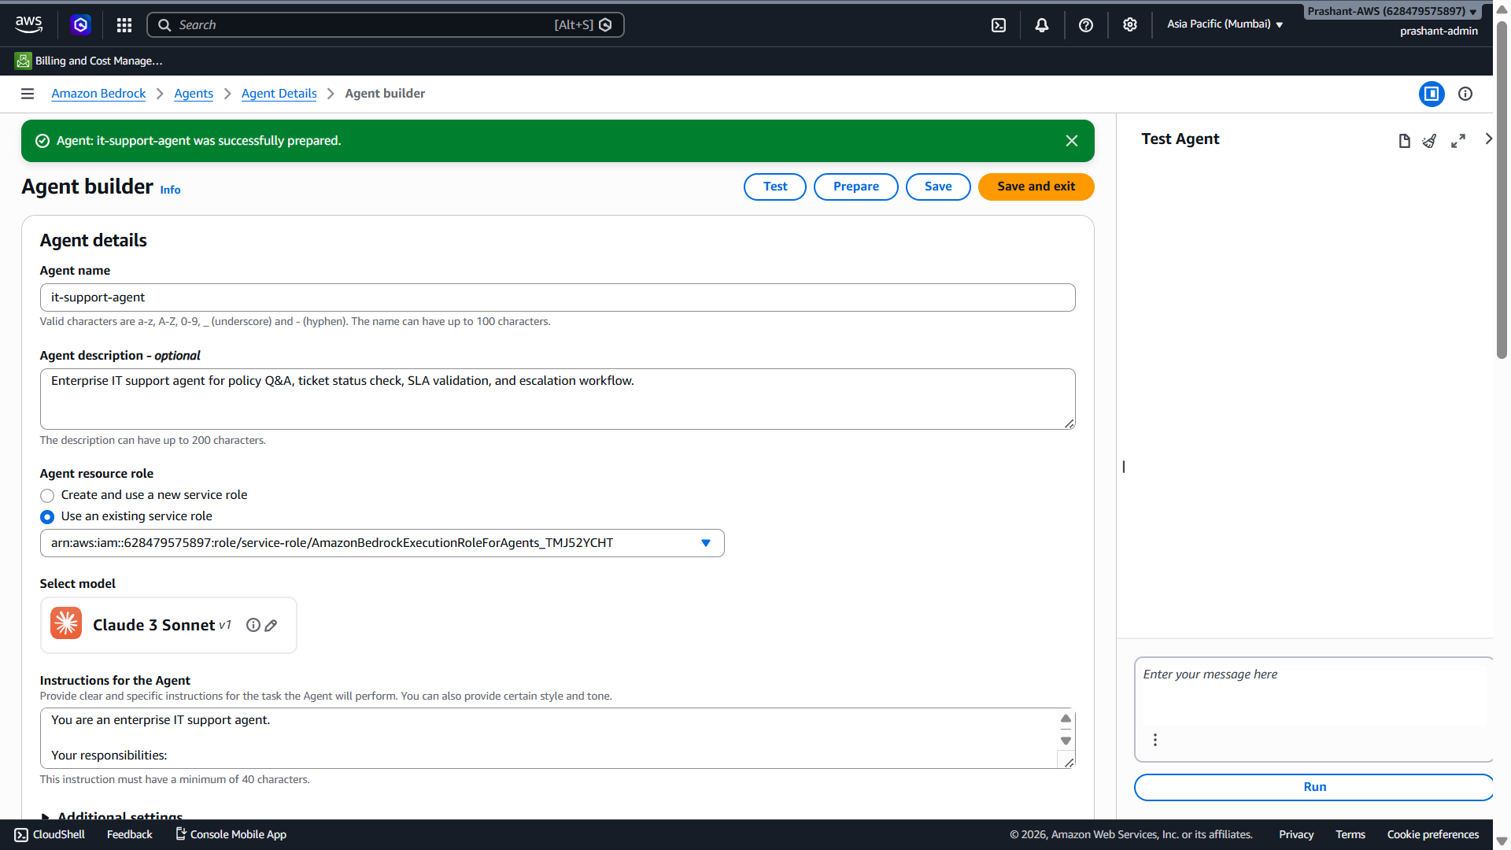

Perfect bhai ✅ Screenshot se confirm hai:
Agent: it-support-agent successfully prepared.
Matlab latest configuration agent ke andar ready ho gayi:
Agent instructions ✅
Knowledge Base attached ✅
Action Group attached ✅
Agent prepared ✅
Ab Prepare dobara click mat karo. Prepare button visible rehna normal hai, but green message confirm kar raha hai ki agent prepared hai.

Ab next kya karna hai?
Right side Test Agent panel mein ab ek single minimal test karte hain, taaki cost control rahe.

Test query run karo
Prompt box mein ye type karo:
What is the laptop replacement SLA?
Phir:
Run
Expected answer:
The laptop replacement SLA is 7 business days from the ticket creation date.
Isse validate hoga ki:
Bedrock Agent
→ Knowledge Base
→ RAG retrieval
→ Claude response
working hai.

Abhi Action Group test mat karo
Action Group query jaise:
Check status for ticket INC123
abhi mat run karo, kyunki humne Action Group mein Return control use kiya hai. Uska output thoda different aayega — agent tool/function call request karega, actual Lambda response nahi milega. Woh next step mein explain karenge.

Interview note
Aap bol sakte ho:
“After attaching Knowledge Base and Action Group, I prepared the Bedrock Agent. Prepare makes the latest agent configuration available for testing. I first validated the RAG path with a policy question, and then separately validated the tool-calling path through the Action Group.”

Current actionable step
Bhai abhi sirf one query run karo:
What is the laptop replacement SLA?
Output screenshot bhej do.

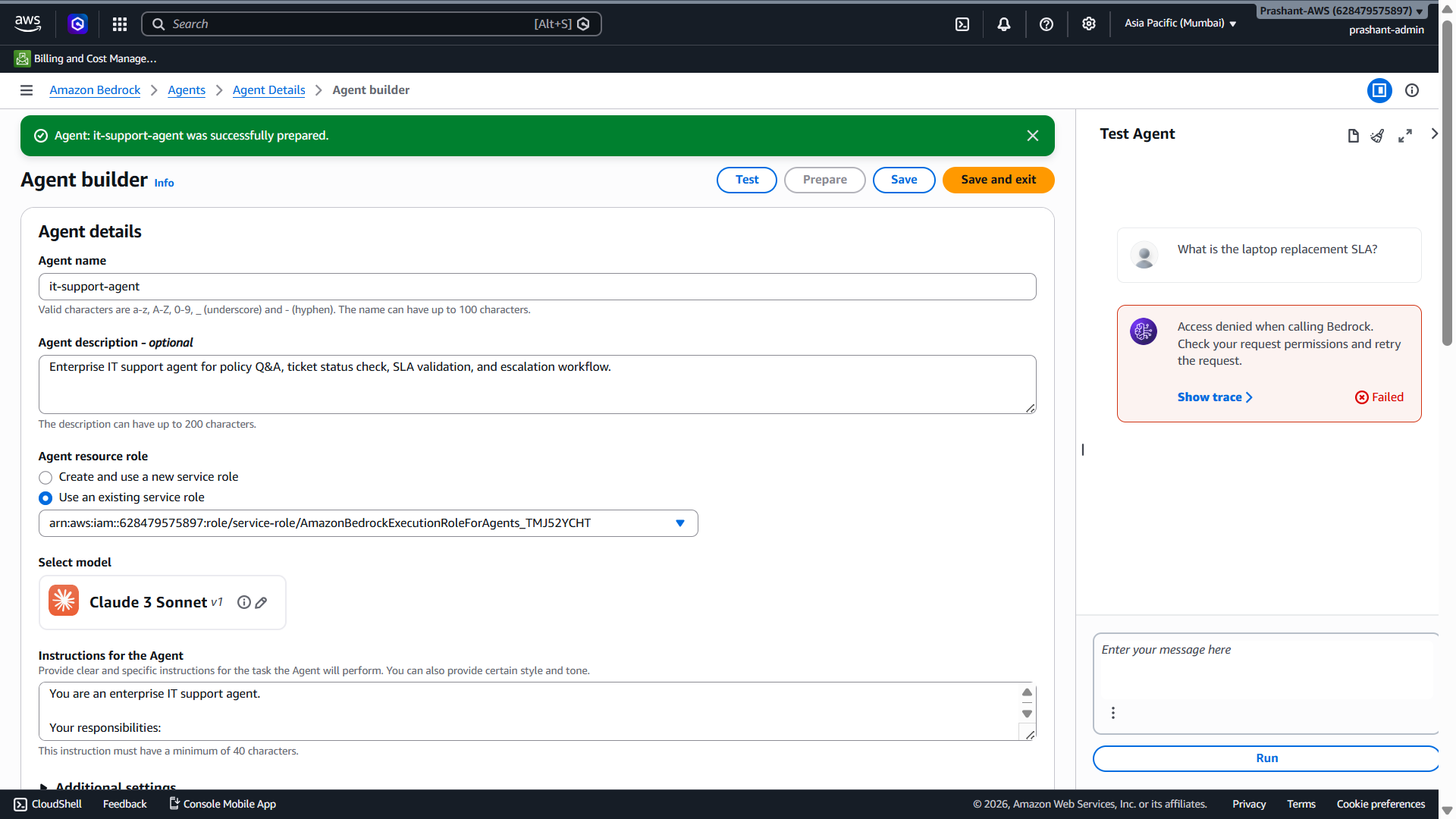

Bhai screenshot se issue clear hai ✅
Right side Test Agent mein error aa raha hai:
Access denied when calling Bedrock.
Check your request permissions and retry the request.
Aur left side mein selected model hai:
Claude 3 Sonnet v1

Root cause likely kya hai?
Yeh Knowledge Base ya Action Group issue nahi hai.
Most likely issue hai:
Claude 3 Sonnet model access enabled nahi hai
ya Agent execution role ko Claude model invoke permission nahi mil rahi
Aapne Knowledge Base test mein Nova Lite use kiya tha aur woh chal gaya tha. Ab Agent mein Claude 3 Sonnet selected hai, isliye Access Denied aa raha hai.

Fastest Fix — Model change karo
Abhi cost-safe aur fast demo ke liye Claude 3 Sonnet ko Amazon Nova Lite se replace karo.

Steps
- Left side mein model ke paas pencil/edit icon dikh raha hai:
Claude 3 Sonnet v1 → pencil icon
- Us par click karo.
- Model selection mein choose karo:
Amazon → Nova Lite
- Apply karo.
- Top par:
Save
- Phir:
Prepare
- Phir sirf ek test query run karo:
What is the laptop replacement SLA?

Agar Claude hi use karna ho
Agar aap Claude use karna chahte ho, toh Bedrock mein model access enable karna padega:
Amazon Bedrock
→ Model catalog / Model access
→ Anthropic
→ Claude 3 Sonnet
→ Request/Enable access
Aur ensure karna hoga ki agent execution role ke paas model invoke permissions ho.
But abhi interview demo ke liye Nova Lite best hai.

Interview explanation
Aap interview mein bol sakte ho:
“While testing the Bedrock Agent, I got an access denied error because the selected foundation model did not have required model access/permissions. I resolved it by either enabling model access for that provider model or switching to an already-approved AWS-native model such as Amazon Nova Lite. This shows that in Bedrock, model selection is not only a design choice but also depends on account-level model access and IAM permissions.”

Current actionable step
Bhai abhi sirf:
Claude 3 Sonnet pencil/edit icon → select Amazon Nova Lite → Apply → Save → Prepare
Phir query run karna.

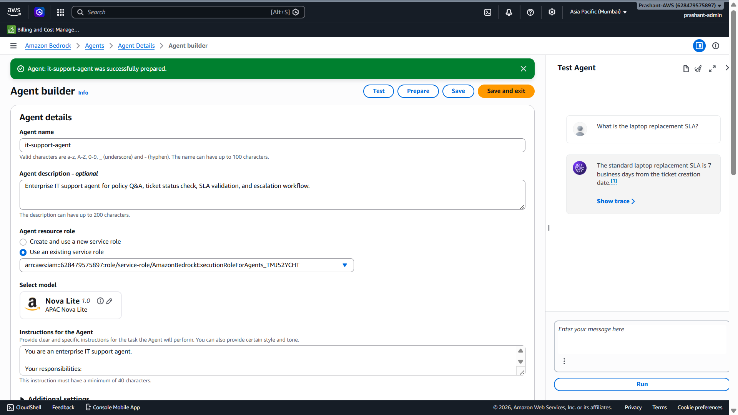

Excellent bhai ✅ **Agent RAG path working ho gaya.**

Screenshot se confirm hai:

```text
Agent: it-support-agent
Model: Nova Lite 1.0
Query: What is the laptop replacement SLA?
Answer: The standard laptop replacement SLA is 7 business days from the ticket creation date. [1]
Status: Success
```

Matlab humne successfully prove kar diya:

```text
Bedrock Agent
→ Knowledge Base attached
→ Agent used RAG
→ Source citation returned
→ Nova Lite response generated
```

***

## Abhi kya complete ho chuka hai?

### 1. S3 source document ✅

```text
it-support-policy-demo.txt
```

### 2. Bedrock Knowledge Base ✅

```text
it-support-policy-kb
```

### 3. Embedding + vector store ✅

```text
Titan Text Embeddings v2
Amazon S3 Vectors
```

### 4. Bedrock Agent ✅

```text
it-support-agent
```

### 5. Knowledge Base attached to Agent ✅

Agent policy questions answer kar raha hai.

### 6. Action Group added ✅

```text
it_ticket_actions
```

Tool-calling capability add ho gayi hai, but abhi actual tool response test nahi kiya.

***

# Screenshot ka citation `[1]` kya show kar raha hai?

Answer ke end mein `[1]` citation hai:

```text
The standard laptop replacement SLA is 7 business days from the ticket creation date. [1]
```

Iska matlab Agent ne answer Knowledge Base ke source chunk se generate kiya, model ne apni memory se guess nahi kiya.

Interview line:

> “The citation proves that the Bedrock Agent generated a grounded answer from the Knowledge Base source document, not from the model’s general knowledge.”

***

# Abhi next step kya hai?

Next step logically hai:

```text
Action Group / Tool calling path validate karna
```

Lekin cost control ke liye aur because `Return control` use kiya hai, hume carefully ek hi test karna chahiye.

Action Group query hogi:

```text
Check status for ticket INC123
```

Expected behavior:

```text
Agent should identify get_ticket_status action
Agent should ask/trigger function with ticket_id = INC123
Because we used Return control, actual Lambda execution nahi hogi
Console may show function invocation/control response requirement
```

***

## Important: Return control ka meaning

Aapne Lambda quick create error ke baad **Return control** use kiya tha. Iska matlab:

```text
Agent tool/function identify karega
But actual business logic Lambda mein execute nahi hogi
Control application/test layer ko return ho jaayega
```

Production mein yeh hota:

```text
Agent → Action Group → Lambda → ServiceNow/Jira → ticket status response
```

Demo mein abhi:

```text
Agent → Action Group → Return control → tool call intent visible
```

***

# Interview mein ab tak ka full pitch

Aap bol sakte ho:

> “I built an AWS-native enterprise IT support agent using Amazon Bedrock. First, I uploaded an IT support policy document to S3 and created a Bedrock Knowledge Base using Titan Text Embeddings v2 and Amazon S3 Vectors. After syncing the data source, the Knowledge Base was able to retrieve policy chunks with citations.
>
> Then I created a Bedrock Agent named `it-support-agent`, attached the Knowledge Base, added clear enterprise instructions, and prepared the agent. I tested a policy query — ‘What is the laptop replacement SLA?’ — and the agent correctly returned ‘7 business days from the ticket creation date’ with a source citation.
>
> I also added an Action Group named `it_ticket_actions` for ticket workflow actions like `get_ticket_status`. For the demo, I used Return Control because Lambda quick-create had an IAM trust issue. In production, I would back the Action Group with a Lambda function integrated with ServiceNow or Jira.”

***

## Current actionable step

Bhai abhi **agar aap cost-safe rehna chahte ho**, yahin stop kar sakte hain — RAG + Agent integration proven hai.

Agar ek final Action Group test karna hai, toh sirf ek query run karo:

```text
Check status for ticket INC123
```

Agar run karoge toh screenshot bhejna. Main bata dunga Action Group invoke hua ya nahi.

Perfect bhai ✅ Action Group invoke ho gaya — screenshot se confirm hai.
Right side Test Agent panel mein dikh raha hai:
Provide action group output

Function:
get_ticket_status({"ticket_id":"INC123"})

Action group:
it_ticket_actions
Iska matlab Agent ne user query samjhi:
Check status for ticket INC123
Aur correctly decide kiya ki:
Knowledge Base nahi, Action Group function call karna hai
Function: get_ticket_status
Parameter: ticket_id = INC123
Yeh Agentic AI tool-calling path successfully trigger ho gaya ✅

Abhi text box mein kya paste karna hai?
Kyuki humne Return control use kiya hai, Bedrock khud Lambda execute nahi karega. Console aapse tool ka mock output maang raha hai.
Is box mein yeh JSON paste karo:
{
"ticket_id": "INC123",
"status": "Pending with Hardware Team",
"priority": "P2",
"assigned_team": "Hardware Support",
"age_days": 10,
"next_action": "Eligible for SLA escalation"
}
Phir:
Submit
click karo.

Submit ke baad expected response
Agent ideally response dega:
Ticket INC123 is pending with the Hardware Support team.
Priority is P2 and the ticket age is 10 days.
Based on the policy, laptop replacement tickets unresolved for more than 7 business days qualify for escalation.
Agar agent exact policy combine karega toh yeh prove hoga:
Action Group output + Knowledge Base policy reasoning

Iska interview meaning
Aap interview mein confidently bol sakte ho:
“I tested the Action Group path by asking the agent to check status for ticket INC123. The agent correctly selected the get_ticket_status function and extracted ticket_id as the parameter. Since I used Return Control for demo, the console asked me to provide the tool output manually. In production, this output would come from a Lambda function integrated with ServiceNow or Jira.”

Return Control vs Lambda — simple explanation
Return Control:
Agent identifies the tool/function and returns control to the caller to provide function output manually or from application code.

Lambda:
Agent invokes Lambda directly, Lambda calls backend systems like ServiceNow/Jira, and returns output automatically.
For demo, Return Control is fine. For production, Lambda/API integration is better.

Current actionable step
Bhai abhi sirf JSON paste karo:
{
"ticket_id": "INC123",
"status": "Pending with Hardware Team",
"priority": "P2",
"assigned_team": "Hardware Support",
"age_days": 10,
"next_action": "Eligible for SLA escalation"
}
Then Submit click karo and output screenshot bhej do.
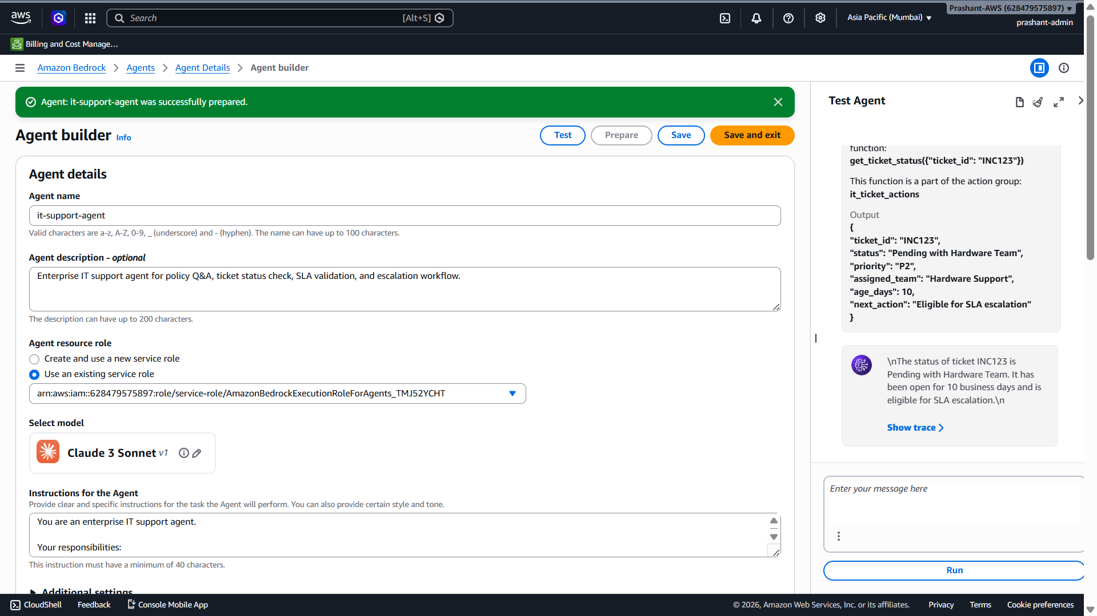

Perfect bhai ✅ Action Group flow bhi successfully prove ho gaya.
Screenshot mein clearly dikh raha hai:
Function called:
get_ticket_status({"ticket_id":"INC123"})

Action group:
it_ticket_actions
Aur aapne jo mock output diya tha, agent ne use karke final response generate kiya:
The status of ticket INC123 is Pending with Hardware Team.
It has been open for 10 business days and is eligible for SLA escalation.
Matlab humara end-to-end Bedrock Agentic AI demo working hai ✅

Ab kya-kya prove ho gaya?

1. RAG path working
Query:
What is the laptop replacement SLA?
Agent ne Knowledge Base use kiya aur answer diya:
7 business days from ticket creation date

2. Tool-calling path working
Query:
Check status for ticket INC123
Agent ne Action Group function choose kiya:
get_ticket_status(ticket_id="INC123")

3. Return Control working
Kyuki humne Lambda nahi lagaya, console ne tool output manually maanga.
Aapne output diya:
{
"ticket_id": "INC123",
"status": "Pending with Hardware Team",
"priority": "P2",
"assigned_team": "Hardware Support",
"age_days": 10,
"next_action": "Eligible for SLA escalation"
}
Agent ne us output ko final business response mein convert kar diya.

Screenshot mein \n kyun aa raha hai?
Response mein dikh raha hai:
\nThe status of ticket...
\n
Yeh formatting escape characters hain. Normally application UI mein isko clean render kar dete hain. Production React UI ya backend response formatter mein newline properly handle karenge.
Interview mein bol sakte ho:
“In console test, the response showed newline escape characters, but in production UI we would format the final response properly before displaying it to the user.”

Interview-ready explanation
Aap yeh bol sakte ho:
“I created a Bedrock Agent with two capabilities. First, RAG capability using a Bedrock Knowledge Base connected to an S3 policy document. Second, tool-calling capability using an Action Group.
For policy questions, the agent retrieved information from the Knowledge Base and returned grounded answers with citations. For operational questions like ticket status, the agent selected the get_ticket_status action group function and extracted the ticket ID parameter.
In the demo, I used Return Control instead of Lambda, so the console asked me to provide mock tool output. In production, this Action Group would be backed by Lambda calling ServiceNow or Jira APIs. The agent then combined the tool output with policy context to return a business-friendly answer.”

Production version ka flow
User:
Check status for ticketBedrock Agent:Check status for ticket INC123
Understands intent = ticket status

Action Group:
Calls get_ticket_status(ticket_id)

Lambda:
Calls ServiceNow/Jira API

API response:
Ticket status, assigned team, priority, age

Agent:
Generates final answer

User:
Gets ticket status and escalation recommendation

Ab cost control
Bhai ab aur test query mat run karo ✅
Humne dono important paths prove kar diye:
RAG path ✅
Action Group path ✅
Abhi console mein:
Save and exit
click kar sakte ho.

Current actionable step
Abhi sirf Save and exit click karo.
Next mein hum isi completed demo ka LangChain + LangGraph + MCP mapping banayenge, jisse aap interview mein bol paoge:
AWS Bedrock Agent version kaise bana
Aur same flow LangChain/LangGraph/MCP mein kaise implement hota

Bhai short answer: jo humne abhi banaya hai, usko “as-is production” mein deploy nahi karna chahiye.
Lekin yeh production architecture ka valid POC/foundation hai. Production ke liye kuch missing controls aur integrations add karne padenge.

Current demo ka production readiness status
Humne abhi successfully prove kiya:
S3 Policy Document ✅S3eddings + S3 Vectors ✅
Bedrock Agent ✅
Knowledge Base attached to Agent ✅
Action Group created ✅
Return Control tool-calling flow ✅
Agent prepared and tested ✅
Bedrock Knowledge Base ✅
Yeh interview/demo ke liye strong hai, but production ke liye abhi incomplete hai.

Production mein kya-kya change/add karna padega?

1. Return Control ko Lambda/API integration se replace karna hoga
Abhi Action Group mein humne Return Control use kiya. Iska matlab tool output manually/application layer se diya ja raha hai.
Production mein yeh hona chahiye:
Bedrock Agent
→ Action Group
→ Lambda
→ ServiceNow/Jira API
→ Ticket status/escalation response
→ Agent final response
Action Group ka actual purpose agent ko APIs/business logic call karwana hota hai, commonly Lambda executor ke through. [repost.aws]
Production gap: abhi real ServiceNow/Jira Lambda nahi hai.

2. Agent Alias create karke deploy karna hoga
Production mein direct draft agent use nahi karte. Flow hota hai:
Agent configuration
→ Prepare
→ Create alias
→ Use alias ID from backend/app
Alias se versioned deployment possible hota hai:
dev alias
test alias
prod alias
Production gap: abhi hum console test mode mein hain, deployed app integration nahi hai.

3. Authentication and authorization add karna hoga
Production mein user identity check karni padegi:
Who is the user?
Is user allowed to check this ticket?
Is user allowed to escalate this ticket?
Can user see this policy?
Possible services:
Cognito / Okta / Enterprise SSO
IAM roles
Application RBAC
JWT token validation
Production gap: abhi user authentication/authorization nahi hai.

4. Guardrails and PII protection add karna hoga
Production mein agent ko PII expose nahi karni chahiye:
Mobile number
Personal email
Aadhaar
PAN
Salary
Home address
Confidential employee records
Bedrock Guardrails RAG/Knowledge Base applications ke saath harmful content filtering aur sensitive information protection ke liye use ho sakte hain. [towardsaws.com]
Production gap: abhi guardrail configured nahi hai.

5. CloudWatch logging and monitoring add karna hoga
Production mein monitor karna hoga:
Agent invocation count
Lambda errors
Action group failures
Bedrock model errors
Latency
Token usage
Cost
Failed retrievals
Guardrail blocks
Production gap: abhi proper CloudWatch dashboards/alarms nahi hain.

6. S3 and Knowledge Base data governance
Production source documents ke liye:
S3 versioning enabled
SSE-KMS encryption
Bucket policy
No public access
Document approval workflow
Sync schedule
Data retention
Backup strategy
AWS Backup for S3 centralized backup/restore provide karta hai, aur S3 backups ke liye S3 Versioning required hoti hai. [medium.com]
Production gap: versioning humne enable kiya hai, but backup plan/KMS/data lifecycle abhi nahi banaya.

7. CI/CD and Infrastructure as Code
Production mein console se manual create karna ideal nahi hota. Better:
Terraform / CDK
GitHub Actions / Jenkins
dev → stage → prod promotion
approval gates
rollback strategy
Production gap: abhi manual console setup hai.

Toh production deploy ka final architecture kaisa hoga?
React / Enterprise Portal
↓
Bedrock AgentCognito / Okta Authentication
├── Knowledge Base for RAG
├── Action Group → Lambda → ServiceNow/Jira
└── Guardrails
↓
CloudWatch Logs + Metrics + Alarms
↓
API Gateway / ALB
↓
Backend Lambda or ECS/Fargate
↓
Invoke Bedrock Agent Alias
↓

Interview mein best answer
Aap bol sakte ho:
“What I built is a working POC of an enterprise Agentic AI flow. It proves both the RAG path and tool-calling path. For production, I would not deploy it as-is. I would replace Return Control with Lambda-backed Action Groups integrated with ServiceNow or Jira, create agent aliases for dev/test/prod, add authentication and RBAC, configure Bedrock Guardrails for PII protection, enable CloudWatch monitoring, use KMS encryption, and deploy infrastructure using Terraform or CDK with CI/CD.”

One-line answer
“Abhi wala setup production POC hai; production deploy ke liye Lambda-backed tools, alias-based deployment, auth/RBAC, guardrails, monitoring, backup, encryption, and IaC/CI-CD add karna hoga.”

Current actionable step
Bhai abhi production ke liye sabse pehla missing piece hai:
Return Control ko real Lambda-backed Action Group se replace karna
Agar aap bolo toh next step mein main production Lambda design explain karunga — bina abhi deploy kiye — jisse aap interview mein confidently bol sako ki ServiceNow/Jira integration kaise hota.

