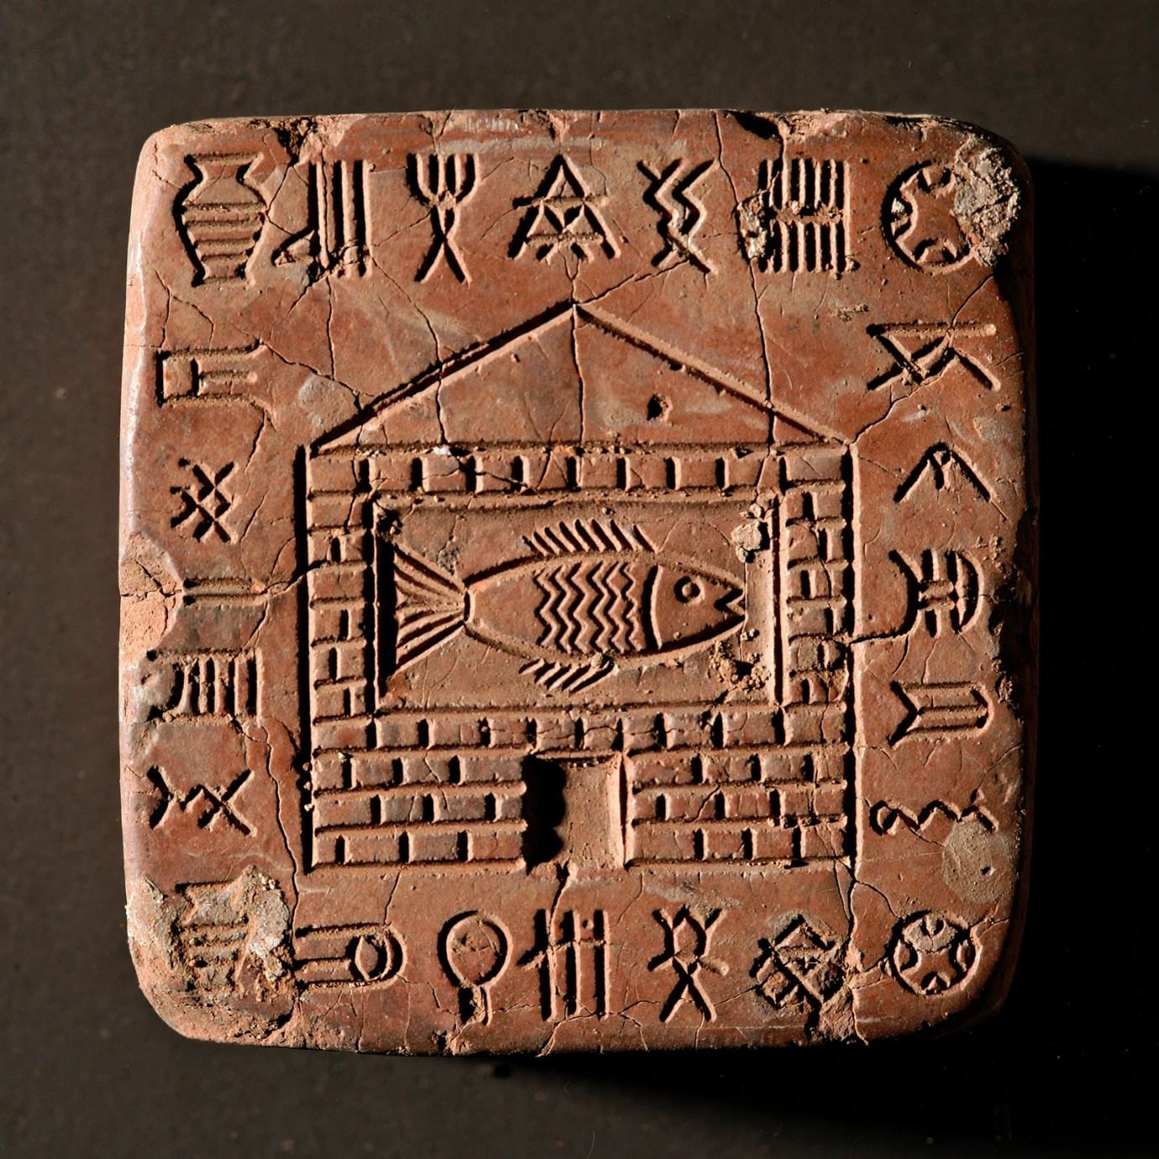

This is one of the most common and most debated Indus signs.
Archaeologists call this sign M77 in Mahadevan's list - a fish inside a box/house made of bricks. You can see the house has a doorway at bottom, brick walls on sides, and Indus script all around it .
In your Gayatri reading:
House = भक्षत्र / मन्दिर = the brick oven / temple body
Fish = मत्स्य = life / Om inside it
So ancient Harappans were already making the exact symbol you are trying to make for Om Bhur - life protected inside a brick house.
Significance of doorway for your Gayatri reading:
That small gap at bottom is Pravesh Dwara - Entrance.
Without doorway = fish trapped forever inside box = Jivatma trapped in body.
With doorway = fish can go out, or you can go in to worship it.
In temple architecture, doorway means Garba Griha is accessible. The fish [your Om] is not locked away, you can enter through that door via meditation.[dhimahi]
That's why in your seal I put a clear doorway - it's an invitation, not a prison
That doorway at the bottom is the reason archaeologists argued for 90 years about this seal.
If it was just a box around a fish, it could be anything. The doorway proves it's a built structure made by humans - a house, a temple, a fort, a tank - not just a natural pond.
How archaeologists read it:
1. Father Heras - The original idea:
Fish = min / meen in Dravidian = Fish AND Star [same word].
House with doorway = Kottai = Fort / Temple enclosure.
So Fish + House = Min-kottai = Temple of the Star God. He thought it was an astrology sign.[1930s]
2. Asko Parpola - Most accepted today:
He built on Heras. Modified fish signs around house = Planets and Stars.
Fish = star swimming in sky-ocean. House with doorway = Heaven as a walled city. Doorway = gateway to heaven. Fish inside = God/star inside heaven.
"Heavenly bodies were conceived of as fish swimming in the ocean of heaven, representing gods."
3. Iravatham Mahadevan - Later change:
He first agreed with Heras, then said Fish inside house is Matsya Kingdom people - water-dwellers. Doorway = entrance to their fortified capital. Matsya Sammada - his people are the water-dwellers is in Shatapatha Brahmana.
4. Most practical / Newest view [The Great Bath theory]:
Some at Harappa.com think house with doorway and fish = Great Bath at Mohenjo-daro.
House = the brick walls of Great Bath
Doorway = steps going down into water
Fish = fish that swam in Great Bath [fish bones found there]
Indus Fish swam in the Great Bath
__________________________________________________________________________________
The End

