JPEG COMPRESSION

ANALYSIS

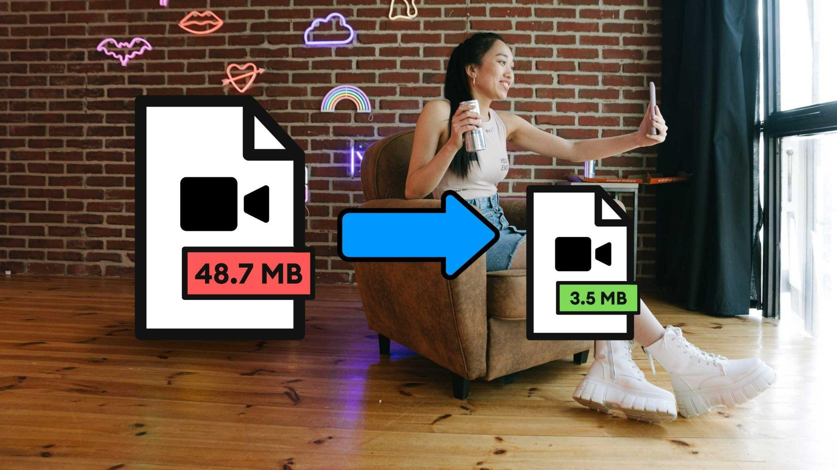

**-PRASHANT SINGH**

**2021CSB1124**

# INTRODUCTION

1. **Color Space Conversion**: The first step in JPEG compression is to convert the image from its original RGB color space to YCbCr color space. This step separates the image into its luminance (Y) and chrominance (Cb and Cr) components.
2. **Dividing the Image into Blocks**: The image is then divided into 8x8 blocks of pixels, and each block is processed independently.
3. **Discrete Cosine Transform (DCT)**: A DCT is applied to each 8x8 block of pixels to transform the spatial domain information into the frequency domain. The DCT essentially separates the image into different frequency components.
4. **Quantization**: The DCT coefficients are quantized by dividing them by a set of quantization values. This step reduces the number of bits required to store the coefficients and is the main reason for the compression.
5. **Compression**: The encoded data is then compressed using various techniques such as run-length encoding, bit-plane coding, and entropy coding.
6. **Decompression**: When the compressed data is received, it is decompressed using the inverse of the compression techniques applied in step 6.
7. **Inverse DCT**: The inverse DCT is applied to the decompressed coefficients to transform them back into the spatial domain.
8. **Color Space Conversion**: The final step is to convert the image back into its original RGB color space.

# ANALYSIS PARAMETERS

1. **Root Mean Squared Error (RMSE)**: It calculates the average difference between the pixel values of the two images. The lower the RMSE, the better the compression algorithm is at preserving the quality of the original image.
2. **Peak Signal-to-Noise Ratio (PSNR)**: PSNR measures the ratio between the maximum pixel value and the RMSE. The higher the PSNR, the better the image quality.
3. **Compression Ratio**: Compression ratio is the ratio of the size of the original image to the size of the compressed image. A higher compression ratio means that the algorithm has compressed the image more effectively, resulting in a smaller file size.

# PSNR Table (considering No. of coefficients sent is default i.e. zeros trimmed)

|  |  |  |
| --- | --- | --- |
| Image Name | Color Image PSNR | Grayscale PSNR |
| kodim01 | 31.84773 | 28.98143 |
| kodim02 | 34.83265 | 31.69771 |
| kodim03 | 36.3536 | 33.08178 |
| kodim04 | 34.94696 | 31.80173 |
| kodim05 | 32.13884 | 29.24635 |
| kodim06 | 33.03795 | 30.06453 |
| kodim07 | 36.02052 | 32.77867 |
| kodim08 | 31.86781 | 28.9997 |
| kodim09 | 35.98811 | 32.74918 |
| kodim10 | 35.69081 | 32.47864 |
| kodim11 | 33.70505 | 30.67159 |
| kodim12 | 35.77897 | 32.55887 |
| kodim13 | 30.75602 | 27.98798 |
| kodim14 | 32.8829 | 29.92344 |
| kodim15 | 35.14479 | 31.98176 |
| kodim16 | 34.54449 | 31.43549 |
| kodim17 | 35.21341 | 32.04421 |
| kodim18 | 32.82501 | 29.87076 |
| kodim19 | 33.84987 | 30.80338 |
| kodim20 | 35.33481 | 32.15468 |
| kodim21 | 33.66305 | 30.63338 |
| kodim22 | 33.76676 | 30.72775 |
| kodim23 | 37.16529 | 33.82041 |
| kodim24 | 33.01645 | 30.04497 |

# AVERAGE PSNR AND COMPRESSION RATIOS (as function of No. of coefficient parameters sent)

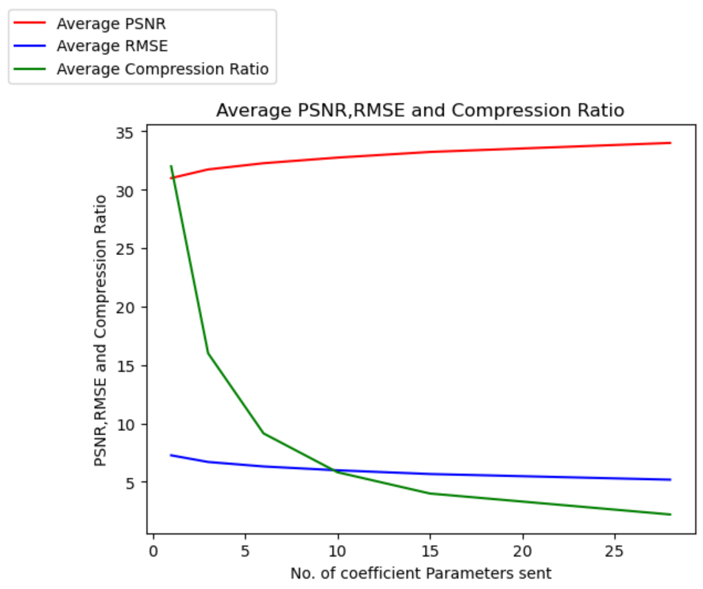

# 

# CONCLUSION

Conclusion JPEG compression is widely used and recognized as a reliable and efficient method for compressing digital images while retaining acceptable image quality. JPEG uses a lossy compression technique that reduces the size of the image file by removing data that is not easily perceptible to the human eye, resulting in a smaller file size without significant loss of image quality.