LZW COMPRESSION

ANALYSIS

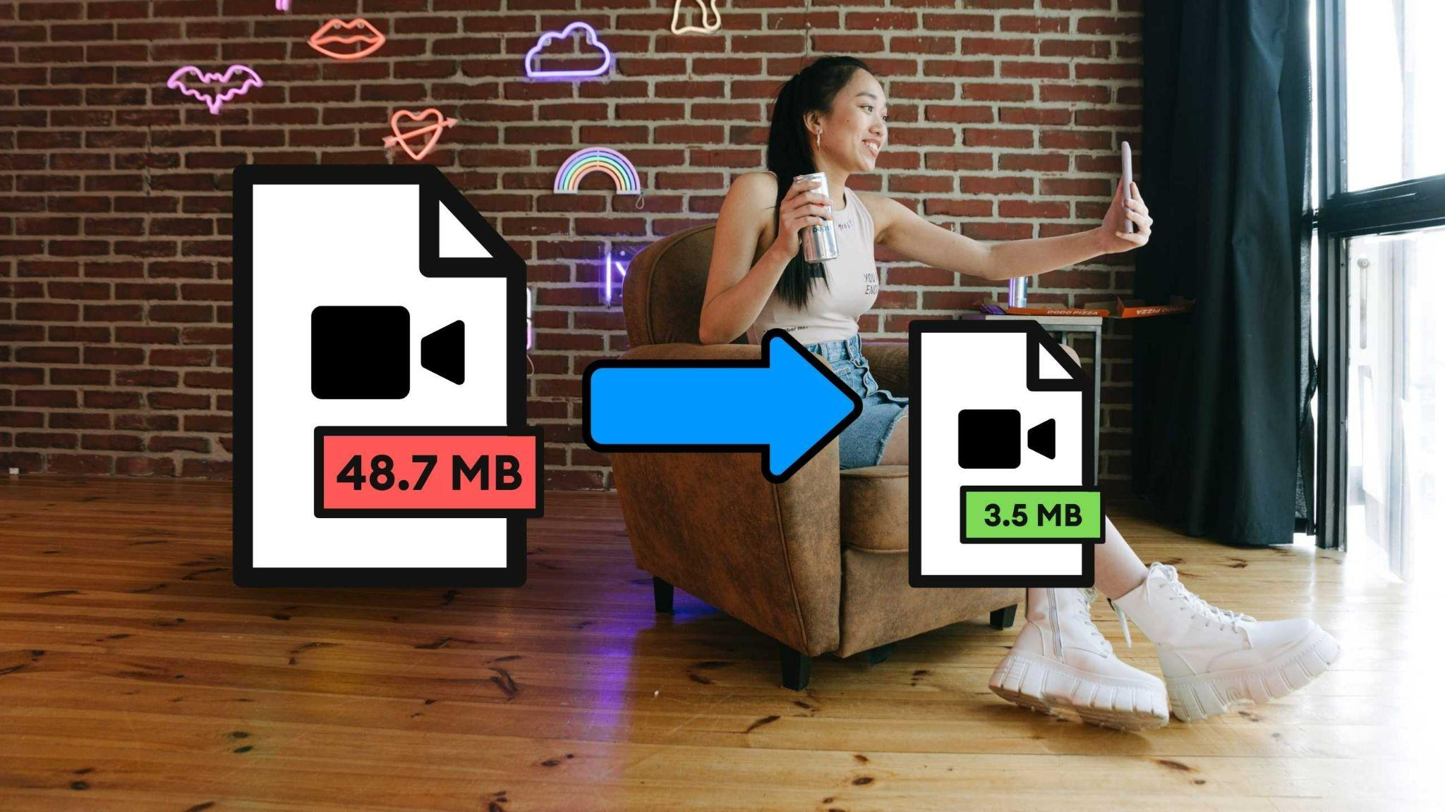

**-PRASHANT SINGH**

**2021CSB1124**

# INTRODUCTION

LZW (Lempel-Ziv-Welch) is a lossless data compression method that was first introduced in 1984. It is a dictionary-based compression algorithm that works by replacing strings of characters with codes that represent those strings.

The basic idea behind LZW is to build a dictionary of frequently occurring patterns of characters in the input data, and then use codes to represent those patterns. During compression, LZW reads in the input data one character at a time and builds up strings of characters that are not yet in the dictionary. When a new string is encountered, LZW adds it to the dictionary and outputs the code for the previously seen string. This process continues until the entire input data has been processed, resulting in a compressed data stream made up of codes.

During decompression, LZW uses the same dictionary to reverse the compression process. It reads in the compressed data stream one code at a time and outputs the corresponding string of characters. As it does this, it builds up its dictionary to include all the strings of characters it encounters, ensuring that it can correctly decode the compressed data.

# ANALYSIS PARAMETERS

1. **Compression Ratio**: Compression ratio is the ratio of the size of the original image to the size of the compressed image. A higher compression ratio means that the algorithm has compressed the image more effectively, resulting in a smaller file size.
2. **Entropy**: Entropy is given by the formula -sum(probability * log2(probability)), where probability is calculated by taking histogram of the image

# COMPRESSION RATIO and ENTROPY

Assumption: 8x8 block size is taken for all images and all the images are treated as grayscale

|  |  |  |
| --- | --- | --- |
| Image Name | Compression Ratio | Entropy |
| checkerboard1024.tif | 3.878787878787879 | 1.0000000000029328 |
| book-cover.tif | 1.65343223239 | 7.425825181235866 |
| Fig81a.tif | 3.0437973154985833 | 1.6613969600765 |
| Fig81b.tif | 1.3333333333333333 | 8.0 |
| Fig81c.tif | 1.2381519161919876 | 1.8134697210283743 |
| fingerprint.tif | 1.89 | 6.567906030152509 |

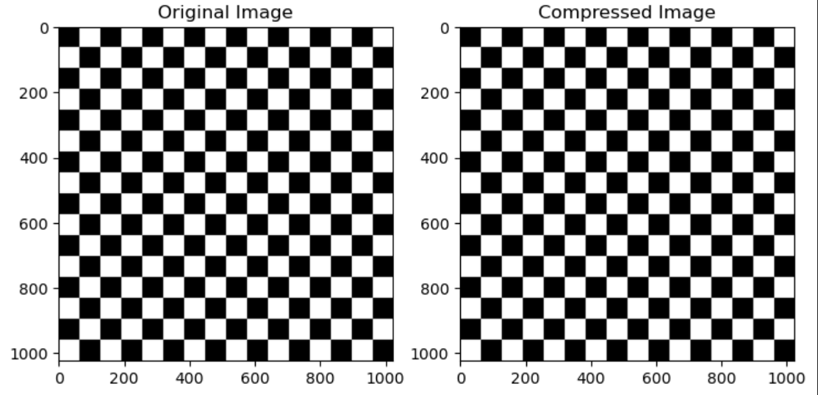

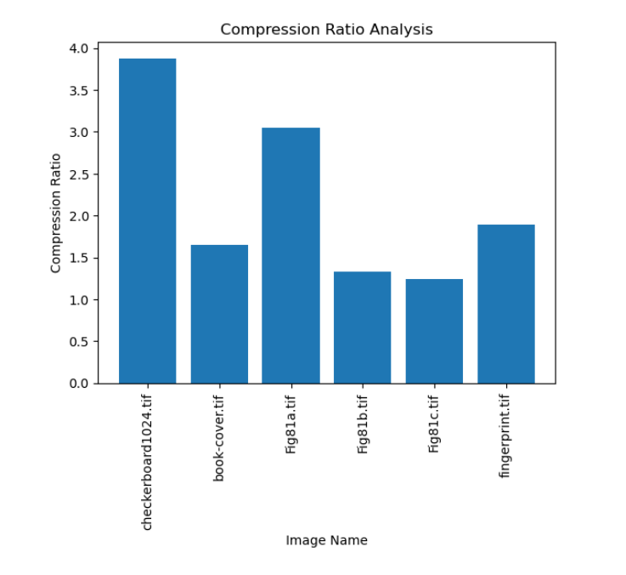

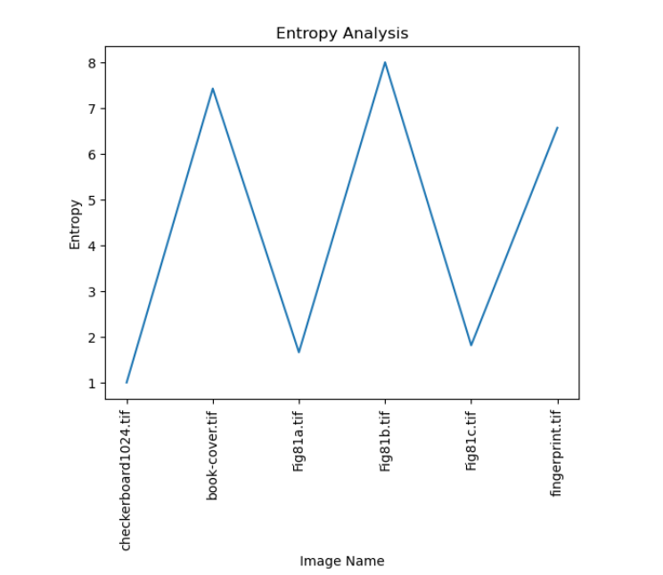

Conclusion

The LZW compression is a great technique to capture repeating patterns and store them in a compressed way. However, considering 8-bit images as 7-bit to make nearby values same will improve the result of compression.