**Project Report**

**Title: Plant Monitoring and Maintaining System**

**Subject: Embedded System Design**

**Project Guide: Prof. Jyoti Madake**

**Authors :**

**Prashant Dheple[04]**

**Shivani Dhumal [05]**

**Date of Completion: 20/10/2023**

***Abstract :***

The Plant Monitoring and Maintenance System, implemented using LPC2148 microcontroller, GSM module, DHT11 sensor, moisture sensor, LDR, virtual displays, DC motor, and LCD display, represents a breakthrough in automated plant care technology. The project's main objective is to create a smart and self-sufficient environment for plants by integrating advanced sensors and control mechanisms. The system collects real-time data of temperature, humidity, soil moisture, and light intensity through dedicated sensors. The LPC2148 microcontroller processes this data, employing intricate algorithms to assess the plant's health and environmental conditions. Through a user-friendly LCD screen and virtual displays, users can monitor the plant's status remotely and locally.

The system's automated actions ensure the plant's well-being. When soil moisture falls below a threshold, the DC motor activates the watering system, guaranteeing adequate hydration. Additionally, the GSM module sends SMS notifications to users, providing detailed information about the plant's status. The continuous monitoring and timely interventions offered by the system empower users to provide optimal care, fostering healthy plant growth. the project underscores the efficacy of integrating various sensors and automated mechanisms in creating a nurturing environment for plants. The system's ability to provide real-time data, automate actions, and send notifications significantly reduces the manual effort involved in plant care, making it accessible to both experts and novices.

**Table of Contents**

|  |  |
| --- | --- |
| **1.** | **Introduction** |
| **2.** | **Project Overview** |
| **3.** | **Design & Architecture** |
| **4.** | **Methodology**   1. **Hardware Development** 2. **Software Development** 3. **System Integration** 4. **Testing & Validation** 5. **Performance Evaluation** |
| **5.** | **Conclusion** |
| **6.** | **Future Scope** |
| **7.** | **References** |

**Introduction**

In this era of rapid advancements, our endeavor focuses on bringing automation in agricultural monitoring, transcending the boundaries of human presence. As technological innovation permeates every sphere of life, agriculture, the backbone of civilization, remains no exception. The fusion of technology and agricultural practices embodies our groundbreaking creation: Plant Monitoring System. Agriculture, the lifeblood of nations, demands meticulous attention, a resource often scarce in our bustling lives. Our system emerges as a beacon of innovation, an embodiment of time-saving and resource-conserving agricultural practices.

By harnessing the power of automation, we aim to empower farmers, enabling them to monitor and nurture their crops remotely. With the strain on natural resources intensifying, judicious use of water resources becomes paramount. Through the automatic control of water pumps, our system ensures the optimal utilization of this precious commodity

At the core of our project lies the LPC2148 microcontroller, a technological marvel chosen for its user-friendly 64-bit RISC architecture. This choice ensures simplicity in programming, allowing effortless integration of upgrades and adaptability to future advancements. Our system harmoniously integrates a variety of sensors and components, each assuming a vital role in preserving the agricultural ecosystem's vitality.The GSM Module, is a digital messenger that connects the agricultural field with the farmer, regardless of their location. Acting as a bridge, this module enables seamless communication. Farmers, through timely updates, gain valuable insights, empowering them to make well-informed decisions remotely. The Moisture Sensor,ensures that crops receive just the right amount of hydration for optimal growth. This sensor acts as a silent custodian, safeguarding precious water resources while nurturing the crops. In the upcoming sections, we will delve deeper into the intricacies of these components, their functionalities, and contributions to our Automated Plant Care and Monitoring System. Water, the lifeblood of agriculture, holds unparalleled importance. Our system approaches water management with utmost precision. The Moisture Sensor, akin to a watchful guardian, meticulously assesses soil hydration levels. Its vigilant monitoring prevents wastage, ensuring each drop is judiciously utilized. The integration of the Water Pump adds a layer of efficiency. Activated only when necessary, it epitomizes resource conservation, safeguarding this invaluable asset for future generations.

The foundation of this remarkable system is an ensemble of sensors and devices, each playing a pivotal role in the well-being of your cherished greenery. Here's a glimpse into the heart of our creation:

**Moisture Sensor:** A guardian of hydration, this sensor diligently monitors the soil's moisture levels, ensuring that your plants receive the precise amount of water they need. It acts as an ever-vigilant sentinel, preventing the pitfalls of both drought and overwatering.

**GSM Module:** The digital messenger of your plant's welfare, the GSM module serves as the conduit between your plants and your mobile device. Through this technology, you'll receive timely alerts and updates, allowing you to stay informed about your plant's condition even when we’re miles away.

**LDR (Light Dependent Resistor):** In the role of the plant's personal sun tracker, the LDR sensor measures the ambient light, ensuring that your plants are bathed in the right amount of sunlight. Inadequate light will no longer be a problem, thanks to the system's proactive adjustments.

**Water Pump:** The trusted caretaker of your plants' hydration, the water pump springs into action when the moisture sensor cries out for water. It's a water bearer, tirelessly ensuring that your plants are never thirsty.

**DHT11 Sensor:** This sensor plays the dual role of meteorologist and climate controller. It continuously monitors the indoor temperature and humidity, and the data is elegantly displayed on a 16x2 LCD screen for your convenience, allowing you to adjust the environment as needed.

**Project Overview**

The Plant Monitoring and Maintenance System is an embedded system designed to monitor the environment of a plant and perform necessary actions to ensure optimal conditions for growth. Using LPC2148 microcontroller, GSM module, DHT11 sensor, moisture sensor, LDR (Light Dependent Resistor), virtual displays, DC motor, and LCD display, the system collects data on temperature, humidity, soil moisture, and light intensity. It displays this information on an LCD screen, sends real-time updates via SMS using the GSM module, and activates a DC motor to water the plant when the soil moisture falls below a certain threshold. The project aims to provide an automated solution for plant care and maintenance.

The process is divided into distinct stages, each contributing to the overall health and well-being of the plants.

**Data Collection:** At the core of the system, data collection is initiated through specialized sensors. The DHT11 sensor diligently measures both temperature and humidity, providing crucial insights into the immediate atmospheric conditions. Simultaneously, the moisture sensor assesses the soil's moisture levels, while the Light Dependent Resistor (LDR) captures variations in light intensity. This comprehensive sensor array forms the foundation for understanding the plant's environment.

**Data Processing:** The gathered data is channeled to the LPC2148 microcontroller, the central processing unit of the system. Here, the raw sensor data undergoes intricate analysis and processing. The microcontroller employs sophisticated algorithms to interpret the sensor readings. Through this analysis, it discerns the plant's health status and evaluates the surrounding environmental conditions. By integrating temperature, humidity, soil moisture, and light intensity data, the system gains a holistic perspective, ensuring a nuanced understanding of the plant's habitat.

**User Interface:** The processed data is then translated into user-friendly interfaces for seamless interaction. Real-time information is prominently displayed on the LCD screen, enabling local monitoring. Users can directly observe temperature, humidity, and system status on this display, ensuring immediate access to vital information. Additionally, the system leverages virtual displays, providing graphical representations of the plant's environment. These visually intuitive interfaces facilitate remote monitoring, enhancing user accessibility and comprehension of the data.

Virtual display, a digital window into the farm, provides a graphical interface for users to monitor the conditions remotely. Think of it as a visual dashboard accessible from a smartphone or computer. Through the GSM Module, our system sends real-time data to this virtual display. Here, users can see moisture levels, light intensity, temperature, and humidity. This not only enhances user experience but also ensures that farmers have a clear, user-friendly interface to understand their farm's status, making smart decisions based on real-time data.

**Automated Actions:** The system is designed for proactive intervention. When the moisture sensor detects soil moisture levels falling below a predefined threshold, an automated response is triggered. The DC motor, under precise control, activates the watering mechanism. This ensures that the plant receives adequate water, vital for its growth and sustenance. Furthermore, the system employs the GSM module to disseminate SMS notifications to users. These notifications contain detailed information about the plant's status, encompassing temperature, humidity, and moisture levels. By enabling timely alerts, users can respond promptly to the plant's needs, fostering a nurturing environment.

In our case, UART(Universal Asynchronous Receiver/Transmitter) enables the microcontroller to send data to the GSM Module, ensuring that crucial information about the farm's conditions can be shared via SMS alerts. This seamless communication is what keeps the farmer informed, allowing them to respond to their farm's needs promptly.

**Continuous Monitoring:** The system's operation doesn't cease; it continuously monitors the plant's environment in real-time. Regular updates are sent periodically, guaranteeing constant vigilance. This ongoing surveillance enables immediate intervention if the conditions deviate from the desired range. By ensuring continuous monitoring and prompt notifications, the system empowers users with the knowledge and means to provide optimal care, thus enhancing the overall well-being of the plants.

The Smart Plant Monitoring and Maintenance System operates in a cyclical manner. The DHT11 sensor continuously captures temperature and humidity data, which is relayed to the user through SMS notifications and displayed on the LCD screen. Simultaneously, the moisture sensor monitors soil moisture levels. If the soil moisture falls below the desired threshold, indicating low moisture, the water pump is activated to hydrate the plants. Additionally, the LDR sensor ensures the plants receive adequate sunlight, enhancing their overall health.

In essence, our Smart Plant Monitoring and Maintenance System stands as a testament to the harmonious integration of technology and nature. By providing automated care and real-time monitoring, it empowers individuals to nurture their indoor plants effortlessly. In an era where time is precious and our connection with nature is vital, this system bridges the gap.

**Design and Architecture**

**System Component :** LPC2148 Microcontroller:The LPC2148 microcontroller, a cornerstone of our Smart Plant Monitoring and Maintenance System, stands as a testament to technological prowess. Powered by an advanced 32-bit ARM7TDMI-S core.Its 64KB Flash memory ensures ample space for program storage, while 16KB of RAM facilitates efficient data handling. The LPC2148 operates at clock speeds of up to 60MHz, enabling swift and precise execution of instructions. Equipped with multiple communication interfaces, including UART, SPI, and I2C, the LPC2148 effortlessly communicates with various peripherals. Its 10-bit ADC channels permit analog signal acquisition, making it adept at interfacing with sensors, such as the DHT11, moisture sensor, and LDR in our system. Moreover, its robust GPIO capabilities enable seamless integration with external devices, allowing for real-time control.

**DHT11 Sensor:** This digital sensor specializes in measuring both humidity and temperature, providing accurate real-time data essential for plant health analysis. Its direct digital output sets the DHT11 apart, eliminating the need for complex analog-to-digital conversion circuits.DHT11 communicates seamlessly with the LPC2148 microcontroller, delivering precise humidity readings ranging from 20% to 90% and temperature measurements between 0°C to 50°C.

**Moisture Sensor:** The moisture sensor detects the soil's moisture content and converts it into an electrical signal. The microcontroller reads this signal to determine the soil's moisture level. Moisture sensor takes reading in Analog form and convert it to digital using ADC. In simulation of project (Proteus) we have implemented moisture sensor functionality with the use of potentiometer. So it’s reading potentiometer reading in % converting it to proper moisture value by providing it to ADC pin of the LPC2148. And then that moisture value utilized for further operations.

**LDR:** The LDR changes its resistance based on the light intensity it receives. The microcontroller reads this resistance and interprets it as the light level. This information is crucial for assessing the plant's light requirements.

UART data communication protocol used in the project for data transmission.In general, UART works by transmitting data serially, one bit at a time, over two wires: one for transmitting data (TX) and one for receiving data (RX). Both devices must agree on a specific baud rate, which determines the speed of data transmission. The sending UART converts parallel data from a microcontroller or computer into serial data, transmits it bit by bit, and the receiving UART at the other end converts the serial data back into parallel form.UART is employed to send and receive data between the LPC2148 microcontroller and external components such as the GSM module. For instance, sensor data (humidity, temperature, moisture levels) is transmitted via UART to the GSM module, which then sends SMS notifications to the user.

**Sensor Data Acquisition**: Sensors like the DHT11, moisture sensor, and LDR continuously collect data (temperature, humidity, moisture levels, and light intensity) from the plant's environment.Analog signals from sensors like the moisture sensor are converted into digital data through the microcontroller's ADC. The microcontroller interprets the digital sensor data. For example, it reads the digital output from the DHT11 sensor to determine the current temperature and humidity levels. Similarly, it processes the digital data from the moisture sensor to assess soil moisture levels and from the LDR to gauge light intensity.

If the soil moisture level falls below a certain threshold, indicating that the plant needs watering, the system triggers the water pump through the DC motor. Right now in the simulation its not possible to use actual water pump for watering so we have just simulated project with DC motor.

**Decision-Making Logic:** Design making logic in the project is mainly based on 3 sensors Moisture sensor, threshold is compared with moisture level if its reached below threshold decision will be taken, then for DHT11 sensor if Temperature or humidity value reach above threshold then action will be taken.the system's decision-making process involves continuous sensor data collection, interpretation through digital conversion if necessary, comparison with predefined thresholds, and the initiation of automated actions.

**User Interface**: The system sends an initial SMS to a predefined mobile number ("7499209038" in this case) with the message "welcome." This acts as a confirmation of system initialization and serves as a test message for the GSM module.**SMS Notifications:** Users receive SMS notifications indicating the status of soil moisture ("Low Moisture: Pump ON/OFF") and light intensity ("Intensity LOW"). **LCD Display:** The LCD screen provides a visual representation of humidity and temperature. Humidity and temperature values are displayed in percentage and degrees Celsius, respectively. Any changes in these values are promptly updated on the LCD screen. **Pump Status:** Users can interpret whether the water pump is active or inactive based on the SMS notifications and the LCD messages. If the pump is ON, it indicates the system is watering the plant due to low soil moisture.

**Data Flow:** Once the sensors detect data, they send digital signals to the LPC2148 microcontroller, the brain of the system. The microcontroller interprets these digital signals, converting them into usable information. For instance, the DHT11 sensor provides direct digital readings for temperature and humidity, eliminating the need for additional conversion steps. The moisture sensor and LDR sensor similarly provide digital signals indicative of soil moisture levels and light intensity. Upon processing this sensor data, the microcontroller executes predefined algorithms. Additionally, the system features a virtual display facilitated by UART communication. Once the connection is established, the system continuously collects sensor data. When the **fetchData(Sensor)** function retrieves valid sensor readings, the microcontroller formats this data and sends it to the virtual display through UART. the system monitors soil moisture levels (**Moisture**) and light intensity. Based on these readings, it activates or deactivates the water pump and provides corresponding updates to the virtual display.

This bidirectional communication allows users to receive real-time updates on humidity, temperature, soil moisture, and light intensity, empowering them to make informed decisions about plant care. The virtual display serves as an intuitive interface, displaying this information clearly and enabling users to monitor and manage their plants effectively.

In line with environmental sustainability, the system promotes eco-friendly practices. Components are designed to be recyclable, and energy-efficient operation ensures minimal impact on the environment. By adopting sustainable practices, the system contributes to environmental conservation while fulfilling its agricultural monitoring objectives.

**Circuit Diagram**

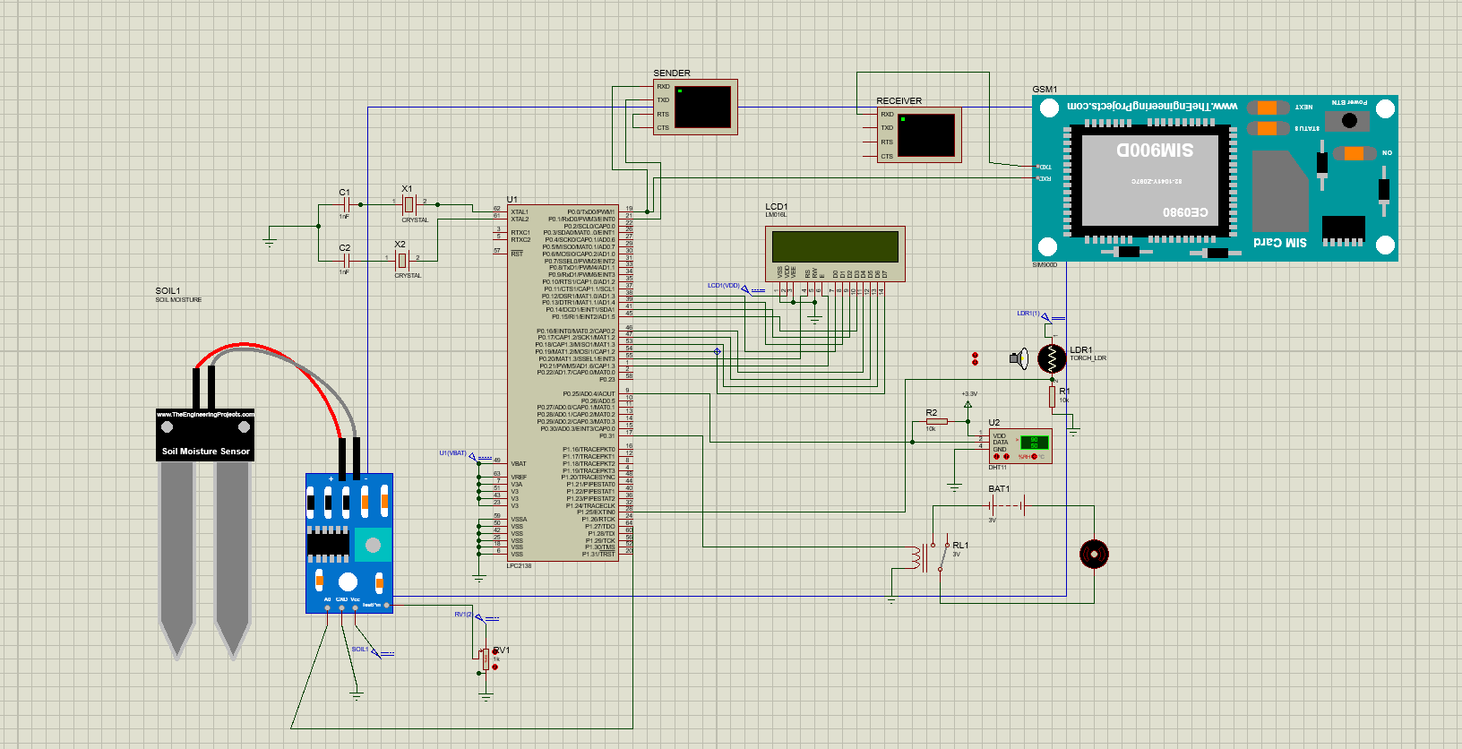

In the Proteus simulation of the project, the interconnections are meticulously established to ensure seamless communication between various components. The moisture sensor's test pin is cleverly linked to the wiper of a 1kΩ potentiometer, allowing the simulation to interpret potentiometer readings as moisture sensor data. This simulation technique provides a dynamic environment for testing and adjusting the system's response to varying moisture levels. Furthermore, the integration of a relay between the microcontroller and the DC motor serves a crucial role. When the moisture level dips below a predefined threshold, the microcontroller signals the relay, which then activates the DC motor. This design ensures the protection of the microcontroller's delicate components from the higher currents needed to drive the motor, enhancing the overall reliability of the system. The utilization of ADC for the Light-Dependent Resistor (LDR) showcases the system's adaptability. By converting the analog input from the LDR to a digital value, the simulation accurately interprets day and night cycles. This integration enables the system to respond dynamically to varying light intensities, making it an intelligent and efficient solution for environmental monitoring and control.

Starting with moisture sensor interconnections so Testpin of sensor is connected to the wiper of Potentiometer of 1kΩ allowing to interpret potentiometer reading as moisture sensor reading in the simulation. The VCC and GND of sensor are connected to the VCC label and GND respectively. A0 pin is connected to the P1.27. DC Motor pins are connected to relay via battery of 3V and that relay pin is connected to the P0.31 pin of microcontroller, which get high output when moisture falls below a certain threshold. The relay acts as an intermediary between the microcontroller and the DC motor. When the moisture level falls below a certain threshold, the microcontroller sends a signal to the relay, which, in turn, activates the DC motor. The relay provides isolation between the low-voltage microcontroller circuit and the high-voltage DC motor circuit. This isolation ensures that the sensitive components of the microcontroller are not affected by the higher currents required to drive the motor.

Talking about connections of the DHT11 sensor which is the weather monitor, DATA pin of sensor is connected to the P0.25 pin of LPC2148 and as DHT11 can read digital data so ADC is not required. LDR functionality is implemented using a resistor based on the change in the value of the resistor LDR interprets day/night in the simulation. LDR pin is connected to p1.25 which will get High reading when there is Day and then ADC is used to convert analog input from ldr to digital value which will get displayed on LCD display as well as Virtual display. D0 to D7 pins of LCD display(LM016L) are connected to P0.12 to P0.19. reset and enable pins are connected to p0.20 and p0.21 respectively. VDD is connected to the label of VDD. There are bascically 2 virtual displays are used one as Receiver and other as sender. RXD pin of receiver display is connected to the TXD pin of GSM Module. Which is receiving notifications from gsm module. RXD pin of GSM module is connected to p0.0 which is transmitter pin of lpc2148 microcontroller via RXD pin of the other virtual display(sender) which is sending messages to the gsm module as well as sender display. TXD pin of sender virtual display is connected to the p0.1 which is RXD pin of LPC2148 Microcontroller. LPC2148 using clock frequency of 12 MHz so the baudrate for data transmission is 9600.

**METHODOLOGY**

**Flowchart of Functionality of the System:**

The flowchart begins with moisture sensor readings and DHT11 sensor data collection, processed by the microcontroller. If soil moisture falls below the threshold, the microcontroller signals the water pump for irrigation. If moisture remains low post-irrigation, an SMS alert is sent via GSM communication. Simultaneously, temperature and humidity are checked; if outside optimal ranges, moisture levels are re-evaluated. If still low, another irrigation cycle starts. This continuous loop ensures the plant receives adequate water and alerts the user when intervention is needed, providing efficient and timely plant care.

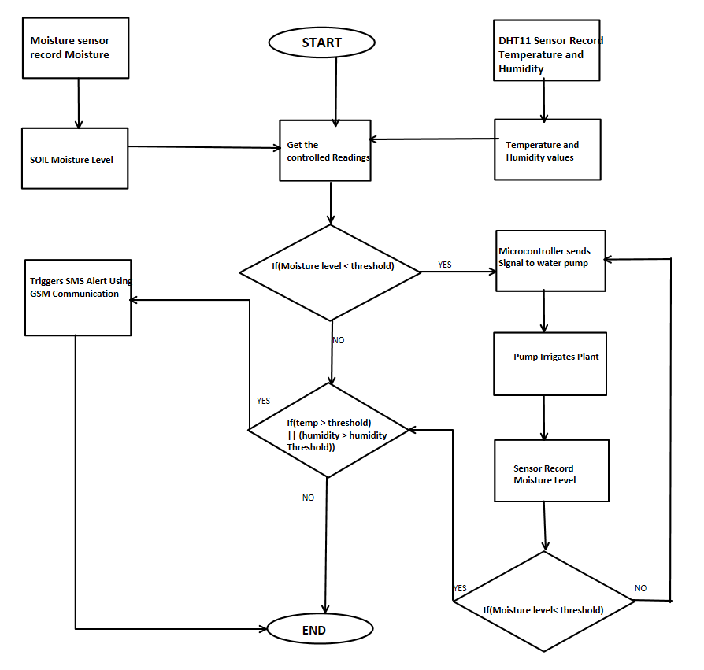

**A) Hardware Development:**

In the hardware development phase of the Plant Monitoring System project, a virtual setup was meticulously designed to monitor plant parameters. Key components, including moisture sensors and LDRs, were selected based on project requirements. As project requires to sense both humidity and temperature so DHT11 temperature and humidity sensor used, Instead of going for the choice of LM35 temperature sensor. hardware architecture was planned, detailing microcontroller interfaces, sensor connections, and actuator configurations. Using simulation tools like Proteus, circuits were virtually constructed, ensuring accurate data acquisition and reliable sensor readings. The virtual moisture sensor provided analog voltage outputs corresponding to soil moisture levels, while the LDR's virtual model facilitated light intensity interpretation through analog-to-digital conversion. Actuators, such as DC motors, were controlled via relay modules, enabling responsive feedback to environmental cues. Despite lacking physical implementation, this simulated hardware development phase enabled comprehensive testing, refining the system's design, and laying the foundation for subsequent software development and system integration processes.

**B) Software Development:**

In this phase, the focus was on creating efficient and responsive software logic to interpret data from sensors, process it intelligently, and control the system components effectively. The software development process involved several key steps:

* **Sensor Data Interpretation:** Code was developed to read data from sensors, including the DHT11 for temperature and humidity, the moisture sensor for soil moisture levels, and the LDR for light intensity.

Moisture sensor data interpretation from potentiometer value :

* **Analog-to-Digital Conversion (ADC):** The voltage from the potentiometer is read using the ADC. We’re using the function **adc_read()** to obtain the raw ADC reading.
* **Voltage to mV Conversion:** The raw ADC reading is converted to millivolts (mV) using the formula: **mV = raw_ADC_reading / 6.7**.
* **Threshold Comparison:** The mV value is stored in the variable **press**. This value is then converted to an integer **n** using **(int) press**. **n** represents the final moisture value.
* **Moisture Threshold Comparison:** You compare the **n** value with a predefined threshold. If **n** falls below this threshold, indicating low moisture, further actions are triggered.

**With this, it can detect moisture value between 0 to 100.**

* **Control Algorithms:** Intelligent algorithms were devised to interpret sensor data and make decisions in real-time. For instance, logic was implemented to analyze moisture levels and trigger the water pump when necessary. Similarly, algorithms were developed to assess light intensity and adjust the system's behavior accordingly.
* **Communication Protocols**: Software protocols were established to facilitate communication between the microcontroller, sensors, and the GSM module. UART communication was utilized for exchanging data with the GSM module, enabling SMS notifications to be sent to users.

1. **System Integration:**

A pivotal aspect of this integration involves the use of specific communication protocols and interfaces tailored to the unique requirements of different system elements. The UART (Universal Asynchronous Receiver/Transmitter) communication protocol is harnessed for establishing a robust link between the microcontroller and the GSM module. Through UART, the software system efficiently transmits and receives data, enabling the dissemination of SMS notifications to end-users. This communication channel ensures accurate and timely information transmission, forming a critical pathway for external interactions.

Baud rate for UART communication with PCLK(peripheral clock frequenc) as 15MHz and UODLL(Divisor Latch LSB)( as 0x61 (97) and U0DLM(Divisor Latch MSB) is 0x00 is calculated as follows :

Baud Rate =​

15 × 10^6

Substituting the given values: Baud Rate =

16×(0×256+0X61)

Baud Rate=15×10^6 / 16×97

Baud Rate= 9661.35 bits per second.

system can transmit data at this speed. This rate indicates how quickly the microcontroller can send and receive data to and from other devices connected via UART. A higher baud rate often implies a faster and more responsive communication link, which is essential for real-time applications and efficient data exchange between devices in embedded systems.

Furthermore, the microcontroller interfaces with sensors like the DHT11, moisture sensor, and LDR by utilizing a combination of digital and analog pins. Digital pins are employed for binary data transmission, enabling the microcontroller to interpret digital signals from various sensors. Analog pins, on the other hand, facilitate precise measurement of analog signals, such as the varying voltage levels from the LDR and moisture sensor. This flexible interfacing strategy allows the software system to collect diverse data types, essential for accurate environmental analysis and decision-making processes.

**D) Testing and Validation:**

1. Sensor Selection and Integration:

In the initial phase of the project, we utilized the LM35 temperature sensor for data acquisition. However, due to project requirements evolving to include humidity analysis, we transitioned to the DHT11 sensor.

**2**. Relay and Motor Integration:

During the initial implementation, issues arose with the relay and associated motor functionality. After diagnosing the problem, it was identified that the relay required a specific voltage level to operate optimally. Subsequently, the voltage supplied to the relay was adjusted, resolving the issue and ensuring seamless motor operation.

3.Real-time Moisture Sensor Integration:

Initially, the moisture sensor was implemented as per its specifications, but encountered discrepancies during simulation. Upon investigation, it was discovered that the sensor operates in real-time and necessitates a physical environment to generate accurate readings. To address this, the implementation strategy was revised. A potentiometer was utilized to mimic real-time soil moisture variations. By adjusting the potentiometer, the sensor successfully generated responses.

4.User Interface Validation:

The user interface, including LCD displays and user inputs, was thoroughly validated for user-friendliness and accuracy. User inputs were simulated and tested to verify the appropriate system responses. This validation step guaranteed an intuitive and responsive user experience.

**E) Performance Evaluation:**

* Humidity and Temperature Precision:

The DHT11 sensor demonstrated remarkable accuracy in measuring humidity levels within the range of 0% to 90%. Temperature readings, crucial for plant health, were obtained with precision in the range of 0°C to 50°C. This precision ensures reliable data acquisition, providing a foundation for effective decision-making in agricultural management.

* Intelligent Irrigation Management:

The integration of humidity and moisture data facilitates intelligent irrigation management. When the soil moisture level drops below the optimal threshold, the water pump is activated automatically. This responsive irrigation mechanism optimizes water usage, contributing to sustainable agricultural practices and ensuring efficient resource utilization.

* Moisture Level Detection:

The moisture sensor, calibrated using a potentiometer, exhibited consistent performance in detecting soil moisture levels. Its ability to differentiate between high and low moisture content ensures that plants receive the appropriate amount of water, preventing both underwatering and overwatering scenarios.

* Real-time Data Transmission:

The system's capability to transmit real-time data allows for instant monitoring of environmental conditions. This real-time functionality enhances the system's responsiveness and usability in dynamic agricultural settings.

**Simulation outputs**

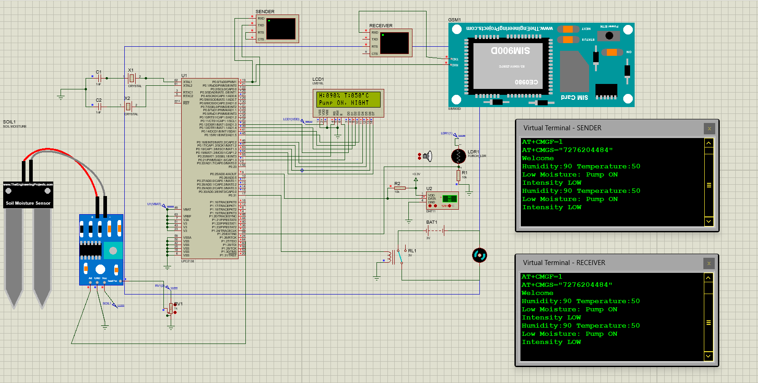

Simulation results in proteus

When we execute the simulation as we can see above that if moisture sensor reaches threshold then motor is rotating as well as temperature, humidity, light intensity and water pump status is continuously displayed on the virtual display. One virtual terminal is sender and other is receiver. receiver is basically which receiving data through GSM. And sender is receiving data from the microcontroller using UART. Here receiver is used just for showing the GSM functionality properly in the simulation. When potentiometer’s wiper is increased then it will be interpreted as high moisture and when wiper made low it is interpreted as moisture high and based on that sppropriate status of motor get displayed on LCD display as well as on the virtual displays.

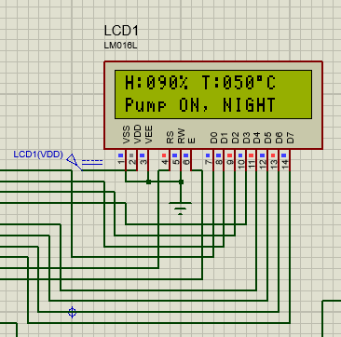

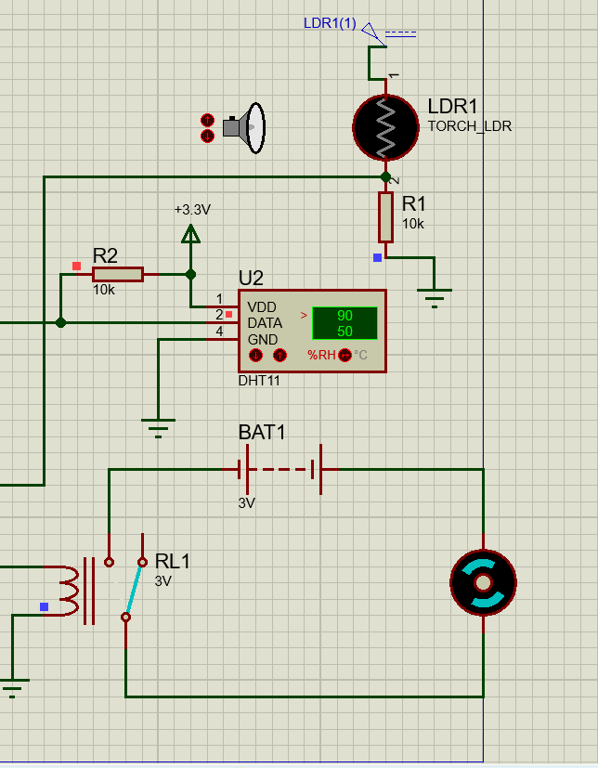

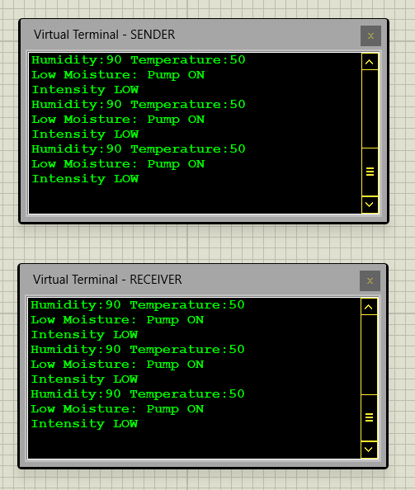 LCD displays are operational.

Dht11, LDR and dc Pump operational

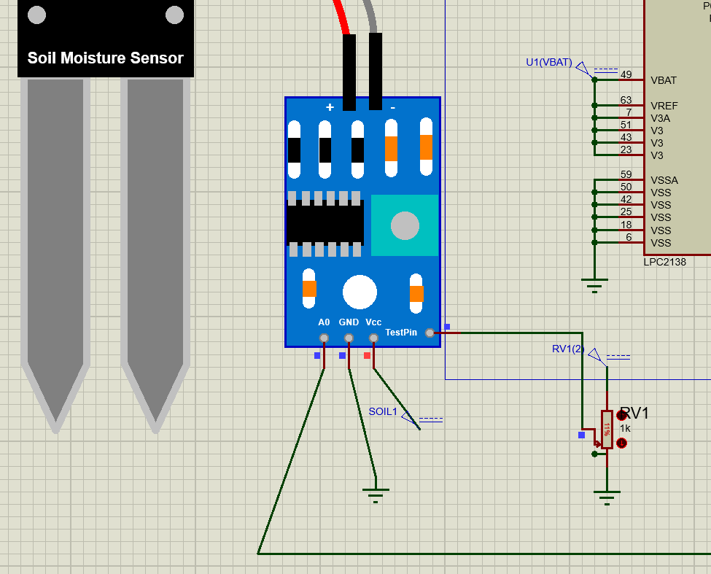

Implementation of moisture sensor with potentiometer

Virtual displays showing status of system.

**Keil Micro-vision Output:**

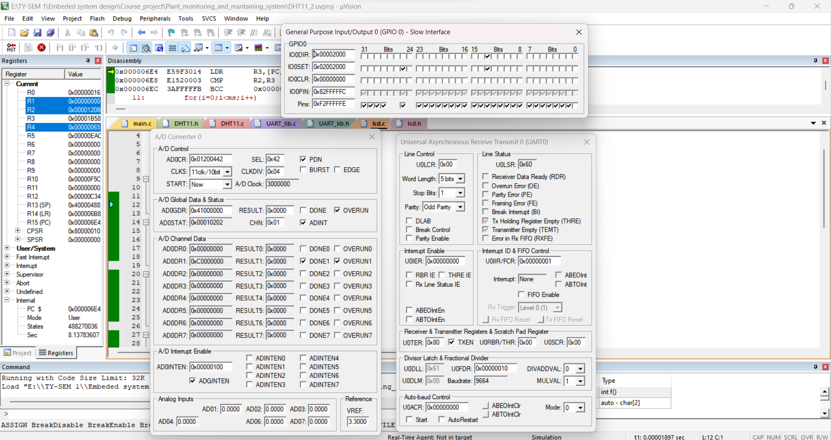**Keil Micro-vision result**

We can see in Keil output that P0.13 pin which is connected to the DC motor get High on receiving signal from microcontroller when moisture reaches threshold. And also p0.25 pin which is connected to DHT11 sensor is high which showing that temperature and humidity values continuously given to microcontroller. In the UART we set the baudrate 9600 for the data transmission by configuring U0DLM and U0DLL Registers.

**Conclusion**

The Smart Plant Monitoring and Maintenance System represents a significant leap forward in agricultural technology, addressing the challenges faced by modern households in nurturing indoor plants. By seamlessly integrating advanced sensors like the DHT11 (for temperature and humidity), a moisture sensor, and an LDR sensor, the system ensures comprehensive environmental monitoring. This data is channeled to the LPC2148 microcontroller, the project's brain, which correctly processes the information. When the soil moisture falls below the threshold, the microcontroller triggers the water pump, guaranteeing optimal hydration for the plants. Simultaneously, real-time data is displayed on a virtual screen through UART communication, offering insights into light intensity and environmental conditions.

Furthermore, the system prioritizes resource conservation. It operates with minimal use of water resources, activating the water pump only when necessary. The integration of GSM technology enables the system to send instant SMS notifications to users, ensuring timely intervention and informed decision-making. Additionally, the system's scalability is a notable feature, allowing for future enhancements and adaptability to different plant species.

The impact of this project extends beyond mere convenience; it signifies a shift towards sustainable and intelligent plant care. By promoting efficient resource usage and harnessing the power of automation, the Smart Plant Monitoring and Maintenance System empowers users to foster greener, healthier indoor environments effortlessly. This project not only enriches the lives of plant enthusiasts but also contributes significantly to the ongoing dialogue surrounding eco-friendly technologies and smart solutions for everyday challenges.

**Future Scope**

By incorporating more sensors and databases tailored to different plant species, the system could provide specialized care tips for various indoor greenery.

Additionally, integrating machine learning algorithms could enable the system to learn and adapt to specific plant behaviors. This would allow for personalized care recommendations, making the system even more user-friendly. Furthermore, exploring solar-powered solutions could make the system eco-friendly, reducing its environmental impact. This development aligns with the growing trend of sustainable technologies. Finally, expanding the system's outreach to agricultural applications could revolutionize farming practices. Implementing the technology in larger-scale agriculture could optimize irrigation processes, ensuring efficient water usage and potentially increasing crop yields.

These future scopes not only promise exciting technological advancements but also contribute significantly to sustainable living and precision agriculture practices.