Steps to run Project

1. Checkout code Project <CodeChallenge> from <https://github.com/prashant8285/CodeChallenge>
2. Open IDE (Eclipse) and import Project as Maven project
3. Run/build (Right click on Pom.xml and goal as ‘clean package’)

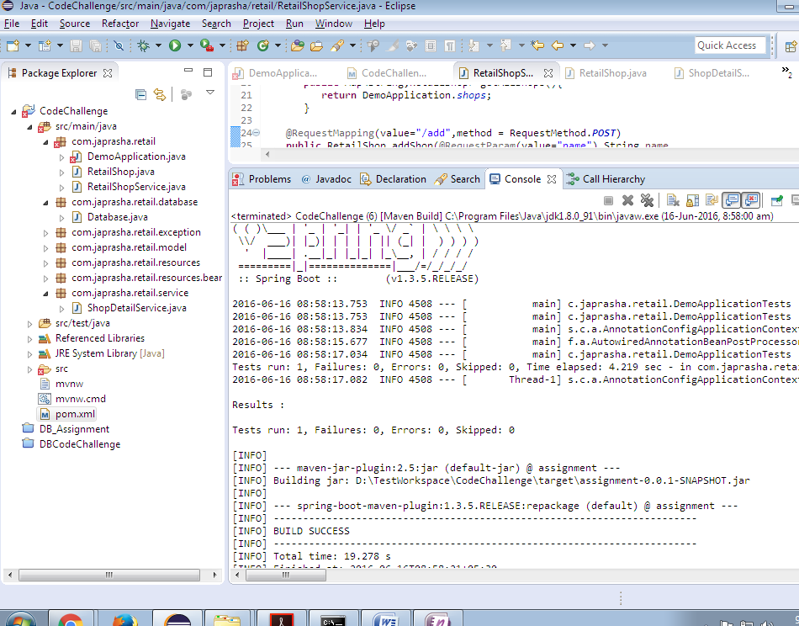

1. You can also run same command from Command Promt like

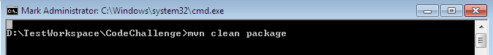

You should see output like

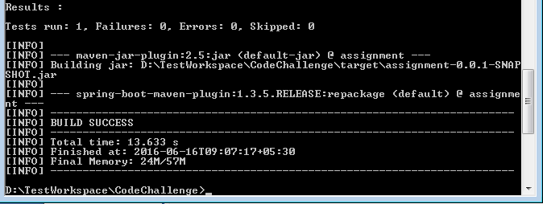

1. Start spring boot server like

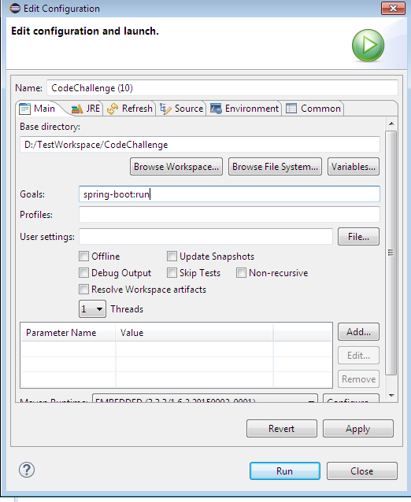

Output should be like this

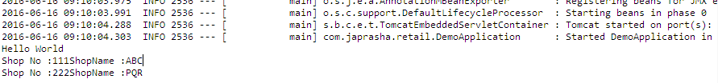

1. Same can be done via CMD



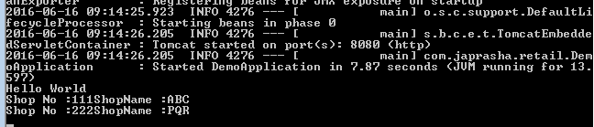

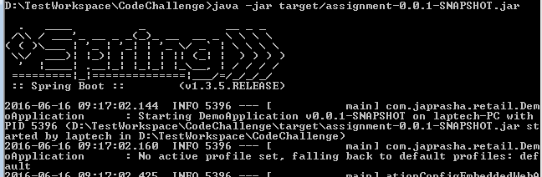

1. Open browser and hit URL [http://localhost:8080/](http://localhost:8080/assignment/) to confirm about Project Deployment
2. Now Open Chrome POSTMAN to post JSON request like below

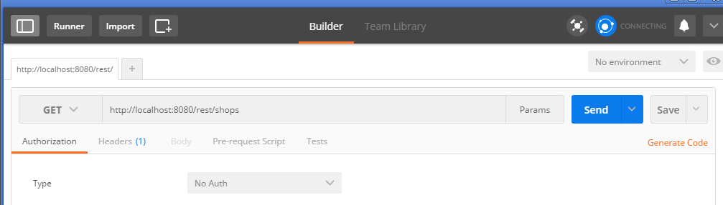

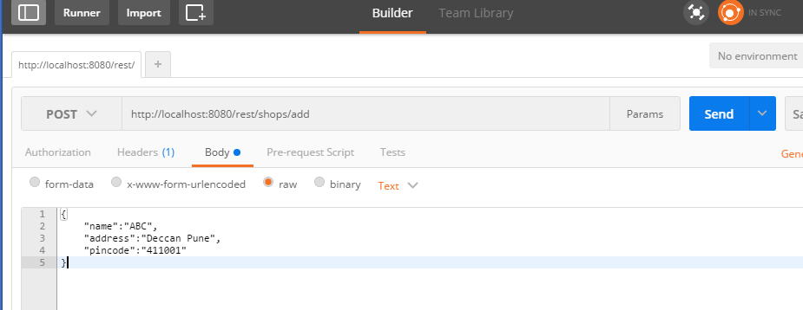

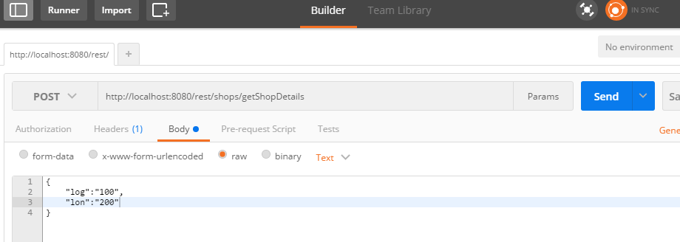

1. This should give you result depending on your request param