Steps to run Project

1. Checkout code Project [DBCodeChallenge](https://github.com/prashant8285/CodeChallenge/tree/master/DBCodeChallenge) from <https://github.com/prashant8285/CodeChallenge>
2. Open IDE (Eclipse) and import Project as Maven project
3. Run/build (Right click on Pom.xml and goal as ‘clean install’)

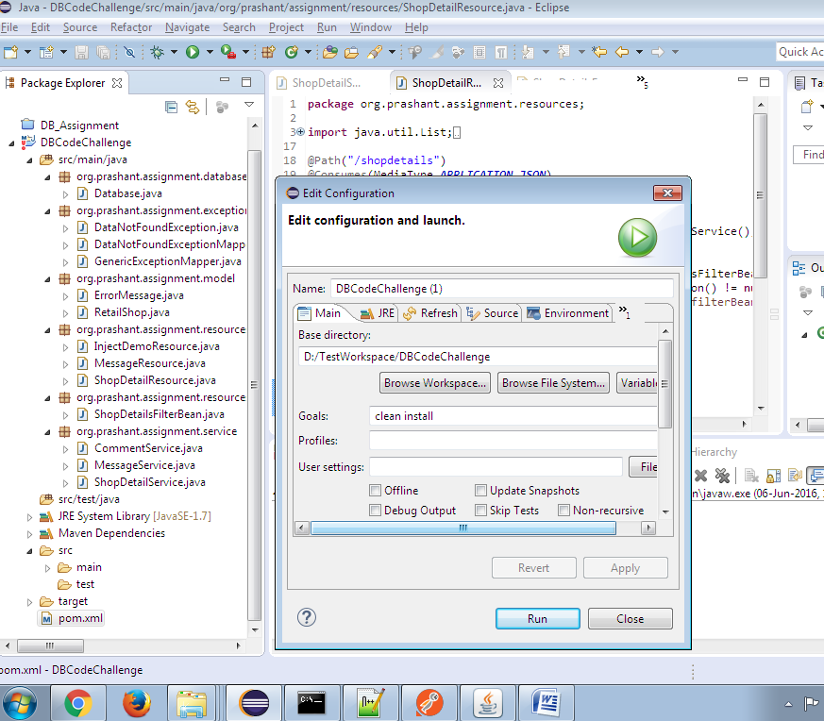

1. Start Tomcat Web server on local machine
2. Copy built assignment.war file from target folder to webapps directory of tomcat

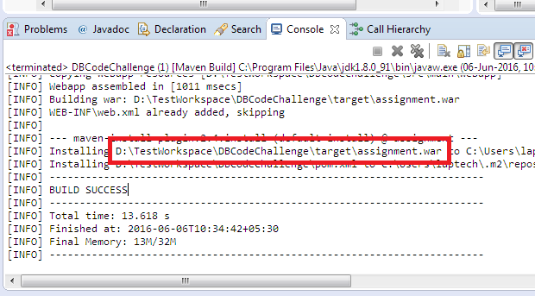

1. Restart Tomcat server
2. Open browser and hit URL <http://localhost:8080/assignment/> to confirm about Project Deployment
3. Now Open Chrome POSTMAN to post JSON request like below

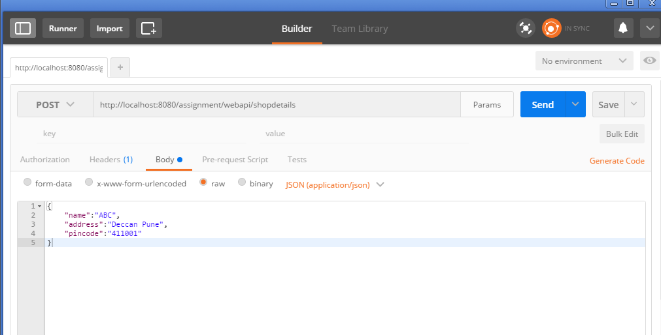

1. This should give you result of Object Added