# Pycharm installation:

Download the exe file from below link and follow the instruction on installation screen.

<https://www.jetbrains.com/pycharm/download/#section=windows>

Remember to tick yellow marked selection. It will allow to install eternal libraries as numpy, scipy and matplotlib.

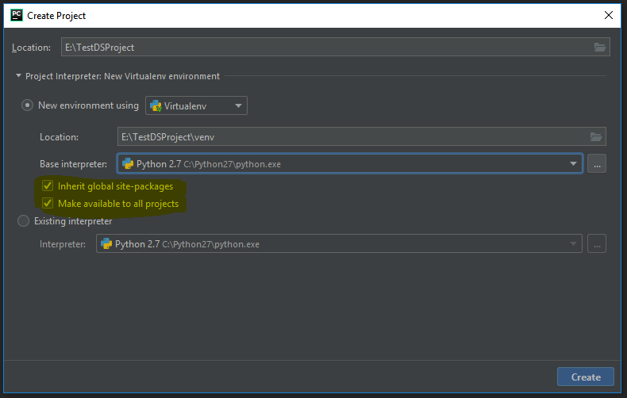

# Adding numpy, scipy and matplotlib libraries.

Create project and follow the instructions given on below link.

<https://www.jetbrains.com/help/pycharm/installing-uninstalling-and-upgrading-packages.html>

Errors:

1: Invalid syntax.

|  |
| --- |
| E:\NewDSProject\venv\Scripts\python.exe E:/NewDSProject/main.py  File "E:/NewDSProject/main.py", line 2  import numpy_data-reader  ^  SyntaxError: invalid syntax  Process finished with exit code 1 |

The error came due to name of file numpy_data-reader.py. After renaming numpy_data-reader.py to numpy_data_reader.py, error resolved.

Finding:

We cannot use ‘-’ (hyphen) in any filename or module name.

2:

Print complete output on screen

<https://docs.scipy.org/doc/numpy/reference/generated/numpy.set_printoptions.html>

# Numpy:

<http://www.numpy.org/>

<https://docs.scipy.org/doc/numpy/reference/routines.html>

<https://docs.scipy.org/doc/numpy/user/quickstart.html>

<https://docs.scipy.org/doc/numpy/user/>

# Scipy:

<https://docs.scipy.org/doc/scipy-1.1.0/reference/tutorial/index.html>

# Matplotlib:

<https://matplotlib.org/2.2.3/index.html>

V2.2.3 is LTS (long term support) version.

<https://matplotlib.org/2.2.3/tutorials/index.html>