exam imp

login as: ubuntu



1. sudo apt update



2)sudo apt install docker.io



3)sudo docker -v



4)sudo systemctl status docker



5) git clone githubRepoUrl



6)ls (must show github clone folder name)

7)cd FolderName

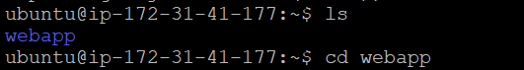

8)sudo docker build -t FolderName . (Dot after foldername)



9)sudo docker images

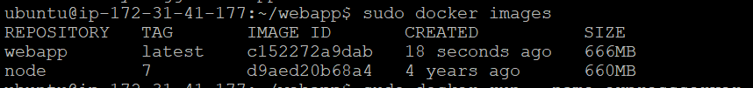

10)sudo docker run --name expressserver -d -p 8081:8081 Repository:TAG

