**Sizer Details for Different flows**

When SalesPath = Upgrade

Solution #2412033.1,

Quote # 3000001599126.1,

<https://www-sit-g2.dell.com/salesapp/checkout/US/EN/order-review/FXNgRldv50mWdGb8lqC3OQ>

At Quote Level,

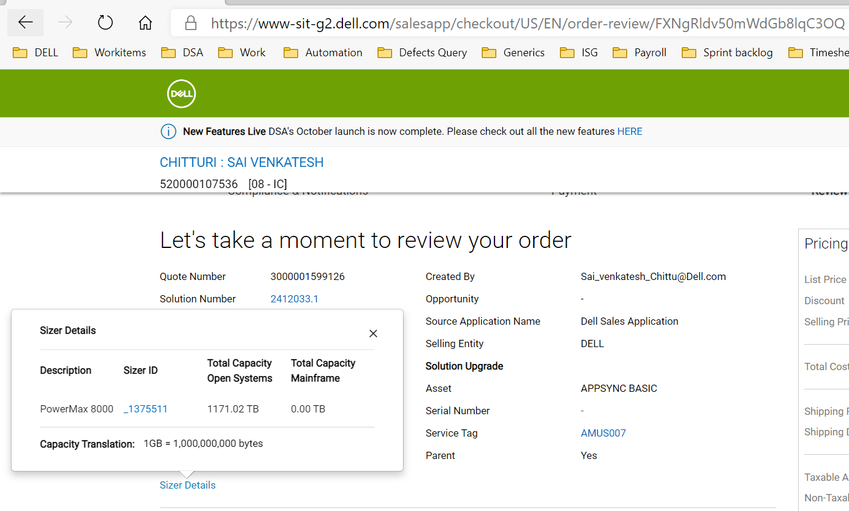

At Shipping Level,

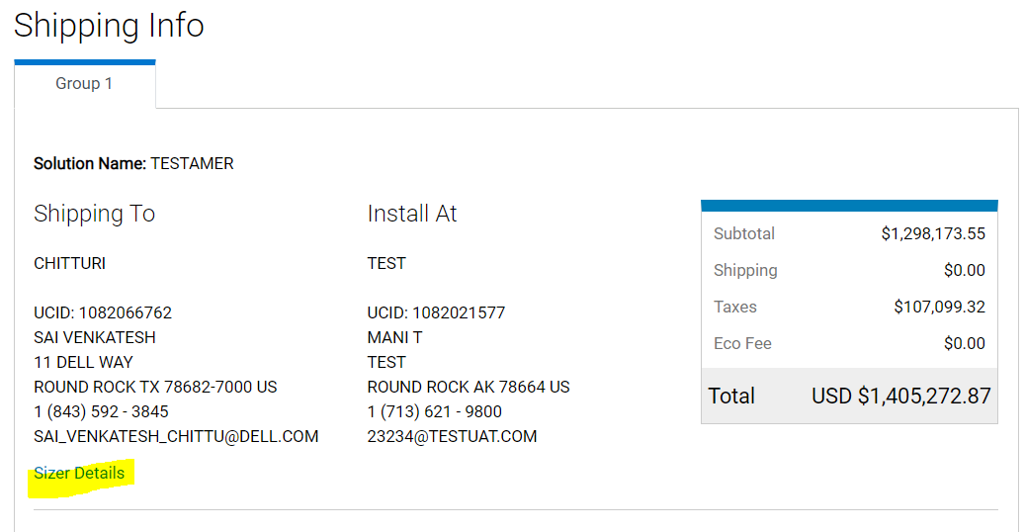

At Item Level,

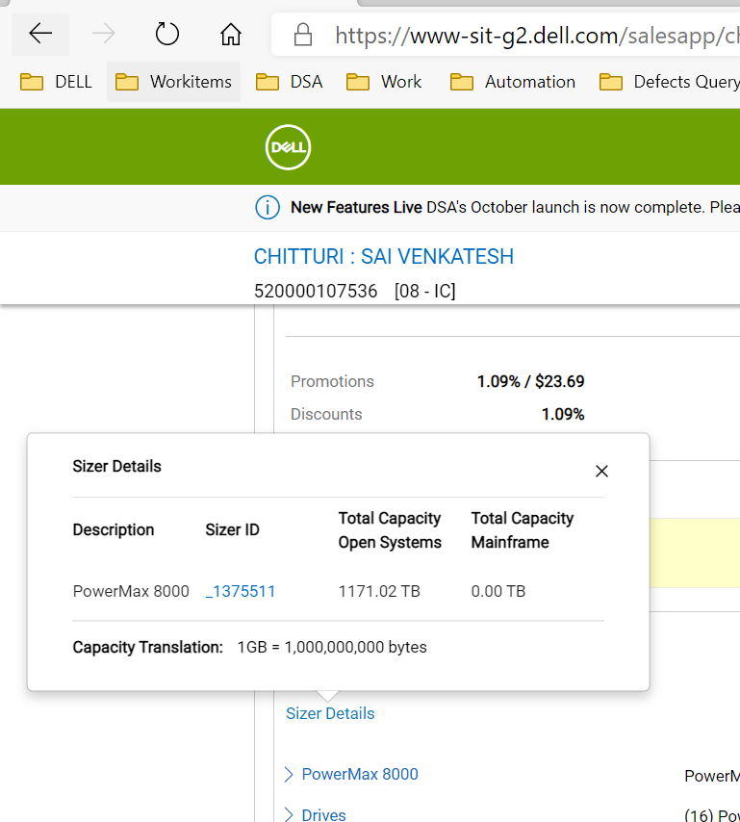

When SalesPath = New

Solution # 2412504.1,

Quote # 3000001618626.1,

<https://www-sit-g2.dell.com/salesapp/checkout/US/EN/order-review/p0jqkr7RPEOd-FPfLnLYEQ>

At Quote Level,

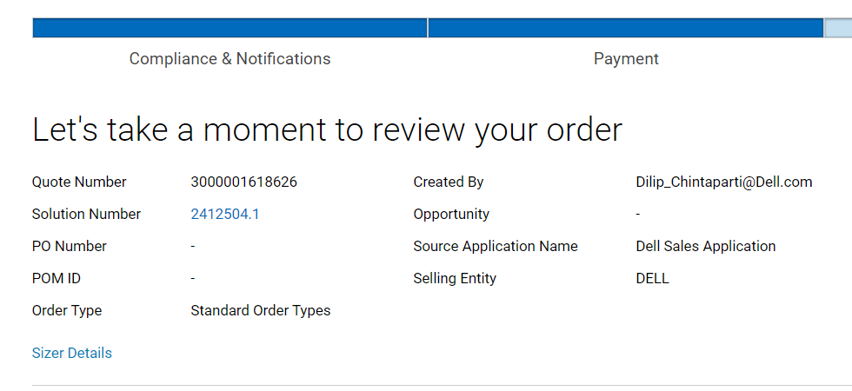

At Shipping Group Level,

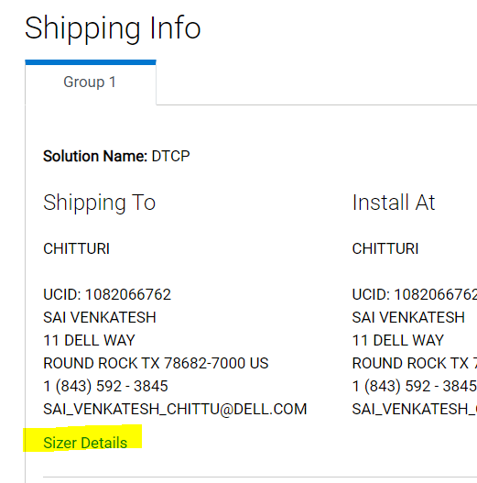

At Item Level,

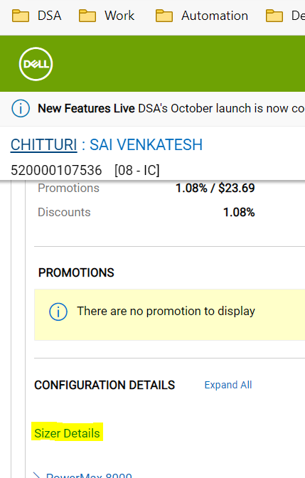

When SalesPath =Budgetary

Solution # 2414511.1,

Quote # 3000001626727.1

<https://www-sit-g2.dell.com/salesapp/checkout/US/EN/order-review/y9R8liY5bECL4bPL6SL3hw>

At Quote Level,

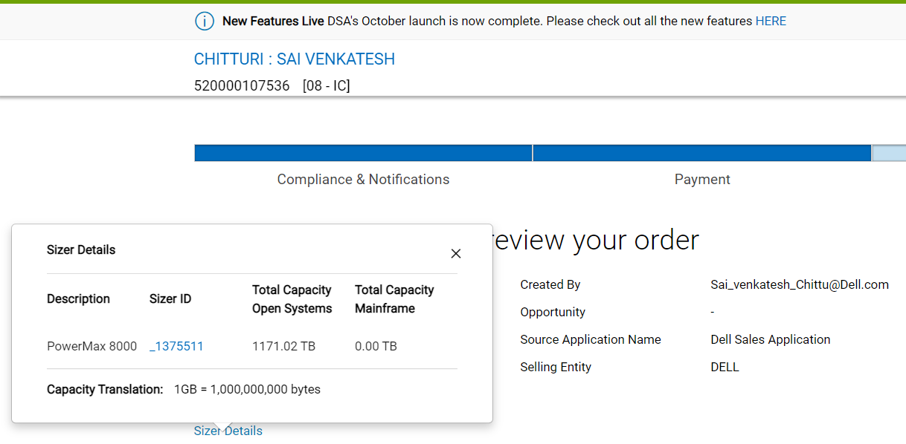

At Shipping Group Level,

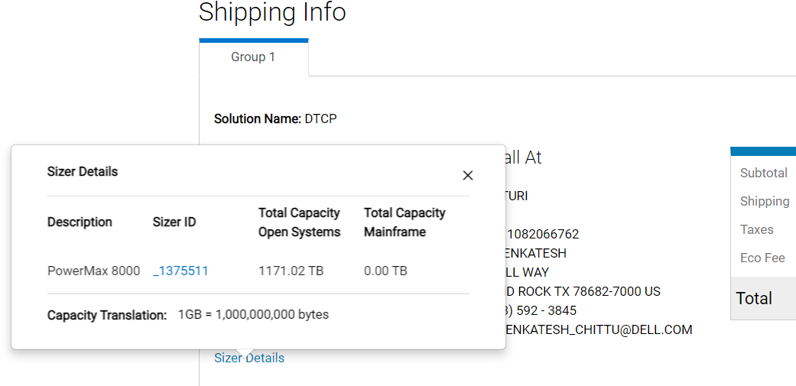

At Item Level,

