What is agile development process?
Entire development is divided in smaller services, these services are developed independently.
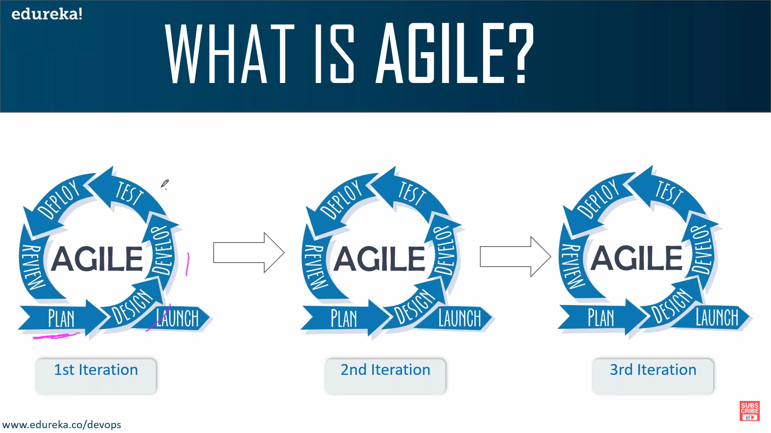
As we can see that launch is outside of the agile process.
This is because after the review of the service the application is finally launched to the live server so that the end user can access it.

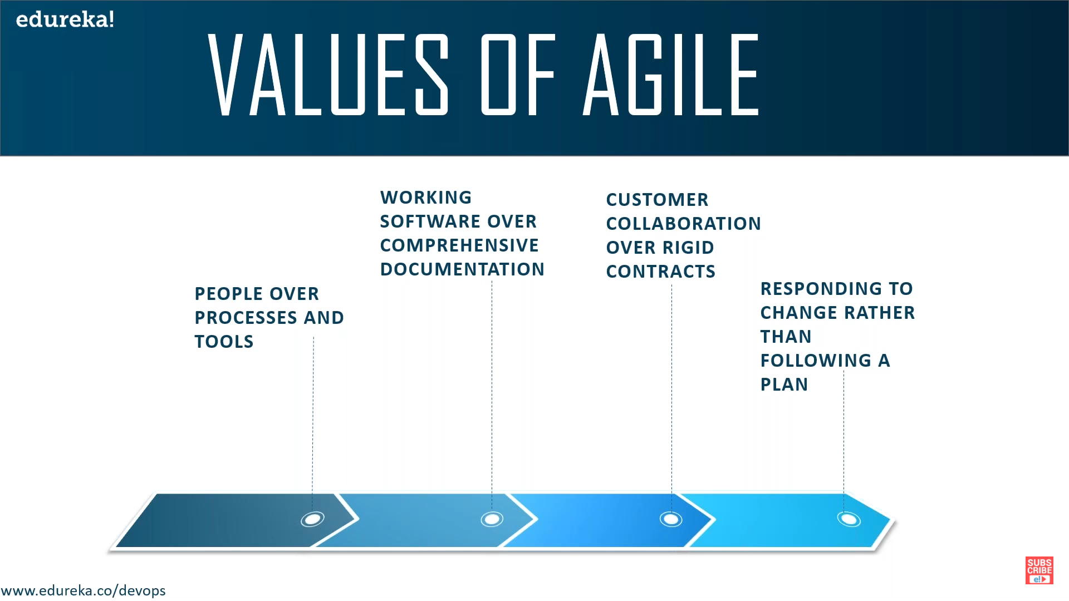
People over process and tools: people i.e. developers, end users are given more importance.
Working software over comprehensive documentation: You are more concerned about functional application is given much more importance than its documentation this is because the code itself is a documentation (if you can clearly understand the code).
Customer collaboration over rigid contracts: So the entire development is collaborative and feedback dependent.
Responding to change over following a plan: Just because the plan has been made that does not mean that there can not be any further changes.

Advantages of agile:
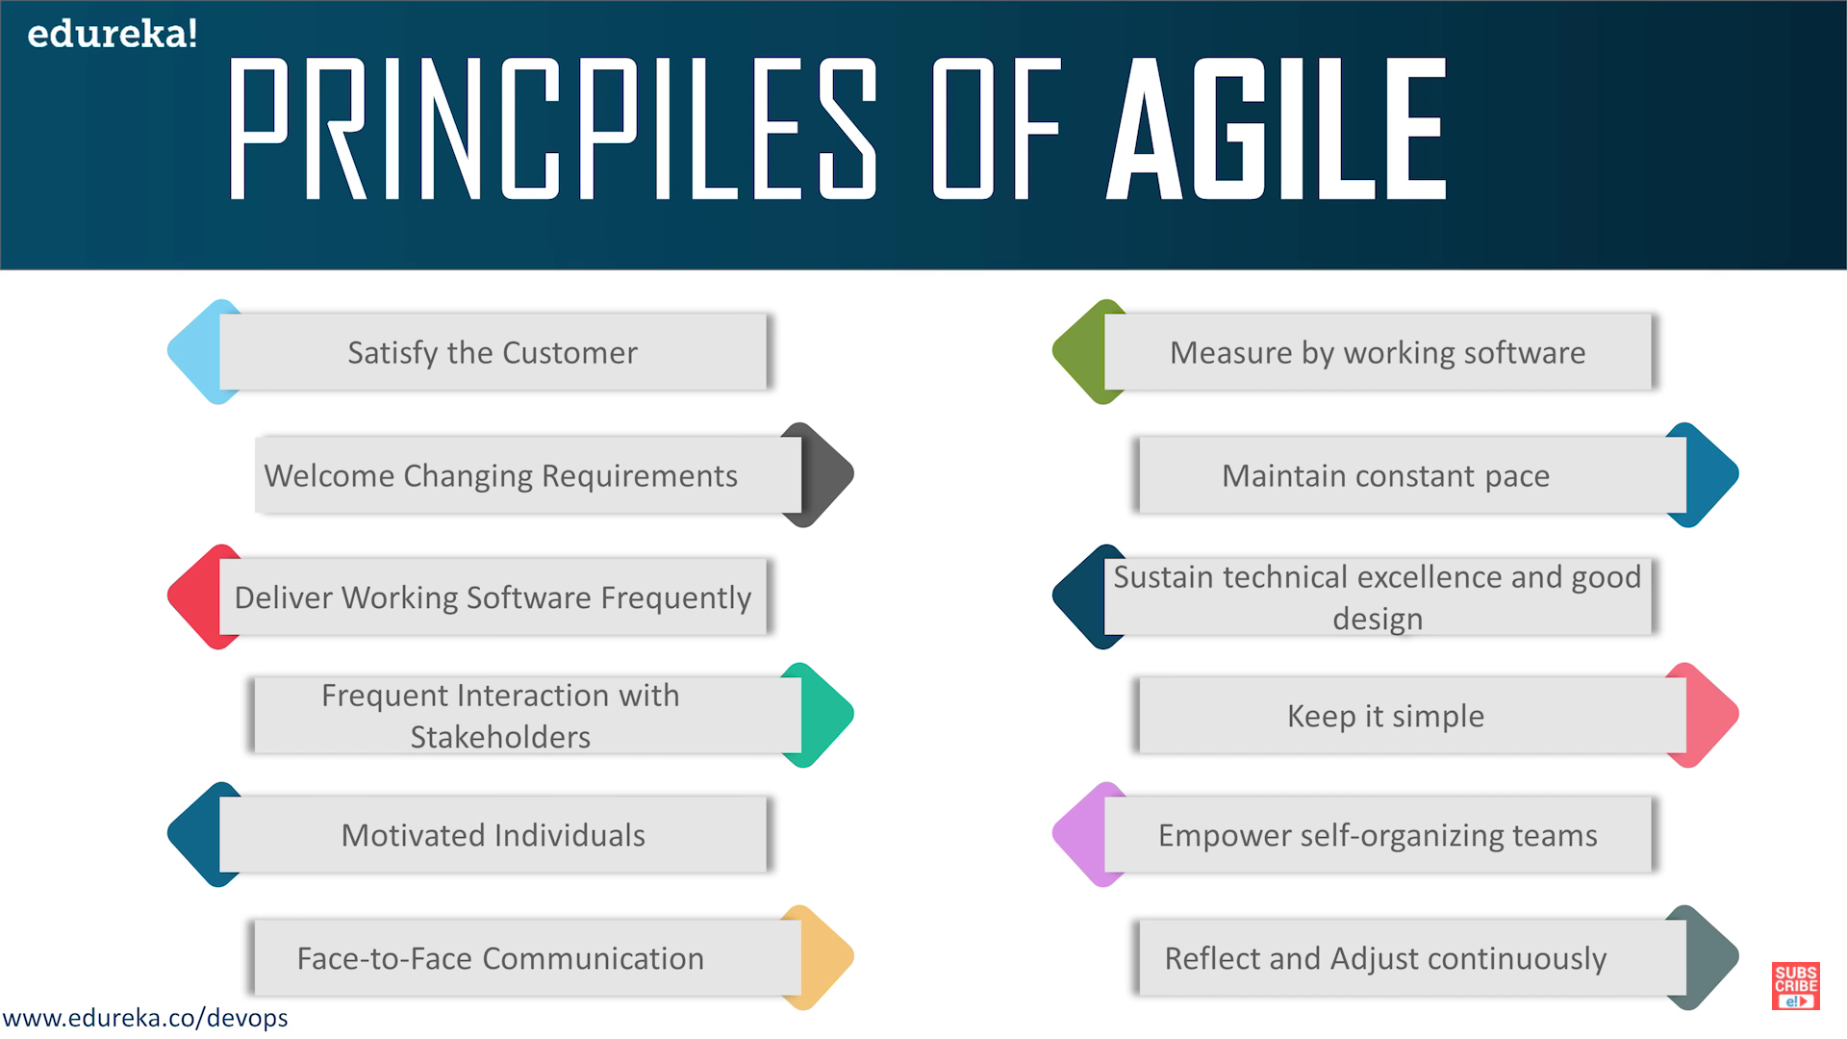
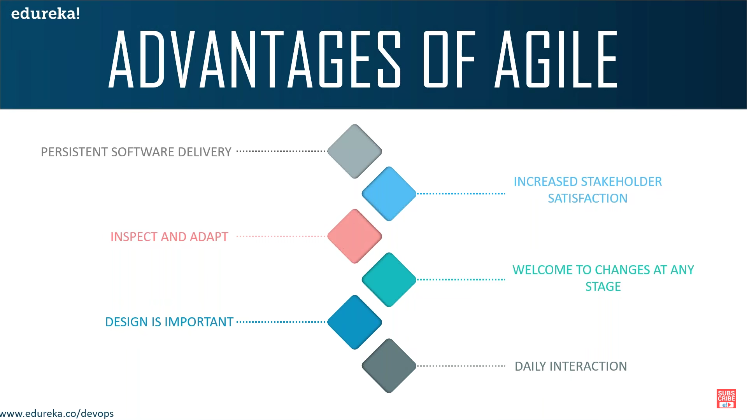
How to implement agile: (There are multiple frameworks or philosophy when it comes to development of the agile methodology
Example: scrum, eXtreme Programming, LEAN, Crystal)

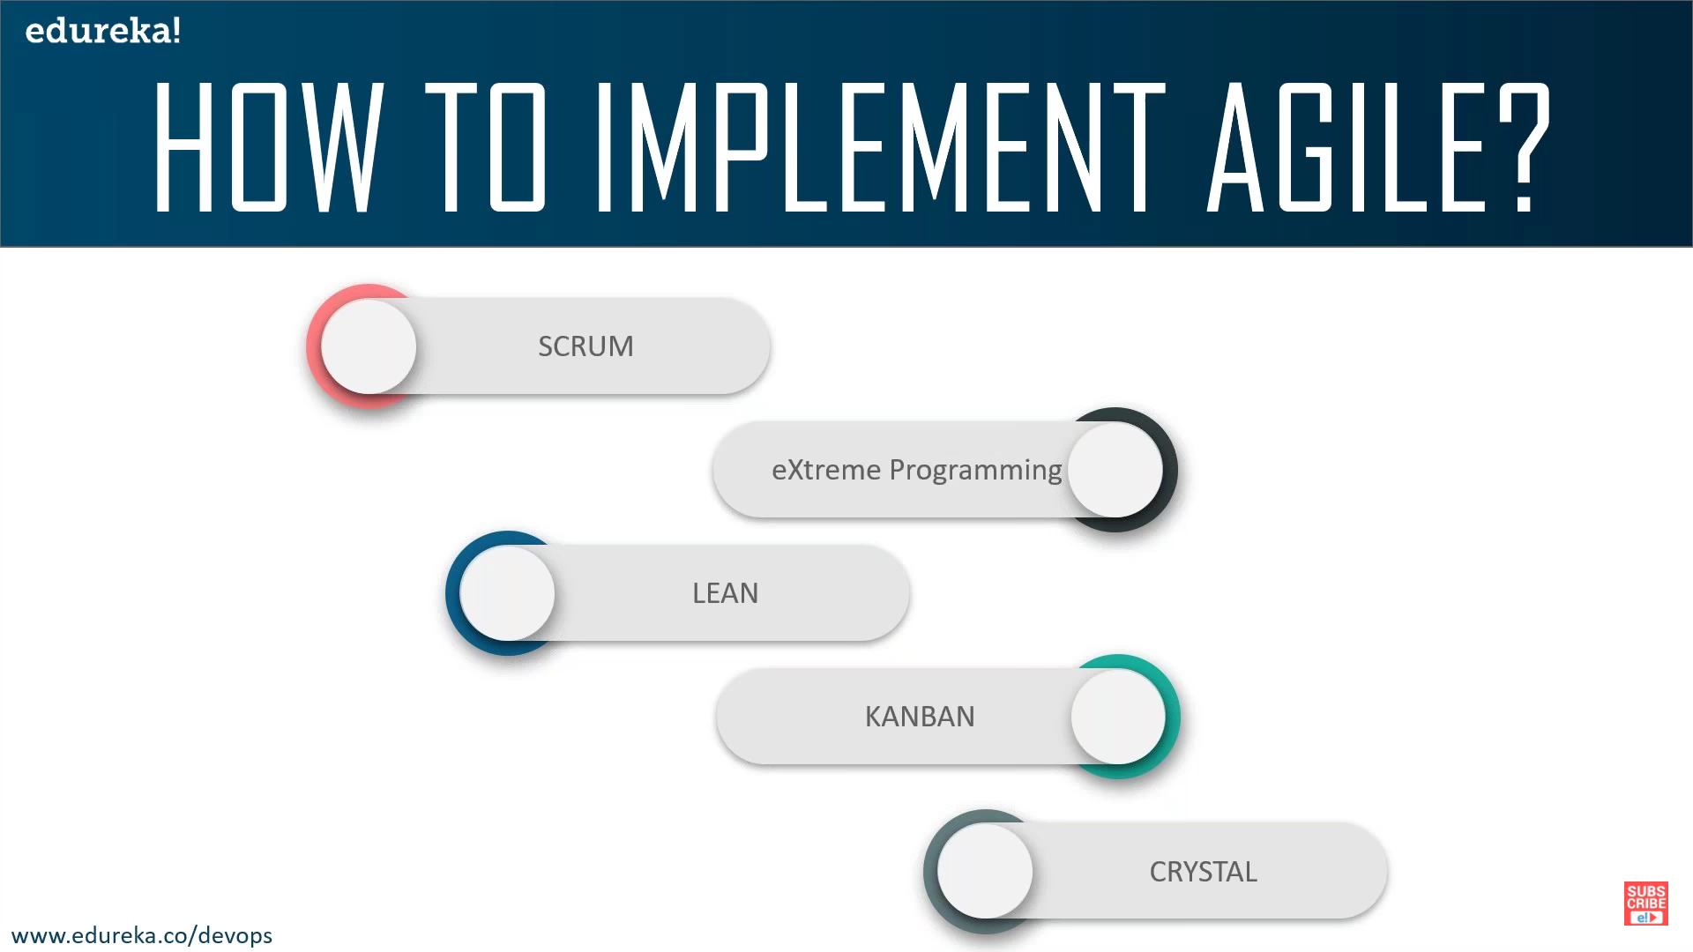
Scrum:
It is iterative philosophy
It is an iteration of plan, build, test, review (so we will be iterating over all of this)
People involved in the scrum team are:
Product owner: think of him/her as manager. He/she is responsible to make sure that the product is being build as per requirement (He may not be the technical guy)
Scrum Master: referred as Team leader or as a project owner. This is the person who is right below the product owner (manager).
This is the person who handles the day to day operation. Example the running the meetings, planning the task,
Team: consists of developer, testers and depending on the requirement we may have more roles.

Parts of the development:

Product backlog:
The same application that needs to be developed has been iterated over smaller tasks.
These tasks are called product backlogs that are supposed to be developed over a period of time.
Its the job of the product owner or scrum master (as the product owner may not be a technical guy) to divide the entire application into smaller tasks (product backlogs)
Cart ser
Plan
Build
Test
Review

Cat ser
Plan
Build
Test
Review

Auth ser
Plan
Build
Test
Review

EmailNtn
Plan
Build
Test
Review

FrontEnd
Plan
Build
Test
Review

Once we have the product backlogs there is something called user stories that comes into picture.
So, after the product backlogs have been decided these product backlogs(front End, Email Notification service, Auth service, catalogue service and cart service) will be called as User stories.
Now the product owner and the scrum master will prioritize different User stories.
Example: Front end > email notification >... etc.

Sprint backlogs:
Depending on the priorities that has been set product owner and the scrum master come up with something called as Sprint backlogs.
This comes into picture when your development teams gets involved because now you already have organized and priorities the user stories.
Sprint backlogs are logical tasks that are given to the developer so that the developer can start working on it.

Different ceremonies:

Sprint planning: The product owner will explain how he imagines the end goal or the product to look like.
Daily scrum: Daily 15 min stand up where the developers, testers give there progress on the assigned task. What did they do yesterday, what will they do today and do they need any assistance.
Sprint review: occurs at the end of the user stories or the backlog story that you (as a developer) have been working on (basically at the end of the sprint cycle).
Each of these User stories have a timeline of 2 weeks in mind. It may also vary from company to company but in majority of the cases each sprint will last for the 2 weeks.

Lets say it has been decided that in one sprit we will deliver 3 user stories. So, the sprint (mostly of 2 weeks) becomes the time line within which the decided stories needs to be delivered. If some of the stories are not completed in this sprint (It is called as Spillover), then they will be added to next sprint.

Scrum - A framework for managing a project, typically used as part of an Agile development model; Scrum, combined with Agile make up a holistic development methodology
Project - A collaborative effort that is planned around achieving a specific goal
Story - A description of a specific software feature from an end-user's point-of-view; a story is used as a requirement for developers to work from
Sprint - A work-cycle that has a set duration; most sprints are set at 2 weeks
So, the relationships between these things is this: Scrum provides the method by which projects get broken down into manageable pieces of work and executed. The manageable pieces of work are the stories. The stories describe one piece of work that needs to be done to make up the whole of the project. A project is made up of many stories. The sprint is simply a set duration in time, in which concentrated work will be done on selected stories.
