Links
Party Manifestos:

- Mahagathbandhan: https://res.cloudinary.com/dkplc2mbj/image/upload/v1761654865/Bihar_Mahagathbandhan_Manifesto_2025_ad3b8a8b7f.pdf

- NDA: https://www.bjp.org/files/election-manifesto-documents/NDA%27s-Sankalp-Patra-for-Bihar-Assembly-Elections-2025.pdf

List of 40 star campaigners:
- Mahagathbandhan:
source:https://www.indiatvnews.com/bihar/news-bihar-elections-2025-congress-releases-list-of-40-star-campaigners-for-phase-1-polling-including-rahul-gandhi-kharge-gehlot-sachin-pilot-2025-10-26-1014464
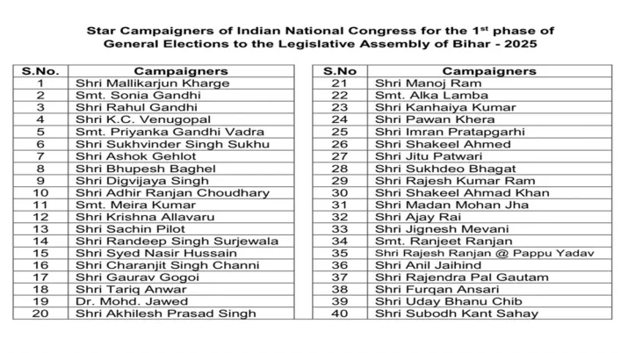
- NDA:
PM Narendra Modi, JP Nadda, Rajnath Singh, Amit Shah, Nitin Gadkari, Shivraj Singh Chouhan, Dharmendra Pradhan, Giriraj Singh, Yogi Adityanath, Devendra Fadnavis, Himanta Biswa Sarma, Mohan Yadav, Rekha Gupta, Smriti Irani, Keshav Prasad Maurya, CR Patil, Dilip Kumar Jaiswal, Samrat Choudhary, Vijay Kumar Sinha, Renu Devi, Prem Kumar, Nityanand Rai, Radha Mohan Singh, Sadhvi Niranjan Jyoti, Satish Chandra Dubey, Raj Bhushan Chaudhary, Ashwini Kumar Choubey, Ravi Shankar Prasad, Nand Kishore Yadav, Rajiv Pratap Rudy, Sanjay Jaiswal, Vinod Tawde, Babulal Marandi, Pradeep Kumar Singh, Gopalji Thakur, Janak Ram, Pawan Singh, Manoj Tiwari, Ravi Kishan, Dinesh Lal Yadav ‘Nirahua’.
source:https://timesofindia.indiatimes.com/city/patna/prime-minister-narendra-modi-amit-shah-among-40-bjp-star-campaigners/articleshow/124609207.cms

Sample URLs:
- For NDA:
  - https://www.youtube.com/live/V0I-UH0tleE?si=QQBKgJc0rc-DxURS
  - https://www.youtube.com/live/ZIGV6RlNSnc?si=bWEYj2EJ5cSW3m1P
  - https://www.youtube.com/live/lX3uyD1Dg_I?si=cimWj0zxrkjRQkkG
  - https://www.youtube.com/live/q0rdJycUsSw?si=TTYy2oPjNoSVI2dx
  - https://www.youtube.com/live/cSSploT1J1E?si=JA5e7XXaaykIsirQ

- For Mahagathbandhan:
  - https://www.youtube.com/live/6lEnnfMSFDM?si=YLW2aUEtJ5tBMGnb
  - https://www.youtube.com/live/PCyBbVsRTXY?si=fCrwwLvB3KhCdfgQ
  - https://www.youtube.com/live/nCItmNzLJRo?si=Z0Lua20JKe6Deqr4
  - https://www.youtube.com/live/UnOe5Xwvads?si=LwCI9TA_slAsNeE5
  - https://www.youtube.com/live/nuzYwNIyqZk?si=HUU_XHjTszuATuai

Methodology
- Download videos/audios using: yt-dlp.
- Audio to Text: https://huggingface.co/vasista22/whisper-hindi-large-v2
- Text from PDFs of manifestos:
- Topic modeling/Topic extraction of the speeches: (e.g., about unemployment or the opposite party)
  - To find a list of some key topics that were discussed in the speeches, and
  - also stats such as, the time was given to each of those topics.
- Similarity checks between the documents.

Meeting_minutes
19 May:
- Start with downloading 2 and later videos from each party alliance
  - Text from PDFs of manifestos
- Convert the audio to text using whisper model for hindi
- We will discuss (1, 2, and one step for similarity comparison) on 23 May (online).
- Amisha will help in getting the text from Pdfs after monday, meanwhile try OCR for Mahagathbandhan manifesto.

23 May (Online):

