**PROJECT**

1. Create a Movie Search Mania which has the following Section:

* Header: Add a heading for to-do list
* Input box: Include an input box in which user will enter the list item and item will be reflected below like MovieName1, MovieName2 respectively.
* Add button: Item is included in the list once user click on Add button.
* Search bar: It will search for items from To-do List items.
* Display to-do list item as entered by the user.
* Delete button: Will remove data from the list
* You can use any other color and you can choose any other item, e.g.: you can create Grocery search, where user can search for an item.
* Choose any design layout, make it responsive

**Sample:**

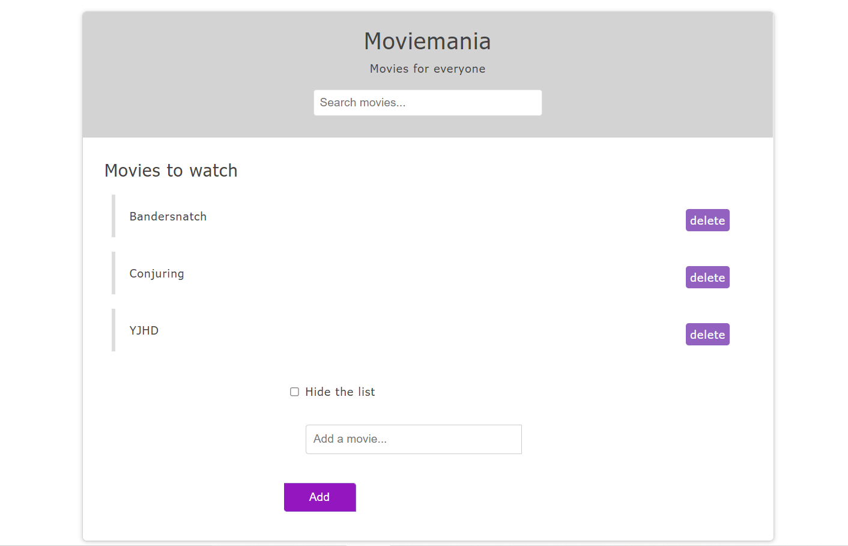

2. In your existing Bootstrap Project, add form validation.