POINTERS

General Syntax

Datatype *Var_name;

Int *ptr;

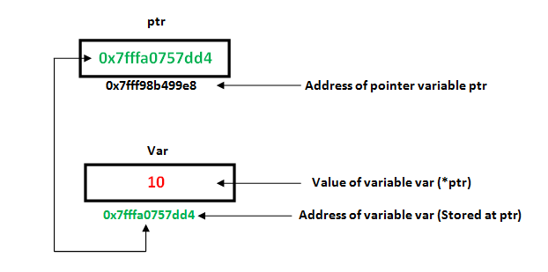

Operation that can be performed on Pointer

++(increment),- -(Decrement),+,-

Main point These operation mostly help on array

Printing an array using Pointer

//array of pointers

#include<iostream>

using namespace std;

int main(){

/*int arr[]={11,12,13};

int *ptr=arr;

for(int i=0;i<3;i++){

cout<<*ptr++<<" ";

}*/

Pointer And Multi Dimension Array

int nums[2][3] = { {16, 18, 20}, {25, 26, 27} };

Doubt

Application of Pointer

**To pass arguments by reference**. Passing by reference serves two purposes

1. **To modify variable of function in other.Swap two variable example**

For Accessing Array elements.

Compiler Internally Uses pointer to access Array

--Basically 2-D array pointer concept

To Return multiple Values

Dynamic Memory Allocation

Easy to use with Data Structure

--References can’t be used because of their fixed location

To Do system Level programming where memory address is useful