**# create vpc**

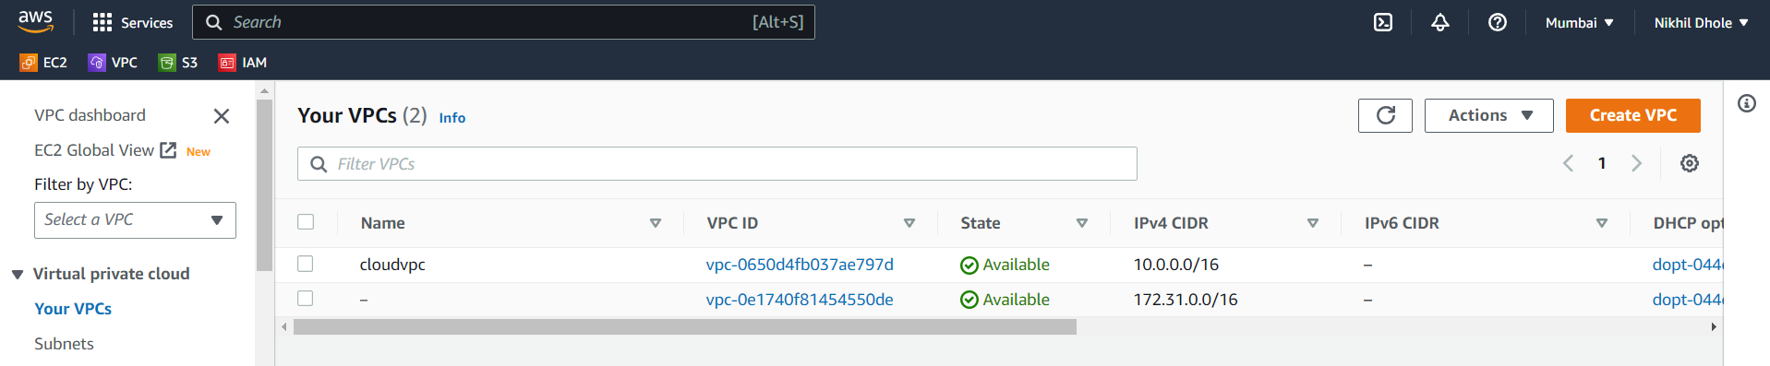

**# create subnets**

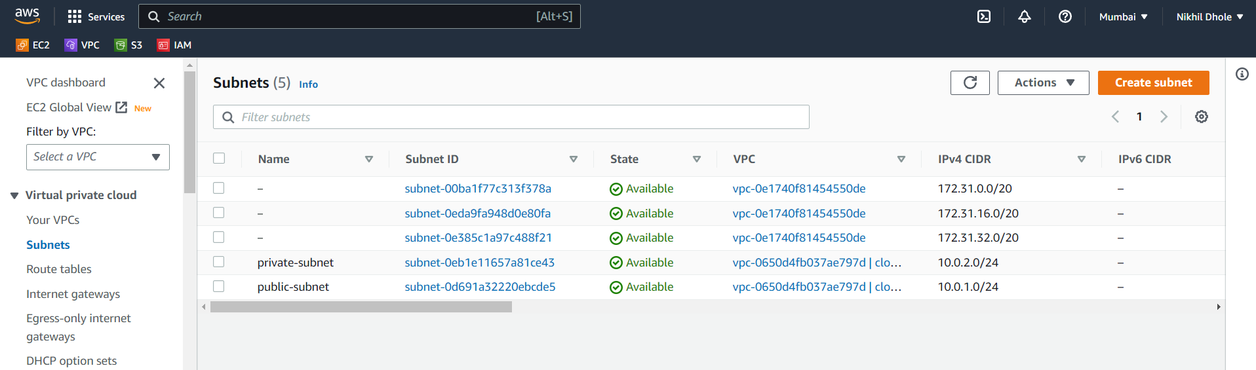

**# create security group**

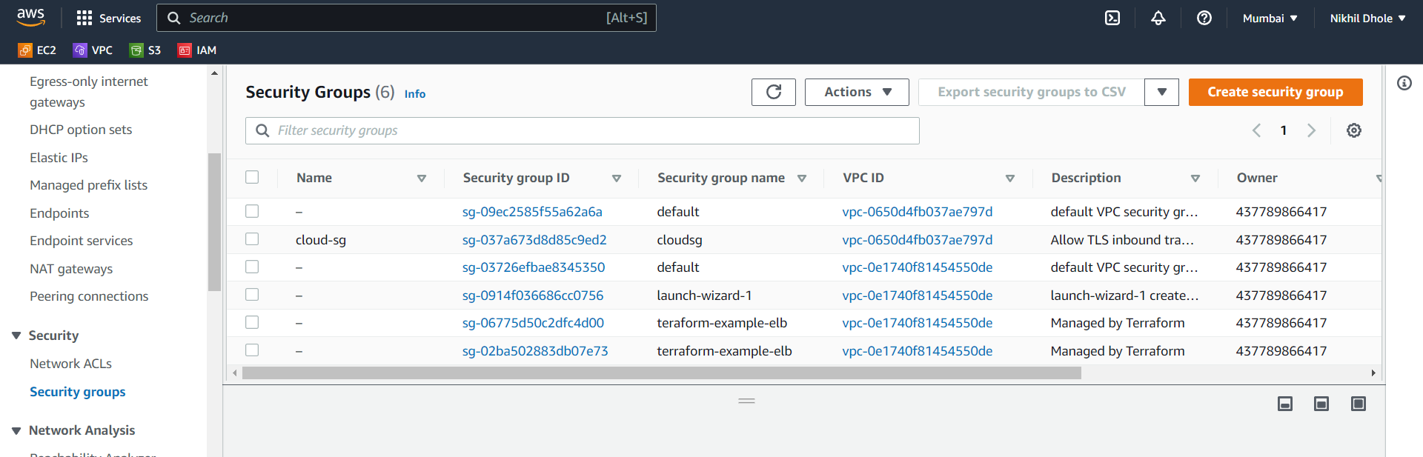

**# create internet gateway**

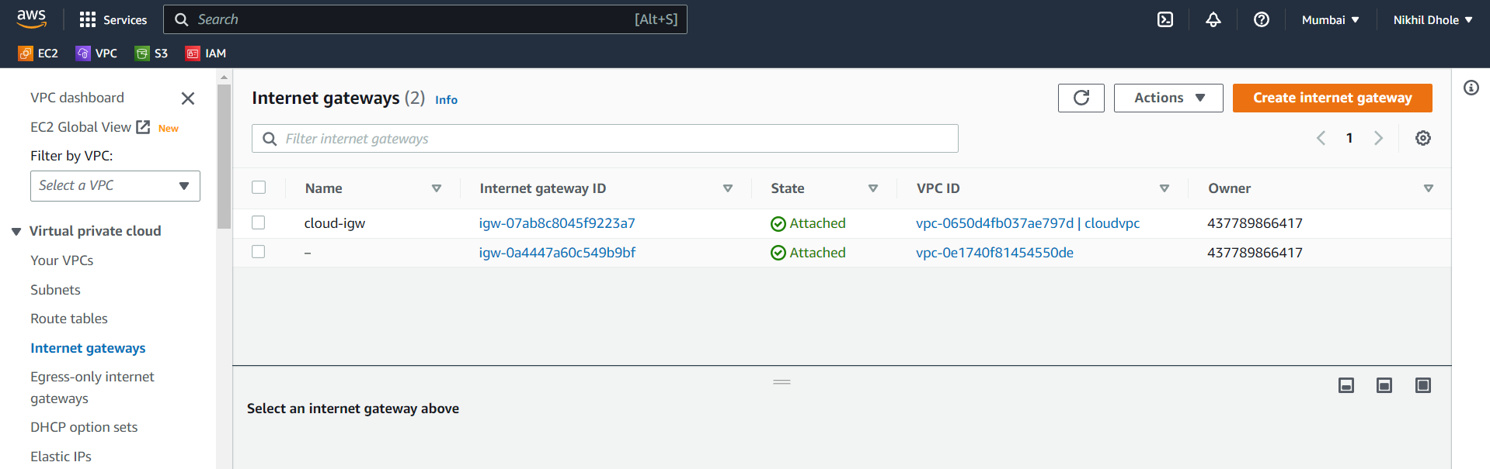

**# create route tables**

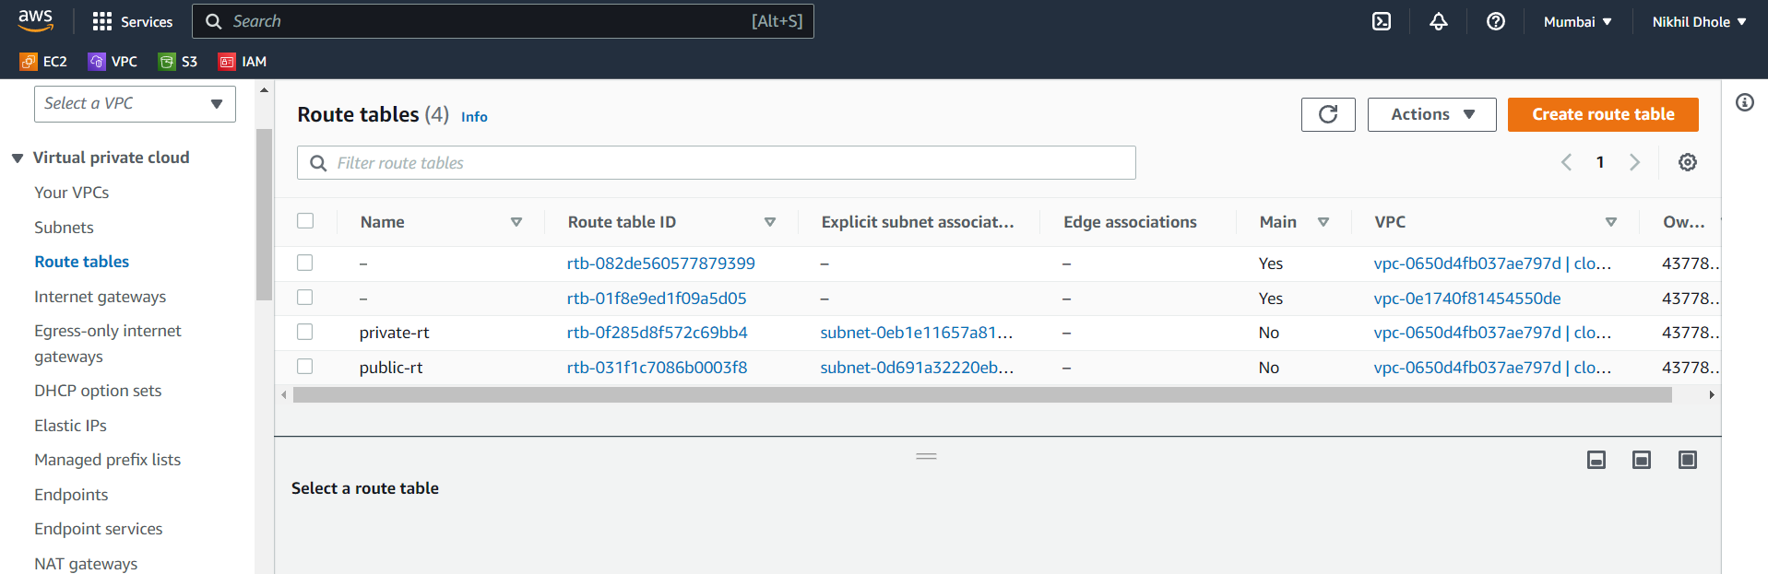

**# create route table associations**

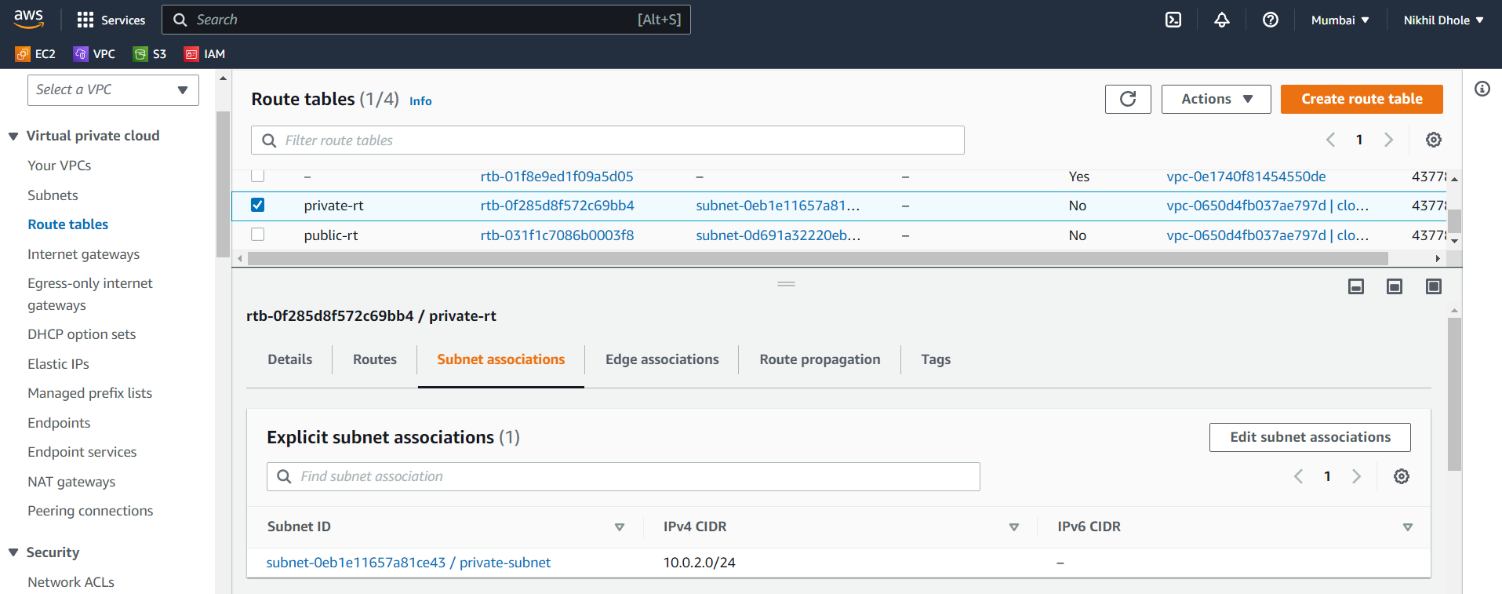

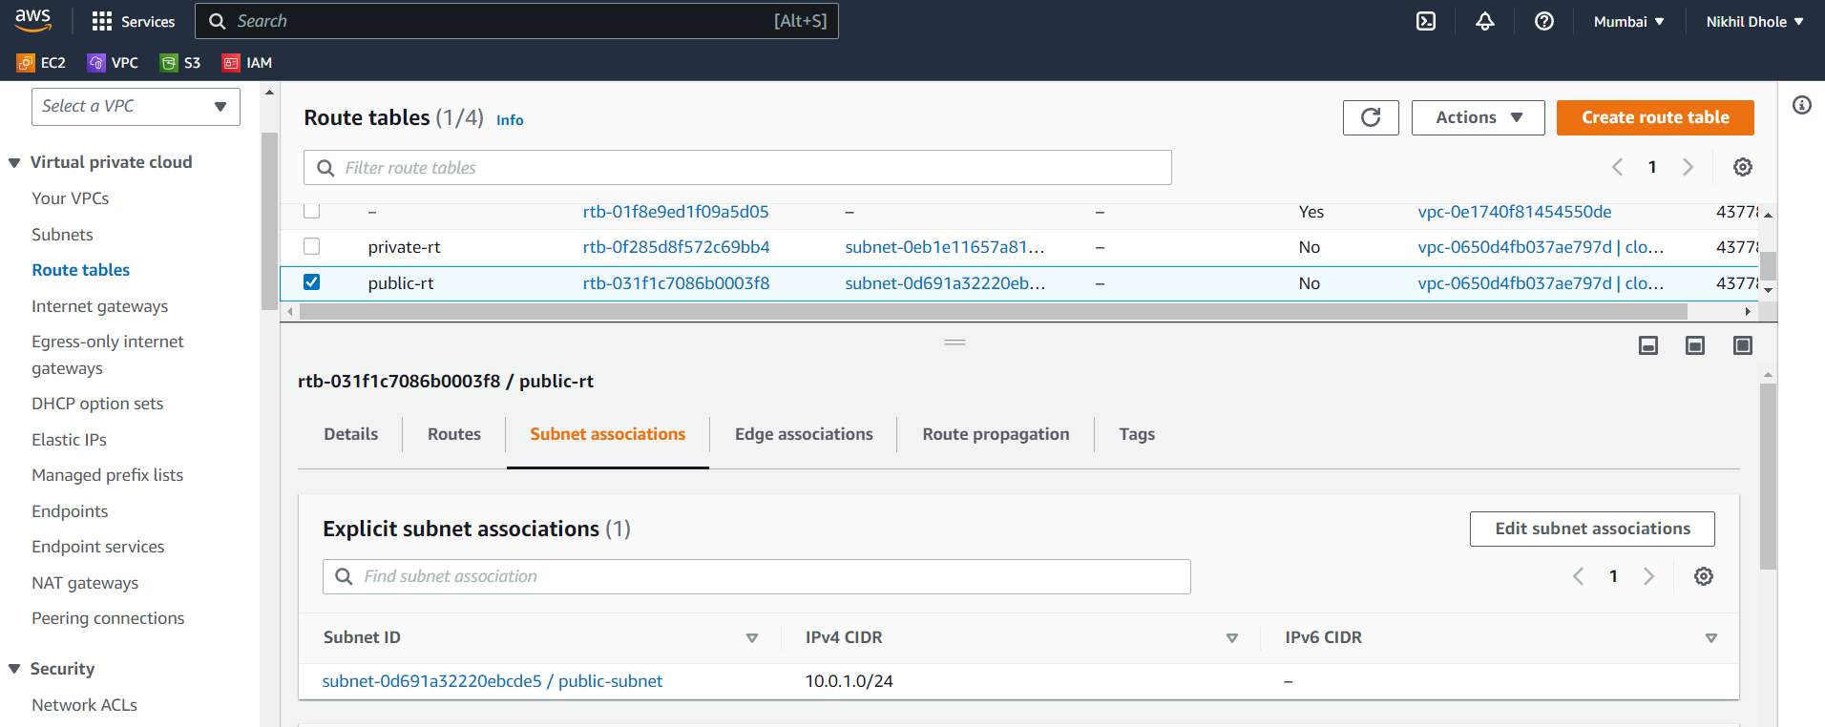

**# create instance**

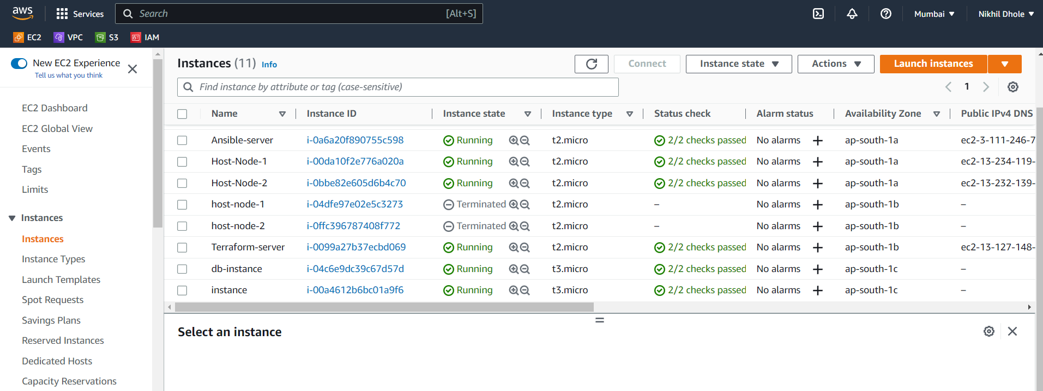

**# Create a Launch Configuration**

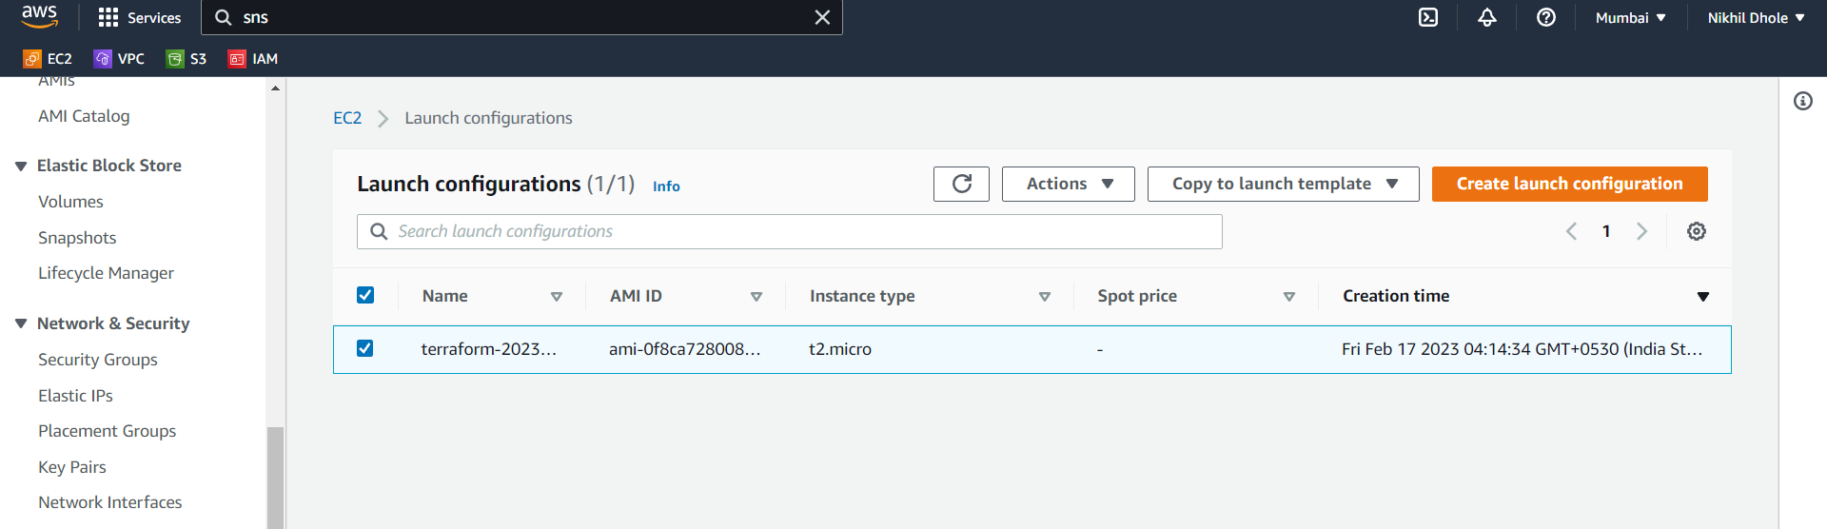

**# Create an Auto Scaling Group**

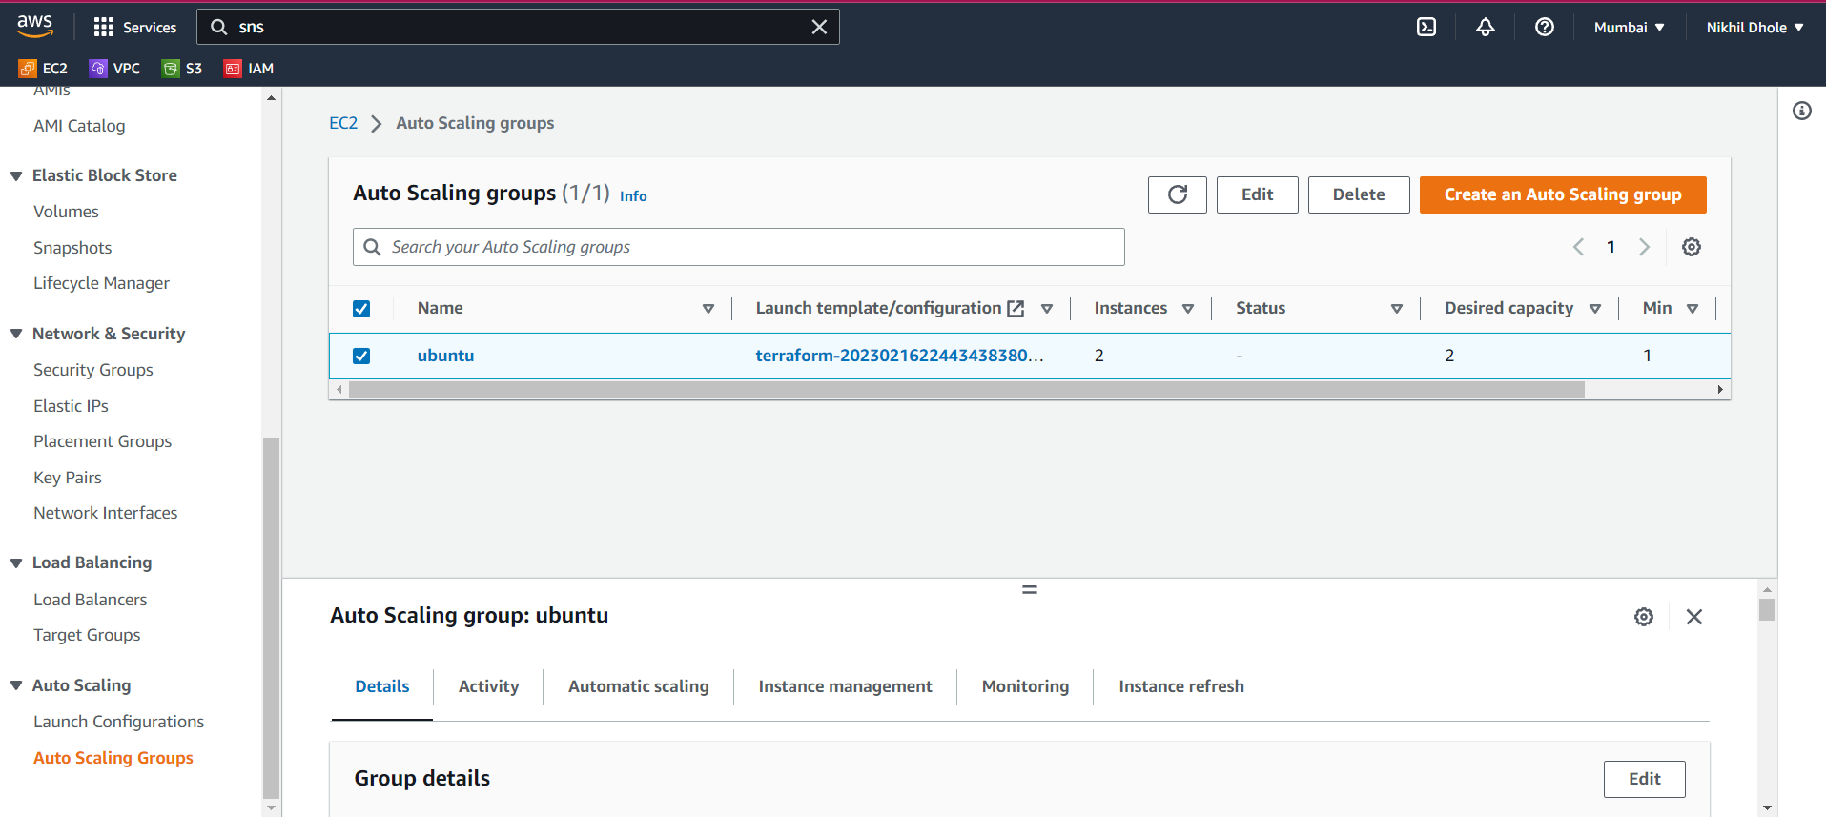

**#create MySQL RDS**

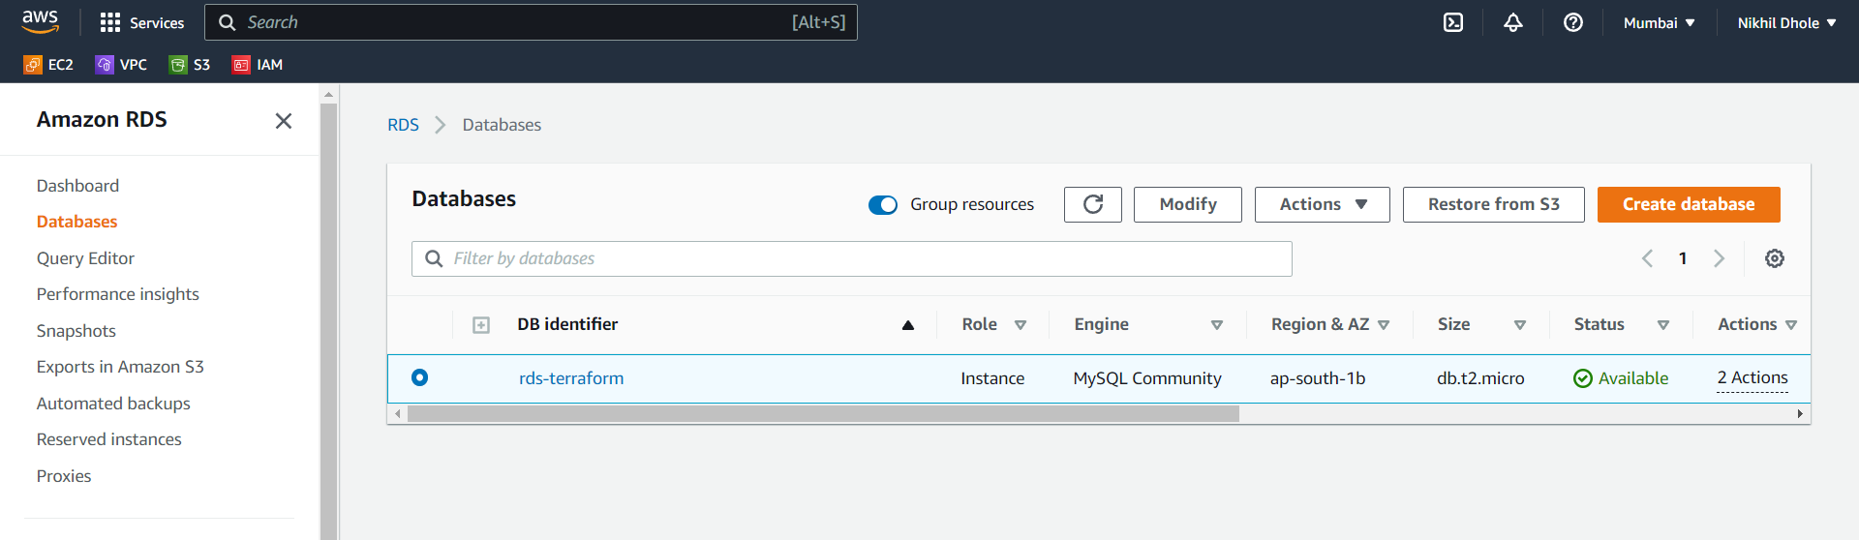

**# create a target group**

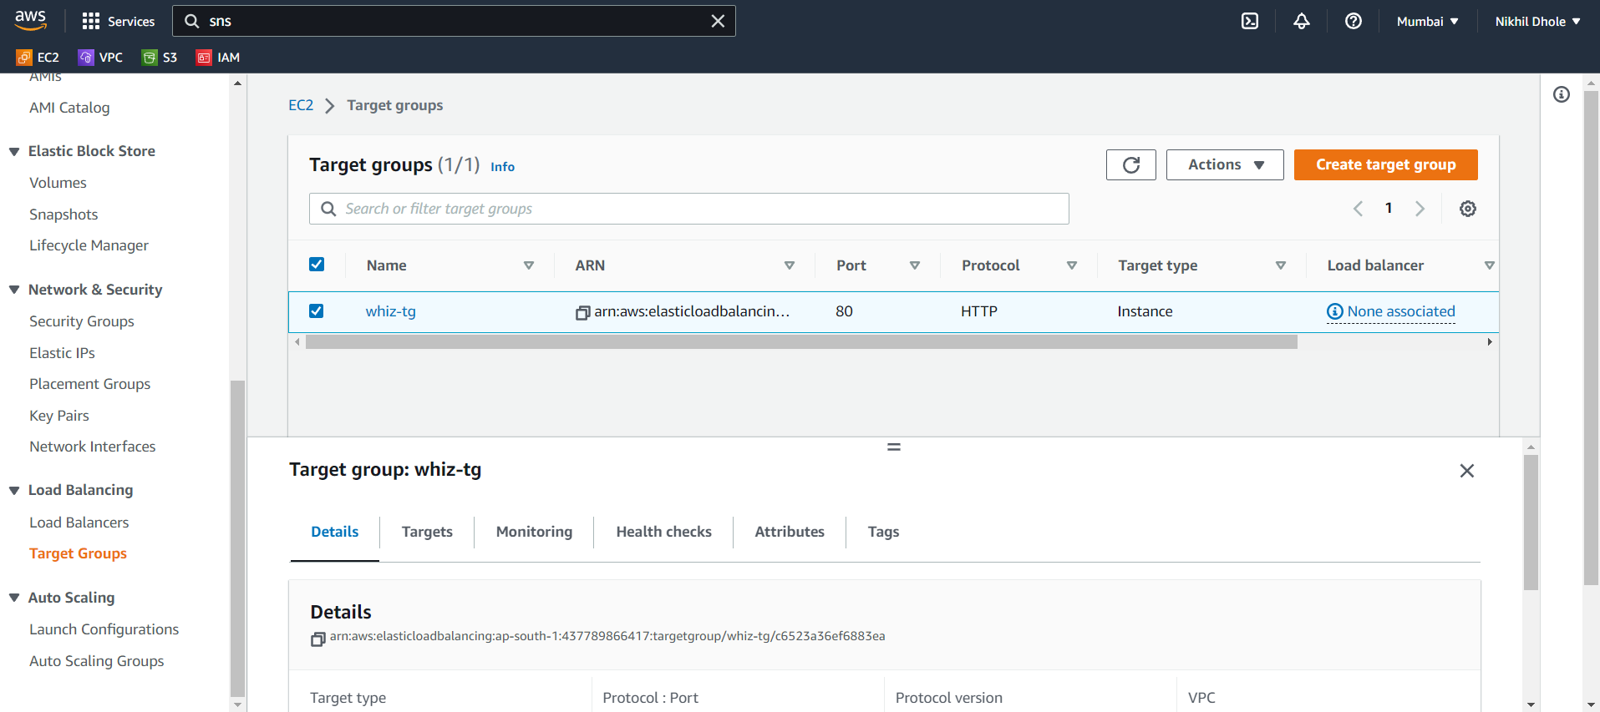

**#create cloud watch**

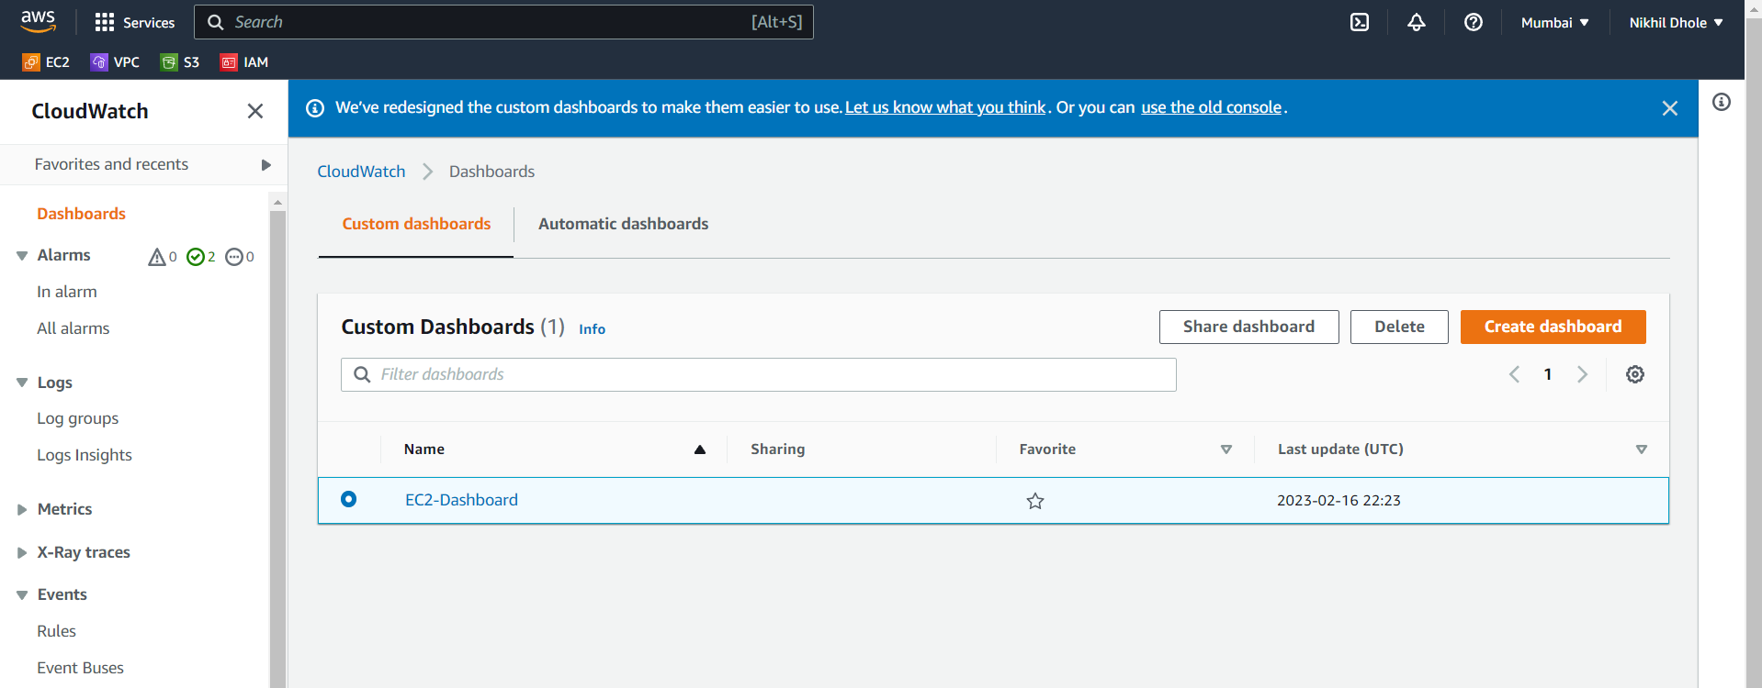

**# create cloudwatch alarm**

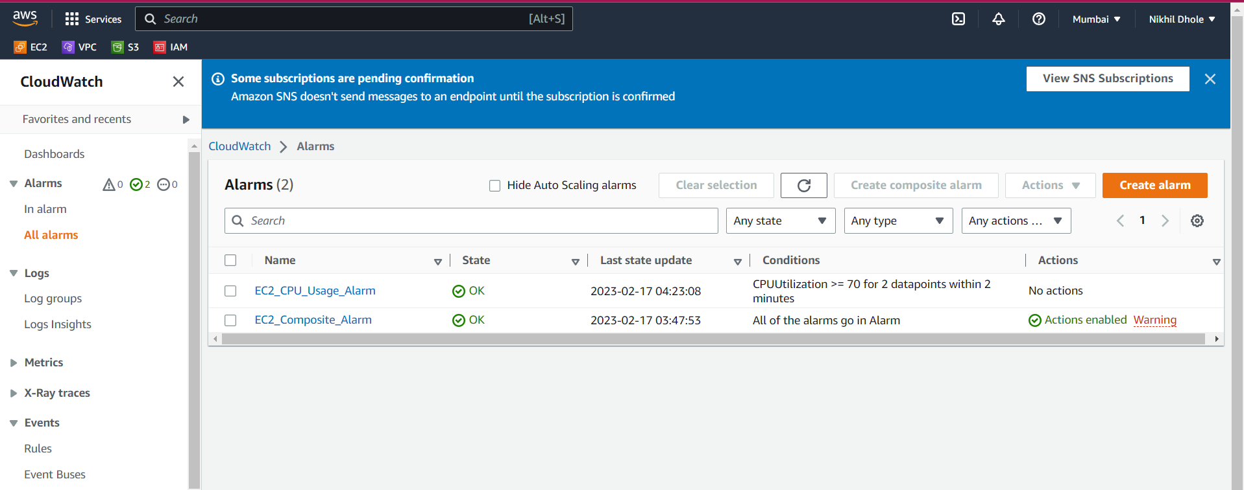

**# Creating the AWS CLoudwatch Alarm that will autoscale the AWS EC2 instance based on CPU utilization.**

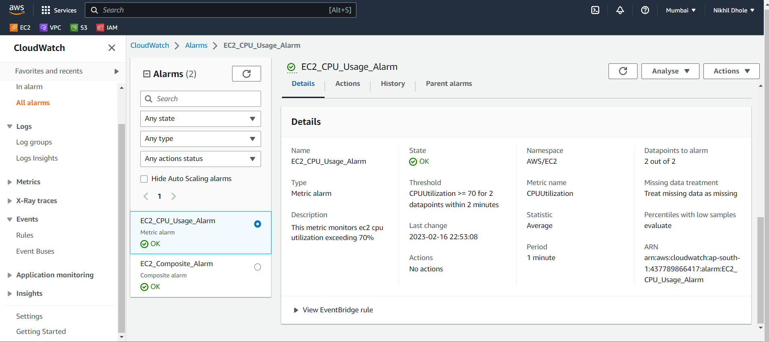

**# create a cloud watch log group**

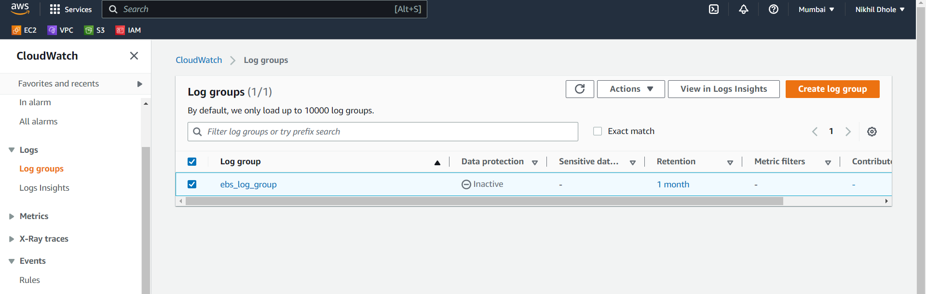

**# create sns topic and subscription**

