**ABSTRACT**

In a mythical world, there is a fighting contest where each fighter fights a monster and needs to defeat monsters as many as possible. A fighter called Geralt has got advantage over others as Geralt can use energy drink which increases his energy but these energy drinks contains toxicity (poison) in it.

So, using these energy bottles and taking into consideration that these bottles also contain toxicity we need to find the maximum number of monsters Geralt can kill provided particular number of potion bottles (energy drink). Also we must take care that Geralt energy must not exceed more than 100 and if toxicity must be less than 100.

**PROBLEM STATEMENT**

A fighter Geralt fights monsters using potion bottles so using these bottles we need to find maximum no of monsters Geralt can defeat.

**PROBLEM DESCRIPTION**

In a mythical world, there is a fighting contest where each fighter fights a monster and needs to defeat monsters as many as possible. Among fighter tribes, a Witcher tribe has advantage over others since they can take energy-boosting potions. These potions instantly increase his or her energy and as long as a Witcher does not run out of energy, he will not be knocked out. Unfortunately, these potions contain toxicity and he can drink at most one potion bottle once he defeats each monster.

Geralt, a legendary Witcher, enters this tournament with N potion bottles. Each bottle has its own strength and toxicity level. If he drinks a potion with strength E, his energy increases by E units, but it will not exceed 100. Potion with toxicity level P increases toxicity level in his blood by P units. If the toxicity level in blood reaches 100, Geralt will be knocked out. In T minutes, his blood toxicity level reduces by T units too. This allows Geralt to safely drink another potion bottle.

Task is to analyze potion and monster data. Then, tell Geralt the maximum number of monsters he can defeat before he will be knocked out. Assume that all monsters are the same (need the same amount of energy and time to be defeated). Furthermore, if the needed energy is K units and Geralt has K or less energy units, Geralt will not be able to defeat a monster.

**REQUIREMENT SPECIFICATION**

1. The number of test cases should be no more than 20 i.e. user can enter at maximum 20 cases to test.
2. Energy required by Geralt to kill one monster should be between 10 to 80 energy units i.e. user can enter maximum 80 energy units and minimum 10 energy units to kill one monster.
3. Time required by Geralt to kill one monster should be not more than 100 time units i.e. user can enter maximum 100 time units to kill one monster.
4. Number of potion bottles that Geralt uses to gain energy should be between 1 to 8 i.e. user can enter maximum 8 potion bottles and minimum 1 bottle for Geralt to use in case if Geralt is out of energy.
5. Energy in one potion bottle should be between 1 to 100 i.e. user can enter maximum 100 energy unit in one bottle and minimum 1 energy units so that Geralt can take that energy can continue killing monsters.
6. Toxicity level in one potion bottle should be between 1 to 100 i.e. user can enter maximum 100 toxicity level in one bottle and minimum 1 toxicity

**REQUIREMENT ANALYSIS**

**Input notations :-**

C – no of test cases (C<=20)

K- Energy required to kill one monster.(10<=K<=80)

M- Time required to kill one monster. (M<100)

N- No. of bottles of potion.(1<=N<=8)

E- Energies in potion bottles.

P- Toxicity level in potion bottles.(1<=Ei , Pi<=10

**Output notation :-**

NoM :- no of monsters Geralt can defeat according to given inputs.

The first line contains a positive integer C ≤ 20, representing the number of test cases. For each test case, the input is as follows:

**Line 1-** contains positive integers K and M where K and M are the amount of energy and time that Geralt needs to spend for each monster. Also, 10 ≤ K ≤ 80 and M ≤ 100

**Line 2-** contains N, the number of potions Geralt has where 1 ≤ N ≤ 8.

**Line 3-**contains positive integers E1, E2, E3, . . . , EN , the potion strength of bottles 1 to N.  **Line 4-** contains positive integers P1, P2, P3, . . . , PN , the potion toxicity level of bottles 1 to N. (1 ≤ Ei , Pi ≤ 100)

TEST CASES

Test case 1:

30 20 - energy and time to kill one monster.

6 - no of potion bottles

30 30 50 100 40 50 - energies in each bottle

10 30 80 90 50 60 - toxicities in each bottle

|  |  |  |  |  |  |
| --- | --- | --- | --- | --- | --- |
| Balance | E | P | Geralt Energy | Geralt Toxicity | Monsters killed |
| - | - | - | 100  - 30  70 | 0 | 0  +1  1 |
| - | - | - | 70  - 30  40 | 0 | 1  +1  2 |
| - | - | - | 40  - 30  10 | 0 | 2  +1  3 |
| - | 100 | 90 | 10  + 100  100 | 0  + 90  90 | - |
| 10 | - | - | 100  - 30  70 | 90  -20  70 | 3  +1  4 |
| 10 | - | - | 70  - 30  40 | 70  -20  50 | 4  +1  5 |
| 10 | - | - | 40  - 30  10 | 50  -20  30 | 5  +1  6 |
| 10 | 50 | 60 | 10  + 50  60 | 30  +60  90 | - |
| 10 | - | - | 60  - 30  30 | 90  - 20  70 | 6  +1  7 |
| 10 | 30 | 10 | 30  + 30  60 | 70  +10  80 | - |
| 10 | - | - | 60  - 30  30 | 80  - 20  60 | 7  +1  8 |
| 10 | 30 | 30 | 30  + 30  60 | 60  +30  90 | - |
| 10 | - | - | 60  - 30  30 | 90  - 20  70 | 8  +1  9 |
| - | - | - | 30  + 10  40 | - | - |
| - | - | - | 40  - 30  10 | 70  - 20  50 | 9  +1  10 |

Test case 1: **10** - maximum no of monsters killed

**PROBLEM SOLUTION**

**Main Algorithm**

1. Start
2. Get no. of test cases.
3. Check if test cases are less than or equal to 20.
4. Yes: continue to program
5. If No : Enter correct no. of test cases.
6. while test cases not equal to 0.
7. Get amount of energy required to kill one monster(K) and time to kill one monster(M).
8. Check 10 <= k <= 80.
   1. if yes , ask time.
      1. -if no , ask to enter correct value between 10 to 80
9. Check is M <100
   * 1. -if yes next step.
     2. -if no , ask to enter correct value less than 100.
10. Get the number of potion bottles(N)
    * 1. -check N should be between 1 to 8.
11. Get energy (E) and toxicity level (P) in each bottle.
12. Set the initial energy to 100 and toxicity level to 0.
13. Arrange the entered potion bottle in ascending order according to their energy levels.
14. While no . Of potion bottles not equal to 0.
15. While (Geralt energy > required energy )
    1. increment the number of monsters killed.
    2. Geralt energy = Geralt energy –required energy.
    3. Geralt toxicity= Geralt toxicity- Time Required.
    4. go back to step 15 .
16. Check if geralt toxicity +toxicity level of last potion bottle is >=100
17. Yes- a) Check if balance energy != 0
    * 1. b) Yes – i)Geralt Energy = Geralt Energy + balance Energy.
         + 1. ii)Set balance energy to 0.
           2. iii) check if Geralt energy greater than required energy.
           3. iv) Yes- go back to step 10.
      2. c) Decrement no of potion bottles.
18. Use potion bottle i.e. increment geralt energy by energy provided by potion bottle.
19. Check if Geralt energy greater than 100
20. Yes : a) Balance energy = geralt energy – 100
    * 1. b)Geralt energy = geralt energy – balance energy
21. Geralt toxicity = Geralt toxicity + toxicity level of potion used
22. Decrement no. of potion bottles.
23. Go back to step 9.
24. Print max no. of monsters killed.
25. Decrement no. of test cases.
26. Go back to step 6.
27. End.

**FLOWCHART**

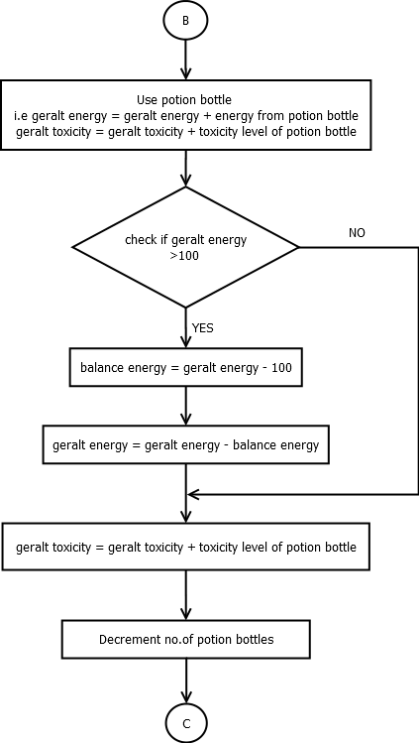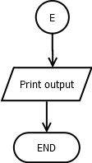

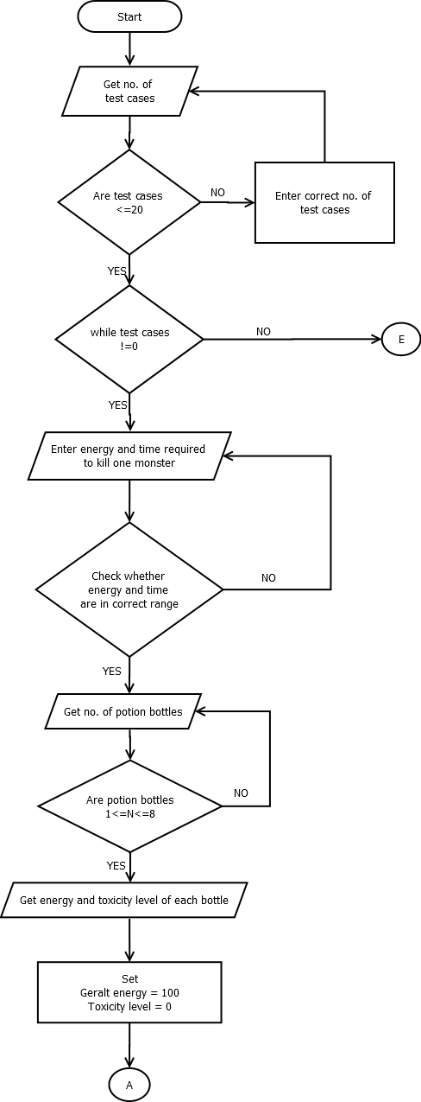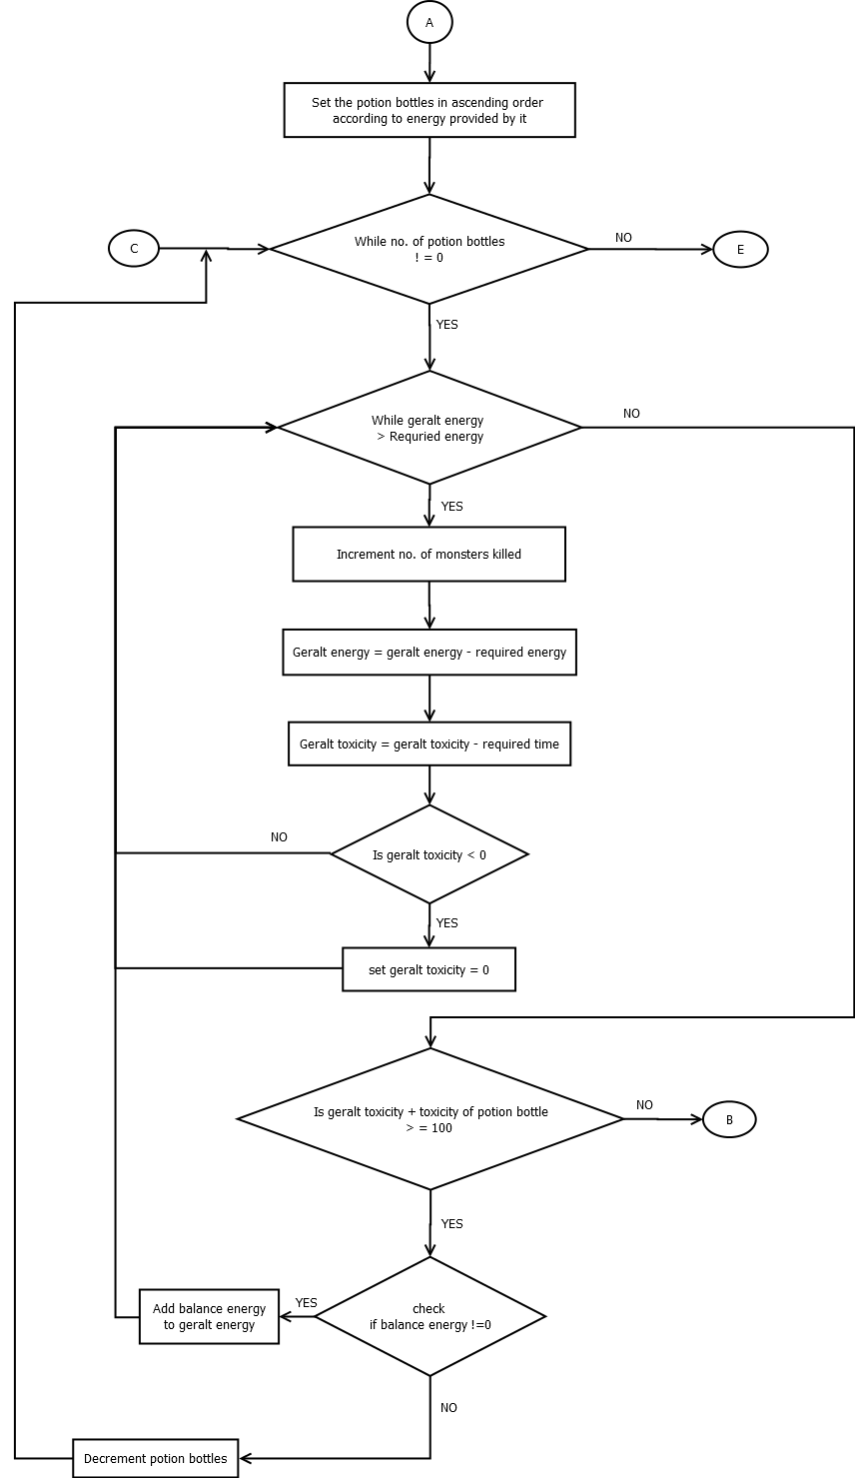

**SNAPSHOT**

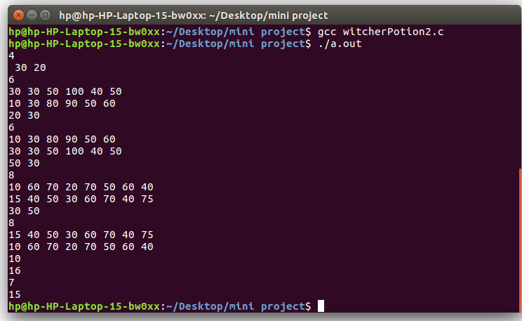

**CONCLUSION**

Given the required energy and time to kill one monster we found out maximum no. of monsters Geralt can defeat, also provided that Geralt can use the potion bottles which contains particular amount of toxicity and energy.

**REFERENCES**

Books:

* Let Us C

Web-links:

* <https://www.codewithc.com/c-projects-with-source-code>**.**