Wireframe / Mock-up Templates

# Page Name / Feature Area

Client Risk Profiling Questionnaire

# Purpose of the Screen

To capture client responses through a dynamic and adaptive questionnaire that helps determine the risk profile accurately.

# Wireframe or Sketch

- Header with client name/context  
- Progress bar showing completion status  
- Dynamic question container with radio/select inputs  
- Navigation buttons (Next, Previous, Save/Resume later)  
- Help icon/tooltips for behavioral explanation

# Annotations / Notes

- Each question dynamically adapts based on client responses  
- Save/Resume option allows partial completion  
- Help tooltips provide clarity for non-technical users

# User Flow (optional)

Client completes questionnaire → Profile score generated → Advisor review

# Version / Iteration Number

Version 1.0

# Feedback from Stakeholders

- Liked progress bar for transparency  
- Suggested simplifying language of some risk-related questions

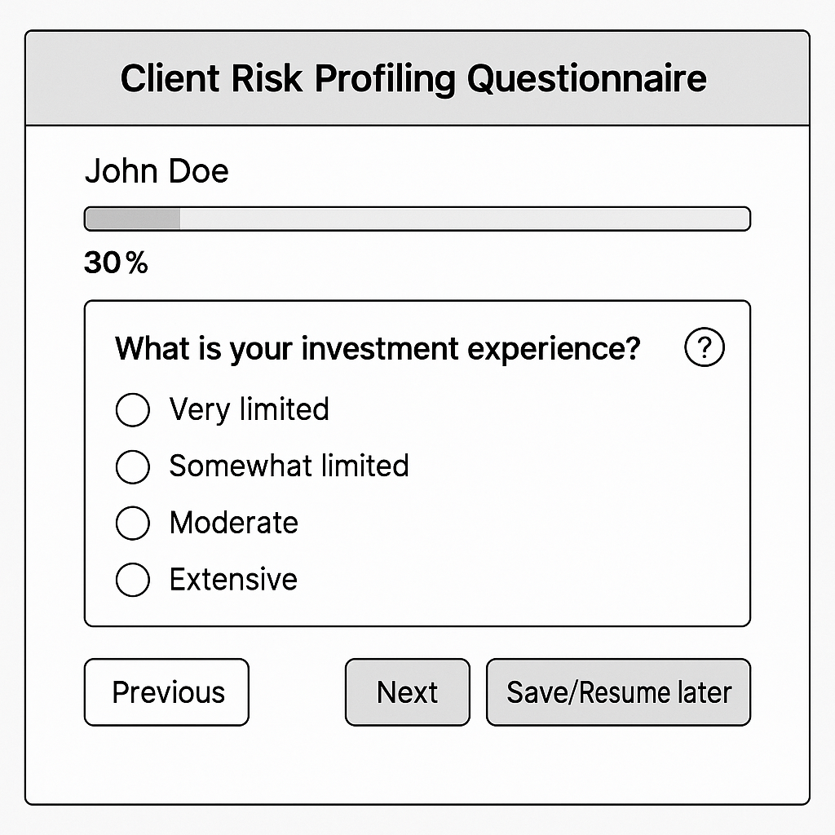

# Page Name / Feature Area

Advisor Dashboard View

# Purpose of the Screen

To give advisors a consolidated view of client profiles, risk scores, and suitability flags for better decision-making and compliance.

# Wireframe or Sketch

- Client list with profile risk score summary  
- Suitability flags/icons  
- Action links for override with audit log option

# Annotations / Notes

- Advisors can filter clients by risk score category  
- Override action is logged for compliance  
- Icons/flags provide quick at-a-glance insights

# User Flow (optional)

Advisor logs in → Views client list → Reviews suitability flags → Overrides if required

# Version / Iteration Number

Version 1.0

# Feedback from Stakeholders

- Appreciated compliance audit log feature  
- Suggested color-coding risk levels for better readability

