**Statement**



A finance company is carrying out a study on the worst stock investments and would like to acquire a program to do so. The program must be able to analyze a chronological series of stock values in order to show the largest loss that it is possible to make by buying a share at a given time t0 and by selling it at a later date t1. The loss will be expressed as the difference in value between t0 and t1. If there is no loss, the loss will be worth 0.

**INPUT:**

**Line 1:** the number n of stock values available.

**Line 2:** the stock values arranged in order, from the date of their introduction on the stock market v1 until the last known value vn. The values are integers.

**OUTPUT:**

The maximal loss p, , expressed negatively if there is a loss, otherwise 0.

**CONSTRAINTS:**

0 < n < 100000  
0 < v < 231

**EXAMPLE 1:**

**Input**

6

3 2 4 2 1 5

**Output**

-3

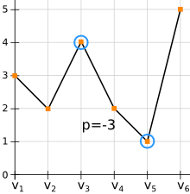

**EXAMPLE 2:**

**Input**

6

5 3 4 2 3 1

**Output**

-4

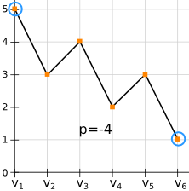

**EXAMPLE 3:**

**Input**

5

1 2 4 4 5

**Output**

0

