
INTERNSHIP PROJECT REPORT
ON
“Design and Development of a Secure User ID Creation and Onboarding System for Banks, Financial Intermediaries, and Other Entities on the NCRP Portal for Citizens’ Financial Cyber Fraud Reporting and Management”
Submitted To
Cyber Fraud Mitigation Center,
Indian Cyber Crime Coordination Center,
Ministry Of Home Affairs,
Government Of India
For fulfilment of the internship
01st Dec-2025 to 02nd April 2026

Submitted By
Prashant Gond

Under the Supervision of
(Lavish Yadav) (Akhilesh Gaur) (Lt. Col. Badal Kaushik)
Sr. Threat Analyst Dy.Director CFMC Director, CFMC

------------------- ------------------- -------------------

ACKNOWLEDGEMENT

I would like to thank my supervisors and mentors at MHA I4C, particularly the Director, CFMC, Lt. Col. Badal Kaushik, Dy. Director Akhilesh Gaur, Mr. Lavish Yadav, Mrs. Sneha Singh, Mrs. Priyanka Kumari for his tremendous guidance, support, and encouragement throughout my internship. This work significantly strengthened my understanding of cybersecurity principles, secure system architecture, and access governance mechanisms. It provided valuable technical exposure to secure authentication, role-based access control, database security, and structured workflows for financial cyber fraud management, while also enhancing my analytical and technical competencies in designing secure and scalable systems.

With Sincere Regards,
Prashant Gond

ABSTRACT

The rapid growth of digital financial services has led to a significant increase in financial cyber frauds, necessitating a secure, efficient, and centralized reporting and management mechanism. The National Cyber Crime Reporting Portal (NCRP) plays a critical role in enabling citizens to report financial cyber fraud incidents. However, effective coordination with banks, financial intermediaries, and other authorized entities requires a robust and controlled onboarding and user identity management system.
This project focuses on the design and development of a User ID creation and onboarding system for banks, financial intermediaries, and other entities within the NCRP ecosystem. The system provides a structured workflow for entity registration, document submission, verification, and approval through an administrative interface. Role-based access control (RBAC) ensures that only authorized personnel can access sensitive fraud-related data, thereby enhancing security and accountability.
The solution integrates secure authentication mechanisms, validation checks, audit logging, and automated approval/rejection workflows to streamline onboarding while maintaining regulatory compliance. Additionally, the system supports scalability and interoperability to accommodate a growing number of participating entities. By strengthening institutional onboarding and access governance, the proposed system improves response efficiency, inter-agency collaboration, and overall effectiveness of financial cyber fraud reporting and management within the NCRP framework.
Keywords: Financial Cyber Fraud, National Cyber Crime Reporting Portal (NCRP), User ID Management, Entity Onboarding System, Banks and Financial Intermediaries, Role-Based Access Control (RBAC), Secure Authentication, Fraud Reporting and Management, Access Governance, Cybersecurity, Digital Identity Management, Administrative Workflow.
.

TABLE OF CONTENTS

S.NO | TITLE | PAGE NUMBER | SIGNATURE
1 | Understanding the National Cyber Crime Reporting Portal (NCRP), its objectives, stakeholders, and role in reporting and managing financial cyber fraud incidents in India | 05 - 09
2 | Design and development of a secure User ID creation and onboarding system for banks, financial intermediaries, and other entities to enable controlled access to the NCRP portal | 10 - 22
3 | Implementation of role-based access control, authentication mechanisms, document verification, and administrative approval workflows for secure financial cyber fraud reporting and management | 23 - 32
4 | Security Framework and Access Governance for Financial Cyber Fraud Management (MySQL Database Implementation) | 33 - 42
5 | SUMMARY | 43 - 45

LIST OF ABBREVIATIONS

Abbreviation | Description
NCRP | National Cyber Crime Reporting Portal
I4C | Indian Cyber Crime Coordination Centre
MHA | Ministry of Home Affairs
FI | Financial Intermediary
RBAC | Role-Based Access Control
UID | User Identification
OTP | One-Time Password
API | Application Programming Interface
GUI | Graphical User Interface
DB | Database
CFMC | Cyber Fraud Mitigation Centre
CFCFRMS | Citizens Financial Cyber Fraud Reporting & Management System

Chapter 1:
Task :1 Understanding the National Cybercrime Reporting Portal (NCRP)

1.1 Introduction
The National Cybercrime Reporting Portal (NCRP) initiative by the Government of India enables citizens to report cybercrimes online. It plays a crucial role in helping victims of cyber fraud, financial scams, online harassment, and other digital offences.

1.2. Purpose of NCRP
The primary objectives of the NCRP are:
- Providing a centralized platform for reporting cybercrimes.
- Assisting law enforcement agencies in tracking and investigating cybercriminals.
- Offering a structured complaint registration process for victims.

1.3. Categories of Cybercrimes Handled
The NCRP allows users to report various cybercrimes, including:
1. Financial Frauds – Online banking frauds, UPI scams, debit/credit card fraud, phishing.
2. Online Harassment and Abuse – Cyberstalking, blackmailing, image/video morphing, defamation.
3. Women and Child-Related Cybercrimes – Child pornography, sexual exploitation, cyberbullying.
4. Other Cybercrimes – Hacking, identity theft, cyber terrorism, fake social media profiles.

1.4. How to File a Complaint
Users can report a cybercrime through the NCRP portal by following these steps:
1. Visit the official NCRP website.
2. Select the category of cybercrime.
3. Provide details of the incident, including evidence such as screenshots, transaction records, or messages.
4. Submit the complaint and note down the unique complaint reference ID.
5. Track complaint status using the reference ID.

1.5. Role of Law Enforcement Agencies
- NCRP complaints are assigned to relevant state or central cybercrime units.
- Investigators analyze evidence and liaise with financial institutions or technology providers for further details.
- Law enforcement uses forensic techniques to trace and apprehend cybercriminals.

1.6. Financial Fraud Handling
- Victims must provide transaction details, screenshots, or bank statements.
- NCRP works with banks and financial institutions to freeze fraudulent transactions.
- Cases are prioritized based on severity and monetary loss.

1.7. Privacy and Security Measures
- NCRP ensures data confidentiality using encryption and OTP authentication.
- Complainants can report sensitive cases anonymously.

1.8. Support and Helpline Services
- 24/7 national cybercrime helpline for emergency assistance.
- Live chat support for guidance on filing complaints.
- Users can check their complaint progress via the portal.

1.9. Conclusion
The NCRP is a significant step towards strengthening cybersecurity and providing victims with a reliable platform for justice. It bridges the gap between victims and law enforcement, ensuring prompt action against cyber offenders.

- Below are some images regarding the NCRP Portal

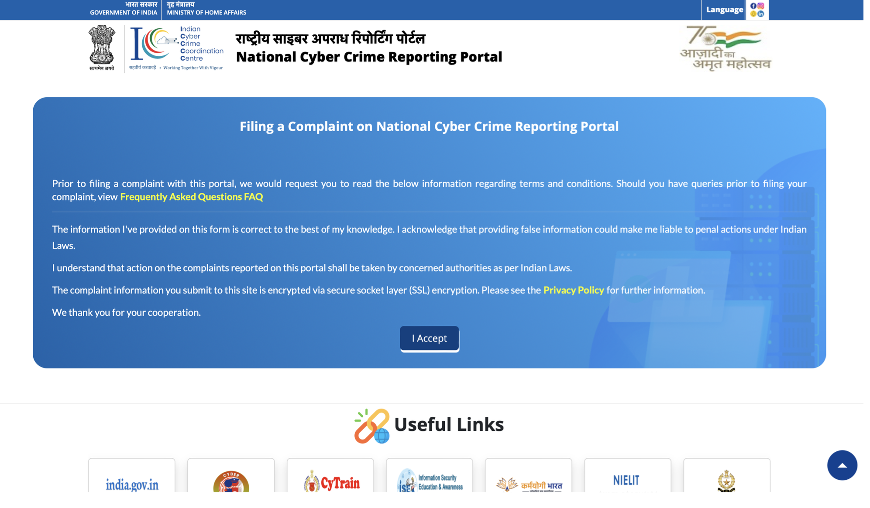
Fig 1.9.1 shows the interface of the NCRP Portal
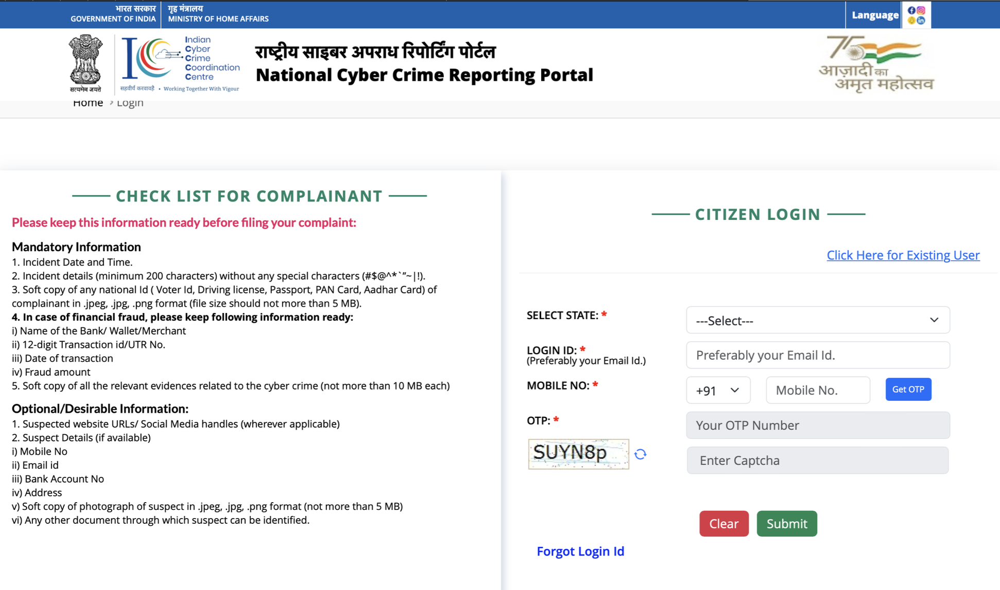
Fig 1.9.2 Citizens login and file their complaints

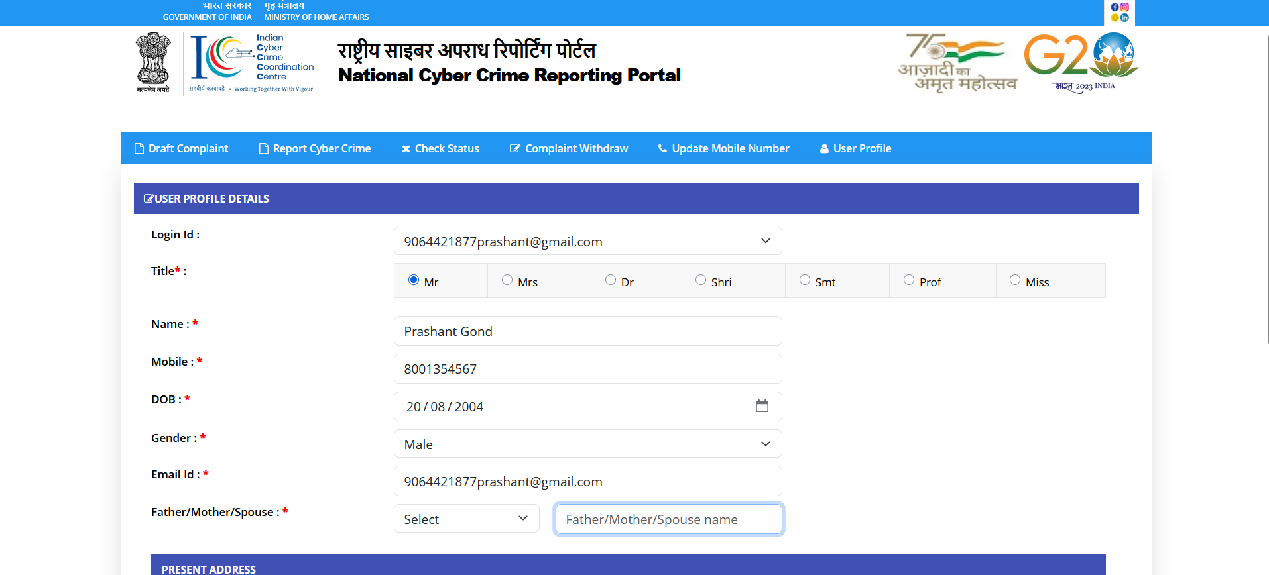
Fig 1.9.3 Here, the citizen fill in their details and tell what type of fraud happens
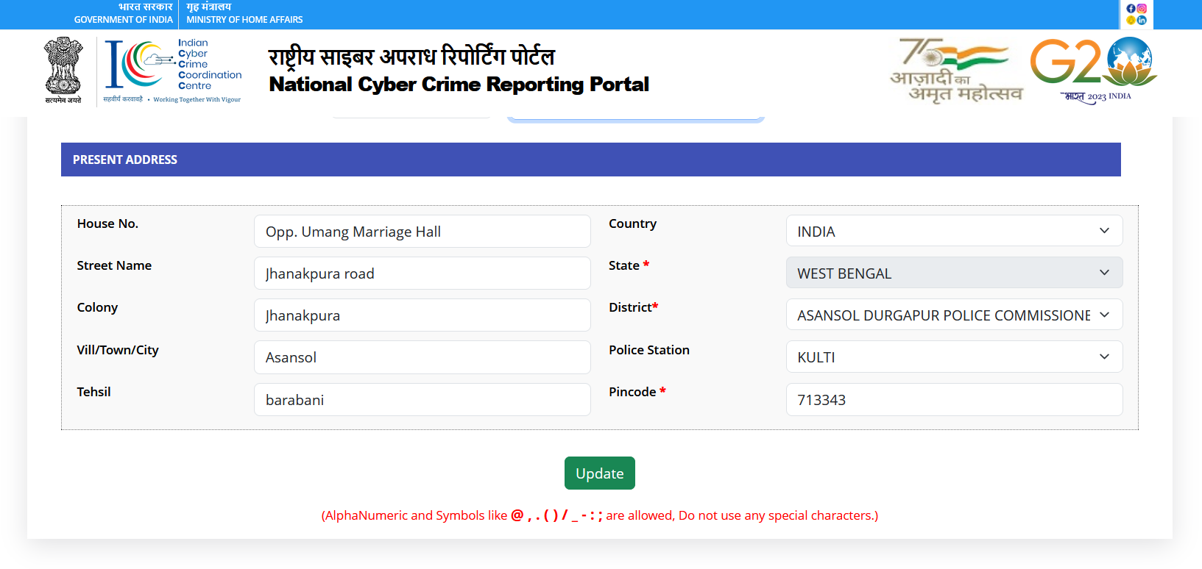
Fig:1.9.4 Here, share the details, and citizens can track their complaints also

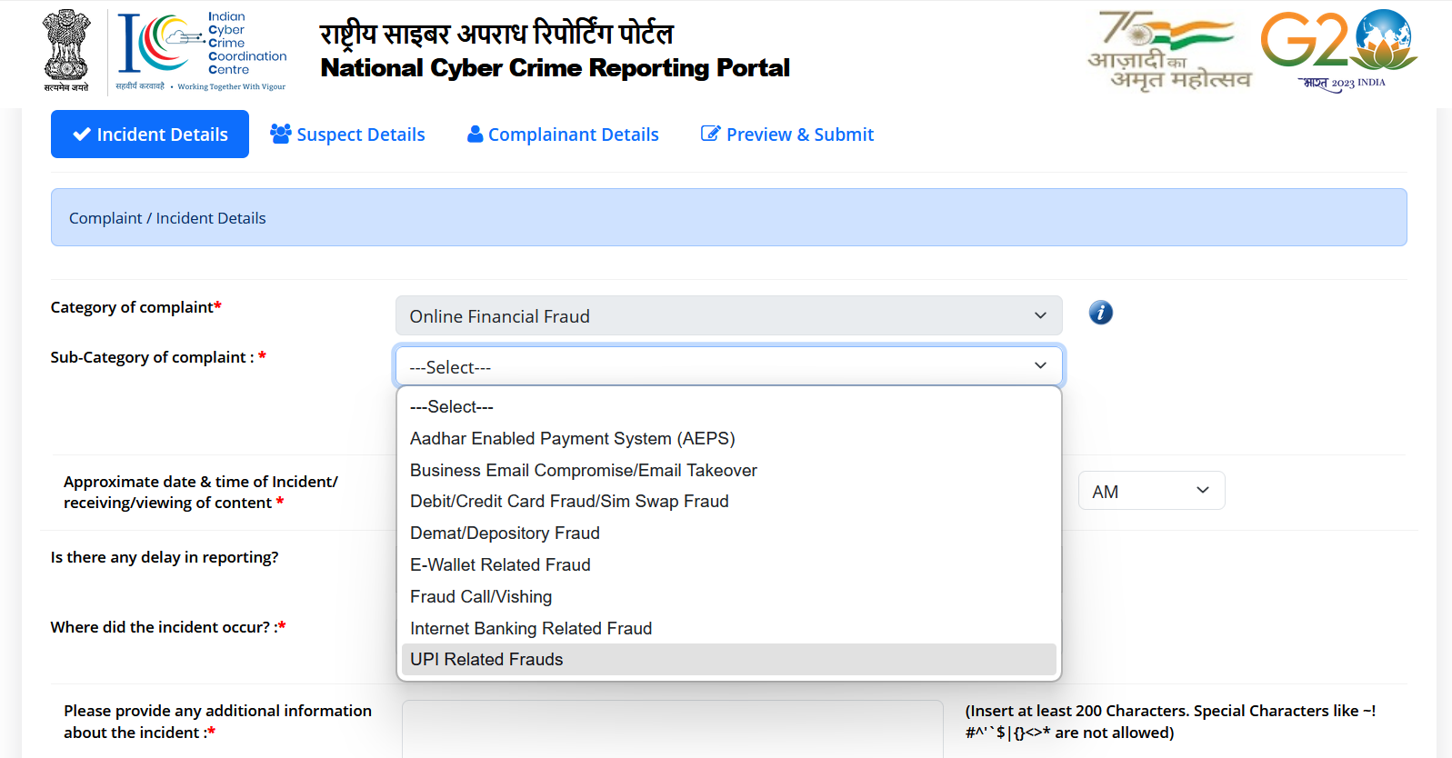
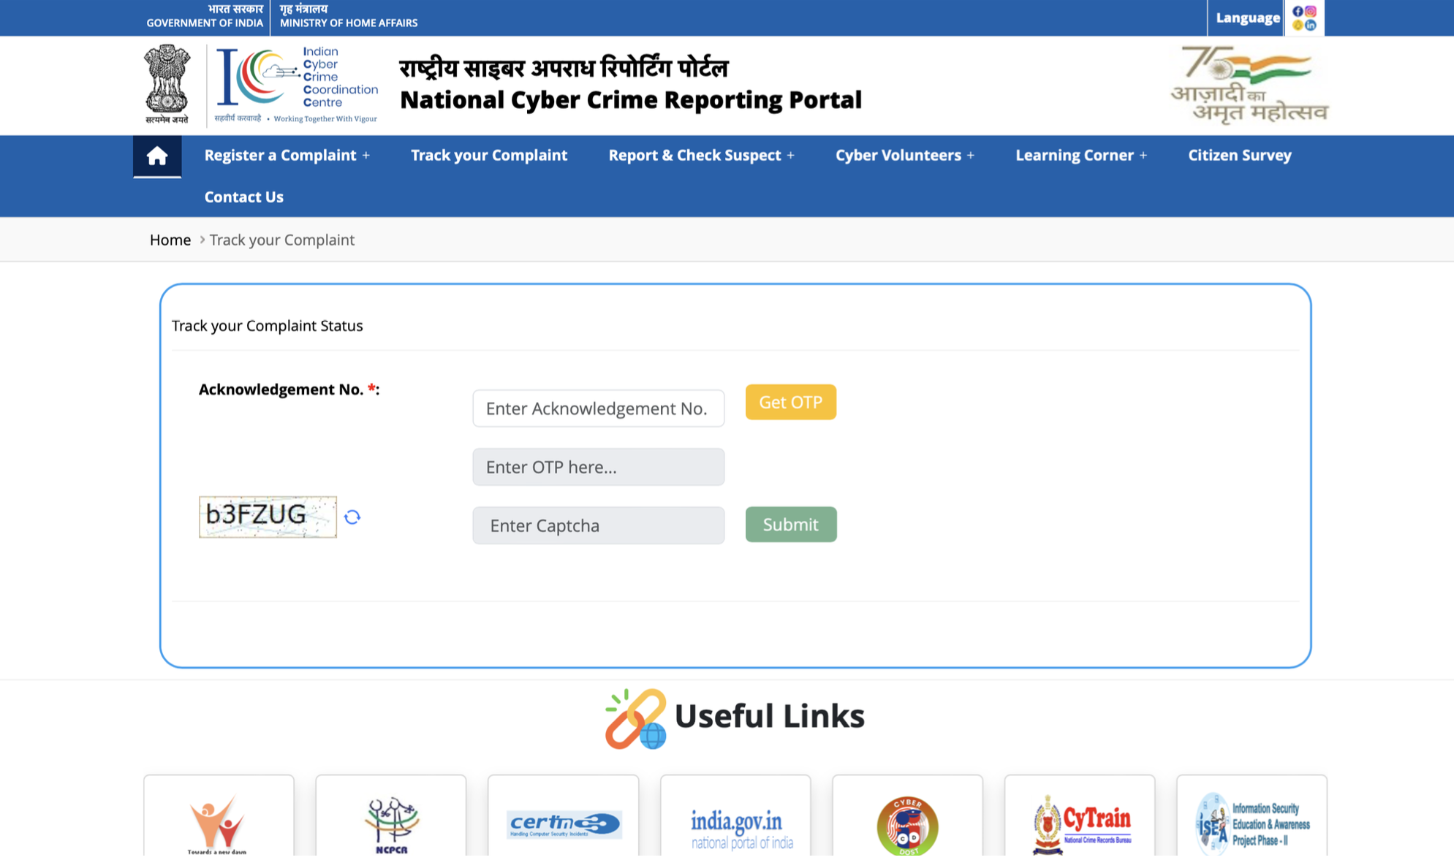

Chapter 2:

Design and Development of a Secure User ID Creation and Onboarding System for Banks, Financial Intermediaries, and Other Entities to Enable Controlled Access to the NCRP Portal

2.1 Introduction
The National Cyber Crime Reporting Portal (NCRP) is a critical national platform for reporting and managing cybercrime incidents, particularly financial cyber fraud. To ensure effective coordination between citizens, law enforcement agencies, banks, financial intermediaries (FIs), and other authorized entities, it is essential to provide a secure and well-governed access mechanism.
This chapter focuses on the design and development of a secure User ID creation and onboarding system for banks, financial intermediaries, and other entities. The system enables controlled access to the NCRP portal while ensuring data confidentiality, integrity, and accountability. A structured onboarding process ensures that only verified and authorized entities can access sensitive financial cyber fraud information.

2.2 Need for a Secure Onboarding System
Financial cyber fraud cases involve sensitive personal, financial, and transactional data. Unrestricted or weak access controls may lead to data leakage, misuse of information, or unauthorized actions. Therefore, a secure onboarding and User ID management system is required to:
- Authenticate legitimate banks, financial intermediaries, and authorized entities
- Prevent unauthorized access to sensitive NCRP data
- Maintain accountability through user-level tracking and audit logs
- Enable faster response and coordination during financial fraud incidents
- Ensure compliance with government cybersecurity and data protection guidelines
2.3 Stakeholders Involved in the Onboarding Process
The onboarding system is designed to support multiple stakeholders involved in financial cyber fraud reporting and management:
- Banks: To verify transactions, freeze fraudulent accounts, and assist victims
- Financial Intermediaries (FIs): Payment gateways, wallets, NBFCs, and fintech platforms
- Other Entities: Telecom service providers, technology partners, and regulatory bodies
- NCRP Administrators: Responsible for verification, approval, and access governance
Each stakeholder is provided access strictly based on their role and responsibilities.

2.4 User ID Creation Workflow
The User ID creation process follows a structured and secure workflow to ensure authenticity and accountability.
Steps involved in User ID creation:
- Entity registration request submission on the NCRP portal
- Upload of required documents such as authorization letters, identity proof, and official credentials
- Validation of submitted details at the system level
- Administrative review and verification by NCRP authorities
- Approval or rejection of the onboarding request
- Secure generation of User ID credentials for approved entities
This workflow minimizes human error and ensures only verified entities are onboarded.

2.5 Entity Onboarding and Document Verification
Document verification is a crucial part of the onboarding system. Entities are required to submit officially approved documents, which may include:
- Organization registration certificates
- Authorization letters issued by competent authorities
- Official email domain verification
- Identity proof of authorized personnel
The NCRP administrative panel enables officers to review documents, request clarifications, and approve or reject onboarding requests. This ensures transparency and traceability in the onboarding process.

2.6 Role-Based Access Control (RBAC)
Role-Based Access Control (RBAC) is implemented to restrict access based on the user’s role. Each User ID is assigned specific permissions depending on the entity type and responsibility.
Examples of roles include:
- Bank User
- Financial Intermediary User
- Administrative User
- Supervisory User
RBAC ensures that users can only access information relevant to their role, reducing the risk of unauthorized data exposure.

2.7 Authentication and Security Mechanisms
To safeguard access to the NCRP portal, multiple security mechanisms are integrated into the User ID system:
- Secure login credentials
- One-Time Password (OTP) based authentication
- Encrypted communication using secure protocols
- Password complexity and expiry policies
These measures help protect against unauthorized access, credential theft, and cyber attacks.

2.8 Administrative Approval and Monitoring
An administrative approval mechanism is built into the system to ensure oversight and governance. NCRP administrators can:
- View onboarding requests
- Verify submitted documents
- Approve or reject User ID requests
- Monitor user activities through logs
Audit logs record login attempts, data access, and actions performed by users, ensuring accountability and compliance.

2.9 System Architecture Overview
The onboarding system follows a layered architecture:
- Presentation Layer: Web-based GUI for entity registration and administration
- Application Layer: Handles business logic, validation, and workflows
- Database Layer: Stores user details, roles, logs, and onboarding records
This architecture ensures scalability, maintainability, and security.

2.10 Conclusion
The secure User ID creation and onboarding system plays a vital role in strengthening the NCRP portal’s operational efficiency. By ensuring controlled access, robust authentication, and role-based authorization, the system enhances trust, coordination, and response effectiveness in financial cyber fraud reporting and management. The proposed design supports scalability and future enhancements while aligning with national cybersecurity objectives.

- Onboarding Login Page
This page represents the onboarding login interface of the NCRP portal developed under I4C.
It serves as the secure entry point for banks, financial intermediaries, and other entities to access the onboarding system.

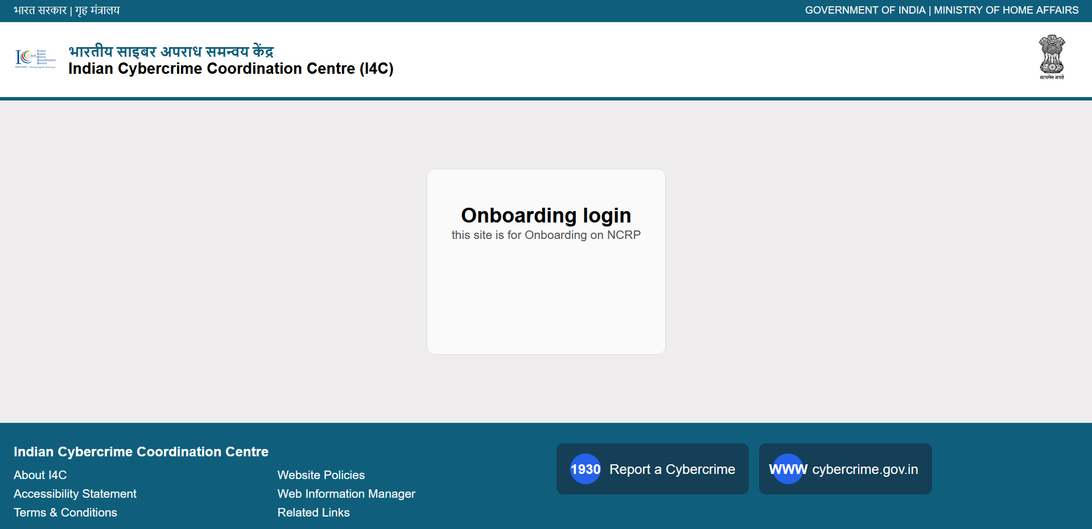

- User Login Page
This page allows registered users to log in using their User ID and password.
Secure authentication ensures that only authorized users can access NCRP onboarding services.

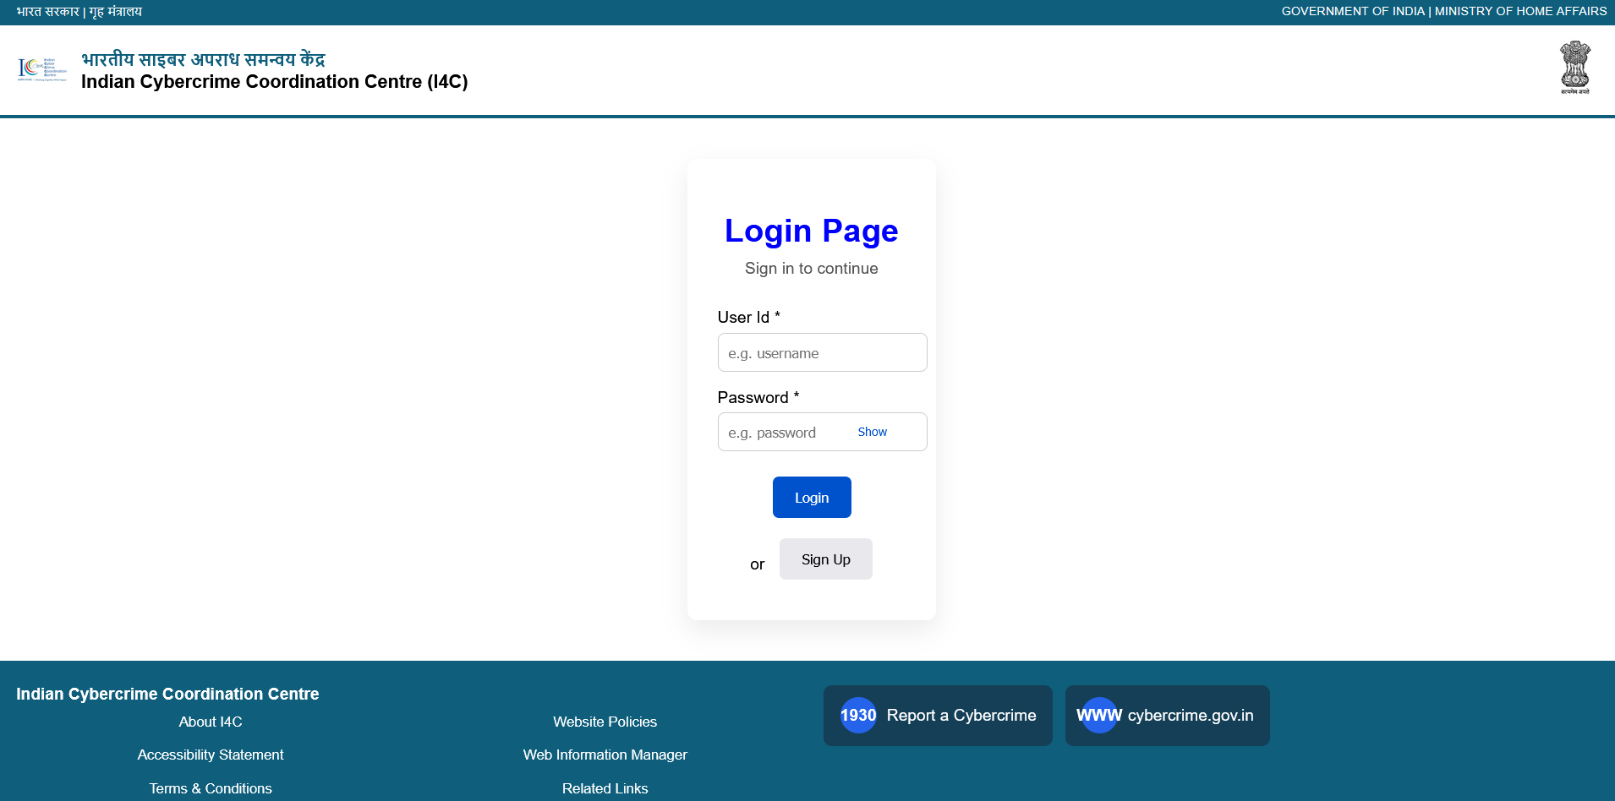
- Authorized Bank Official Details Page
This page captures personal and official details of the authorized bank official.
The information is used to create a unique User ID and ensure accountability of the registered user.

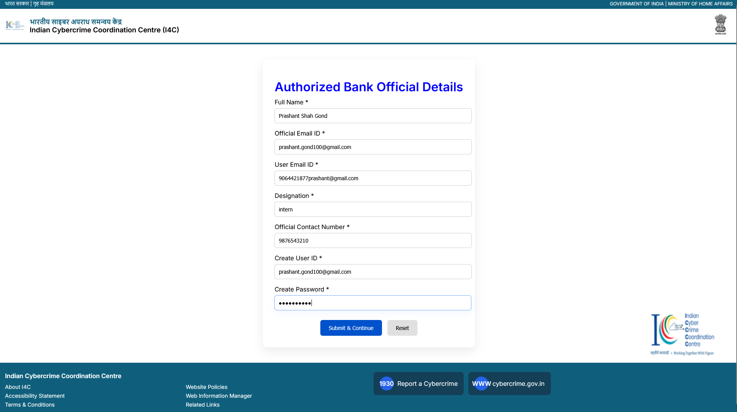

- Registration of Banks / FIs / Other Entity Page
This page facilitates the registration of banks, financial intermediaries and other entities on the NCRP portal.
Users are required to provide organizational and regulatory details as per RBI guidelines.

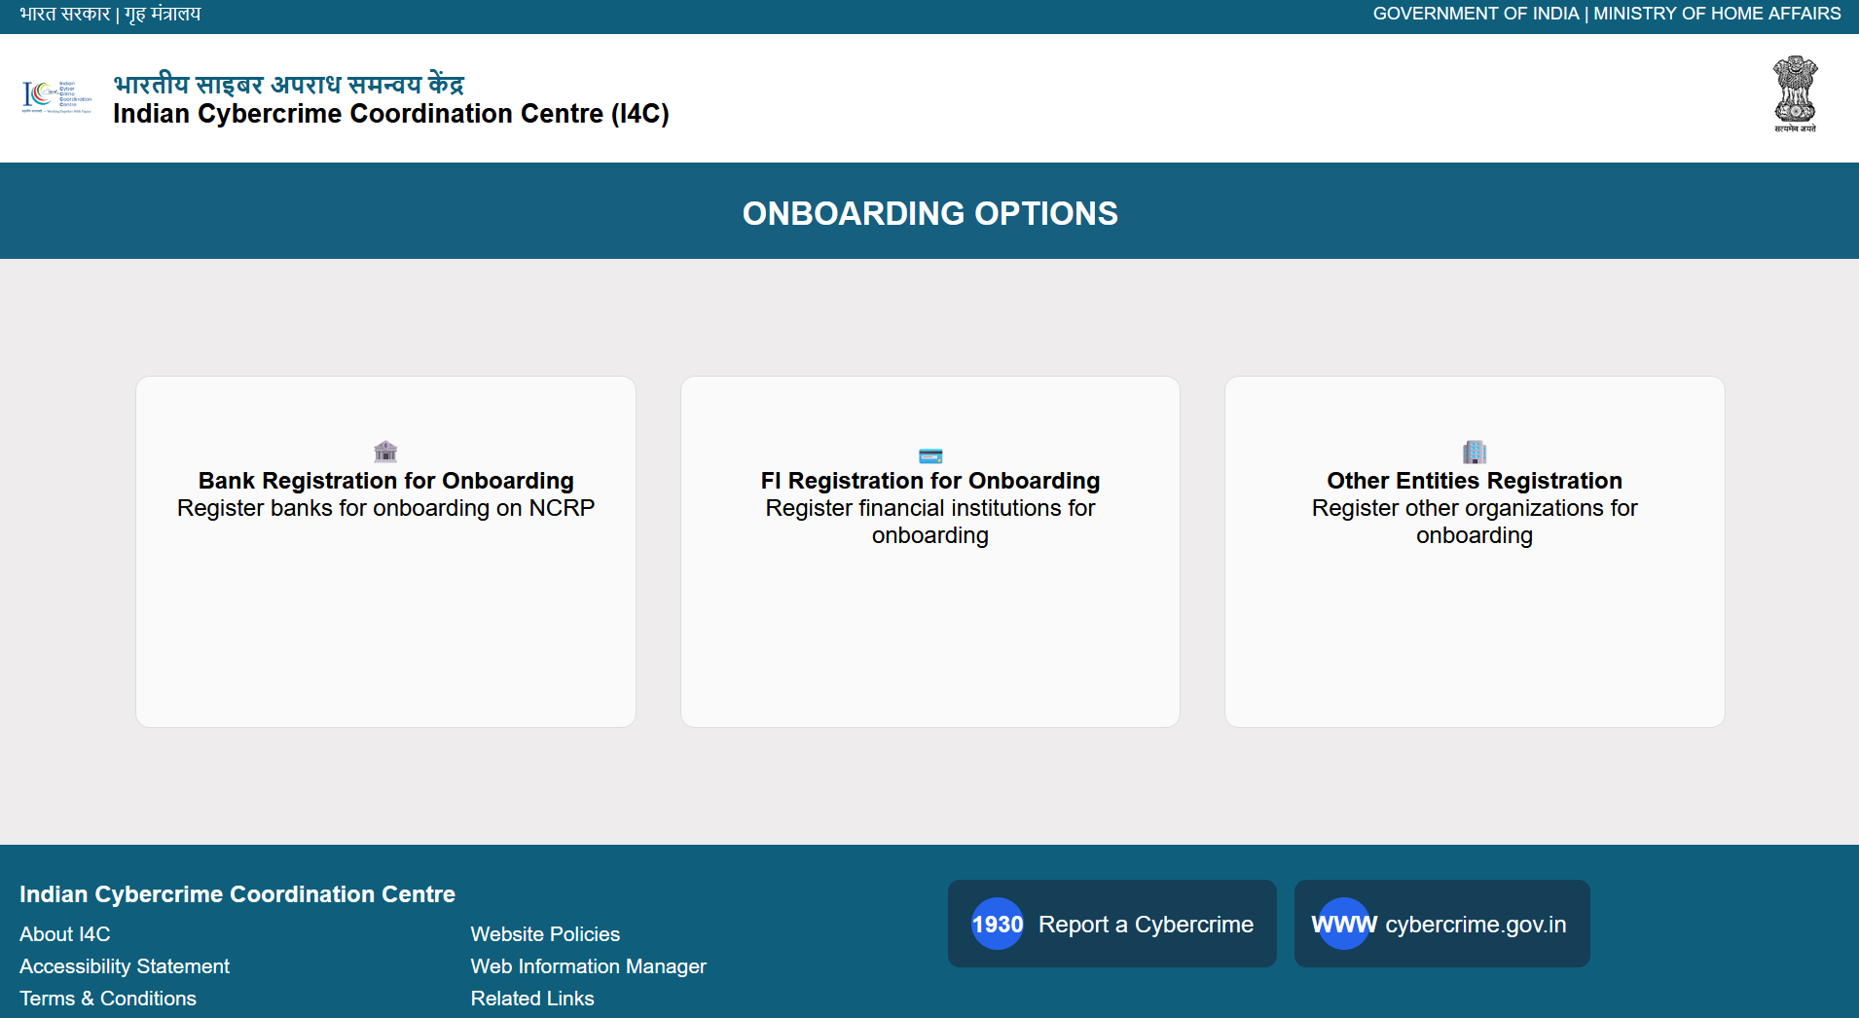
- Registration of Banks Page
This page facilitates the registration of banks on the NCRP portal.
Users are required to provide organizational and regulatory details as per RBI guidelines.

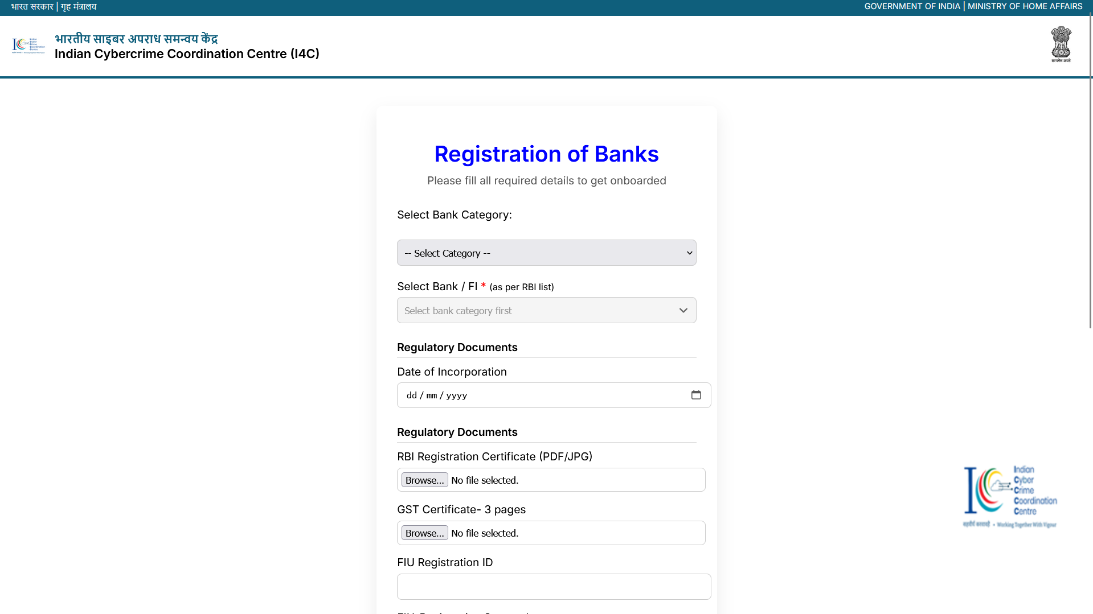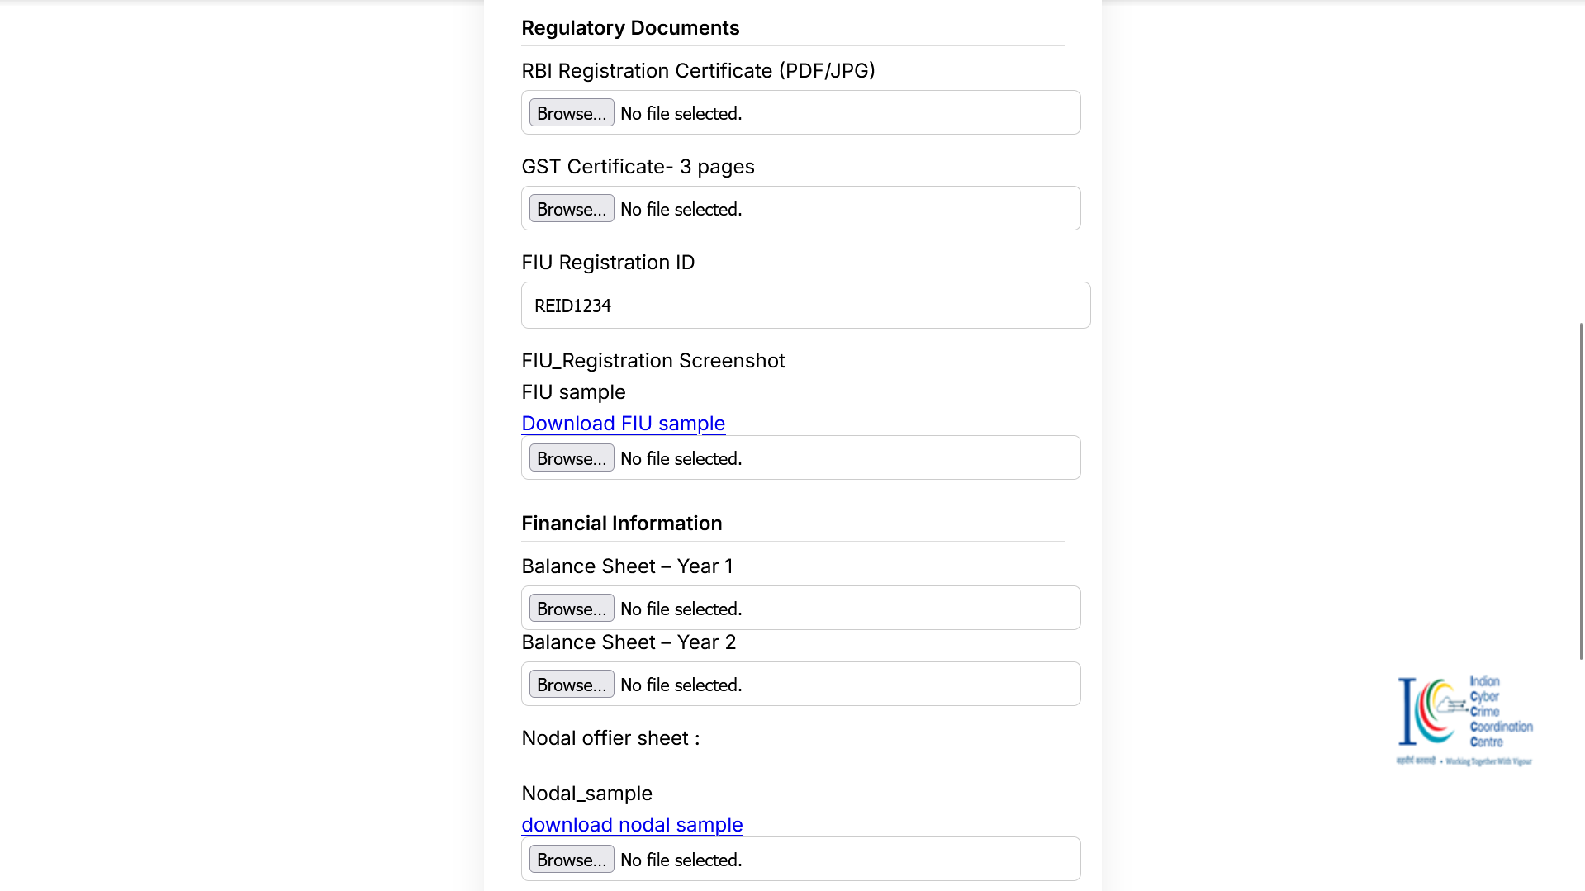

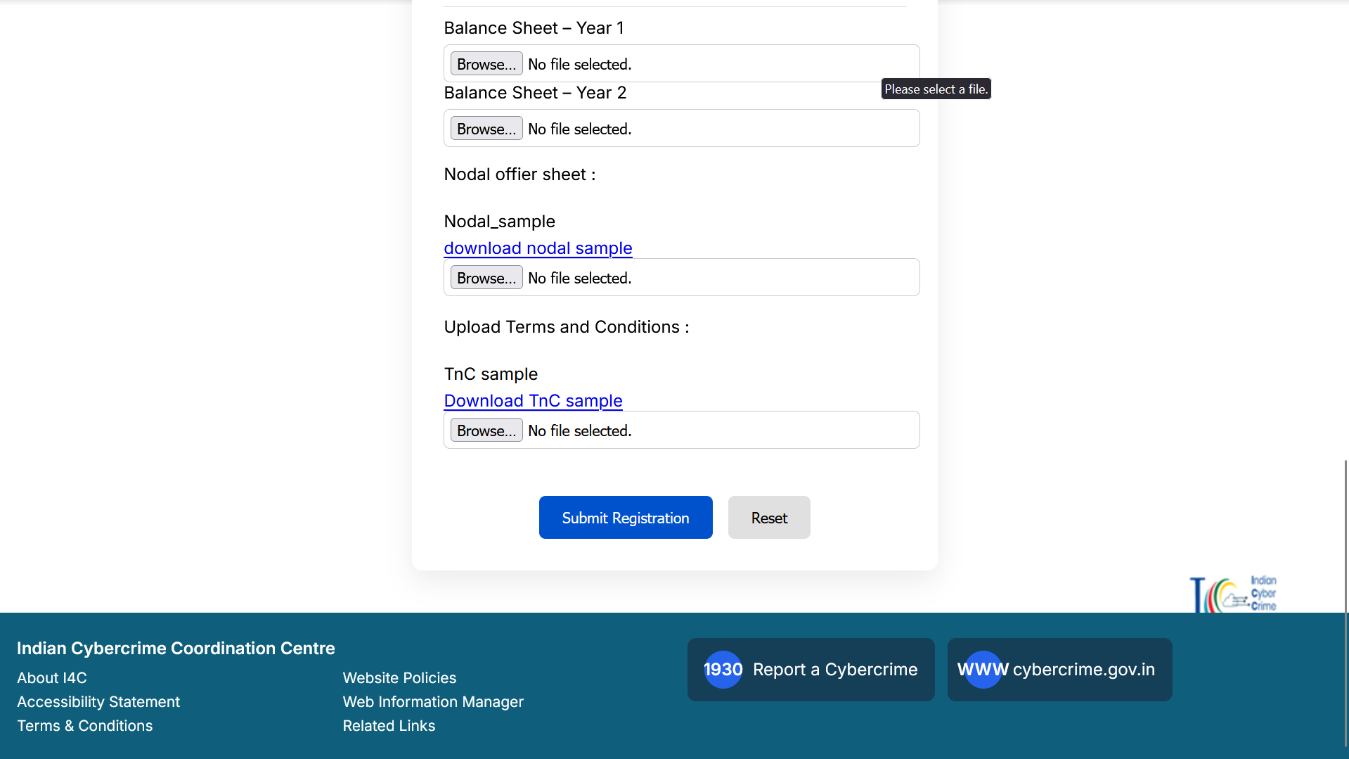

- Financial Intermediaries Registration
This page is used for registering financial intermediaries involved in payment systems.
It captures regulatory, financial, and operational details required for NCRP access.

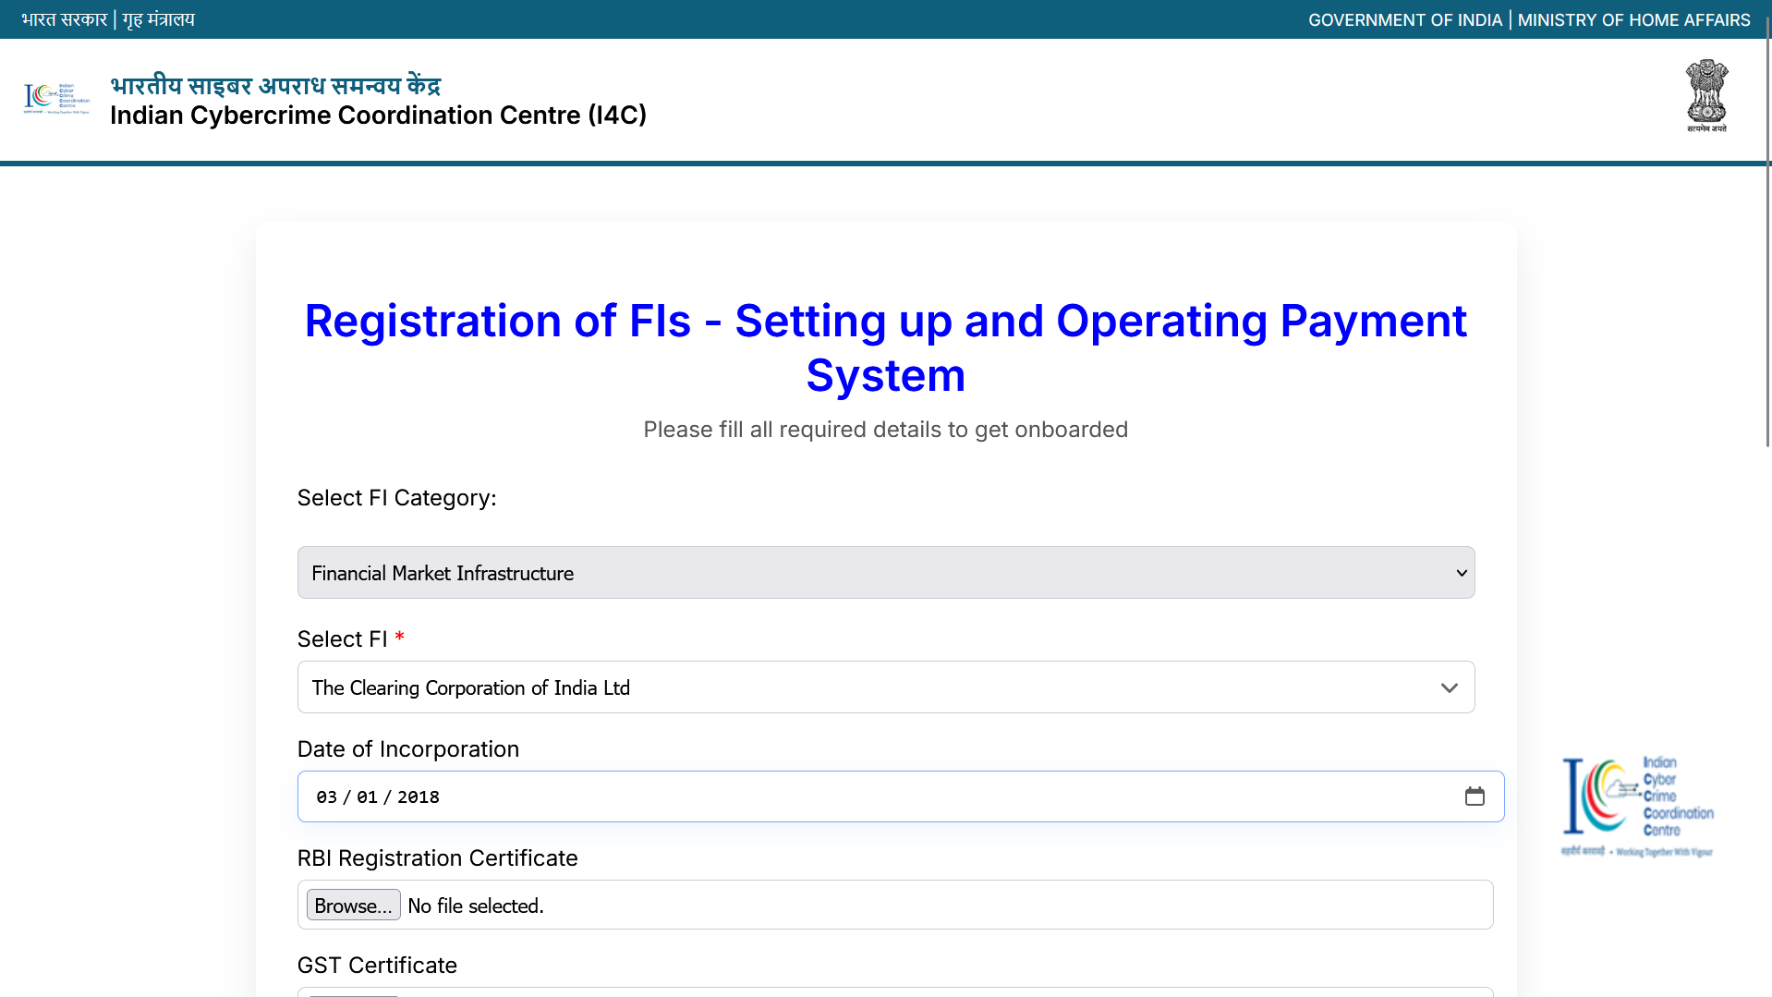
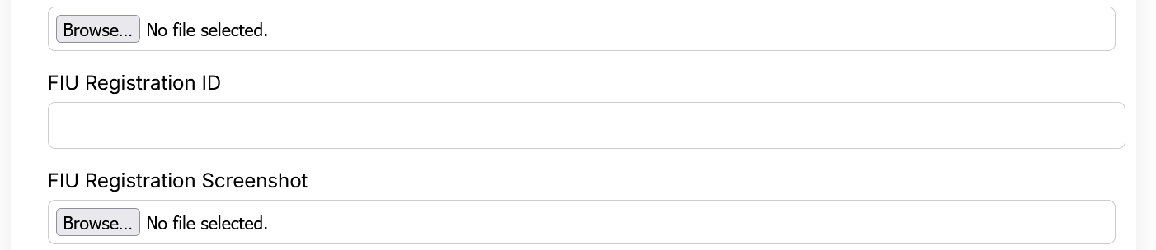

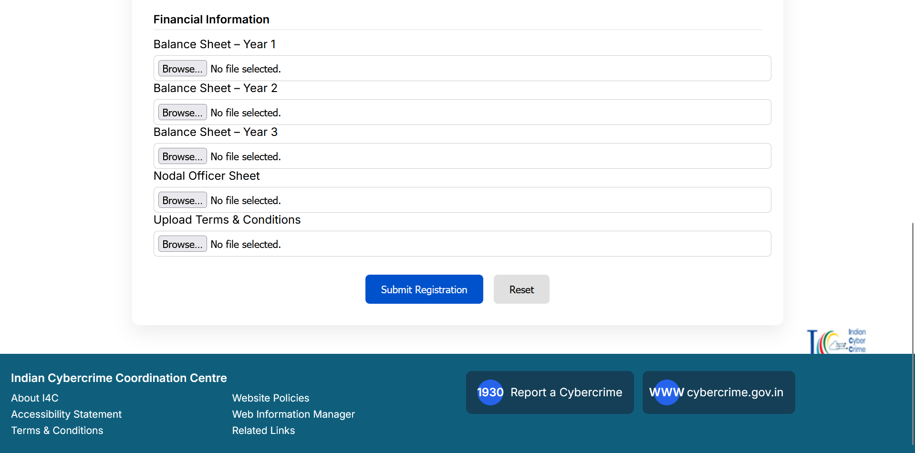

- Registration for Other Entities Page
This page enables onboarding of organizations other than banks and financial intermediaries on the NCRP portal.
It collects regulatory and organizational details required to verify and authorize access for such entities.

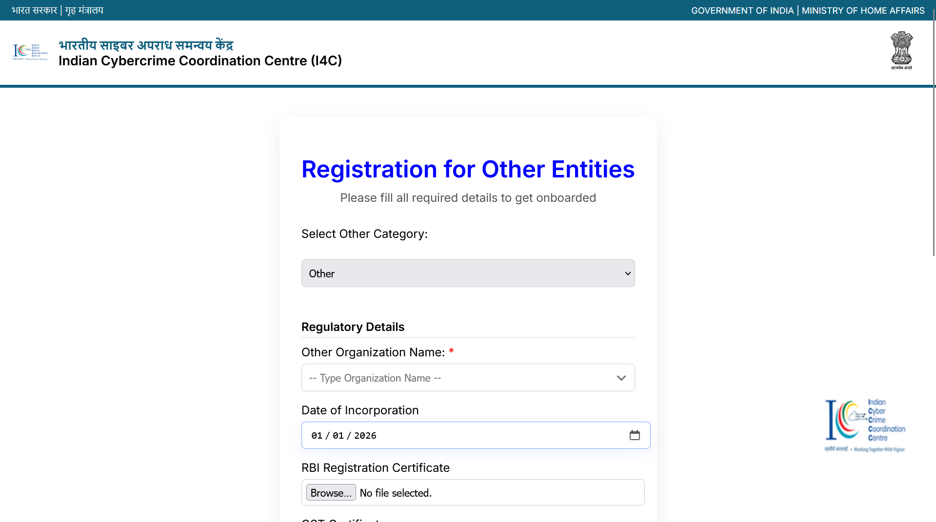
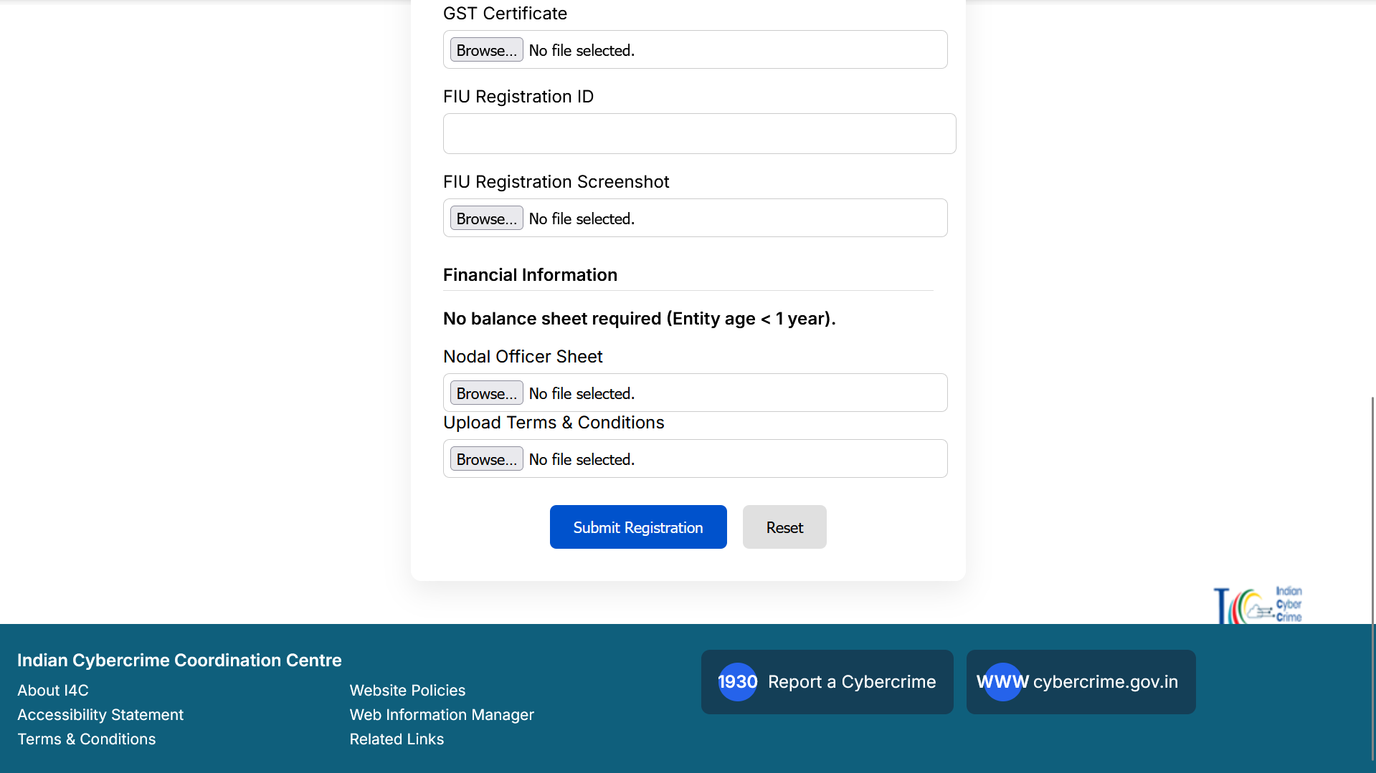

- NCRP Onboarding Dashboard Page for registered Users.
This page provides a consolidated dashboard for registered users to view onboarding status and submission details.
It also includes support features such as registration tracking and the NCRP help bot for user assistance.

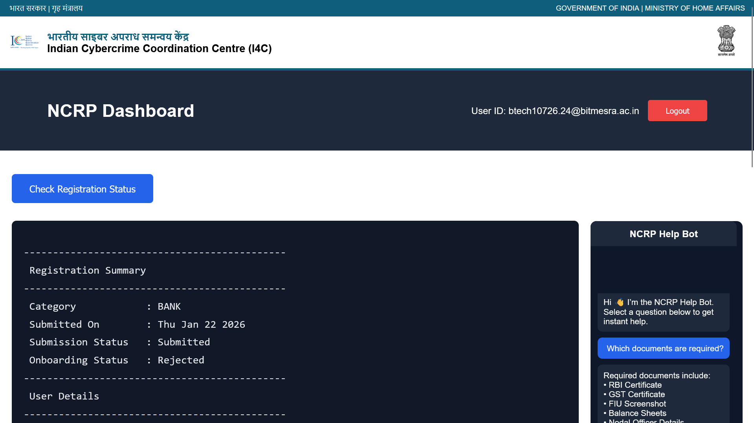
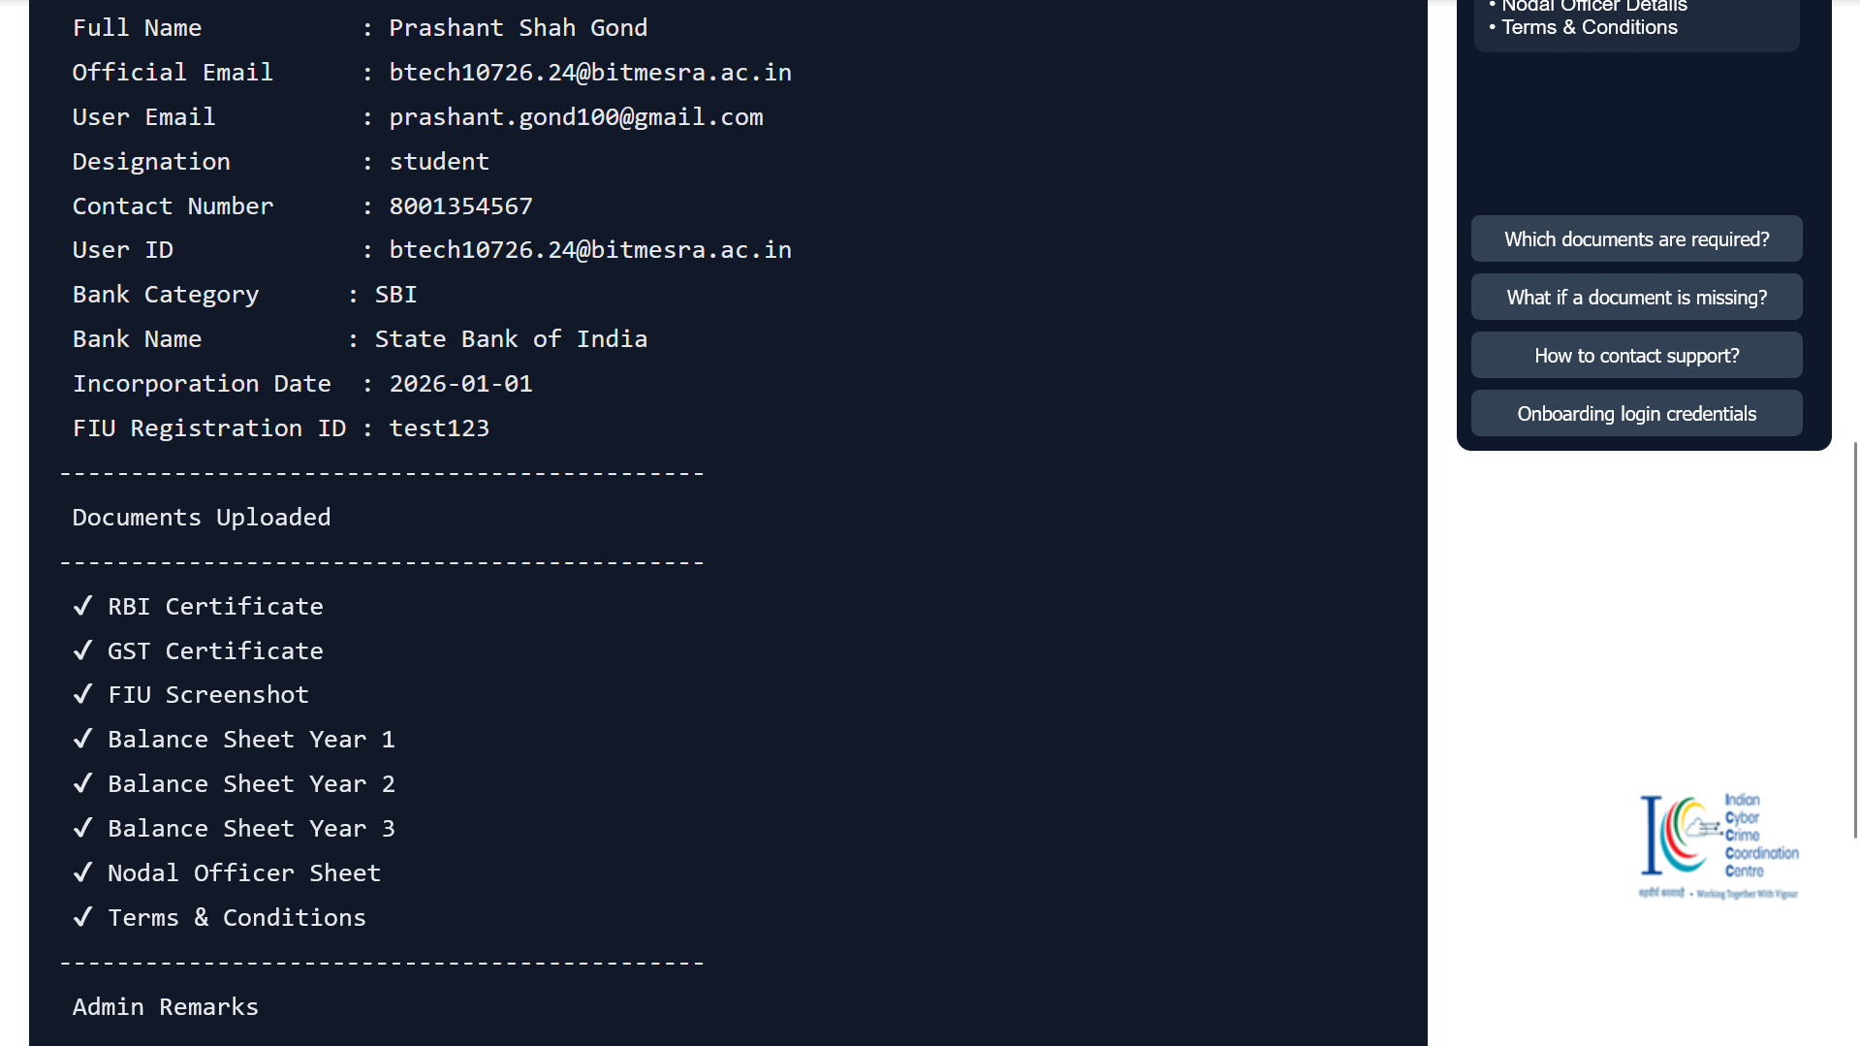

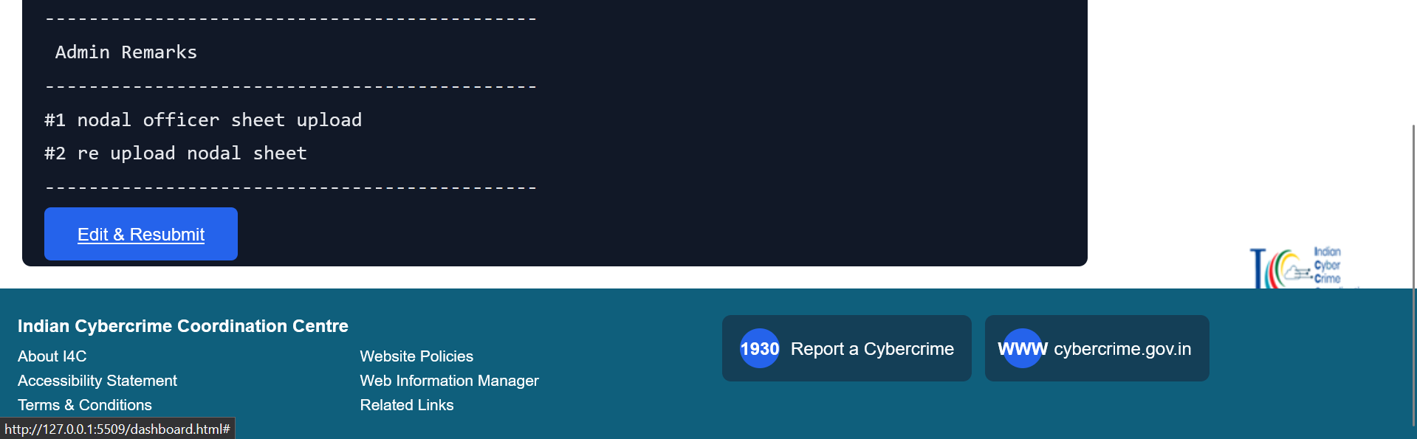

USER-SITE ONBOARDING WORKFLOW
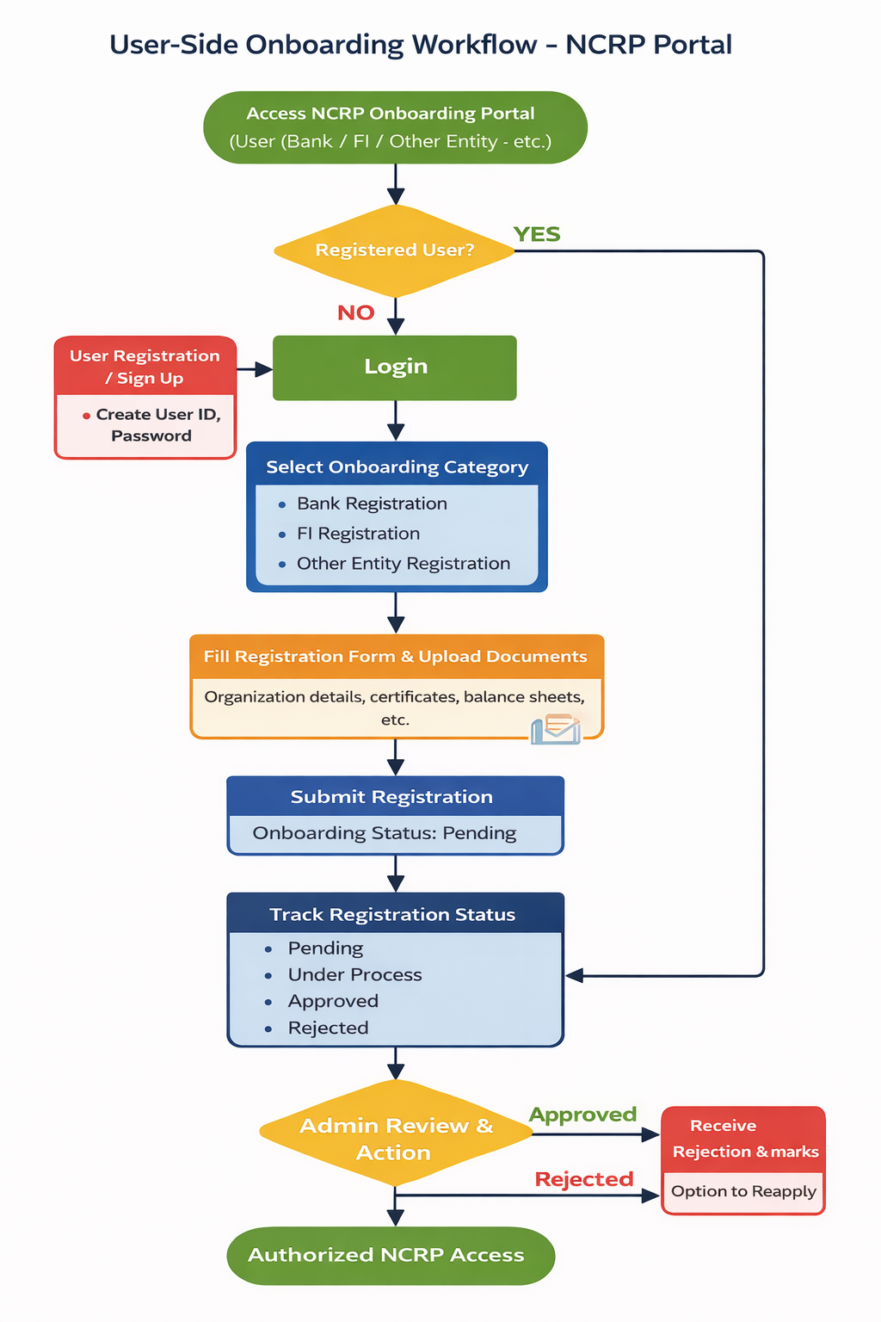

Chapter 3

Implementation of Role-Based Access Control, Authentication Mechanisms, Document Verification, and Administrative Approval Workflows for Secure Financial Cyber Fraud Reporting and Management

3.1 Introduction
The increasing scale and complexity of financial cyber fraud incidents demand a secure and well-governed access management system within the National Cyber Crime Reporting Portal (NCRP). As multiple stakeholders such as banks, financial intermediaries, other entities, and administrators interact with sensitive data, it becomes essential to implement strong access control, authentication, and verification mechanisms. This chapter discusses the implementation of Role-Based Access Control (RBAC), authentication mechanisms, document verification processes, and administrative approval workflows to ensure secure and efficient financial cyber fraud reporting and management.

3.2 Need for Access Control and Secure Workflows
Financial cyber fraud cases involve confidential information including personal identities, banking details, transaction records, and regulatory documents. Unauthorized access or misuse of such information can lead to serious legal and financial consequences. Therefore, NCRP requires a structured security framework that ensures:
- Access is granted strictly on a need-to-know basis
- Only verified users can perform specific actions
- Every activity is traceable and auditable
- Administrative oversight is maintained at all stages
RBAC and secure workflows together form the foundation of this framework.

3.3 Role-Based Access Control (RBAC)
Role-Based Access Control is a security mechanism where system access permissions are assigned based on the roles of users rather than individual identities. In the NCRP system, RBAC ensures that users can only access information and functionalities relevant to their designated role.

3.3.1 Roles Defined in NCRP
The following key roles are implemented within the system:
- Bank User: Access limited to bank-related fraud cases, document uploads, and response actions
- Financial Intermediary (FI) User: Access to payment system related fraud information
- Other Entity User: Restricted access based on organizational function
- Administrator: Full access to onboarding requests, document verification, and approval workflows
Each role is mapped with predefined permissions to prevent unauthorized actions.

3.4 Authentication Mechanisms
Authentication ensures that only legitimate users gain access to the NCRP portal. The system employs multiple authentication layers to strengthen security.

3.4.1 User Credential Authentication
Users are required to log in using a unique User ID and password created during the onboarding process. Password policies enforce minimum complexity requirements and periodic updates.

3.4.2 One-Time Password (OTP) Authentication
To add an additional security layer, OTP-based verification is used during login and sensitive operations. OTPs are sent to registered contact details, reducing the risk of unauthorized access.

3.4.3 Secure Communication
All authentication transactions are performed over encrypted channels to protect credentials from interception.
3.5 Document Verification Process
Document verification plays a critical role in validating the authenticity of banks, financial intermediaries, and other entities seeking access to NCRP.

3.5.1 Types of Documents Verified
Entities are required to submit the following documents during onboarding:
- RBI registration certificate
- GST certificate
- FIU registration details
- Balance sheets and financial statements
- Nodal officer authorization documents
- Signed terms and conditions

3.5.2 Verification Workflow
Submitted documents are reviewed through the administrative interface. Administrators can view, verify, approve, or reject individual documents. This step ensures regulatory compliance and institutional legitimacy.

3.6 Administrative Approval Workflow
The administrative approval workflow ensures that onboarding requests undergo proper scrutiny before access is granted.

3.6.1 Request Status Categories
Onboarding requests are categorized into the following statuses:
- Pending
- Under Process
- Approved
- Rejected
These categories allow administrators to track and manage requests efficiently.

3.6.2 Approval and Rejection Actions
Administrators can approve or reject applications based on document verification results. In case of rejection, remarks are provided to inform users about deficiencies or corrections required.

3.7 Dashboard and Monitoring Features
The admin dashboard provides a centralized view of all onboarding activities. It displays real-time statistics of pending, approved, and rejected requests, enabling effective monitoring and decision-making.
Audit logs capture user activities such as login attempts, document access, approvals, and rejections, ensuring accountability and traceability.

3.8 Security Measures and Compliance
The system follows best practices in cybersecurity and access governance. Key security measures include:
- Role-based access enforcement
- Encrypted data transmission
- Secure storage of credentials and documents
- Regular access reviews by administrators
These measures help NCRP comply with national cybersecurity standards and data protection policies.

3.9 Benefits of the Implemented System
The implementation of RBAC and secure workflows provides multiple benefits:
- Reduced risk of unauthorized access
- Faster and more reliable onboarding of entities
- Improved coordination between stakeholders
- Enhanced transparency and accountability
The system strengthens the overall effectiveness of financial cyber fraud reporting and management.

3.10 Conclusion
The implementation of Role-Based Access Control, authentication mechanisms, document verification, and administrative approval workflows significantly enhances the security and governance of the NCRP portal. By ensuring controlled access and structured verification, the system supports secure collaboration among banks, financial intermediaries, other entities, and law enforcement agencies, thereby improving the national response to financial cyber fraud incidents.

- Admin Login Page
This page provides secure login access to NCRP administrators.
Only authorized admin users can log in to manage onboarding and verification processes.

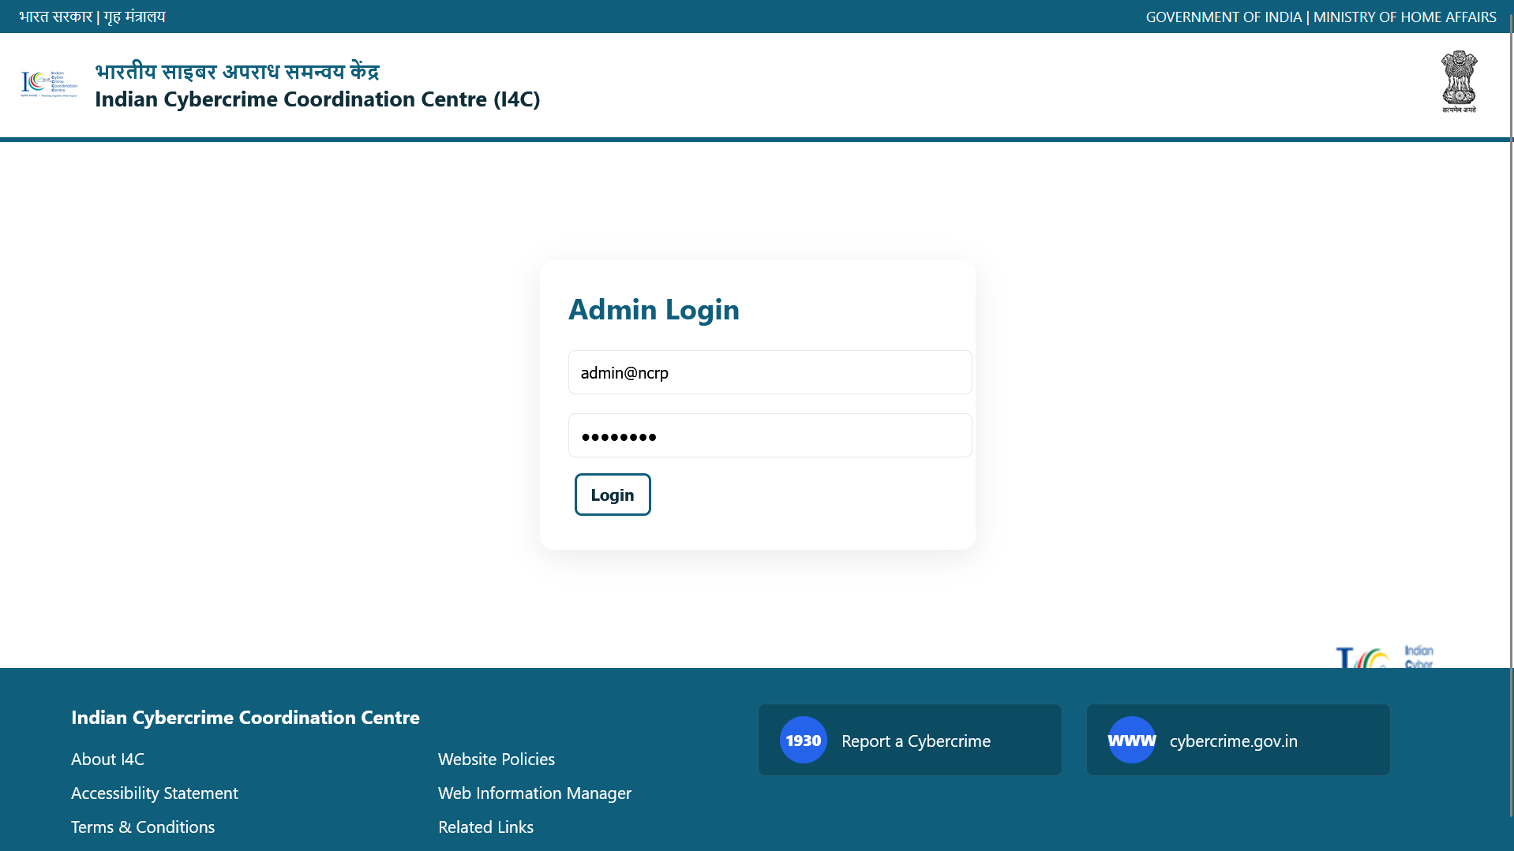

- Admin Dashboard Page
This dashboard displays a summary of onboarding requests categorized as pending, under process, approved, and rejected.
It enables administrators to monitor onboarding activities efficiently.

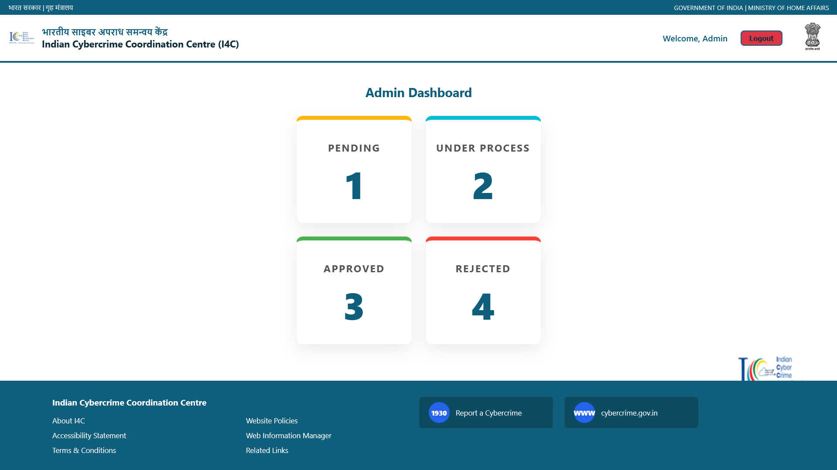
- Registration Requests – Pending Page
This page lists onboarding requests that are pending administrative review.
Admins can view submitted entity details and download uploaded documents.

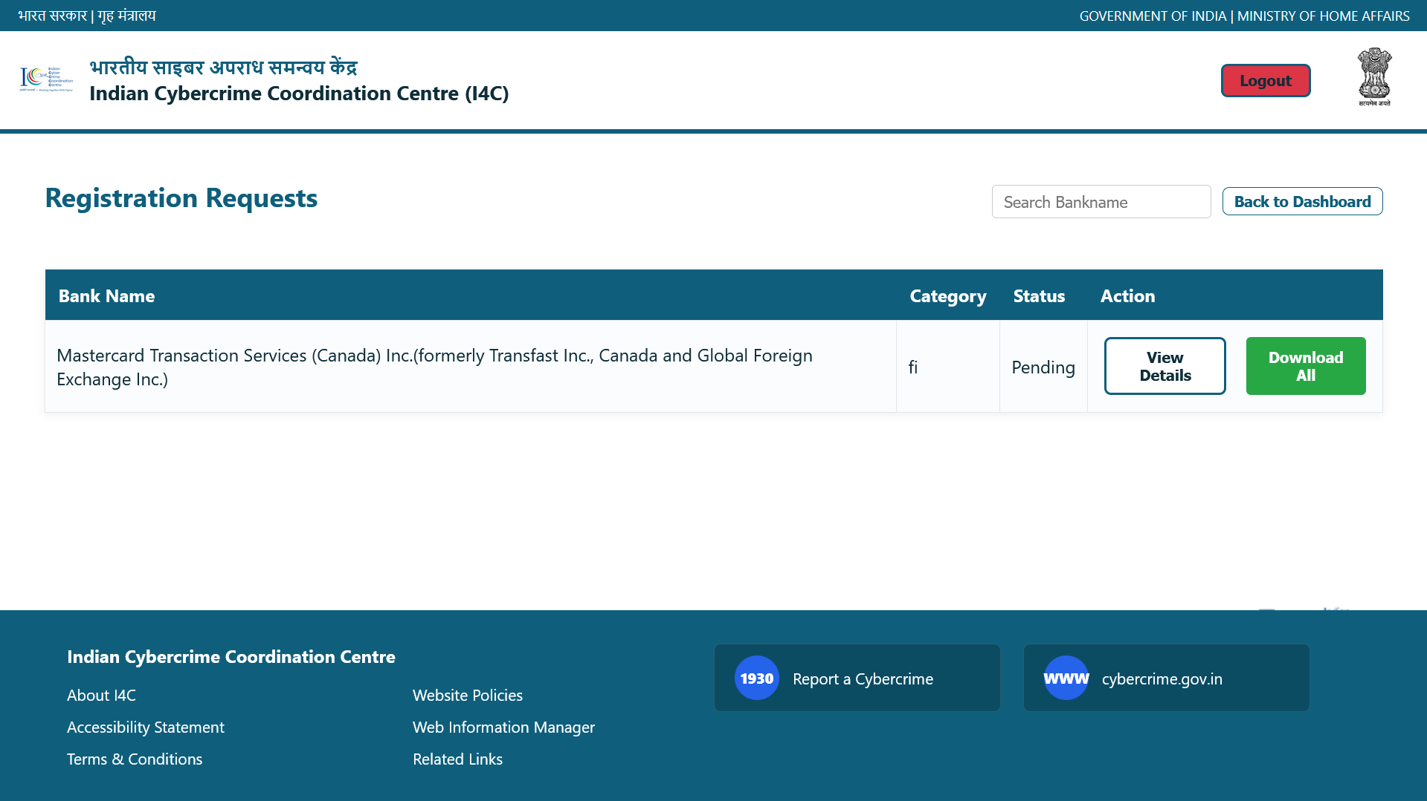

- Registration Requests – Under Process Page
This page shows onboarding applications currently under verification.
It helps administrators track requests that are being reviewed or validated.

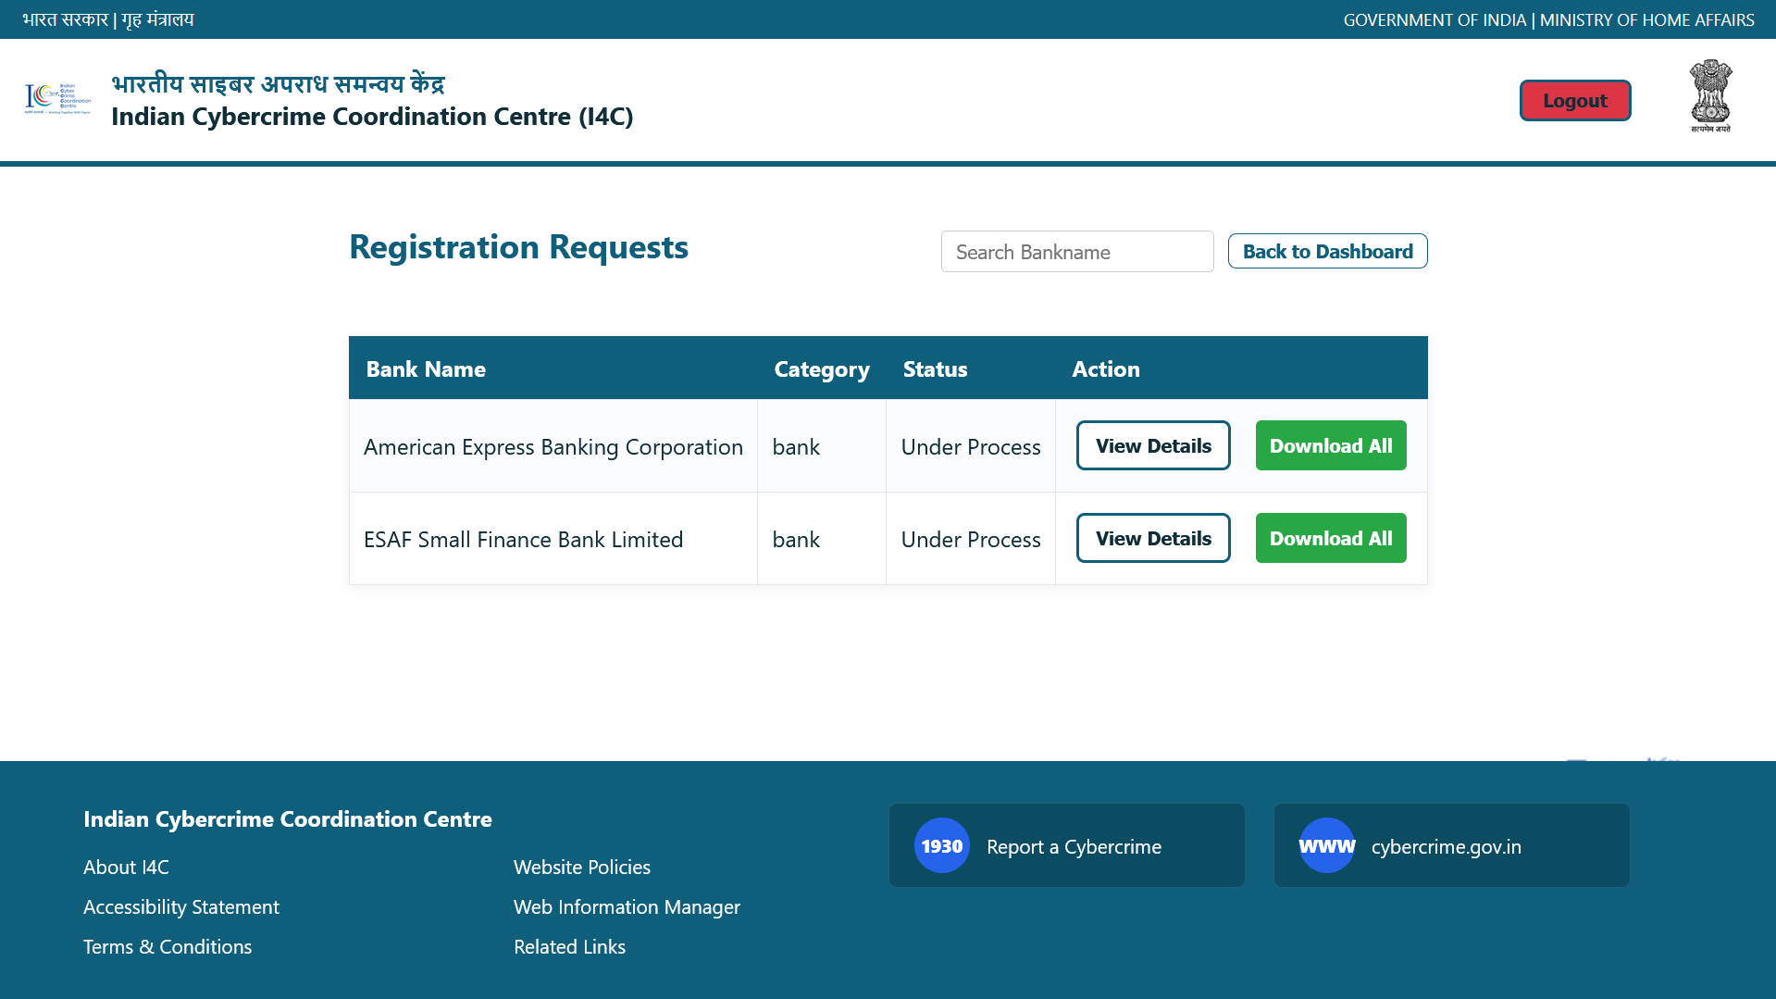
- Registration Requests – Approved Page
This page displays entities whose onboarding requests have been approved.
Approved entities are granted authorized access to the NCRP portal.

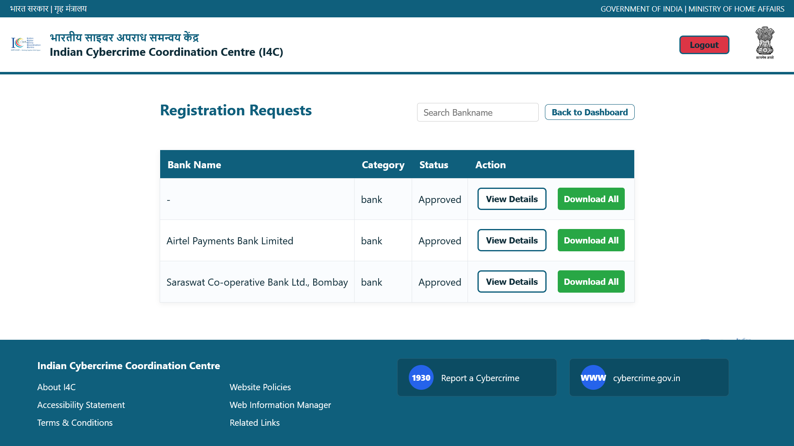

- Registration Requests – Rejected Page
This page lists onboarding requests that have been rejected by the administrator.
Rejected entries include entities that failed verification or compliance checks.

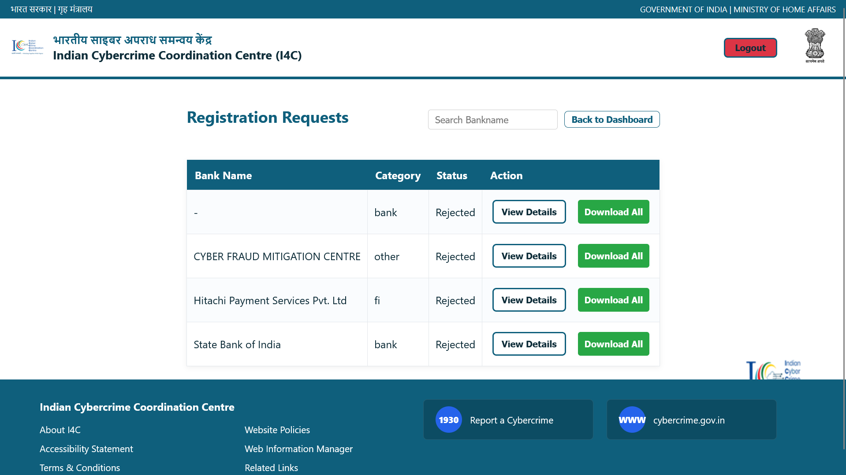
- Registration Details and Document Verification Page
This page allows administrators to review complete registration details and uploaded documents.
Admins can approve or reject individual documents and provide remarks to the user.

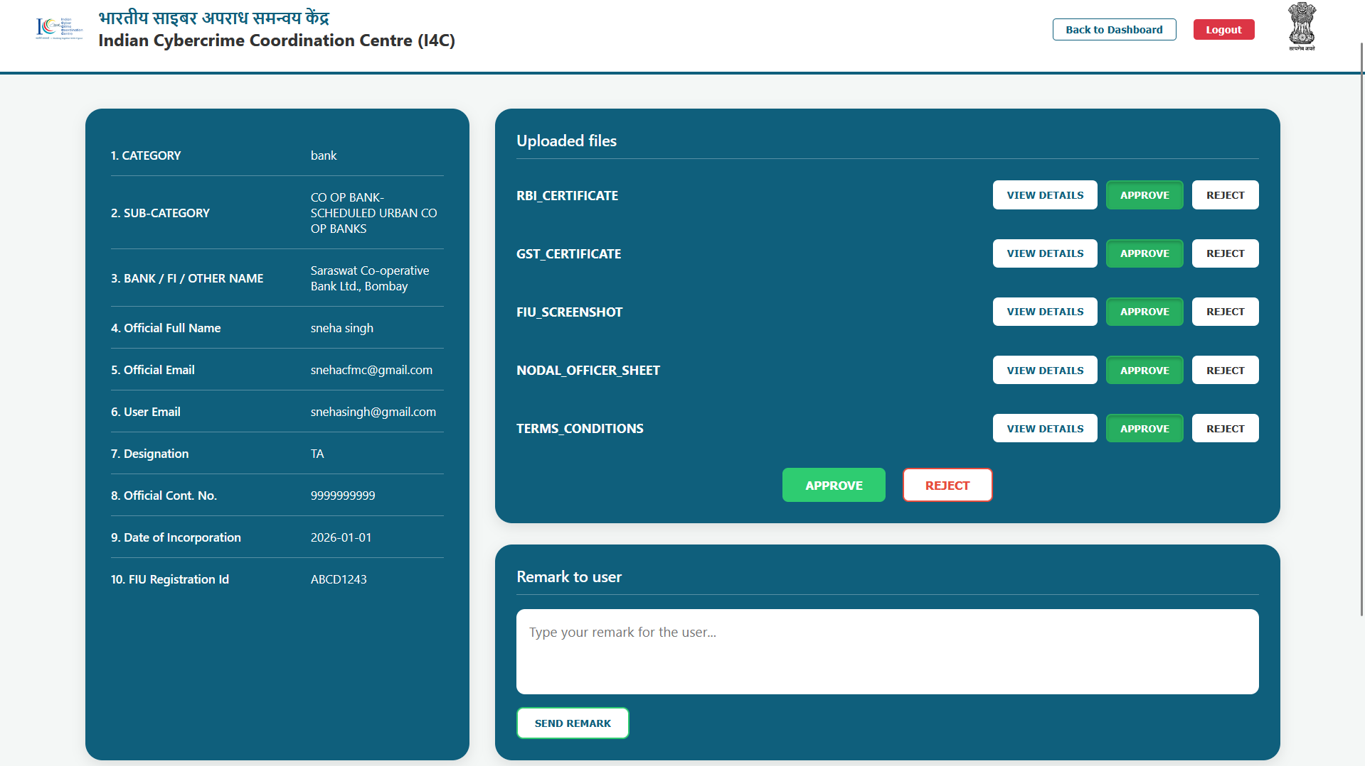

ADMIN-SITE ONBOARDING WORKFLOW
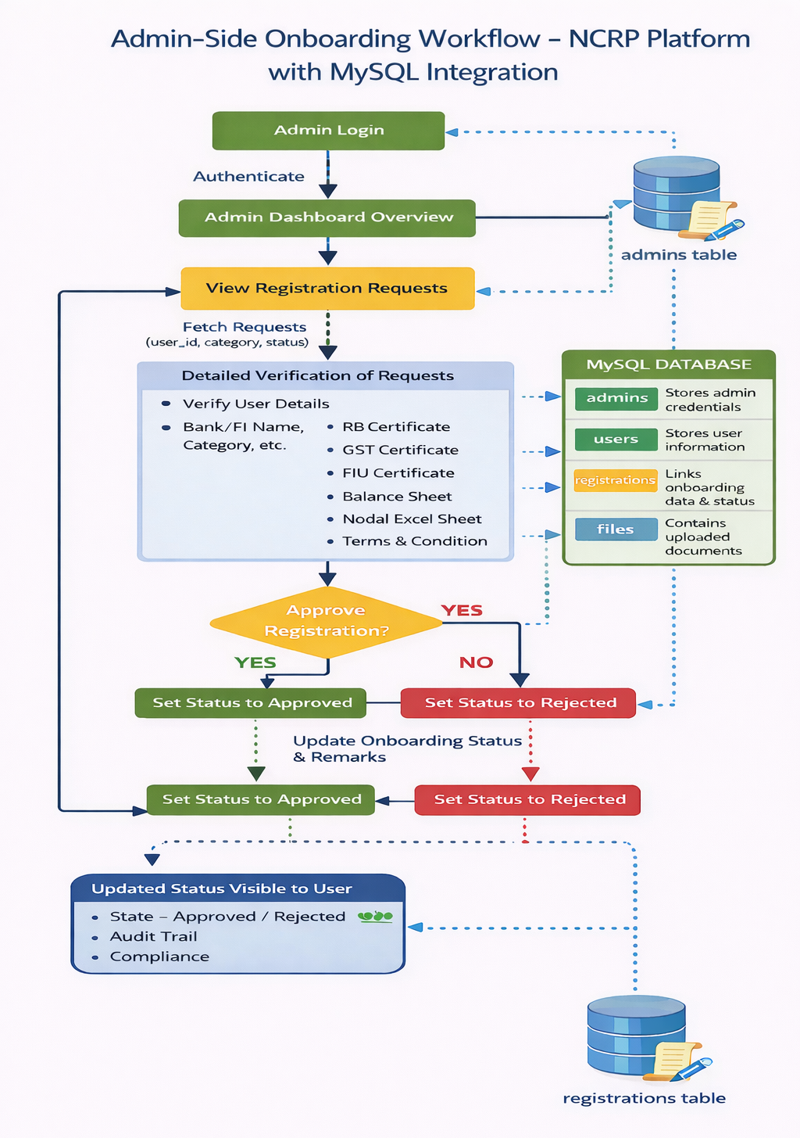

Chapter 4

Security Framework and Access Governance for Financial Cyber Fraud Management (MySQL Database Implementation)

4.1 Introduction
Financial cyber fraud has emerged as one of the most critical challenges in the digital ecosystem, affecting citizens, banks, financial intermediaries, and government institutions. The National Cyber Crime Reporting Portal (NCRP) handles large volumes of sensitive data related to fraud complaints, user identities, financial documents, and investigation workflows. To safeguard this information, a robust security framework and access governance mechanism is essential.
This chapter explains the security framework and access governance model implemented for financial cyber fraud management using a MySQL database. The design focuses on secure data storage, controlled access, role-based authorization, and administrative oversight to ensure data confidentiality, integrity, and availability.

4.2 Role of Database Security in NCRP
The database forms the backbone of the NCRP system, storing critical information such as user credentials, onboarding requests, uploaded regulatory documents, and approval statuses. Any compromise at the database level can severely impact system security and trust.
MySQL is used as the relational database management system due to its reliability, support for strong constraints, and ability to enforce data integrity through relationships and access controls. Database-level security complements application-level security to provide end-to-end protection.

4.3 Database Schema Overview
The MySQL database schema is designed to support secure onboarding and access governance. It consists of the following core tables:
- Users table
- Registrations table
- Files table
- Admins table
These tables are interconnected using primary and foreign keys to maintain referential integrity and prevent unauthorized or inconsistent data manipulation.

4.4 User Authentication and Credential Security

4.4.1 Users Table Design
The users table stores registered user credentials including unique user IDs, encrypted passwords, and account creation timestamps. Each user is uniquely identified using an auto-incremented primary key, ensuring accurate mapping across the system.
Password fields are designed to store hashed values rather than plain text passwords. This protects user credentials even if database access is compromised.

4.4.2 Secure Authentication Workflow
During login, user credentials are validated against stored records in the MySQL database. Authentication success depends on correct credentials and role validation, ensuring only authorized users gain access.

4.5 Role-Based Access Control (RBAC) Using Database Design
RBAC is implemented through a combination of database structure and application logic. Each user is assigned a role based on their category such as bank, financial intermediary, other entity, or administrator.
The registrations table includes a category field that defines the role and scope of access. This ensures that users can only access records and functionalities relevant to their assigned role, enforcing the principle of least privilege.

4.6 Secure Onboarding and Registration Management
The registrations table stores onboarding data submitted by banks, FIs, and other entities. Registration data is stored in structured JSON format, allowing flexibility while maintaining consistency.
Each registration is linked to a specific user using foreign key constraints. This linkage ensures accountability and prevents orphan records or unauthorized registrations.

4.7 Document Storage and Verification Security
The files table stores regulatory and supporting documents uploaded during onboarding. Documents such as RBI certificates, GST certificates, balance sheets, and authorization letters are stored as BLOBs.
Each file record includes a file type and verification status, enabling document-level approval or rejection. Foreign key constraints ensure that documents are always linked to a valid registration.

4.8 Administrative Access Governance
Administrative users are managed through the admins table, which stores admin usernames and encrypted passwords. Only records present in this table are allowed to access the admin dashboard.
Admins have exclusive rights to view onboarding requests, verify documents, approve or reject registrations, and provide remarks. This separation of privileges prevents misuse of administrative functions.

4.9 Workflow Status Tracking and Monitoring
The system uses status fields such as pending, under process, approved, and rejected to track onboarding progress. These statuses are stored directly in the MySQL database, ensuring consistency across the system.
Status tracking enables real-time monitoring of onboarding requests and supports transparent decision-making by administrators.

4.10 Data Integrity and Referential Constraints
MySQL constraints such as primary keys, foreign keys, and cascading deletes are used to enforce data integrity. For example, deleting a registration automatically removes associated documents, preventing stale data.
These constraints protect the system from inconsistent states and accidental data corruption.

4.11 Auditability and Accountability
Timestamps such as created_at and uploaded_at are stored for users, registrations, and files. These fields help track when records were created or modified.
Auditability supports forensic analysis during cybercrime investigations and enhances accountability among system users.

4.12 Compliance with Security Best Practices
The database design aligns with security best practices such as least privilege access, encrypted credential storage, and strict role separation. Sensitive data is accessed only by authorized roles, reducing exposure risk.
Such compliance strengthens trust among stakeholders and supports lawful handling of financial cyber fraud data.

4.13 Benefits of the MySQL-Based Security Framework
Using MySQL for implementing security and access governance offers several advantages:
- Strong relational integrity
- Efficient role-based access enforcement
- Secure document management
- Scalable onboarding workflow management
These benefits improve the overall robustness of the NCRP system.

4.14 Limitations and Future Enhancements
Although the current MySQL-based framework provides strong security, future enhancements can include database encryption at rest, advanced audit logging, and integration with centralized identity management systems.
Such improvements can further strengthen the NCRP security posture.

4.15 Conclusion
The implementation of a security framework and access governance model using a MySQL database plays a crucial role in secure financial cyber fraud management within the NCRP portal. By combining structured database design, role-based access control, secure authentication, document verification, and administrative oversight, the system ensures confidentiality, integrity, and accountability. This approach significantly enhances the effectiveness of financial cyber fraud reporting and management at a national level.

- Users Table Creation
This table stores login credentials of registered users accessing the NCRP onboarding system.
Each user is assigned a unique User ID with password details and account creation timestamp.
It supports secure authentication and identity management.

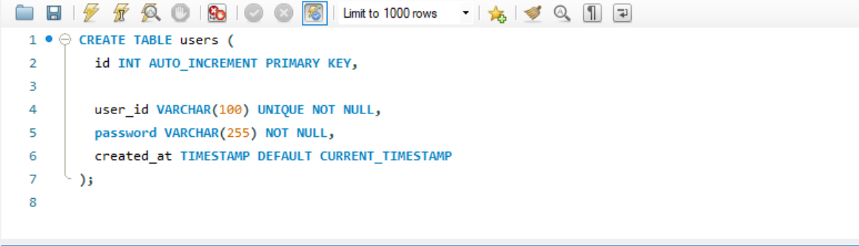

- Registrations Table Creation
This table stores onboarding requests submitted by banks, financial intermediaries, and other entities.
It links each registration to a user and stores category-specific form data in JSON format.
The table enables tracking of onboarding requests through timestamps and status fields.

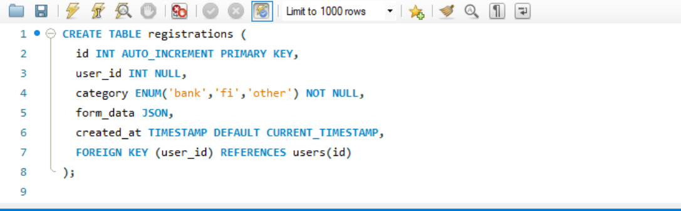

- Files Table Creation
This table stores all regulatory and supporting documents uploaded during onboarding.
Each file is linked to a specific registration and includes file type and upload timestamp.
Cascade deletion ensures data integrity when a registration is removed.

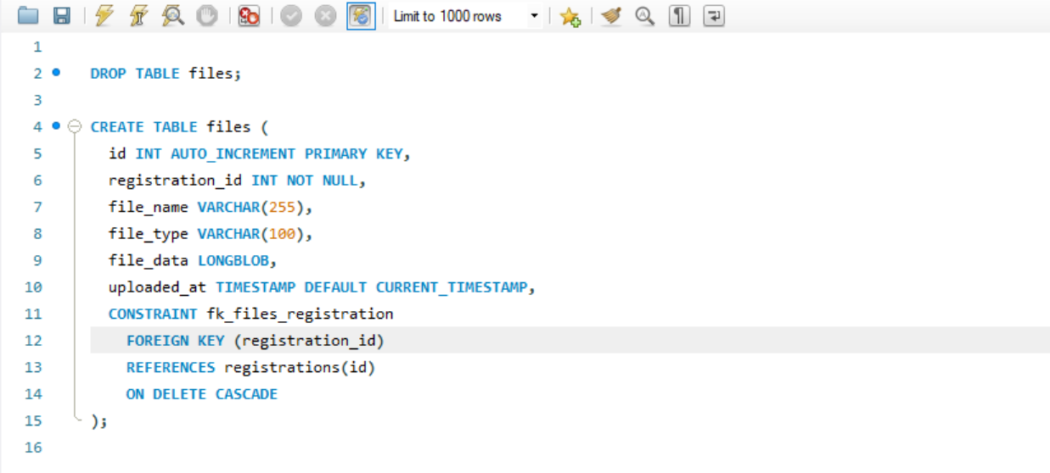

- Admins Table Creation
This table maintains credentials for NCRP administrative users.
Only authorized administrators stored in this table can access the admin dashboard.
It supports secure login and administrative control functions.

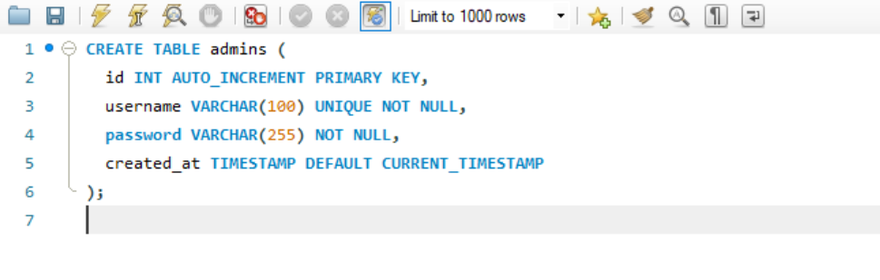

- Users Table – Stored Records
This displays registered users with their User IDs and creation timestamps.
It shows both entity users and administrative users stored in the system.
The data confirms successful user registration and account creation.

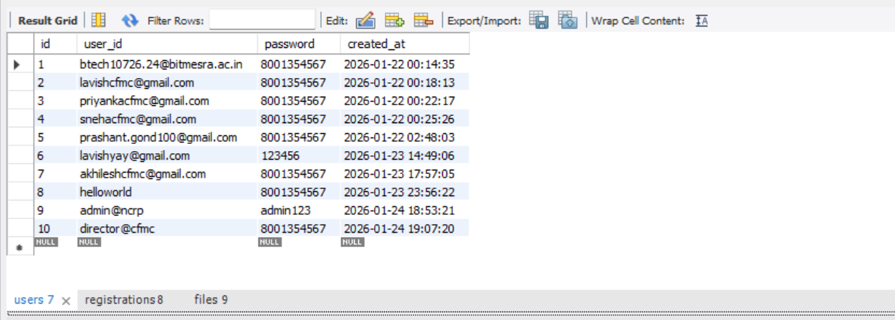

- Registrations Table – Stored Records
This table shows onboarding requests submitted under different categories such as bank, FI, and other.
Each record reflects the current onboarding status like approved, rejected, pending, or under process.
It supports workflow tracking and administrative decision-making.

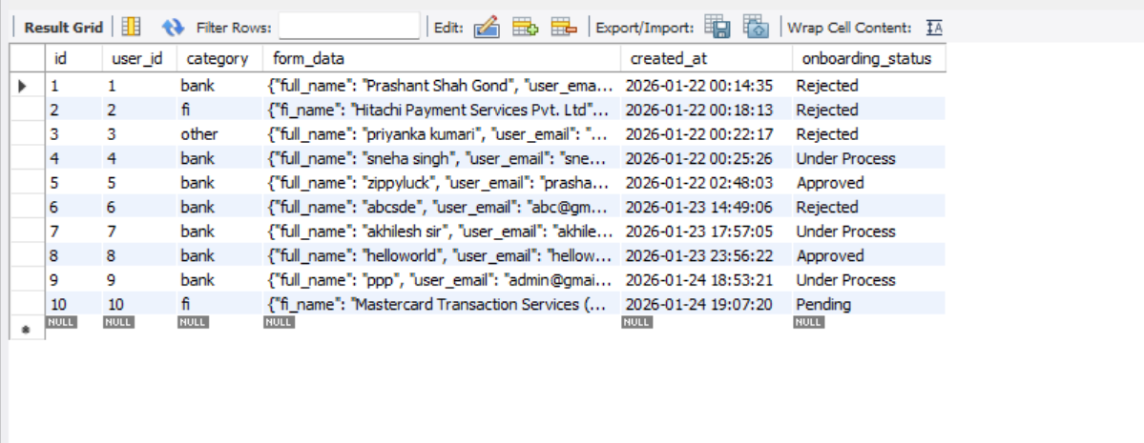

- Files Table – Stored Records
This table displays uploaded documents such as RBI certificates, GST certificates, and balance sheets.
Each document includes its verification status indicating approval or pending review.
It supports document-level validation within the onboarding workflow.

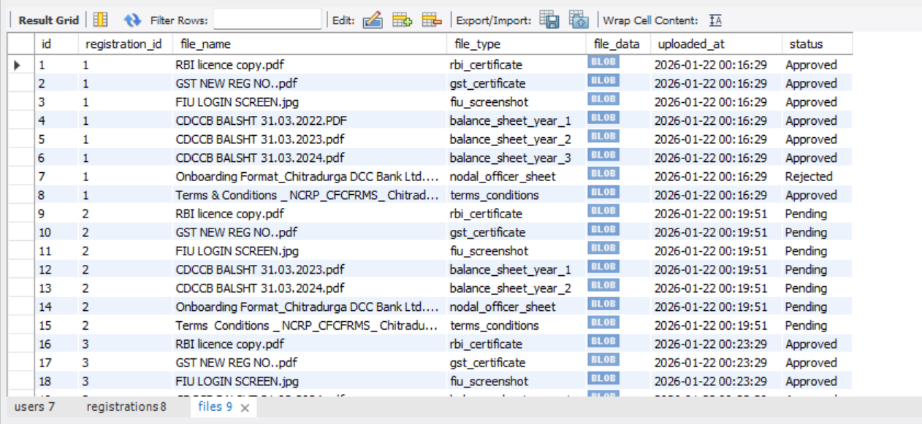

MYSQL-DATABASE WORKFLOW


Summary

The present project focuses on the design, development, and implementation of a secure and integrated framework to support financial cyber fraud reporting and management through the National Cyber Crime Reporting Portal (NCRP), an initiative of the Government of India under the Ministry of Home Affairs. With the rapid growth of digital payments and online financial services, cyber fraud incidents such as phishing, UPI frauds, debit and credit card frauds, identity theft, and unauthorized transactions have increased significantly. NCRP serves as a centralized digital platform that enables citizens to report cybercrimes efficiently while assisting law enforcement agencies in investigation and response.
The primary objective of this project is to strengthen the institutional side of the NCRP ecosystem by developing a secure User ID creation and onboarding system for banks, financial intermediaries, and other authorized entities. The system ensures that only verified and legitimate organizations are granted access to sensitive fraud-related information. By incorporating structured onboarding workflows, document verification, and administrative approval mechanisms, the project enhances trust, accountability, and coordination among all stakeholders involved in financial cyber fraud management.
The initial phase of the project involved understanding the operational structure and functional workflow of the NCRP portal. This included studying how cybercrime complaints are registered by users, categorized based on the nature of the offence, and routed to appropriate state or central cybercrime units. The role of banks and financial intermediaries in validating transactions, freezing fraudulent accounts, and supporting investigations was also analyzed. This understanding formed the foundation for designing a secure onboarding and access governance framework aligned with NCRP objectives.
A major component of the project is the implementation of Role-Based Access Control (RBAC) to ensure controlled and restricted access to the system. Different roles such as bank users, financial intermediary users, other entity users, and administrators were defined, each with specific permissions. RBAC enforces the principle of least privilege, ensuring that users can access only the data and functionalities relevant to their responsibilities. This significantly reduces the risk of unauthorized access and misuse of sensitive information.
Authentication and identity management mechanisms were incorporated to further strengthen system security. Each user is assigned a unique User ID during the onboarding process, and secure login procedures are enforced. Additional security measures such as OTP-based verification and credential validation help protect the system from unauthorized access attempts. These mechanisms collectively enhance the confidentiality and integrity of the NCRP portal.
The security framework and access governance model were implemented using a MySQL database, which acts as the core data repository for the system. Well-structured database tables such as users, registrations, files, and admins were designed to store user credentials, onboarding details, uploaded regulatory documents, and administrative information. Primary keys, foreign keys, and referential constraints were used extensively to maintain data integrity and prevent inconsistent or unauthorized data manipulation.
The registrations table plays a crucial role in managing onboarding requests submitted by banks, financial intermediaries, and other entities. Each registration record captures category-specific information and tracks the onboarding status using predefined states such as pending, under process, approved, and rejected. This status-based workflow ensures transparency and enables administrators to monitor and manage onboarding requests effectively.
Document management and verification were handled through a dedicated files table, where regulatory and supporting documents such as RBI certificates, GST certificates, balance sheets, FIU details, and authorization letters are securely stored. Each document is linked to its corresponding registration and includes verification status information. This allows administrators to approve or reject documents individually and maintain a clear audit trail for compliance and accountability.
Administrative users are managed separately through the admins table, ensuring a clear separation of privileges between normal users and administrators. Admin dashboards provide a consolidated view of onboarding activities, enabling efficient review, verification, approval, and rejection of requests. The inclusion of timestamps and status indicators supports traceability and forensic analysis, which is essential in financial cyber fraud investigations.
Overall, this project demonstrates a practical and secure approach to financial cyber fraud management through effective access governance and database-driven security mechanisms. By integrating structured onboarding, role-based access control, secure authentication, document verification, and administrative oversight, the system strengthens the operational effectiveness of the NCRP portal. The proposed framework is scalable and can be further enhanced in the future by incorporating advanced security features such as encryption at rest, centralized identity management, and automated risk scoring, thereby contributing to a stronger national cybercrime response infrastructure.

References

1. Official Portals & Government Resources
● National Cyber Crime Reporting Portal (NCRP), Government of India.
https://www.cybercrime.gov.in
● Ministry of Home Affairs (MHA) – Indian Cyber Crime Coordination Centre (I4C).
https://www.mha.gov.in
● Reserve Bank of India (RBI). Registered Banks/Fi’s/o and Digital Payment Guidelines.
https://www.rbi.org.in
2. Technical & Security Documentation
● MDN Web Docs (Mozilla). HTML, CSS, and JavaScript Documentation.
https://developer.mozilla.org
● OWASP Foundation. OWASP Top 10 – Web Application Security Risks.
https://owasp.org
● MySQL Documentation. User Management and Database Security.
https://dev.mysql.com/doc
3. Organizational Reference
● Indian Cyber Crime Coordination Centre (I4C). Internal SOPs and onboarding workflow documentation.

