PLOTTING GRAPHS
Graphical analysis is crucial in the exploratory phase of machine learning. It helps in understanding the distributions of individual variables (univariate), relationships between two variables (bivariate), or complex interactions among multiple variables (multivariate).
  - Univariate Analysis individual variables
  - Bivariate Analysis two variables
  - Multivariate Analysis multiple variables

Univariate Analysis
Univariate Analysis is a statistical method that describes and summarizes a single variable or feature within a dataset. The focus is on understanding the distribution, central tendency, and spread of the data related to that one variable. Univariate analysis is often the first step in Exploratory Data Analysis (EDA), as it helps to gain insights into the variable's behaviour before moving on to more complex analyses.
- Describing the basic properties of a single variable.
- Summarizing its characteristics such as the mean, median, mode, standard deviation, range, etc.
- Understanding the shape of the distribution (e.g., whether the data is skewed or symmetric).
- Visualizing the data through histograms, box plots, etc.
Applications of Univariate Analysis in Real-Time Projects
- Business: Understanding sales data, customer age groups, and product preferences.
- Healthcare: Analysing patient data (e.g., heart rate, blood pressure) to understand trends or patterns.
- Finance: Analysing stock prices, market volatility, or individual financial metrics (e.g., income distribution).
- Social Media/Marketing: Analysing user engagement metrics (e.g., number of clicks, likes, comments).
The real-time use of univariate analysis helps in:
- Data cleaning: Identifying errors, missing values, or outliers in the data.
- Feature selection: Understanding which variables are important for further analysis or model building.
- Decision-making: Allowing businesses to make informed decisions based on data distribution (e.g., adjusting marketing campaigns based on customer age group distribution).

Key Measures in Univariate Analysis:
Central Tendency: Mean, median, mode.
Dispersion: Variance, standard deviation, range.
Shape: Skewness, kurtosis

Real Time Univariate Analysis Process
1. Data Collection:
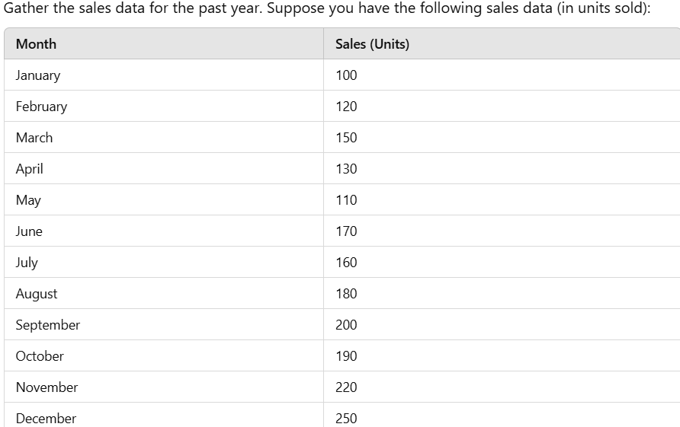

2. Data Summarization (Measures of Central Tendency and Spread):
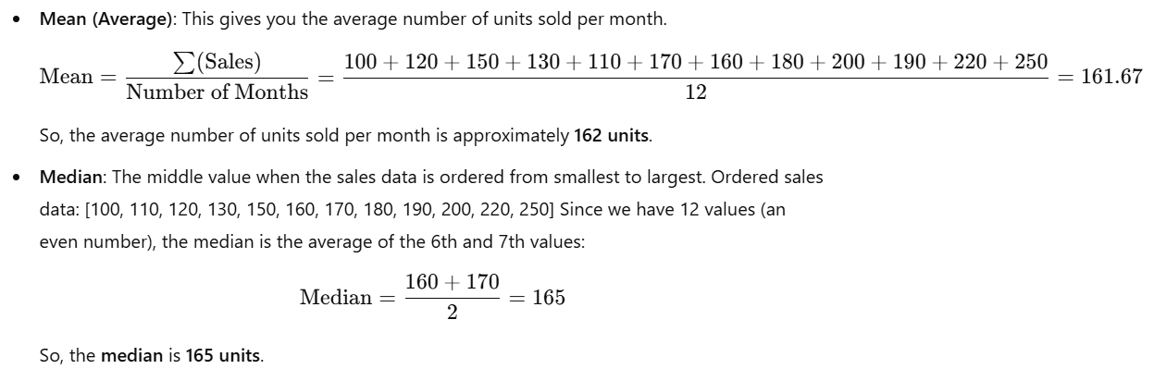

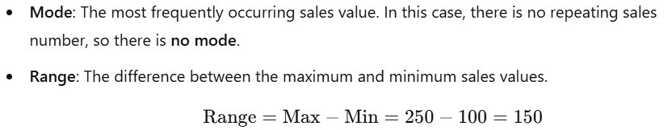
So, the range of the sales data is 150 units.
Standard Deviation: A measure of how spread out the sales data is. It's calculated as the square root of the variance. For simplicity in manual calculations, you can estimate it by understanding the spread of data around the mean.
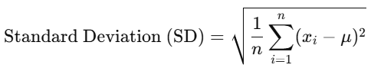

Sales (Units) = [100,120,150,130,110,170,160,180,200,190,220,250]

And we already calculated the mean of the sales data as 161.67 (approximately).
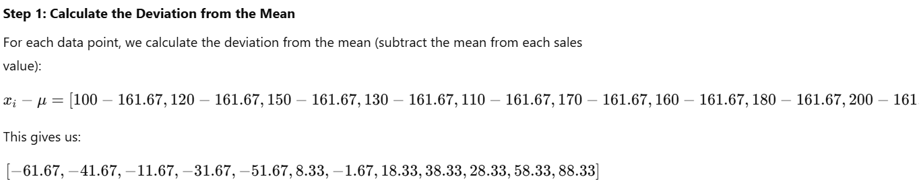
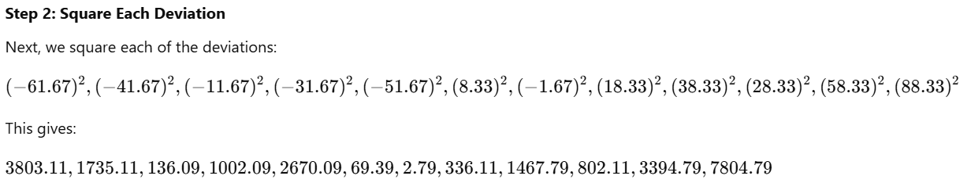
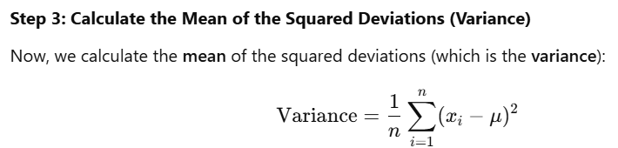
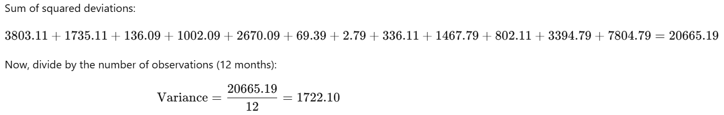
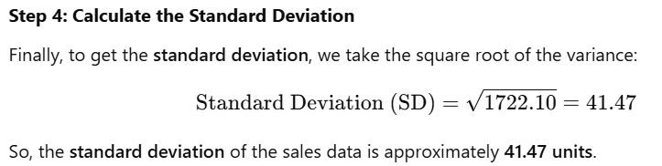
Numerical (Quantitative) Data Analysis:
- Boxplot
- Histogram
- Density Plot

Visualizing the Sales Data Using Python
import pandas as pd
import matplotlib.pyplot as plt
import seaborn as sns
# Sales data for each month
data = {
'Month': ['January', 'February', 'March', 'April', 'May', 'June',
'July', 'August', 'September', 'October', 'November', 'December'],
'Sales (Units)': [100, 120, 150, 130, 110, 170, 160, 180, 200, 190, 220, 250]
}

# Convert the data into a DataFrame
df = pd.DataFrame(data)

# Create a figure with subplots
plt.figure(figsize=(18, 6))

# Box Plot
plt.subplot(1, 3, 1) # 1 row, 3 columns, 1st plot
sns.boxplot(x=df['Sales (Units)'], color='lightblue')
plt.title('Box Plot of Monthly Sales', fontsize=16)
plt.xlabel('Sales (Units)', fontsize=12)

# Histogram
plt.subplot(1, 3, 2) # 1 row, 3 columns, 2nd plot
sns.histplot(df['Sales (Units)'], bins=8, kde=False, color='skyblue', edgecolor='black')
plt.title('Histogram of Monthly Sales', fontsize=16)
plt.xlabel('Sales (Units)', fontsize=12)
plt.ylabel('Frequency', fontsize=12)

# Density Plot
plt.subplot(1, 3, 3) # 1 row, 3 columns, 3rd plot
sns.kdeplot(df['Sales (Units)'], shade=True, color='green')
plt.title('Density Plot of Monthly Sales', fontsize=16)
plt.xlabel('Sales (Units)', fontsize=12)
plt.ylabel('Density', fontsize=12)

# Show plots
plt.tight_layout()
plt.show()

Categorical (Qualitative) Data Analysis:
Bar Chart: Displays the frequency of each category as bars.
Pie Chart: Shows the proportion of each category as slices of a pie.

PYCODE:
import pandas as pd
import matplotlib.pyplot as plt
import seaborn as sns
# Sales data for each month
data = {
'Month': ['January', 'February', 'March', 'April', 'May', 'June',
'July', 'August', 'September', 'October', 'November', 'December'],
'Sales (Units)': [100, 120, 150, 130, 110, 170, 160, 180, 200, 190, 220, 250]
}

# Convert the data into a DataFrame
df = pd.DataFrame(data)
# Create a figure with two subplots (1 row, 2 columns)
plt.figure(figsize=(18, 6))

# Bar Chart
plt.subplot(1, 2, 1)
sns.barplot(x='Month', y='Sales (Units)', data=df, palette='Blues_d')
plt.title('Monthly Sales Bar Chart', fontsize=16)
plt.xlabel('Month', fontsize=12)
plt.ylabel('Sales (Units)', fontsize=12)
plt.xticks(rotation=45)

# Pie Chart
plt.subplot(1, 2, 2)
plt.pie(df['Sales (Units)'], labels=df['Month'], autopct='%1.1f%%', startangle=140, colors=sns.color_palette('Blues_d', len(df)))
plt.title('Sales Distribution by Month', fontsize=16)

# Show the combined plot
plt.tight_layout()
plt.show()

Identify Trends and Outliers
We will identify trends and outliers using the sales data you provided for the 12 months of the year.

Example:
import pandas as pd
import matplotlib.pyplot as plt
import seaborn as sns
from scipy import stats

# Sales data for each month
data = {
'Month': ['January', 'February', 'March', 'April', 'May', 'June',
'July', 'August', 'September', 'October', 'November', 'December'],
'Sales (Units)': [100, 120, 150, 130, 110, 170, 160, 180, 200, 190, 220, 250]
}

# Convert the data into a DataFrame
df = pd.DataFrame(data)

# Line plot to visualize sales trends
plt.figure(figsize=(10, 6))
plt.plot(df['Month'], df['Sales (Units)'], marker='o', color='b', linestyle='-', markersize=8)

# Add title and labels
plt.title('Monthly Sales Trend', fontsize=16)
plt.xlabel('Month', fontsize=12)
plt.ylabel('Sales (Units)', fontsize=12)

# Rotate x-axis labels to make them readable
plt.xticks(rotation=45)

# Show plot
plt.tight_layout()
plt.show()

2. Moving Average
A moving average smooths out fluctuations in the data, highlighting trends over time. A 3-month moving average is often used to detect long-term trends.

Example:
import pandas as pd
import matplotlib.pyplot as plt
import seaborn as sns
from scipy import stats

# Sales data for each month
data = {
'Month': ['January', 'February', 'March', 'April', 'May', 'June',
'July', 'August', 'September', 'October', 'November', 'December'],
'Sales (Units)': [100, 120, 150, 130, 110, 170, 160, 180, 200, 190, 220, 250]
}

# Convert the data into a DataFrame
df = pd.DataFrame(data)

# Calculate 3-month moving average
df['Moving Average (3 Months)'] = df['Sales (Units)'].rolling(window=3).mean()

# Plot original data and moving average
plt.figure(figsize=(10, 6))
plt.plot(df['Month'], df['Sales (Units)'], marker='o', label='Monthly Sales', color='b', linestyle='-', markersize=8)
plt.plot(df['Month'], df['Moving Average (3 Months)'], label='3-Month Moving Average', color='r', linestyle='--', linewidth=2)

# Add title and labels
plt.title('Monthly Sales Trend with 3-Month Moving Average', fontsize=16)
plt.xlabel('Month', fontsize=12)
plt.ylabel('Sales (Units)', fontsize=12)

# Rotate x-axis labels to make them readable
plt.xticks(rotation=45)

# Add legend
plt.legend()

# Show plot
plt.tight_layout()
plt.show()

Identifying Outliers in the Data
Example:
import pandas as pd
import matplotlib.pyplot as plt
import seaborn as sns
from scipy import stats

# Sales data for each month
data = {
'Month': ['January', 'February', 'March', 'April', 'May', 'June',
'July', 'August', 'September', 'October', 'November', 'December'],
'Sales (Units)': [100, 120, 150, 130, 110, 170, 160, 180, 200, 190, 220, 250]
}

# Convert the data into a DataFrame
df = pd.DataFrame(data)

# Box plot to identify potential outliers
plt.figure(figsize=(10, 6))
sns.boxplot(x=df['Sales (Units)'], color='lightblue')

# Add title and labels
plt.title('Box Plot of Monthly Sales', fontsize=16)
plt.xlabel('Sales (Units)', fontsize=12)

# Show the plot
plt.tight_layout()
plt.show()

Drawing Conclusions and Actionable Insights
After analysing the sales data using trends and outliers, we can derive conclusions and formulate actionable insights for the business. This is an essential step in data analysis as it provides directions for decision-making and strategic improvements. Your sales data indicates a positive growth trend overall, with a significant peak in December driven by seasonal factors. The actionable insights include preparing for seasonal demand, expanding marketing efforts, and focusing on customer retention to sustain growth throughout the year. Monitoring trends regularly will help the business identify opportunities for improvement and ensure that sales continue to rise over the long term.

Decision Making Based on Sales Data Insights
- Increase Marketing Investment to capitalize on the positive trend in sales and further amplify growth.
- Maximize Sales during Peak Seasons (like December) with targeted promotions, inventory management, and customer-centric strategies.
- Boost Sales during Off-Peak Months by offering discounts, new product introductions, and customer retention strategies.
- Monitor Sales Regularly using dashboards and predictive analytics to ensure the business can adapt to changing market conditions.
- Focus on Customer Retention through loyalty programs, personalized communication, and subscription models to create long-term customer relationships.
- Optimize Operations to handle increased demand and ensure smooth delivery and customer service during peak periods.
- Evaluate Business Strategies regularly to identify areas for improvement and adapt to market changes.
Bivariate Analysis involves the analysis of two variables to explore the relationship between them. Unlike univariate analysis, which focuses on one variable, bivariate analysis aims to understand how one variable influence or correlates with another. This type of analysis is widely used in statistics and data science to identify patterns, relationships, and potential cause-and-effect associations.

Objectives of Bivariate Analysis:
- To determine the relationship between two variables.
- To assess the strength and direction of the association.
- To identify patterns, correlations, or dependencies between the variables.

Types of Bivariate Data:
- Numerical vs. Numerical: Both variables are numerical (e.g., height vs. weight).
- Numerical vs. Categorical: One variable is numerical and the other is categorical (e.g., income vs. job category).
- Categorical vs. Categorical: Both variables are categorical (e.g., gender vs. occupation).

1. Numerical vs. Numerical Data:
Scatter Plot: A graphical method where each point represents an observation. The x-axis corresponds to one variable and the y-axis to the other. Scatter plots help visualize the relationship (linear, nonlinear, etc.) between two variables.

Example: PYTHON
import pandas as pd
import numpy as np
import matplotlib.pyplot as plt
from scipy.stats import pearsonr

# Example data
x = np.array([1, 2, 3, 4, 5, 6, 7, 8, 9])
y = np.array([2, 4, 5, 4, 5, 7, 8, 9, 10])

# Scatter Plot
plt.scatter(x, y)
plt.title('Scatter Plot of X vs Y')
plt.xlabel('X values')
plt.ylabel('Y values')
plt.show()

# Correlation Coefficient
corr, _ = pearsonr(x, y)
print(f"Pearson Correlation Coefficient: {corr}")

Correlation Coefficient (Pearson's r): Measures the strength and direction of the linear relationship between two variables. The value ranges from -1 (perfect negative correlation) to +1 (perfect positive correlation).
- r=1: Perfect positive linear relationship.
- r=0: No linear relationship.
- r=−1: Perfect negative linear relationship.

Regression Analysis: This is used to quantify the relationship between two variables. A simple linear regression can predict the value of one variable based on the other.

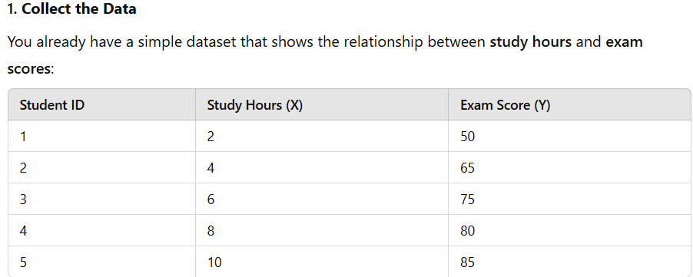

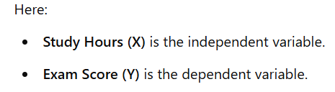
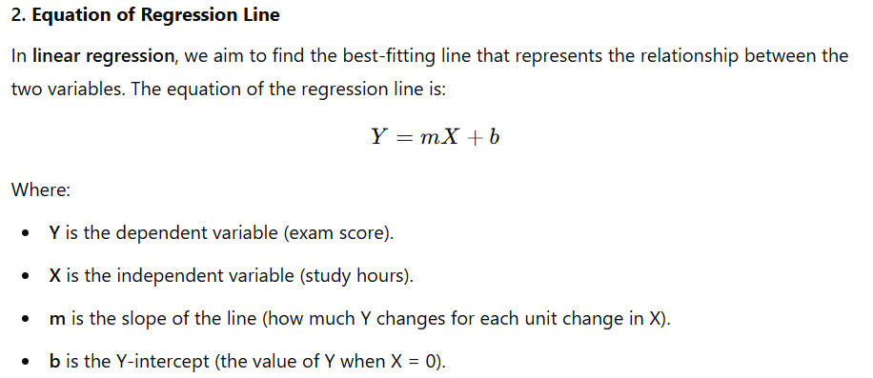

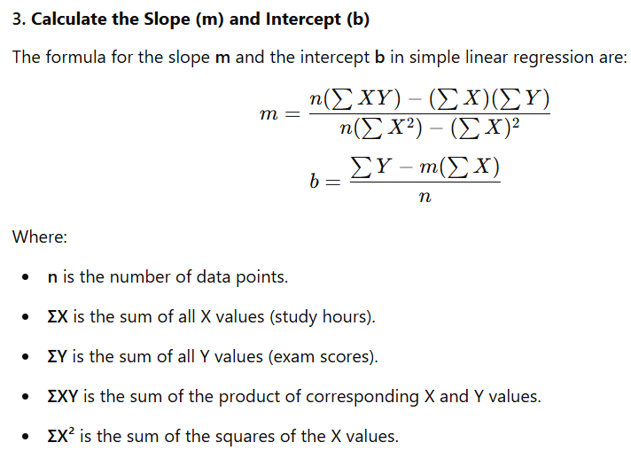

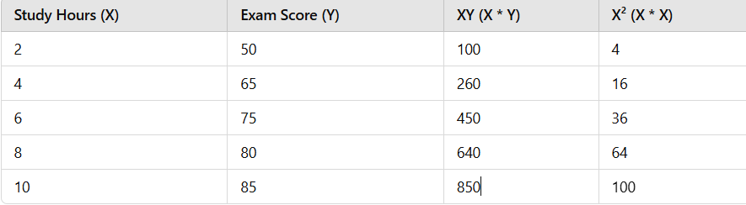

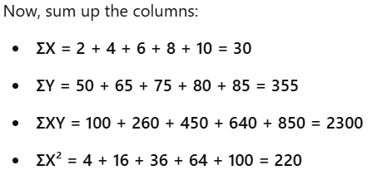

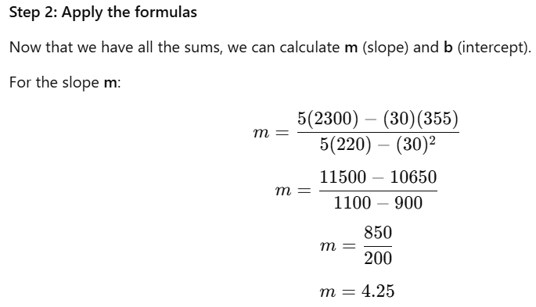

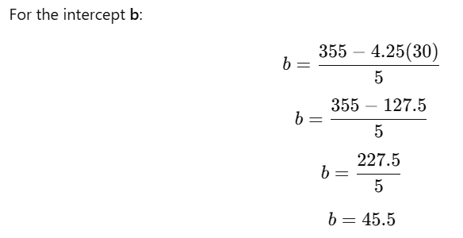

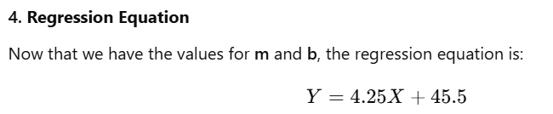

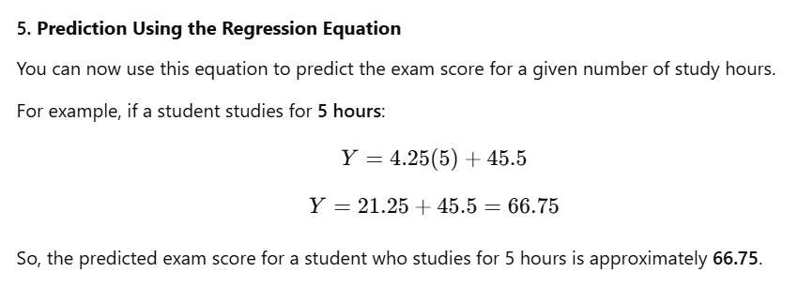

Key Points
- Linear regression helps model the relationship between two variables and make predictions based on this relationship.
- The slope (m) tells you how much the dependent variable changes when the independent variable increases.
- The intercept (b) gives you the starting value of the dependent variable when the independent variable is zero.
- Regression analysis is a powerful tool for prediction and understanding the relationship between variables, especially when making decisions based on data.

Numerical vs. Categorical Data:
Box Plot:
Box Plot: Displays the distribution of the numerical variable for each category. It helps to visualize how the numerical data is spread within each group.

Example:
import pandas as pd
import seaborn as sns
import matplotlib.pyplot as plt

# Example data
df = pd.DataFrame({
'Category': ['A', 'A', 'B', 'B', 'C', 'C', 'C'],
'Values': [5, 7, 8, 6, 10, 9, 11]
})

# Boxplot
sns.boxplot(x='Category', y='Values', data=df)
plt.title('Boxplot of Values by Category')
plt.show()

Categorical vs. Categorical Data:
When both variables are categorical, common methods include:
Contingency Table (Crosstab): A table that shows the frequency of occurrences for each combination of categorical variables.
Chi-Square Test: A statistical test used to determine whether there is a significant association between two categorical variables.
Stacked Bar Plot: A visual method for showing how the distribution of one categorical variable change across different categories of the other.

Example:
import pandas as pd
import seaborn as sns
import matplotlib.pyplot as plt

# Example data
df = pd.DataFrame({
'Gender': ['Male', 'Female', 'Female', 'Male', 'Female', 'Male'],
'Product': ['A', 'B', 'A', 'B', 'A', 'A']
})

# Crosstab (Contingency Table)
crosstab = pd.crosstab(df['Gender'], df['Product'])
print(crosstab)

# Stacked Bar Plot
crosstab.plot(kind='bar', stacked=True)
plt.title('Stacked Bar Plot of Gender vs Product')
plt.ylabel('Count')
plt.show()

Multivariate Analysis
Multivariate Analysis is a statistical technique used to analyse data that involves more than two variables at the same time. It helps researchers and analysts understand relationships, patterns, and dependencies among multiple variables, allowing them to study the combined effects of these variables and make more informed decisions.
Objectives of Multivariate Analysis:
- To examine the relationships between multiple variables.
- To identify patterns and structures within the data.
- To make predictions based on multiple input variables.
- To reduce the dimensionality of large datasets while retaining important information.
Plots for Multivariate Analysis
- Pair Plot (for visualizing pairwise relationships between variables)
- Principal Component Analysis (PCA) (for dimensionality reduction to 2D)
- Heatmap (for correlation matrix)
- 3D Scatter Plot (for visualizing 3 features)

Pairplot: It is also known as a scatterplot matrix, is a type of visualization used to understand the relationships between multiple variables in a dataset.

Key Features of a Pair Plot:
- Pairwise Scatter Plots
- Diagonals
- Colour Coding
- Symmetry
Purpose of Pair Plot
- Visualizing Relationships
- Detecting Correlations
- Identifying Clusters
- Identifying Outliers
Example of Pair Plot
- Sepal length
- Sepal width
- Petal length
- Petal width

Example:
import seaborn as sns
import pandas as pd
from sklearn.datasets import load_iris

# Load the Iris dataset
data = load_iris()
df = pd.DataFrame(data.data, columns=data.feature_names)
df['Species'] = data.target_names[data.target]

# Create the pair plot
sns.pairplot(df, hue='Species')

Principal Component Analysis (PCA)
It is a technique to reduce the dimensionality of the data and project it onto 2 or 3 principal components for easier visualization.

Example:
import matplotlib.pyplot as plt
from sklearn.decomposition import PCA

# Apply PCA to reduce data to 2 dimensions
pca = PCA(n_components=2)
X_pca = pca.fit_transform(df.iloc[:, :-1])

# Create a DataFrame for the PCA results
pca_df = pd.DataFrame(X_pca, columns=['PC1', 'PC2'])
pca_df['Species'] = df['Species']

# Plot the PCA result
plt.figure(figsize=(8, 6))
sns.scatterplot(data=pca_df, x='PC1', y='PC2', hue='Species', palette='Set2')
plt.title('PCA - Iris Dataset')
plt.xlabel('Principal Component 1')
plt.ylabel('Principal Component 2')
plt.show()

Heatmap (for correlation matrix):
It is useful for visualizing the correlation between multiple variables. It uses colour to represent the strength of the correlation.

Example:
import seaborn as sns
# Correlation matrix
corr_matrix = df.iloc[:, :-1].corr()
# Plotting the heatmap
plt.figure(figsize=(8, 6))
sns.heatmap(corr_matrix, annot=True, cmap='coolwarm', fmt='.2f', linewidths=0.5)
plt.title('Correlation Heatmap - Iris Dataset')
plt.show()

3D Scatter Plot (for visualizing 3 features)
If you have three features, you can create a 3D scatter plot to visualize their relationships in 3D space.

Example:
from mpl_toolkits.mplot3d import Axes3D
from sklearn.decomposition import PCA
import matplotlib.pyplot as plt

# Select the first three features
X = df.iloc[:, :-1].values

# Create a 3D scatter plot
fig = plt.figure(figsize=(10, 8))
ax = fig.add_subplot(111, projection='3d')

# Plotting
ax.scatter(X[:, 0], X[:, 1], X[:, 2], c=data.target, cmap='viridis')

# Set labels
ax.set_xlabel('Sepal Length')
ax.set_ylabel('Sepal Width')
ax.set_zlabel('Petal Length')
ax.set_title('3D Scatter Plot - Iris Dataset')
plt.show()

