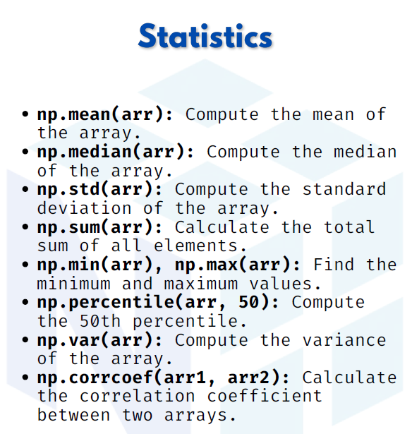

Statistics

1. np.mean(arr) → Compute the mean of the array
The mean is the average of all numbers in the array.

import numpy as np
arr = np.array([1, 2, 3, 4, 5])
print(np.mean(arr))

Output:
3.0

2. np.median(arr) → Compute the median of the array
The median is the middle value when the numbers are sorted.

print(np.median(arr))
Output:
3.0

3. np.std(arr) → Compute the standard deviation
The standard deviation shows how much the data spreads out from the mean.
print(np.std(arr))
Output:
1.4142135623730951

4. np.sum(arr) → Calculate the total sum of all elements
This function adds all numbers in the array.
print(np.sum(arr))

Output:
15

5. np.min(arr), np.max(arr) → Find the minimum and maximum values
These functions return the smallest and largest numbers in the array.
print(np.min(arr)) # Minimum
print(np.max(arr)) # Maximum
Output:
1
5

6. np.percentile(arr, 50) → Compute the 50th percentile
The percentile tells us the value below which a given percentage of data falls.
- 50th percentile = median.
print(np.percentile(arr, 50))
Output:
3.0

7. np.var(arr) → Compute the variance of the array
The variance is the average of squared differences from the mean.
print(np.var(arr))
Output:
2.0

8. np.corrcoef(arr1, arr2) → Correlation coefficient between two arrays
The correlation coefficient measures the relationship between two datasets.
- Value near 1 → strong positive relation
- Value near -1 → strong negative relation
- Value near 0 → weak/no relation

arr1 = np.array([1, 2, 3, 4, 5])
arr2 = np.array([2, 4, 6, 8, 10]) # Perfect positive correlation
print(np.corrcoef(arr1, arr2))
Output:
[[1. 1.]
[1. 1.]]

