FEATURE ENGINEERING
It is the process of transforming raw data into meaningful features that improve the performance of ML models. It involves creating, modifying, and selecting the most relevant features to make patterns in the data more apparent to the learning algorithm.
Dataset: House Prices Prediction
Assume we have a dataset with the following columns:
LotArea: Area of the lot in square feet.
YearBuilt: Year the house was built.
TotalRooms: Total number of rooms in the house.
GarageCars: Number of cars the garage can hold.
SalePrice: The target variable, representing the sale price of the house.

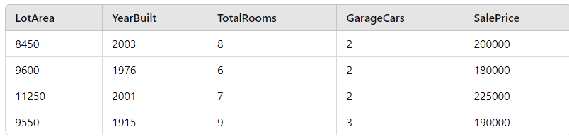
Feature Engineering Steps:
1. Feature Creation: HouseAge
Problem: The YearBuilt feature represents the year the house was built. However, the age of the house might be more relevant than the exact year.
Solution: Create a new feature HouseAge by subtracting YearBuilt from the current year (let's assume the current year is 2025).
Transformation:
HouseAge=2025−YearBuilt

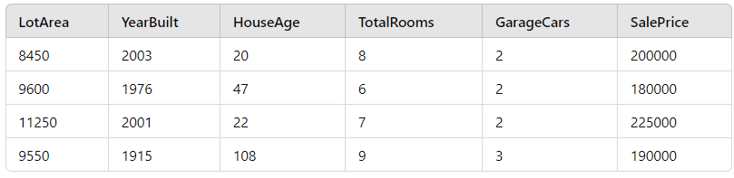

2. Feature Transformation: TotalRoomsPerGarage
Problem: The number of total rooms and the garage capacity may interact in predicting the sale price. For example, a house with many rooms but a small garage might be priced differently than a house with fewer rooms and a large garage.
Solution: Create a feature that combines the TotalRooms and GarageCars to capture the relationship between the two. We can create a ratio: TotalRoomsPerGarage.
Transformation:
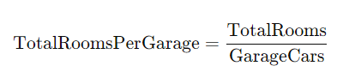

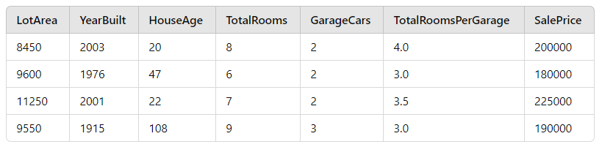

3. Binning: LotAreaCategory
Problem: The LotArea (size of the land) is continuous, and there may be different patterns based on whether the lot is small, medium, or large.

Solution: We can create a new categorical feature LotAreaCategory by binning the LotArea into categories like Small, Medium, and Large.​

Transformation:
If LotArea < 9000, label it as Small.
If 9000 <= LotArea < 11000, label it as Medium.
If LotArea >= 11000, label it as Large.

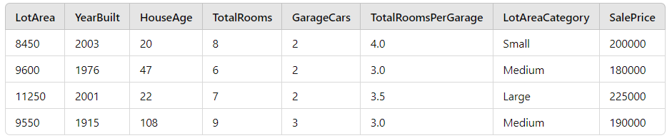

4. One-Hot Encoding: LotAreaCategory
Problem: Machine learning algorithms typically don’t work well with categorical data. You need to convert LotAreaCategory into a format that the model can understand.
Solution: Apply one-hot encoding to the LotAreaCategory column, creating binary columns for each category.
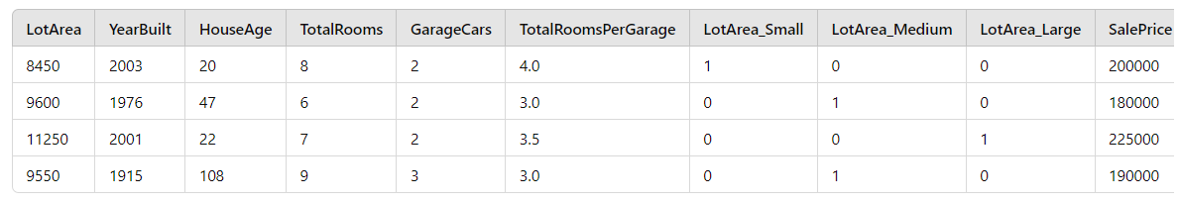

Final Dataset After Feature Engineering:
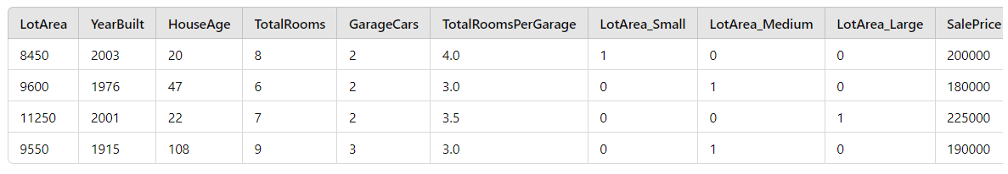

Key Insights and Benefits of Feature Engineering:
HouseAge: This feature now allows the model to understand the influence of the house's age on the price. Older houses might have a lower sale price due to wear and tear.
TotalRoomsPerGarage: This interaction term captures the balance between the number of rooms and garage space, which might impact home value.
LotAreaCategory: Converting LotArea into categories like Small, Medium, and Large helps the model identify pricing patterns based on the lot size.
One-Hot Encoding: This ensures that categorical variables are represented numerically in a way that machine learning models can interpret without assuming ordinal relationships.

Finally:
This example demonstrates how raw data can be transformed into more meaningful representations through feature engineering. By creating new features (HouseAge, TotalRoomsPerGarage), transforming existing ones (LotAreaCategory), and encoding categorical features, we improve the model's ability to capture underlying patterns and relationships in the data.

FEATURE SCALING

Feature Scaling is a technique used to standardize the range of independent variables (or features) in a dataset. Many machine learning algorithms are sensitive to the scale of the input data, and feature scaling ensures that all features contribute equally to the model, especially when features have different units or ranges.

Common Methods for Feature Scaling:
Normalization (Min-Max Scaling):
Rescales the values to a fixed range, usually [0, 1] or [-1, 1].

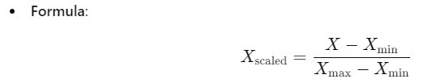
When to use: When you know the distribution of your data is not Gaussian and you want to preserve relationships between feature values.

Example: If a feature has values between 10 and 1000, normalization will scale all values to be between 0 and 1.

Standardization (Z-Score Normalization):
Standardizes the data to have a mean of 0 and a standard deviation of 1 (unit variance).
Formula:
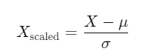
Where 𝜇 is the mean of the feature, and σ is the standard deviation.

When to use: When your data has a Gaussian (normal) distribution or when many machine learning algorithms assume your data is cantered at 0.

Example: If a feature has a mean of 100 and a standard deviation of 50, standardization will shift and scale the feature so that the mean is 0 and the standard deviation is 1.

Robust Scaling:
Uses the median and interquartile range instead of mean and standard deviation. This makes it robust to outliers.
Formula:
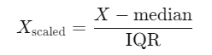

When to use: When your data contains many outliers that you don't want to remove, but still want to scale.

When to Use Feature Scaling?
Algorithms Requiring Scaling:
Algorithms sensitive to feature scales include:
Gradient-based algorithms: e.g., linear regression, logistic regression, neural networks.
Distance-based algorithms: e.g., k-nearest neighbors (k-NN), support vector machines (SVM), k-means clustering.
PCA: Feature scaling is crucial in Principal Component Analysis because it seeks to maximize variance, and large-scaled features would dominate.

Example:
Consider a dataset with the following features:
Age: Ranges from 18 to 90 years.
Salary: Ranges from $20,000 to $120,000.

Without scaling, the salary feature would dominate most machine learning algorithms since its values are much larger than the age values. After feature scaling, both features will have similar ranges and will equally contribute to the model.

Example:
from sklearn.preprocessing import StandardScaler
# Sample data
X = [[20, 20000], [30, 30000], [40, 40000], [50, 50000]]
# Standardize the data
scaler = StandardScaler()
X_scaled = scaler.fit_transform(X)
print(X_scaled)

Finally:
Feature scaling helps ensure that all features contribute equally to the machine learning model. Depending on the nature of the data and the algorithm used, different scaling methods (such as normalization, standardization, or robust scaling) may be appropriate.

