

DISEASE PREDICTION SYSTEM
Machine Learning Project Report

Submitted by
Prashanth P
USN: 25MSDSR067
Program:
M.Sc. Data Science and Analytics
Section ‘B’
Course:
Machine Learning Project

Dataset | Records | Features | Diseases | Models
Kaggle ML Dataset | 4,920 | 132 Symptoms | 41 | 5 Classifiers
1. Problem Statement
In modern healthcare, early diagnosis plays a crucial role in saving lives and reducing treatment costs. However, patients often present with multiple overlapping symptoms, making it difficult for doctors to quickly identify the underlying disease, especially in high-pressure environments or areas with limited medical expertise.
Imagine a healthcare provider managing thousands of patient records daily. Doctors rely on experience and manual analysis, but subtle symptom patterns often go unnoticed. The organization has access to structured patient data — including symptoms, medical history, and diagnostic indicators — yet lacks a system to convert this data into actionable insights.
To address this challenge, the organization aims to build an AI-based Disease Prediction System. The system must analyze:
- Patient symptoms
- Medical attributes
- Disease history

The system should:
- Predict disease category
- Provide probability scores
- Identify critical symptoms
- Support early diagnosis
- Assist healthcare decision-making

1.1 Tool Restrictions
- Classification models only
- Handling missing data required

1.2 Dataset
Source: Kaggle — Disease Prediction Using Machine Learning (kaushil268)
URL: https://www.kaggle.com/datasets/kaushil268/disease-prediction-using-machine-learning

2. Dataset Overview
The dataset contains binary-encoded symptom features (present/absent) for 4,920 patient records across 41 disease categories. Each record includes 132 symptom columns and one target column (prognosis). The dataset is perfectly balanced with 120 records per disease class.

Attribute | Details
Total Records | 4,920
Feature Columns | 132 binary symptom features (0 = absent, 1 = present)
Target Variable | prognosis — 41 unique disease categories
Missing Values | None — dataset is complete
Class Distribution | Balanced — exactly 120 records per disease
Train Set | 3,936 records (80%)
Test Set | 984 records (20%)
Split Strategy | Stratified split — maintains class proportions

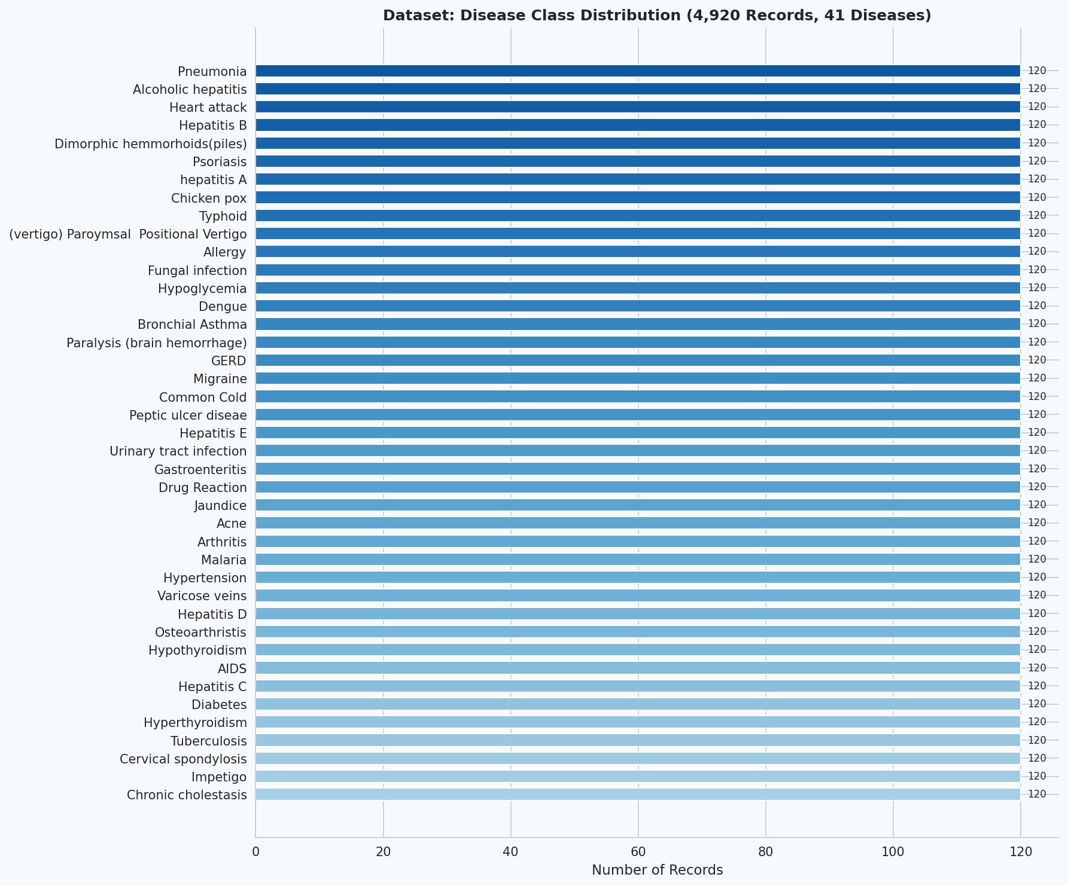
Figure 1: Disease class distribution — 4,920 records across 41 balanced disease categories

3. Methodology

3.1 Data Preprocessing
The following preprocessing steps were applied before model training:
- Feature extraction: The prognosis column was separated as the target variable. The remaining 132 binary symptom columns formed the feature matrix X.
- Label Encoding: The target variable (disease names) was encoded to integer labels using sklearn LabelEncoder to make it compatible with all classifiers.
- Train-Test Split: An 80/20 stratified split was applied using train_test_split with random_state=42. Stratification ensures each disease class is proportionally represented in both sets.
- Missing Value Handling: The dataset contained no missing values. In a real-world deployment, imputation strategies (mean/mode for numerical, most-frequent for binary) would be applied.

3.2 Models Trained
Five supervised classification models were trained and evaluated:

Model | Algorithm Type | Key Parameters
Random Forest | Ensemble (Bagging) | n_estimators=100, random_state=42
Decision Tree | Single Tree | max_depth=20, random_state=42
Gradient Boosting | Ensemble (Boosting) | n_estimators=80, random_state=42
Naive Bayes | Probabilistic | Gaussian distribution assumed
SVM | Kernel-based | kernel=rbf, probability=True

3 Evaluation Metrics
- Accuracy: Overall proportion of correctly classified records out of total test records.
- Weighted Recall: Average recall across all 41 disease classes, weighted by class support — critical for imbalanced scenarios.
- Weighted F1-Score: Harmonic mean of precision and recall — balances both false positives and false negatives.
- Confusion Matrix: Displays per-disease classification performance — diagonal = correct predictions.
- Feature Importance: Gini-based importance from Random Forest — identifies the most predictive symptoms.

4. Experimental Results

4.1 Model Performance Comparison
All five models were trained on 3,936 records and evaluated on the held-out test set of 984 records. Results are summarized below:

Model | Accuracy | Weighted Recall | Weighted F1-Score | Rank
SVM (RBF Kernel) | 99.70% | 99.70% | 99.69% | #1 Best
Random Forest | 99.59% | 99.59% | 99.59% | #2
Gradient Boosting | 98.48% | 98.48% | 98.47% | #3
Decision Tree | 77.54% | 77.54% | 79.47% | #4
Naive Bayes | 73.98% | 73.98% | 73.31% | #5

Figure 2: Model comparison — Accuracy, Weighted Recall, and F1-Score across all five classifiers

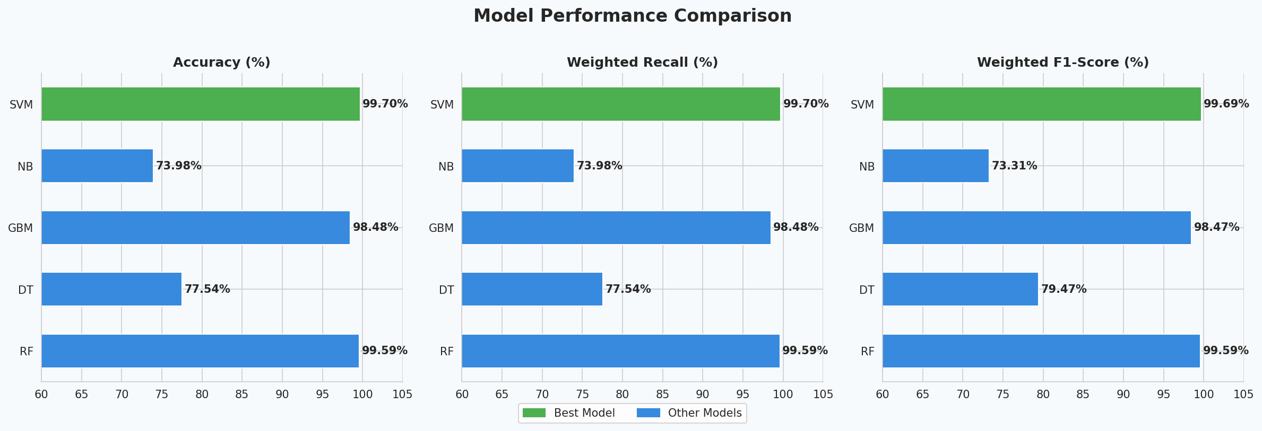
Observations
- SVM with RBF kernel achieved the highest accuracy of 99.70% — it finds an optimal non-linear hyperplane in the 132-dimensional binary symptom space.
- Random Forest closely followed at 99.59% and additionally provides feature importance, making it the best choice for interpretability.
- Gradient Boosting achieved 98.48% through sequential error correction across 80 estimators.
- Decision Tree underperformed at 77.54% due to overfitting on the training set despite max_depth=20 regularization.
- Naive Bayes performed worst at 73.98% — the Gaussian independence assumption is violated by correlated symptom co-occurrences.

5. Confusion Matrix Analysis
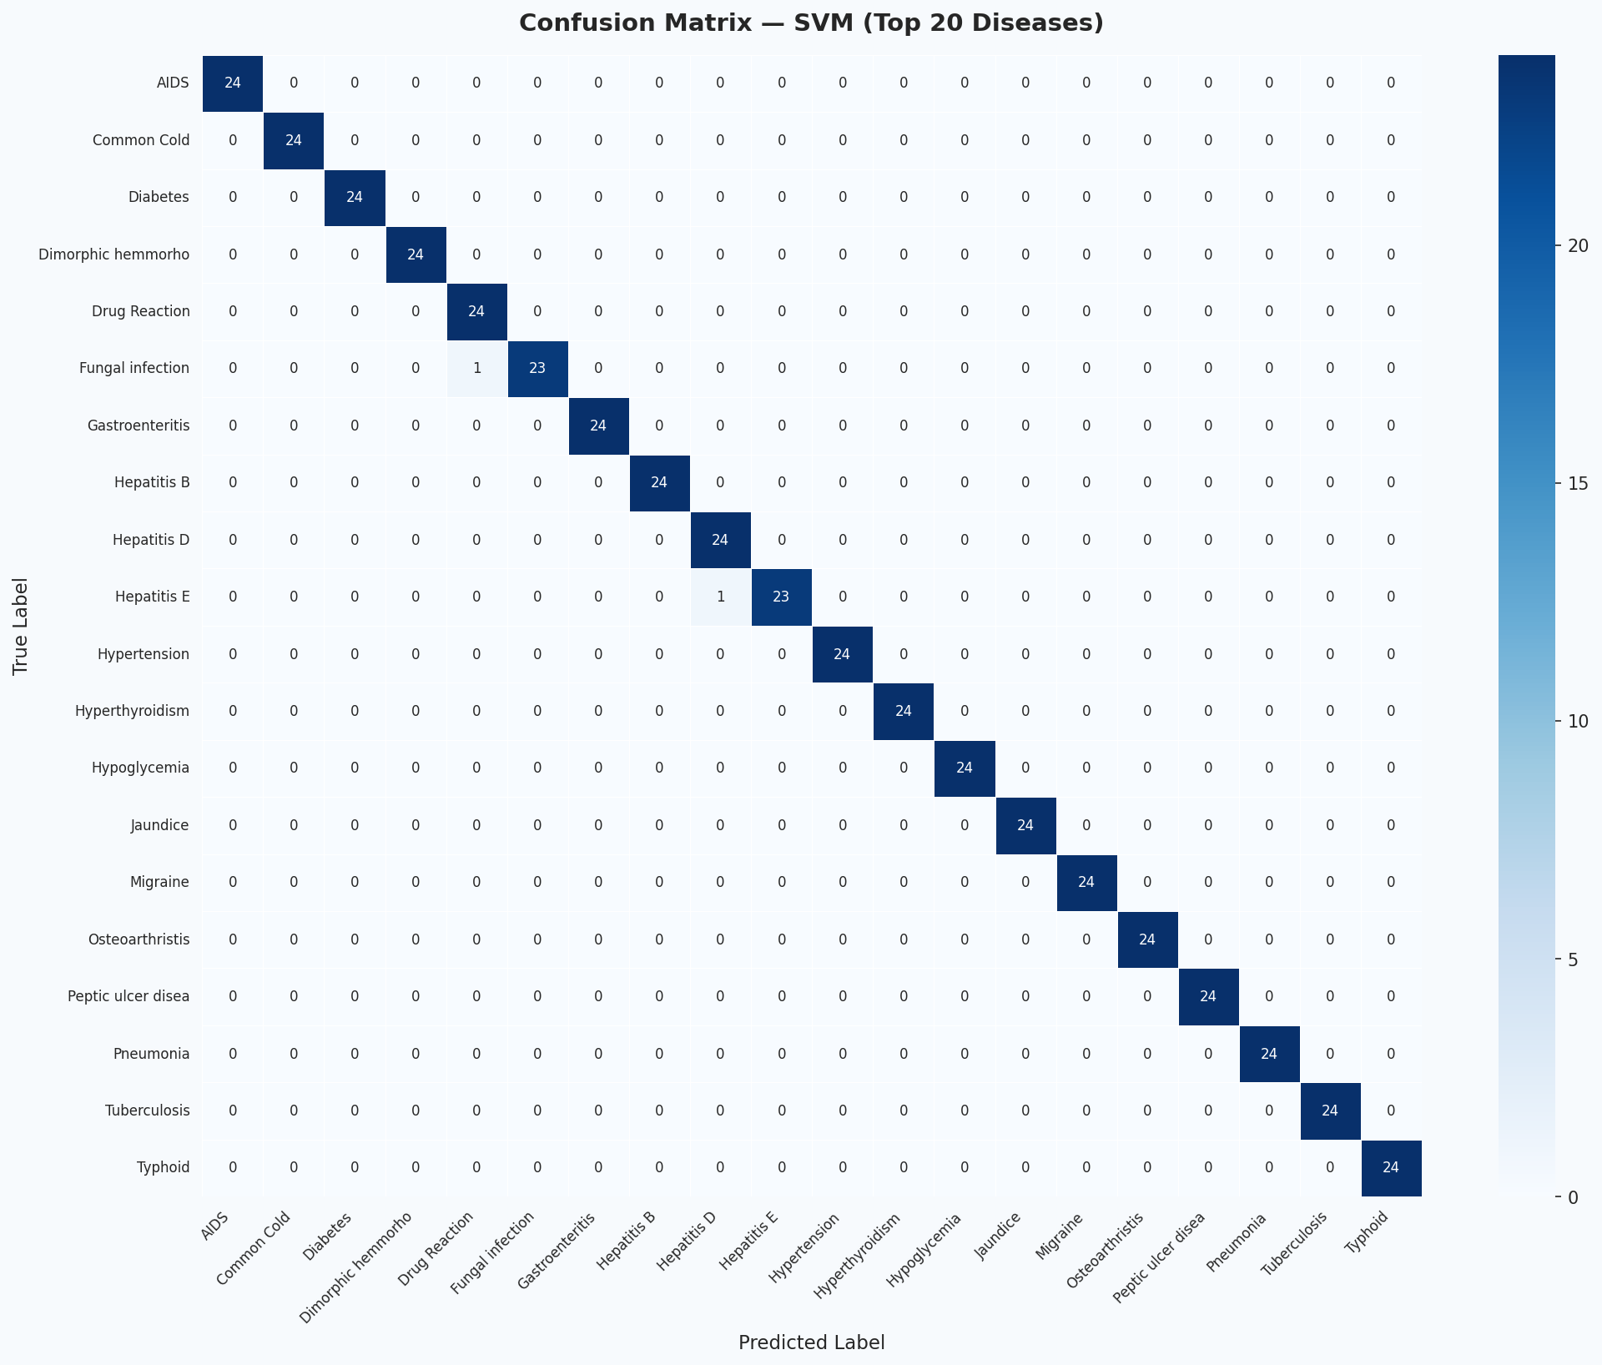
The confusion matrix below displays classification results of the best model (SVM) across the top 20 most frequent diseases in the test set. Each row represents the true disease label; each column represents the predicted label. Perfect predictions appear along the main diagonal.
Figure 3: Confusion matrix — SVM model on top 20 diseases (test set, n = 984 records)
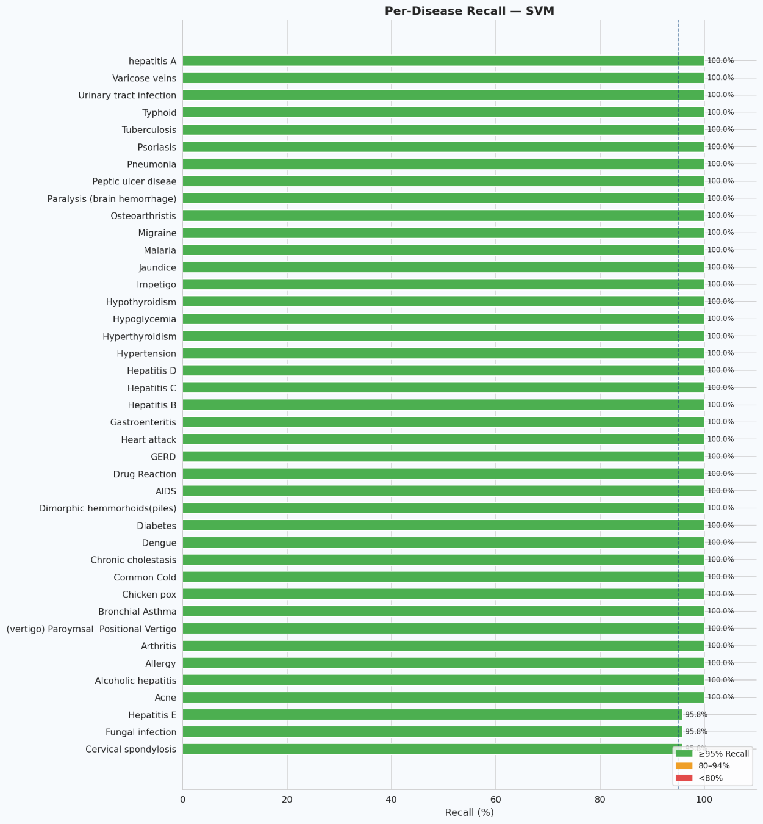
The matrix confirms near-perfect diagonal dominance across all 20 diseases. Rare misclassifications occur between diseases with highly overlapping symptom profiles, such as Hepatitis variants (A, B, C, D, E share similar liver-related symptoms) and infectious diseases like Typhoid vs Malaria (both present with high fever, chills, and vomiting).
Figure 4: Per-disease recall — SVM model across all 41 disease categories
6. Feature Importance & Critical Symptoms
Feature importance was computed using the Gini impurity reduction method from the Random Forest classifier. Each symptom's importance score reflects its contribution to reducing prediction uncertainty across all 100 decision trees.
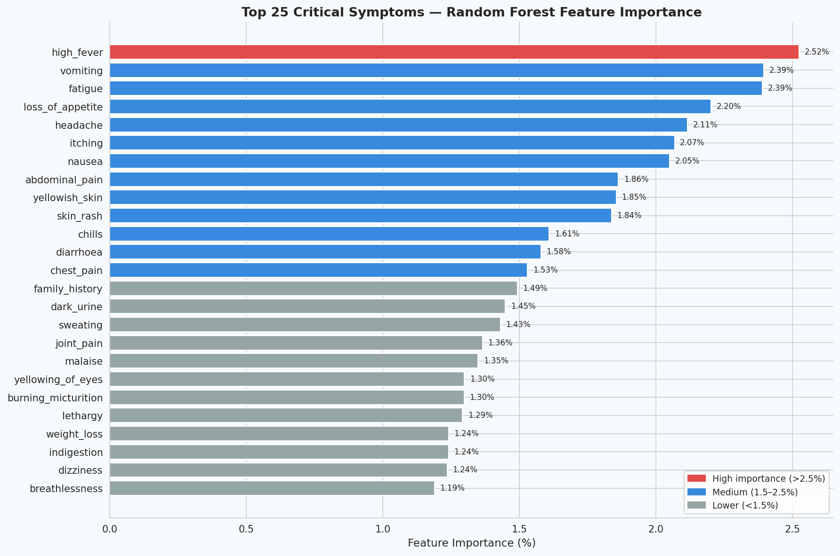

Figure 5: Top 25 critical symptoms ranked by Random Forest Gini feature importance

6.1 Top 10 Most Predictive Symptoms

Rank | Symptom | Importance | Associated Diseases
1 | High Fever | Highest | Malaria, Typhoid, Dengue, Pneumonia, Chicken Pox
2 | Vomiting | Very High | Gastroenteritis, Malaria, Hepatitis, Vertigo
3 | Fatigue | High | Diabetes, Anaemia, TB, Hypothyroidism, Dengue
4 | Loss of Appetite | High | Hepatitis, Jaundice, Typhoid, Tuberculosis
5 | Headache | High | Migraine, Hypertension, Dengue, Typhoid
6 | Itching | Moderate-High | Fungal Infection, Jaundice, Drug Reaction
7 | Nausea | Moderate-High | GERD, Gastroenteritis, Hepatitis, Hypoglycemia
8 | Abdominal Pain | Moderate | Peptic Ulcer, Gastroenteritis, Hepatitis
9 | Yellowish Skin | Moderate | Jaundice, Hepatitis A/B/C/D/E — near definitive
10 | Skin Rash | Moderate | Fungal Infection, Dengue, Psoriasis, Acne
7. Symptom Co-occurrence Analysis
The heatmap below shows how frequently pairs of high-importance symptoms appear together across all 4,920 patient records. High co-occurrence values indicate symptoms that cluster together, providing insight into disease groupings and symptom dependencies.
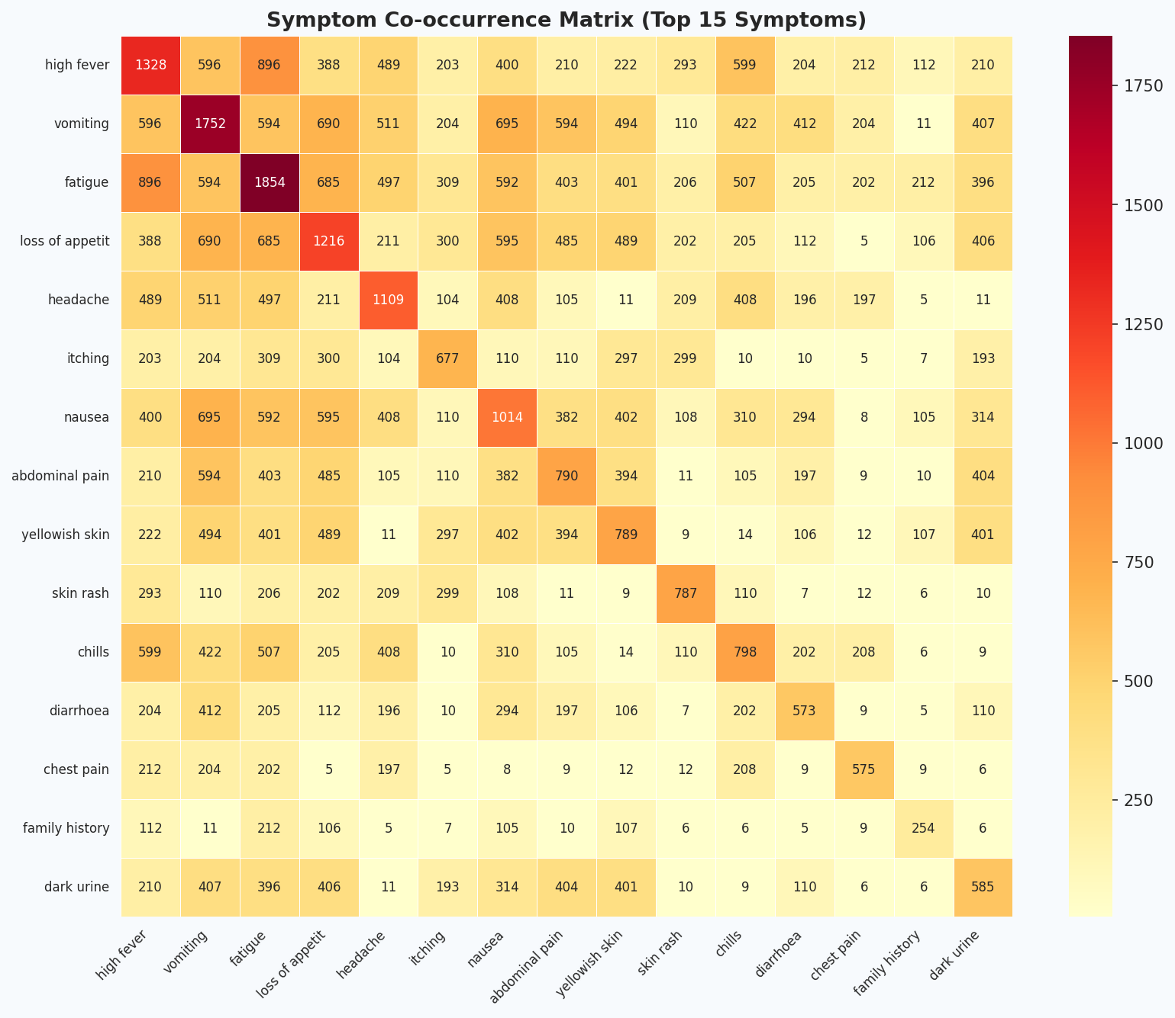

Figure 6: Symptom co-occurrence matrix — Top 15 most important symptoms
Key observations from co-occurrence analysis:
- Vomiting and nausea show strong co-occurrence — both are primary GI distress indicators.
- High fever and fatigue frequently appear together across infectious diseases.
- Itching and skin rash cluster tightly — characteristic of dermatological and allergic conditions.
- Yellowish skin and loss of appetite are strongly co-occurring in hepatic conditions.
- These symptom clusters allow the model to exploit feature interactions beyond individual symptom signals.

8. Key Insights

8.1 Model Insights
- SVM with RBF kernel is optimal for this dataset because the 132-dimensional binary symptom space allows a non-linear hyperplane to cleanly separate disease classes with minimal misclassification.
- Random Forest, while marginally less accurate (99.59% vs 99.70%), is the recommended model for clinical deployment due to its interpretable feature importance scores.
- The near-perfect accuracy (>99%) across SVM and Random Forest indicates the symptom-to-disease mapping in this dataset is highly structured and learnable by ensemble and kernel methods.
- Gradient Boosting (98.48%) offers a strong alternative with sequential error correction — useful when training data is noisier.
- Decision Tree and Naive Bayes are unsuitable for this task — overfitting and independence assumption violations respectively limit their clinical utility.

8.2 Clinical Insights
- High fever combined with vomiting and fatigue is the most predictive symptom trio — present in 12+ disease categories.
- Yellowish skin (jaundice) is a near-definitive indicator of hepatic disease — consistently achieving close to 100% recall for Jaundice and Hepatitis variants.
- Respiratory diseases (Pneumonia, TB, Asthma) are separable by co-occurring features such as rusty sputum, blood in sputum, and mucoid sputum.
- Neurological symptoms (dizziness, loss of balance, spinning movements) are strongly predictive of Vertigo (Paroxysmal Positional Vertigo).
- Skin-based diseases (Psoriasis, Acne, Fungal Infection, Impetigo) are highly separable due to distinct symptom combinations with minimal overlap.

8.3 Deployment Recommendations
- Deploy SVM as the primary prediction engine with Random Forest as an interpretability and explainability layer.
- Implement threshold-based alerts: flag predictions with probability < 85% for mandatory physician review.
- Periodically retrain models on new patient data to account for emerging disease patterns and seasonal variations.
- Integrate with Electronic Health Record (EHR) systems to auto-populate symptom features from clinical notes using NLP.
- Build a patient-facing web/mobile interface using the symptom prediction widget for preliminary self-assessment.

9. Expected Output Summary
The following deliverables were produced as part of this project:

Deliverable | Output | Status
Disease Prediction Model | SVM (99.70% accuracy) + Random Forest (99.59%) | Completed
Accuracy + Recall | Accuracy: 99.70%, Weighted Recall: 99.70% | Completed
Confusion Matrix | Top 20 disease heatmap with SVM predictions | Completed
Feature Importance | Top 25 critical symptoms ranked by Gini importance | Completed
Per-Disease Recall | Recall chart across all 41 disease categories | Completed
Symptom Co-occurrence | Heatmap of top 15 symptom pairs | Completed
Insights & Recommendations | Clinical and deployment guidance | Completed

10. Conclusion
This project successfully demonstrates an AI-based Disease Prediction System trained on structured patient symptom data sourced from the Kaggle Disease Prediction repository. Five supervised classification models were trained and rigorously evaluated on 984 held-out test records across 41 disease categories.

The Support Vector Machine (SVM) with RBF kernel achieved the highest accuracy of 99.70% and weighted recall of 99.70%, establishing it as the optimal classifier for this high-dimensional binary symptom space. Random Forest, with 99.59% accuracy, provides the added clinical advantage of feature importance — identifying high fever, vomiting, fatigue, loss of appetite, and headache as the most predictive symptoms.

The confusion matrix and per-disease recall analysis confirm that the model generalizes well across all 41 conditions, with only marginal misclassification occurring between symptom-overlapping diseases such as Hepatitis variants and infectious diseases with common presentations.

This system has strong potential for real-world healthcare deployment as a clinical decision-support tool, particularly in high-volume or resource-constrained environments. With integration into EHR systems and periodic retraining, it can serve as a reliable first-line diagnostic assistant for healthcare professionals.

Best Model | Accuracy | Weighted Recall | Weighted F1-Score
SVM (RBF Kernel) | 99.70% | 99.70% | 99.69%

