# VISVESVARAYA TECHNOLOGICAL UNIVERSITY

## Jnana Sangama, Santhibastawad Road, Machhe Belagavi - 590018, Karnataka, India



**A REPORT**

**ON**

*“*QUIZ*”*

## BACHELOR OF ENGINEERING

**IN**

**COMPUTER SCIENCE ENGINEERING**

**For the Academic Year 2019-2020**

**SUBMITTED BY:**

PRASHANTH D S (IJS18CS112)

MOHAMMED AYAAN (1JS18CS084)

DISHA PANJAWANI (1JS18CS197)

ANANDI SAGAR (1JS18CS200)

**Under the Guidance of**

**MRS.RAJESHWARI KS**



**2019-2020**

## DEPARTMENT OF COMPUTER SCIENCE ENGINEERING

**JSS ACADEMY OF TECHNICAL EDUCATION**

**JSS Campus, Dr.Vishnuvardhan Road, Bengaluru-560060**

**JSS MAHAVIDYAPEETHA, MYSURU**

# JSS ACADEMY OF TECHNICAL EDUCATION

**JSS Campus, Dr.Vishnuvardhan Road, Bengaluru-560060**

**DEPARTMENT OF INFORMATION SCIENCE & ENGINEERING**



**CERTIFICATE**

This is to certify that Project work entitled **“Quiz”** is a bonafide work carried out by **our group** in partial fulfillment for the award of degree of Bachelor of Engineering in Computer Science Engineering of Visvesvaraya Technological University Belagavi during the year 2019-2020.

|  |  |  |  |
| --- | --- | --- | --- |
| **Signature of the Guide** |  |  | **Signature of the HOD** |
|  |  |  | **Dr. Dayananda P** |
|  |  |  | Professor & Head |
| Dept. of CSE |  |  | Dept. of ISE |
| JSSATE, Bengaluru |  |  | JSSATE, Bengaluru |

**ACKNOWLEDGEMENT**

The satisfaction and euphoria that accompany the successful completion of any task would be incomplete without the mention of the people who made it possible. So with gratitude, we acknowledge all those whose guidance and encouragement crowned my effort with success.

We express our sincere gratitude for our beloved Head of the department, **Dr. Naveen NC**, for his co-operation and encouragement at all the moments of our approach.

It is our pleasant duty to place on record our deepest sense of gratitude to our respected guide **Mrs. Rajeshwari KS,** for the constant encouragement, valuable help and assistance in every possible way.

#### 

**INTRODUCTION**

The objective of this project is to implement a QUIZ application which is not a old school type but a new approach to tackle malpractice. It uses concept of OOP with a Luxury of using programming language developed at Sun Microsystems and later acquired and further developed by Oracle Corporation i.e JAVA which is one of the top most language used for GUI Programming i.e **Swings** in this case.

The quiz menu has 4 parts:

1. General knowledge.
2. Entertainment.
3. Sports.
4. Literature.

* The user is supposed to enter their respective name and choose preference of their choice from the menu (Combo Box).
* Random questions related to the genre chosen will be given to user with 4 options, where options will also be randomly arranged for that particular question which also is random out of which only one answer is right.
* The user will be scored for his performance. Totally 10 questions where each right answer is awarded with 1 point.
* One more highlighting feature is that as it is common in many applications that we just tend to answer a question and move on for next with next button, but here we even provide the feature to go back i.e previous button if at all someone had to skip a question at a moment.
* It is not mandatory to attend all 10 questions. If at all user has to quit in between they can submit the quiz and they will be graded for the number of questions attended and as soon as submit is actioned the leaderboard for that particular chosen genre will appear where all of them are ranked starting from 1.
* This quiz application will be secure as questions and options will appear randomly which mostly will not lead for any malpractice (Breach of Ethics).
* Last but not least At the end we can view the leaderboard for each preferences separately irrespective whether they’ve participated in quiz or not.

**OBJECT ORIENTED CONCEPTS:**

As the name suggests, Object-Oriented Programming or OOPs concepts refers to languages that uses objects in programming. Object-oriented programming aims to implement real-world entities like inheritance, hiding, polymorphism, encapsulation etc in programming. The main aim of OOP is to bind together the data and the functions that operate on them so that no other part of the code can access this data except that function.

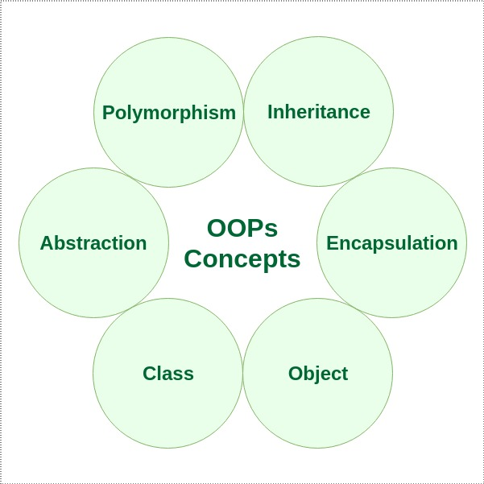

**PROGRAMMING LANGUAGE JAVA :**

**Java** is a general purpose programming language that is class-based, object-oriented, and designed to have as few implementation dependencies as possible. It is intended to let application developers *write once, run anywhere*,  meaning that compiled Java code can run on all platforms that support Java without the need for recompilation. Java applications are typically compiled to bytecode that can run on any Java virtual machine (JVM) regardless of the underlying computer architecture. The syntax of Java is similar to [C](https://en.wikipedia.org/wiki/C_(programming_language)) and [C++](https://en.wikipedia.org/wiki/C%2B%2B), but it has fewer low-level facilities than either of them.

**Features :**

#### **Simple**

Java is easy to learn and its syntax is quite simple, clean and easy to understand.The confusing and ambiguous concepts of C++ are either left out in Java or they have been re-implemented in a cleaner way.

*Eg :* Pointers and Operator Overloading are not there in java but were an important part of C++.

#### **Object Oriented**

In java, everything is an object which has some data and behaviour. Java can be easily extended as it is based on Object Model. Following are some basic concept of OOP's.

1. Object
2. Class
3. Inheritance
4. Polymorphism
5. Abstraction
6. Encapsulation

#### **Robust**

Java makes an effort to eliminate error prone codes by emphasizing mainly on compile time error checking and runtime checking. But the main areas which Java improved were Memory Management and mishandled Exceptions by introducing automatic **Garbage Collector** and **Exception Handling**.

#### **Platform Independent**

Unlike other programming languages such as C, C++ etc which are compiled into platform specific machines. Java is guaranteed to be write-once, run-anywhere language.

On compilation Java program is compiled into bytecode. This bytecode is platform independent and can be run on any machine, plus this bytecode format also provide security. Any machine with Java Runtime Environment can run Java Programs.

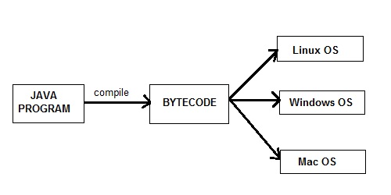

#### **Secure**

When it comes to security, Java is always the first choice. With java secure features it enable us to develop virus free, temper free system. Java program always runs in Java runtime environment with almost null interaction with system OS, hence it is more secure.

#### **Multi**-**Threading**

Java multithreading feature makes it possible to write program that can do many tasks simultaneously. Benefit of multithreading is that it utilizes same memory and other resources to execute multiple threads at the same time, like While typing, grammatical errors are checked along.

#### **Architectural Neutral**

Compiler generates bytecodes, which have nothing to do with a particular computer architecture, hence a Java program is easy to intrepret on any machine.

#### **Portable**

Java Byte code can be carried to any platform. No implementation dependent features. Everything related to storage is predefined, example: size of primitive data types

#### **High Performance**

Java is an interpreted language, so it will never be as fast as a compiled language like C or C++. But, Java enables high performance with the use of just-in-time compiler.

#### **Distributed**

Java is also a distributed language. Programs can be designed to run on computer networks. Java has a special class library for communicating using TCP/IP protocols. Creating network connections is very much easy in Java as compared to C/C++.

**Uses:**

* Mobile applications (specially Android apps)
* Desktop applications
* Web applications
* Web servers and application servers
* Games
* Database connection

**SYSTEM DESIGN / NON-FUNCTIONAL REQUIREMENTS**

**For JAVA SE 7 and above……**

**2.1 Software Requirements**

#### **Windows**

* Windows 10 (7u85 and above)
* Windows 8.x (Desktop)
* Windows 7 SP1
* Windows Vista SP2
* Windows Server 2008 SP2 and 2008 R2 SP1 (64-bit)
* Windows Server 2012 (64-bit) and 2012 R2 (64-bit)
* Browsers: Internet Explorer 7.0 and above, Firefox 3.6 and above

#### **Mac OS X**

* Intel-based Mac running Mac OS X 10.7.3 (Lion) or later.
* Administrator privileges for installation
* 64-bit browser

#### A 64-bit browser (Safari, for example) is required to run Oracle Java on Mac.

#### **Linux**

* Oracle Linux 5.5+
* Oracle Linux 6.x (32-bit), 6.x (64-bit)3
* Oracle Linux 7.x (64-bit)3 (7u67 and above)
* Ubuntu Linux 10.04 and above
* Browsers: Firefox 3.6 and above

**2.2 Hardware Requirements**

* RAM: 128 MB; 64 MB for Windows XP (32-bit)
* Disk space: 124 MB
* Keyboard: Standard qwerty serial or PS/2 keyboard
* Mouse: Standard serial or PS/2 mouse

This quiz application will run on virtual machines such as VMware, VirtualBox and Virtual Services, Citrix and XenApp provided JVM or DVM is present.

**FUNCTIONAL REQUIREMENTS**

* Javax.swing.*
* Java.awt.event.*
* Java.io.*
* Java.util.*

**IMPLEMENTATION (AlGORITHM)**

1. START.
2. In class say Quiz which extends JFrame and implements ActionListener, then in main function use SwingUtilities.invokeLater() where we create a Runnable object run the quiz constructer.
3. In the constructer while class is extending JFrame so call Super() to create a frame, then set some basic constraints for the frame then add ImageIcon(clg logo), JTextField(Name), JLabel(Submitted by), and a JComboBox(preferences) with a Jbutton(submit, All Leaderboards) for submission of data.
4. Goto step 19 if All Leaderboards is clicked.
5. For each Component in JFrame there is a action listener added so we should have a actionPerformed(ActionEvent e) method so as to control the actions on specific components.
6. Enter your name, Preferences are GK, Entertainment, Sports, Literature. Select anyone to attempt the quiz, then submit.
7. For that GUI, In class say Preference which extends JFrame and implements ActionListener, then in the constructor create the JFrame then again set basic required constraints and setup a JLabel for question and 4 JRadioButtons under ButtonGroup. Here Utitlity class is created under that in method get_random_question_indexes() collect the integer array consisting of random number from 0 to 9 with no duplicates in variable indexes.
8. Then call display() to display questions and answers, in there call get_random_option_index() then collect the integer array of random indexes from 0 to 3 with no duplicates, and declare global variable current = 0.
9. Then go for a if else ladder to display questions where in each if statement indexes[current] is equal to index from 0 to 9, then in under each if setText for the question’s JLabel used in constructer.
10. Then collect call random_options () where we call random_options_generator() which will return a string of random options and actual answers index of the string with the help of another class Return_type which is structured to have only two return type varibles as it’ll be easy to collect 2 variables. So in random_options() we create obj of Return_type class and hence with that we collect random options string and actual answes index from that string.
11. For ActionListener three jButtons used are previous, next and submit, for performing action when ever button is clicked we override actionPerormed(ActionEvent e) implemented from ActionListener Interface.
12. Now if next is clicked we call check() from Utility class which returns Boolean value so by considering if actual JRadioButton is selected Boolean value will be checked. If found true we increment the score by 1.
13. Then increment current irrespective whether answer is correct or not and again call display until it current reaches 9 and it disposes the frame automatically.
14. If previous is clicked we just decrement current by 1 and display the previous question.
15. If submit is clicked perform Step 12 and we call store(FileName, Name, Score) from Utility class where we store the data in file i.e name and score are comma separated as in csv format each entry is differed by newline (“\n”) with help of BufferdWriter and FileWriter class
16. Next we call sort_data() method from Utility class which sorts all entries present in the file according to the scores of each entry. We store those entries in 2d string array and this will be returned following another Return_type class so as we can collect two variables and collect 2d string array and total number of entries(integer).
17. Then call change_file(FileName, 2d string array, total entries) from Utility class then store all the data I same format as in step 15.
18. Then show a message dialog box to show the score/result. After clicking ok the leaderboard for that particular genre appears and users can see where they’ve been ranked goto step 20.
19. if the user clicks all leaderboards then a new frame is created where there are four buttons representing all the genres after clicking any of button leaderboard for that particular genre will open.
20. When leaderboard has to appear class Leaderboard extending JFrame is used where the constructor needs to receive a string referenced for that particular genre lastly for actionPerformed method as param so it’ll be easy to display from that particular file. We display the table by creating JTable(data, heading_col) and we include this JTable to JScrollPane(JTable), in order to achieve scrolling feature as well.
21. Data is a 2d string array and heading_col is column names, data 2d string array is created by storing all data from file considering format mentioned in step 15 then frame is setVisible(true) then leaderboard appears.
22. Main frame created will not exit until we close it so quiz can be attempted numerous times.
23. Same functionality is used for all genres.
24. END.

**SNAPSHOTS / TESTING**

* **CASE 1: “No Access to Quiz”**
  + Message dialog box will appear if TextBox is empty(“”) or same as the placeholder(“Enter Your Name”).
  + Until a desired string except ones said above is entered access to quiz is denied, irrespective whatever genre chosen.
  + Name: “” / “Enter Your Name”
  + Genre: Sports and submit.
    - Access denied to quiz.

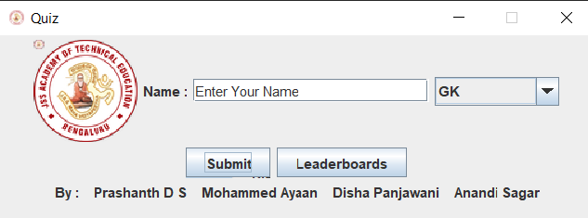

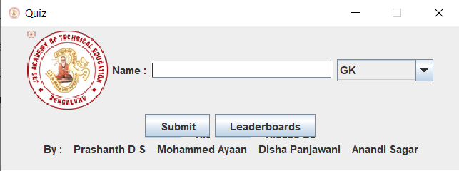

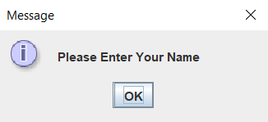

* **CASE 2: “ATTEMPTING ALL QUESTIONS”**
  + Once Proper string and genre is chosen and click submit, quiz layout appears.
  + Answers all questions serially without using previous button.
  + Name: Gray.
  + Genre: GK and submit.
  + Attempts quiz serially till end and clicks submit.
    - Gray is scored for his attempt and message dialog box with score appears.
    - Then Leaderboard of GK appears, where he can see where he is ranked.

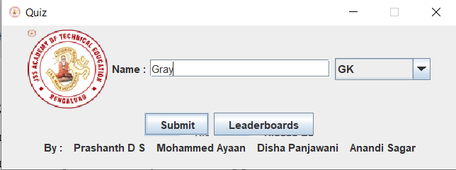

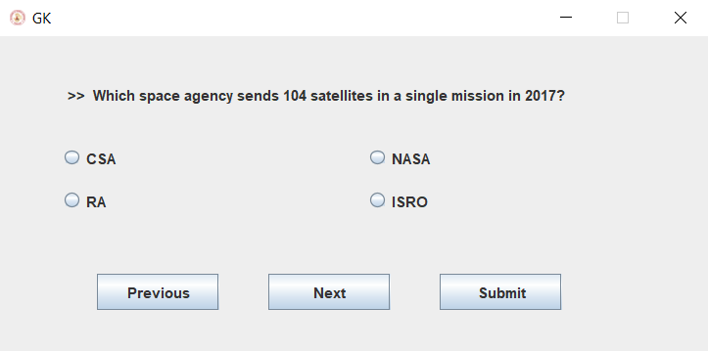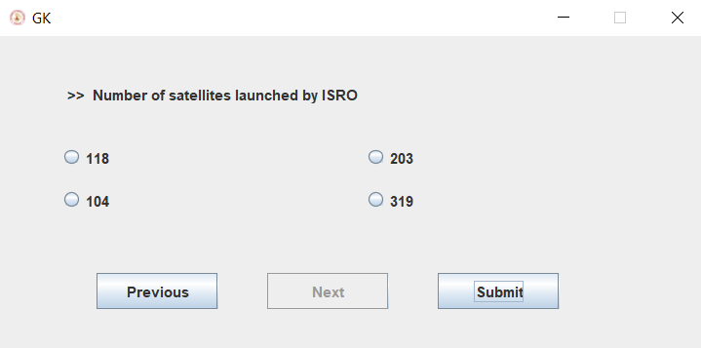

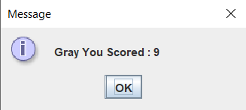

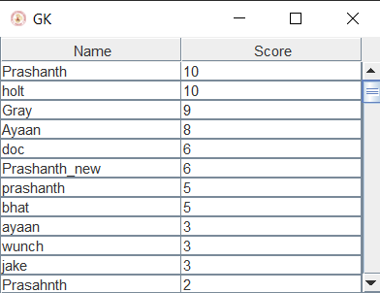

* **CASE 3: “ATTEMPTING PARTIAL QUESTIONS”**
  + Once Proper string and genre is chosen and click submit, quiz layout appears.
  + Consider user will not attempt all instead attempt partial number of questions not all 10.
  + User will be scored for the no. of questions attempted.
  + Name: Ray.
  + Genre: Literature.
  + Attempts quiz partially and clicks submit.
    - Ray id scored for his attempt and message dialog box with score appears.
    - Then Leaderboard of Literature appears, where he can see where he is ranked.

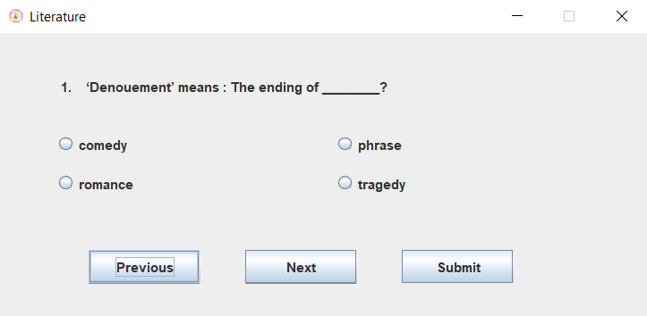

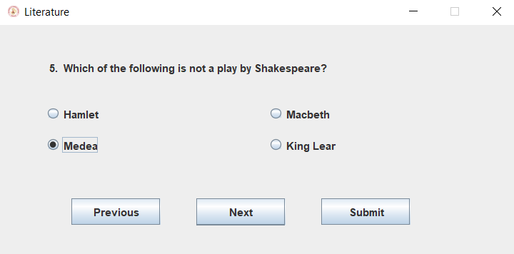

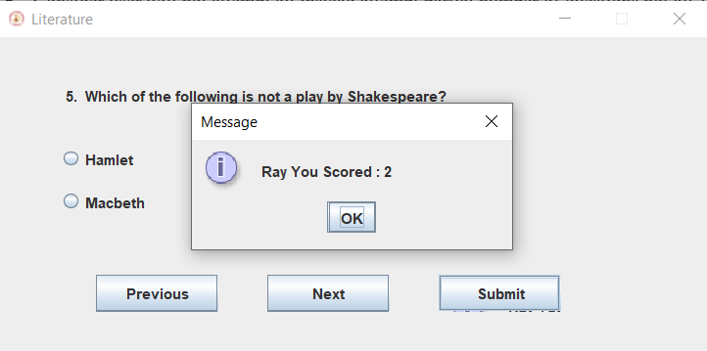

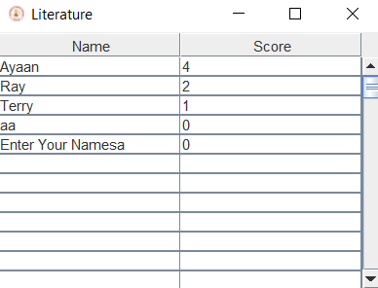

* **CASE 4: “USING PREVIOUS AND NEXT OPTIONS FREQUENTLY”**
  + Once Proper string and genre is chosen and click submit, quiz layout appears.
  + Now user may attempt the quiz completely or partially, but here when user uses previous and next options frequently scoring will vary i.e if going serially scoring doesn’t vary, if used previous option there is no buffer to keep that memory of previous answers, so user always have to answer questions coming after clicking next, if at all it went to previous option.
  + This is not a old school quiz application maybe weird…. But one of the ways to tackle malpractice.
  + Name: Terry.
  + Genre: Entertainment.
  + Terry attempts 4 questions and later goes back to 3rd to change it, after changing clicks next he will again answer 4th and so on….
    - Terry will be scored for correct answers given serially even if he’s been to previous questions and message dialog box with score appears.
    - Then Leaderboard of Literature appears, where he can see where he is ranked.

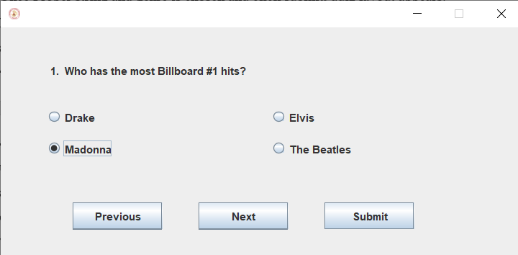

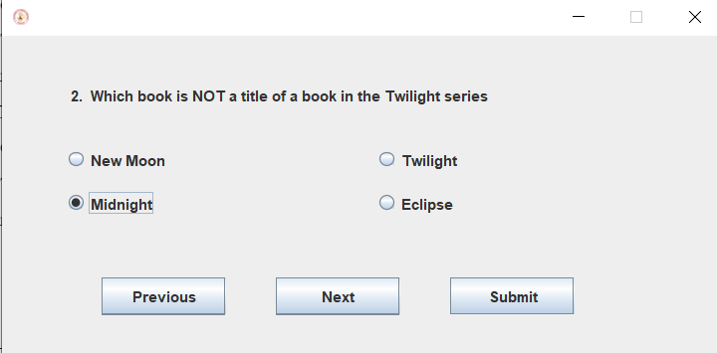

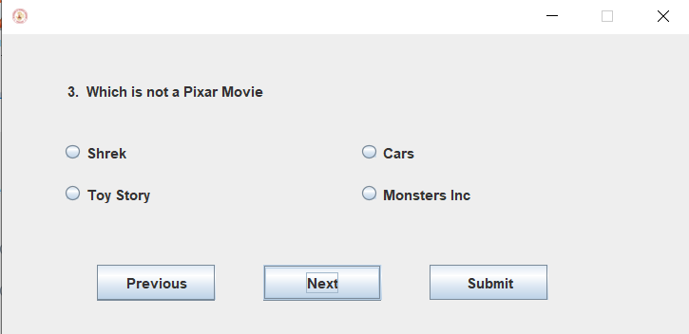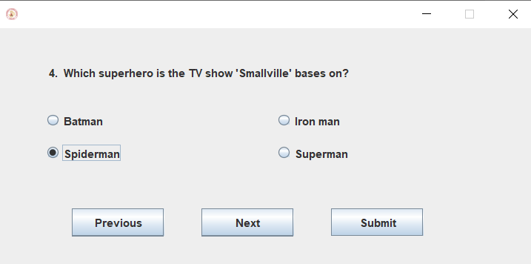

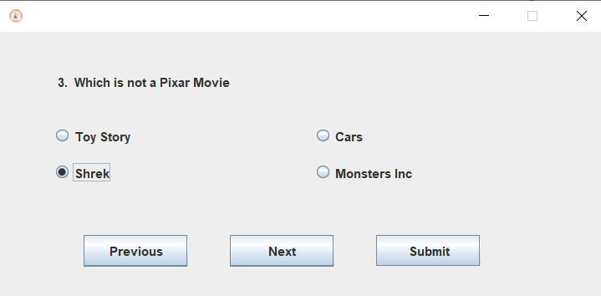

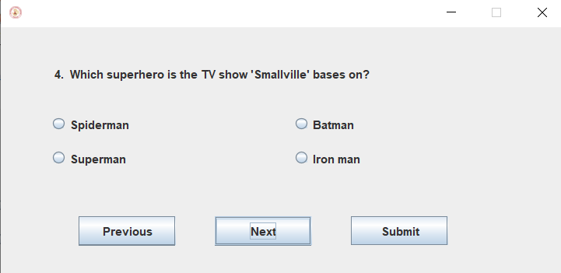

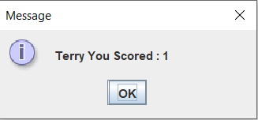

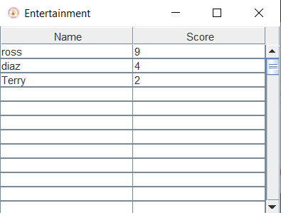

* **CASE 5: “VIEWING ALL LEADERBOARDS”**
  + Clicking Leaderboards form main frame will lead to new frame having options to view all four genres.
  + Leaderboard for each genre can be viewed.
    - Random user goes to leaderboard and views all four leaderboards.
    - Leaderboard appears and random user can view other users / their own rankings across various genres.

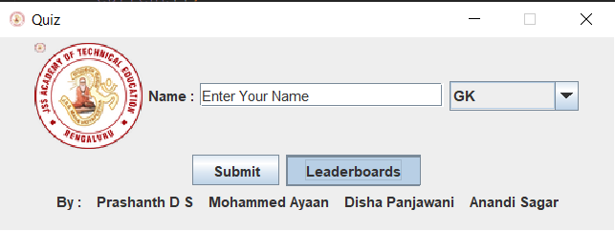

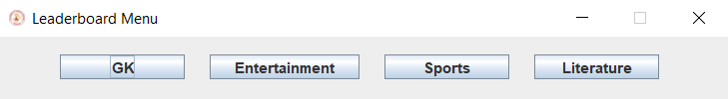

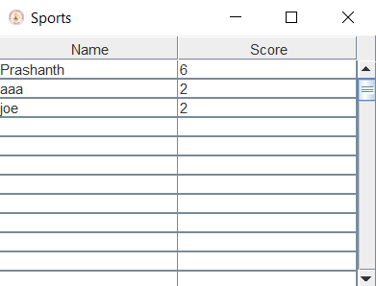





**CONCLUSION**

We attempted to design and implement quiz application which would be one of the several approaches to curb malpractices. This project is built using java programming language which is a GUI and not command line, as GUI gives features like easy to handle and more user friendly but typing in command line isn’t user friendly. The presence of many inbuilt classes and methods

Take more most of GUI functionality reduce the job of doing it but except GUI most of logic is been implemented raw.

There’ll be many people who might offend/disagree with the approach used here / bugs present, but this is one of our approach to tackle breach of ethics. Lastly we’ve created a user friendly project with negligible bugs as of the algorithm.

**Limitations:**

* + As of the implementation is offline, many people across the web can’t access this but if algorithm is implemented using any of the available web frameworks this will serve the need to many people across the globe.
  + As it is an offline application, data is stored in csv format i.e a normal text format considering how vulnerable this can be, is one of the things to be noted, but working the databases or with encryption and decryption approaches data will be safe more often than not.
  + UI doesn’t seem to be extremely pleasing to the eyes but standard UI of swings with different layout’s makes things quite pleasing.

**SOURCE CODE**

* [Google Drive](https://drive.google.com/drive/folders/1M46c_SVQ2R44ToP6-RiaWybKF6C6y_b_?usp=sharing)

**BIBLIOGRAPHY**

* + Java: The Complete Reference, Eleventh Edition : Herbert Schildt
  + Oracle Documentation on java : <https://docs.oracle.com/en/java/>
  + Project’s layout taken from : <https://www.javatpoint.com/online-exam-project-in-java-swing-without-database>
  + OOP figure used : <https://media.geeksforgeeks.org/wp-content/cdn-uploads/20190717114649/Object-Oriented-Programming-Concepts.jpg>
  + Java programming language : <https://www.studytonight.com/java/features-of-java.php>
  + System Requirements : <https://www.java.com/en/download/help/sysreq.xml>