**TRAFFIC SIGN DETECTION AND RECOGNITION**

In this paper 3 different techniques are described using various machine learning algorithms such as LeNet, CNN and RCNN. Here we are implementing propose technique with LeNet architecture using MASTIF TS2009, TS2010 and TS2011 datasets as this technique and datasets giving flexibility to detect traffic signs from videos but other detecting did not provide any dataset to detect signs from videos so we are using LeNet and MASTIF TS2009, TS2010 and TS2011 datasets.

MASTIF TS2009 contains 6000 traffic images categories in 5 category such as A, B, C, D and E, all this categories images you can see inside train folder and we are using this images to train our classifier and detector. TS2010 contains video with annotation but those annotations are not properly marks so just we are able to detect signs from video. Here we are TS2010 video for traffic sign detection, First classifier will be trained on 6000 images and then video will be uploaded and then classifier starts sign detection from video.

First frame will be extracted from video and then pre-processing will be applied on frame to clear image by applying Hough Transformations and then frame will be passed to classifier to detect traffic signs.

**LeNet CNN working procedure**

To demonstrate how to build a convolutional neural network based image classifier, we shall build a 6 layer neural network that will identify and separate one image from other. This network that we shall build is a very small network that we can run on a CPU as well. Traditional neural networks that are very good at doing image classification have many more parameters and take a lot of time if trained on normal CPU. However, our objective is to show how to build a real-world convolutional neural network using TENSORFLOW.

Neural Networks are essentially mathematical models to solve an optimization problem. They are made of neurons, the basic computation unit of neural networks. A neuron takes an input (say x), do some computation on it (say: multiply it with a variable w and adds another variable b) to produce a value (say; z= wx + b). This value is passed to a non-linear function called activation function (f) to produce the final output (activation) of a neuron. There are many kinds of activation functions. One of the popular activation function is Sigmoid. The neuron which uses sigmoid function as an activation function will be called sigmoid neuron. Depending on the activation functions, neurons are named and there are many kinds of them like RELU, TanH.

If you stack neurons in a single line, it’s called a layer; which is the next building block of neural networks. See below image with layers

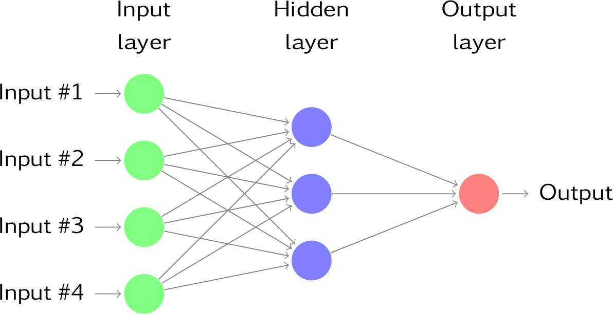

To predict image class multiple layers operate on each other to get best match layer and this process continues till no more improvement left.

Note: No algorithms can predict traffic signs 100 percent so our implementation also able to predict few signs only. MASTIF TS2009 contains only 5 types of traffic signs

Screen shots

To run this project double click on ‘run.bat’ file to get below screen

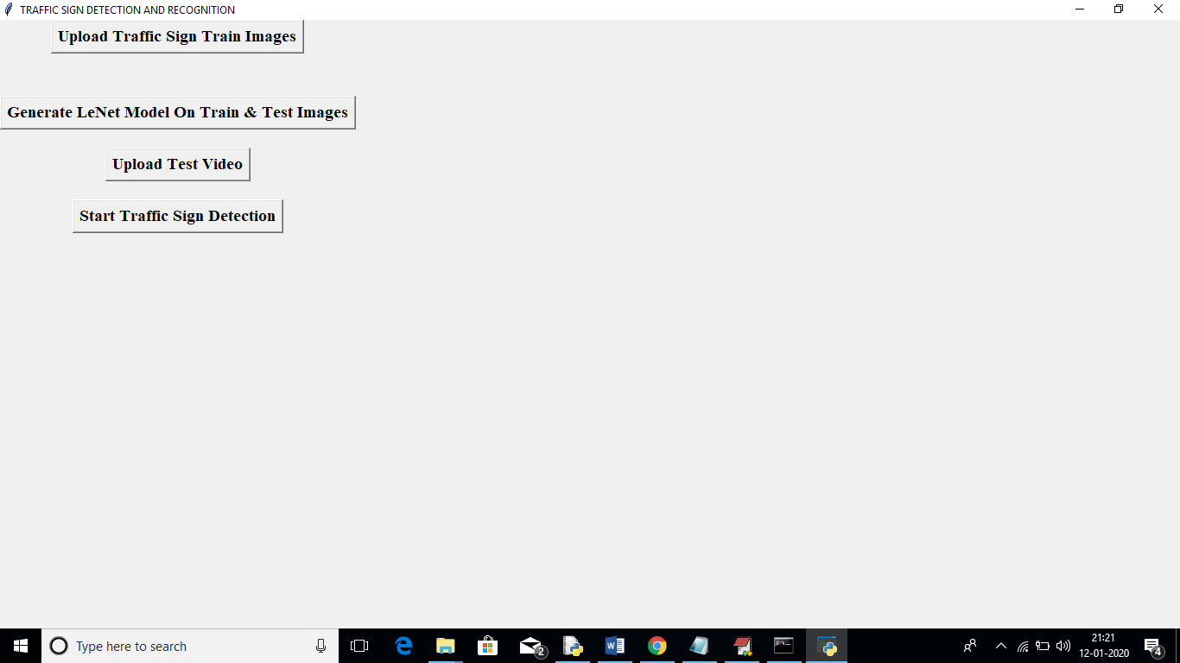

In above screen click on ‘Upload Traffic Sign Train Images’ button to upload training images

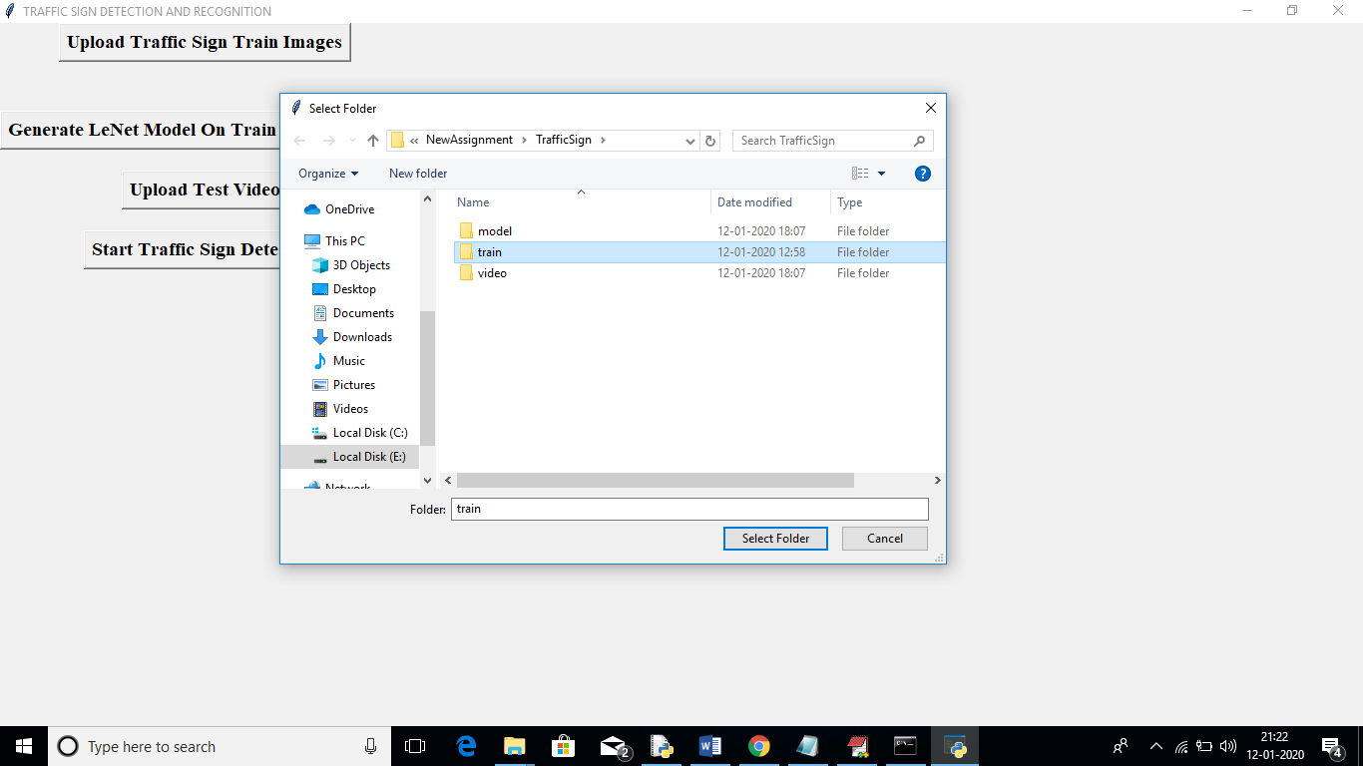

In above screen uploading ‘train’ folder which contains 5 different types of traffic signs and each type contains nearly 1500 images. After uploading train folder will get below screen

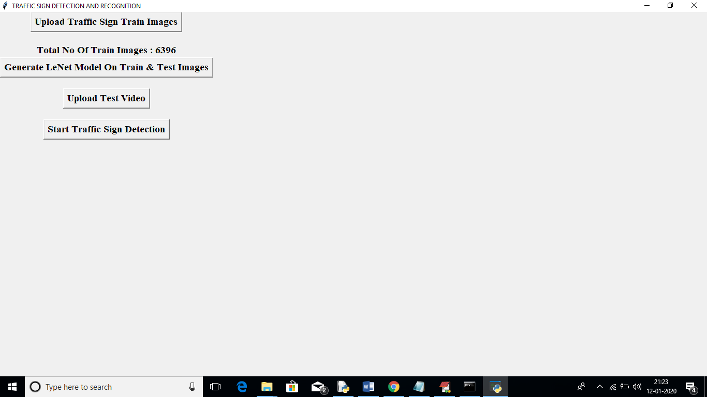

In above screen we can see total 6396 images used for training and here each image will be pre-processed and then store in train and test array. Now click on ‘Generate LeNet Model On Train & Test Images’ button to generate LeNet classifier model on train and test array

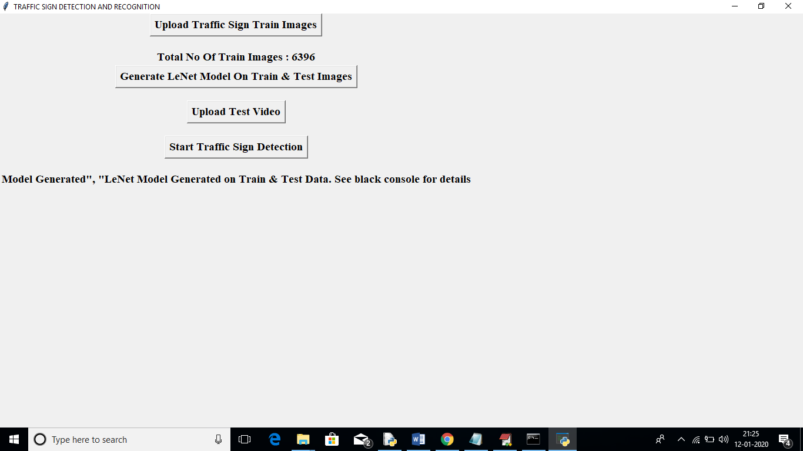

In above screen we can see model generated message and we can check black console to see LeNet Model details

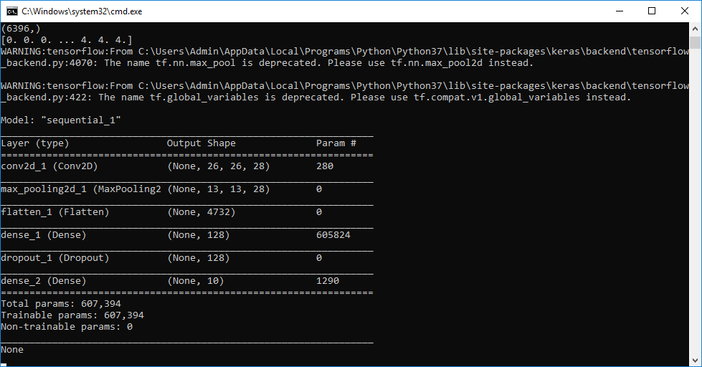

In above screen we can see different layers on generate for each image with different sizes to make prediction better. In first layer image features extracted using 26X26 height and width and in next layer 13X13 height and width used and goes on. Now click on ‘Upload Test Video’ button to upload video file

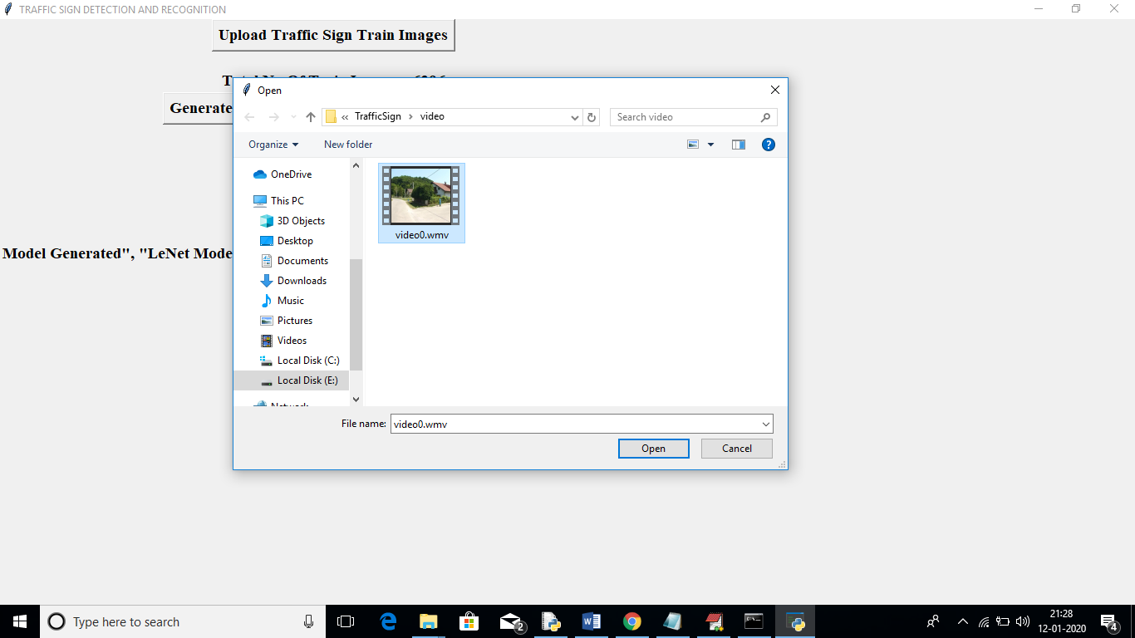

In above screen uploading one video and in this video vehicle with mounted camera will moved on road and our classifier predicts signs as vehicle moved. After uploading video click on ‘Start Traffic Sign Detection’ button to start playing video and sign detection

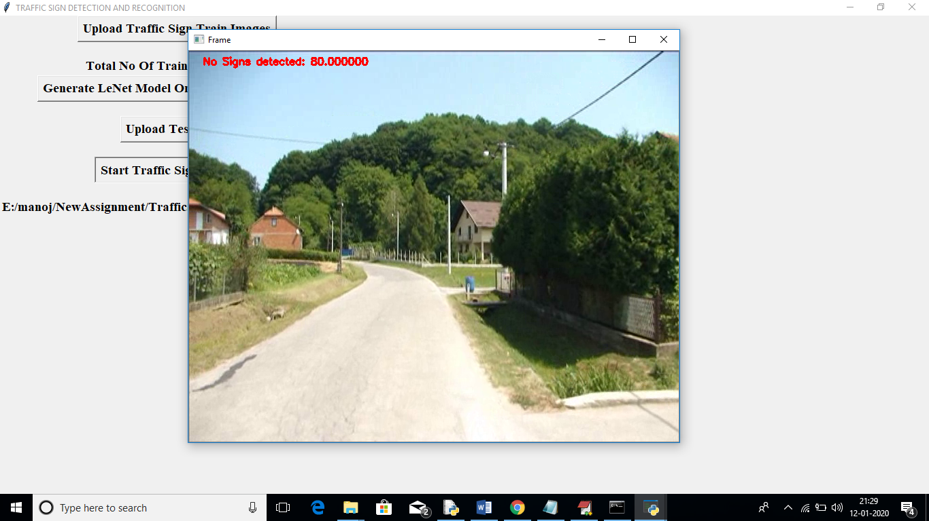

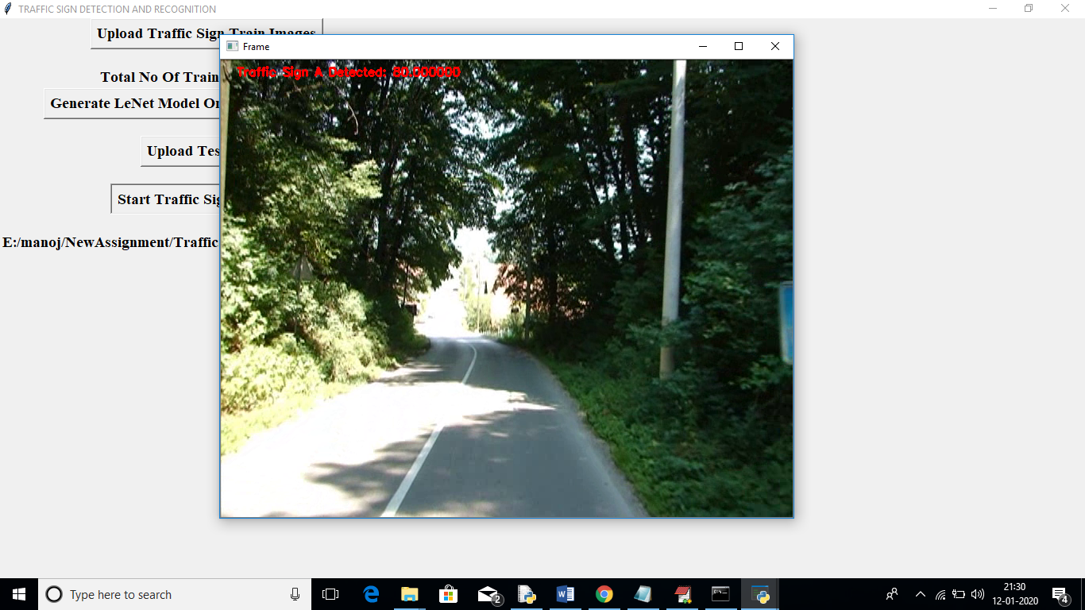

In above screen we can see Traffic Sign A detected and we can see traffic sign detection in Red Colour message as annotation for this video is not working properly to draw bounding boxes

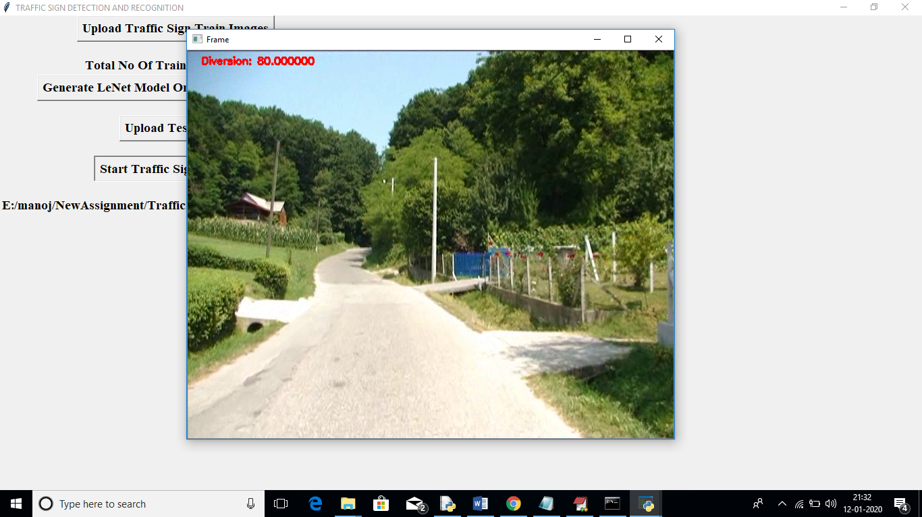

In above screen we can see Diversion board detected. Like this vehicle move and display detection information.

Note: this application may not detect some signs as dataset not contains all types of signs. Actually in real world 43 different traffic signs are there and this dataset has only 5 types. You can close video frame by pressing ‘q’ key from keyboard.