# CITY GUIDE

**An Industrial Internship Report**

***Submitted in partial fulfillment for the award of the degree of***

# B.TECH

***In***

# Information Technology

***By***

# T PRASHANTH REDDY 12BIT0077



**AUGUST 2015**

**DECLARATION BY THE CANDIDATE**

I hereby declare that the project report entitled ***“*CITY GUIDE*”*** submitted by me to School of Information Technology & Engineering, Vellore Institute of Technology University, Vellore in partial fulfillment of the requirement for the award of the degree of **B.Tech (Information Technology)** is a record of bonafide **Industrial Internship *–* ITE399** work carried out by me. I further declare that the work reported in this **Industrial Internship report** has not been submitted and will not be submitted, either in part or in full, for the award of any other degree or diploma in this institute or any other institute or university.

Place: Vellore Signature of the Candidate

Date: T PRASHANTH REDDY

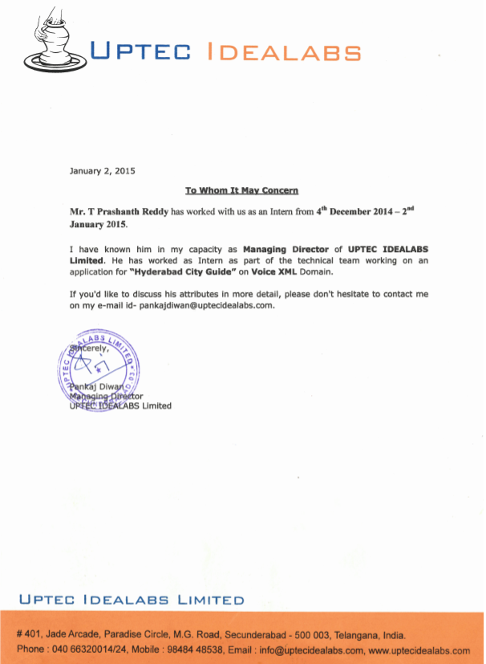



# School of Information Technology & Engineering [SITE] CERTIFICATE

This is to certify that the Industrial Internship report entitled ***“*CITY GUIDE*”*** submitted by **T PRASHANTH REDDY (12BIT0077)** to School of Information Technology & Engineering, Vellore Institute of Technology University, Vellore in partial fulfillment of the requirement for the award of the degree of **B.Tech. (Information Technology)** is a record of bonafide **Industrial Internship *–* ITE399** work carried out by him in **UPTEC IDEALABS PRIVATE LTD**. The **Industrial Internship** project fulfills the requirements as per the regulations of this Institute and in my opinion meets the necessary standards for submission. The contents of this report have not been submitted and will not be submitted either in part or in full, for the award of any other degree or diploma in this institute or any other institute or university.

Mr. Pankaj Diwan, Co-founder and Director, Uptec IdeaLabs pvt Ltd,

#401, JadeArcade, Secunderabad,

Telangana-500045.

**Examiner:**

**(Name and Signature)**

# ACKNOWLEDGEMENT

With the completion of the internship I would like to thank all the staffs of the firm as well as the university. Special Thanks to:

Chancellor **Dr**. **G. Viswanathan**

Vice Chancellor **Dr.V.Raju**

Pro-Vice Chancellor **Dr**. **S. Narayanan** *Dean - SITE -* ***Dr. K.Ganesan*** *Program Chair –* ***Prof.R.K.Nadesh***

*Year Coordinator –* ***Prof. P.Prabhavathy & Prof.K.Arivuselvan***

*Internship Panelist:* ***Prof.Lakshmi Priya G G***

*Director IdeaLabs:* ***Pankaj Diwan***

Without the continuous support of above people it was difficult to complete the industrial internship successfully.

# Table of Contents

|  |  |  |
| --- | --- | --- |
| Chapter  No | Contents | Page  No |
|  | LIST OF FIGURES | I |
| 1 | Introduction | 1 |
| 1.1 | Background | 1 |
| 1.2 | Problem Statement | 1 |
| 1.3 | Importance | 1 |
| 2 | Overview and Planning | 2 |
| 2.1 | Proposed System Overview | 2 |
| 2.2 | Challenges | 2 |
| 2.3 | Assumptions | 2 |
| 2.4 | Architecture Specifications | 2 |
| 2.5 | Hardware Requirements (Optimum requirements) | 3 |
| 2.6 | Software Requirements | 3 |
| 2.7 | Project Schedule (Gantt chart) | 4 |
| 2.7 | Work Breakdown Structure | 5 |
| 3 | Literature Survey and Review | 6 |
| 3.1 | Literature Survey | 6 |
| 4 | System Design | 6 |
| 4.1 | High-Level Design | 6 |
| 4.2 | Low-Level Design | 6 |
| 5. | System Implementation | 7 |

|  |  |  |
| --- | --- | --- |
| 5.1 | Code | 7 |
| 6. | Results and Discussion | 34 |
| 6.1 | Output | 34 |
| 6.2 | Results Analysis | 35 |
| 6.3 | Discussion | 35 |
| 7 | Conclusion and Future Work | 35 |
| 7.1 | Conclusion | 35 |
| 8 | References | 36 |

**LIST OF FIGURES**

|  |  |  |
| --- | --- | --- |
| **Figure No**  Fig. 2.4.1 | **Title**  Architecture Specification | **Page No.**  2 |
| Fig. 2.7.1 | Project Schedule | 4 |
| Fig. 2.8.1 | Work Break Down Structure | 5 |
| Fig. 4.1.1 | High Level Design | 6 |
| Fig. 4.2.1 | Low Level Design | 6 |
| Fig. 6.1.1 | Input | 35 |
| Fig. 6.1.2 | Output | 36 |

1. **INTRODUCTION**
   1. **BACKGROUND**
2. **Overview:**

The application acts as a vanguard or pathfinder to the pioneers as well as residents in the city in finding the exact bus service information to reach the destination or the tourist place. It congregates the required information and provides the exact bus service information to catch up. Thus, helps user in channelizing the path through the use of technology.

1. **Existing System:**

At present there is no technological solution through the use of mobile technology. The solution exists through the use of internet which is less percolated with access to 10.4% population in India compared to tele-density which is of 74% .The use of internet is of much complex in nature compared to a mobile phone. Another way is to enquire the people around which has following disadvantages.

1. **Disadvantages** 
   1. Reliability of the information provided
   2. Appropriate timings and schedule
   3. Information provided can be limited
   4. Availability of the person and
   5. Security may be also in trouble.

So, due to the above setbacks the use of existing systems is not recommended.

1. **Proposed System:**

In the proposed system the user dials up the given Phone number and provides the required information and acquires the required information to reach the destination. It has following advantages over the existing systems like

1. **Advantages**:
   1. It is more reliable
   2. Available by 24 by 7
   3. Provides appropriate timings
   4. Access the required information of whole city
   5. Appropriate planning before leaving to destination
   6. Access from any remote location.

# PROBLEM STATEMENT

The combination of the mobile phone and the Internet server is the trend of the future information development and software applications. Mobile phones are the most commonly used communication tools. Using mobile phones to obtain information is not only quick, but also more convenient shortcut to improve people's lives. we propose the software development architecture based on voice XML services. This framework introduces the three-layer architecture into mobile phone software development. Based on the three-layer architecture, the voice XML based city tour guide system is developed. The Voice XML based city guide system can realize to query information for bus, restaurant and tourist . The voice XML based city guide system has more practical significance.

# IMPORTANCE

As the city guide software which will guide to people who are new to the city to get the bus details ,restaurant address and tourist place information. This

software works on the latest technology on voice XML and jsp. Access from any remote location. Provides appropriate timings. Available by 24 by 7 .

# OVERVIEW AND PLANNING

* 1. **PROPOSED SYSTEM OVERVIEW**

The application acts as a vanguard or pathfinder to the pioneers as well as residents in the city in finding the exact bus service information to reach the destination or the tourist place. It congregates the required information and provides the exact bus service information to catch up. Thus, helps user in channelizing the path through the use of technology

# CHALLENGES

The system has many challenges which on flexibility ,storage data and more conveniently user friendly and faster access to the guide .As we are doing this subject on behalf even the user no need of internet and also no need of smartphones. Each and every is new to the city can be guided through this system.

# ASSUMPTIONS

We need to pronounce the exact place in which can they get the correct information.

# ARCHITECTURE SPECIFICATIONS

Architecture consists of mainly the deployment server to access the information to the guide quickly .The server need’s internet to send the message to the mobile phone for guides.

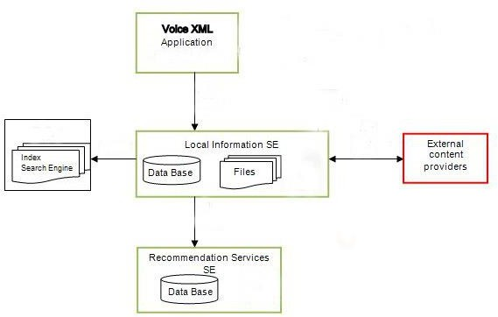

# Fig.2.4.1

* 1. **HARDWARE REQUIREMENTS (OPTIMUM REQUIREMENTS)**

> mainframe server

> mobile phone

# SOFTWARE REQUIREMENTS

> Dezign for databases

> Eclipse

> MySql Database

>voxeo prophecy server

# PROJECT SCHEDULE (GANTT CHART)

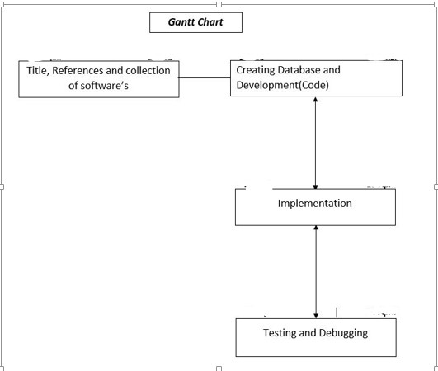

**Fig.2.7.1**

* 1. **WORK BREAKDOWN STRUCTURE**

Product testing

voxeo prophecy server

Integrstion

testing

PSTN

Server

Unit Testing

Eclipse &

Database

Testing

Implementation

System setup

Developing tool

**Fig.2.8.1**

1. **LITERATURE SURVEY AND REVIEW**
   1. **LITERATURE SURVEY**

The city guide needed to the people new to the city. As the technology is well developed the city guide application is developed in some of the OS platform which it contains the smartphones and even Internet on it . But in this subject we are totally free of smartphone’s and Internet . The user must need an mobile phone with contain certain sim network .They can get information through the sms when they asked to guided network with IVRS with exact information

# SYSTEM DESIGN

* 1. **HIGH-LEVEL DESIGN**

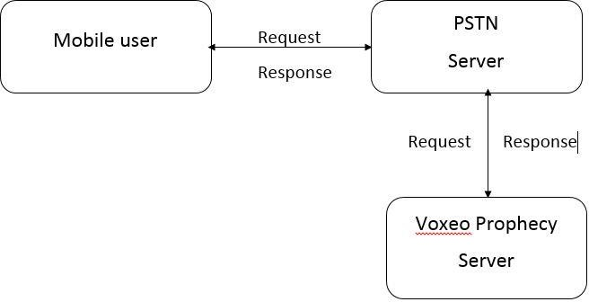

**Fig.4.1.1**

* 1. **LOW-LEVEL DESIGN**

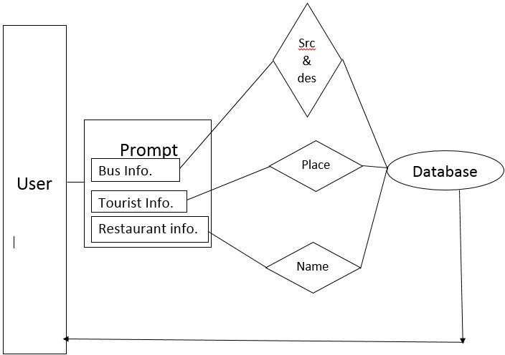

**Entity Relationship Diagram:**

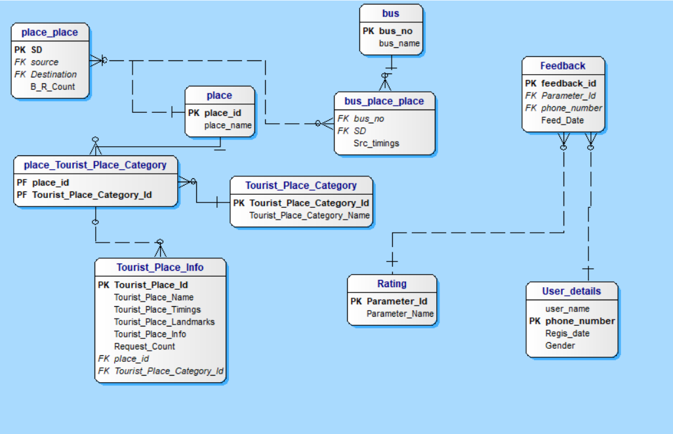

**Modules**

**1. Registration/Authentication**

**Functionality:**

To acquire and authenticate the user info for further processing

**Provisions:**

User details

1. name
2. phone no
3. Registered date
4. gender

**Queries:**

**Alerts:**

**Reports:**

Users Information who availed the service.

**2. Furnishing the Queried Information**

**Functionality:**

To provide the required information to the user which helps them to have a comfortable travel time

**Provisions:**

Place

1. Place id
2. Place name
3. Bus
4. Bus number
5. Bus name
6. Timings
7. Tourist place

**Queries:**

1. Bus service available from source to destination
2. How to reach and information about a particular tourist place.
3. Restaurants and food courts located around a particular place

**Alerts:**

1. SMS containing information to reach destination from a particular source.
2. SMS containing information about a tourist place and how to reach it.
3. SMS containing information about the food courts and restaurants located around a particular place.

**Reports:**

Information about the users who availed the service.

**3. Feedback**

Functionality:

Obtaining the feedback on the quality of service provided

**Provisions:**

Rating

1. Parameter id
2. Parameter name

**Queries:**

**Alerts:**

Thanking message for valuable feedback

**Reports:**

Evaluation report based on feedback for further analysis

# RESULTS AND DISCUSSION

* 1. **OUTPUT**

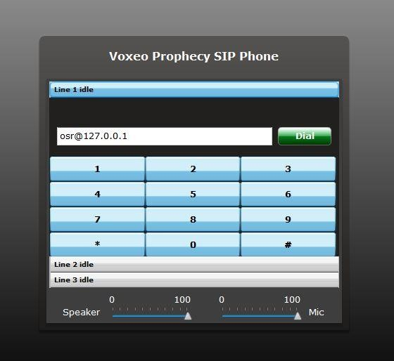

**Fig.6.1.1**

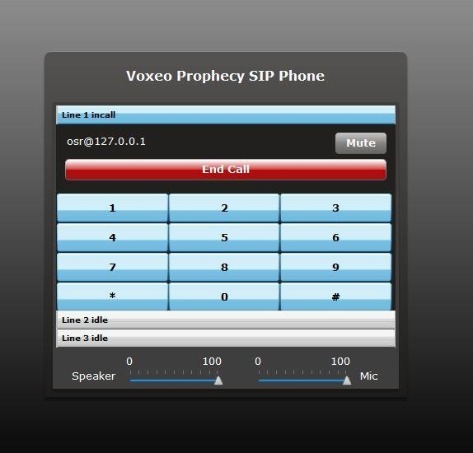

**Fig.6.1.2**

* 1. **RESULTS ANALYSIS**

Now, we have three categories of customers.

The bank can prepare separate plans for three categories as per their business goals.

# DISCUSSION

City Guide Project in Java is an essential when ever we are visiting a particular city.It gives us the valuable information about the city and saves the time. Our project laid a web based platform for the city guide and can

search every place in the city with out taking the help of any personal guide. You can search a city for its prominent places of the city user

# CONCLUSION AND FUTURE WORK

* 1. **CONCLUSION**

The application helps a person to navigate through the entire city without a guide

at any time in a safe and comfortable manner just away from call. can get social and political information of the city, city culture,security

,entertainment, Business ,Hotels,Jobs etc.

# REFERENCES

Conference Papers

Sagiroglu, S.; Sinanc, D. (20-24 May 2013),”City Guide”.

Mukherjee, A.; Datta, J.; Jorapur, R.; Singhvi, R.; Haloi, S.; Akram, W. (18 -22 Dec. 2012) “City Guide”.

Aditya B. Patel, Manashvi Birla, Ushma Nair (6-8 Dec. 2012) “City guide”.

Web [http://ieeexplore.ieee.org/xpl/login.jsp?tp=&arnumber=6567202](http://ieeexplore.ieee.org/xpl/login.jsp?tp&amp;arnumber=6567202) [http://ieeexplore.ieee.org/xpl/login.jsp?tp=&arnumber=6507520](http://ieeexplore.ieee.org/xpl/login.jsp?tp&amp;arnumber=6507520) <http://ieeexplore.ieee.org/xpl/articleDetails.jsp?arnumber=1578784>

[http://www.ijarcsse.com/docs/papers/Volume_3/10_October2013/V3I10 -0415.pd](http://www.ijarcsse.com/docs/papers/Volume_3/10_October2013/V3I10-0415.pdf)f [http://ieeexplore.ieee.org/xpl/articleDetails.jsp?tp=&arnumber=1017616](http://ieeexplore.ieee.org/xpl/articleDetails.jsp?tp&amp;arnumber=1017616)