Home Automation using Raspberry pi

SECOND REVIEW PROJECT REPORT

Submitted in partial fulfillment for the award of the degree of

B.TECH

in

Information Technology

by

N Nagamani 12BIT0258
T Prashanth Reddy 12BIT0077
Roop Sai Krishna 12BIT0156

Under the Guidance of
Prof. Hari Ram Vishwakarma


School of Information Technology & Engineering

April 2016


School of Information Technology and Engineering
B.Tech (IT) Final Semester Project (ITE499)–Winter 2015
1.Team Member(s) with Reg #
Mobile/e-mail :
N Nagamani;12BIT0258;8883381239;nagamani.n2012@vit.ac.in
T PrashanthReddy;12BIT0077;9177519830;tprashanth.reddy2012@yahoo.com
Roop Sai Krishna;12BIT0156;9159896598;prskrishnar@gmail.com

2.Type of Project : Internship (In-house – Internship - SAP )
3. Project Title: Home Automation using Raspberry pi
4. Name and Signature of the Guide /Internal Guide : Prof. Hari Ram Vishwakarma
5. Name and Signature of

Panel chair :

Panel Member 1 : Prof. Ajit Kumar Santra

Panel Member 2 : Prof. NallaKaruppan

Second Review Report

TABLE OF CONTENTS

1. Introduction 1
1.1 Background 1
1.2 Problem Statement 1
2. Overview and Planning 2
2.1 Proposed System Overview 2
2.2 Architecture Specifications 2
2.3 Hardware Requirements 3
2.4 Software Requirements 3
3. Literature Survey 4
4. System Design 5
5. System Implementation 6
5.1 Hardware Description: 6
5.2 Software Description: 8
6. Test Cases 9
7. Partial result analysis 9
8. References 10

1. Introduction

1.1 Background

With the rising power of technology, we are able to accomplish things at a much quicker rate. We have at the touch of a button access to large amounts of information due to the capability of computers and the Internet. Not only has technology given us more information, but it also has given us the ability to communicate, organize, and manage our time.

Homes of the 21st century will become more and more self-controlled and automated. Simple devices such as a timer to turn on one’s coffee maker in the morning have been around for many years, but much more sophisticated mechanisms will soon be prevalent in homes around the world. Imagine walking into your home and being greeted at the door with lights illuminating your path without you ever having to touch a light switch, with your favorite music streaming through the speakers in whichever room you enter (because your home recognized that it was you and not some other household member), all while having the peace of mind knowing that your home automation system took care of activating your security system. Furthermore, such a system could allow the user to schedule events to occur at recurring intervals (e.g., turn on sprinkler system at 4:30a.m. every Tuesday and Thursday).

The project is proposed to develop a system which increases your independence and gives you a greater control of your home environment. It improves home’s energy efficiency and provides comfort and safety. It makes easier to communicate with the family and improves personal safety by alerting you audibly and visually in emergency situations.

1.2 Problem Statement

Home automation is future of every home on the planet. We humans have a tendency of innovating everything around us. As most of our time after offices is spend in our home it is a natural tendency for people to start looking for smatter home. With time out need for smart gadget has also increased. A decade ago keypad based cellphones were a boom but are now nowhere to be seen. Thus it is very obvious that next big boom in technology might be seen in homes. Actually it’s already been happening without much of us knowing it. The smatter TV set that allow you to save your favorite show and even pause live stream. Smart fridges that automatically control temperature based on its content and prevent frost in ice chamber etc.

But these system are independent product and cannot provide whole sum experience. What companies have failed to understand is that by home automation humans are looking for a product that could enable them to control the whole home as one single body. There have been products in the past like universal remote that give user complete control over all the products in his home i.e. v ac light etc. but fundamental issue with this remote based system is that is requires the person to be inside the home. Also these system were mainly just to allow fundamental automation to user that is switch on or off a device, change volume level etc. with the proposed system we want to bring in the concept of internet of thing in home automation. This will allow all the devices to controlled centrally like other system but will also allow control from remote place i.e. user might control devices in his home or even in his car from his offices. This provides a very important factor called mobility which is very important. This sole concept is responsible for slimmer phones, smaller devices, light weight laptop etc. this remote access will allow us to monitor user’s general usage patterns of various devices remotely.

This data can be used to notify user whenever there is an abnormal behaviors show by the system. These notifications will be generated to user’s handheld devices like cellphone to make it easier to access as we carry them everywhere. These messages will be customized to users need. They can notify about a light on for long time when user is in office. Doorbell ring when user is at office. This will enable user to have greater control over his house even if he is not physically present there. These notification will also be focused towered saving power. I.e. in case outside temperature is 20 the notification will be generate to switch off the ac to save power.

2. Overview and Planning

2.1 Proposed System Overview

This project forwards the design of home automation and security system using Raspberry pi, a credit sized computer. Raspberry pi provides the features of a mini computer, additional with its GPIO pins where other components and devices can be connected. GPIO registers of raspberry pi are used for the output purposes. We have design a power strip that can be easily connected to GPIO Pins of the Raspberry pi. The home appliances are connected to the input/output ports of Raspberry pi along with the power strip and their status is passed to the raspberry pi. The android running OS in any phone connected to a network can access the status of the home appliances via an application. It presents the design and implementation of automation system that can monitor and control home appliances via android phone or tablet.

2.2 Architecture Specifications
Android controlled Smart Home Automation should be able to control the home appliances wirelessly with effectively and efficiently.
Controlling Home Appliances via Application
To develop an application that includes the features of switches and voice mode application. Switch Mode or Voice Mode can be used to control the switches of home appliances.
Secure Connection Channels between Application and Raspberry pi
Use of secure protocols over Wi-Fi so that other devices cannot control the appliances. Options for secure connection is SSL over TCP, SSH
Controlled by any device capable of Wi-Fi (Android, iOS, PC)
To make the home appliances flexible in control, any device capable of Wi-Fi connectivity will able to control the home appliances from remote location.
Extensible platform for future enhancement
The application is to be highly extensible, with possibility of adding features in the future as needed.
The system integrated with different features can be applied in the following fields.

The system can be used in home, small offices to the big malls
The system can be used from home to offices to control the electrical appliances.
For remote access of appliances in internet or intranet
The home/office appliances can be controlled in intra-network or can be accessed via internet.
For the development of technology friendly environment
The system incorporates the use of technology and making smart home automation. By the use of day to day gadgets we can utilize them for different prospective.

The android OS provides the flexibility of using the open source. The inbuilt sensors can be accessed easily. Android Phone acts as a client and data are sent via sockets programming.
All the devices are connected to a common network. Smart phone and raspberry pi are connected to the common network Router is used to create a common network.
Wi-Fi Adapter is used to connect raspberry pi to the network. Raspberry pi is used to maintain the server. The pi collects the data analyses it and further activates GPIO pins as necessary. The GPIO pins of raspberry pi are connected to the relay. Relay switch are used to connect the home appliances.

2.3 Hardware Requirements
- Raspberry Pi 512MB RAM
- WiFi Adapter
- SD card 8GB (bigger size)
- Relays (6V,3A,PCB Mount)

- Jumper Wires

- Resistors

- Capacitors

2.4 Software Requirements
1. Android Developer Tools (ADT)
To build the android application to receive and to send the control signals to control the robot.
2. RPI-GPIO library
GPIO interface library for the Raspberry Pi.

3. Literature Survey

As per our survey, there exist many systems that can control home appliances using android based phones/tablets. Each system has its unique features. Currently certain companies are officially registered and are working to provide better home automation system features. Following models describes the work being performed by others.

N. Sriskanthan and Tan Karand. “Bluetooth Based Home Automation System”. Journal of Microprocessors and Microsystems, Vol. 26, pp.281-289, 2002.
N. Sriskanthan explained the model for home automation using bluetooth via PC. But unfortunately the system lacks to support mobile technology.

Muhammad Izhar Ramli, Mohd Helmy Abd Wahab, Nabihah, “TOWARDS SMART HOME: CONTROL ELECTRICAL DEVICES ONLINE” , Nornabihah Ahmad International Conference on Science and Technology: Application in Industry and Education (2006)
Muhammad Izhar Ramli designed a prototype electrical device control system using Web. They also set the server with auto restart if the server condition is currently down.

E. Yavuz, B. Hasan, I. Serkan and K. Duygu. “Safe and Secure PIC Based Remote Control Application for Intelligent Home”. International Journal of Computer Science and Network Security, Vol. 7, No. 5, May 2007
Hasan has developed a telephone and PIC remote controlled device for controlling the devices pin check algorithm has been introduced where it was with cable network but not wireless communication.

Amul Jadhav, S. Anand, Nilesh Dhangare, K.S. Wagh “Universal Mobile Application Development (UMAD) On Home Automation” Marathwada Mitra Mandal’s Institute of Technology, University of Pune, India Network and Complex Systems ISSN 2224-610X (Paper) ISSN 2225-0603 (Online) Vol 2, No.2, 2012
Amul Jadhav developed an application in a universal XML format which can be easily ported to any other mobile devices rather than targeting a single platform

4. System Design
Block diagram of proposed system

Android device
(mobile or tablet) Network
(Router)

Wi-Fi Adapter

Raspberry Pi

Relay
Relay Relay
Relay

Appliance 1 Appliance 2 Appliance 3 Appliance 4

Block Diagram of Proposed System

The architecture shown above is the basic idea of how system would communicate. The interaction between the raspberry pi and the android app is done via network. The raspberry pi is further connected to relays. Then relays are connected to home appliances which ever devices we want to control remotely.

5. System Implementation

5.1 Hardware Description:

The power strip is designed and relays are connected to power strip. The home appliances are connected to the power strip. The Relays are connected to the GPIO pins of the raspberry pi.

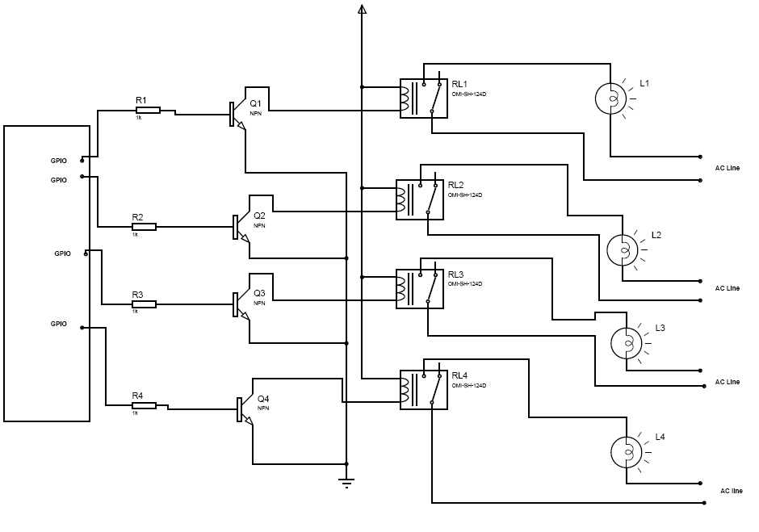

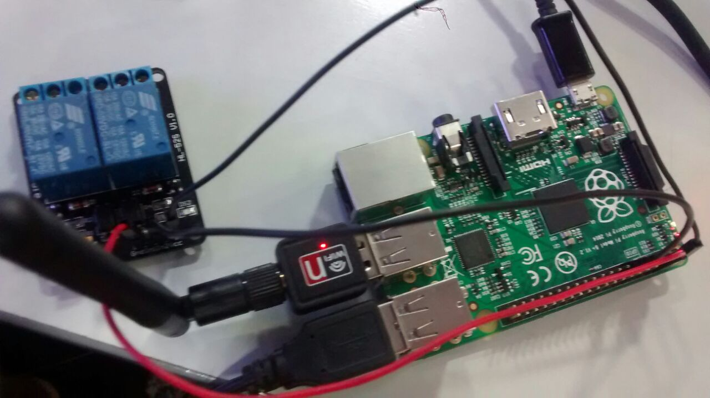

Figure 1 Relay setup

Relay Switches are mainly used here to switch on and off a device. The relay switch when signaled from the raspberry pi closes that circuit allowing the current to flow through it. It maintains that state until told otherwise. Relay switches can handle high voltages thus even ac and fridges can be connected to the circuit. Relays are highly reliable too. Wi-Fi modem is connected in order to access the internet.
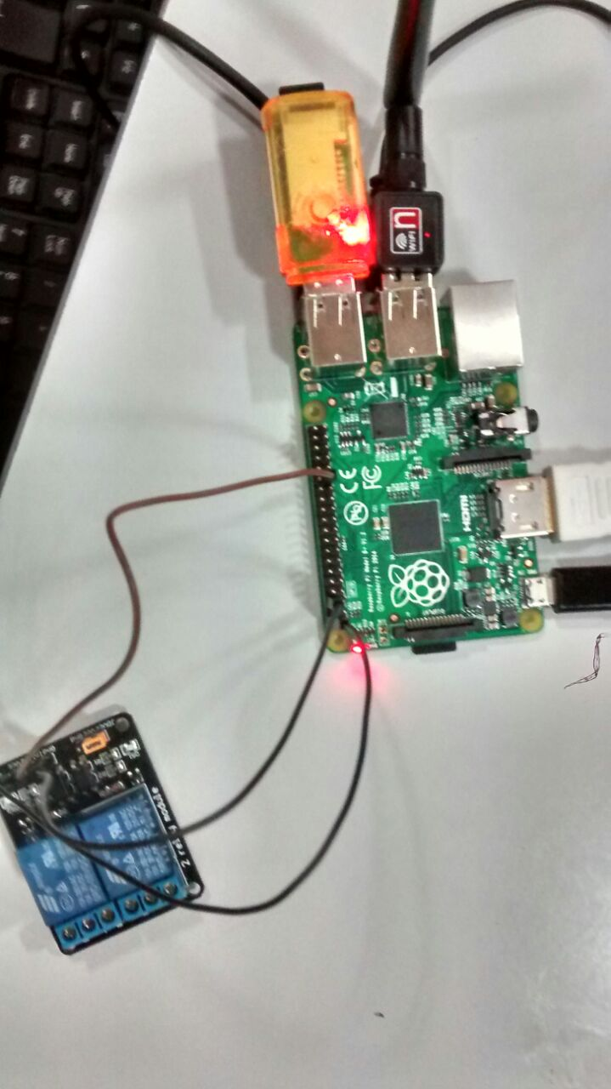

Figure 2 External memory
It features a Broadcom system on a chip (SOC) which include an ARM compatible CPU and an on chip graphics processing unit GPU (a VideoCore IV).
CPU speed range from 700 MHz to 1.2 GHz for the Pi 3 and on board memory range from 256MB to 1GB RAM. Secure Digital SD cards are used to store the operating system and program memory in either the SDHC or MicroSDHC sizes.

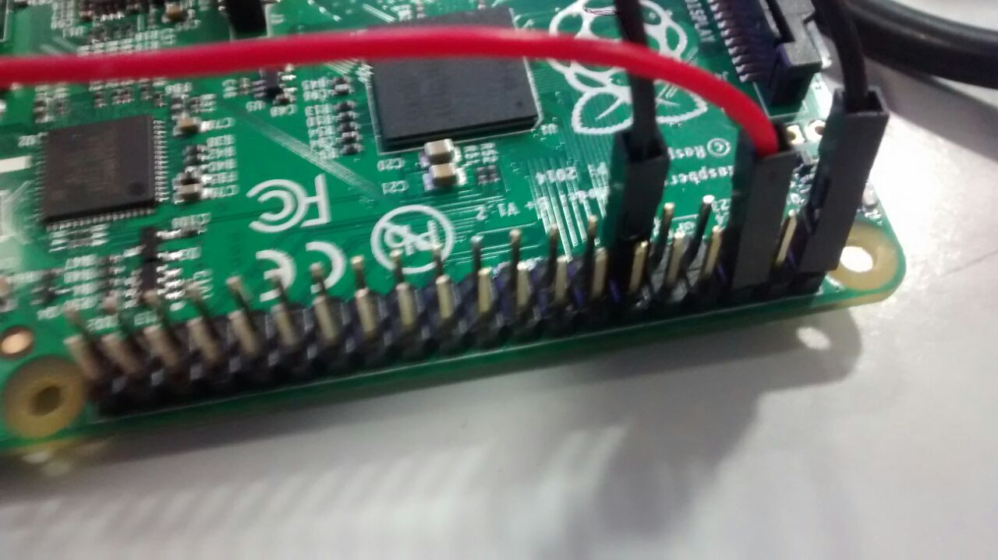
Figure 3 GPIO
General Purpose Input/Output (GPIO) is a generic pin on a chip whose behaviour (including whether it is an input or output pin) can be controlled (programmed) through software.
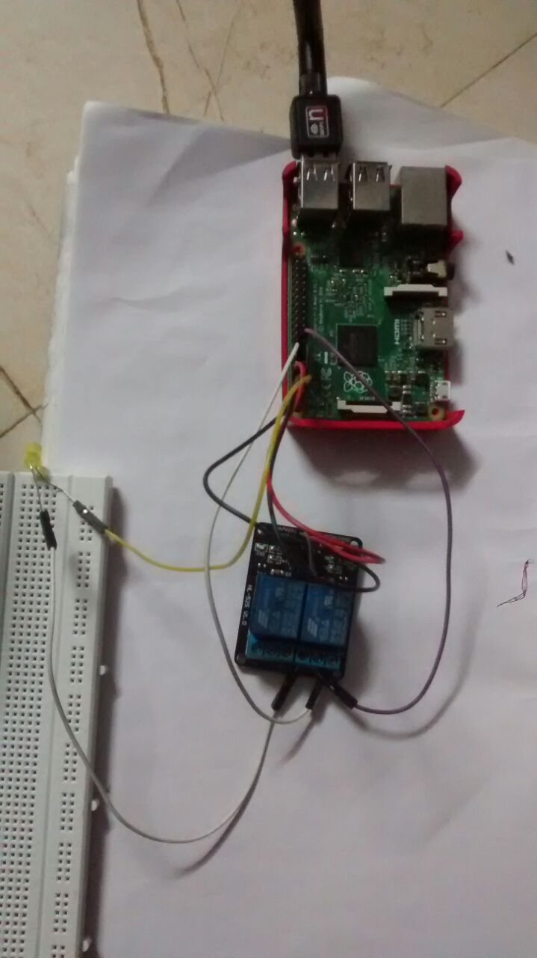
Figure 4 LED SETUP
The pi collects the data analyses it and further activates GPIO pins as necessary. The GPIO pins of raspberry pi are connected to the relay. Relay switch are used to connect the home appliances. In this setup a led is connected to relay. Based on input to relay it switch it on or switch it off the led.

5.2 Software Description:

Android Software Development kit incorporates Eclipse software where Java programming is performed. Eclipse software is used to write the codes for the application under Java Platform. Raspbian OS is used at the raspberry pi. Server is established at raspberry pi. Python Language is used to write the codes of server, and to control the GPIO Pins of OS.

5.2.1. Java:

Java is a set of several computer software products and specifications from Oracle Corporation that provides a system for developing application software and deploying it in a cross-platform computing environment. Java is used in a wide variety of computing platforms from embedded devices and mobile phones on the low end, to enterprise servers and supercomputers on the high end.

5.2.2. Python:

Python is an interpreter, interactive, object-oriented programming language. It incorporates modules, exceptions, dynamic typing, very high level dynamic data types, and classes. Python combines remarkable power with very clear syntax. It has interfaces too many system calls and libraries, as well as to various window systems, and is extensible in C or C++. It is also usable as an extension language for applications that need a programmable interface. Python is a high-level general- purpose programming language that can be applied to many different classes of problems.

5.2.3. Raspbian:

Raspbian is a free Operating System based on Debian optimized for the raspberry pi hardware. Raspbian comes with more than 35000 packages; pre-combined software bundled in a nice format for easy installation on Raspberry pi.
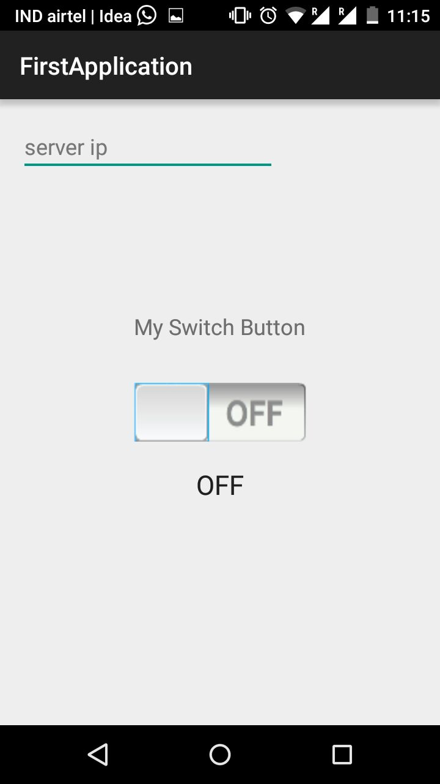
Figure 5 APP
The app plays a very important role here. It is going to be the prime interface between the user and the system. It will provide a display of users home, all his rooms and devices and instruments in his room connected to the micro controller. All the action taken by the microcontroller is to be immediately reflected in the app. This will allow user to be in control of everything. It allows users to access his home remotely. You can see the status of device. By selecting a device you can either switch it on or switch it off.

6. Test Cases
Test cases are important to determine the efficiency of the system and to ensure that all the important cases are very well handled. In test case the general intent is to check if all the boundary cases are handled. In this project two testing were performed. The unit testing and the Integration testing on server side. The app also has integration testing performed on it.
The unit testing included testing of individual APIs and independent functions. The boundary condition were checked along with return type of data. The other test performed was integration testing where we test the whole system instead of individual system.
In app testing becomes a bit difficult when it comes to testing individual components. But again android provides support for unit tests and integration test on the function used which is used to test the backend mostly. Thus most of the app testing was manual with variation in usage patterns. Several cases have been handled such as no internet, continuous update etc.
A user testing was also done to know how users interact with app and to understand what user actually needs from the app. The app is then modified to allow users to have more control and flexibility over their devices and to provide them with important data to help them make decisions as if they were present at the spot.

7. Partial result analysis

The project has around 60 percentage of work completed till now. This includes a complete working app, server side script to process the request and generate the response for app.

APP: App has 1 screen. It has one button to switch on or off and it displays the current status of the light whether it is switched on or switched off. This allows the user to switch on or off the electrical appliances remotely.

RASPBERRY PI: This acts as a server. It is configured with static IP address and further Wi-Fi modem is connected to it in order to access the internet. Using the static IP address the app can be connected to raspberry pi. There is a script that runs on raspberry pi to handle the app’s request. The request is generated from app by user to either switch on or off a device to server. Then the server process the request and further it enable or disable the particular GPIO pin which is connected to relay. The relay is connected to the light. Based on the input to the relay it switches on or off the electronic equipment.

8. References

Conference Papers
- N.Sriskanthan and Tan Karand. “Bluetooth Based Home Automation System”. Journal of Microprocessors and Microsystems, Vol. 26, pp.281-289, 2002.
- Amul Jadhav, S. Anand, Nilesh Dhangare, K.S. Wagh “Universal Mobile Application Development (UMAD) On Home Automation” Marathwada Mitra Mandal’s Institute of Technology, University of Pune, India Network and Complex Systems ISSN 2224-610X (Paper) ISSN 2225-0603 (Online) Vol 2, No.2, 2012
- Preville, Cherie (26 Aug 2013). "Control Your Castle: The Latest in HVAC Home Automation". ACHRNews (ACHRNews). Retrieved 15 Jun 2015.
- Griffiths, Melanie (March 2008). "Smart Home Security". Homebuilding & Renovating. Retrieved 27 February 2012.
- Berger, Lars T.; Schwager, Andreas; Pagani, Pascal; Schneider, Daniel M. (February 2014). Smart Grid Applications, Communications, and Security. Devices, Circuits, and Systems. CRC Press. ISBN 9781466557529.
- E. Yavuz, B. Hasan, I. Serkan and K. Duygu. “Safe and Secure PIC Based Remote Control Application for Intelligent Home”. International Journal of Computer Science and Network Security, Vol. 7, No. 5, May 2007
- Muhammad Izhar Ramli, Mohd Helmy Abd Wahab, Nabihah, “TOWARDS SMART HOME: CONTROL ELECTRICAL DEVICES ONLINE”, Nornabihah Ahmad International Conference on Science and Technology: Application in Industry and Education (2006)

