1. Purpose & Objective
This SOP defines the provisioning and controlled usage of a dedicated sandbox environment for DevOps and AI Ops activities. The objective is to provide a secure, isolated platform for development, testing, and experimentation without impacting UAT or Production, while complying with organizational security and governance standards.
Key Intent & Outcomes:
- Establish a dedicated isolated sandbox environment
- Enable safe experimentation without impacting UAT/Production
- Support DevOps pipelines, automation workflows, and AI integrations
- Eliminate environment mismatch (Local vs UAT)
- Improve deployment quality and turnaround time
- Ensure controlled internet usage and governance compliance
This Document is written to support audit, architectural view, and optional continuity.
2. Scope
This SOP applies to all activities related to the setup, access, and usage of the dedicated sandbox environment for DevOps and AI Ops. It defines the boundaries, stakeholders, and permissible operations within the sandbox to ensure controlled usage and compliance with organizational security standards.
In Scope:
- Provisioning of sandbox infrastructure (VLAN, VM, storage, network configuration)
- Configuration and usage of DevOps tools (CI/CD, containerization, orchestration)
- Implementation and testing of AI/ML and automation workflows
- Controlled internet access for approved tools and services
- Security controls, monitoring, and logging within the sandbox
- Access management for authorized users and teams
Stakeholders Covered:
- DevOps and Engineering Teams
- AI/ML and Automation Teams
- Infrastructure and Network Teams
- Information Security / CISO Office

3. High-Level Architecture
The sandbox environment is a controlled and isolated setup with restricted internet access enforced via firewall policies.
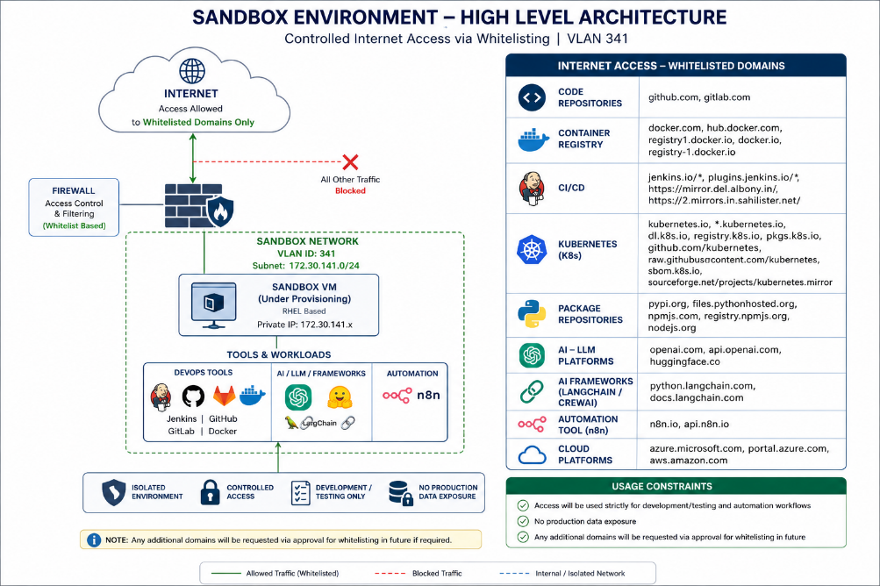
Flow:
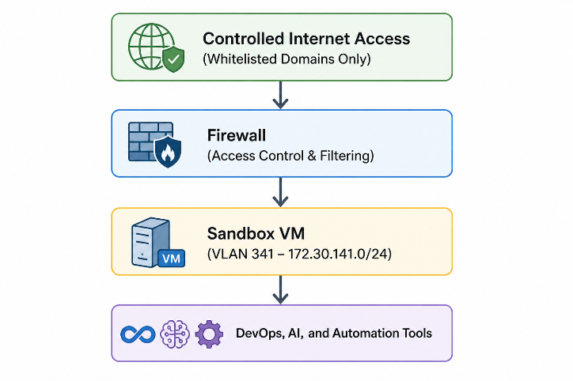
Key Components:
- Internet Access: Whitelisted domains only (default deny)
- Firewall: Domain/category-based filtering
- Sandbox VM: Dedicated environment for integrations, testing, and workflows
4. Infrastructure Overview
The sandbox environment is provisioned as a dedicated and isolated infrastructure setup within the data center to support DevOps and AI Ops activities.
Network Configuration
- VLAN ID: 341
- Subnet: 172.30.141.0/24
- Type: Isolated Sandbox Network
Virtual Machine Configuration
Component | Specification
CPU | 8 vCPU
RAM | 32 GB
Operating System | RHEL
Storage | OS (90 GB), /opt (50 GB), /app (100 GB)
Location | Data Center

Infrastructure Characteristics
- Dedicated VM provisioned within isolated VLAN
- No direct connectivity to Production or UAT environments
- Configured for controlled outbound internet access
- Designed to support containerized workloads and automation tools
5. Application Layer & Approved Use Cases
The sandbox hosts a containerized environment to support DevOps, AI Ops, and automation workflows within a controlled setup.
Components & Usage
- DevOps: CI/CD pipelines, code repositories, container workflows
- AI Ops: Log analysis, incident summarization, AI integrations
- Automation: Workflow orchestration and API-based integrations
Deployment
- Docker / Kubernetes (where applicable)
- Self-contained environment with minimal dependency on internal systems
Restriction
- Strictly limited to non-production usage only
7. Internet Access Model
The sandbox environment is configured with a restricted and controlled internet access model, allowing connectivity only to approved external platforms required for development, testing, and automation workflows.
Access Strategy
- Whitelist-based access only (default deny)
- Access granted via:
  - Category-based approval OR
  - Explicit domain/URL whitelisting
Approved Internet Access (Whitelisted Domains)
Category | Domains
Code Repositories | https://github.com, https://gitlab.com
Container Registry | https://www.docker.com, https://hub.docker.com, https://registry-1.docker.io
CI/CD Tools | https://www.jenkins.io, https://plugins.jenkins.io, https://mirror.del.albony.in, https://2.mirrors.in.sahilister.net
Kubernetes (K8s) | https://kubernetes.io, https://pkgs.k8s.io, https://registry.k8s.io, https://dl.k8s.io, https://github.com/kubernetes, https://raw.githubusercontent.com/kubernetes, https://sbom.k8s.io, https://sourceforge.net/projects/kubernetes.mirror
Package Repositories | https://pypi.org, https://files.pythonhosted.org, https://www.npmjs.com, https://registry.npmjs.org, https://nodejs.org
AI Platforms | https://openai.com, https://api.openai.com, https://huggingface.co
AI Frameworks | https://docs.langchain.com, https://python.langchain.com
Automation Tools | https://n8n.io, https://api.n8n.io
Cloud Platforms | https://azure.microsoft.com, https://portal.azure.com, https://aws.amazon.com

Conditions
- Development and testing use only
- No production or sensitive data exposure
- Additional domains require prior approval and whitelisting
8. Security & Governance
This section defines the security controls and governance mechanisms enforced within the sandbox environment to ensure safe, compliant, and controlled usage of DevOps and AI tools.
Category | Controls
Network Security | Isolated VLAN (341); No access to Production/UAT; Firewall-enforced outbound control; Default deny for all traffic
Data Restrictions | No production or sensitive data; Only test or masked data allowed
AI Usage Rules | Only approved tools/APIs; No confidential data sent externally; Usage limited to development/testing
Access Control | Authorized users only; Role-based access control (RBAC); No public exposure
Monitoring & Logging | Network and system activity logged; Logs available for audit and review

Risk Controls
Risk | Control
Unauthorized access | Firewall whitelist enforcement
Data leakage | No production data policy
AI misuse | Approval and usage restrictions
External threats | Network isolation and filtering
Misconfiguration | RBAC and monitoring

9. Responsibilities
This section outlines the roles and responsibilities of various teams involved in the provisioning, management, and usage of the sandbox environment.
Team | Responsibility
Infrastructure Team | Provision and maintain sandbox VM, compute, and storage resources
Network Team | Configure VLAN, firewall rules, and network access controls
IT Security / CISO Team | Review and approve internet access, AI tools, and security policies
DevOps Team | Set up CI/CD pipelines, container platforms, and development tools
AI / Automation Team | Implement AI models, workflows, and automation use cases
Users (Authorized) | Use the sandbox strictly for development, testing, and approved activities

Clear ownership and defined responsibilities ensure controlled usage, proper governance, and accountability across all teams involved in the sandbox environment.

