**Q1. Which are the top three variables in your model which contribute most towards the probability of a lead getting converted?**

**Ans**. We need to work towards a rational approach taking into account variables as follows

* Tags_Closed by Horizon
* Tags_Lost to EINS and
* Tags_Will revert after reading the email

As the coefficient of these variables are high in descending order respectively and hence the conversion ratio is higher in case of these leads.

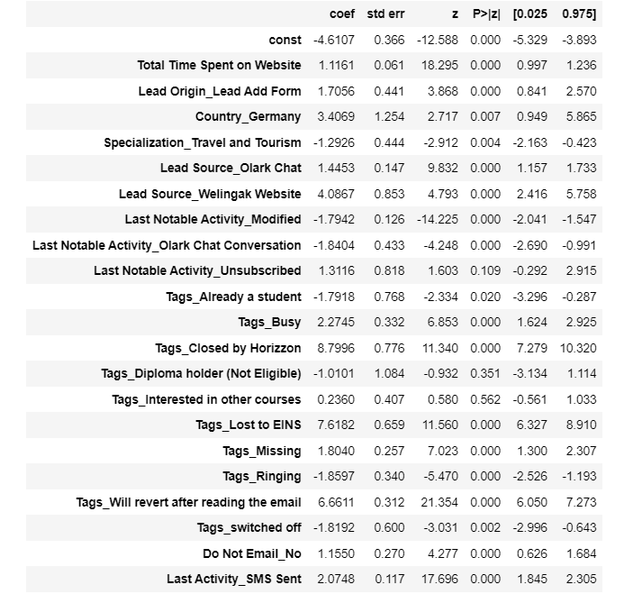

**Q2. What are the top 3 categorical/dummy variables in the model which should be focused the most on in order to increase the probability of lead conversion?**

**Ans.** Tags_Closed by Horizon, Tags_Lost to EINS and Tags_Will revert after reading the email are the top 3 categorical/dummy variables in the model that should be focused the most to increase the probability of lead conversion as these 3 variables are having the highest coefficients that shows they have more positive effect on the target variable ‘converted’.

**Q3. X Education has a period of 2 months every year during which they hire some interns. The sales team, in particular, has around 10 interns allotted to them. So during this phase, they wish to make the lead conversion more aggressive. So they want almost all of the potential leads (i.e. the customers who have been predicted as 1 by the model) to be converted and hence, want to make phone calls to as much of such people as possible. Suggest a good strategy they should employ at this stage.**

**Ans.** People who have been assigned scores higher than 50 should be approached first by the sales team and they should try to persuade them to sell the courses.

Tags-Closed by Horizon, Tags_Lost to EINS and Tags_Will revert after reading the email are the variables with high coefficient, so people having these attributes are more likely to be converted. So, the sales team can focus on these people more.

**Q4. Similarly, at times, the company reaches its target for a quarter before the deadline. During this time, the company wants the sales team to focus on some new work as well. So, during this time, the company’s aim is to not make phone calls unless it’s extremely necessary, i.e., they want to minimize the rate of useless phone calls. Suggest a strategy they should employ at this stage.**

**Ans.** The organisation should focus more on the agents’ training on getting strong hold on product knowledge, new ways and counters for objection handling alongside training them regarding maintaining a Salesforce/CRM hygiene. So that down the line, they get an idea on which leads to call upon. Taking appropriate huddles, time to time, to check upon if the agent is good at probing a lead and how they judge a lead based upon the conversation.

A value delivery team could work upon customer satisfaction and look for more referrals, by inducing referral policies.

Product and tech team can work upon the CRM to make it user friendly and product more appealing by adding sets for value addition purposes.