Week 4 Assignment: The Agentic MCP Workflow
Prashanth Pattepu | Outskill AI Generalist Fellowship | Cohort 7

Overview
This week’s focus was on Agentic AI and the Model Context Protocol (MCP). The core idea is powerful: instead of just asking AI questions, we can let it act on our behalf managing files, interacting with tools, and executing real tasks autonomously. The assignment asked us to install a host, connect tools, execute a task, and verify the results.
I chose Goose as my MCP host and gave it a practical, real-world task: organize my messy Downloads folder. This was a low stakes but genuinely useful task, exactly the kind of starting point the course recommends for building trust with agentic systems before granting access to calendars or project management tools.

What I Did

Step 1: Install a Host
I installed Goose on my Windows machine. Goose acts as the control layer that manages MCP servers and coordinates tool connections. It connects to Claude Opus 4.6 as the underlying LLM, which handles the reasoning and decision-making behind each action.

Step 2: Connect Tools & Execute the Task
I connected Goose to my local file system through its developer extension and pointed it at my Downloads folder. My prompt was straightforward: organize the folder into a clean structure following best practices for download folder management, and advise me on what to clean up.
Goose immediately got to work. It scanned the entire Downloads folder using PowerShell commands, analyzed 392 files (~7.2 GB), and autonomously created a logical folder structure. Below are the screenshots showing the process:
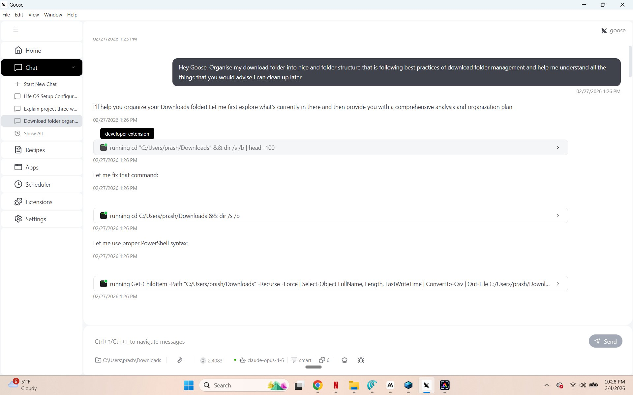
Figure 1: Goose receiving the task and executing file system commands
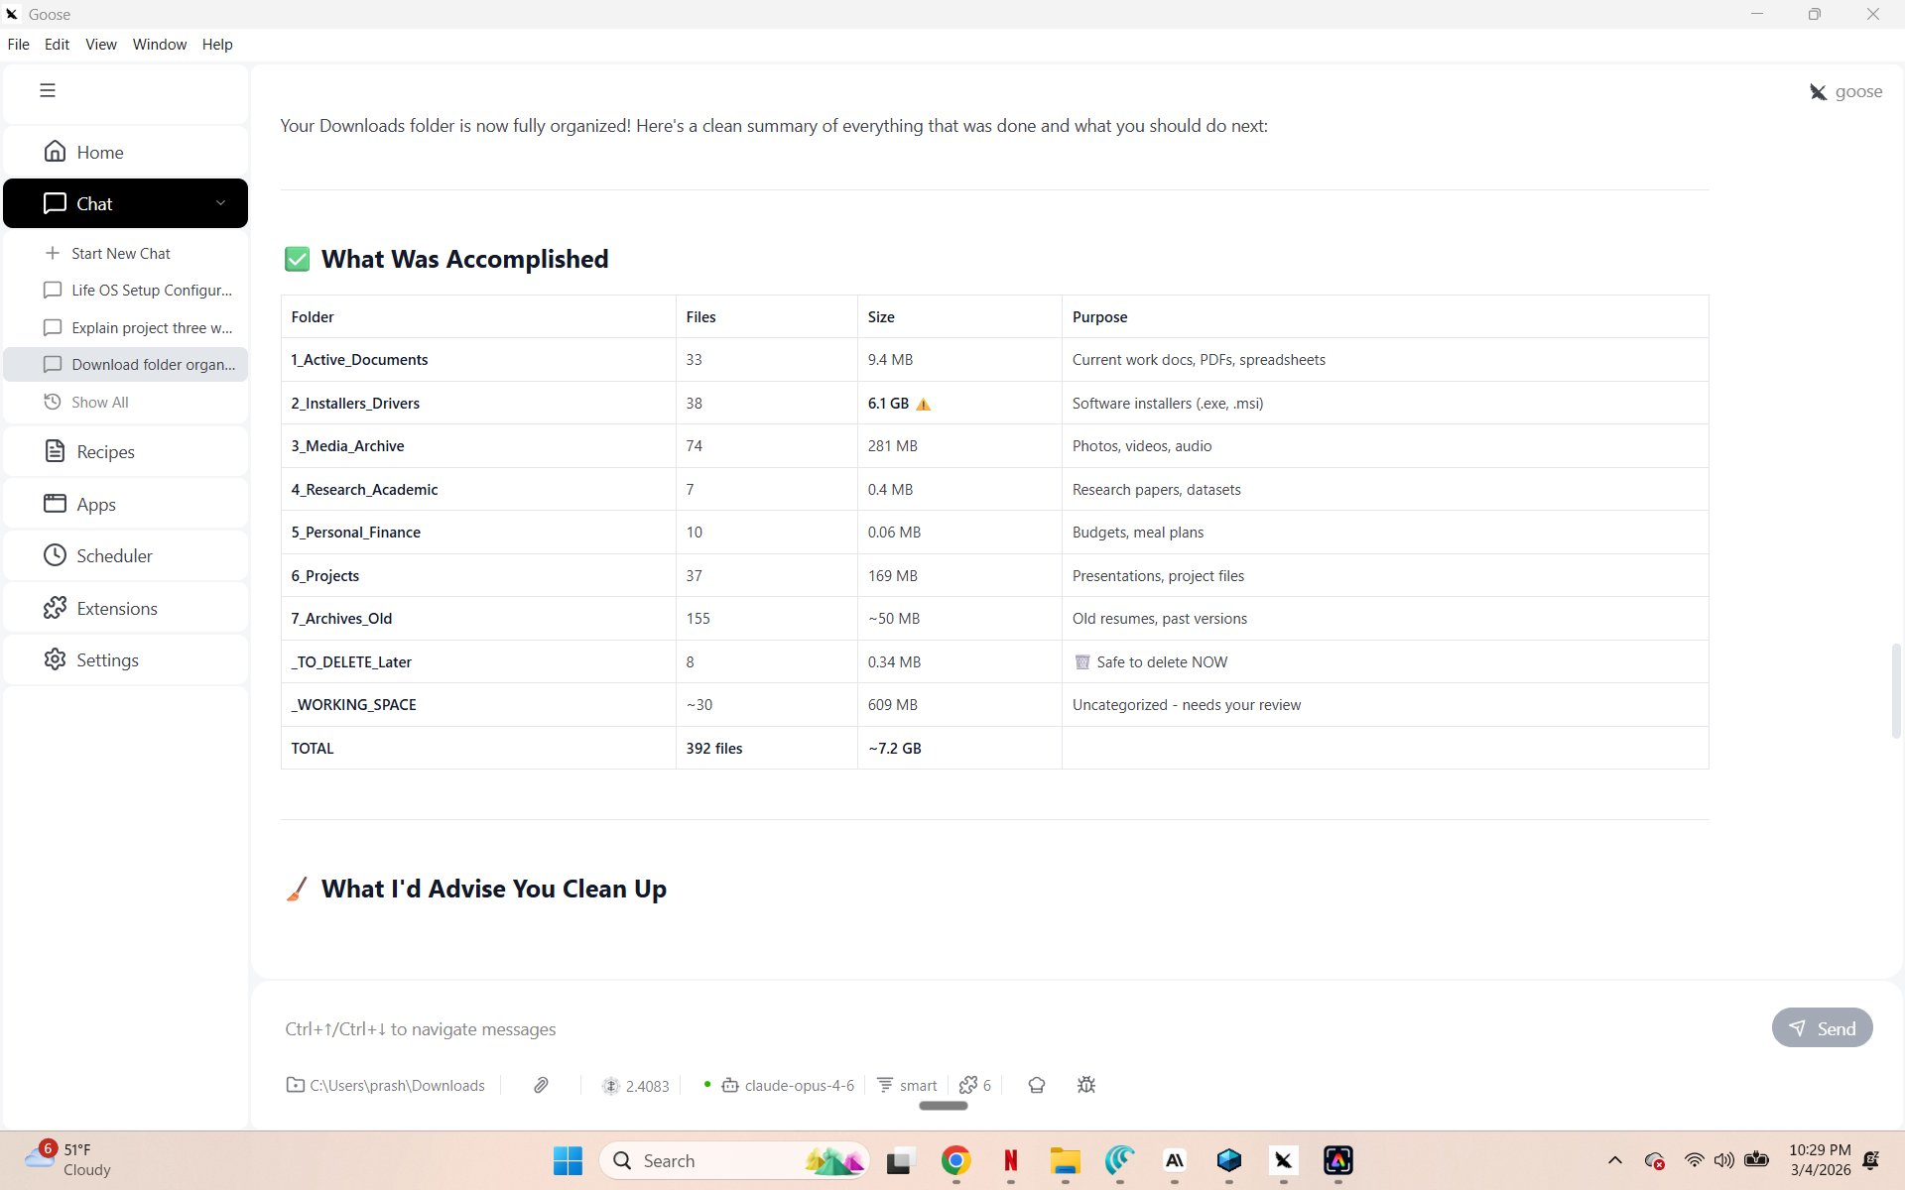
Figure 2: Goose’s completed organization — 392 files sorted into 9 categorized folders

Step 3: Verify & Approve
After organizing, Goose didn’t just stop it provided a detailed cleanup report with prioritized recommendations. It identified that my Installers Drivers folder alone was 6.1 GB (85% of total space) and flagged duplicate MstyStudio and LM-Studio installers for deletion. It also recommended reviewing archived resumes, cleaning old media backups, and sorting the working space folder.
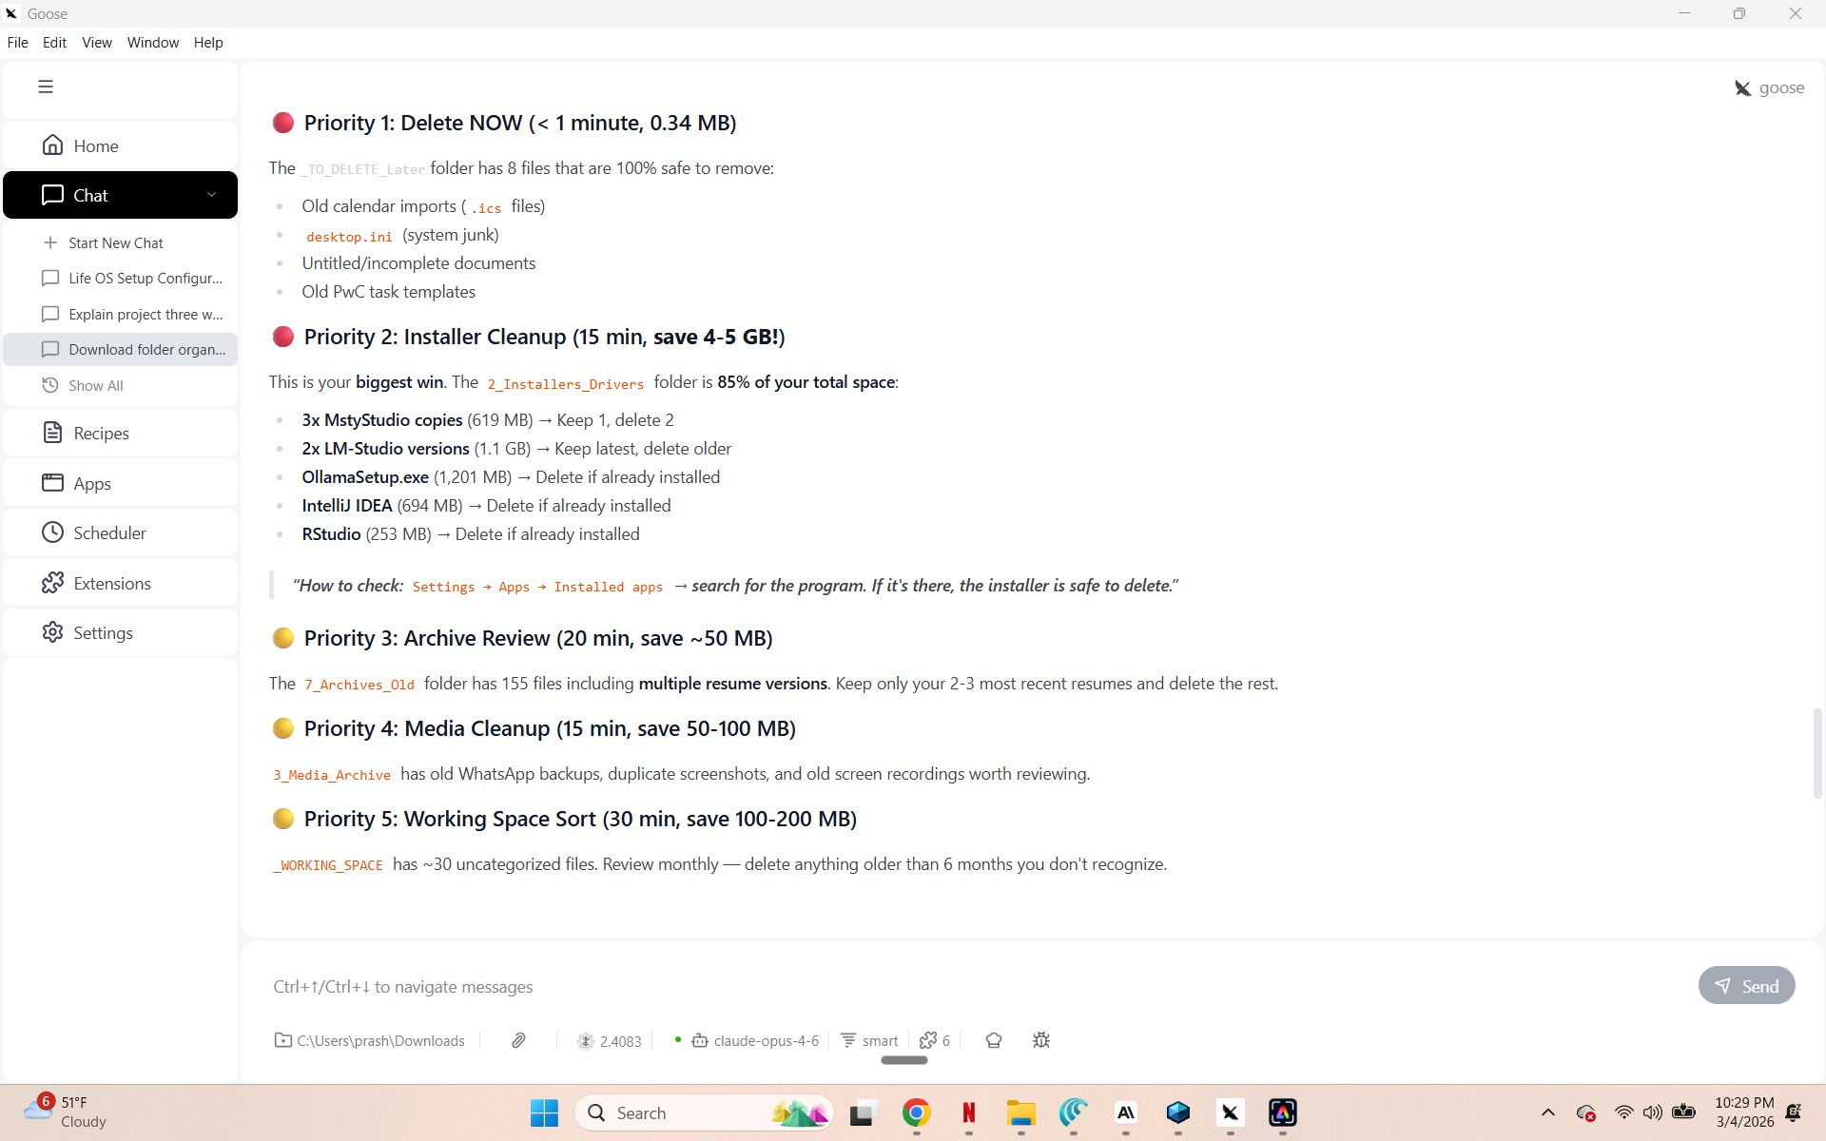
Figure 3: Goose’s prioritized cleanup recommendations estimated 4-5 GB of recoverable space
The result speaks for itself. My Downloads folder went from a chaotic dump of 392 files to a clean, organized structure with clearly labeled folders:
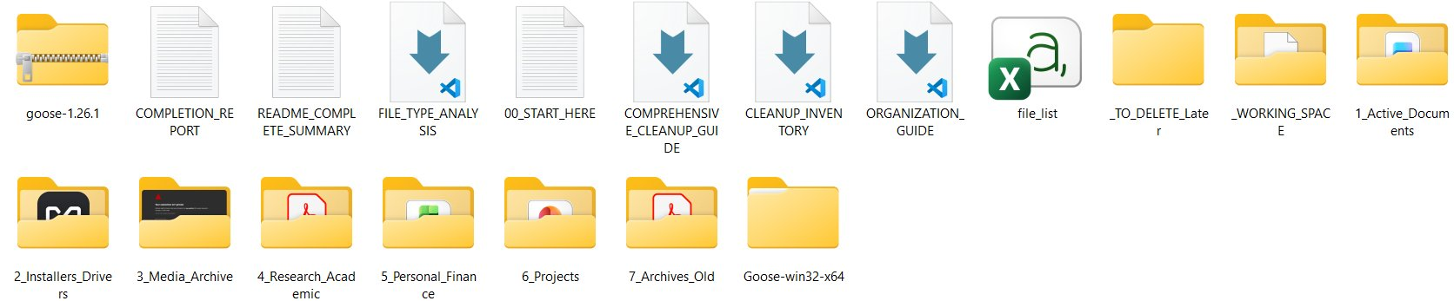
Figure 4: The organized Downloads folder before Goose this was a single flat directory

Reflection
What stood out most was how Goose handled errors gracefully. It tried a command, realized the syntax didn’t work, corrected itself to use proper PowerShell syntax, and continued without any input from me. That self-correcting behavior is what makes agentic AI different from a simple chatbot it reasons, adapts, and completes the task.
The practical impact was real: what used to take me about 60 minutes of manual sorting was done in under 5 minutes. More importantly, Goose’s cleanup report gave me actionable next steps I wouldn’t have thought of on my own, like checking installed apps before deleting installers.

Tools Used
- Goose - MCP host for agentic task execution
- Claude Opus 4.6 - LLM powering the reasoning behind Goose’s actions
- MCP (Model Context Protocol) - the protocol enabling AI to interact with real-world tools
- Developer Extension (File System) - Goose’s connection to the local file system

