Jenkins -01
- title: install Jenkins and run on port number 8081
objective: need to install Jenkins and run with port number from 8080 to 8081
prerequisites:
AWS
ec2
java
step by step process:
first create one instance with Jenkins name and launch the instance
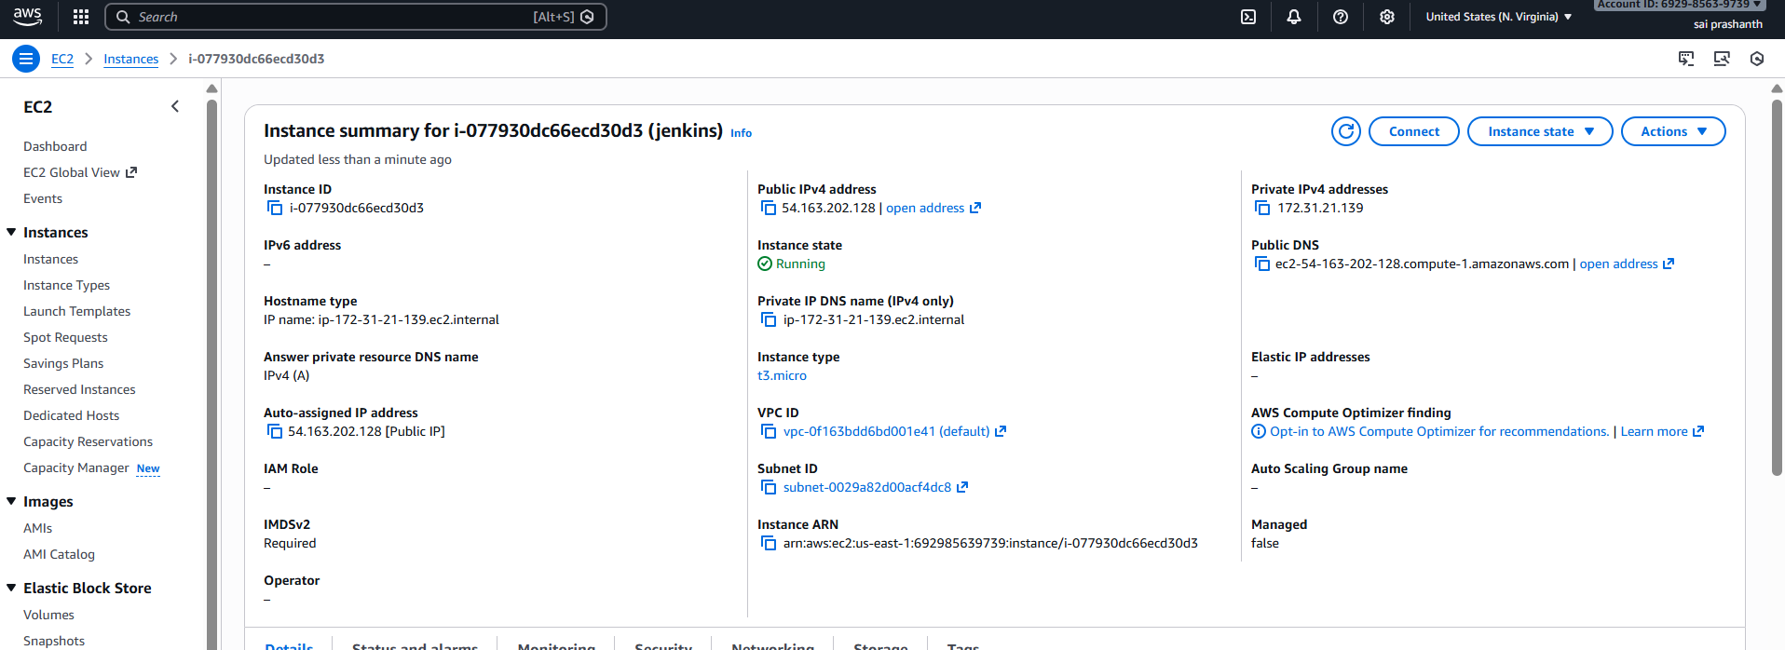
now connect in cli with ssh
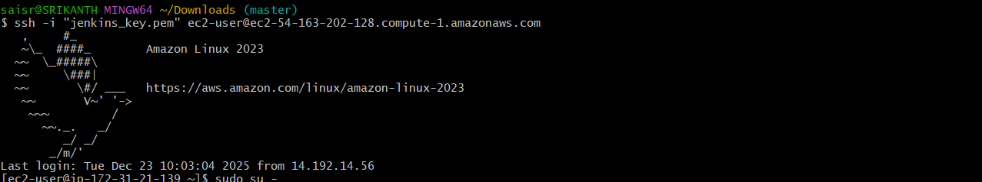
now we need to install Jenkins
before we need to install java
we need to use the command to install java
sudo yum install -y java-17-amazon-corretto
now check the java version---use the command
java -version

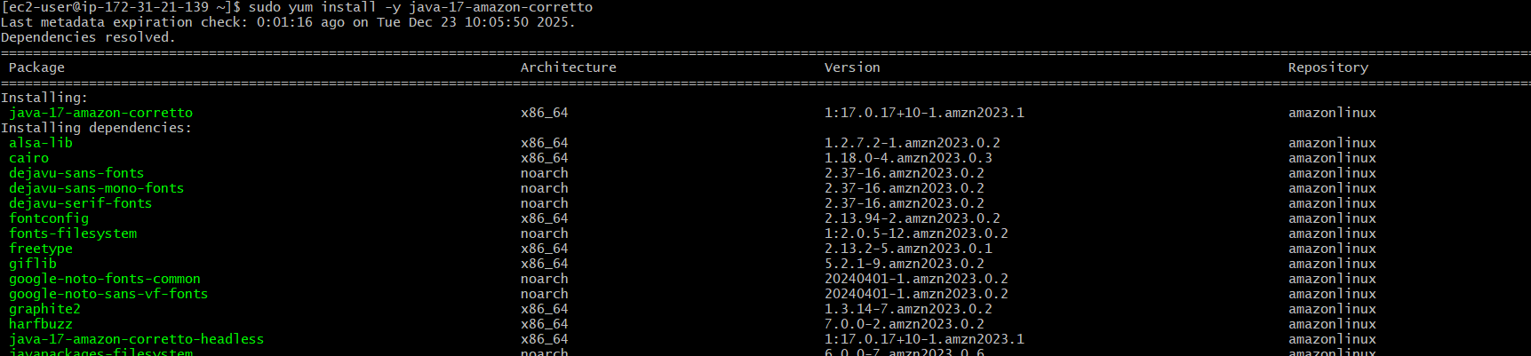
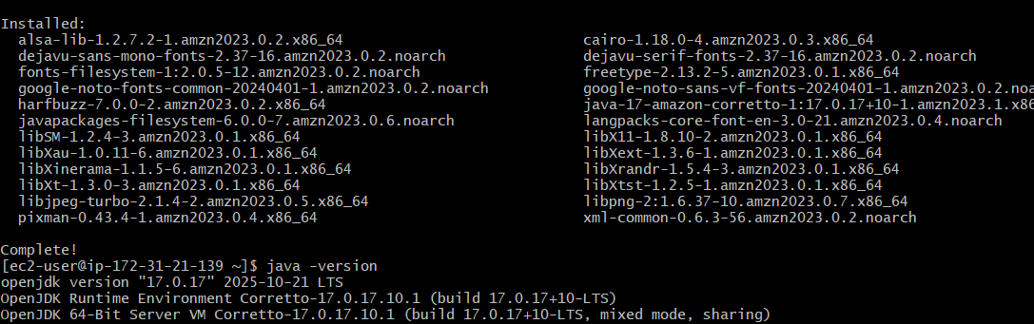
now go to your browser and search for Jenkins download
click on redhat option---copy the link and paste it here
use the command--- sudo wget -O /etc/yum.repos.d/jenkins.repo \
https://pkg.jenkins.io/redhat-stable/jenkins.repo
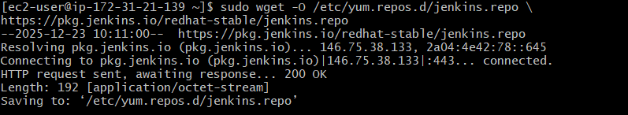
download the rpm key also which is available
use the command
sudo rpm --import https://pkg.jenkins.io/redhat-stable/jenkins.io.key
now install Jenkins---use the command---yum install Jenkins
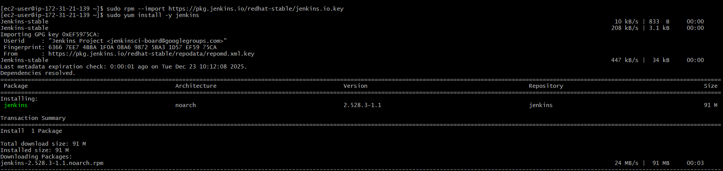
after getting installed check the status of Jenkins
systemctl start Jenkins
systemctl status Jenkins
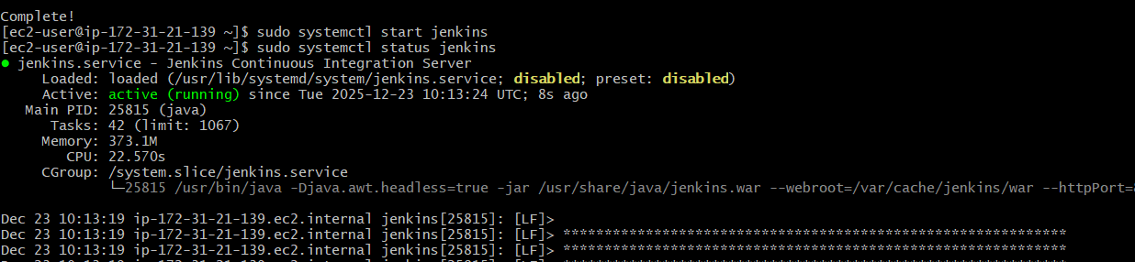
now to change the port number from 8080 to 8081 we need to use the command
vi /usr/lib/systemd/system/jenkins.service
edit the port number from 8080 to 8081 and save it
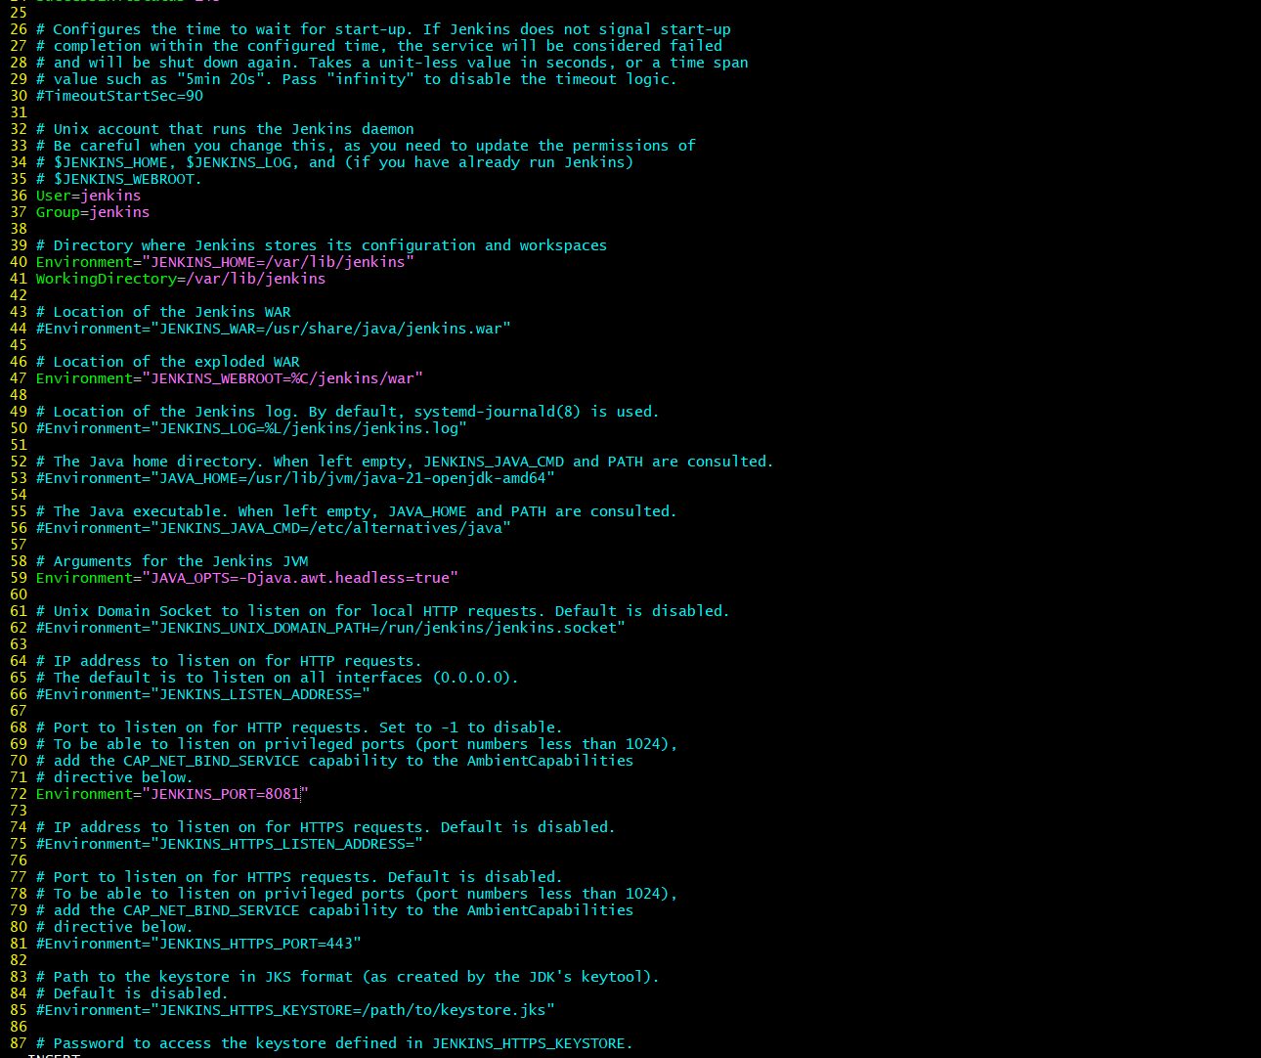
now after saving…run the command
systemctl daemon-reload
systemctl restart Jenkins
you can check in browser and check with your public Ip and port number
validation steps:
you can see Jenkins is running on port number 8081 now
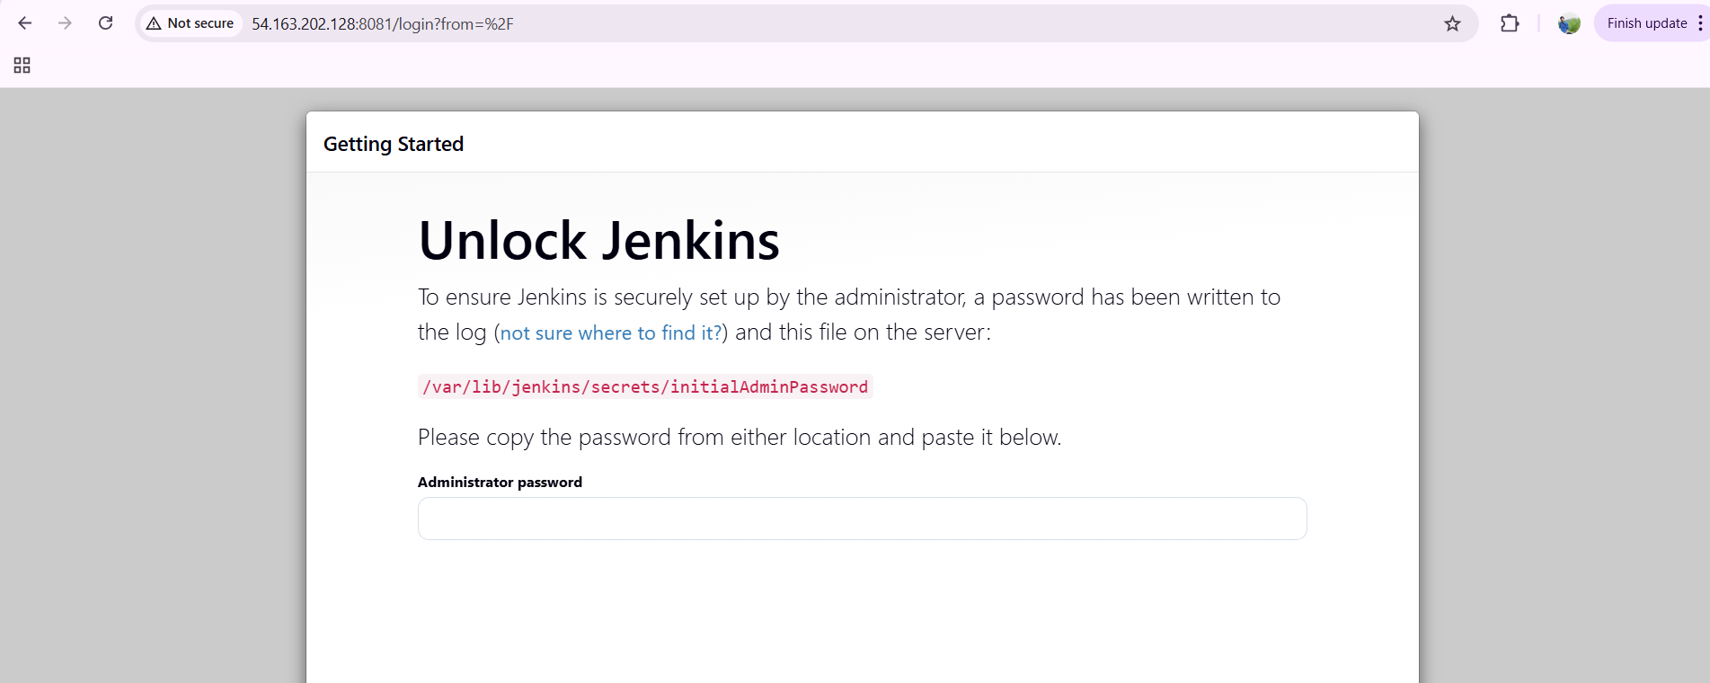
- title: Secure Jenkins server
objective: we need to secure our Jenkins server
prerequisites:
Jenkins
user name
custom password
step by step process:
after installing Jenkins…login with existing password first
now create one user name. Password
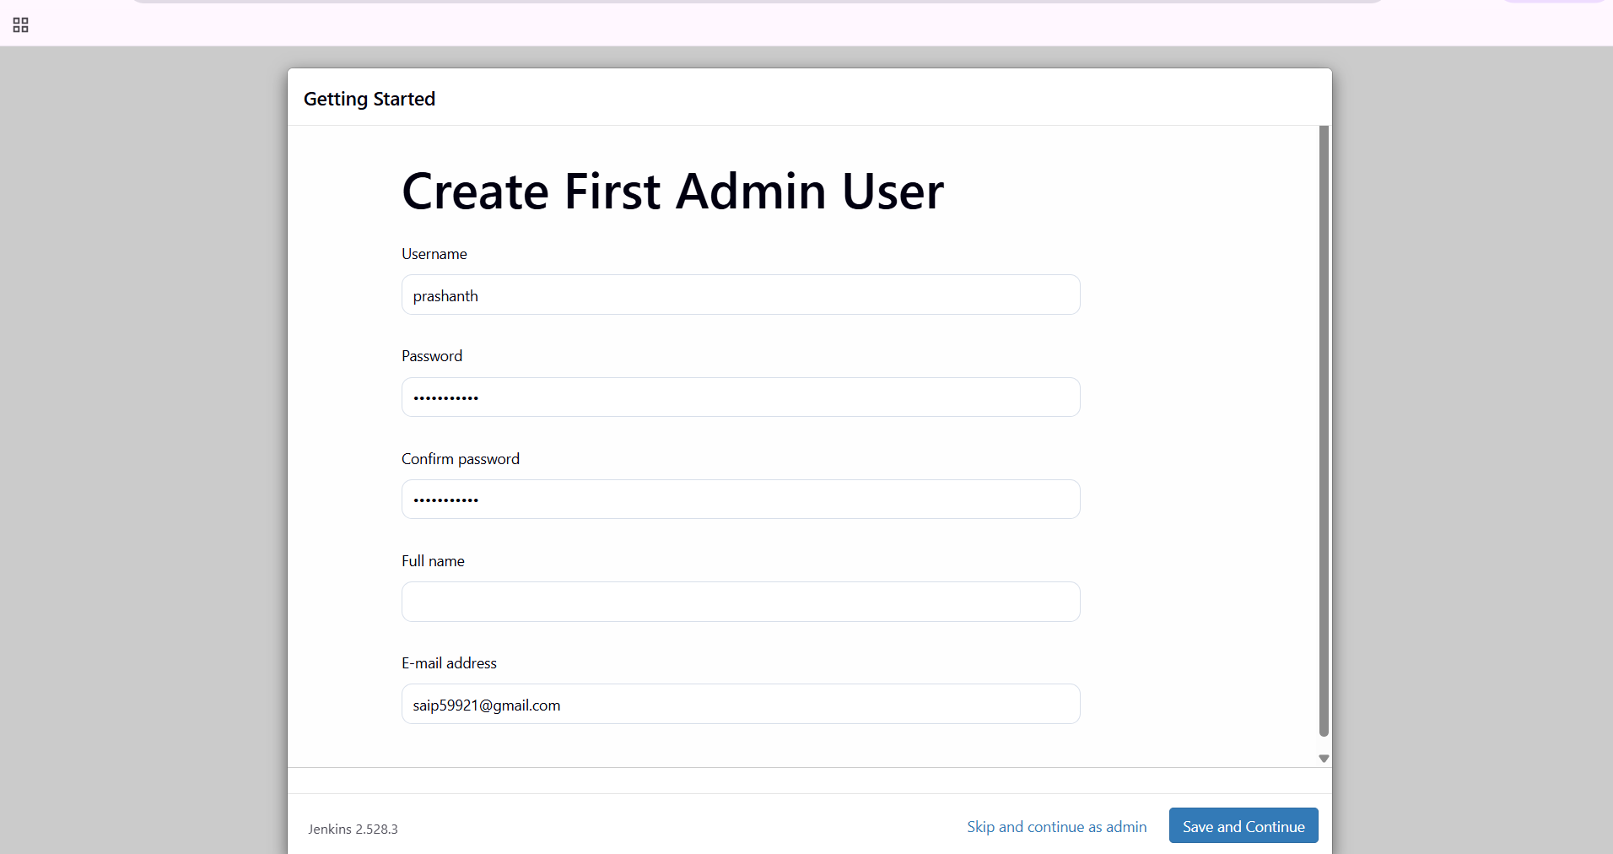

click on save and finish
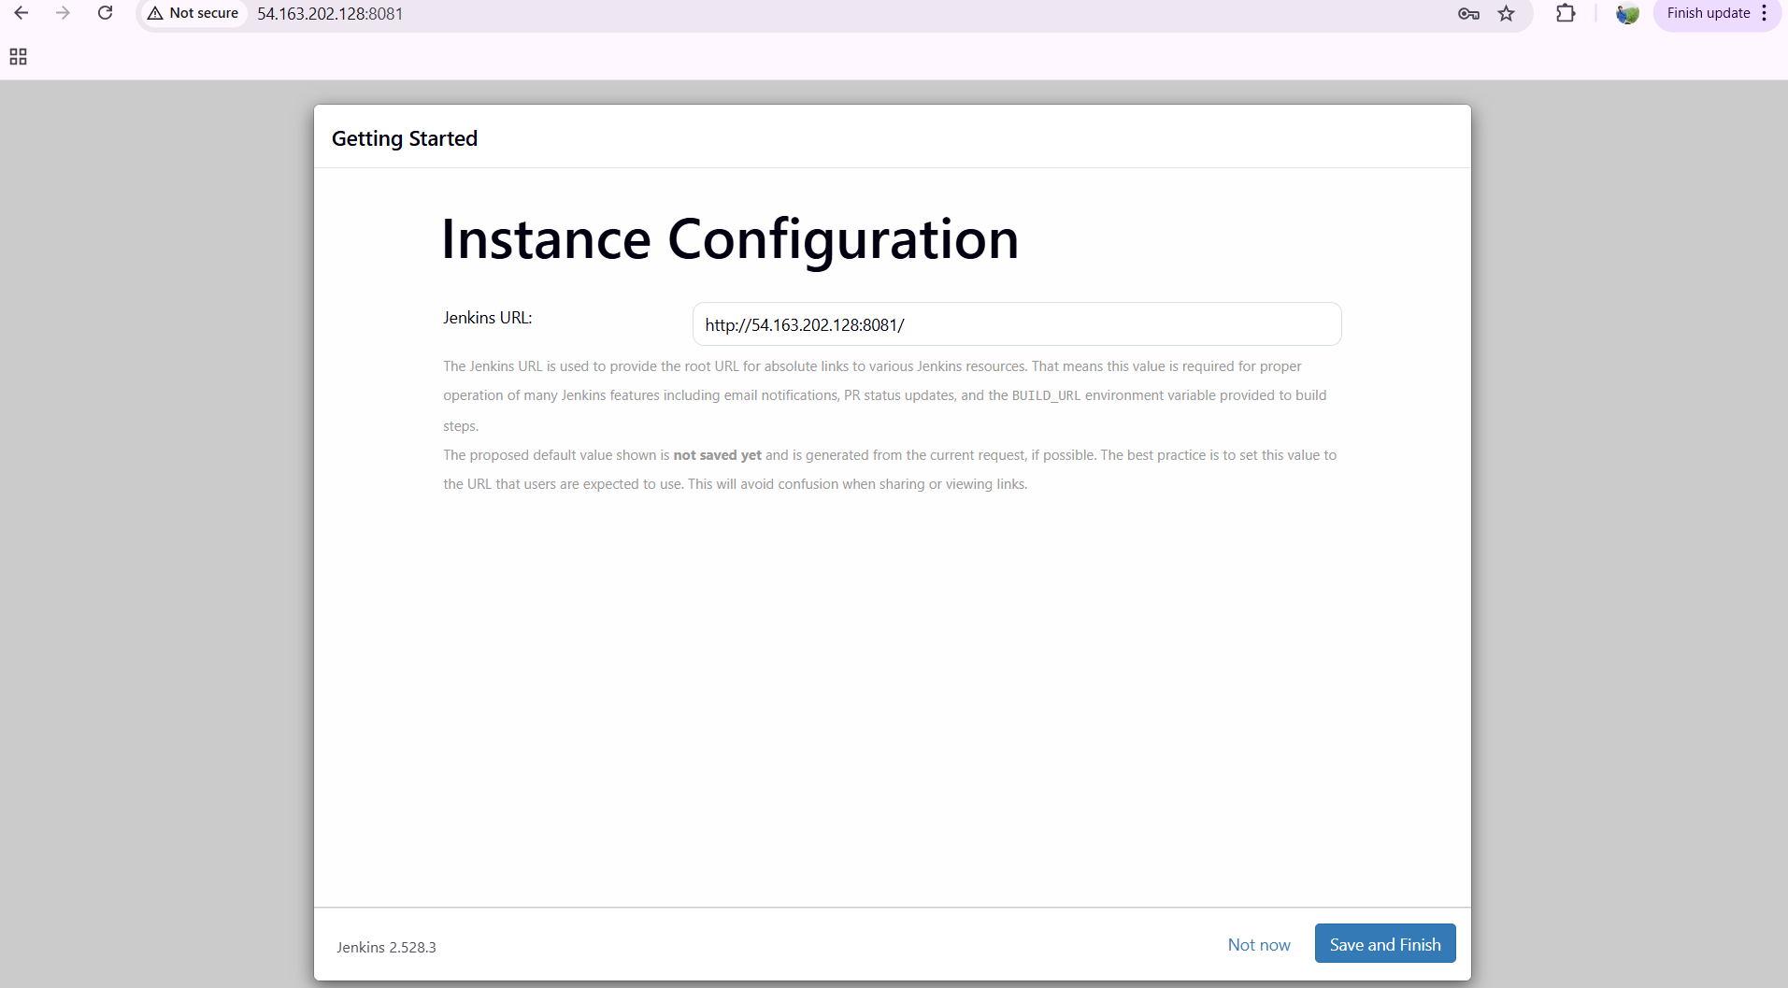
validation steps:
now Jenkins is ready with our own custom password securely
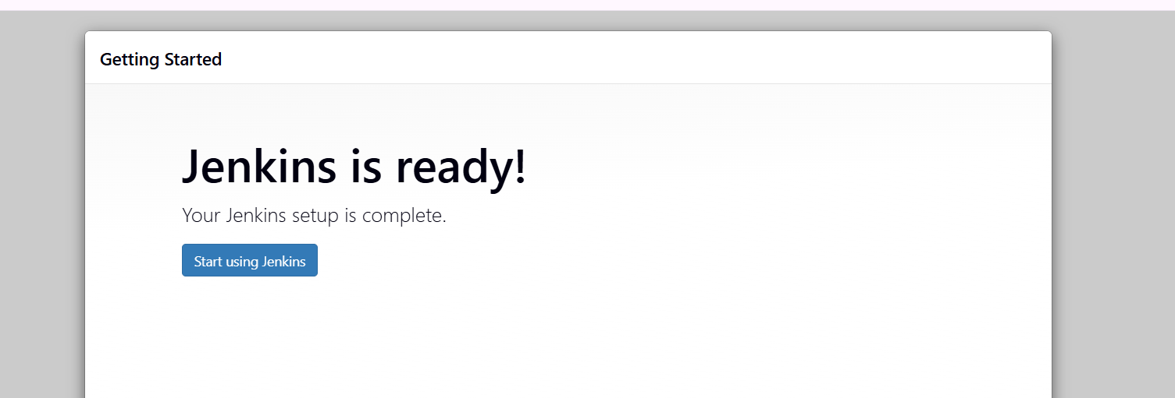
- title: Create users called DevOps, Testing in Jenkins with Limited access.
objective: we need to create two user names with names Devops and Testing
prerequisites:
jenkins
users
custom passwords
access
step by step process:
first after logging to jenkins---click on manage jenkins—security—click on users
enter user name devops and create one password
another user name testing and create one password

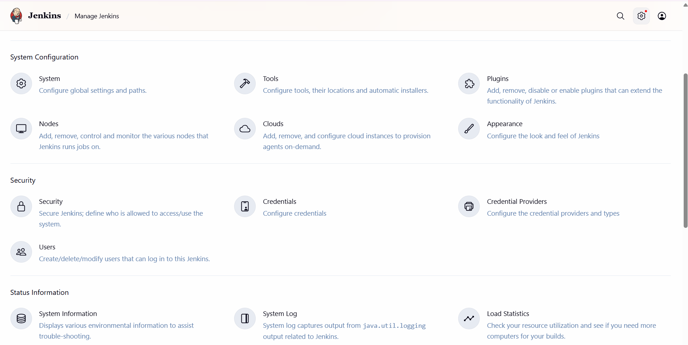
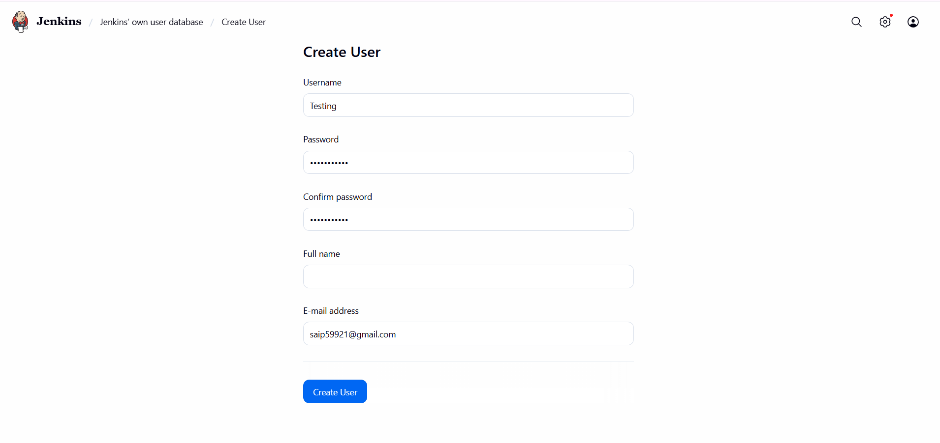

you can see the users has been created
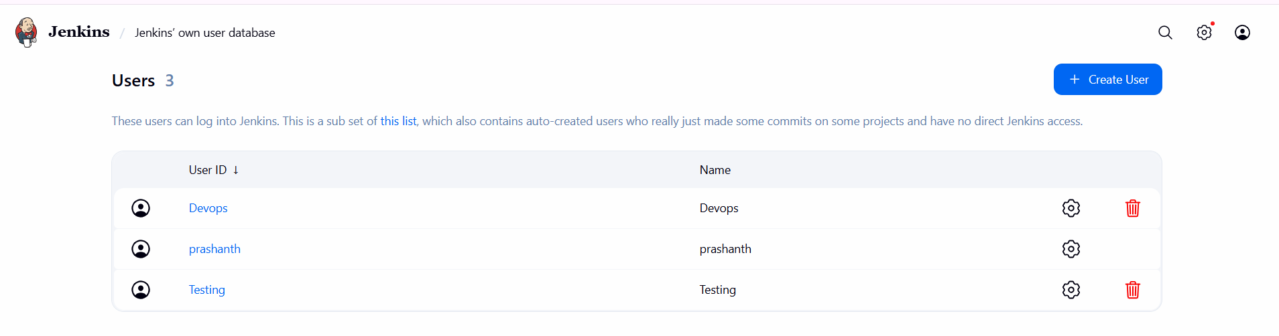
now to give permissions---go to manage jenkins—click on security
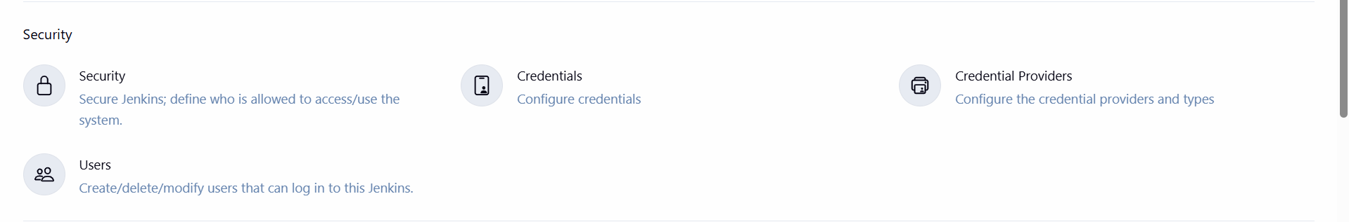
now click on authorization---select project-based matrix authorization strategy
add the users and give limited access and click on save
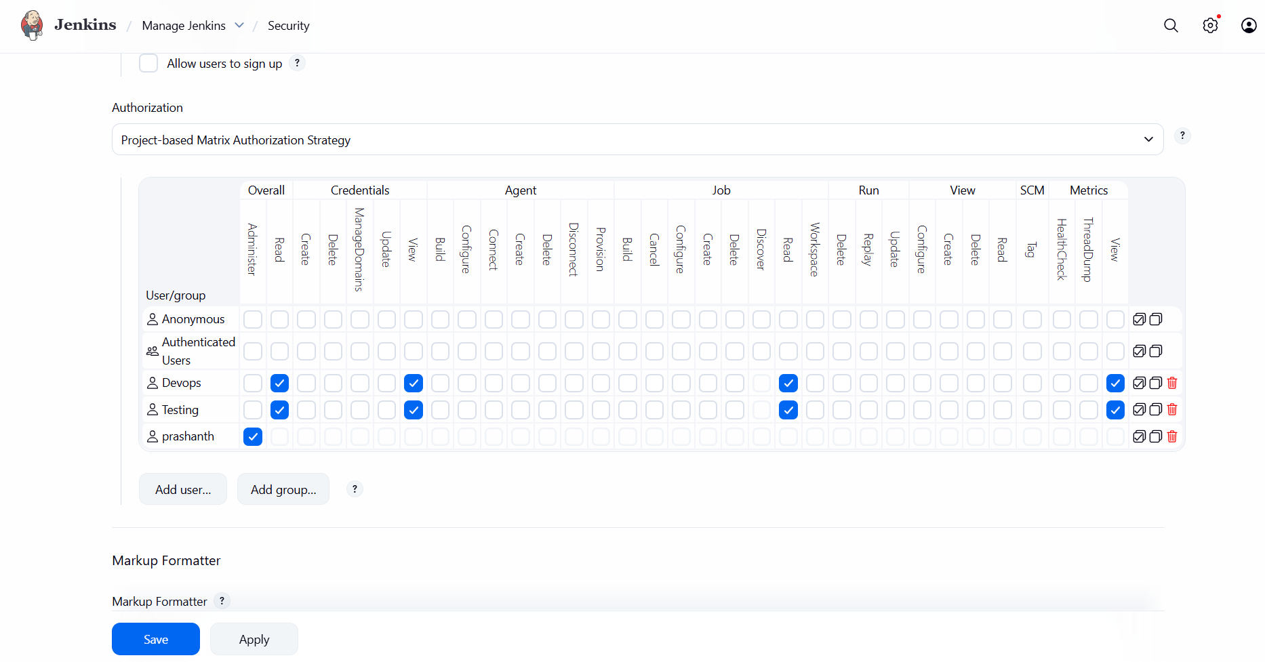
validation steps:
you can see now we can login with two users
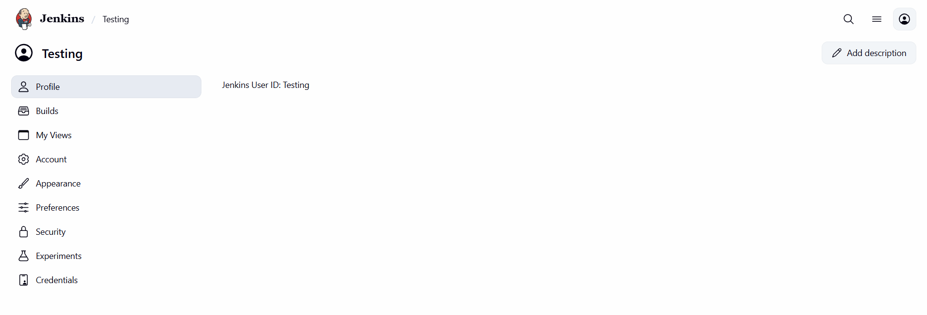
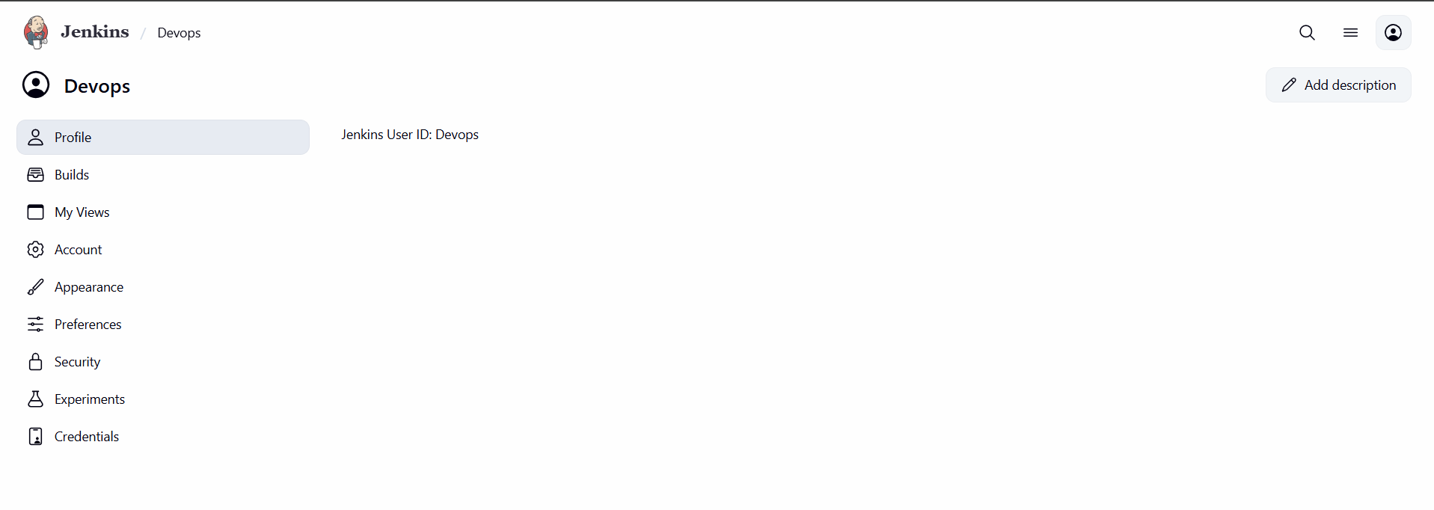
- title: Configure labels and restrict the jobs to execute based on label only.
objective: need to configure labels by installing node and to restrict the job
prerequisites:
Jenkins
node and label parameter
label name
configuration of label
step by step process:
login to Jenkins---go to plugin—search for node—select node and label parameter---install it

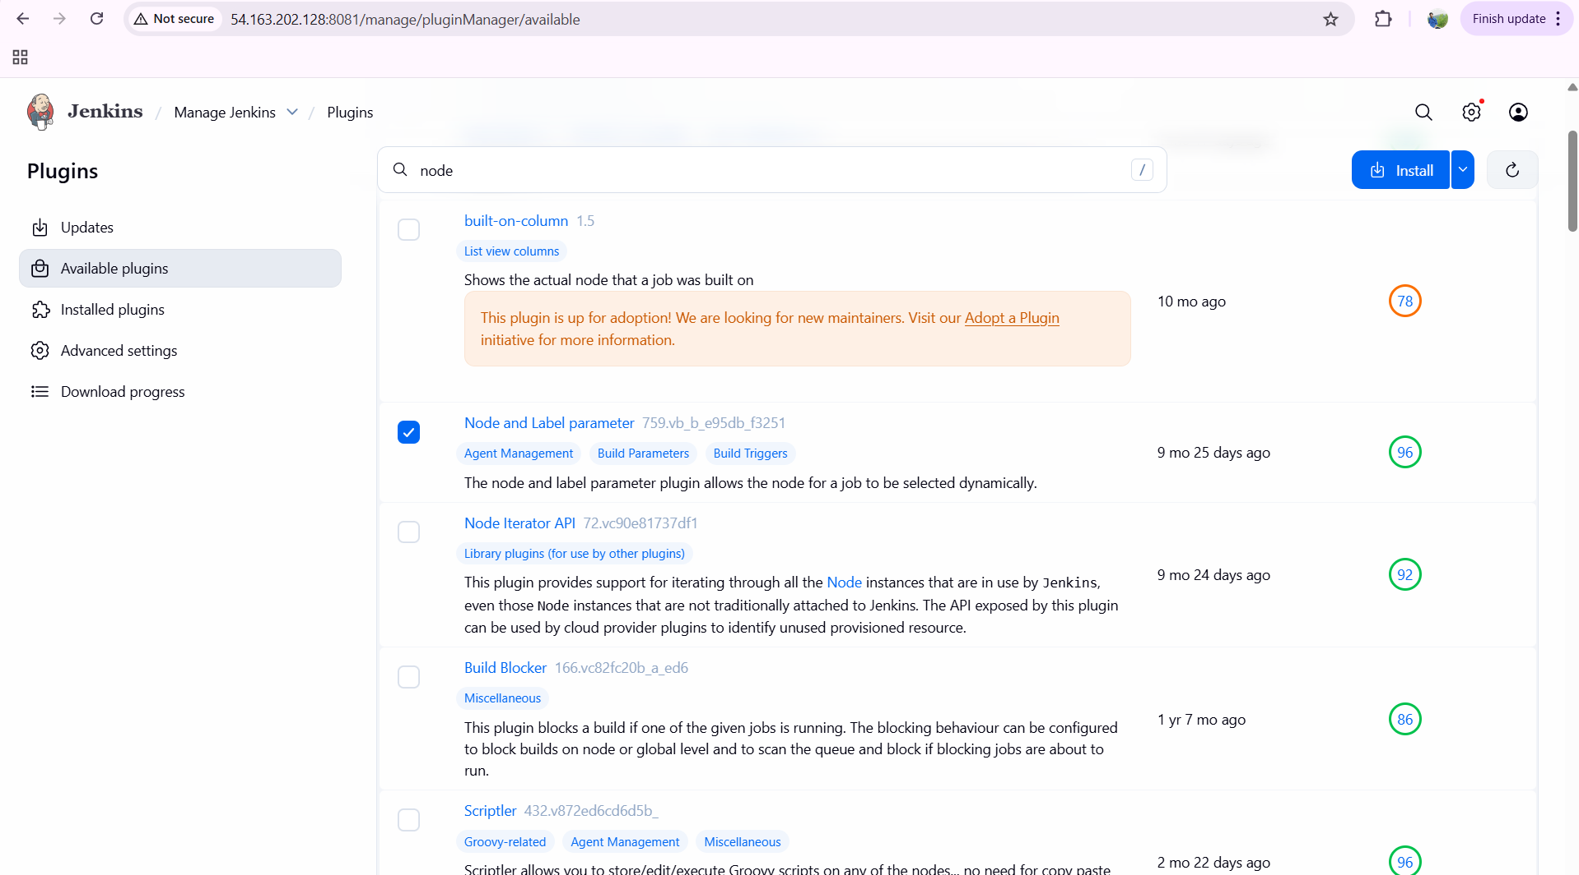
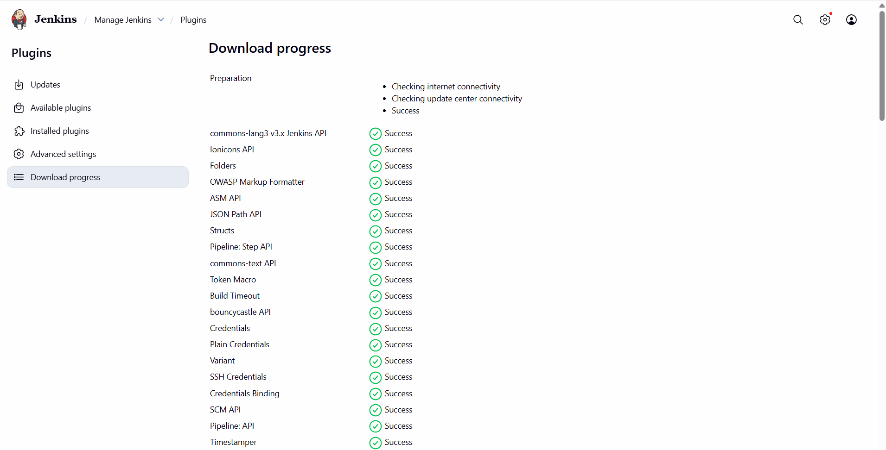
after installing we need to do configuration
go to manage Jenkins---select system---enter label name master—select usage only build jobs—click on save
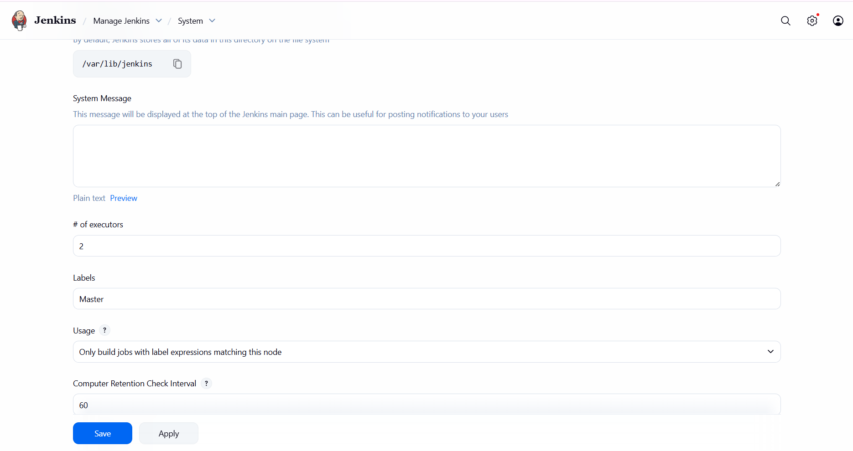
come to dashboard now---click on built in node and select configure---select node properties—select disk space monitoring thresholds—we need to provide 0.1,0.2,0.2 and click on save
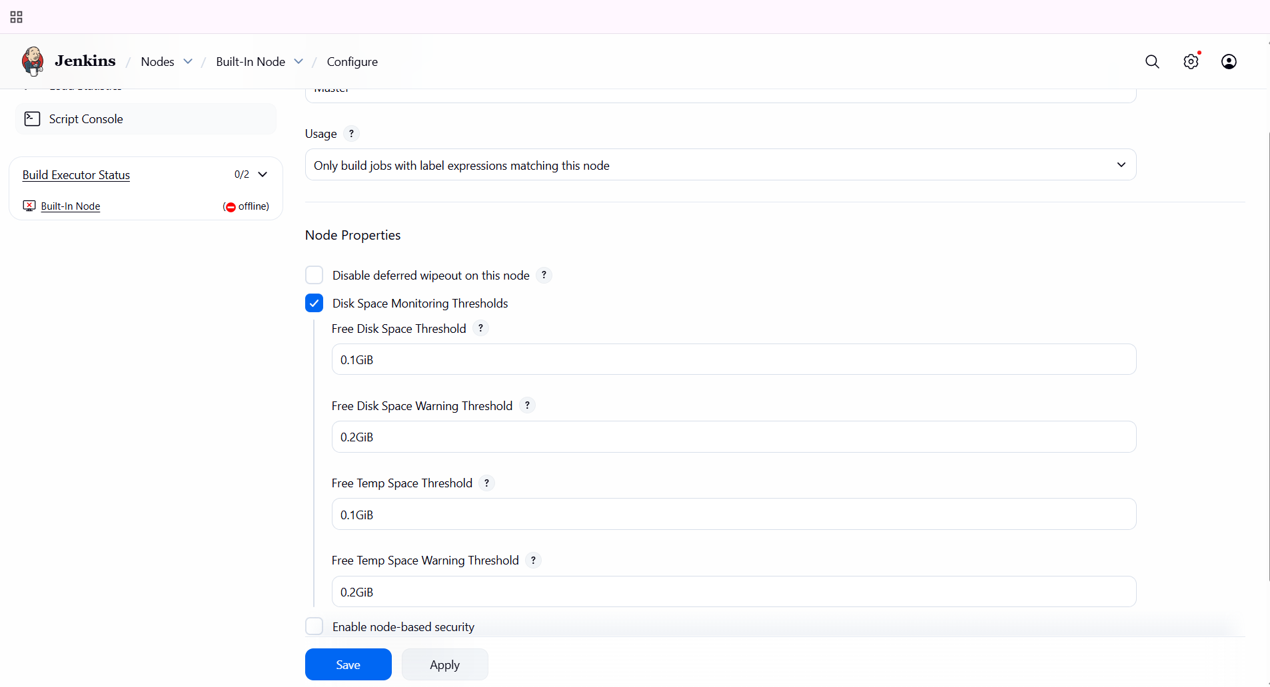

now click on built on node you can see the label name master has been created
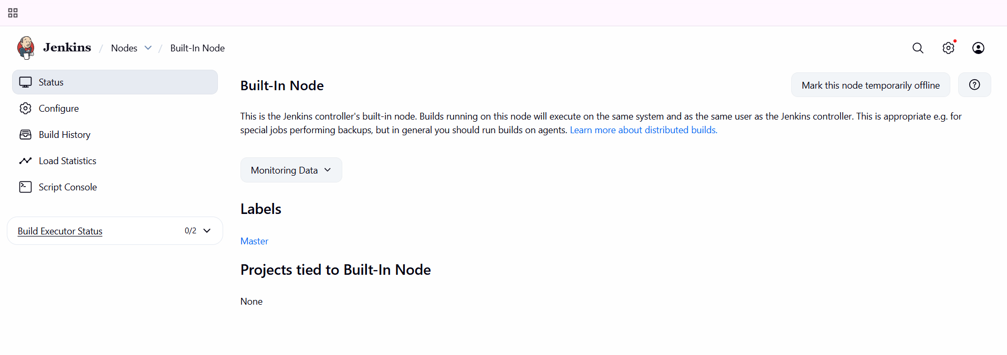
validation steps:
click on plugins---search for node you can see health is 96%
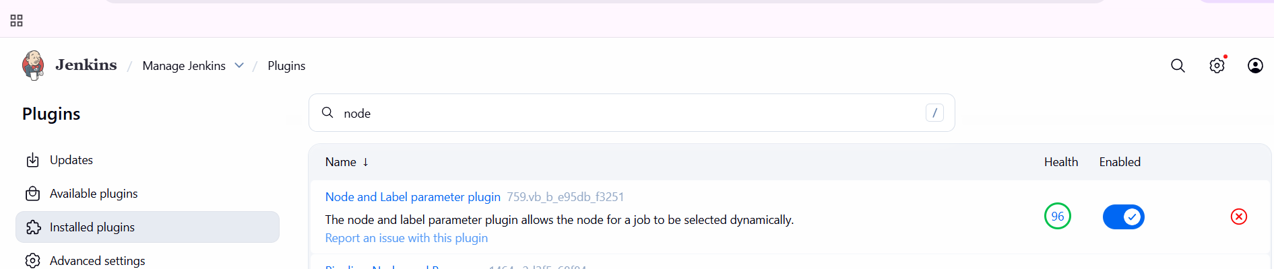
- title: Create Three sample jobs using the below URL. https://github.com/betawins/Techie_horizon_Login_app.git
objective: we need to create three jobs using the above repo link
prerequisites:
Jenkins
new item
installation of git
url
step by step process:
first click on new item---provide one name---sleect freestyle project—and give ok

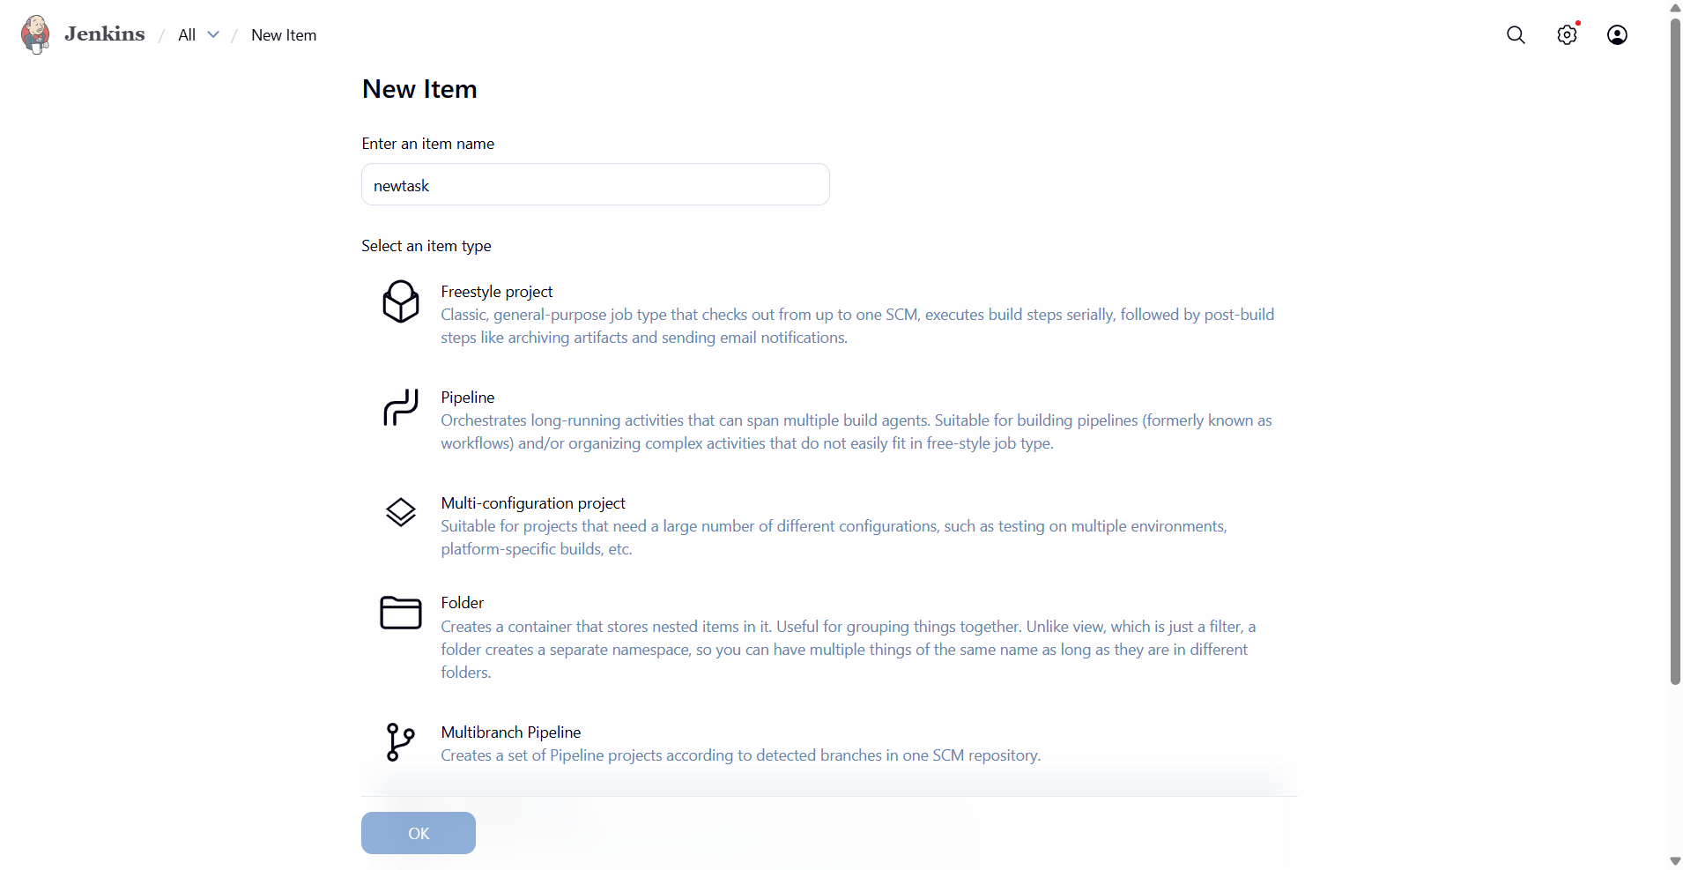
now click on source code management—select git---enter repository URL---save
before we need to install git
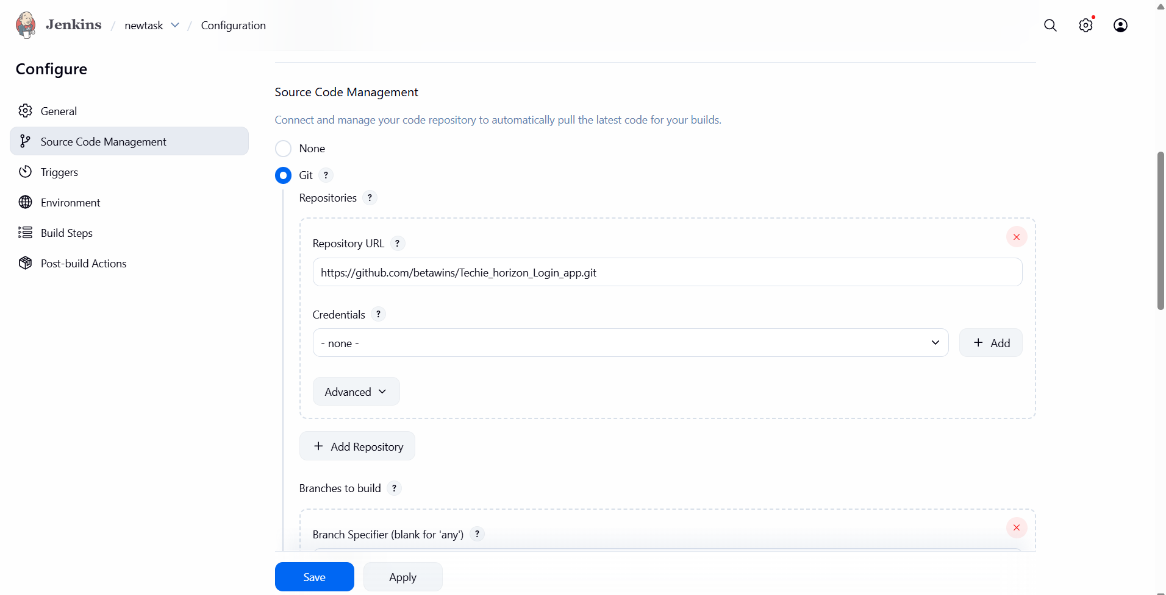
click on general---provide you created your label name master—and click on save again
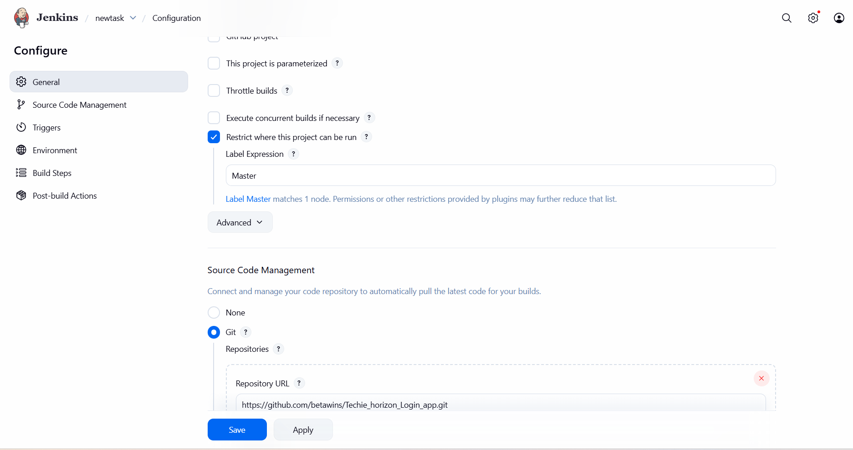
you can see the jobs has been created
validation steps:
click on status
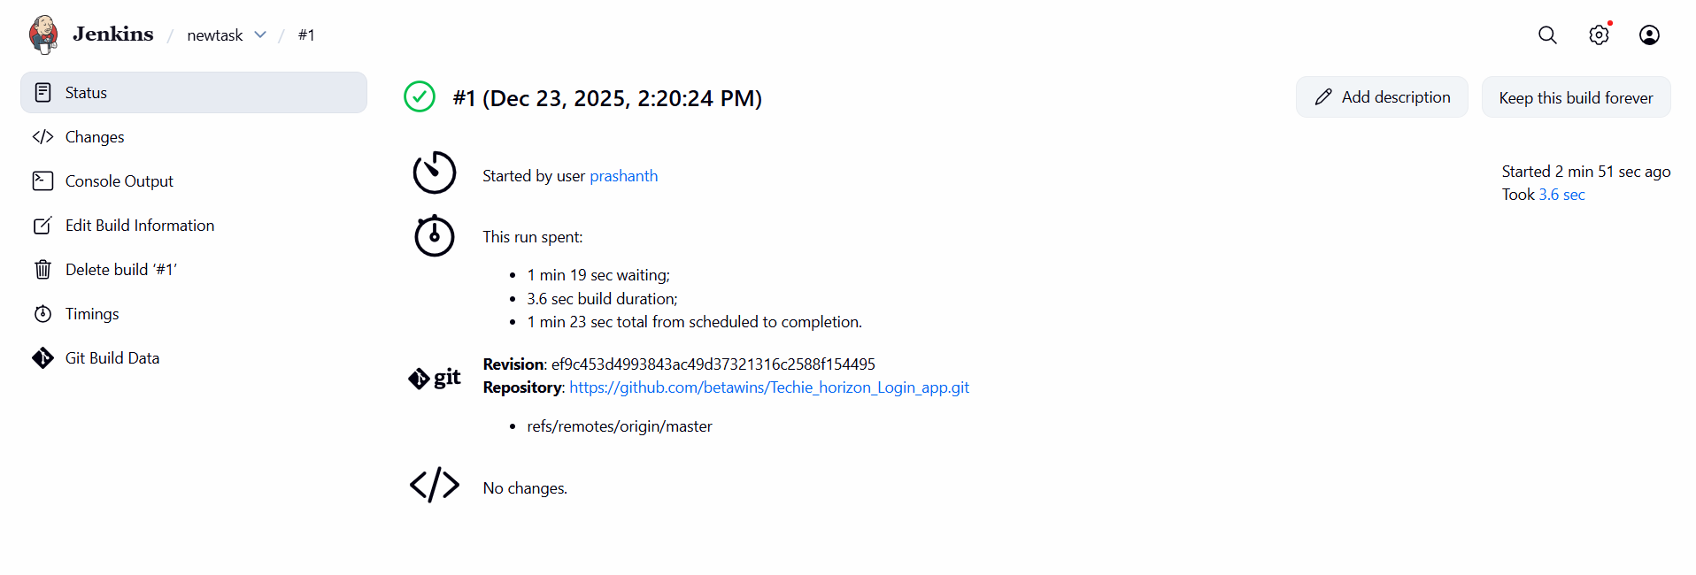
click on console output—you can see who has been created, URL version
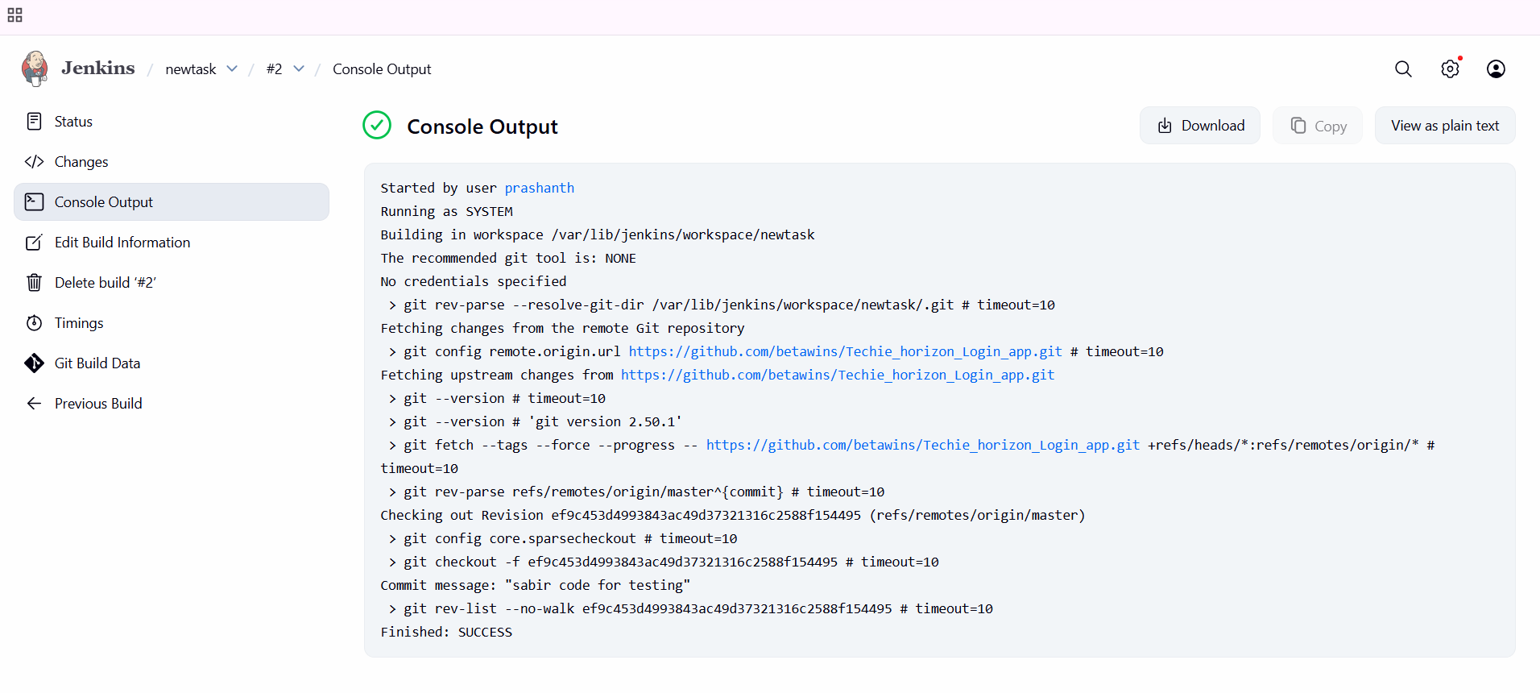
conclusion: three jobs has been created using the URL which has been provided.
- title: Create one Jenkins job using git hub Private repository.
objective: The objective of this task is to configure a Jenkins Freestyle job to securely access and build source code from a private GitHub repository
prerequisites:
Jenkins access login
git installation
git hub with private repo
personal access of your repo
step by step process:
first go to your dash board—create one item---select free style project—click on ok

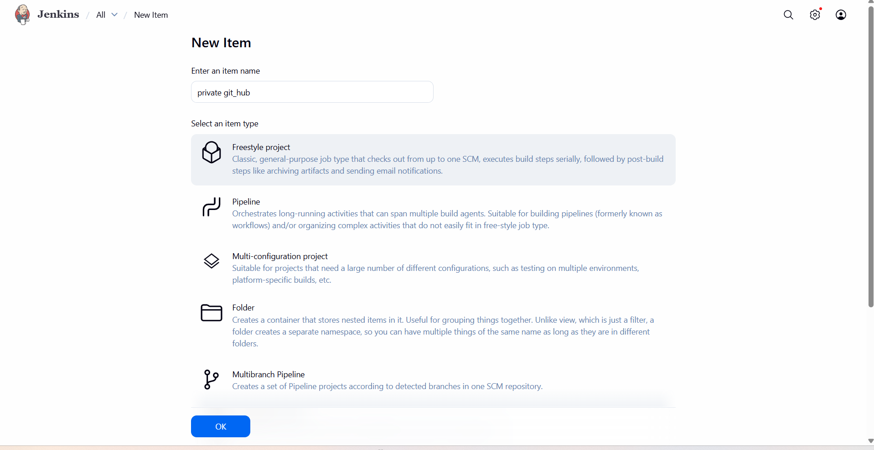
then we need to provide credentials like user name and password of your access key and enter the branch
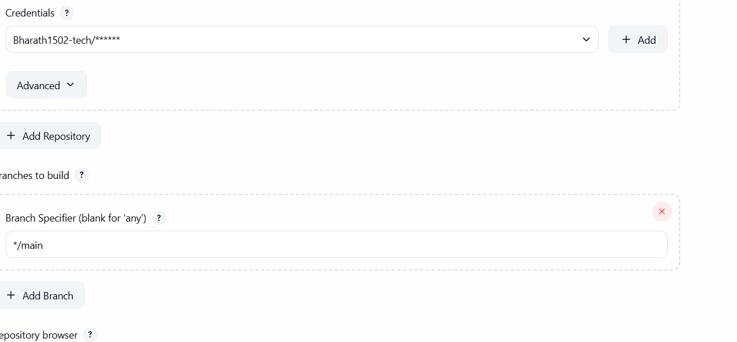

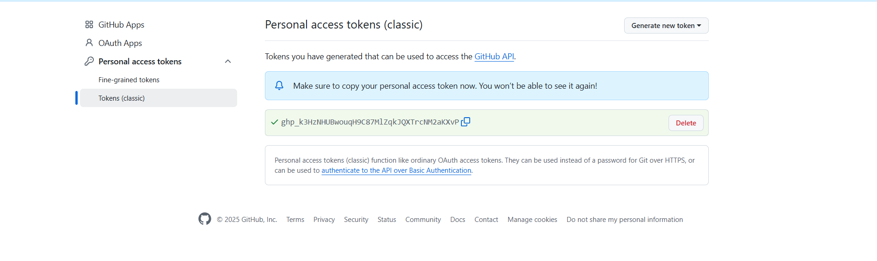

now yiu can see the credentials are given
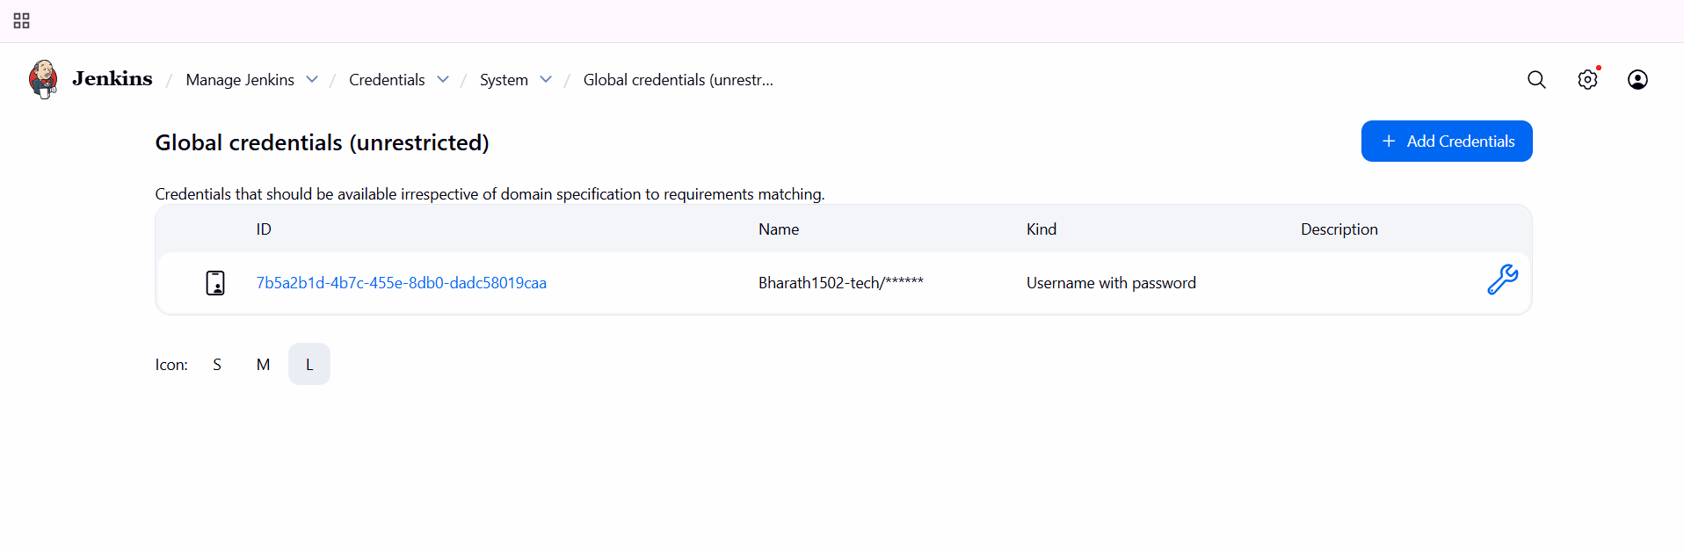
now come to source code management---enter the URL of private repo and select the credentials
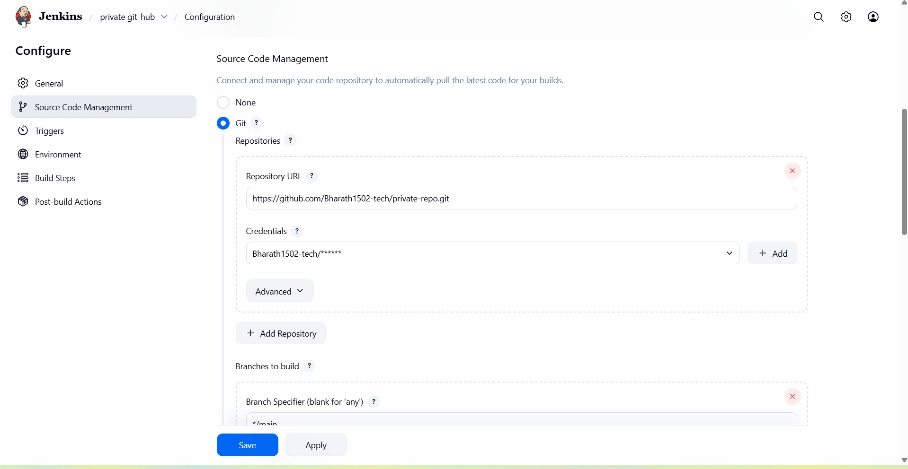
now come to your dashboard…click on private git_hub and you can see the status
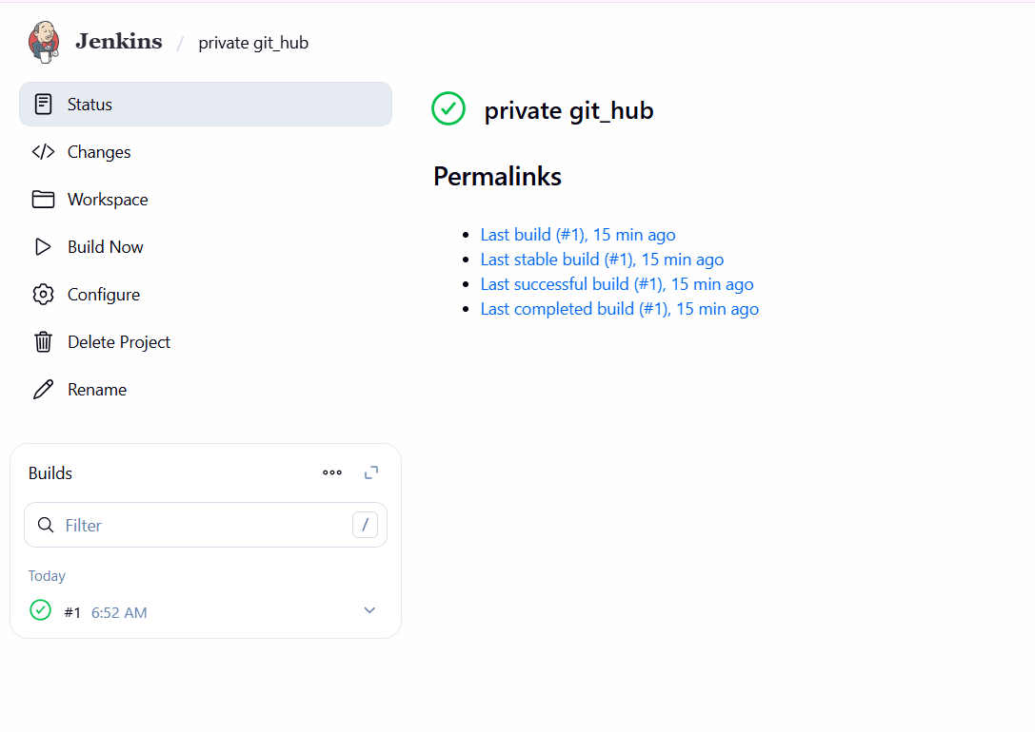
validation steps:
you can see the job has been created through private git hub url
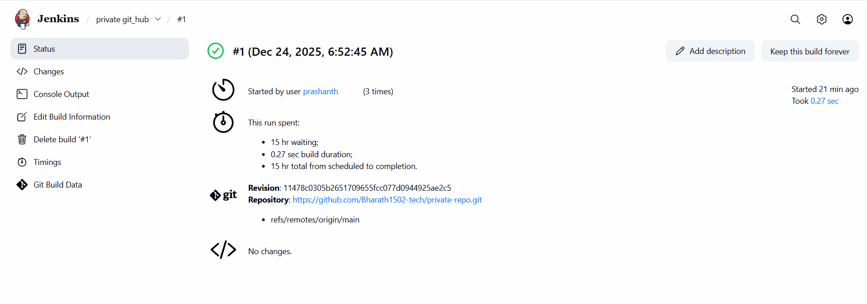
to view in console output
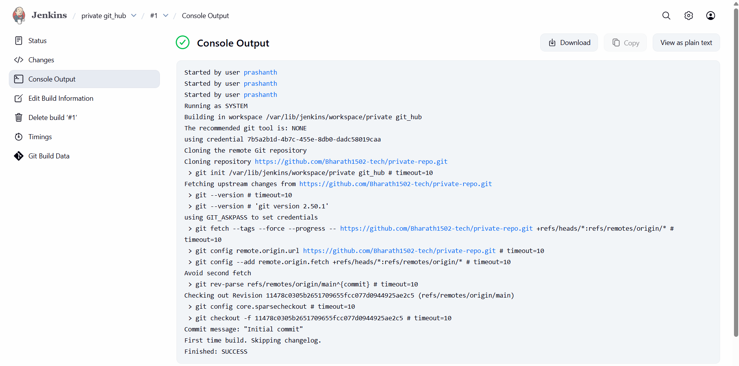
conclusion:
The job has been created through private git hub. Private repository integration was securely configured using a GitHub Personal Access Token, with initial authentication issues resolved successfully.

