Jenkins-02
- title: Configure 2 slave machines in Jenkins master.
objective: To configure two Jenkins slave (agent) machines and connect them to a Jenkins master so that build and deployment jobs can be executed in a distributed manner, improving performance, scalability, and resource utilization.
prerequisites:
ec2 instance
create one Jenkins master instance
install two instances for slave 1 and 2
ssh-keygen
nodes
configuration
step by step process:
first install Jenkins in master server
install java first Sudo yum install -y java-17-amazon-corretto
then copy the Jenkins link from browser
sudo wget -O /etc/yum.repos.d/jenkins.repo \https://pkg.jenkins.io/redhat-stable/jenkins.repo
copy the rpm link also sudo rpm --import https://pkg.jenkins.io/redhat-stable/jenkins.io.key
then install Jenkins Sudo yum install Jenkins
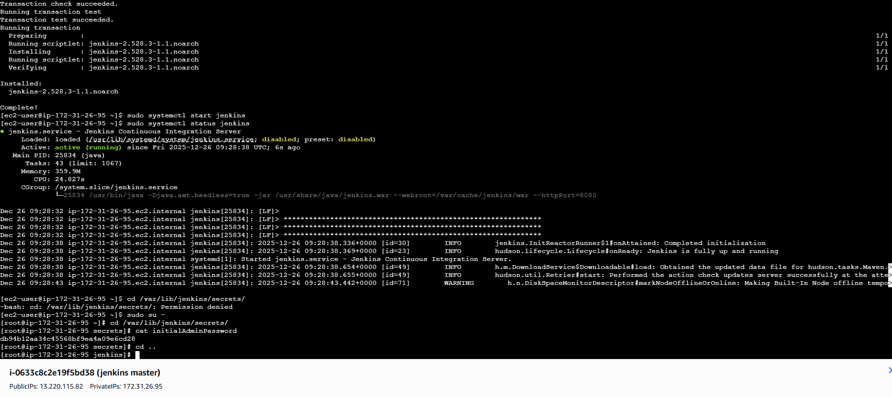
then install java in both slaves 1 and 2
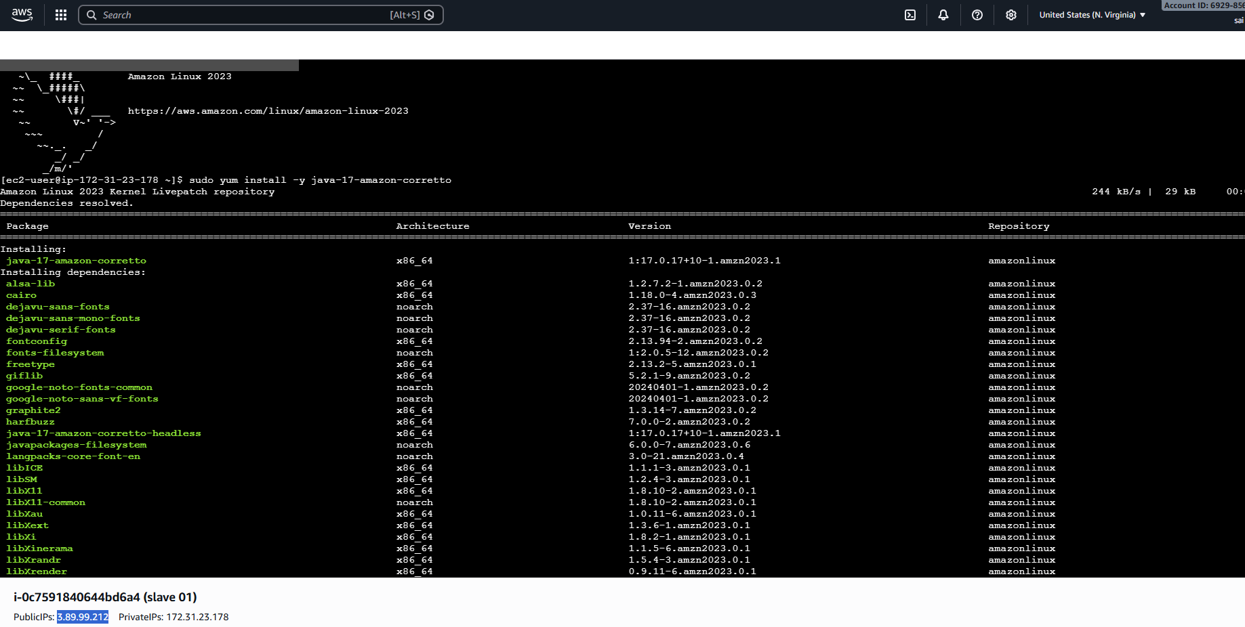
now create one directory in slave 1 and execute permissions
mkdir -p ~/.ssh
chmod 700 ~/.ssh
then give ssh-keygen to connect password less authentication
now add public key to authorized keys and give permissions
cat ~/.ssh/id_rsa.pub >> ~/.ssh/authorized_keys
chmod 600 ~/.ssh/authorized_keys
now enter
cat ~/.ssh/id_rsa to copy the full content of the key
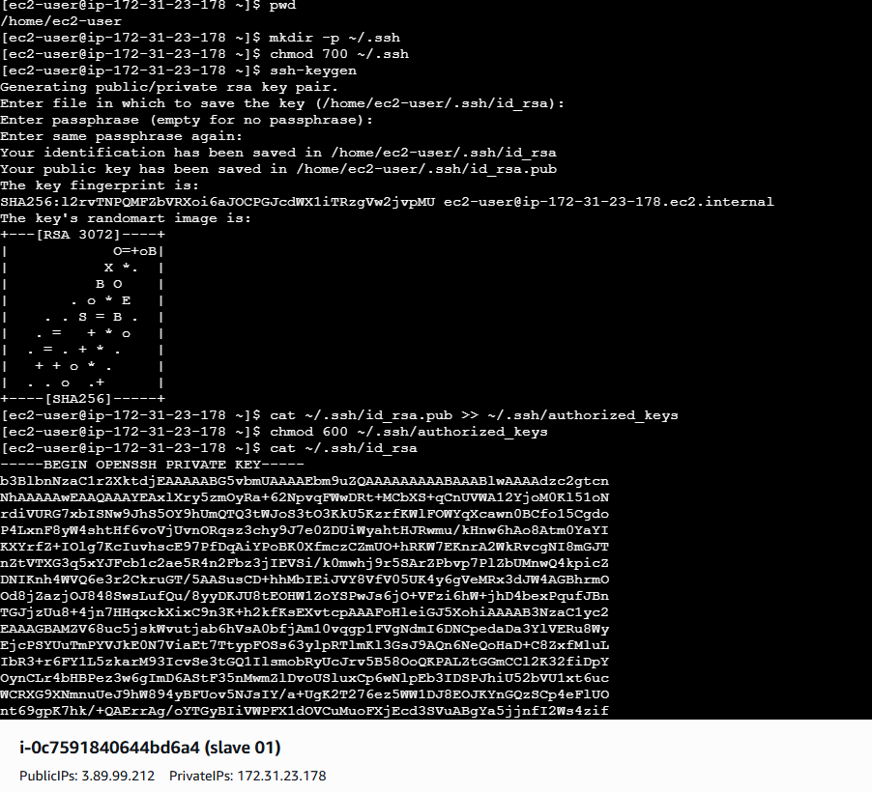

now come Jenkins GUI
go to manage Jenkins—click on nodes---create a node—slave-01
number of executors-1
remote root directory- /home/ec2-user/jenkins
label name—java

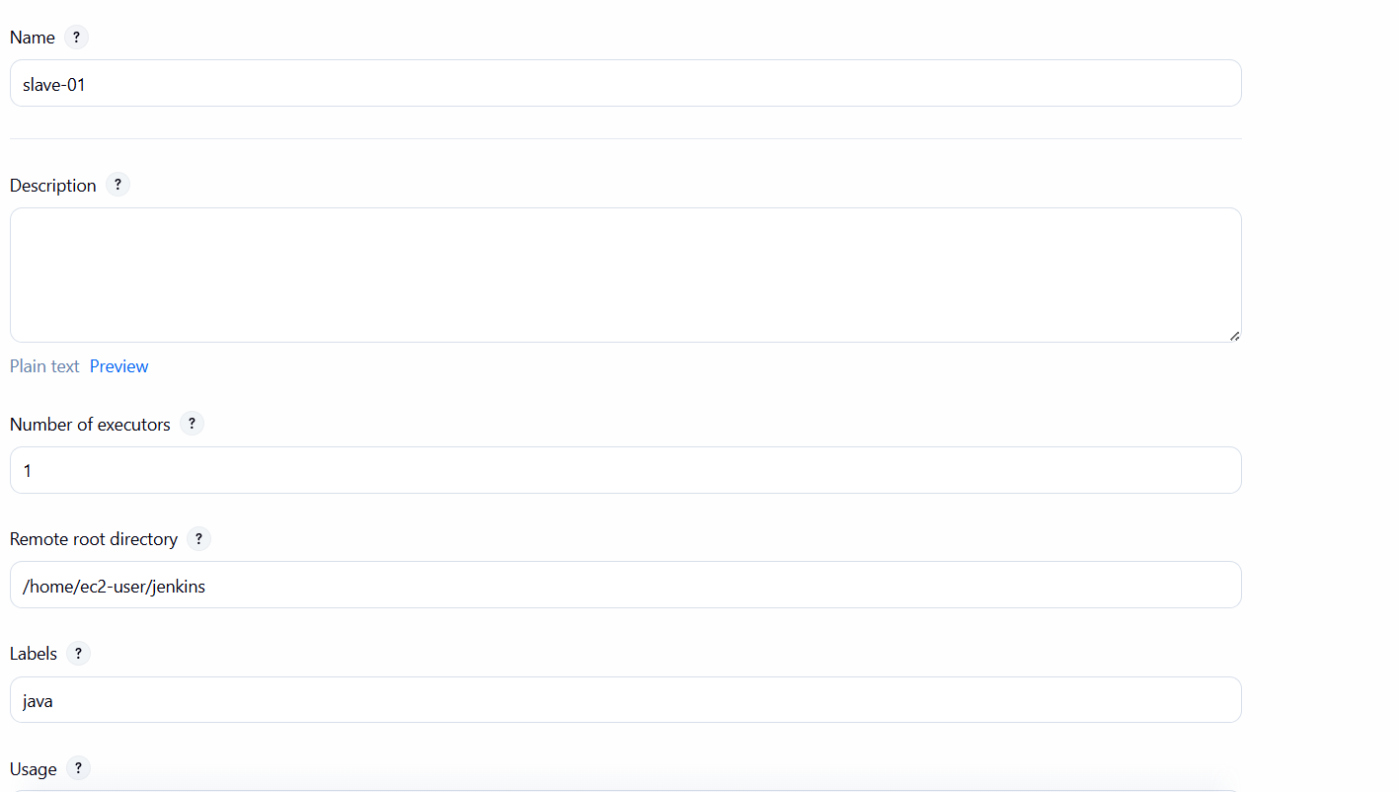
then select launch method—launch agents via ssh
give host name—slave 1 public Ip
in credentials click on add—add one user name ec2-user and id and select directly with private key option---copy the key which have u done in cli and paste it here and click on save
select now in credentials—ec2-user
now select host key verification strategy---non verifying verification strategy and click on save

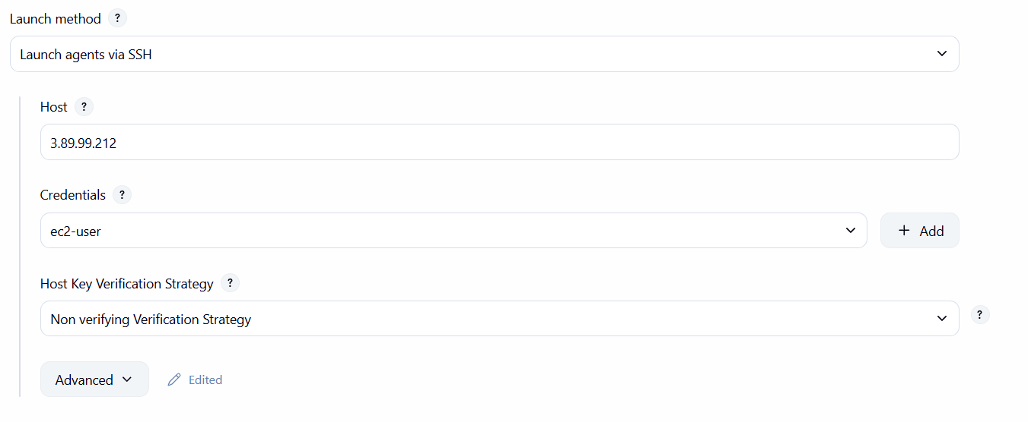
now you can see slave-01 has been executed successfully
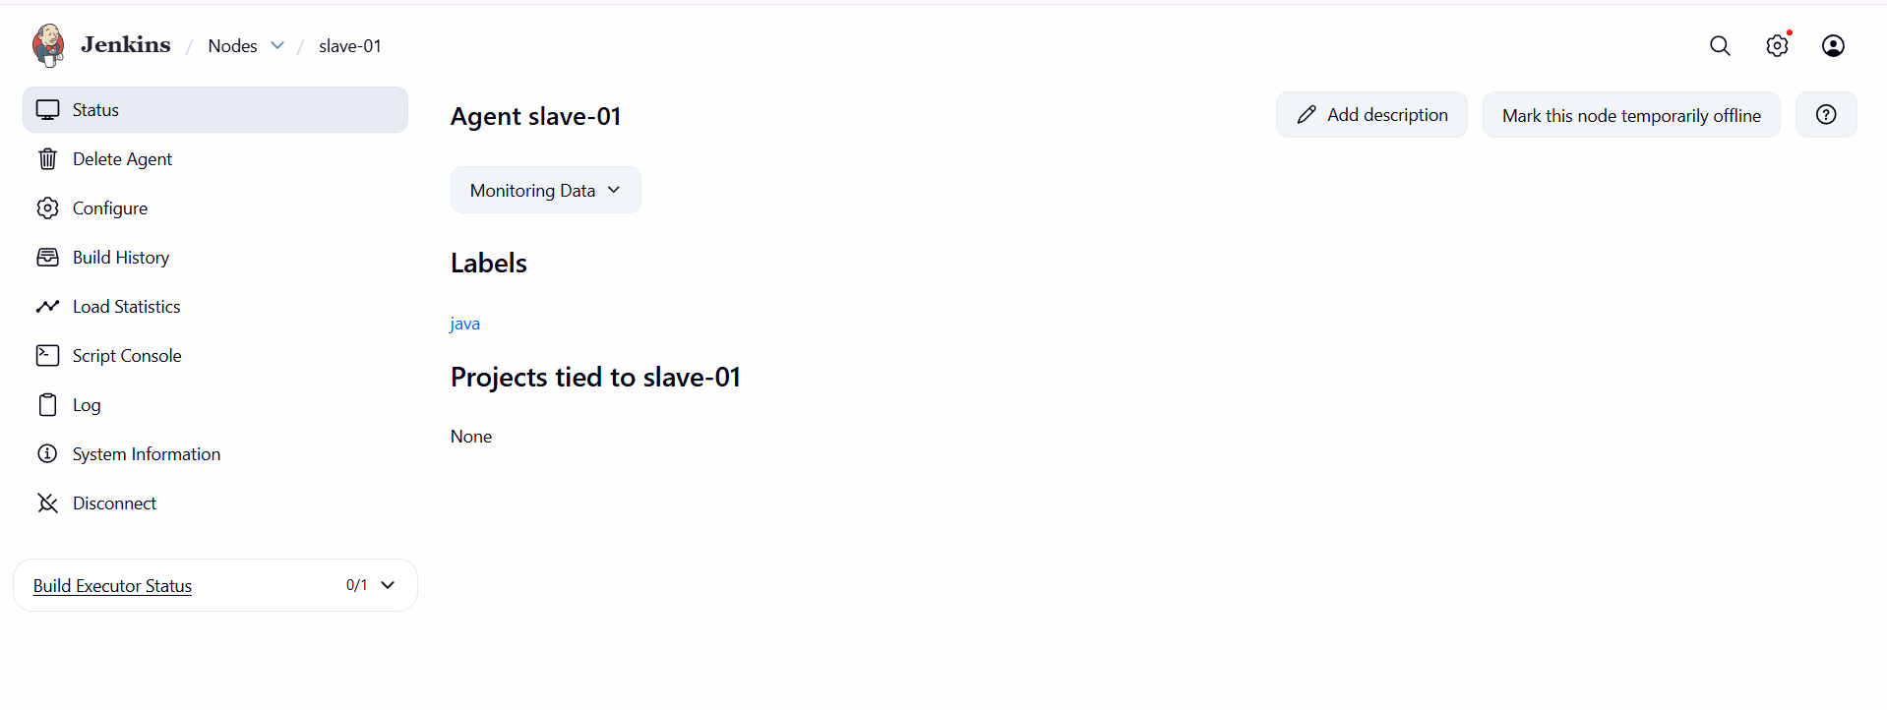
same steps for slave -02

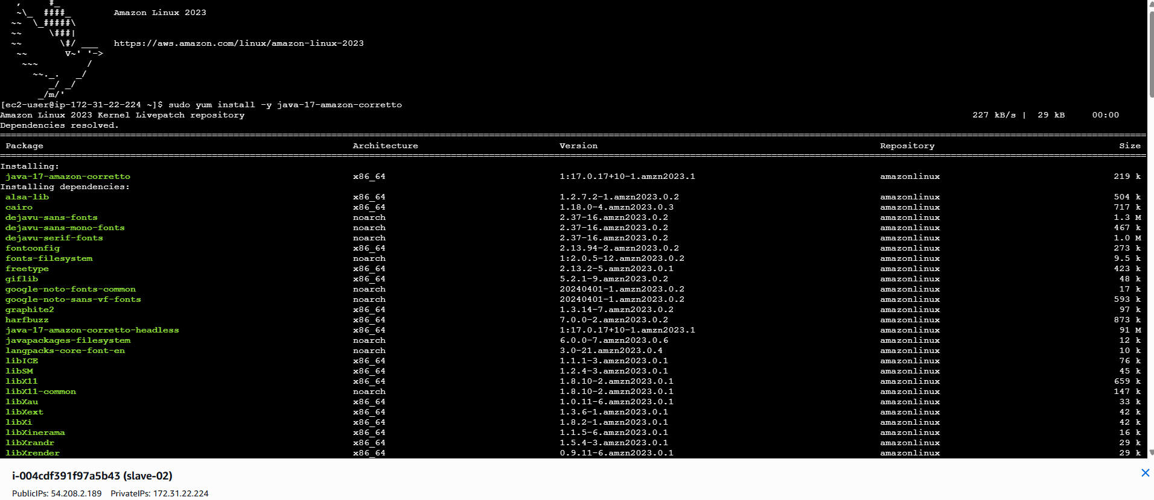
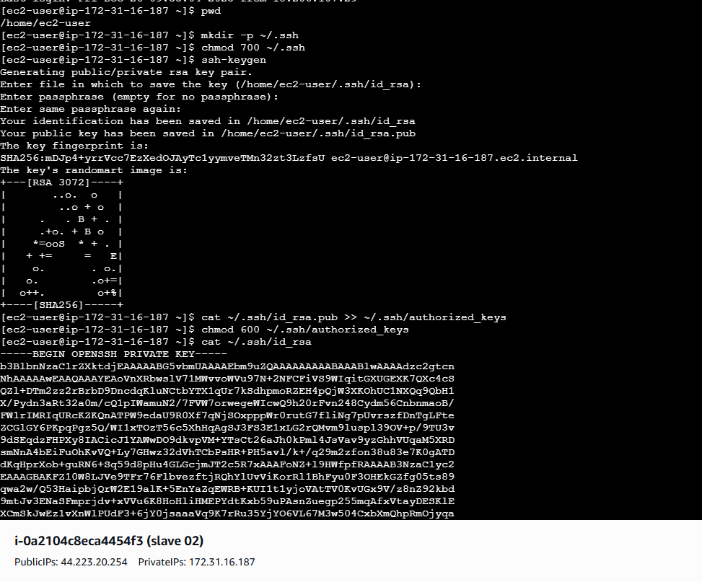
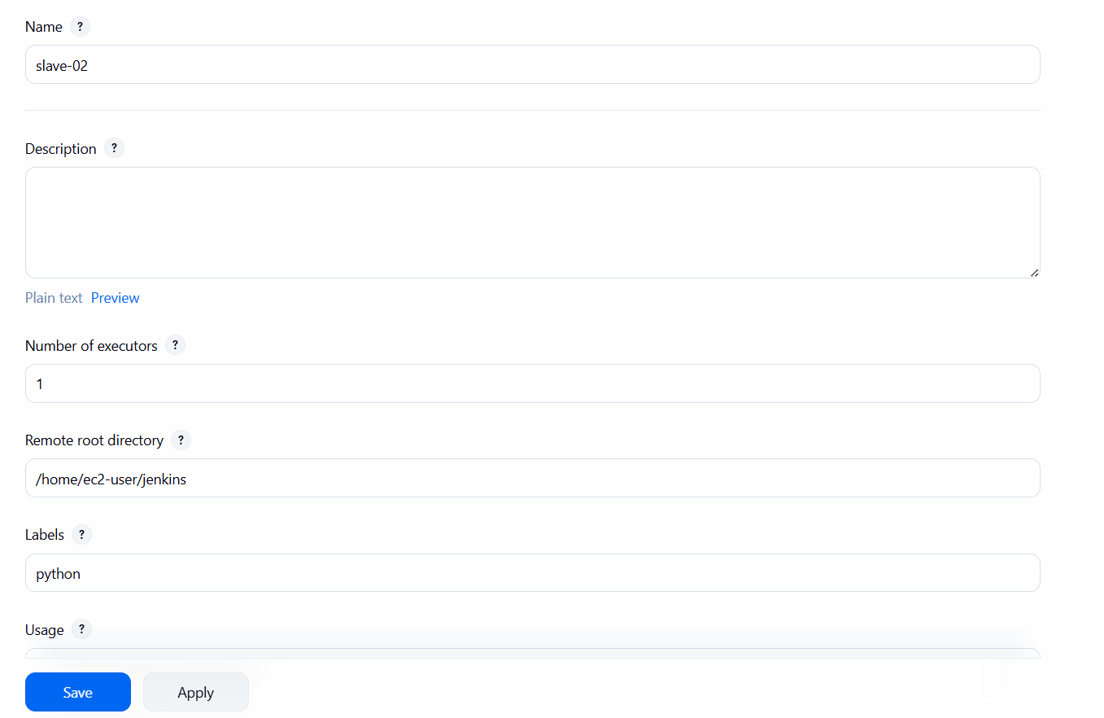
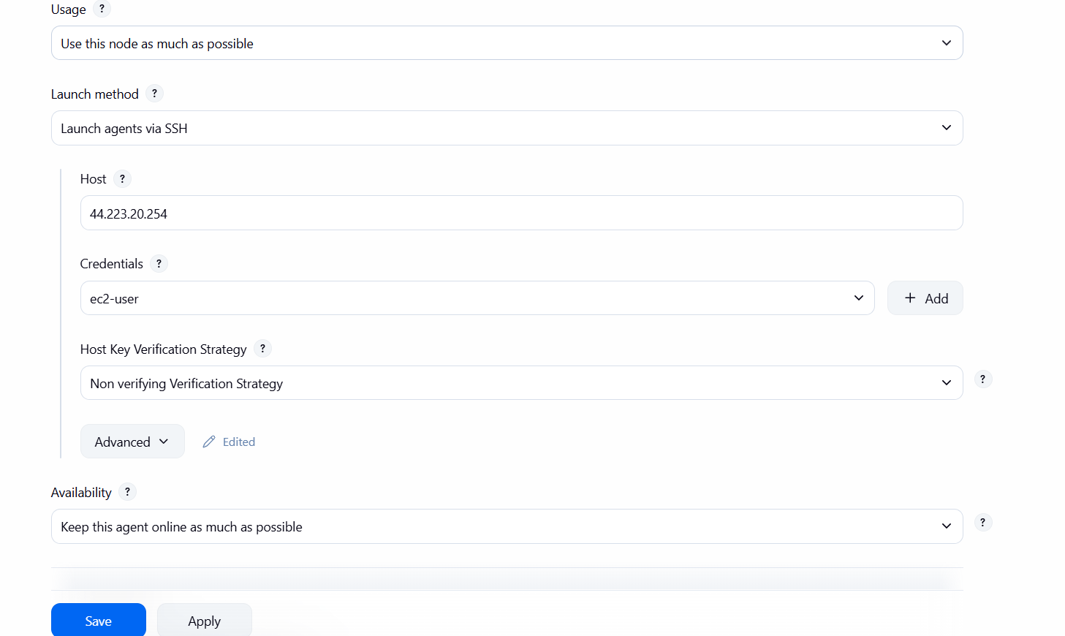
verification steps:
now you can both slaves 1 and 2 has been executed with master
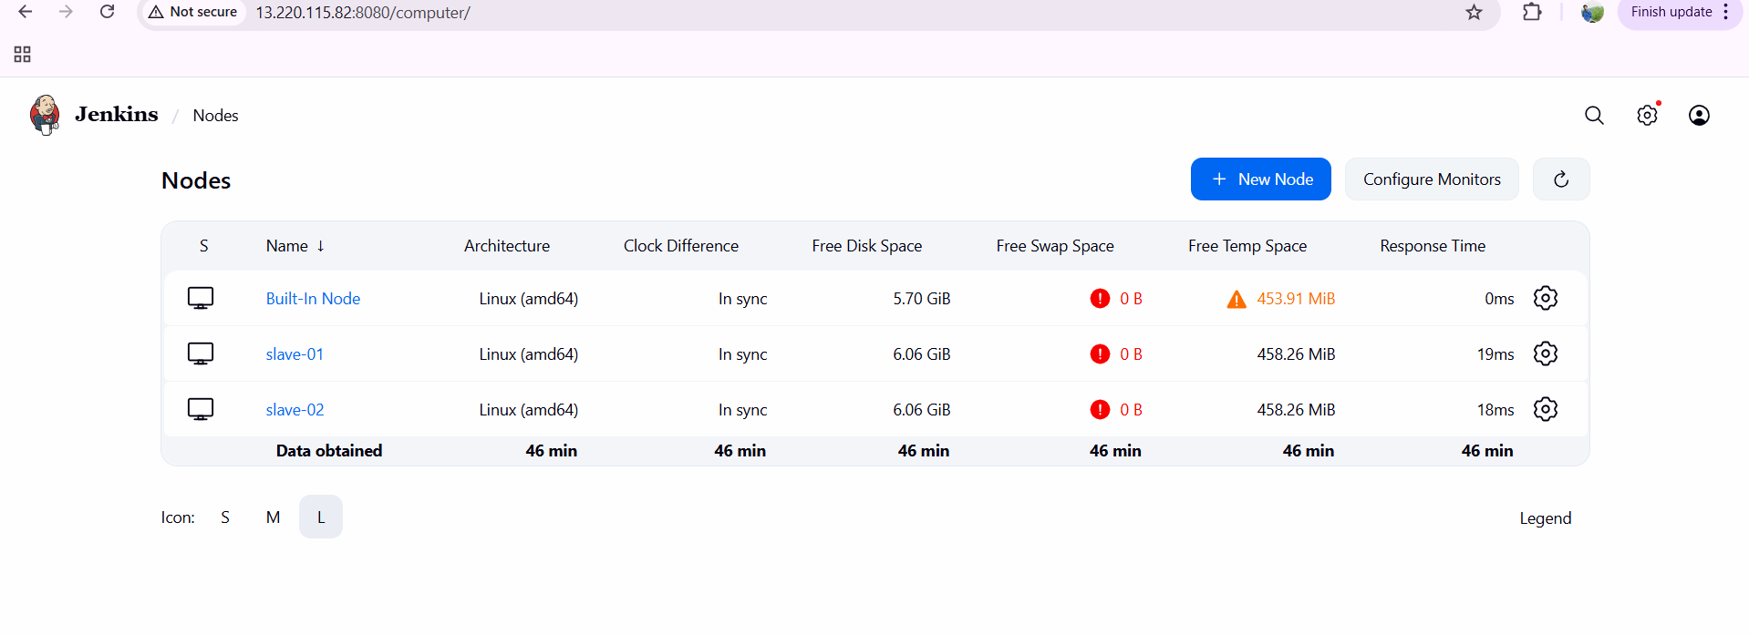
conclusion:
Configuring two slave (agent) machines with a Jenkins master enables distributed and parallel build execution, which significantly improves performance, scalability, and reliability of the CI/CD pipeline.

- title: Configure webhooks to Jenkins job.
objective: To automatically trigger a Jenkins job whenever a change (push, pull request, or merge) occurs in a source code repository (GitHub/GitLab/Bitbucket), enabling continuous integration without manual intervention.
prerequisites:
git installation in jenkins machine
repository url
enable webhook
proper credentials
step by step process:
first go to your repository---select any one and copy the URL
now come to Jenkins dashboard---click on new item---create one job new_webhook
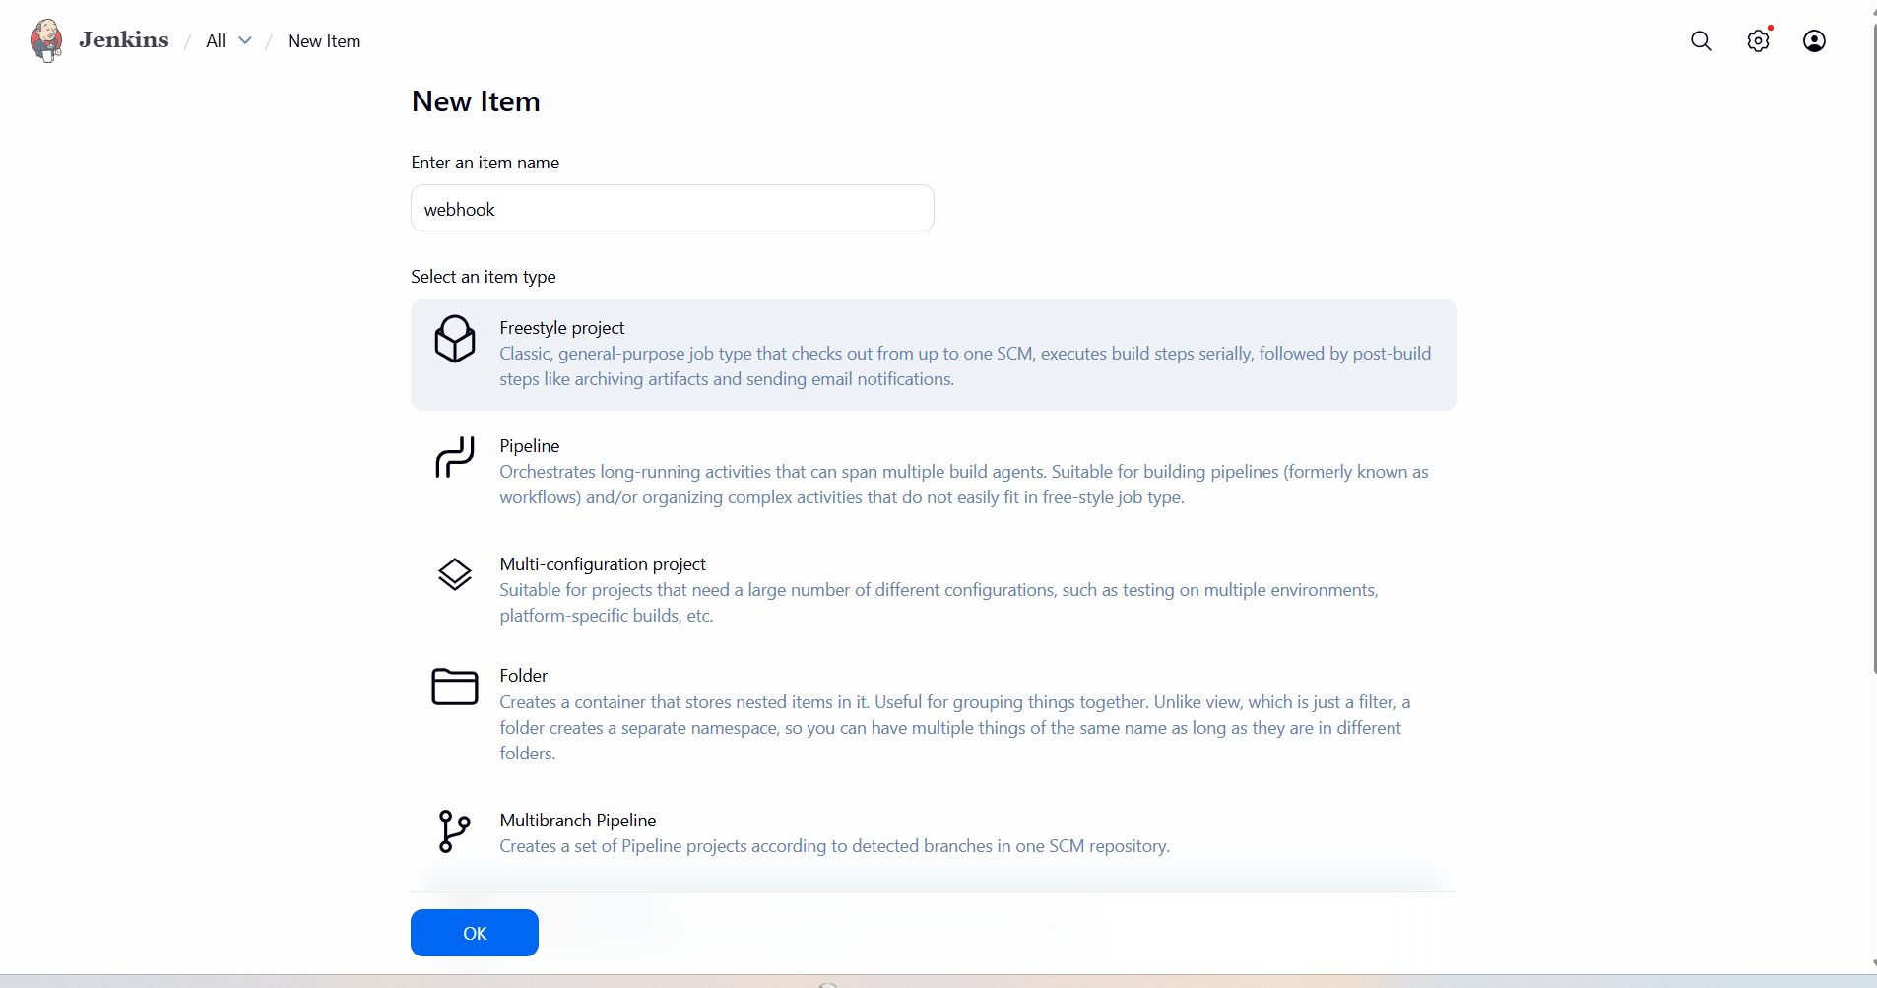
under source code management—select git—in repository URL add your repository URL—add credentials as none as it is public only
enter what the branch---here it is main—click on save
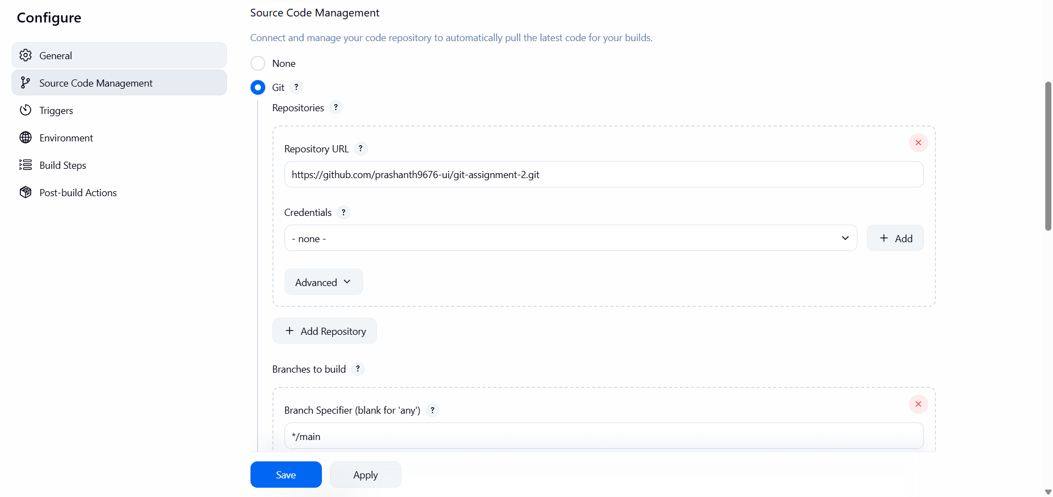
now go to triggers---select git hub hook trigger for GITscm polling and click on save
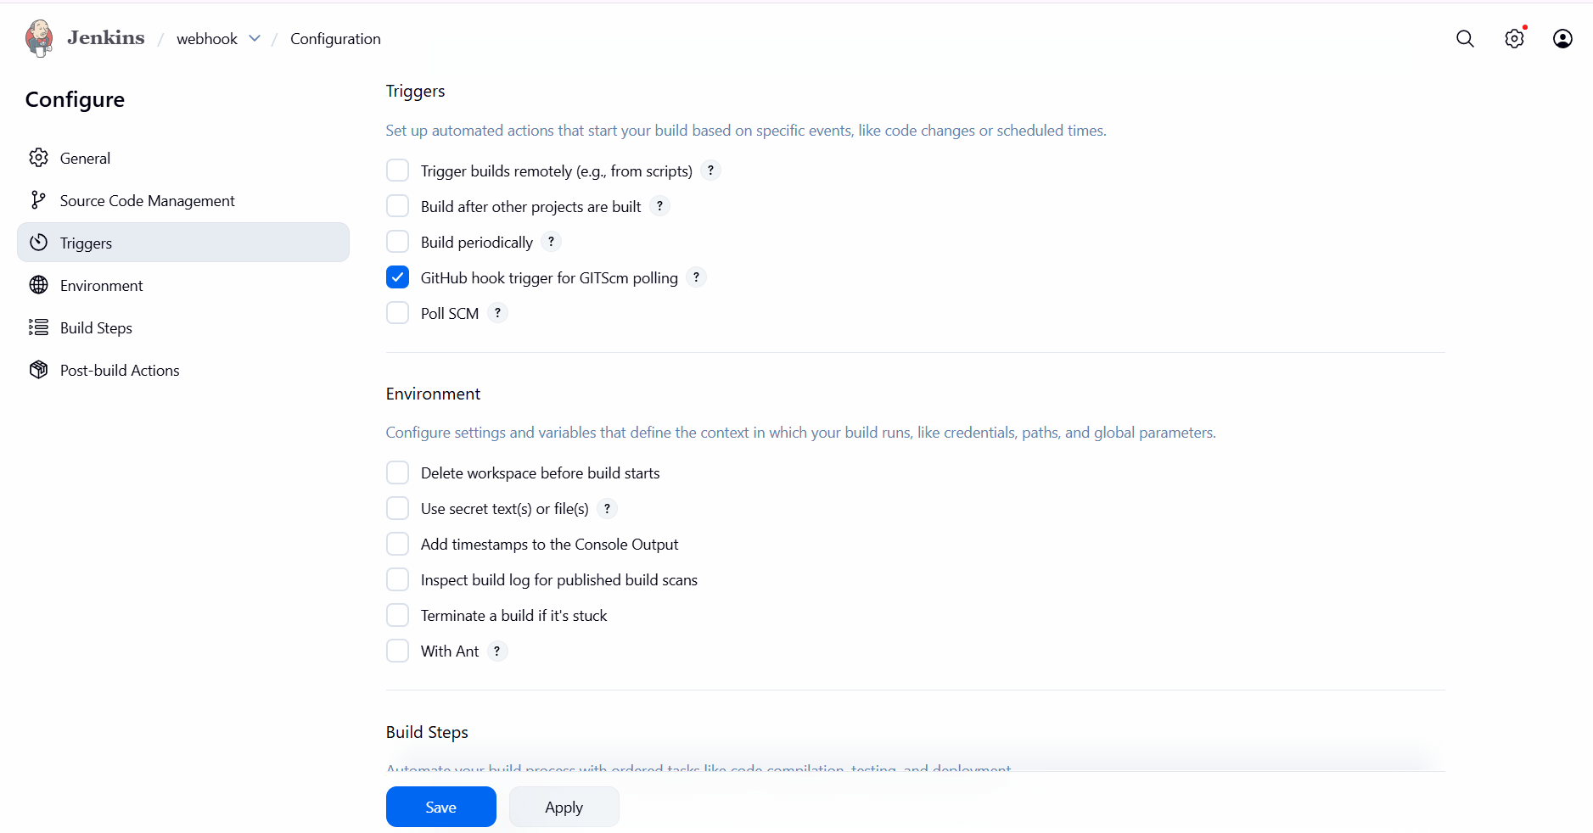
now come to your git hub repository---in settings select web hook---in payload url add the link as http://public Ip of your jenkins:8080/github-webhook/
in which events—select send me everything and add the webhook
wait for some time---it should get successful

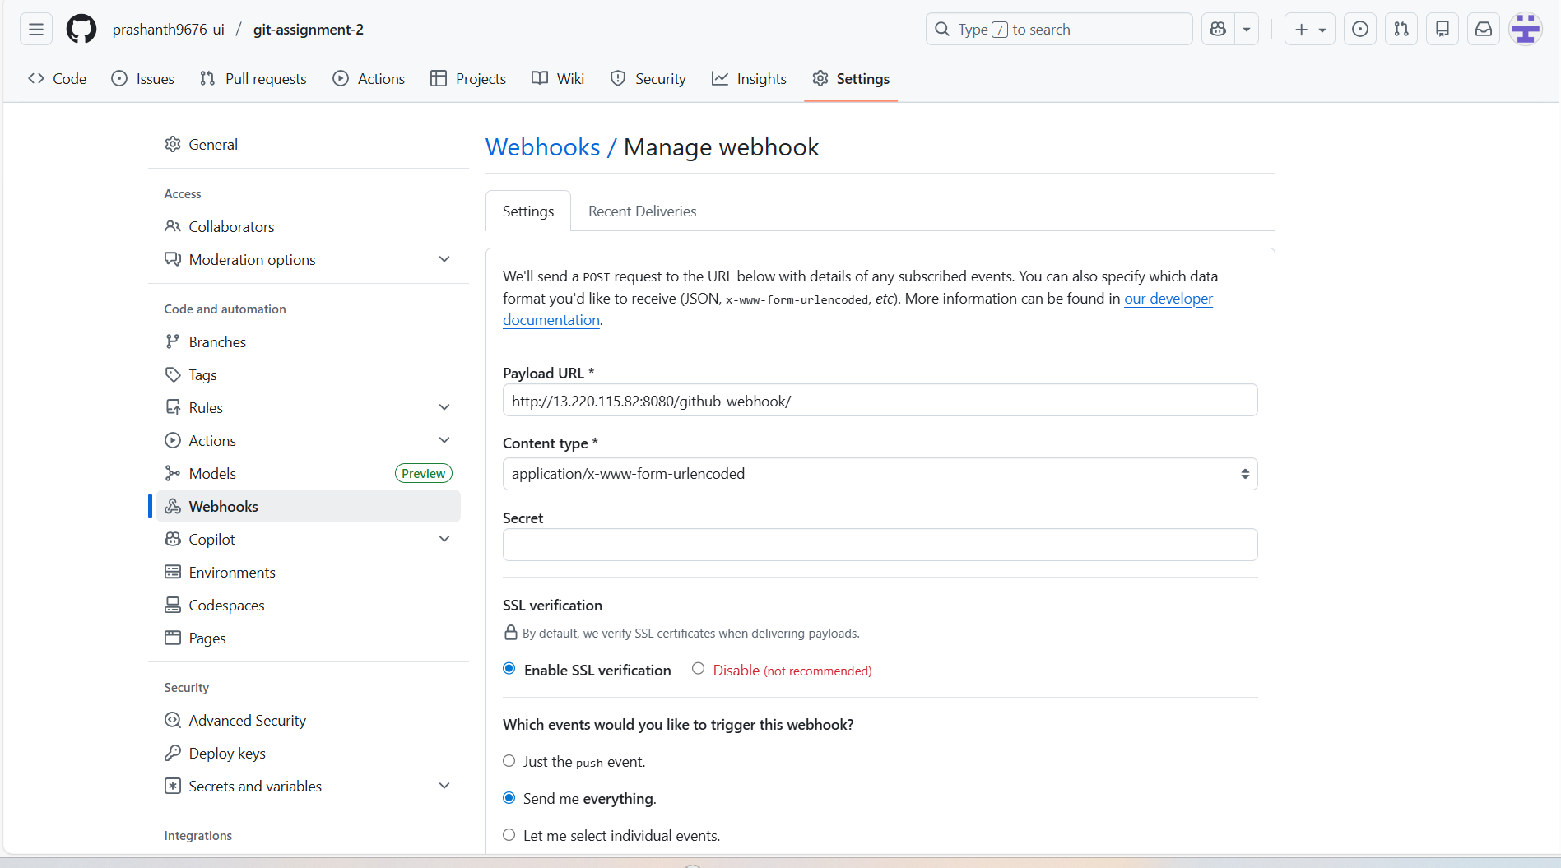

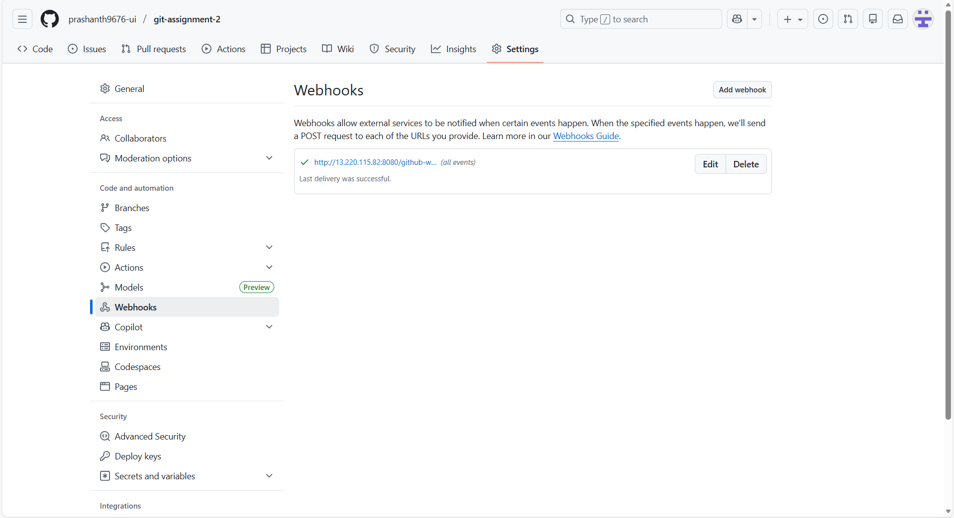
validation steps:
now come to Jenkins dashboard and click on build now
you can see the job has been created without manual intervention
example: I added one file in repository and triggered in jenkins

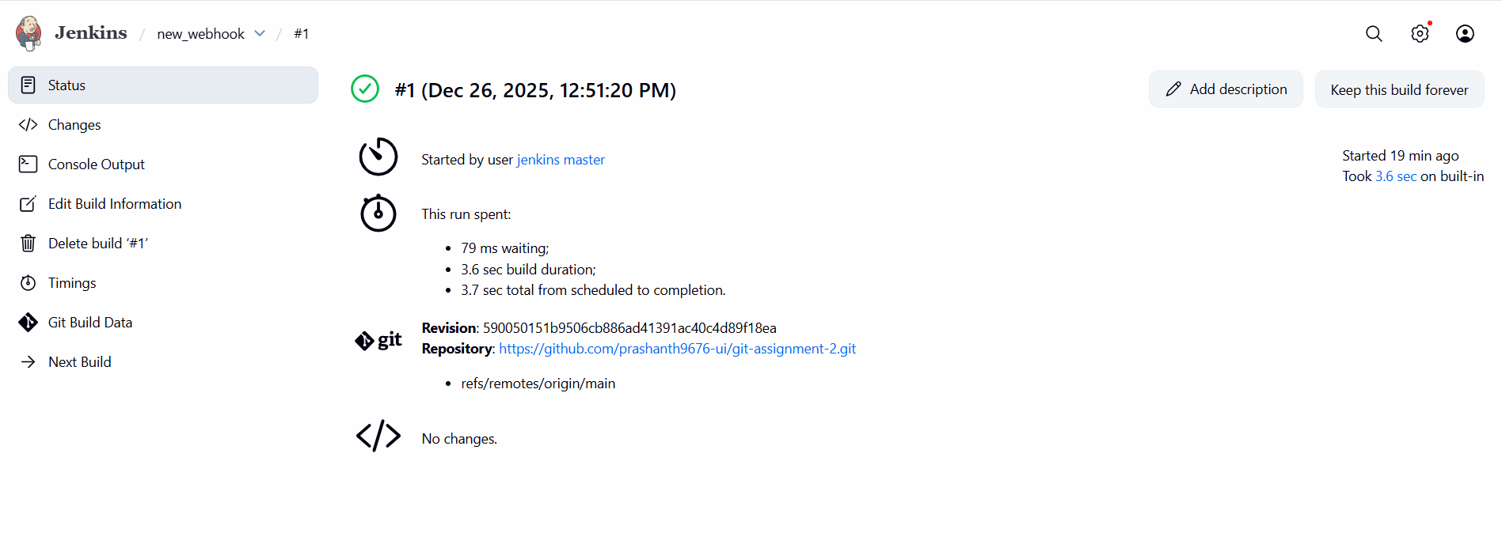
you can see job has been triggered as testing purpose
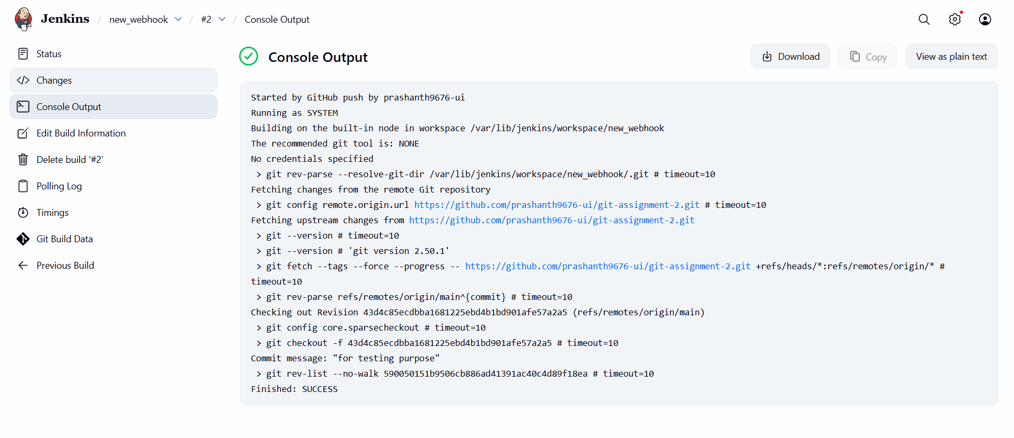
conclusion:
Configuring webhooks in Jenkins ensures that builds are automatically triggered on every code change, eliminating the need for manual or scheduled polling. This setup improves CI/CD efficiency, reduces build latency, and enables faster feedback to developers. Webhooks are a best practice for modern DevOps pipelines, providing real-time integration between source control systems and Jenkins.
- title: Configure poll scm and build periodical options in Jenkins job.
objective: To automatically trigger Jenkins builds either by checking the source code repository for changes (Poll SCM) or by running builds at fixed time intervals (Build Periodically), ensuring continuous integration and scheduled execution.
prerequisites:
Jenkins running
installation of git
repository URL
triggering pollscm
step by step process:
first go tp jenkins dashboard---click on create new item—jobname--pollscm
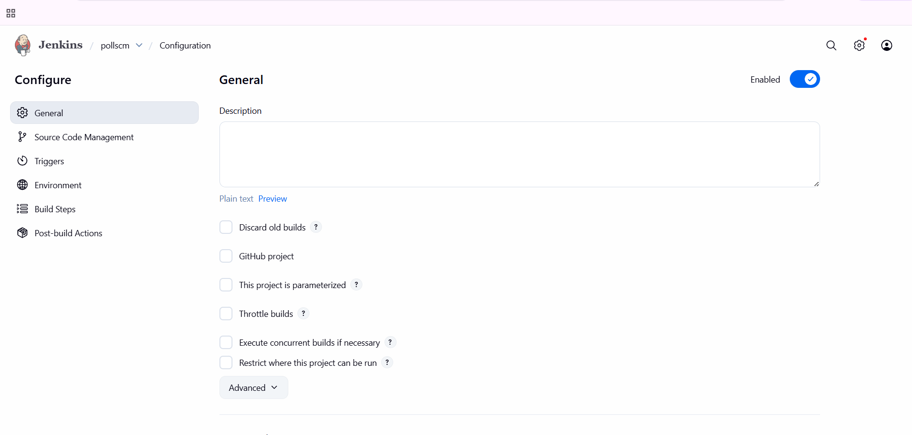
now go to configure—source code management—select git—enter your repository url---branch main
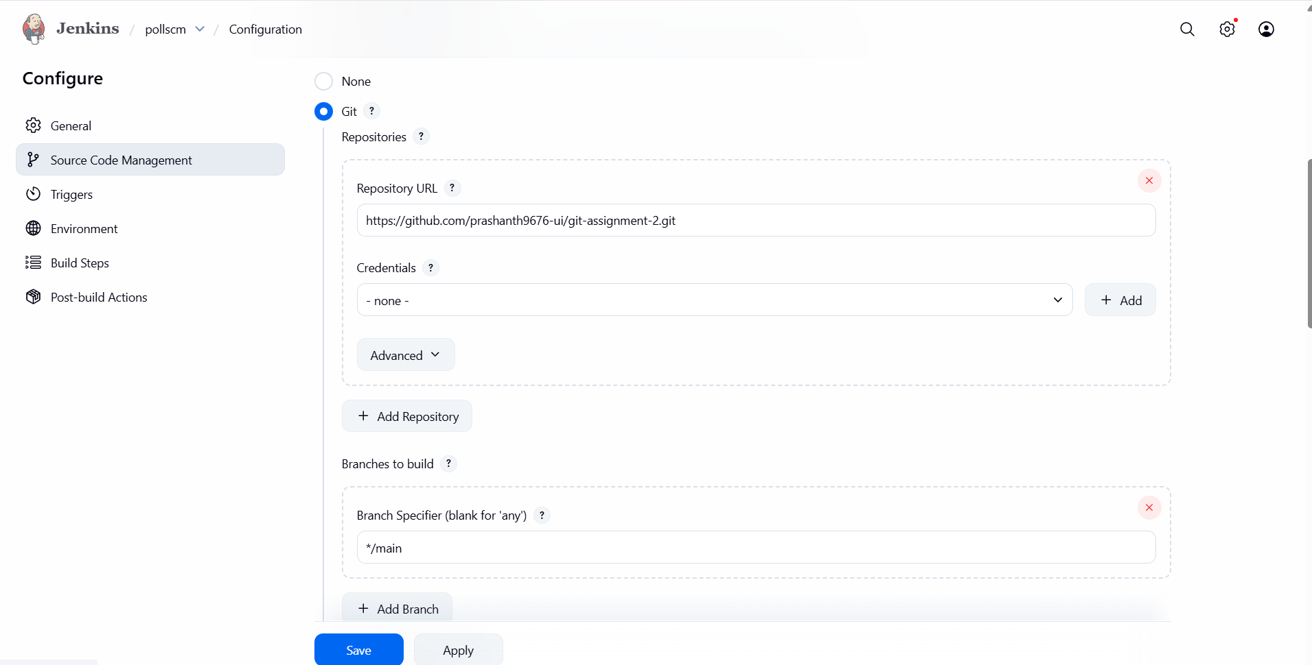
now go to triggers—select poll scm and schedule * * * * *
it means like it has to trigger each and every minute—click on save
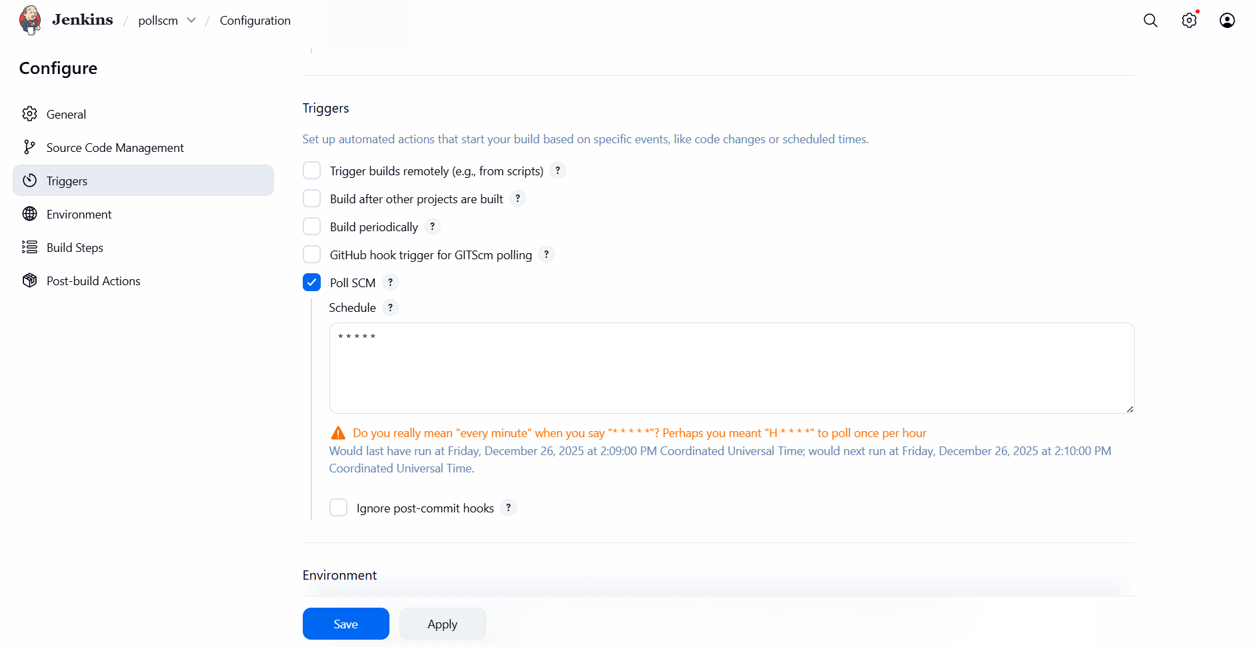
now check in polling log
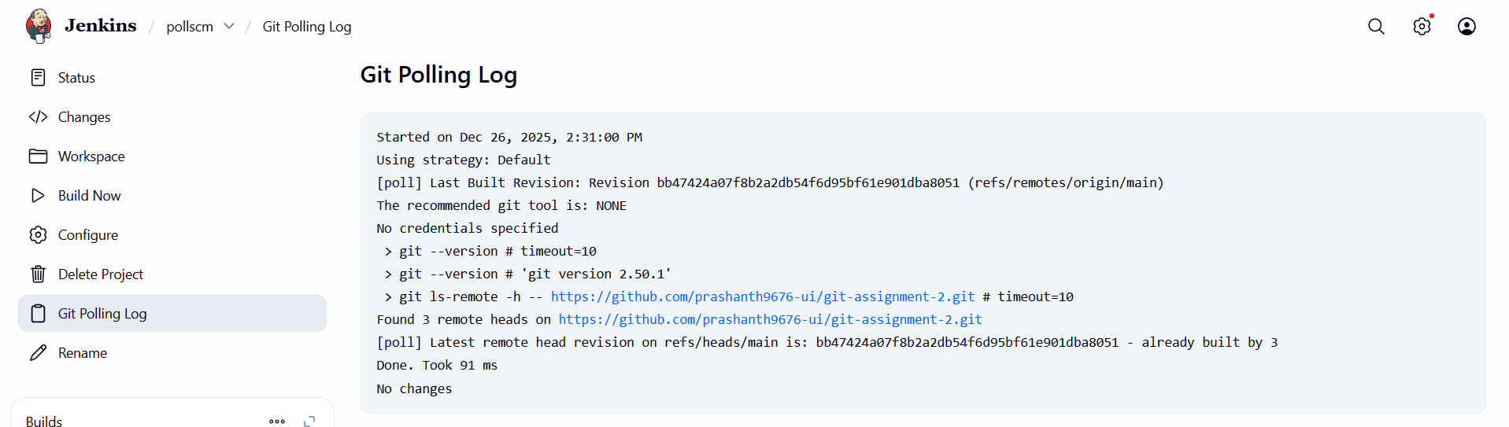
validation steps:
now you can check in console output
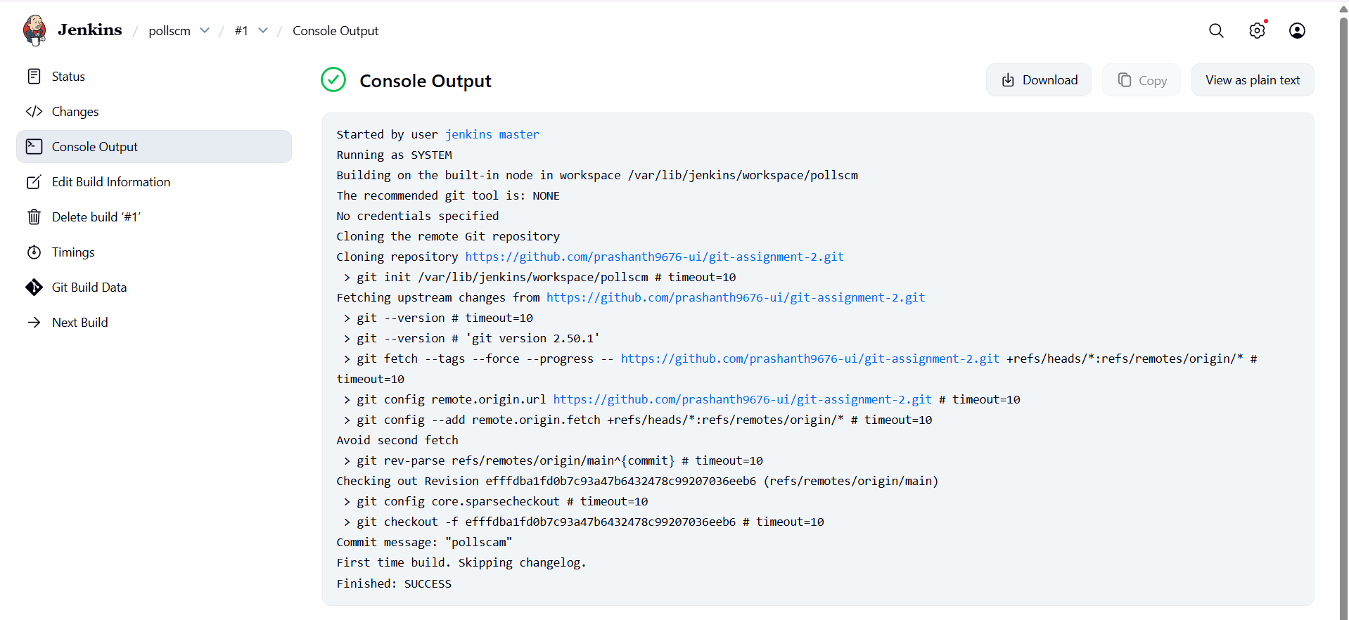
now I just made a change in readme file in my repository
here I added . and clicked on commit changes
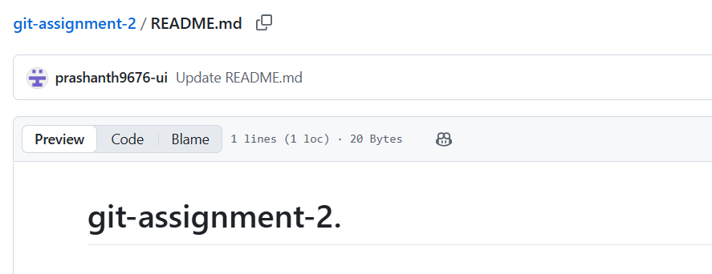
now we can check in console output
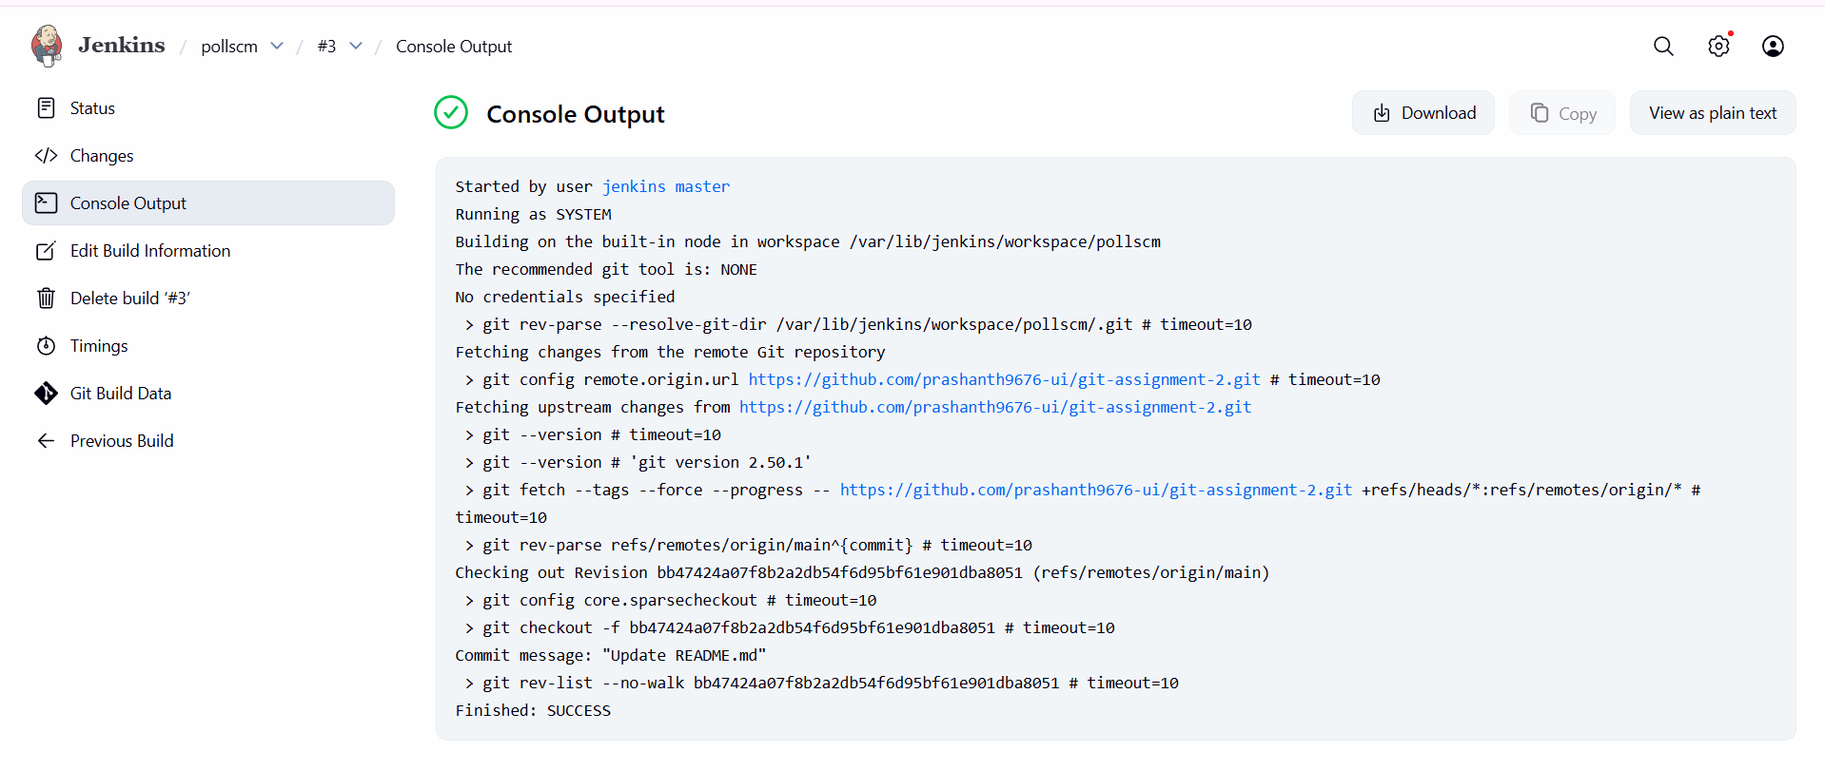

conclusion: Poll SCM and Build Periodically are powerful Jenkins scheduling mechanisms that automate job execution. Poll SCM ensures builds run only when source code changes occur, making it ideal for CI pipelines
- title: Take backup of Jenkins server by using bash script.
objective: to safely back up Jenkins configuration, jobs, plugins, credentials, and build metadata using a Bash script, ensuring quick recovery in case of server failure, data loss, or migration.
prerequisites:
jenkins running
bash script for backup
step by step process:
go to cli of jenkins server—switch to root user
vi jenkins-backup.sh
#!/bin/bash -xe
set -o pipefaildate=$(date +"%d%m%y%H%M")
readonly JENKINS_HOME="/var/lib/jenkins"
readonly DEST_FILE="/root"
readonly CUR_DIR=$(cd "$(dirname "${BASH_SOURCE:-$0}")" && pwd)
readonly TMP_DIR="${CUR_DIR}/tmp"
readonly ARC_NAME="jenkins-backup"
readonly ARC_DIR="${TMP_DIR}/${ARC_NAME}"
readonly TMP_TAR_NAME="${TMP_DIR}/${date}.tar.gz"backup_jobs() {
local run_in_path="$1"
local rel_depth=${run_in_path#${JENKINS_HOME}/jobs}
rel_depth=${rel_depth#/} [ -d "${run_in_path}" ] || return 0 cd "${run_in_path}" find . -maxdepth 1 -type d | while read -r job_name; do
[ "${job_name}" = "." ] && continue
[ "${job_name}" = ".." ] && continue mkdir -p "${ARC_DIR}/jobs/${rel_depth}/${job_name}" find "${run_in_path}/${job_name}" -maxdepth 1 \( -name "*.xml" -o -name "nextBuildNumber" \) -print0 \
| xargs -0 -r -I {} cp {} "${ARC_DIR}/jobs/${rel_depth}/${job_name}/" if [ -f "${run_in_path}/${job_name}/config.xml" ] &&
grep -q "com.cloudbees.hudson.plugins.folder.Folder" "${run_in_path}/${job_name}/config.xml"; then
backup_jobs "${run_in_path}/${job_name}/jobs"
fi
done cd "${OLDPWD:-/}" || true
}cleanup() {
rm -rf "${ARC_DIR}"
}main() {
rm -rf "${ARC_DIR}" "${TMP_TAR_NAME}" for dir in plugins jobs users secrets nodes workspace; do
mkdir -p "${ARC_DIR}/${dir}"
done cp "${JENKINS_HOME}/"*.xml "${ARC_DIR}" 2>/dev/null || true
cp "${JENKINS_HOME}/plugins/"*.[hj]pi "${ARC_DIR}/plugins" 2>/dev/null || true
cp "${JENKINS_HOME}/plugins/"*.[hj]pi.pinned "${ARC_DIR}/plugins" 2>/dev/null || true [ -d "${JENKINS_HOME}/users" ] && cp -R "${JENKINS_HOME}/users/"* "${ARC_DIR}/users" 2>/dev/null || true
[ -d "${JENKINS_HOME}/secrets" ] && cp -R "${JENKINS_HOME}/secrets/"* "${ARC_DIR}/secrets" 2>/dev/null || true
[ -d "${JENKINS_HOME}/nodes" ] && cp -R "${JENKINS_HOME}/nodes/"* "${ARC_DIR}/nodes" 2>/dev/null || true
[ -d "${JENKINS_HOME}/workspace" ] && cp -R "${JENKINS_HOME}/workspace/"* "${ARC_DIR}/workspace" 2>/dev/null || true [ -d "${JENKINS_HOME}/jobs" ] && backup_jobs "${JENKINS_HOME}/jobs" cd "${TMP_DIR}"
tar -czvf "${TMP_TAR_NAME}" "${ARC_NAME}"
cd "${OLDPWD:-/}" || true mv -f "${TMP_TAR_NAME}" "${DEST_FILE}"
cleanup
exit 0
}main
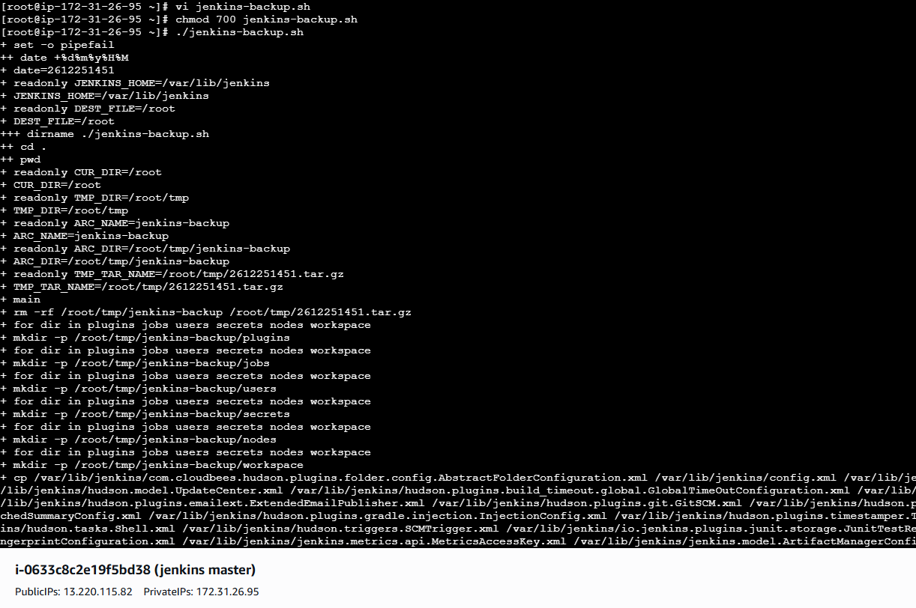
inside vi paste the script
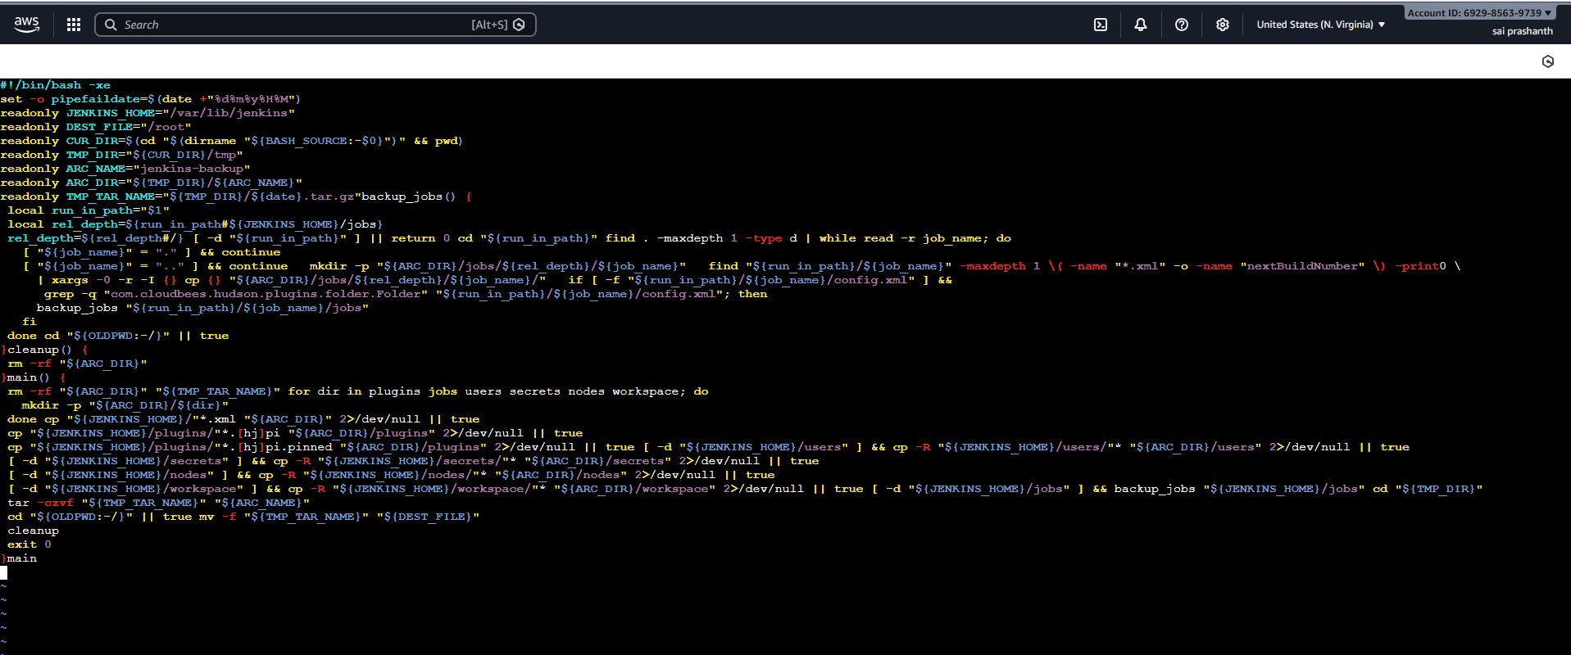
validation steps:
now we can see back up has been created successfully
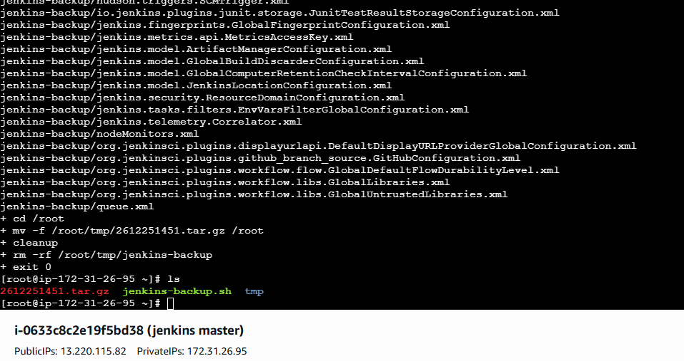
conclusion:
Taking regular Jenkins backups using a Bash script ensures business continuity, disaster recovery, and fast restoration. Automating backups with cron and storing them securely (S3/NFS) is a best practice for production Jenkins environments, protecting critical CI/CD data from accidental loss or system failures.
- title: Take backup of Jenkins using rethin backup plugin
objective: To back up Jenkins jobs, configurations, plugins, and credentials using the ThinBackup plugin, enabling easy restore, migration, and disaster recovery without manual scripting.
prerequisites:
jenkins running
plugins
install thin backup
cli verification
backup path
step by step process:
go to jenkins dashboard---click on plugins

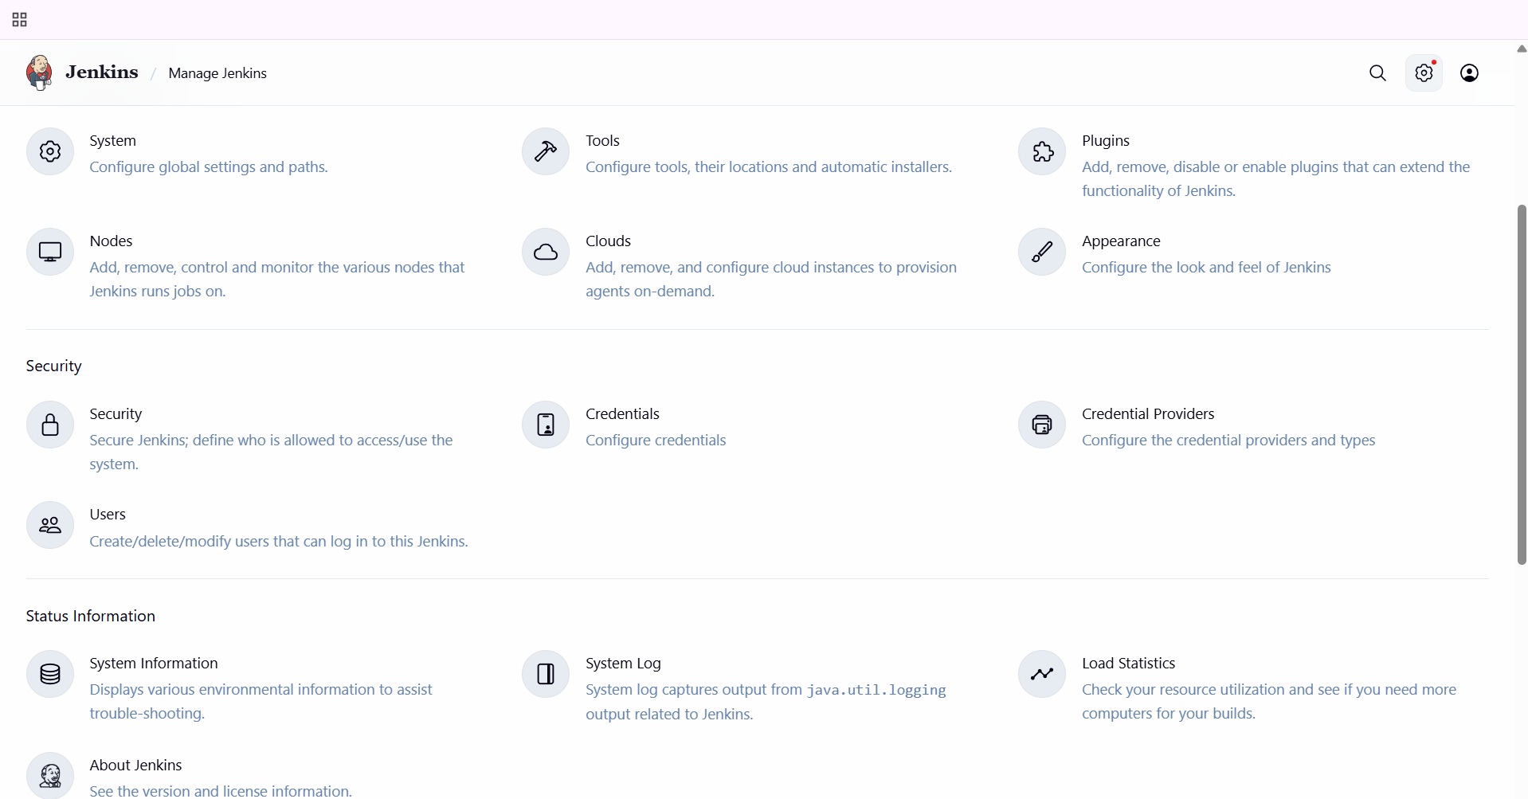
select available plugins---search for thin backup---install it
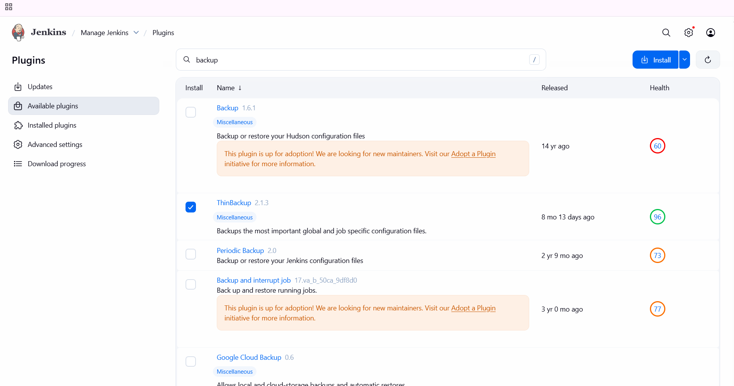
check it’s downloading
you can see it has been installed
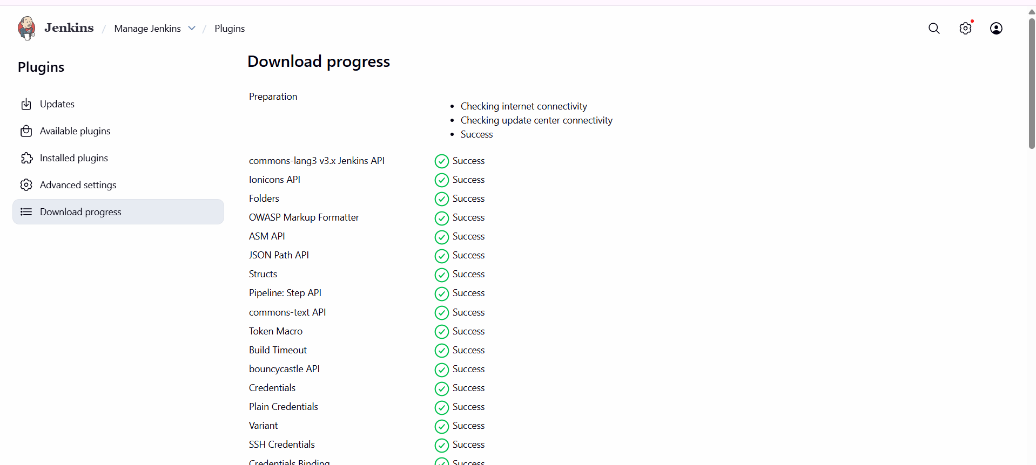
go to manage jenkins—system---select thinbackup configuration
and enter the directory path as /var/lib/jenkins/thinbackup
and save it
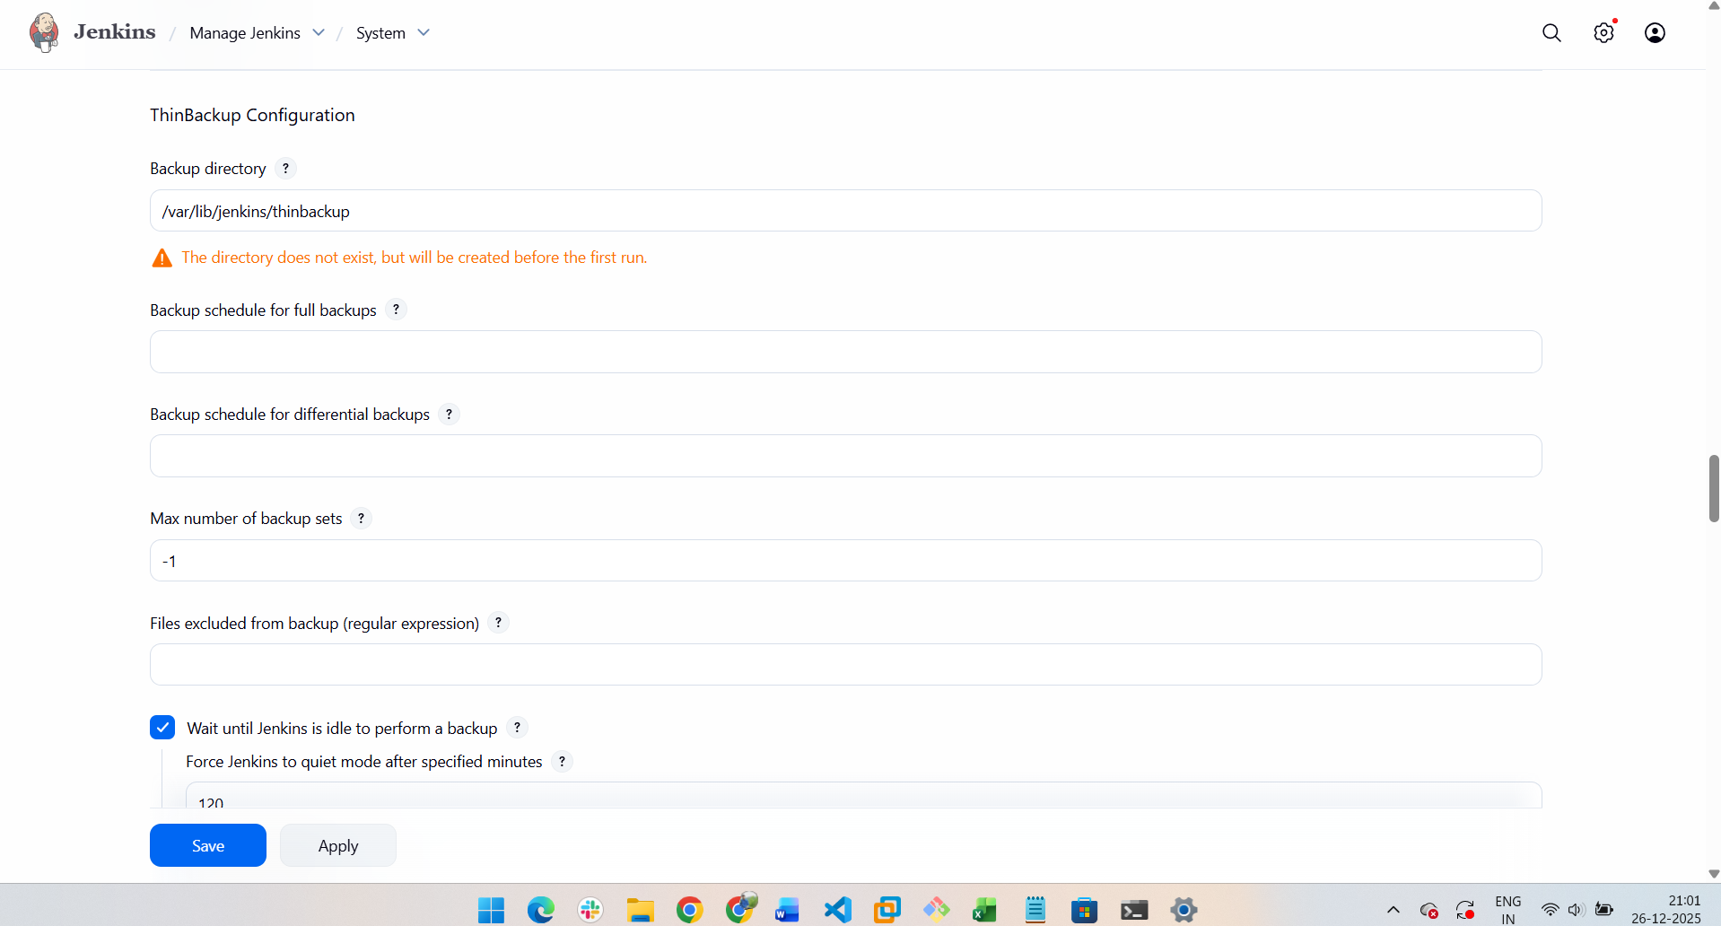
now click on thinbackup---click on backup
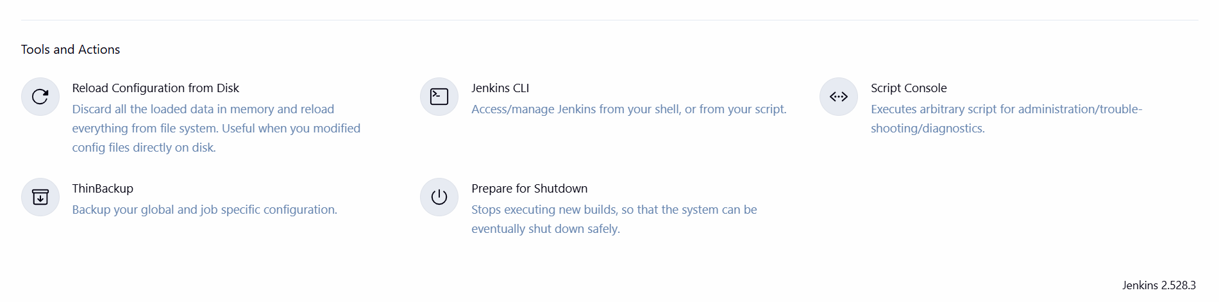
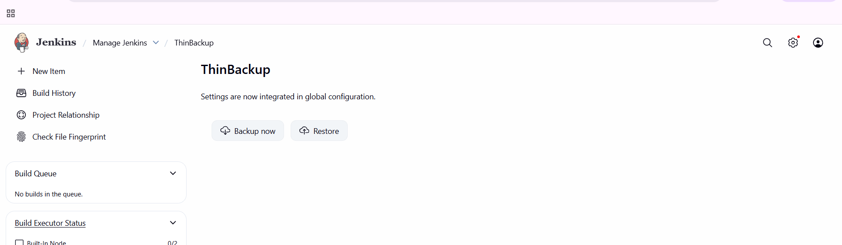
validation steps:
now you can verify in cli by giving the path as cd /var/lib/jenkins/thinbackup
ls
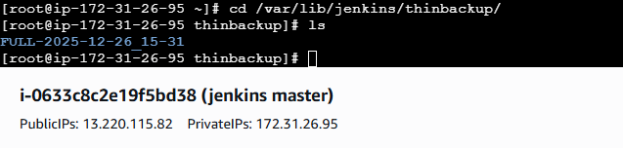
conclusion: Using the Thin Backup (Rethin) plugin provides a simple and reliable way to back up Jenkins configurations and jobs. It reduces operational overhead, supports scheduled backups, and enables quick restoration during failures or migrations, making it a recommended Jenkins backup solution for production environments.
- title: Setup a new Jenkins server and dump the backup taken in task4.
objective: To set up a new Jenkins server and restore Jenkins configuration and data by transferring and dumping a previously taken back up from an existing Jenkins server, ensuring continuity and disaster recovery readiness.
prerequisites:
new ec2 instance required
Jenkins installed and running on the new server
SSH access to both source and destination EC2 instances
Jenkins backup archive available from Task 4
step by step process:
first try to connect with Jenkins server and create backup from exixting instance only
then connect with scp -i jenkins_backup_instance.pem <backup-file>.tar.gz ec2-user@<destination-public-ip>:/home/ec2-user/

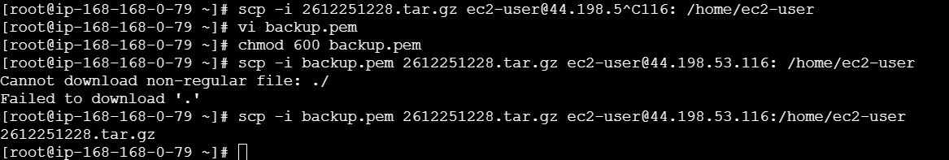
now login to destination server
now do the backup archive to /var/lib/jenkins
validation steps:
cp <backup-file>.tar.gz /var/lib/jenkins/
cd /var/lib/jenkins/

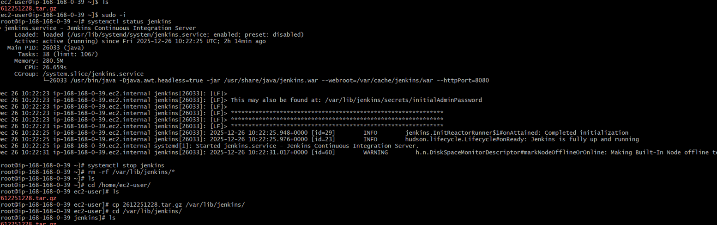
conclusion:
The Jenkins environment was successfully configured with multiple slave nodes, automated build triggers, and robust backup mechanisms. Both script-based and plugin-based backups were implemented and validated. A new Jenkins server was set up and restored using the existing backup, ensuring full disaster recovery capability and demonstrating a production-ready Jenkins CI/CD architecture.

