**Sreekanth D**

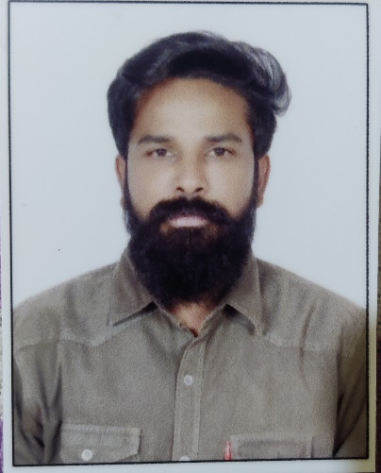

🕿: +91 8522098696

**🖂**: [sreekannthmahi148@gmail.com](mailto:sreekannthmahi148@gmail.com)

_________________________________________________________________________

**Objective:**

Seeking a challenging position where I can apply my knowledge and ability to the maximum extent and grow professionally with the organization and be a part of its success.

**Summary of Skills:**

* Proficient with Microsoft word and Excel,
* Positive thinking, Quick learning, Self-confidence, Patience,
* Superior organizational and intrapersonal skills,
* Familiar with Medical Terminology and Billing procedures,
* Sound ability to work under deadlines and multitask under deadlines.

**Work Experience:**

* Worked in Arya Medical Billing Services as a Medical Biller for 1 Year.
* Working in Medico Health Care Services as a Medical Biller since 1 Year.

**Job Profile:**

* In depth knowledge of processing full cycle billing and charge entry for all types of claims,
* Knowledge with insurance eligibility and verification,
* In depth knowledge with billing edits, charge entry related issues like modifiers, diagnosis codes and evaluation and management procedures.
* Trained in preparing and submitting clean claims to various insurance companies,
* Proven ability to prepare and review patient statements and resolve patient issues regarding billing,
* Review provider charge tickets like date of service, procedures, diagnosis, patient identification and provider signature for accuracy,
* Handle the tasks of balancing charge summary to tickets keyed before updating the charges,
* Entered all appropriate charges into the billing system,
* Ensure that the charges in the record are correct and accurate as well as make corrections, as required,
* Knowledge with insurance eligibility and verification,
* Correct denial claims with correct information and resubmit claims,
* Setup practice management software for submission of electronic claims to clearinghoause, work with clearinghouse to resolve file compatibility issues.

**Academic Profile:**

* Completed Graduation from Sri Vani Degree college, Anantapur in 2017
* Completed 12th from Sri Chaitanya Junior College, Hyderabad in 2011
* Completed I.C.S.E Board of Secondary Education from Vijaya Vani Residential, Chowdepalli in 2009.

**Computer & Software Skills:**

* Operating Systems - Windows [OS] 98/2000/2007/XP, Vista.

**Software Known:**

* AMD (Advanced MD), ReLi

**Personal Profile:**

Father : D.Narayana,

Languages known : English, Hindi and Telugu,

Marital Status **:** Un-Married,

Address **:** D.No:9-1-34/30/75/b, Bapu Nagar, Langar House

Hyderabad,500008

**Declaration**:

I hereby declare that the above information given is true to the best of my knowledge.

**Sreekanth.D**