PES1201800410 sem 5 sec G roll no 24 Prashanth A R

Assign Ip address
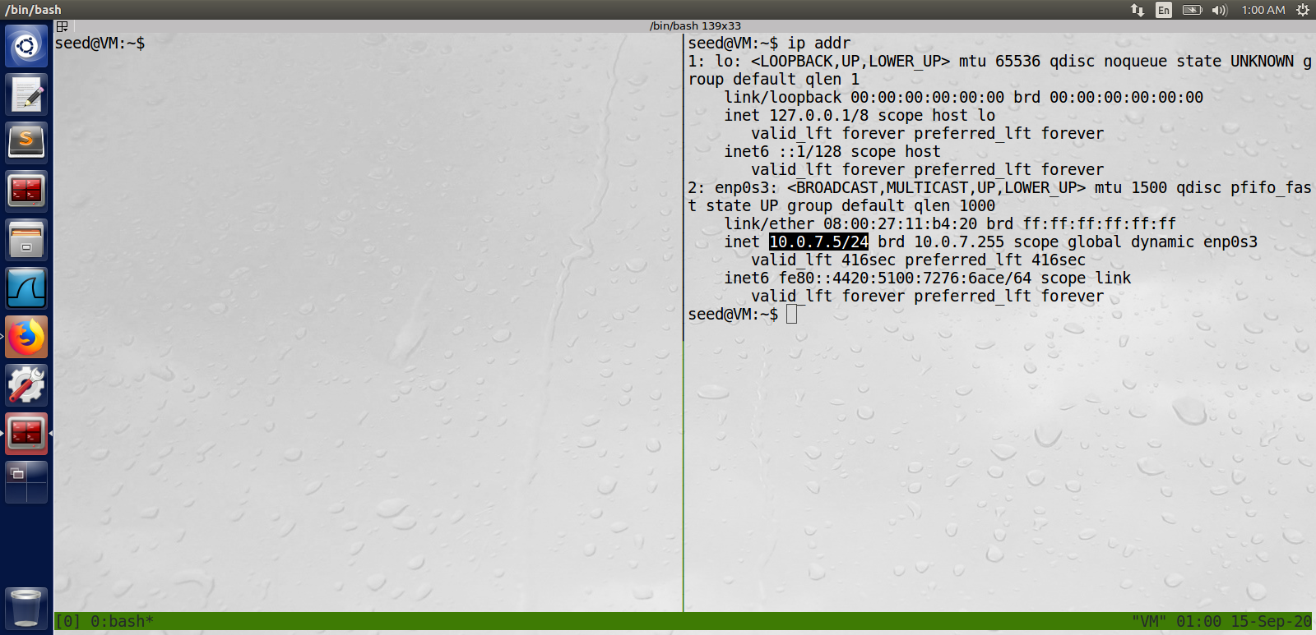

Apache2.conf – maxkeepalive condition
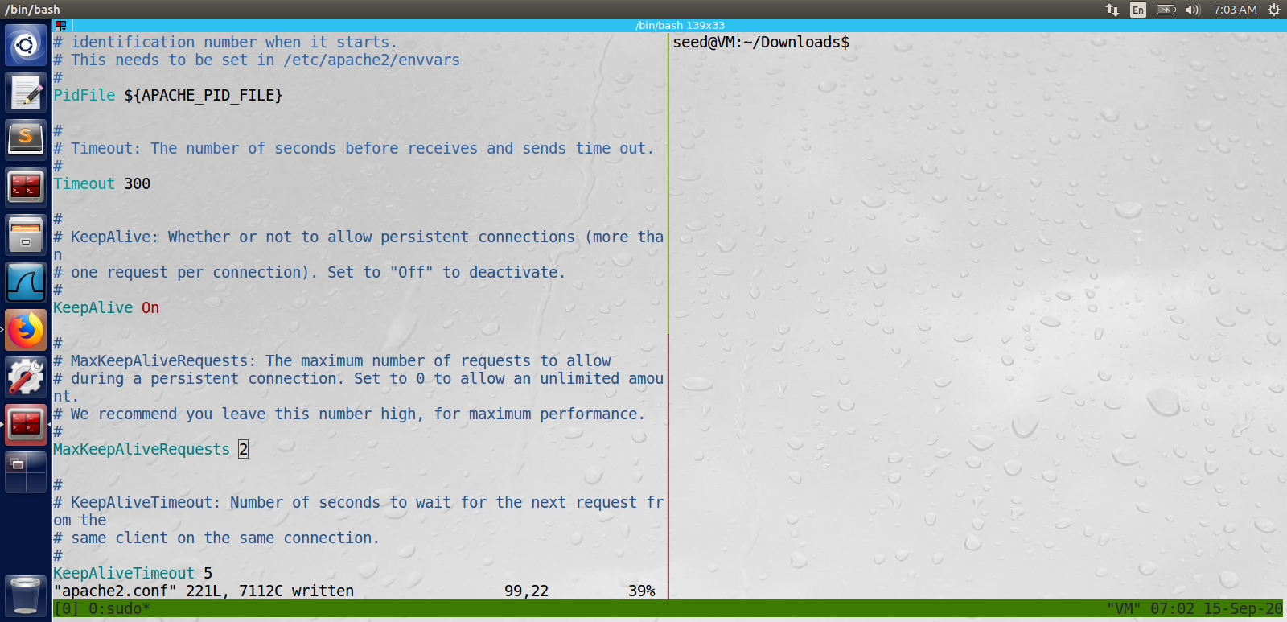

Apache status
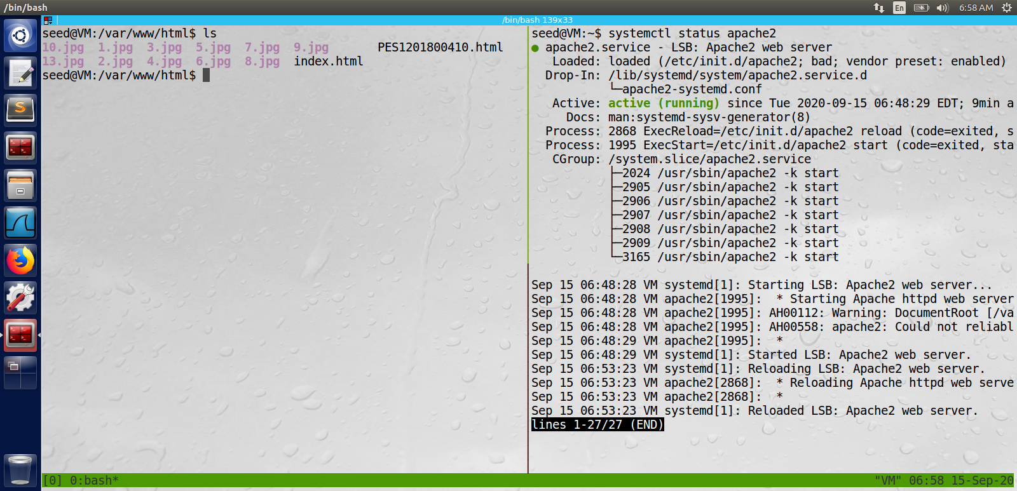

main html page
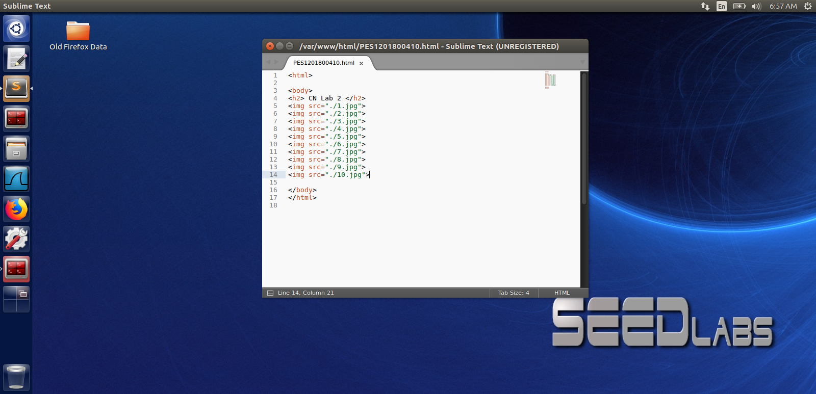

Firefox web page
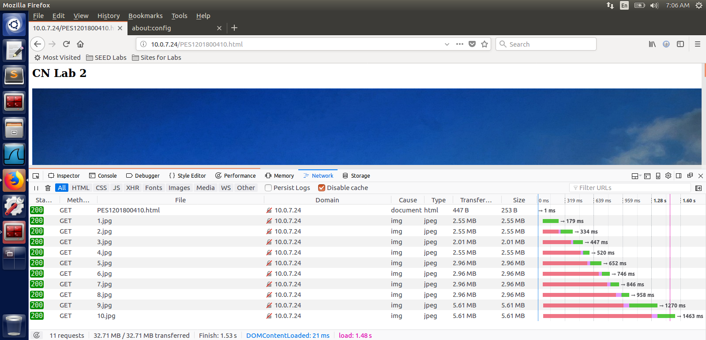

No persistent Connections
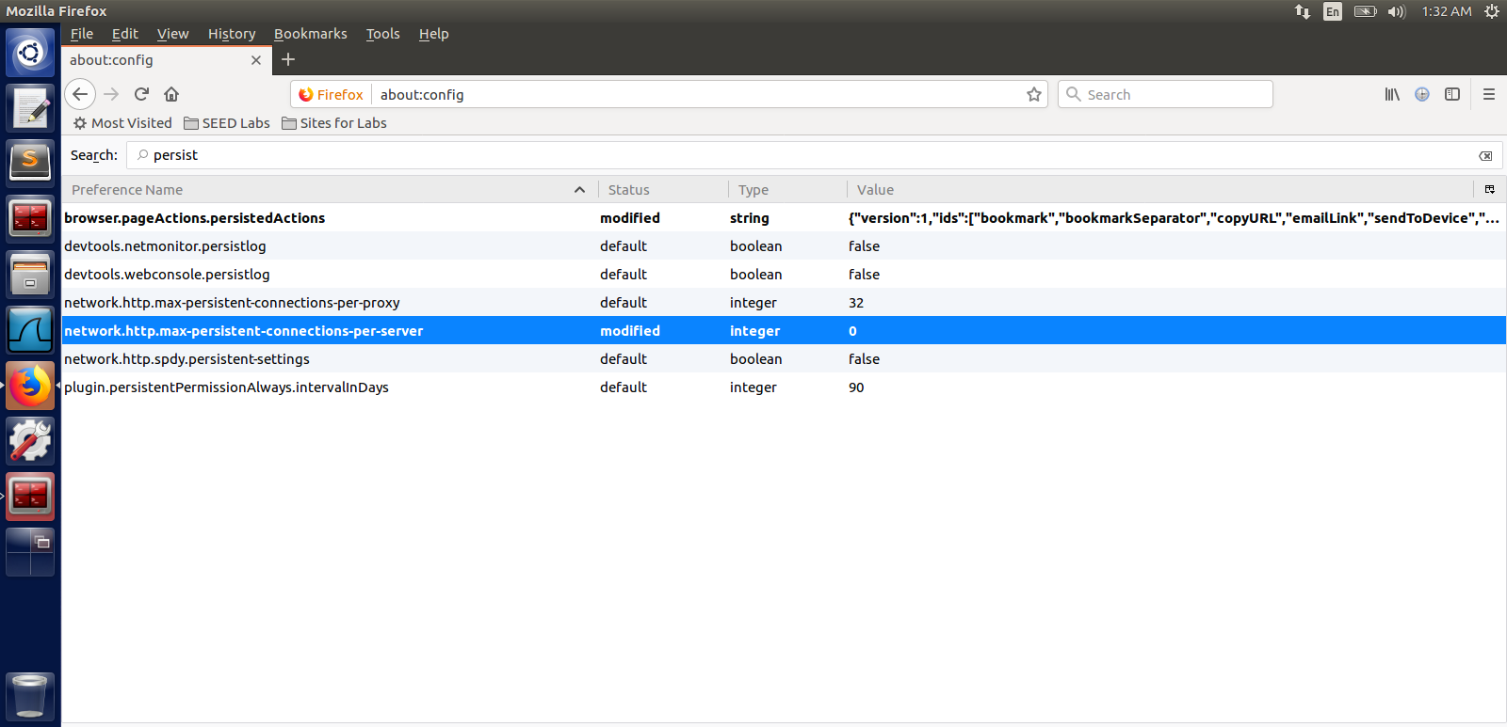

wireshark output

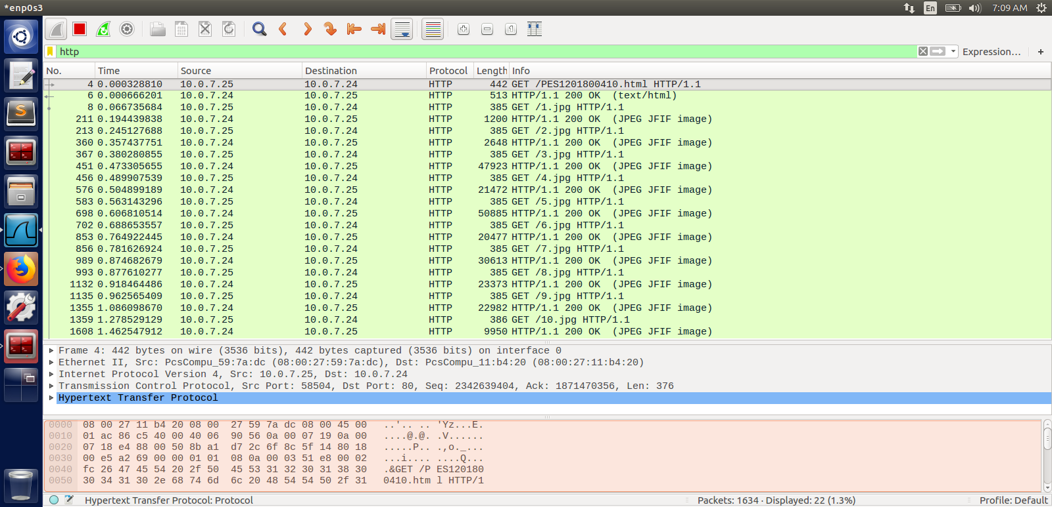
Time taken = 1.462547912 – 0.000328810 = 1.462219102

2 persistent
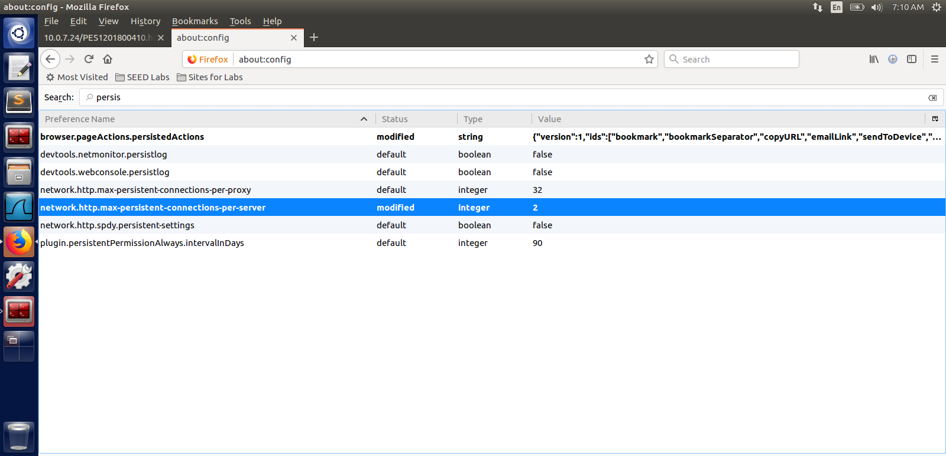

2 persistant wireshark output
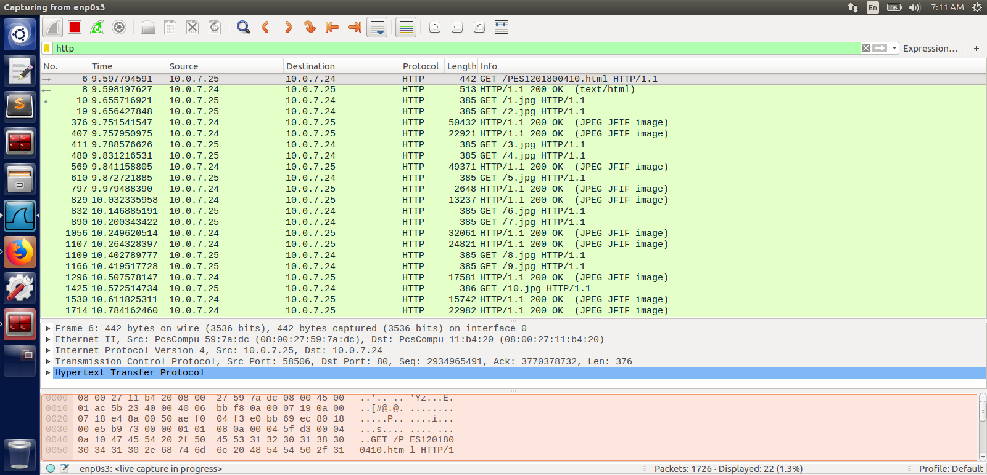
Time taken = 10.784162460 – 9.597794591 = 1.1863678689999997

4 persistant connections
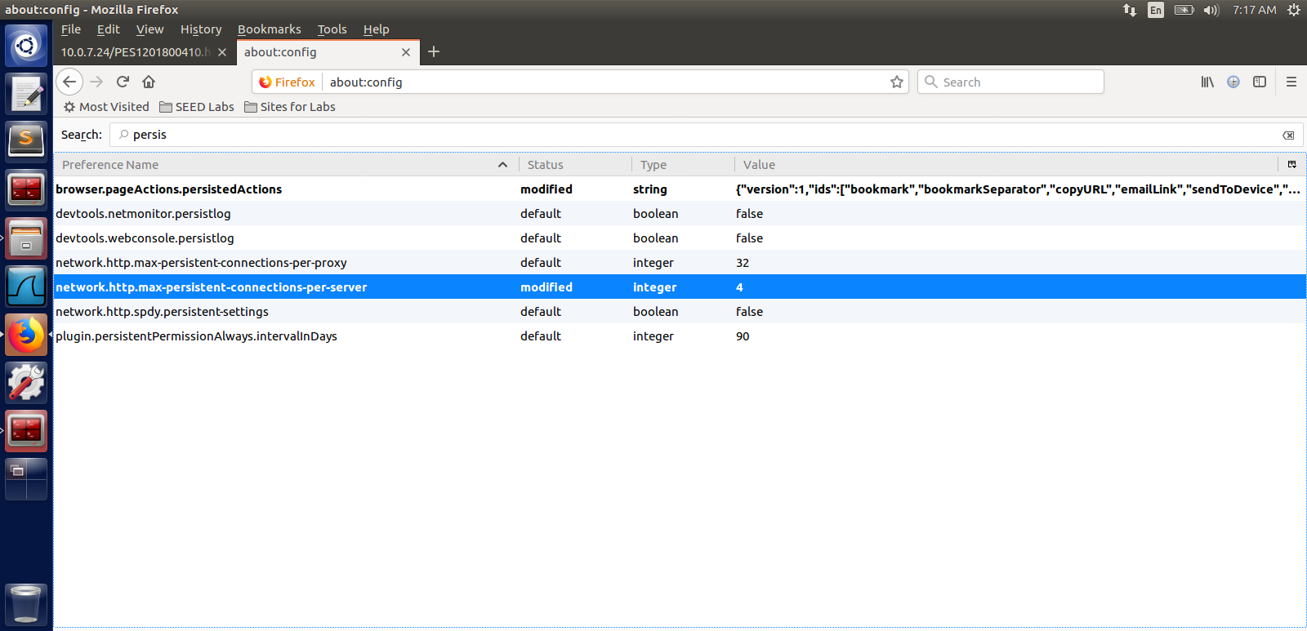

wireshark output

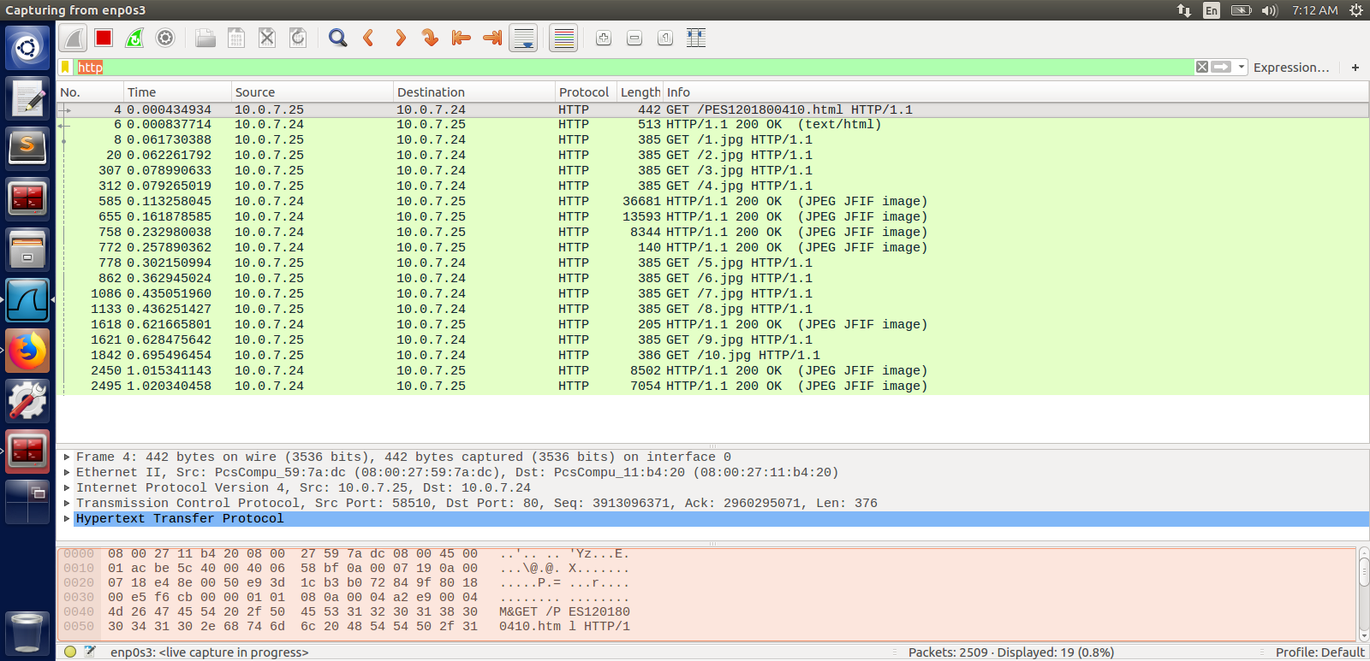

Time taken = 1.020340458 – 0.000434934 = 1.019905524

6 persistant connections

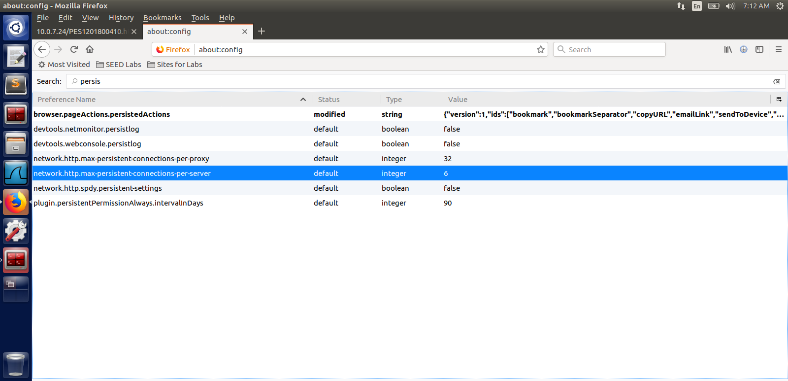

wireshark output

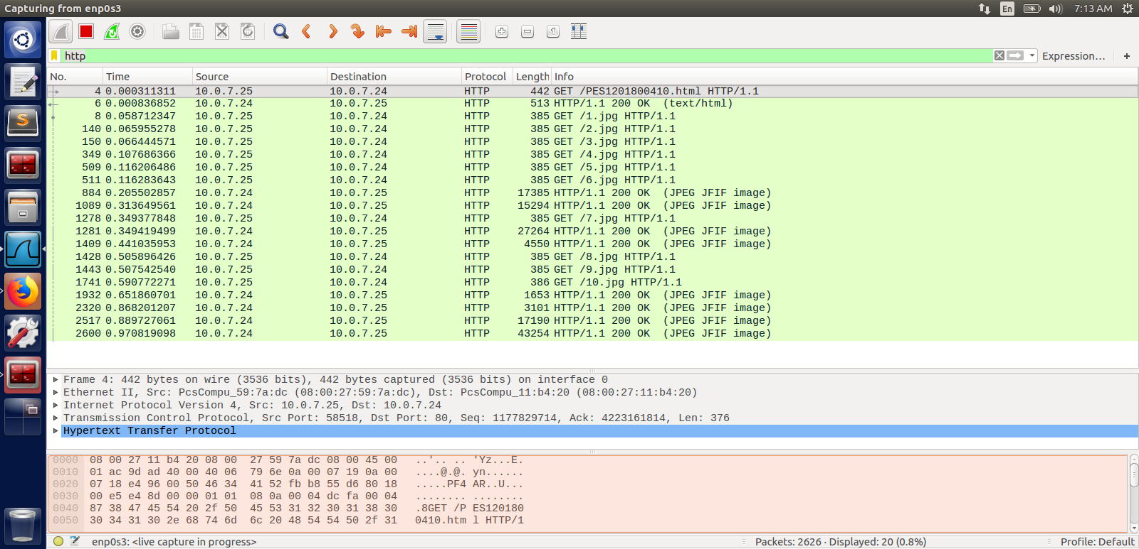

Time taken = 0.970819098 – 0.000311311 = 0.970507787

8 persistant connections

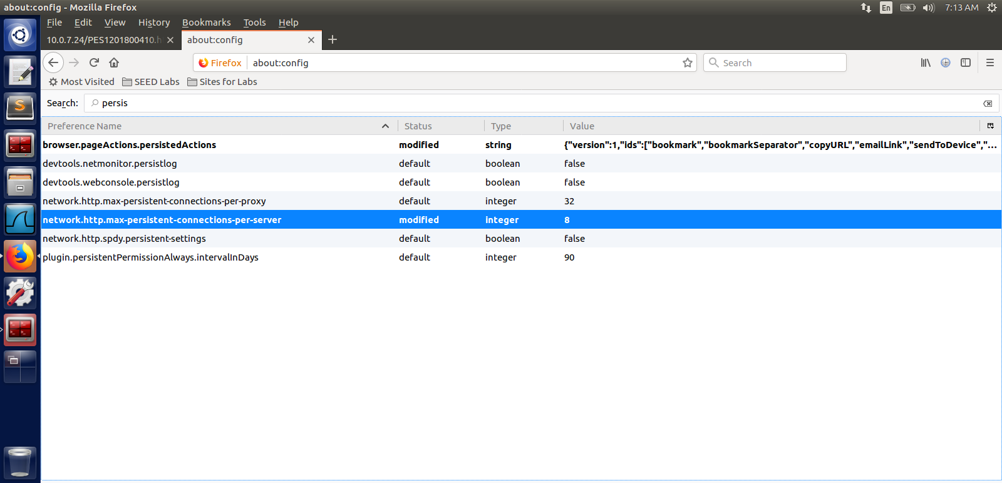

wireshark output

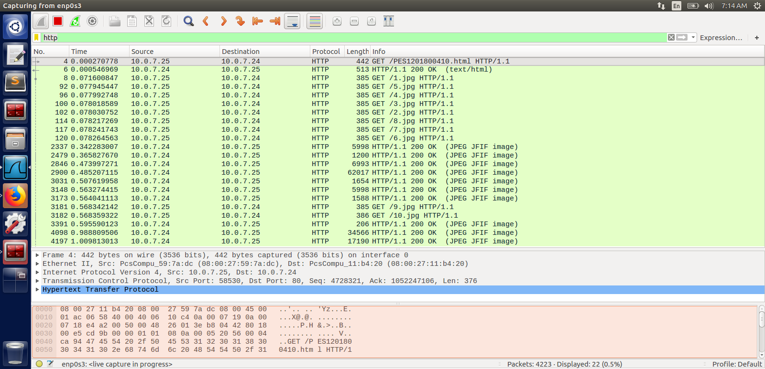

Time taken = 1.009813013 – 0.000270778 = 1.009542235

10 persistant connections

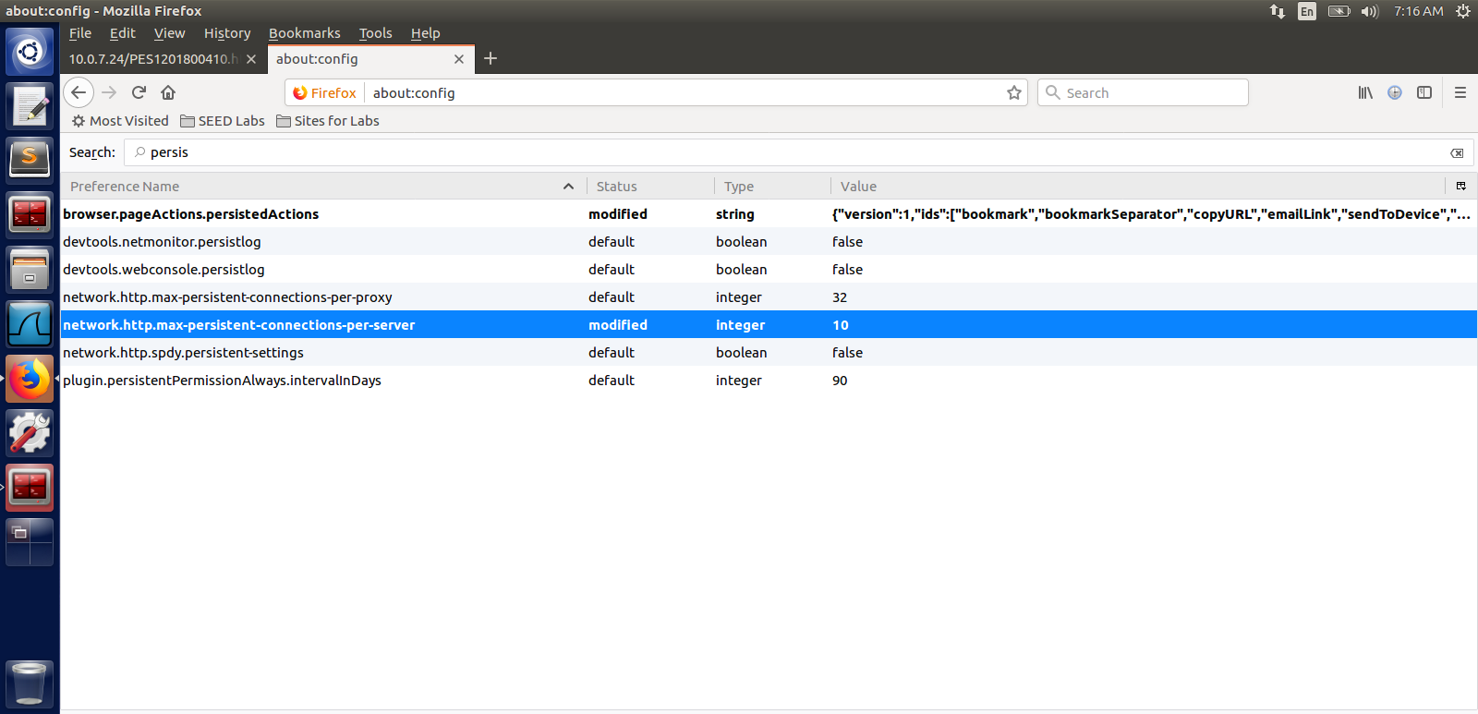

wireshark output

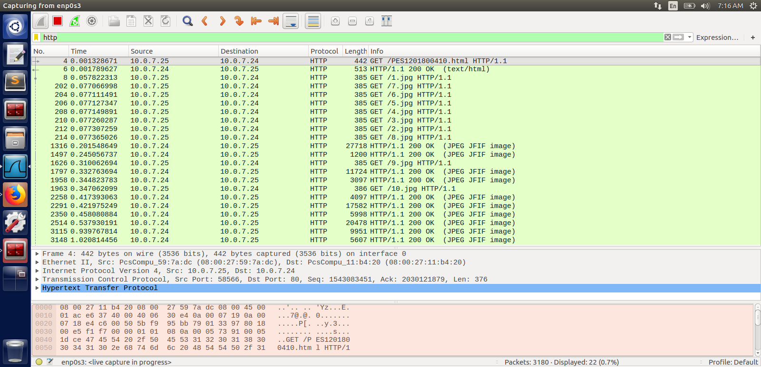

Time taken = 1.020814456 – 0.001328671 = 1.019485785

Find out the time taken to load images for 2 4 6 persistent connections is lesser or greater than 10 persistent compared to non-persistent
And: Is greater lesser than 10 persistent connections

factors affecting no of connections are
- Each transaction opens/closes a new connection, costing time and bandwidth.
- Each new connection has reduced performance because of TCP slow start.
- There is a practical limit on the number of open parallel connections.

So the best no of persistant connection is 6 (for apache setting maxkeepaliveRequest 2)

