PES1201800410 sem V roll no 24 Prashanth A R

Setting up apache server with auth
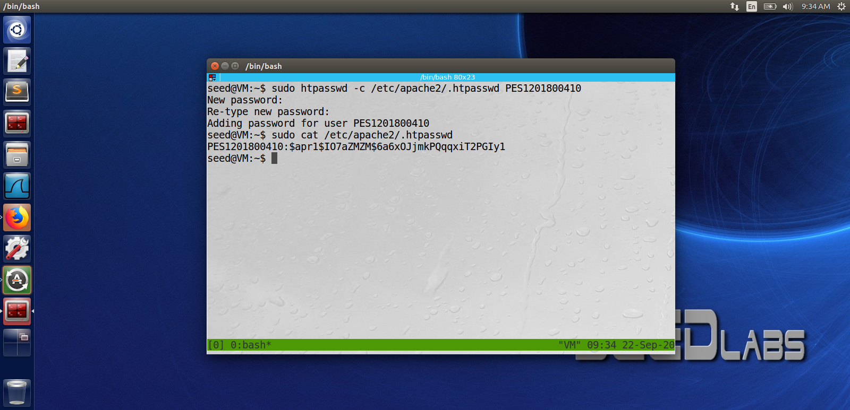

Username : PES1201800410
Password : 12345

firefox apache login page
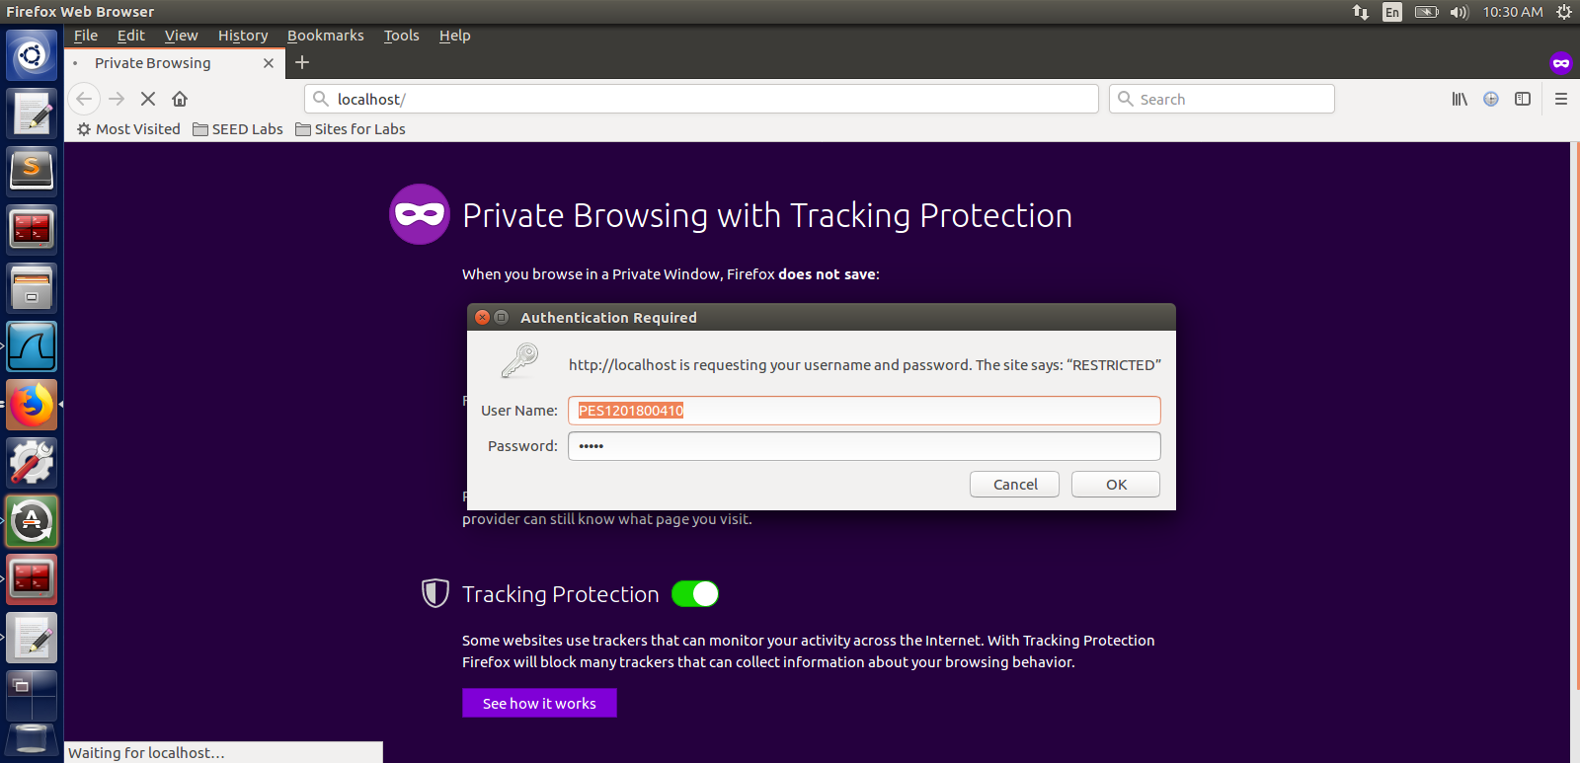

Wireshark follow TCP stream of localhost basic auth page of apache
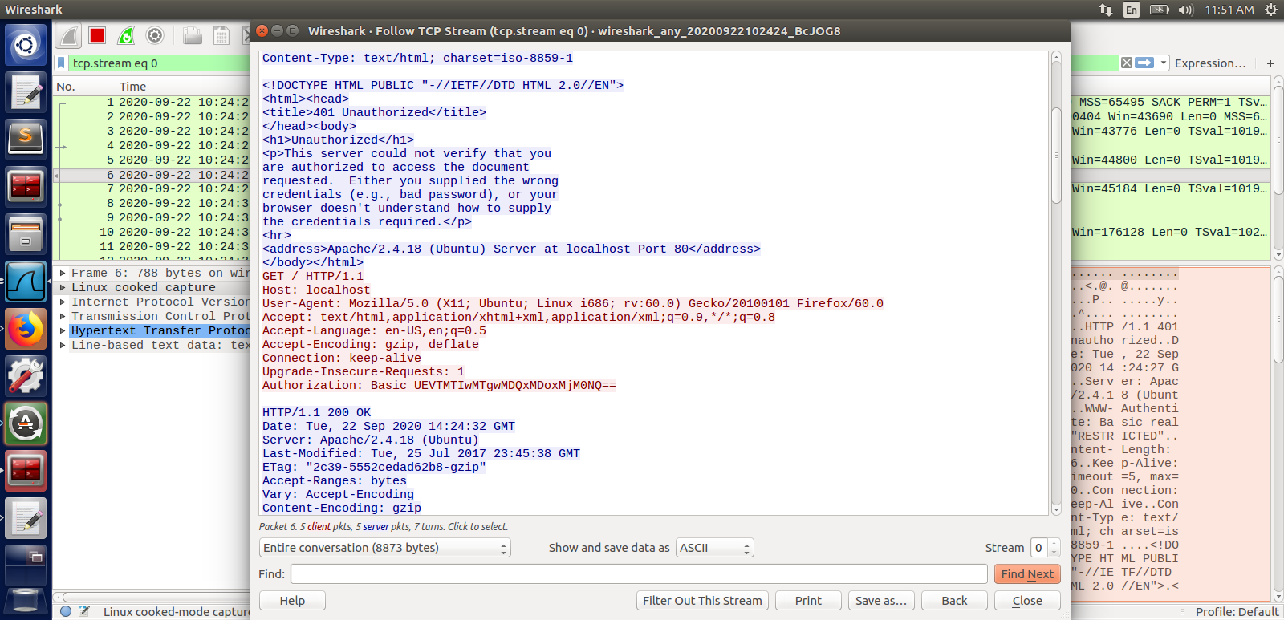

Decrypting base64 value found in wireshark
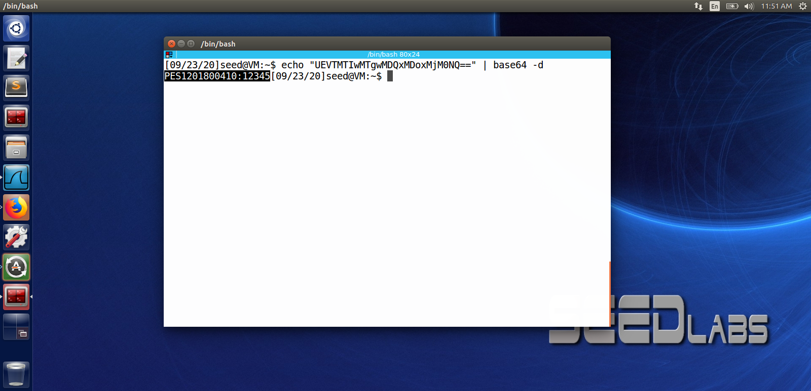

We found that it is in the format username:password which is PES1201800410:12345

website basic code

<html>
<?php
setcookie("PES120180410" , "Prashanth A R" , time() + 1000);
setcookie("rollno" , "24");
?>
<img src="sample.png" width="300" height="300" title="password" />
</html>

Wireshark capture of the cookie
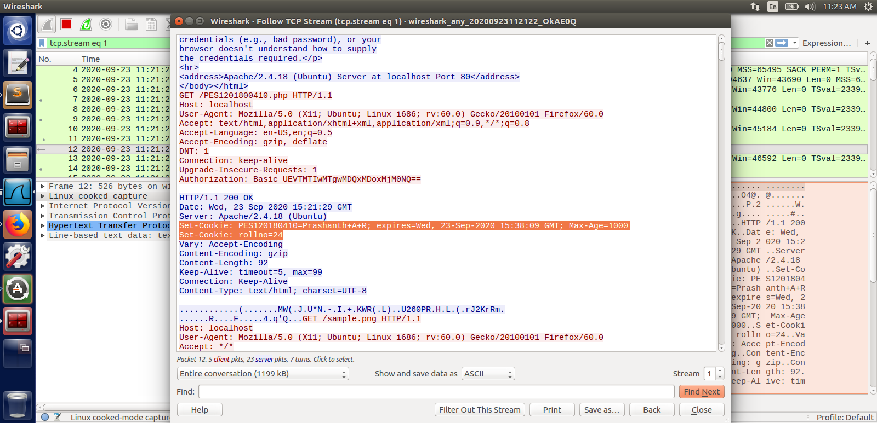
cookie 1
set-Cookie: cookie_name=Cookie_value ; expires=time when it expires ; Max-Age=time in secs

cookie 2
Set-Cookie: cookie_name=Cookie_value ; // no expire date bcz it not mentioned in the php file ie we didn’t set the expire date

wireshark IF-MODIFIED-SINCE
1st time
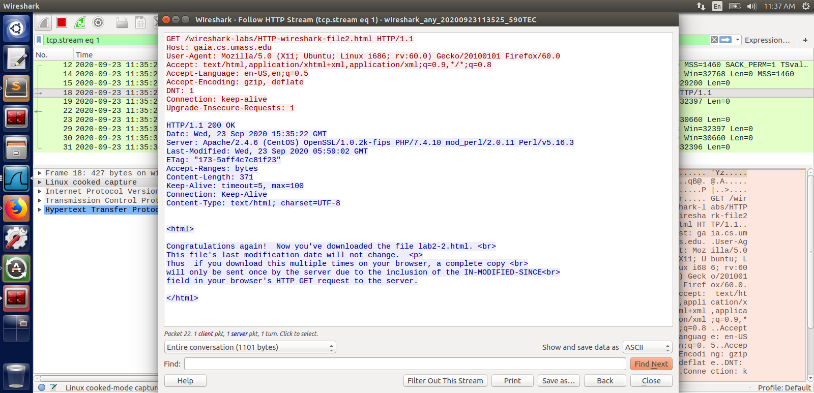
after a refresh
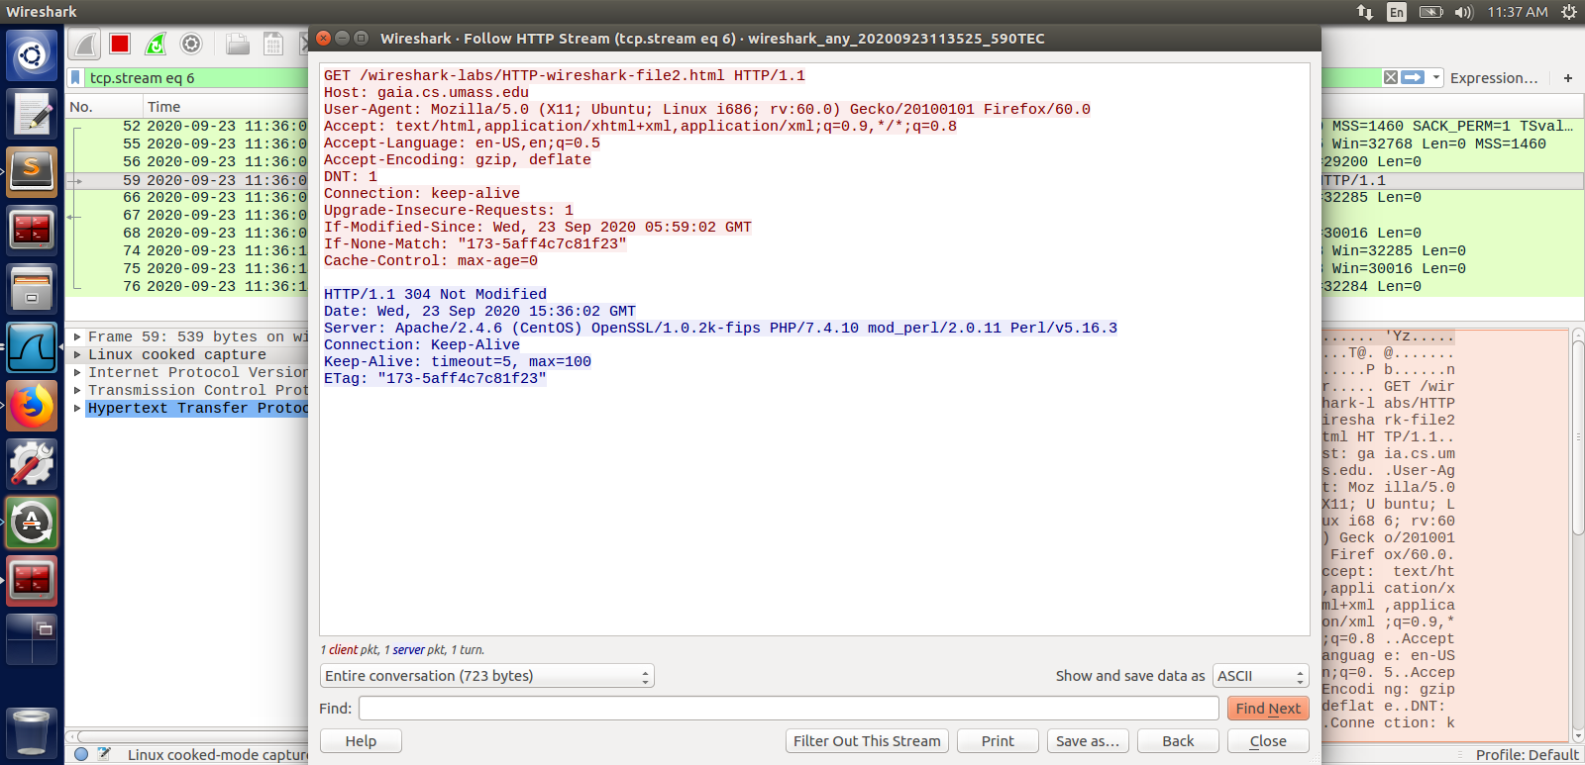

OBSERVATION

1.Inspect the contents of the first HTTP GET request from your browser to the server. Do you see an “IF-MODIFIED-SINCE” line in the HTTP GET?

Ans: NO

2.Inspect the contents of the server response. Did the server explicitly return the contents of the file? How can you tell?

Ans: yes because we got response code 200 which tells file is found and successfully retrived from the server.

3.Now inspect the contents of the second HTTP GET request from your browser to the server. Do you see an “IF-MODIFIED-SINCE:” line in the HTTP GET? If so, what information follows the “IF-MODIFIED-SINCE:” header?

Ans: Yes we find “IF-MODIFIED-SINCE:” header in the second HTTP GET request
which contains “IF-MODIFIED-SINCE:Wed, 23 Sep 2020 05:59:02 GMT”

4.What is the HTTP status code and phrase returned from the server in response to this second HTTP GET? Did the server explicitly return the contents of the file? Explain.

Ans: status code is 304 which is content not modified
No server didn’t explicitly return the contents of the file because the file content was not modified from the last request there fore it the client that content is not modified hence old content can be reused.

