PES1201800410, sec G, rollno 24 , Prashanth A R

Task 1: Linux Interface Configuration(ifconfig / IP command)

Step 1:

ip address table
Interface name | Ip address | Mac address
eth0 | (not in use so not assigned) | 08:97:98:9c:90:19
mpqemubr0 | 10.225.240.1 | 52:54:00:76:85:8c
wlan0 | 192.168.43.149 | D2:F8:8C:FA:7F:5F
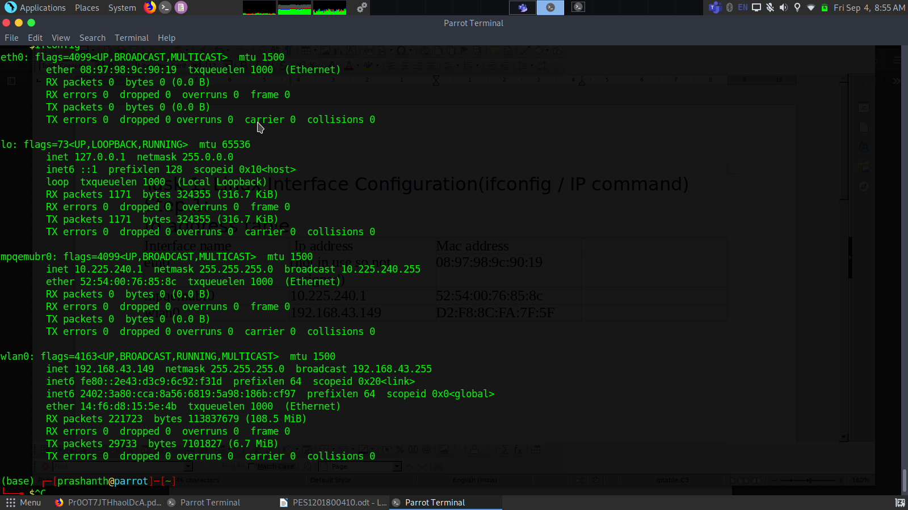

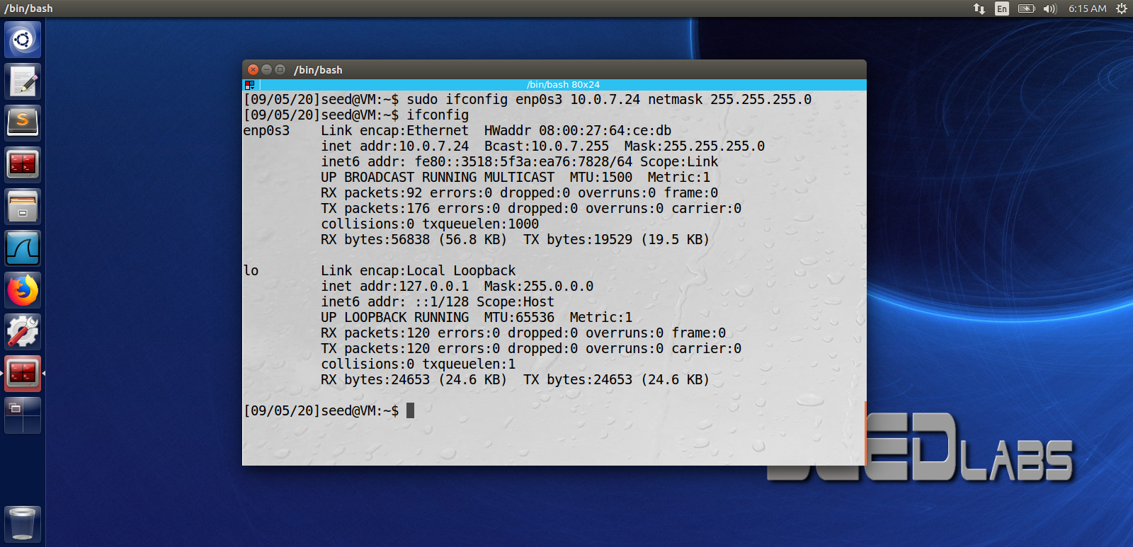
step 2:
step 3 + step 4

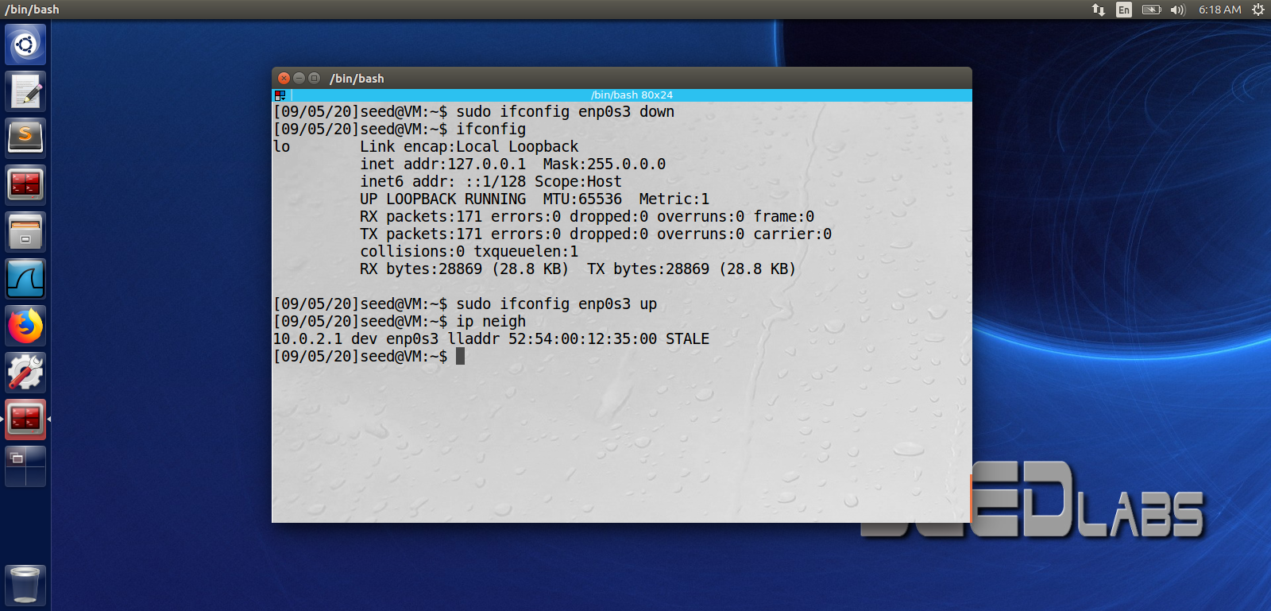

Task 2 :Ping PDU (Packet Data Unitsor Packets) Capture

Details | First Echo Request | First Echo Reply
Frame number | 3 | 4
Source IP address | 10.0.7.24 | 10.0.7.24
Destination IP address | 10.0.7.24 | 10.0.7.24
ICMP Type Value | 8 | 0
ICMP Code Value | 0 | 0
Source Ethernet Address | 00:00:00:00:00:00 | 00:00:00:00:00:00
Destination Ethernet Addres | 00:00:00:00:00:00 | 00:00:00:00:00:00
Internet Protocol Version | 4 | 4
Time To Live (TTL) Value | 64 | 64

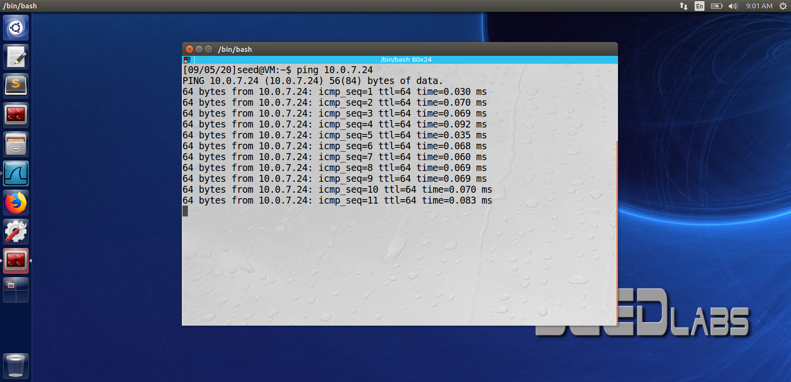

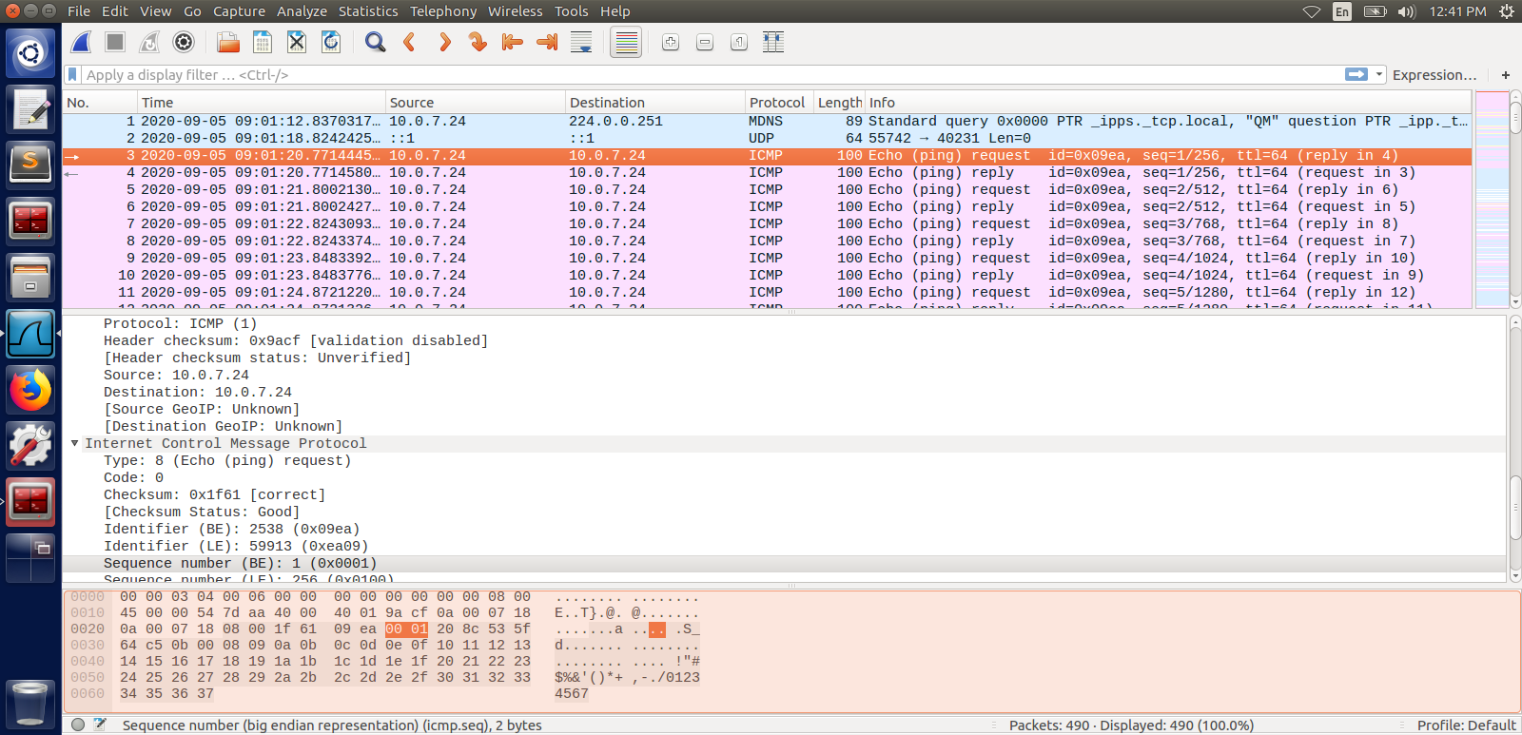

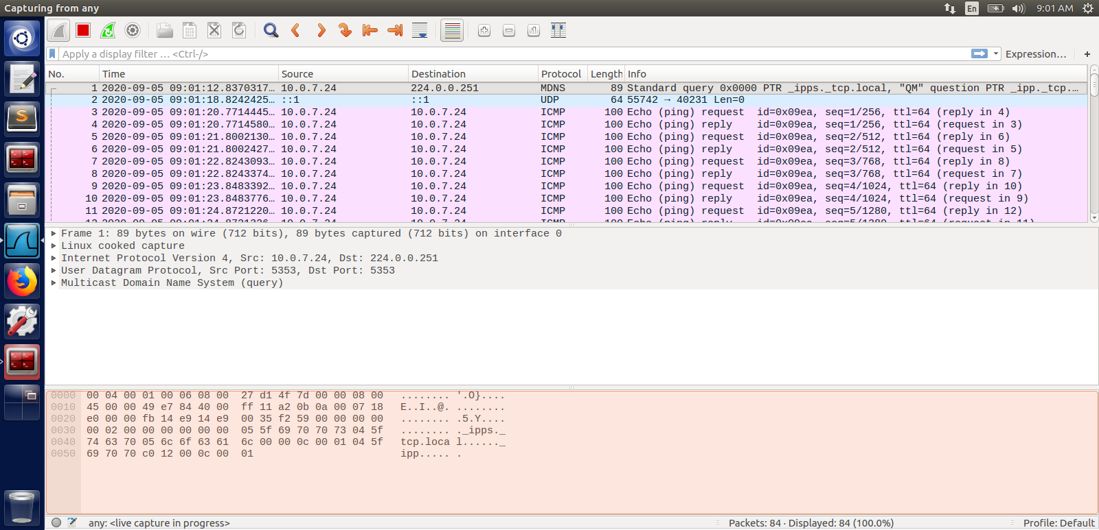

Task 3 :HTTP PDU Capture

Details | First Echo Request | First Echo Reply
Frame number | 423 | 424
Source port | 42232 | 80
Destination port | 80 | 42232
Source IP address | 10.0.2.5 | 163.53.78.110
Destination IP address | 163.53.78.110 | 10.0.2.5
Source Ethernet Address | 08:00:27:d1:4f:7d | 52:54:00:12:35:00
Destination Ethernet Addres | nan | nan

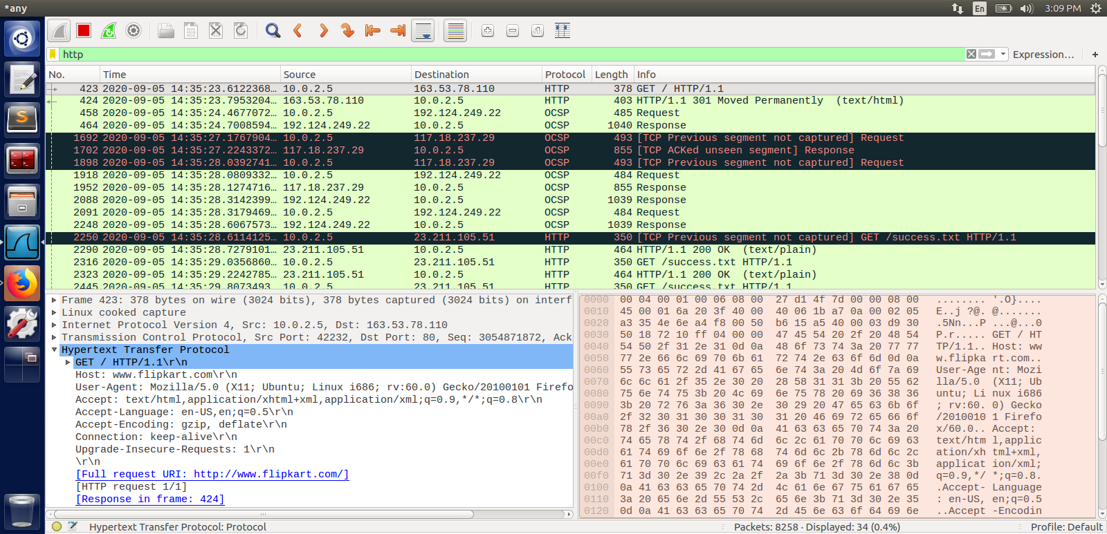
HTTP Request |  | HTTP Response
Get | HTTP/1.1 | Server | nginx
Host | Www.flipkart.com | Content-Type | text/html
User-Agent | Mozilla/5.0(X11; Ubuntu; Linux i686; rv:60.0) Genko/20100101 Firefox/60.0 | Date | Sat, 05 Sep 2020 18:35:23 GMT
Accept-Language | en-US,en;q=0.5 | Location | https://www.flipkart.com/
Accept-Encoding | gzip, deflate | Content-Length | 178
Connection | keep-alive | Connection | nan

Using Wireshark’s Follow TCP Stream
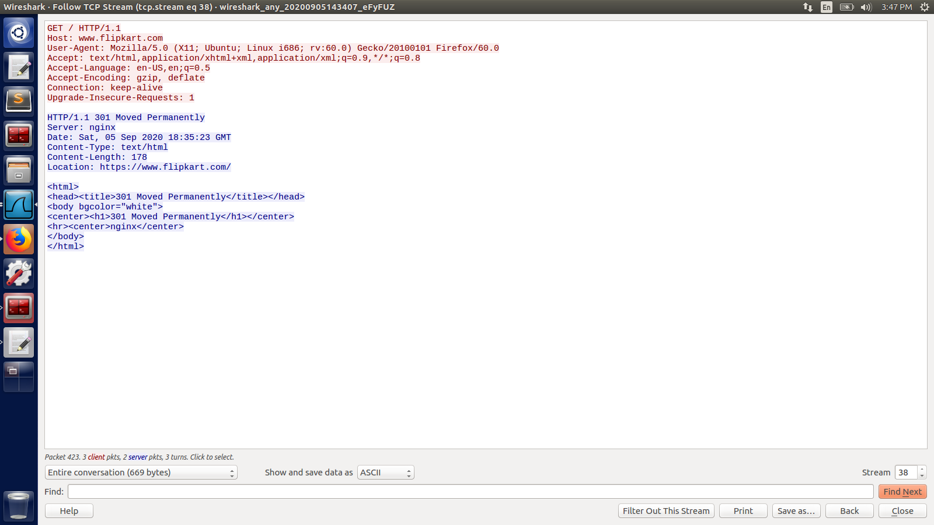

Task 4: Capturing packets with tcpdump

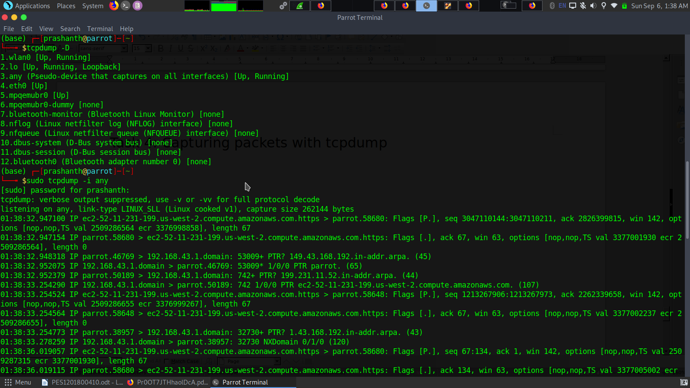
format:
timestamp , ipv4 or ipv6 , src ip.port > dst ip.port , tcp flags and respective infomations

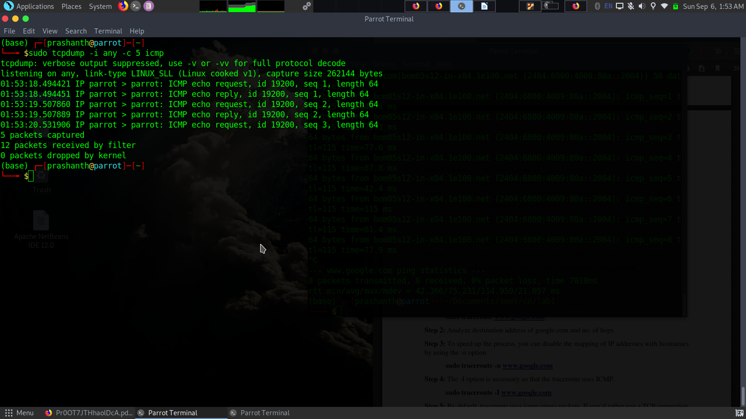

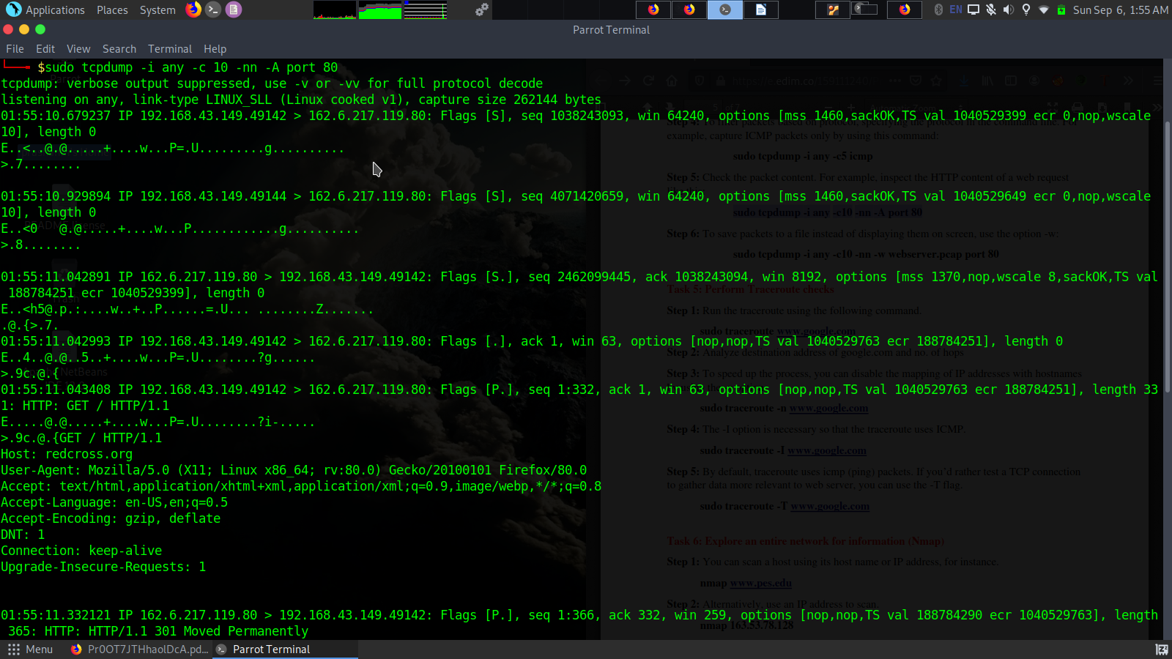
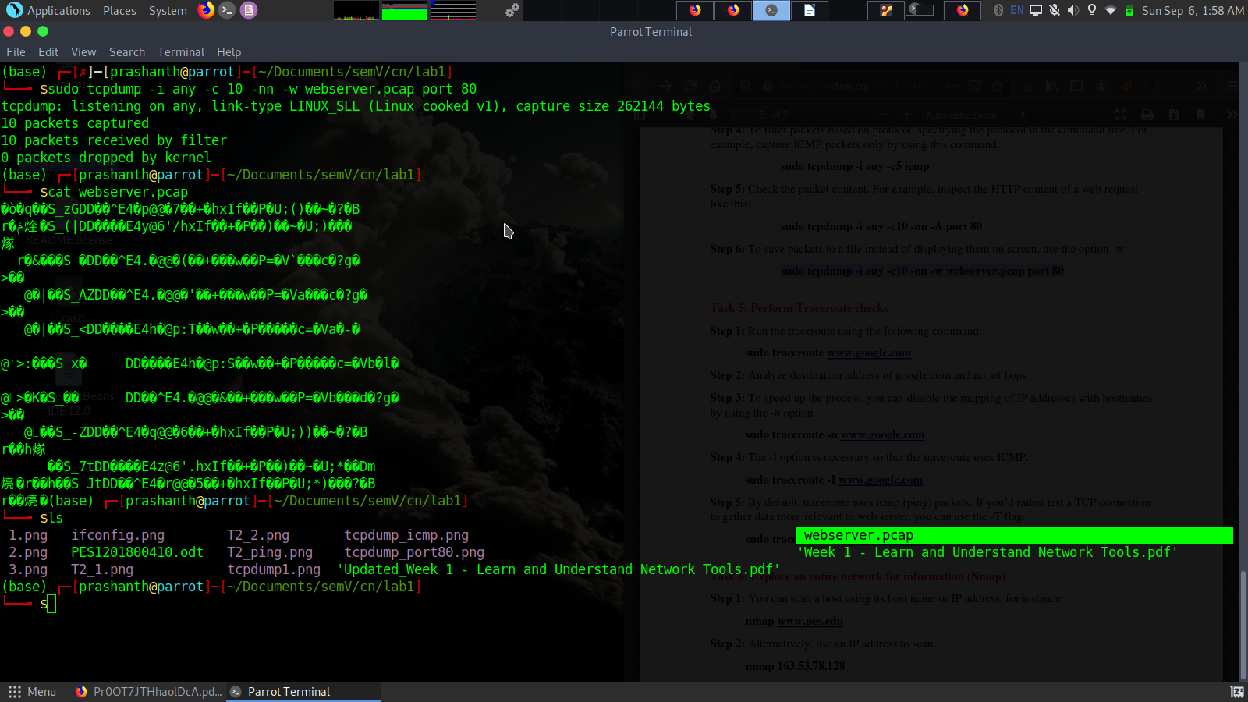

Task 5: Perform Traceroute checks

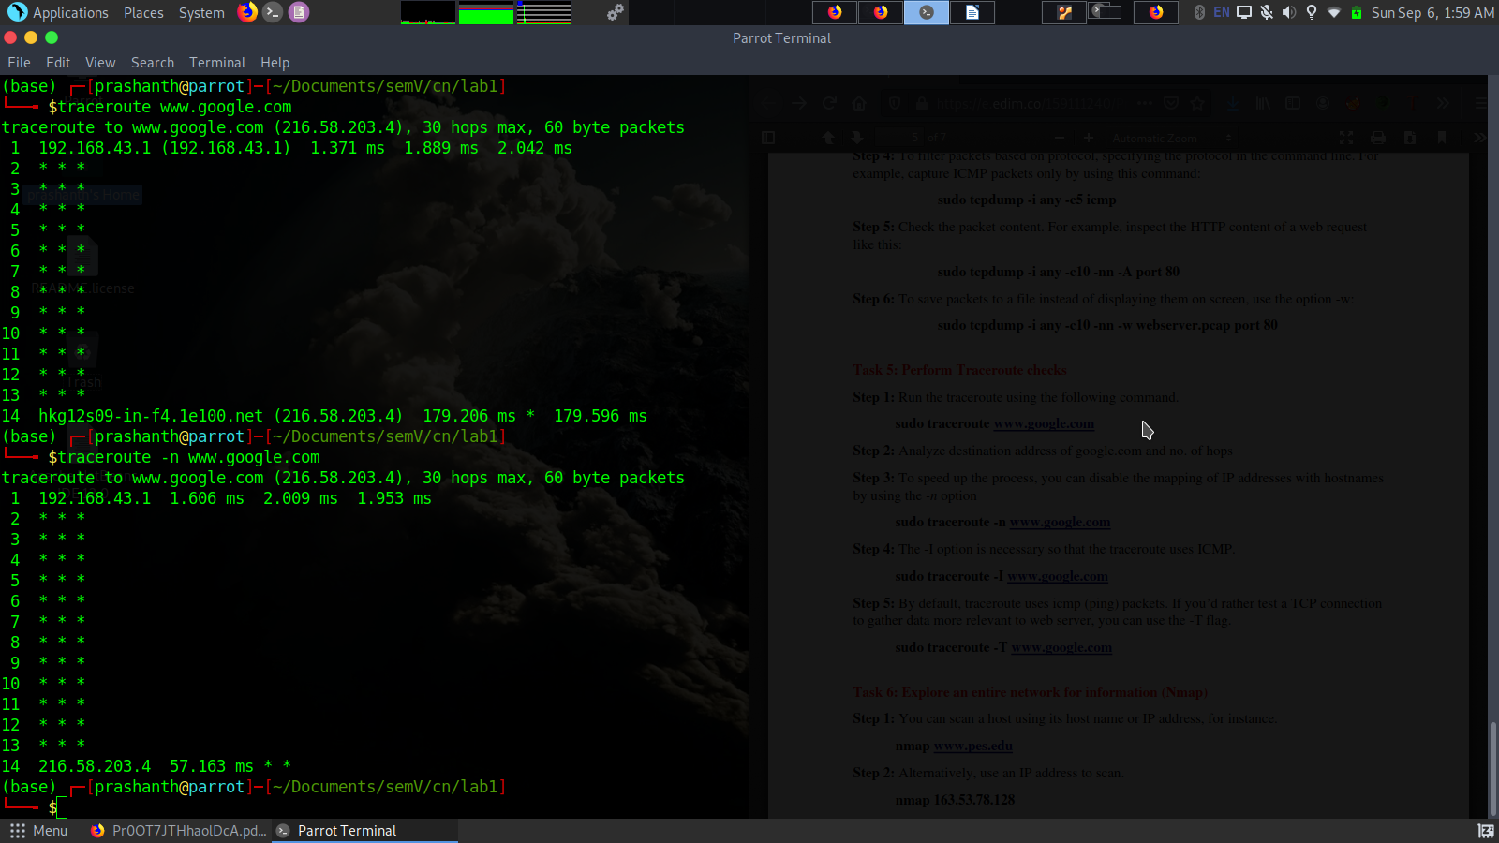

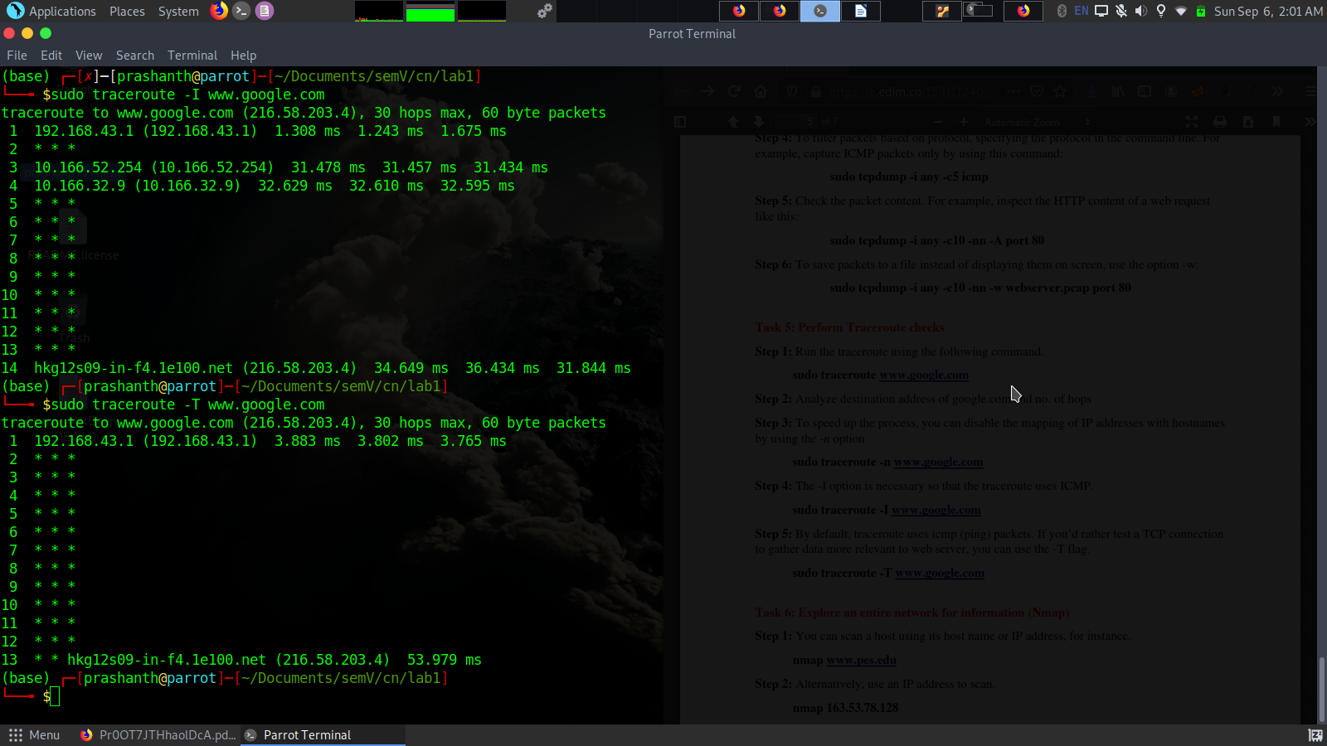

Task 6:Explore an entire network for information(Nmap)
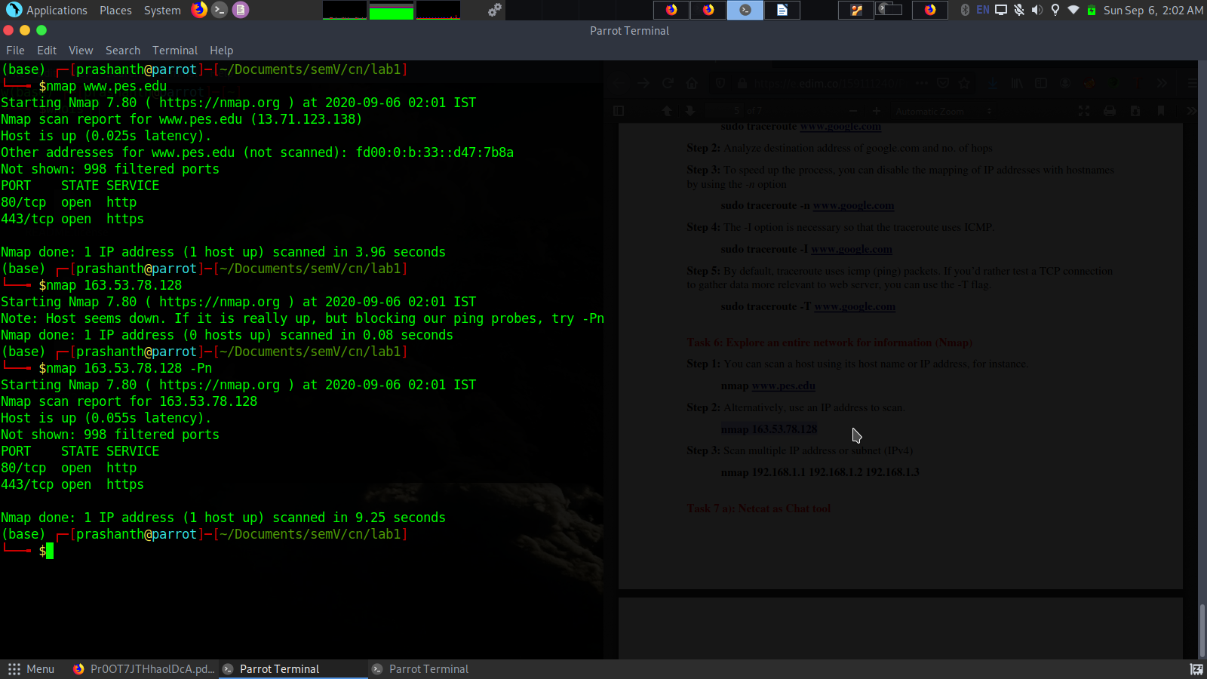

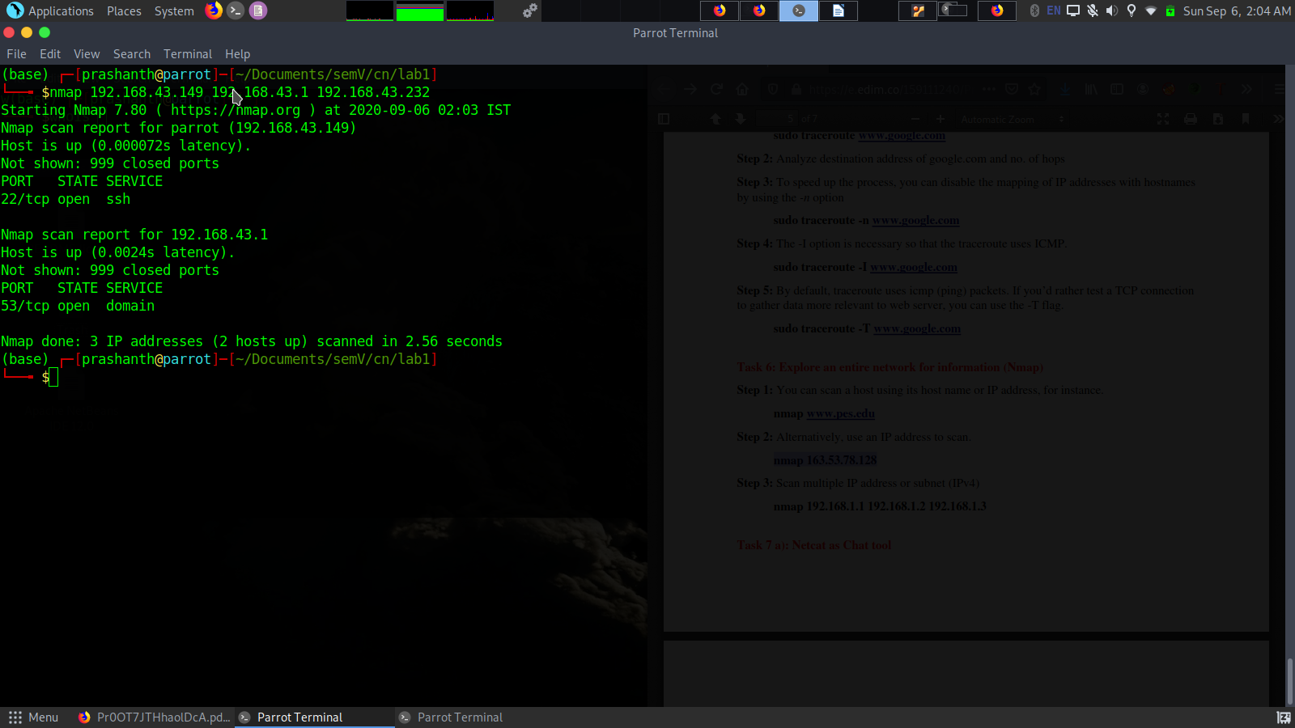

Questionson above observations:

1)Is your browser running HTTP version 1.0 or 1.1? What version of HTTP is the server?
Ans: HTTP 1.1

2)When was the HTML file that you are retrieving last modified at the server?
Ans:
Tue, 26 May 2020 22:22:26 GMT --this is from the website i visited

3)How to tell ping to exit after a specified number ofECHO_REQUESTpackets?
Ans: By using -c flag
eg $ping -c 5 www.google.com

4)How will you identify remote host apps and OS?
Ans: By using -O Os-detection in nmap
-A to give details about the apps running on the host at a perticular port (there are many different options -A is just one way to go)
eg $nmap www.pes.edu -O -A

