PES1201800410 sem V Prashanth A R

Private Ethereum By Example
creation of docker container
docker run -it ethereum/client-go:alltools-stable
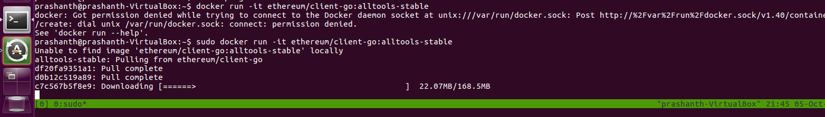

create a new account in all the three nodes
geth --datadir ./datadir account new
node 1
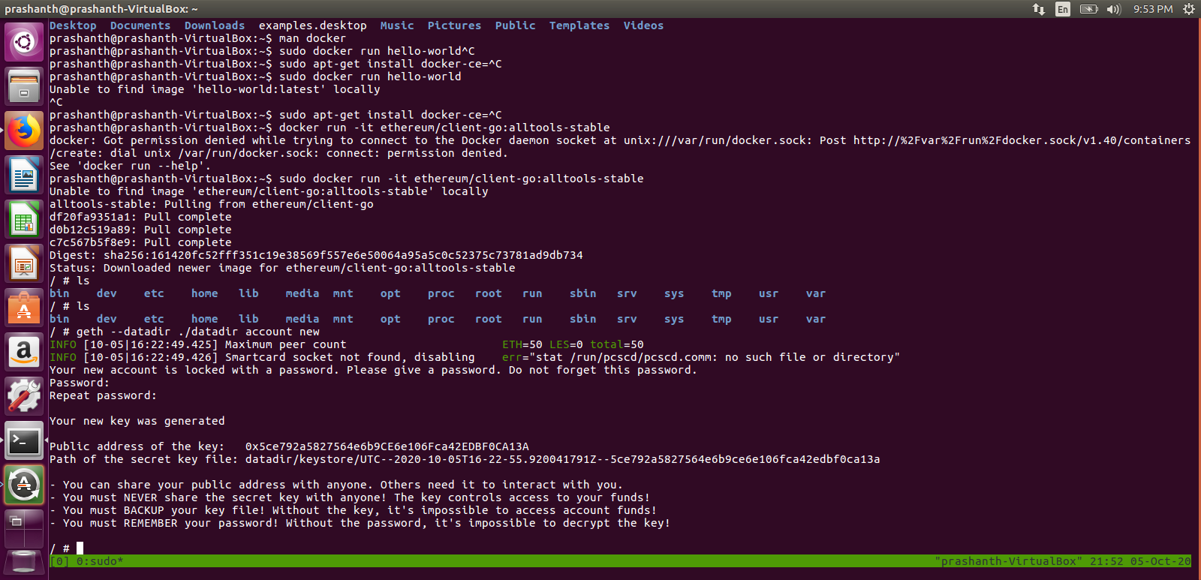
node 2
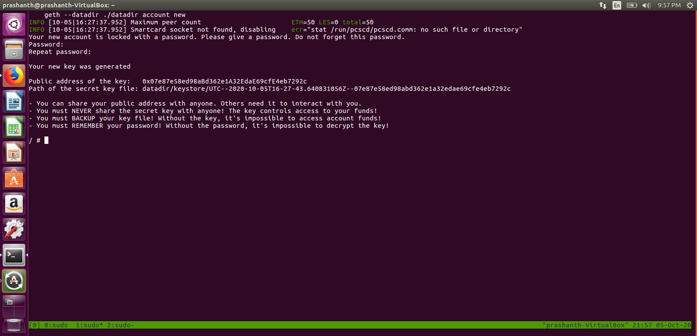

node 3
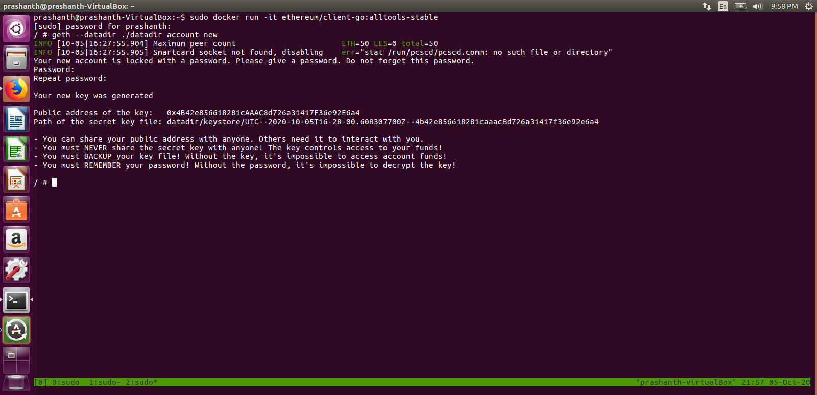
Puppeth

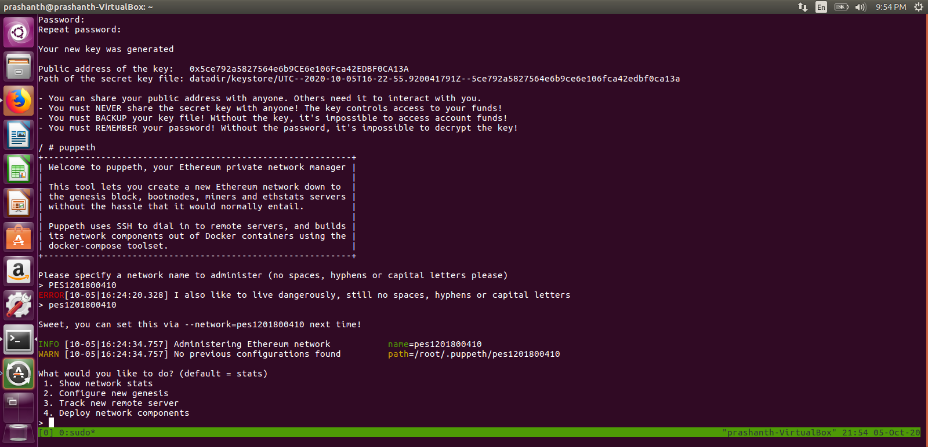
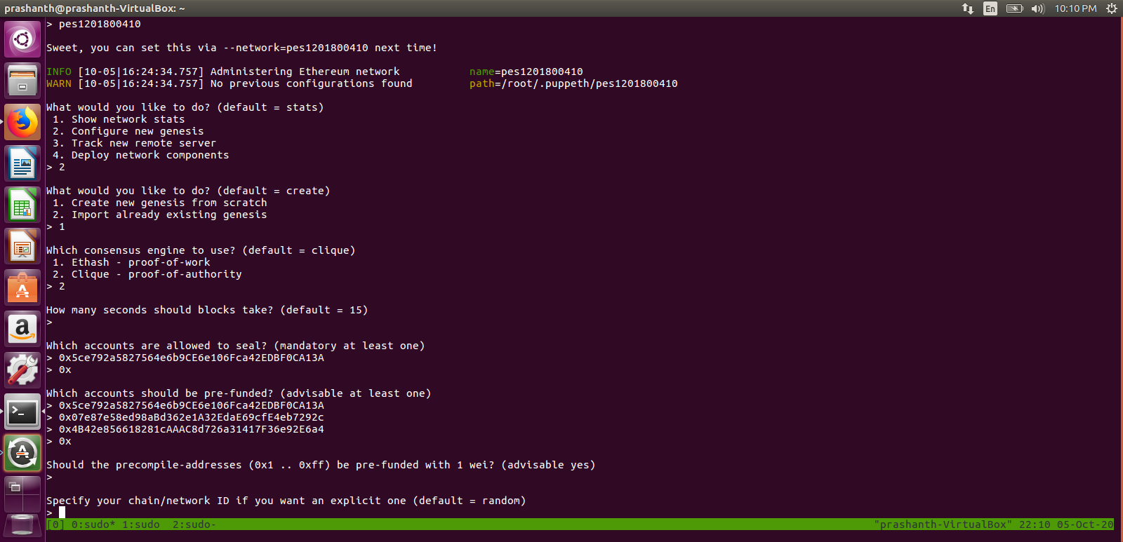

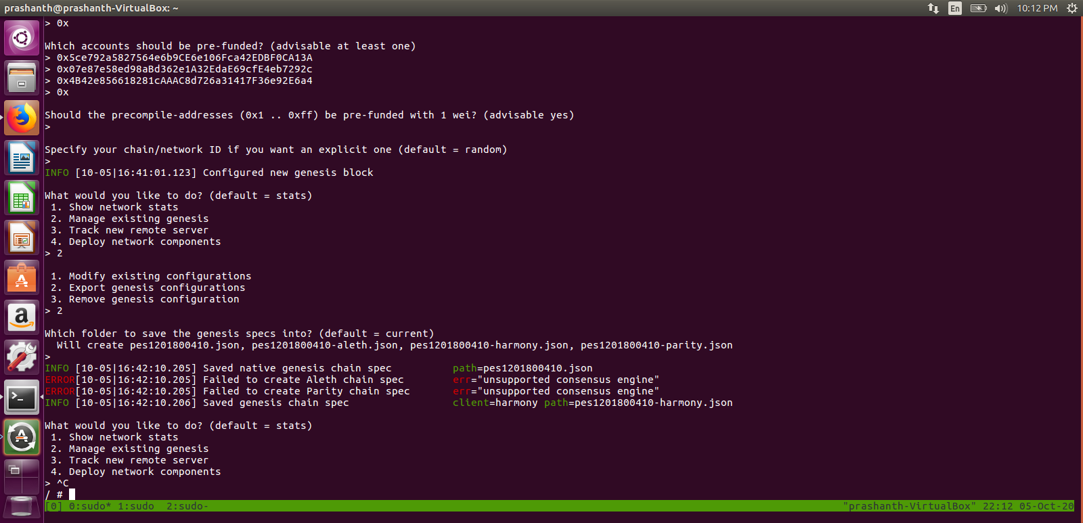

renaming to genesis.json and removing harmony.json
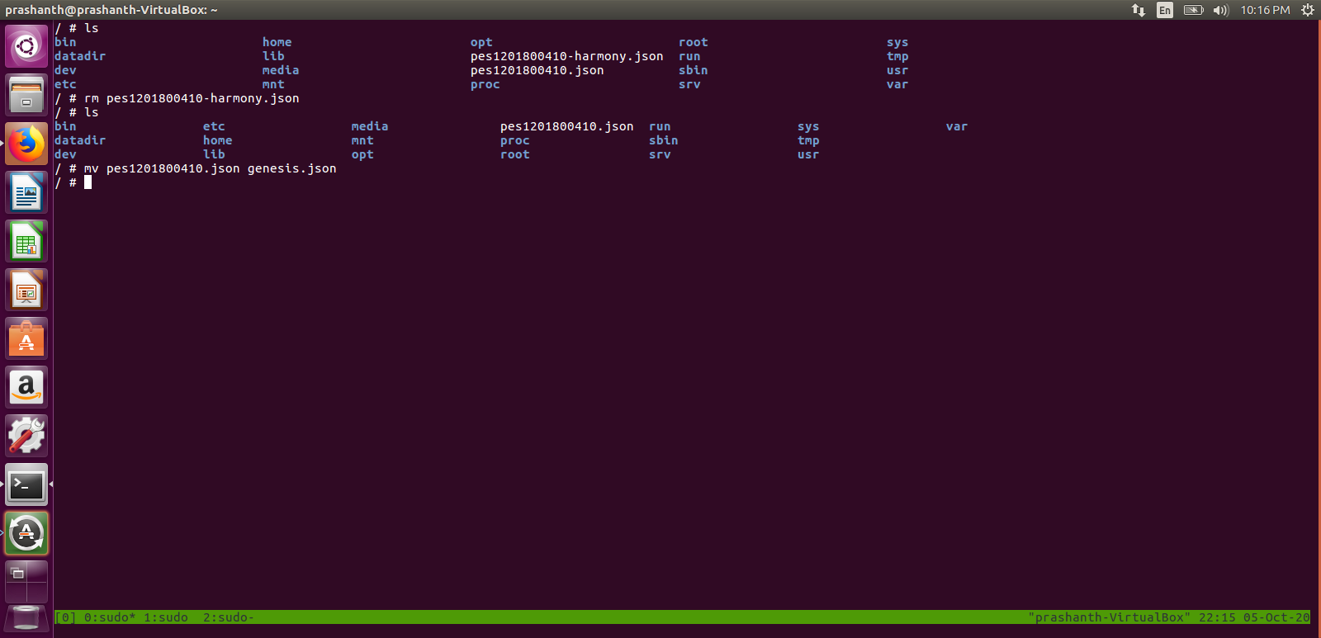
copy genesis.json to all the three nodes
geth --datadir ./datadir init genesis.json
on node 1
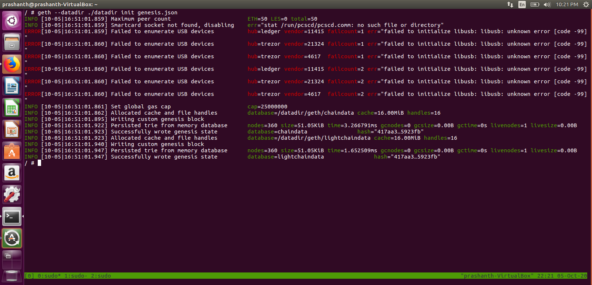
on node 2

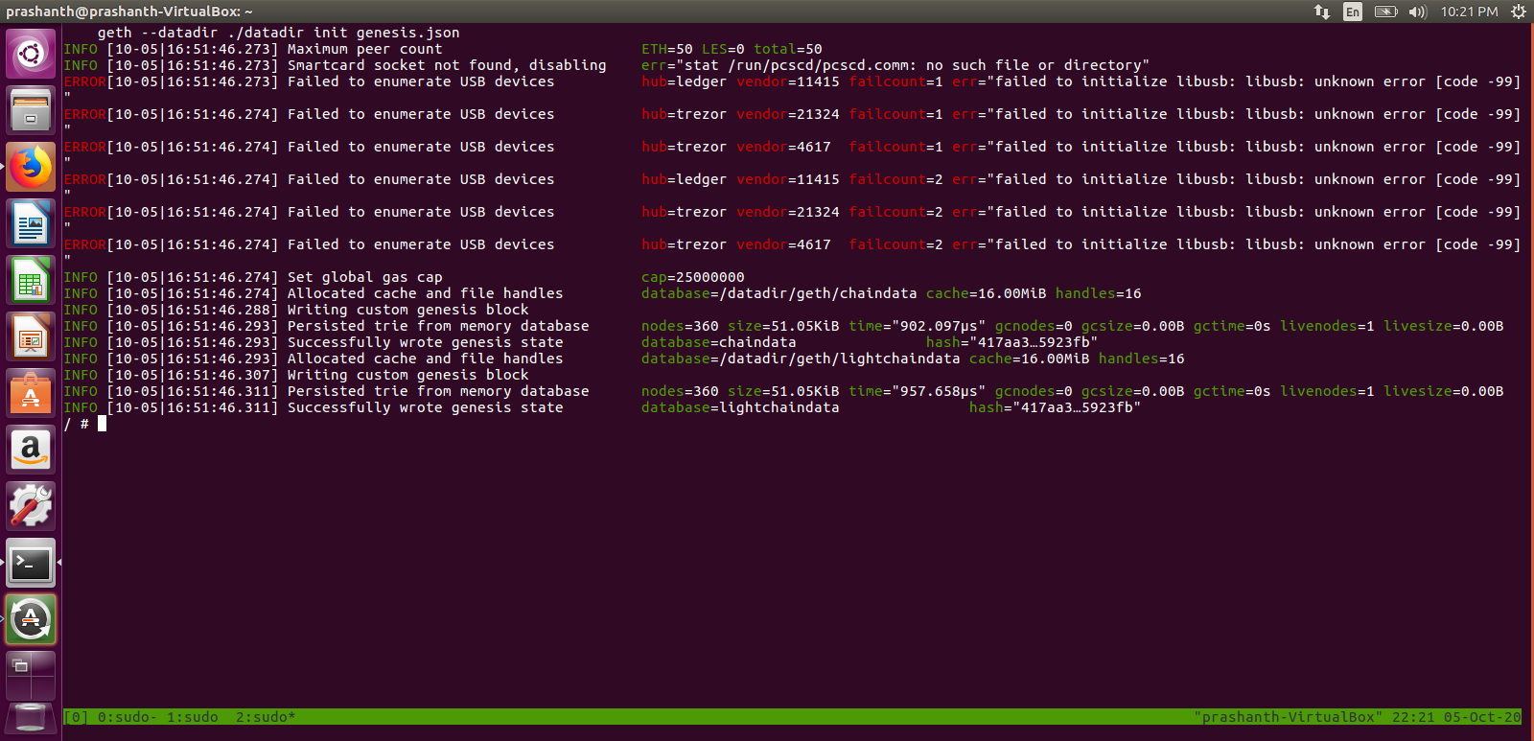
on node 3

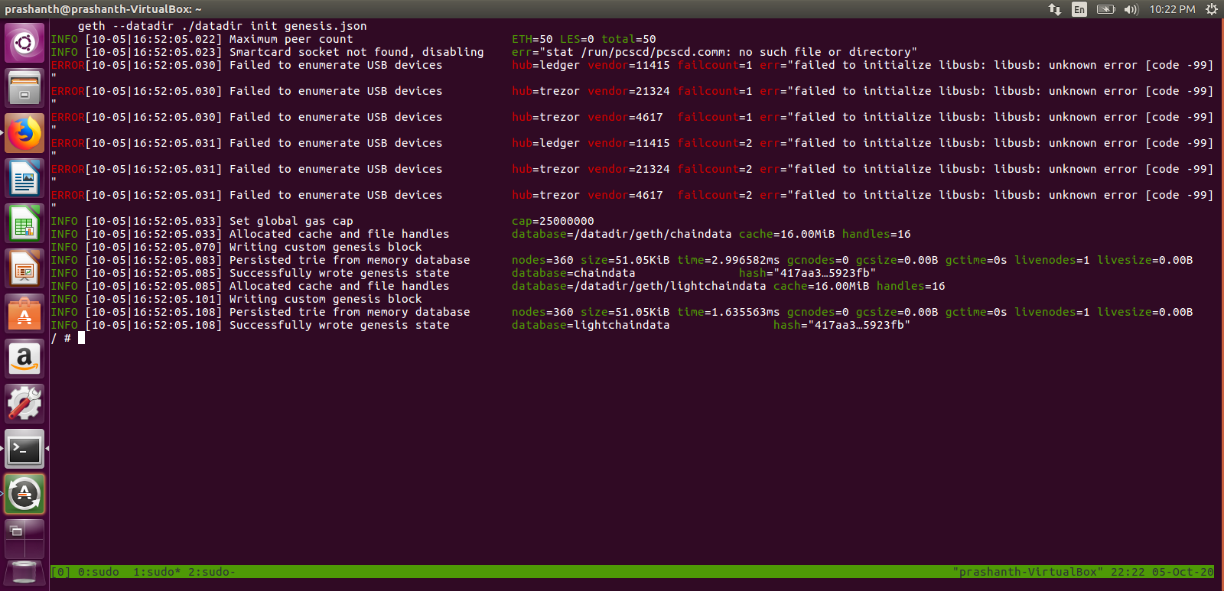
connecting to the blockchain network
geth --datadir ./datadir --nat extip:`hostname -i` console
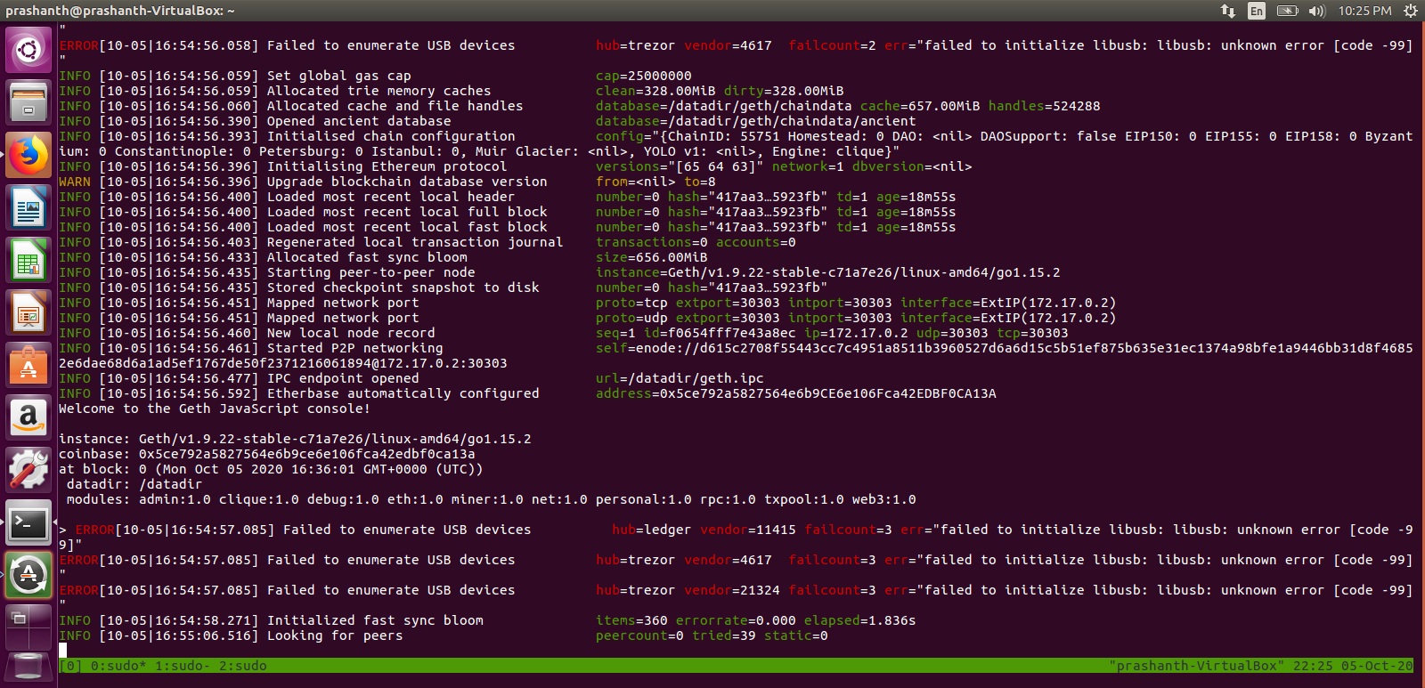
let try with by loggin in
password.txt
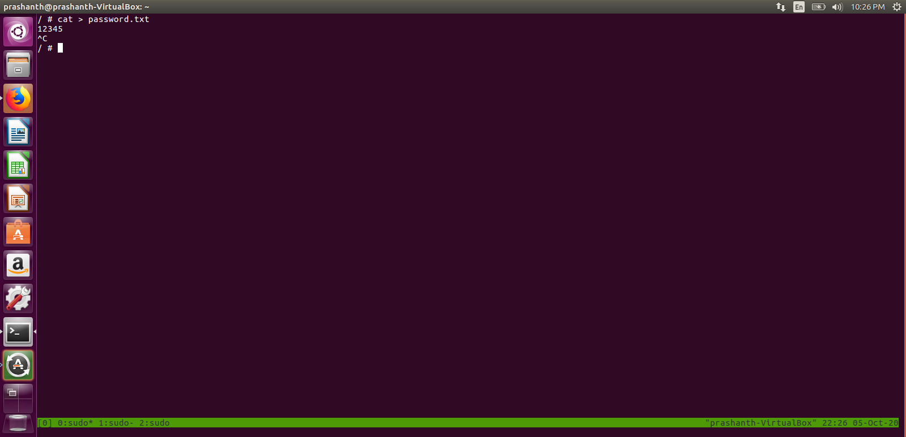
node 1
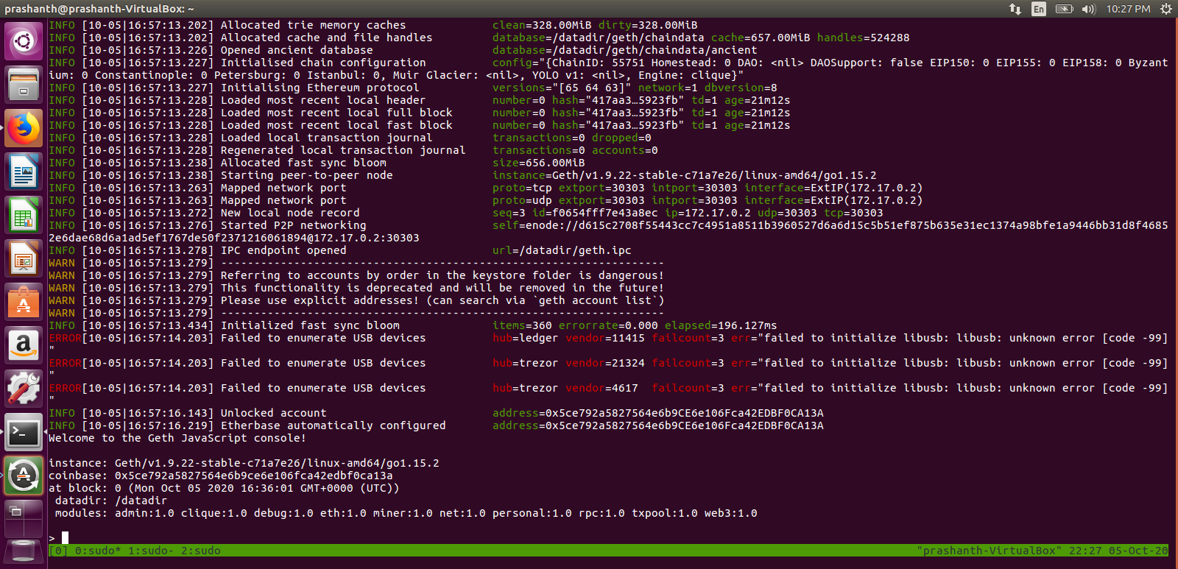
node 2 similar to node 3
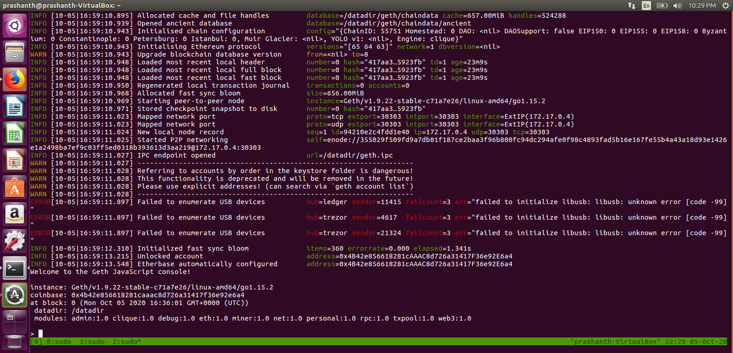
find node address using admin.nodeInfo.enode to add peers
node 1 info
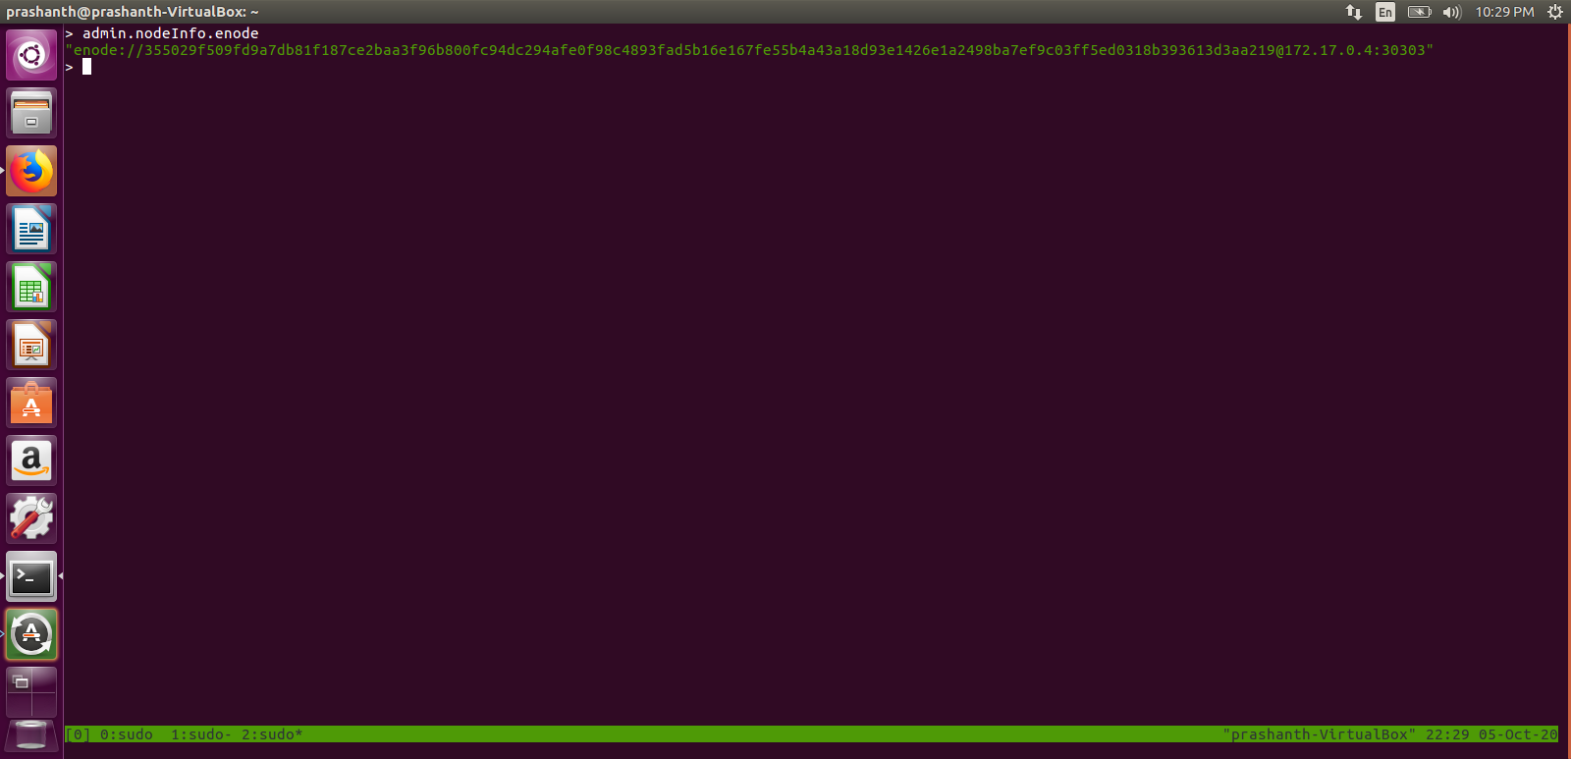
node 2 info
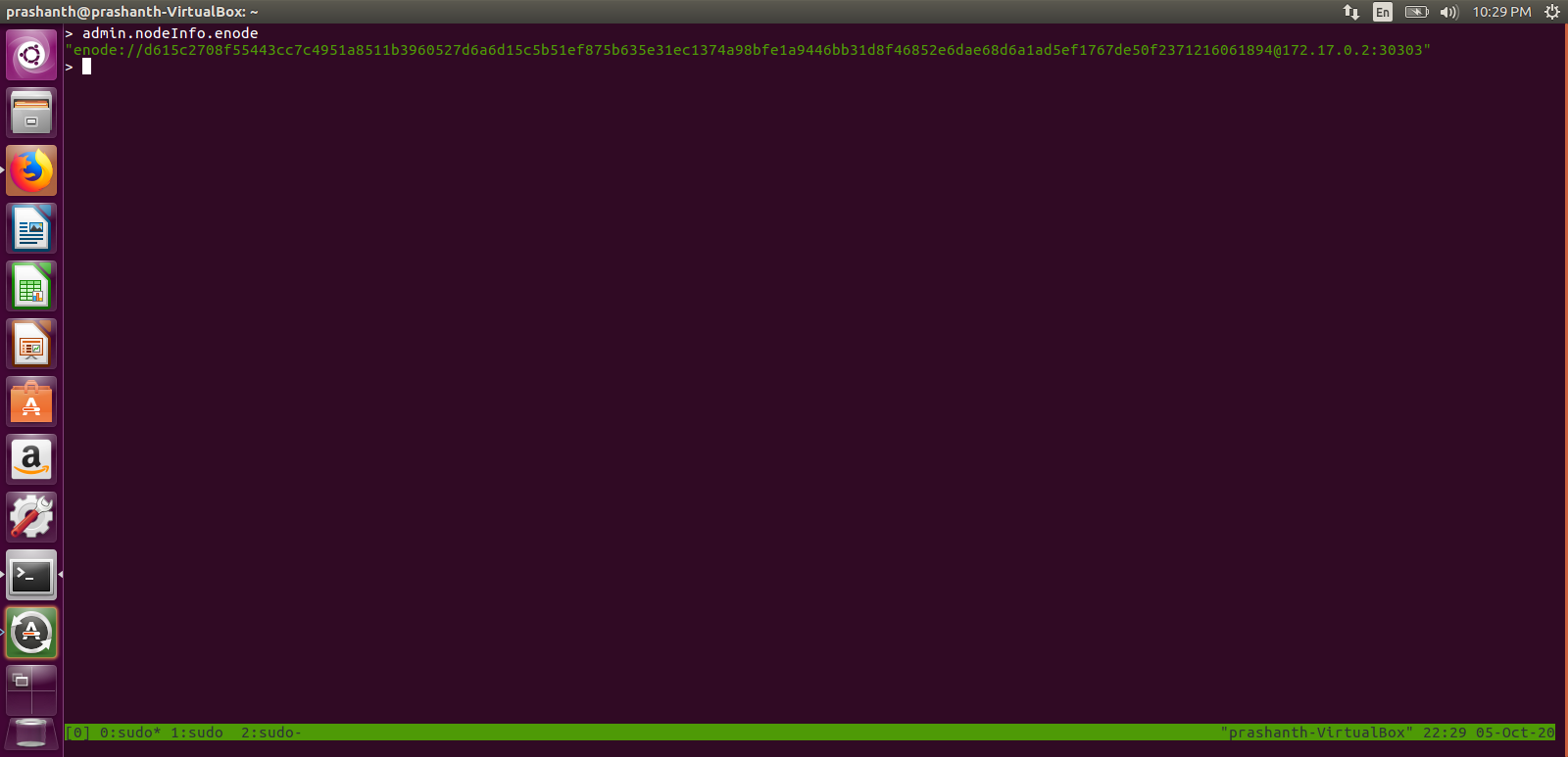
node 3 info
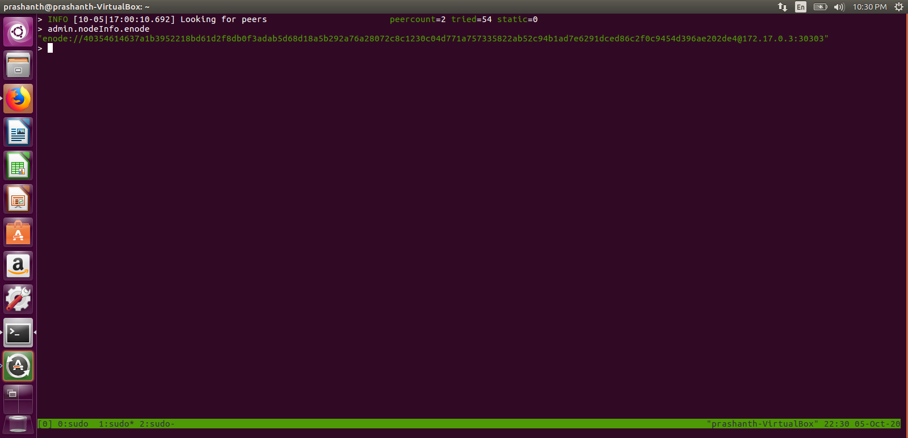
add peers using admin.addPeer(“client address”)

list all peers using admin.peers
for node 1
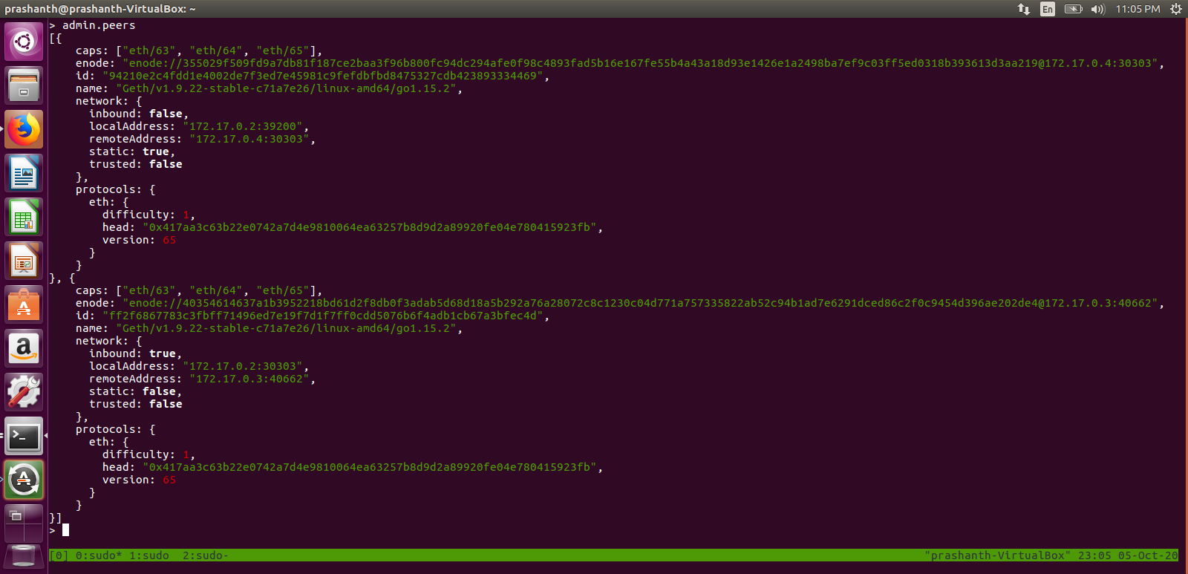
node 2 peers
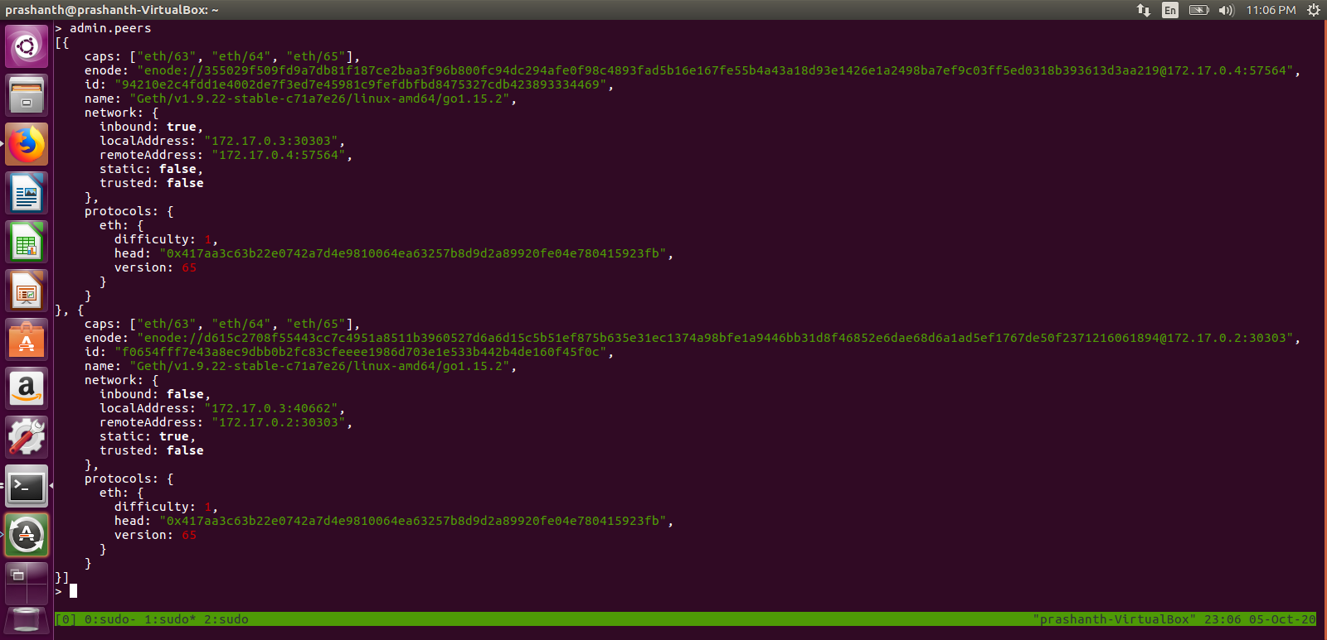
node 3 peers
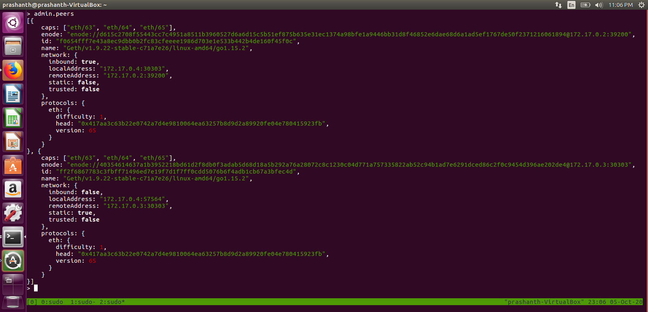
start mining
miner.start(1)
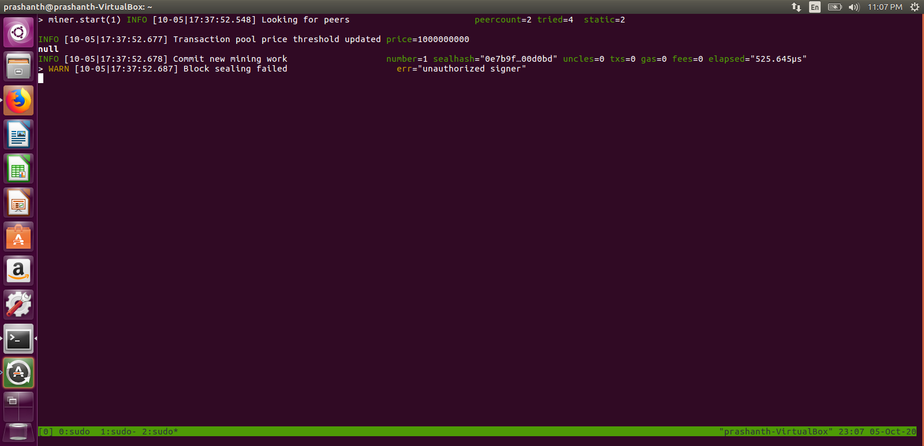
we can observer we don’t have authority to start mining
so we go to authorized node and start mining
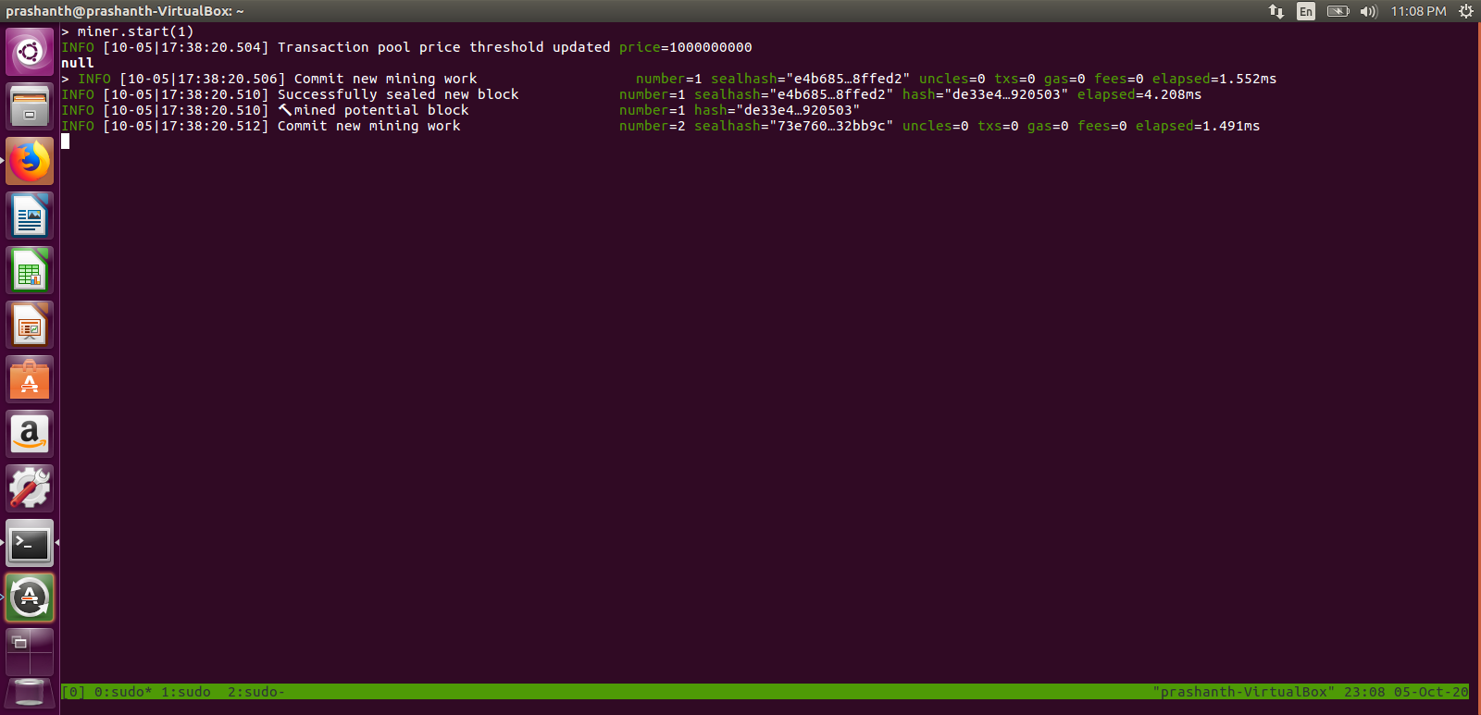
mining logs on all nodes
node 2 logs
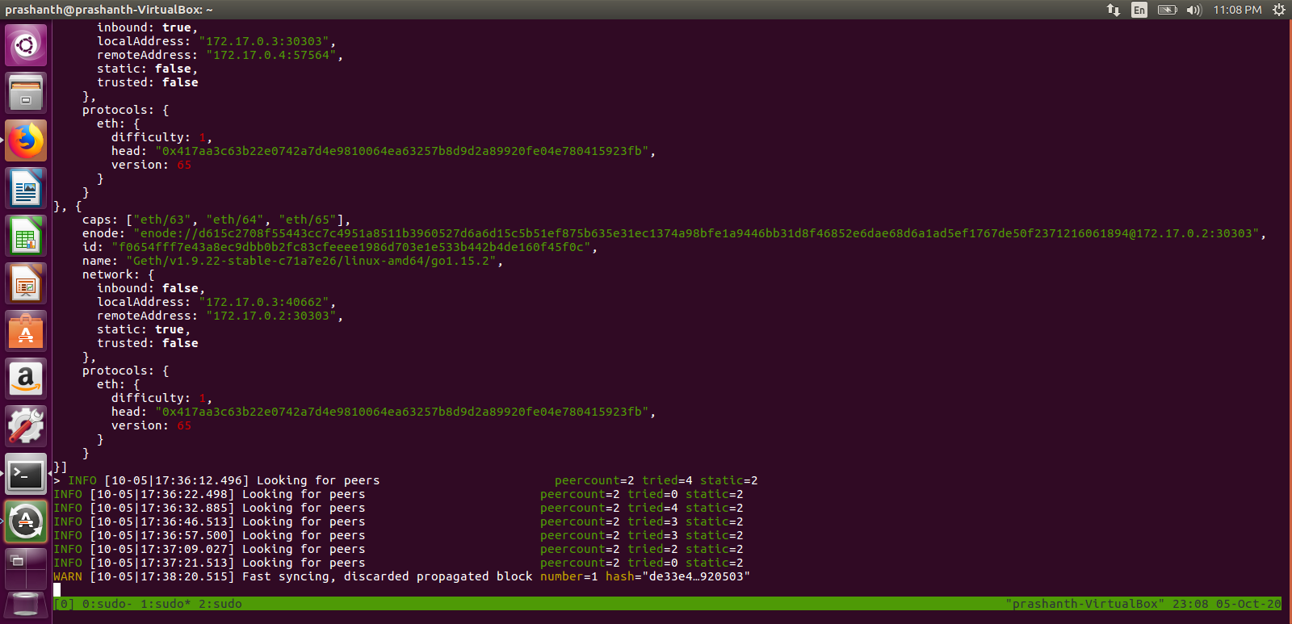

node 3 logs
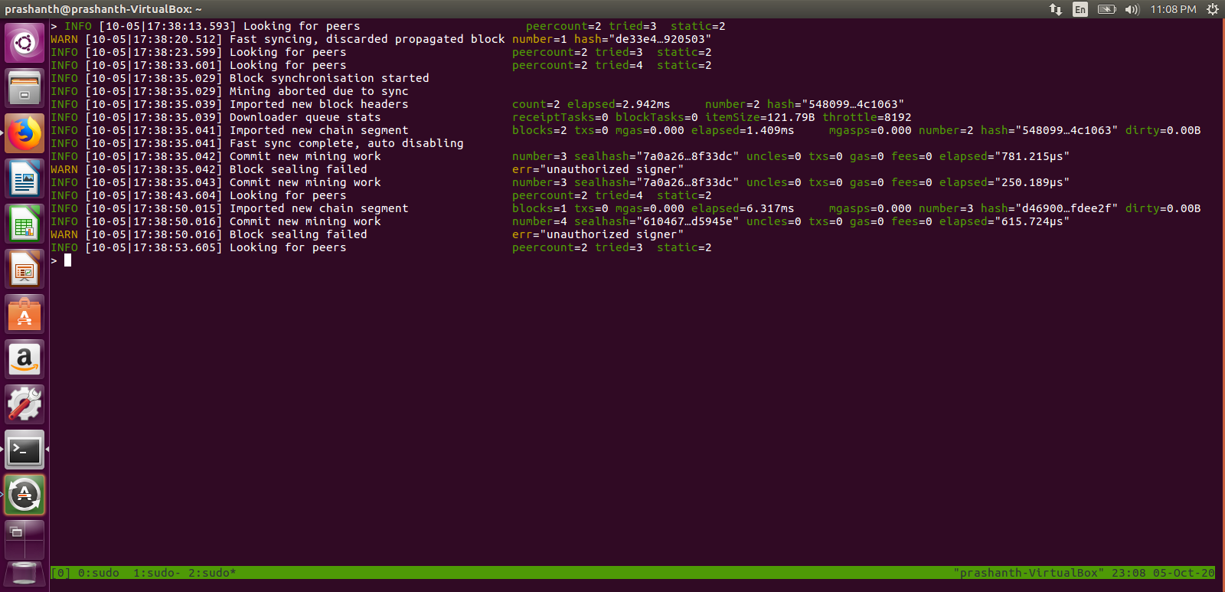
we can observer a block is created every 15 secs

