PES1201800410 sem V roll no 24 Prashanth A R

WEEK 10-11

Week 10
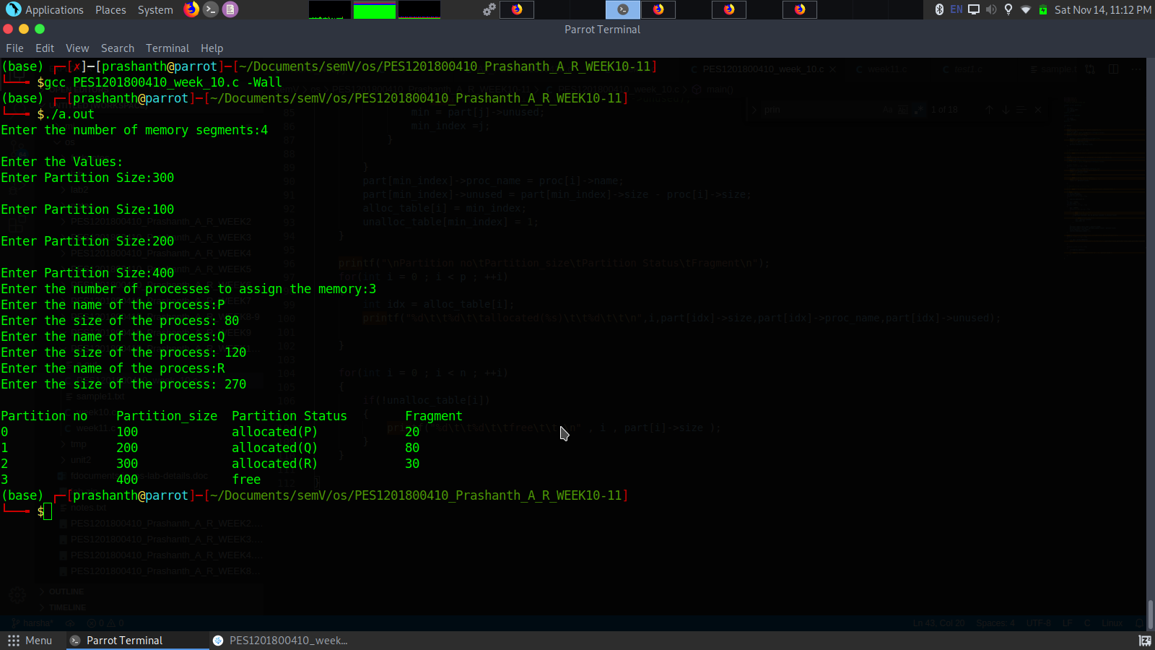
Week 11
