PES1201800410 sem V roll no 24 A R PRASHANTH

Week 12 – 13

Week 12

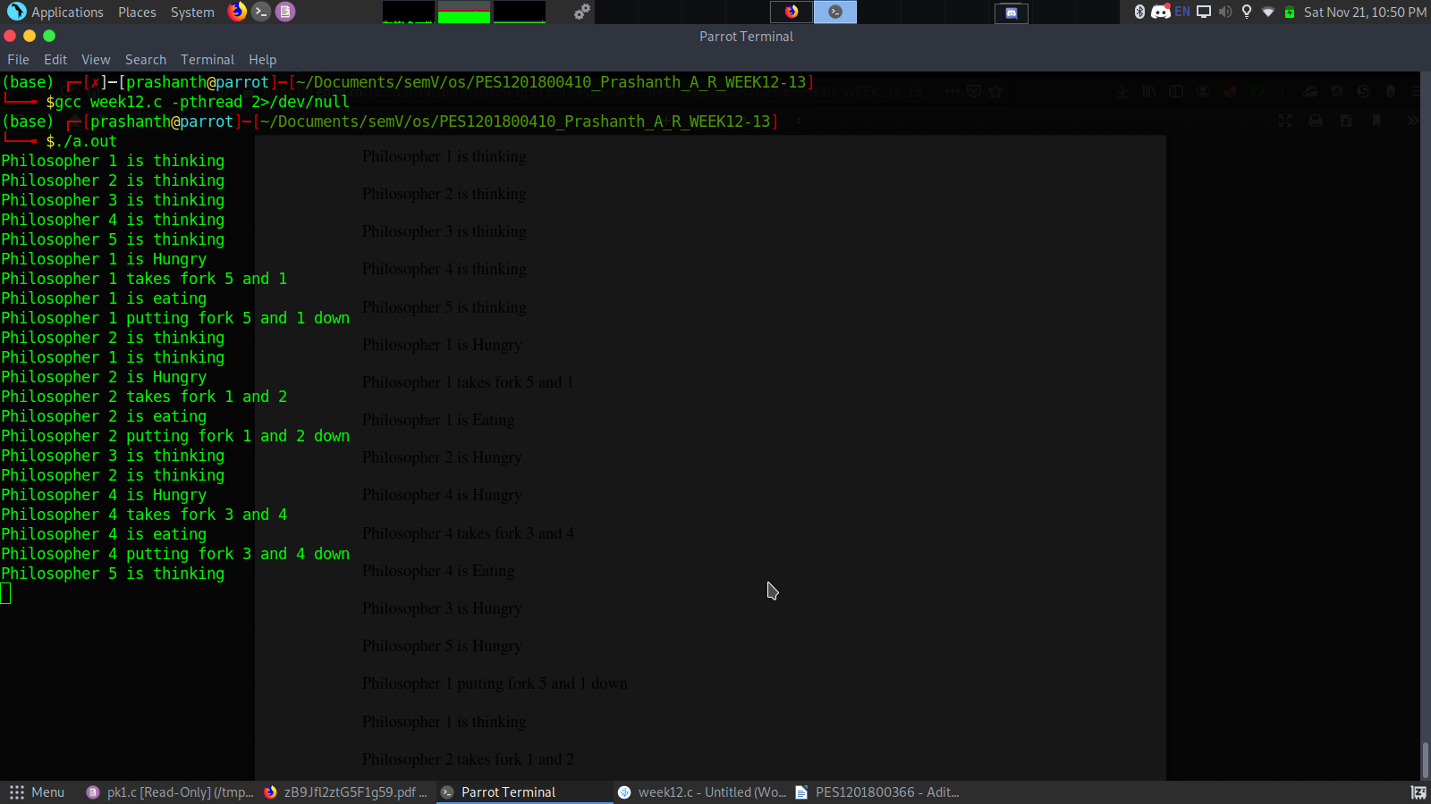
Week 13

