PES1201800410 sec:G roll_no:24 Prashanth A R

Exercise1

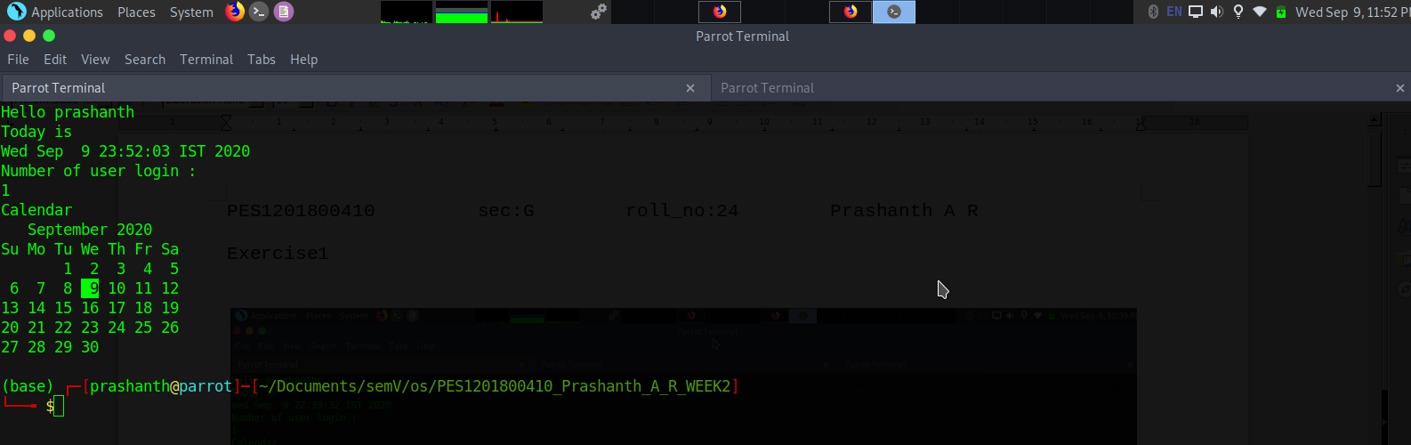

exit 0 indicates that the program has been successfully completed.
$ - is a used to use the variable defined already

Exercise2

1) If you want to print your home directory location then you give command:
a) echo $HOME
we can’t use just HOME because it doesn’t know what is HOME ,
where as “$” tells the bash that its a variable

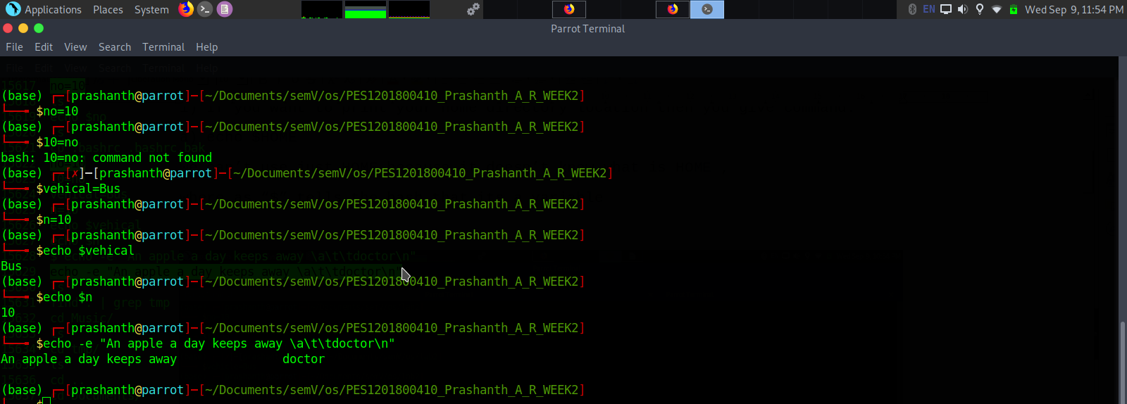

Excercise 3

What is the output of the following expressions?

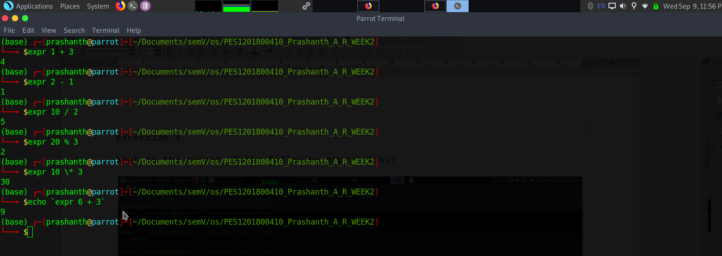

Excercise 4

What is the meaning of Single quote (‘), Double quote (“) and Back quote (`) in shell?

In other words, single quotes completely protect a string from the shell while double quotes protect some things (spaces for example) but allow variables and special characters to be expanded/interpreted correctly.
What ever u write inside the back quote it will be executed in that perticular shell. Like we saw in the example : echo `expr 6 + 3`

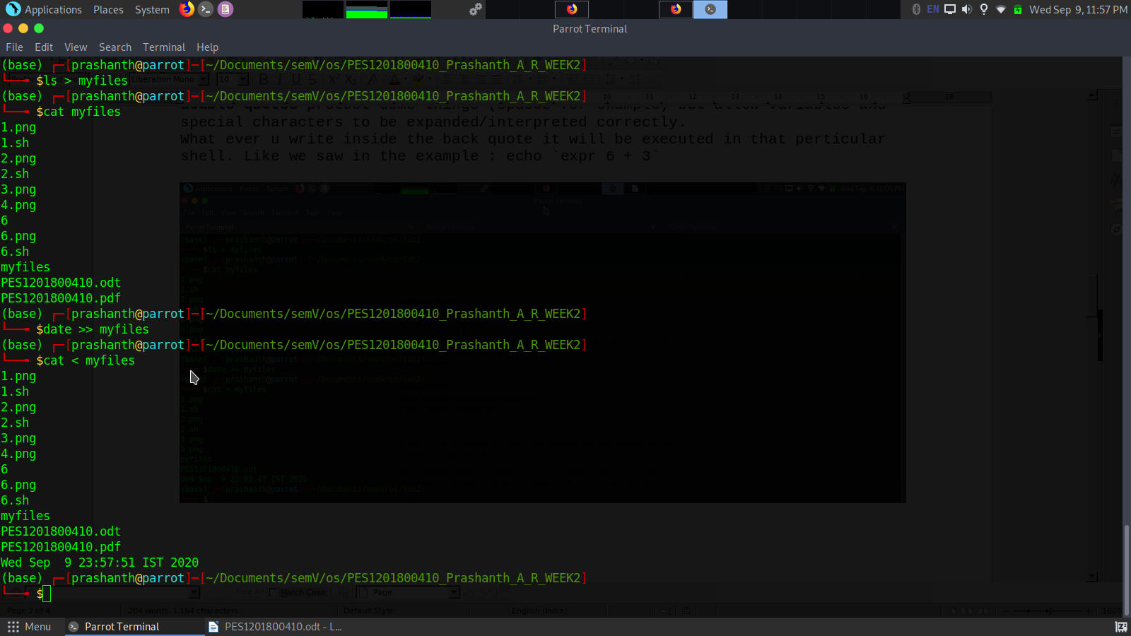

Excercise 5

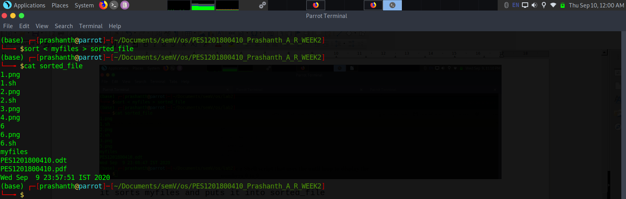
it sorts myfiles and puts it into sorted_file

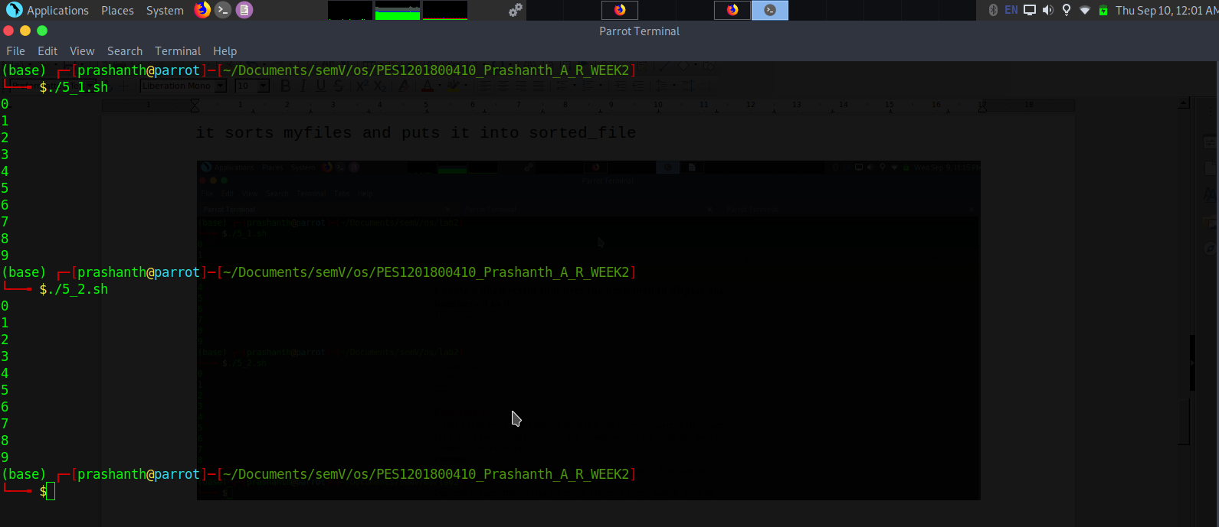

Exercise 6:
Create a shell script (using Bourne Shell or Bash) which converts all file names in the current directory to lowercase. You should execute the script and send a screenshot of the output.
Ans:

#!/bin/bash

for i in *;
do
mv $i ${i,,};
done

