PES1201800410 sem V A R PRASHANTH

lab 4

MD5 Collision Attack Lab

Task 1
generating 2 files with with same md5 hash using md5collegen
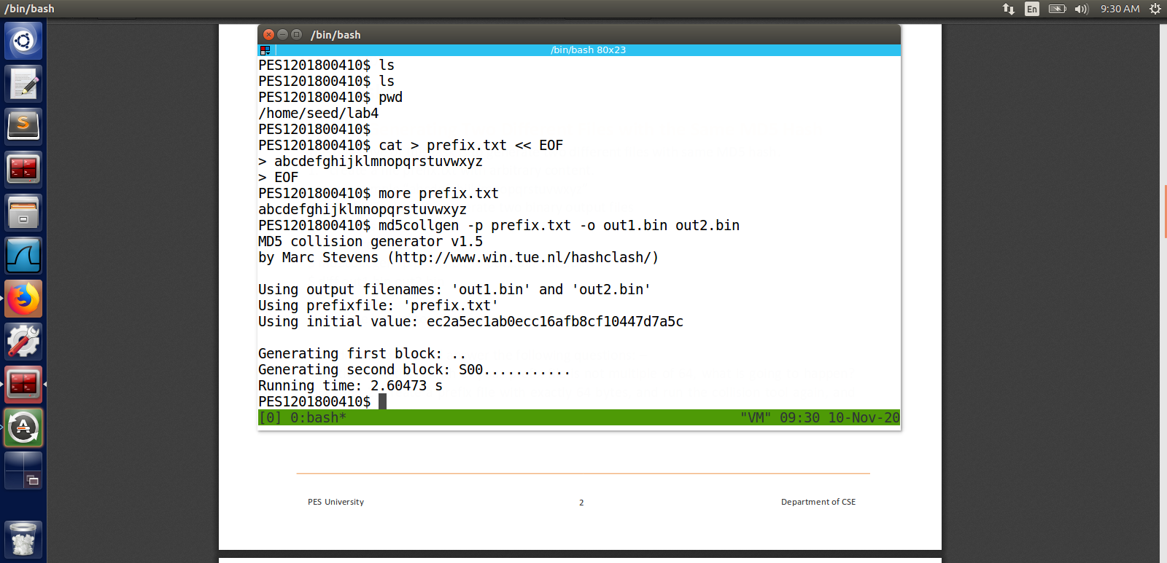

watch the difference in bless

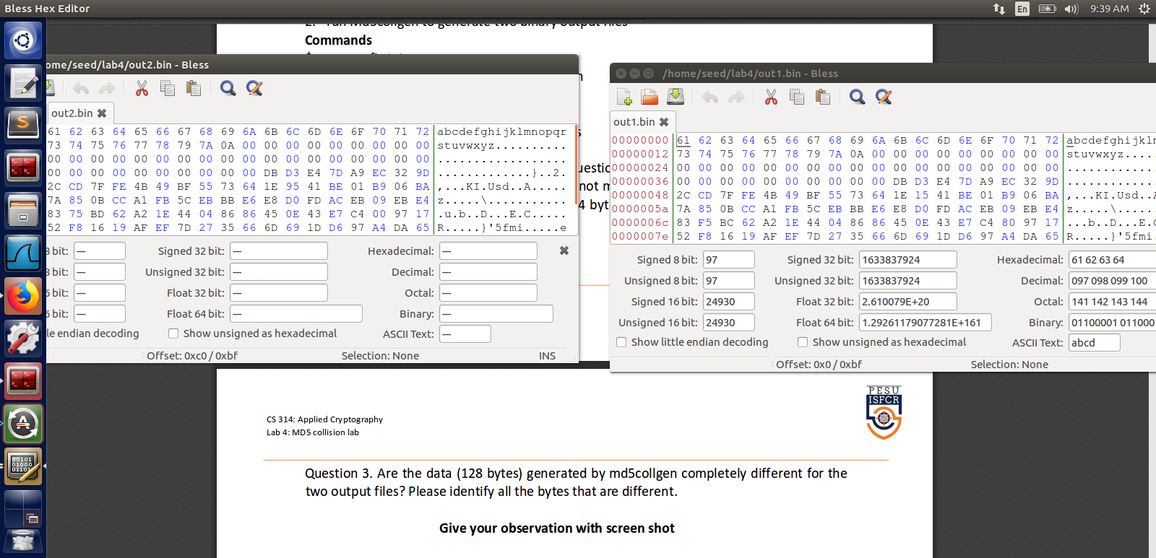

try creating new file with 64 bytes
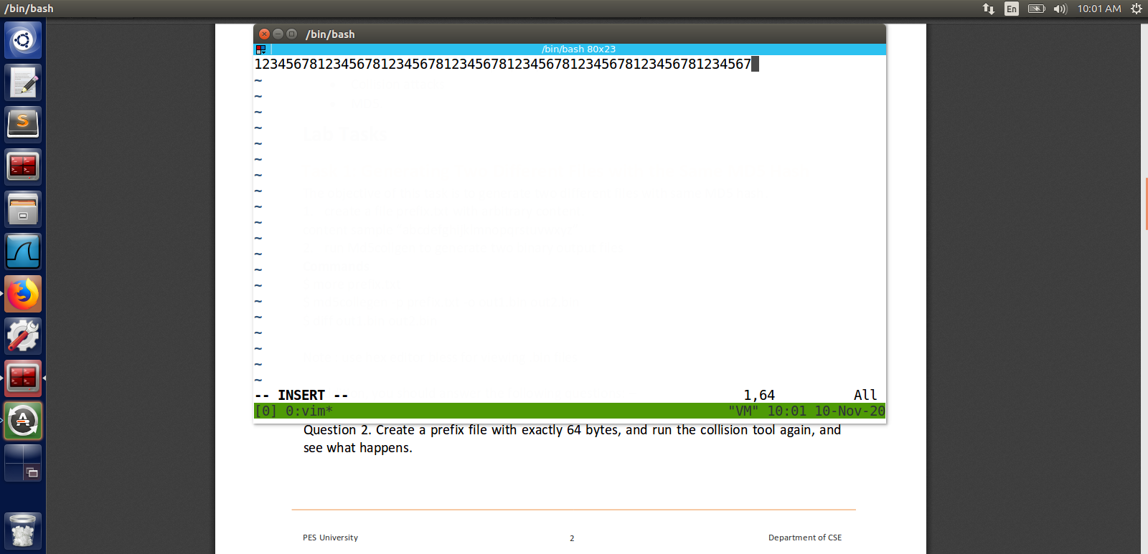
create 2 files with md5collegen
check difference using bless
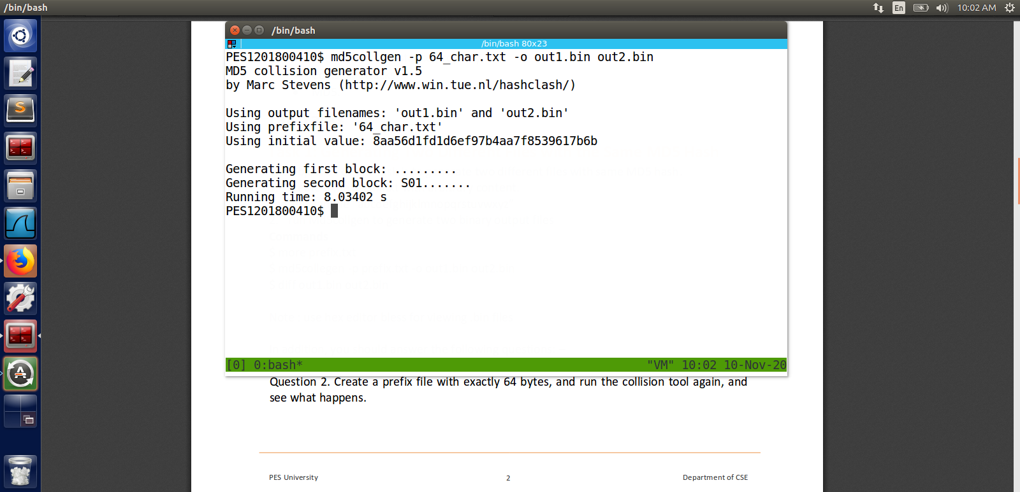
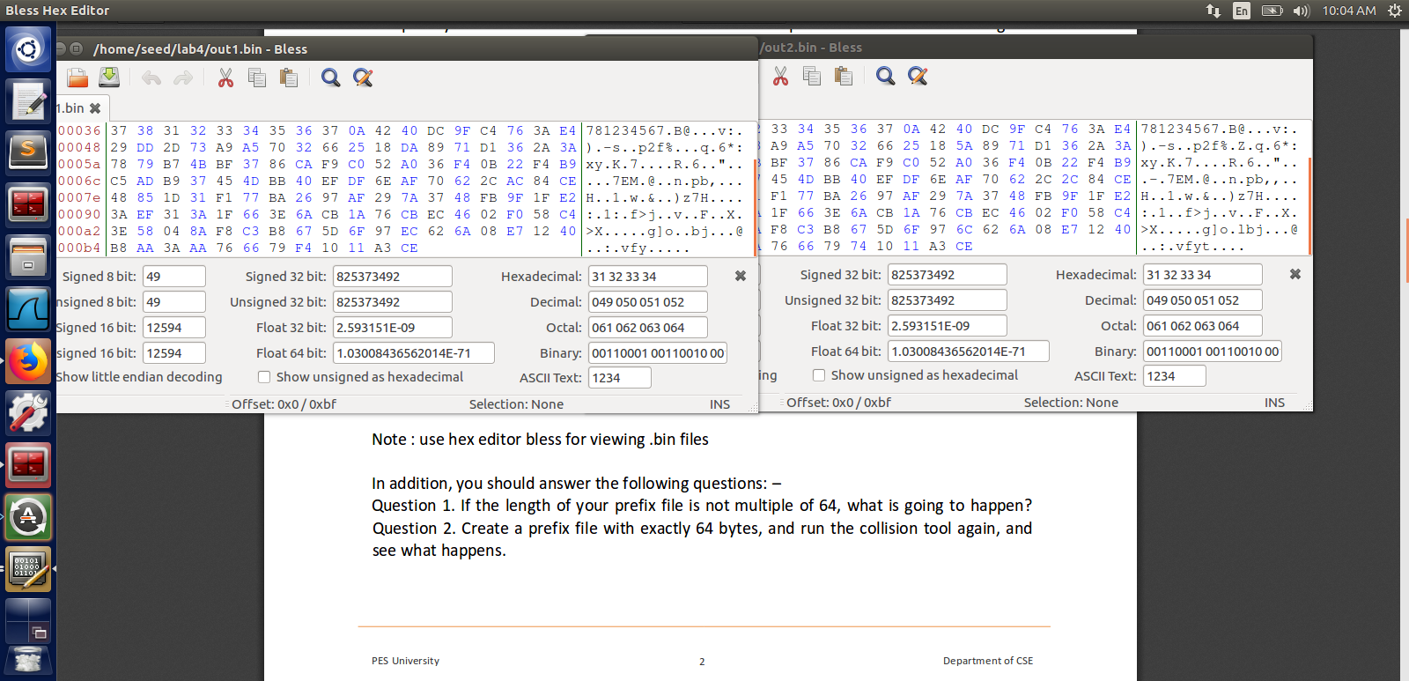
we can obeserve that there is no padding of \x00 in the end of the data.
Ans 1: there will be a 00 till the file becomes multiple of 64
And 2: there will be no 00 or padding as it will be multiple of 64
And 3: as we can see there are minor changes

Task 2
find md5sum of both files
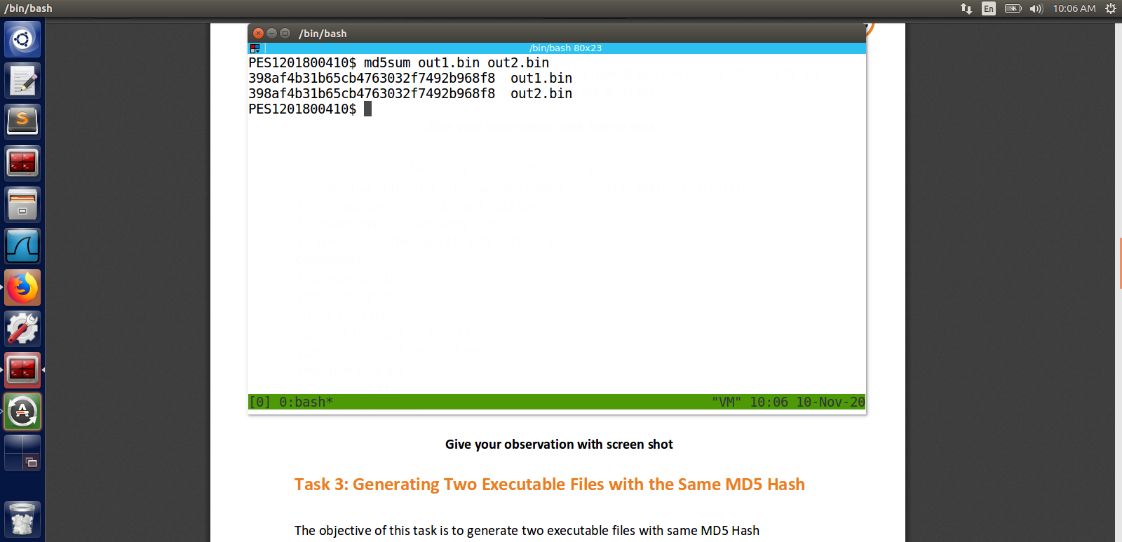

create a file with adding some input string to both the file and check for md5sum
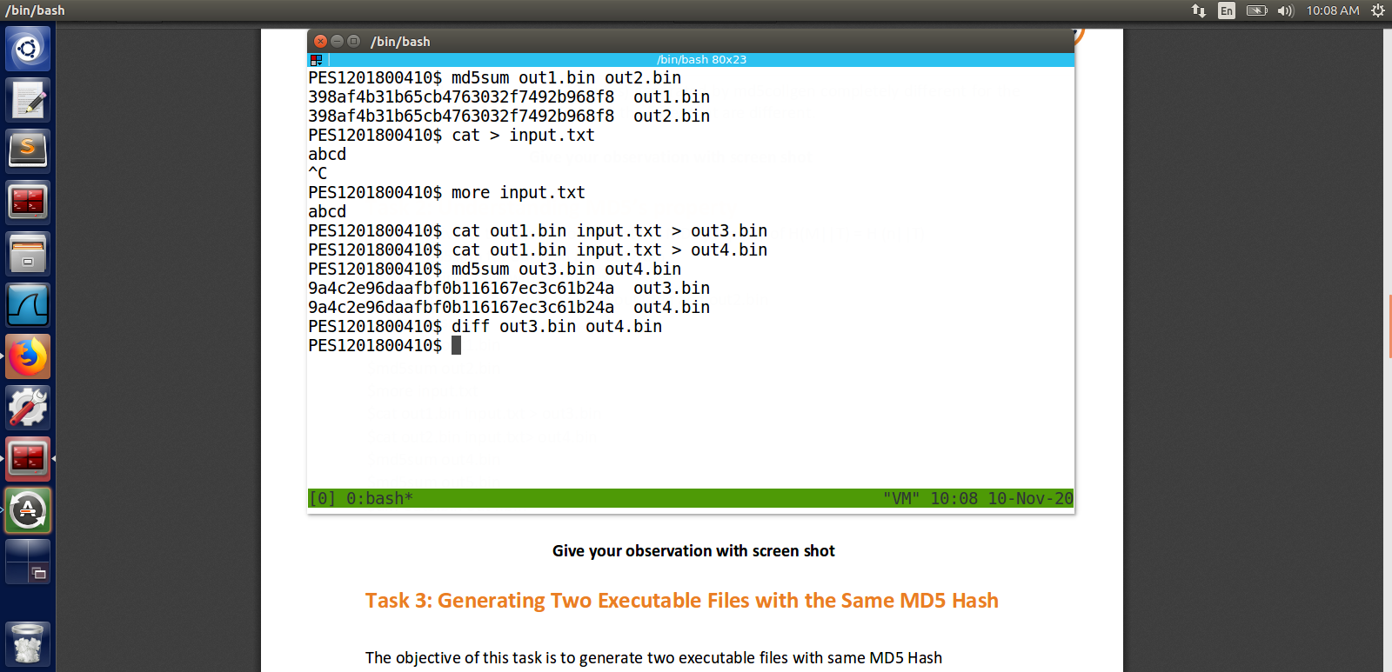
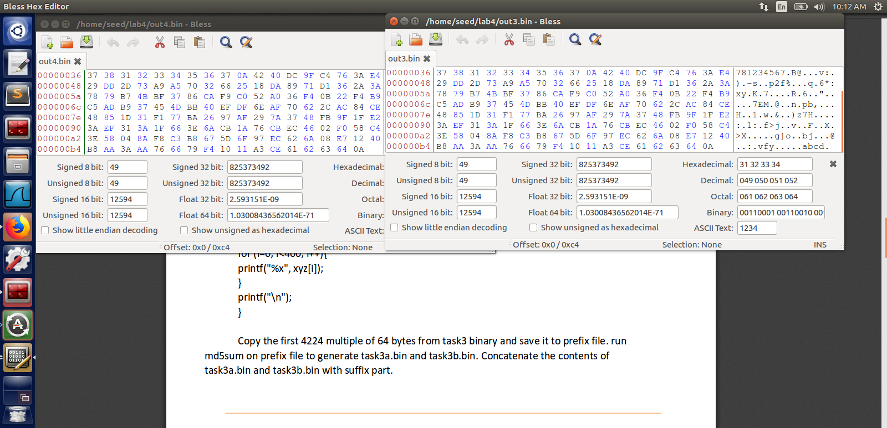

Task 3

compile gen_prefix.c file given in the manual .

gen_prefix source code
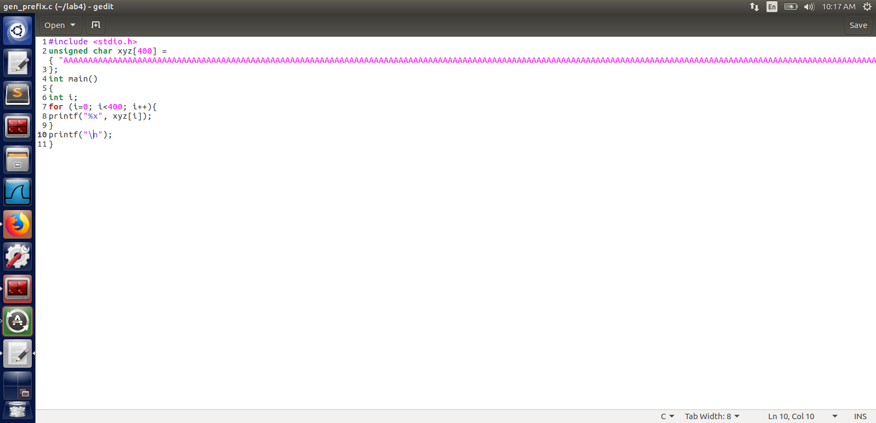

Cut 4224 bites and create a md5collegen
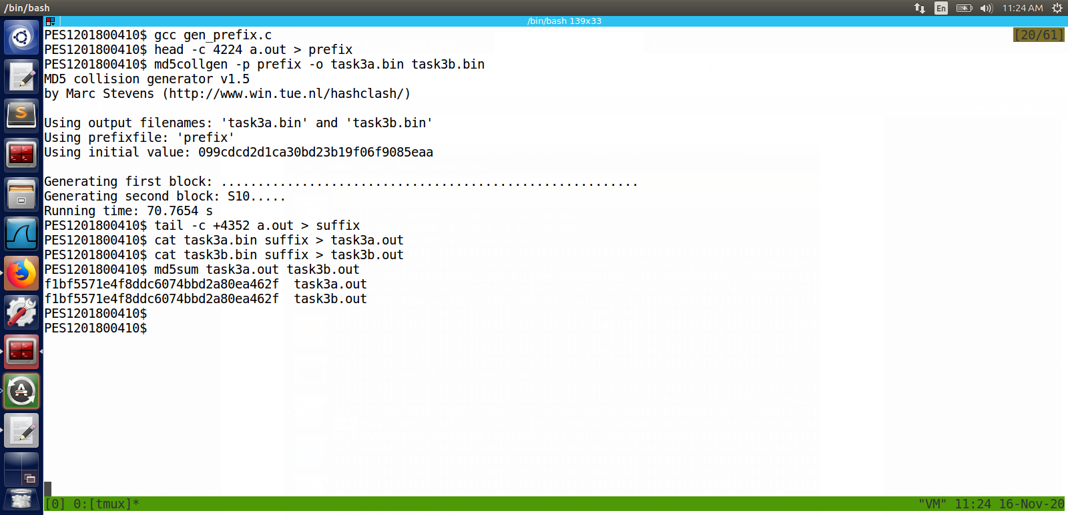
execute and check for differences in both the programms
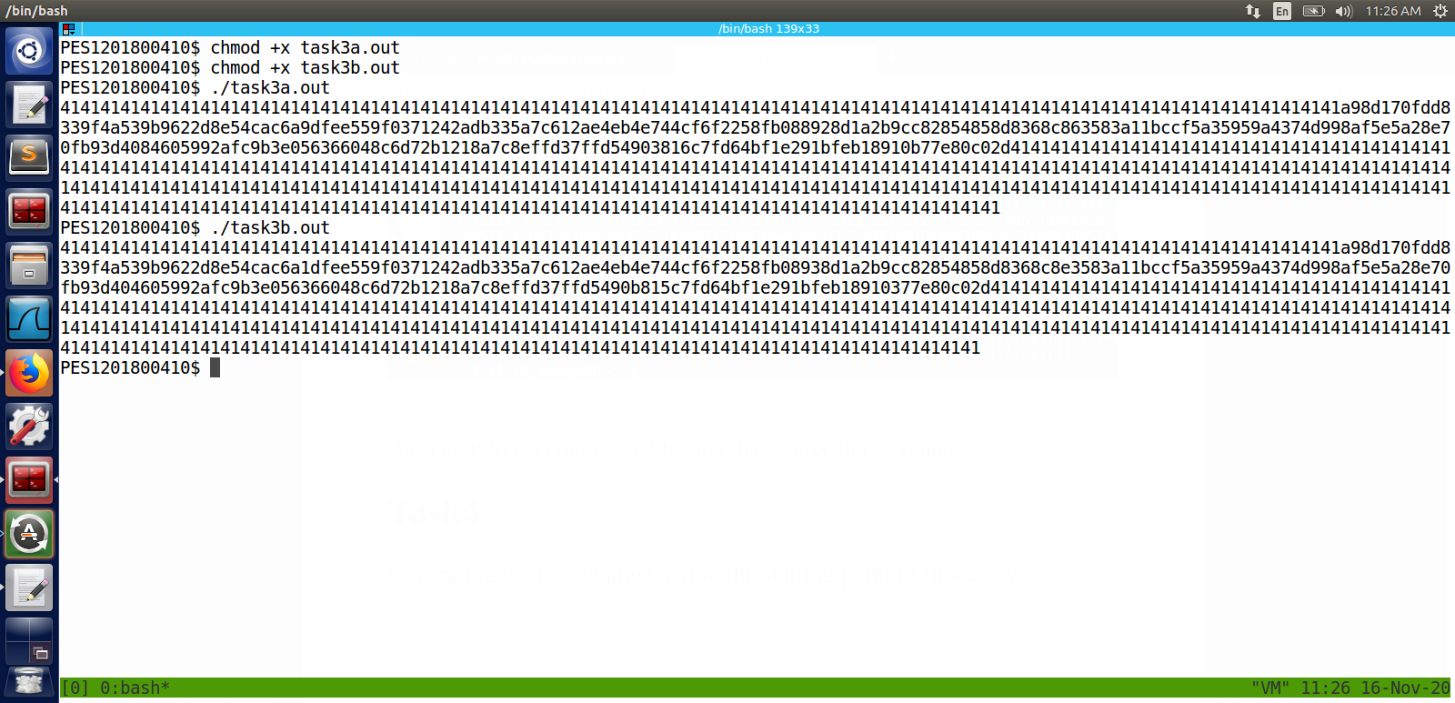

Task 4

compile the source code given
task4.c

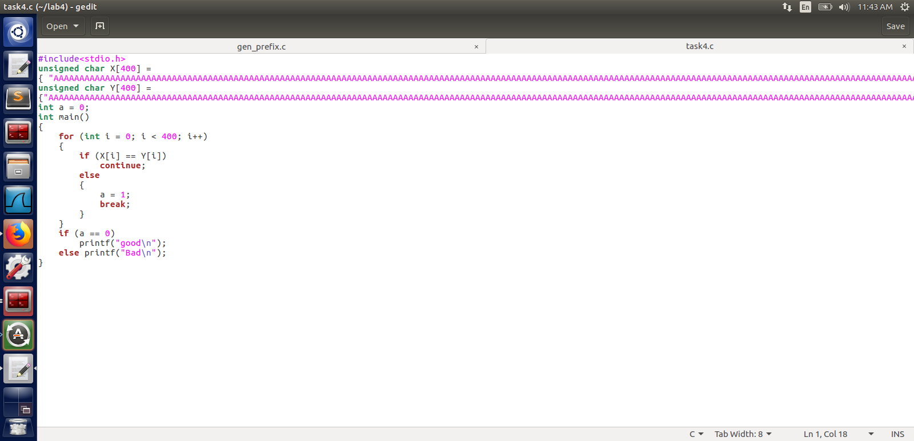

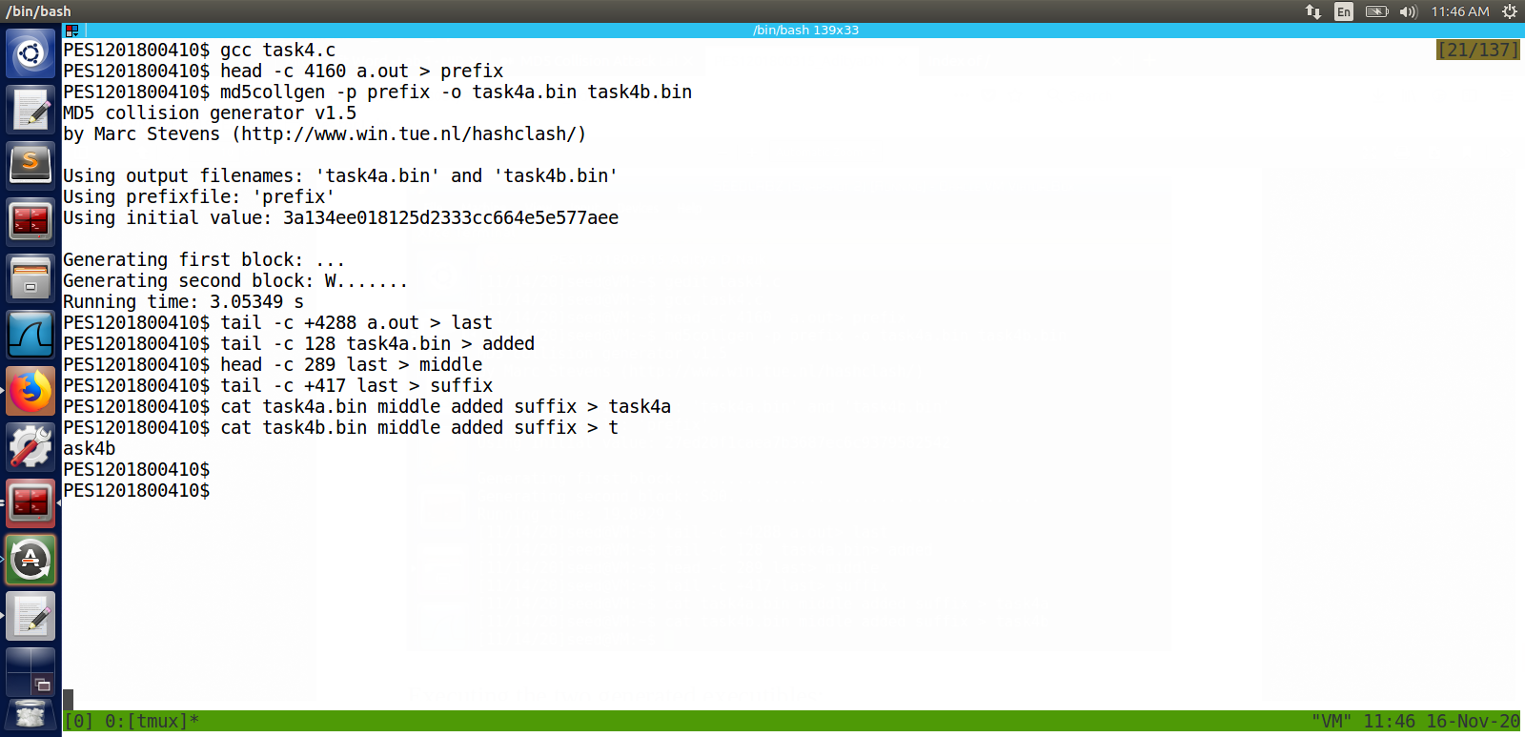
bless of a.out
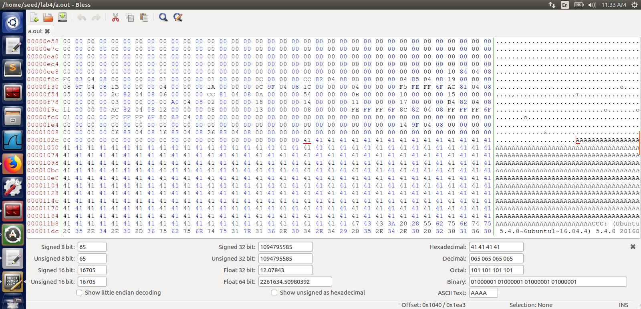
bless of last
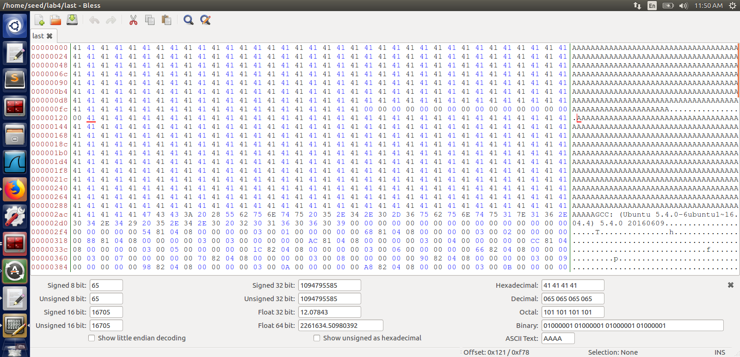
execute and see the differences
if there is any changes in the file it will print bad else good
