Task 1: A Complete Example of BIGNUM
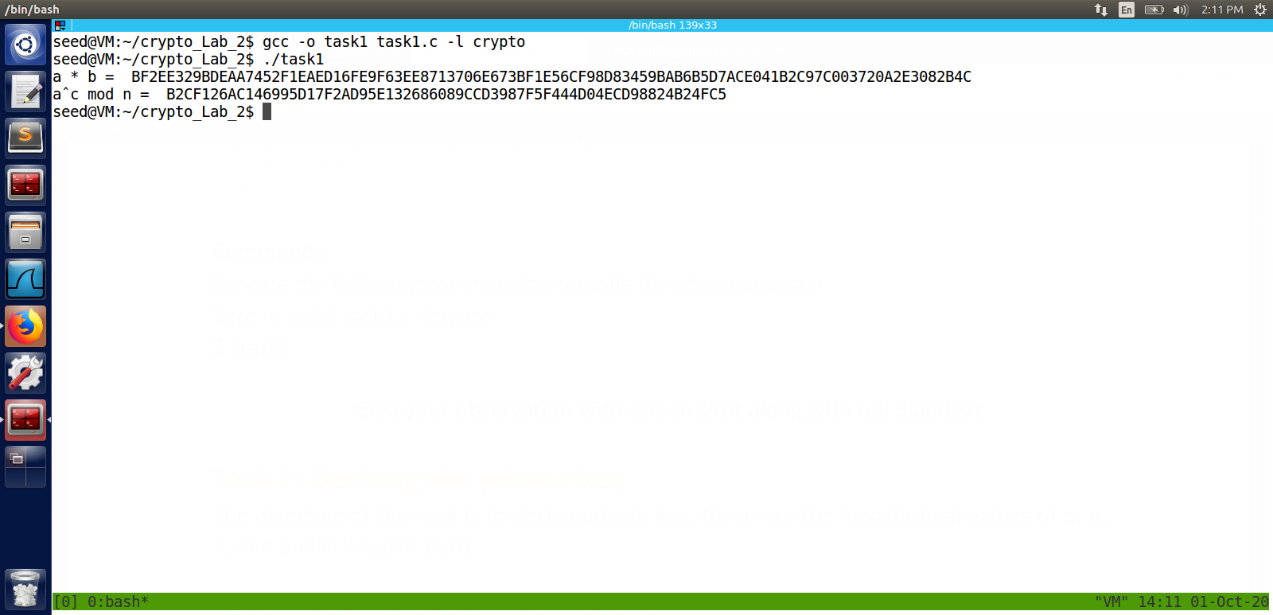

Observation:
Its a long hexdecimal number NOT decimal number
finding mod_exp using openssl/bn.h libraray

Task 2: Deriving the private key
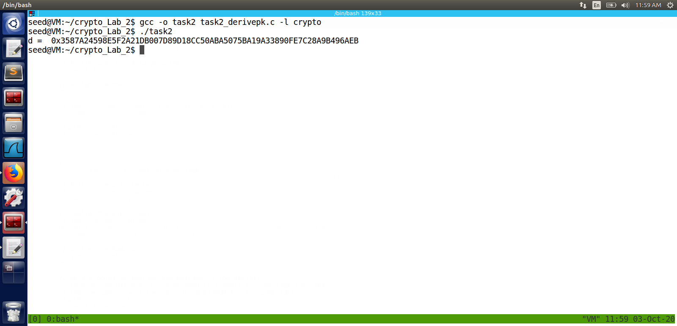
Observation:
finding modular inverse usig BN_mod_inverse function
d is private key

Task 3: Encrypting a message
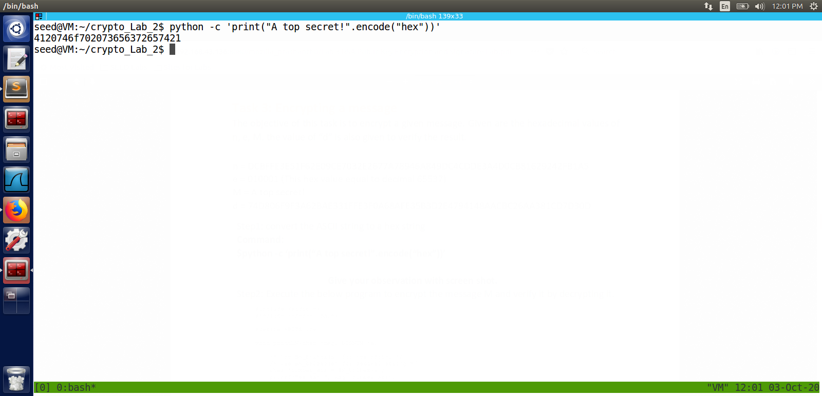

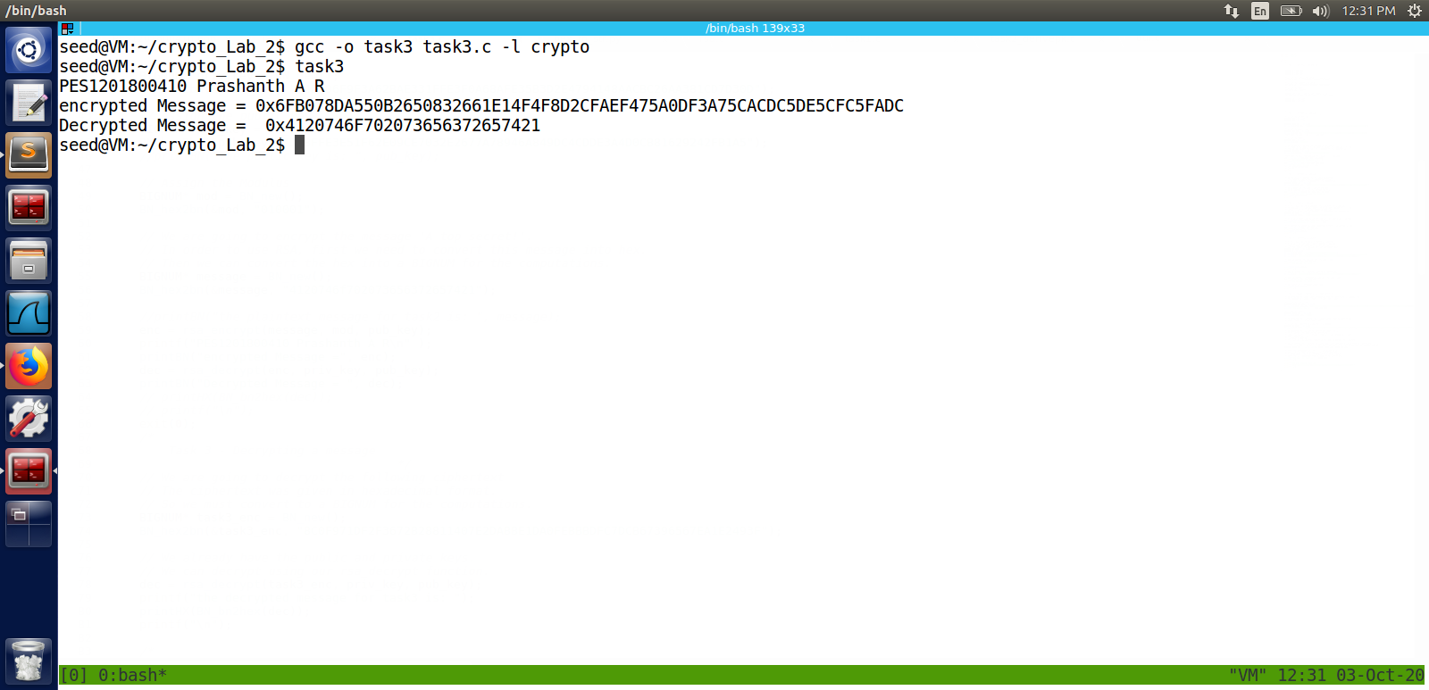

using python to convert hex to string and vice versa
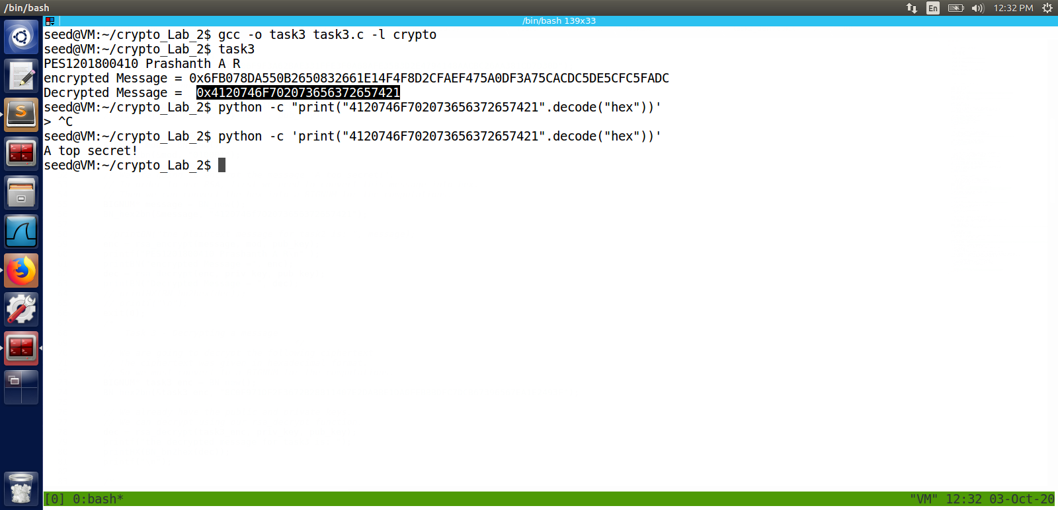

Observation:
we are using python to convert from hex to string and vice versa
decrypting the message using n , e , d , m = meassage.
enc = m^e mod n ;//to encrypt
dec = enc^d mod n ; // to decrypt

Task 4: Decrypting a message
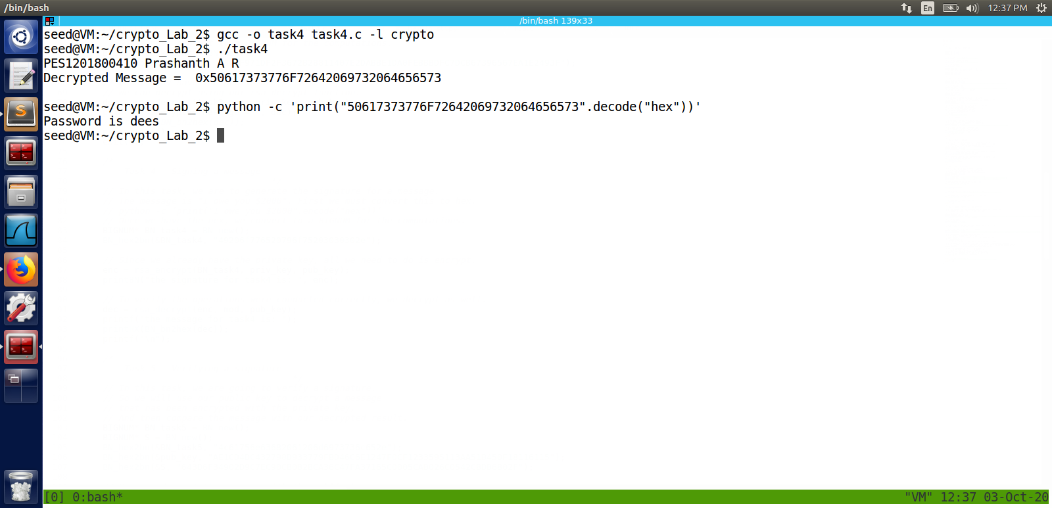

Observation:
decrypting a give message , n , e, d
same as last task
decrypted message is “Password is dees”
which apperently is seed lab root password xD.

Task 5: Signing a Message
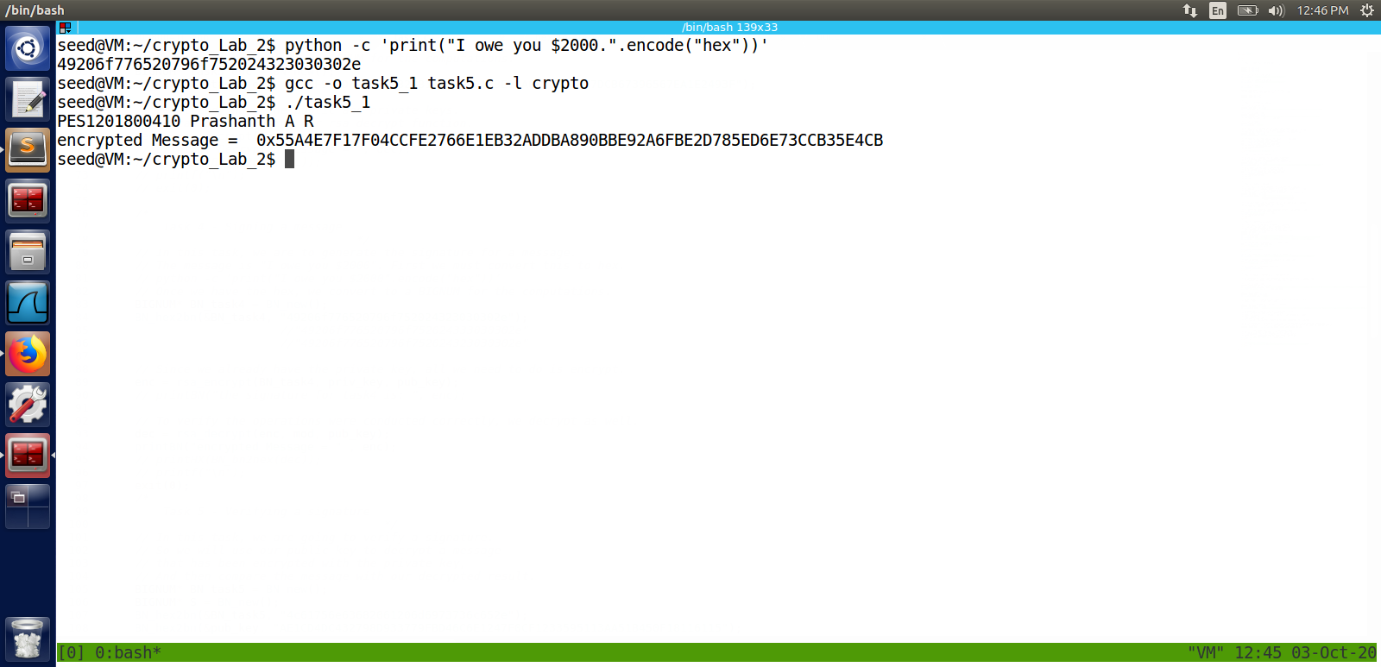

After changing $2000 to $3000

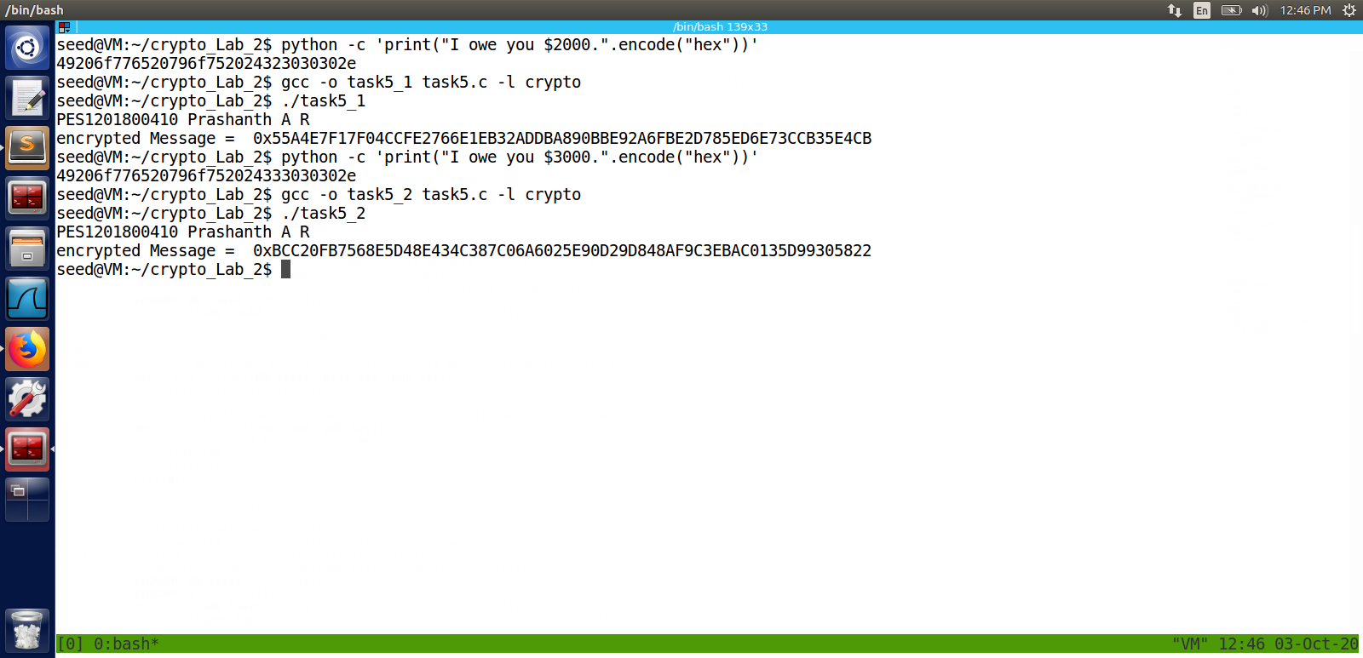
Observation:
we can see a great change in cipher text just by chaning one letter for plaintext
We can observer avalanche effect in RSA .

Task 6: Verifying a Signature
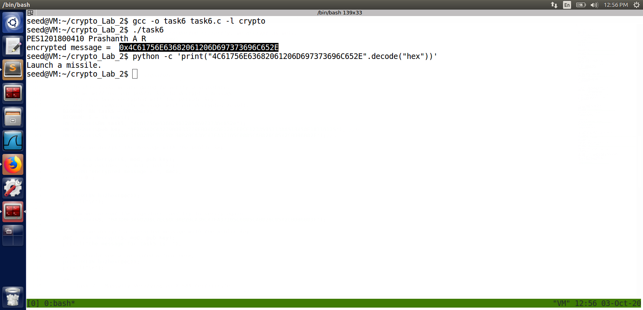

Observation:
Same as Task5 or Task4 given message , S(signature) which is d, e , n decrypt the message
decrypted message is Launch a missile.

Task 7: Manually verifying an X.509 Certificate
c0.pem has server certificate , c1.pem has root certificate
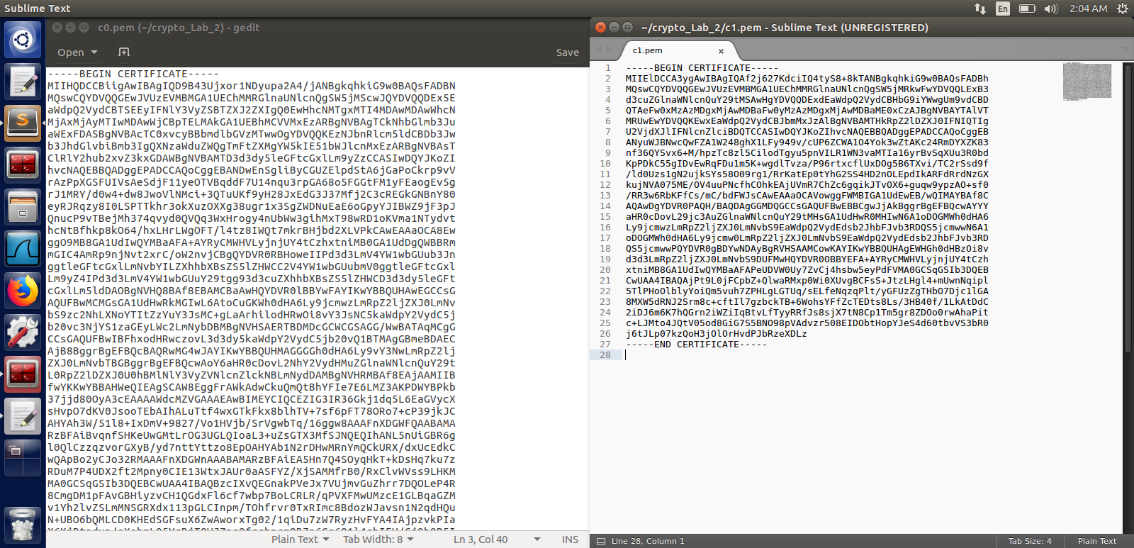
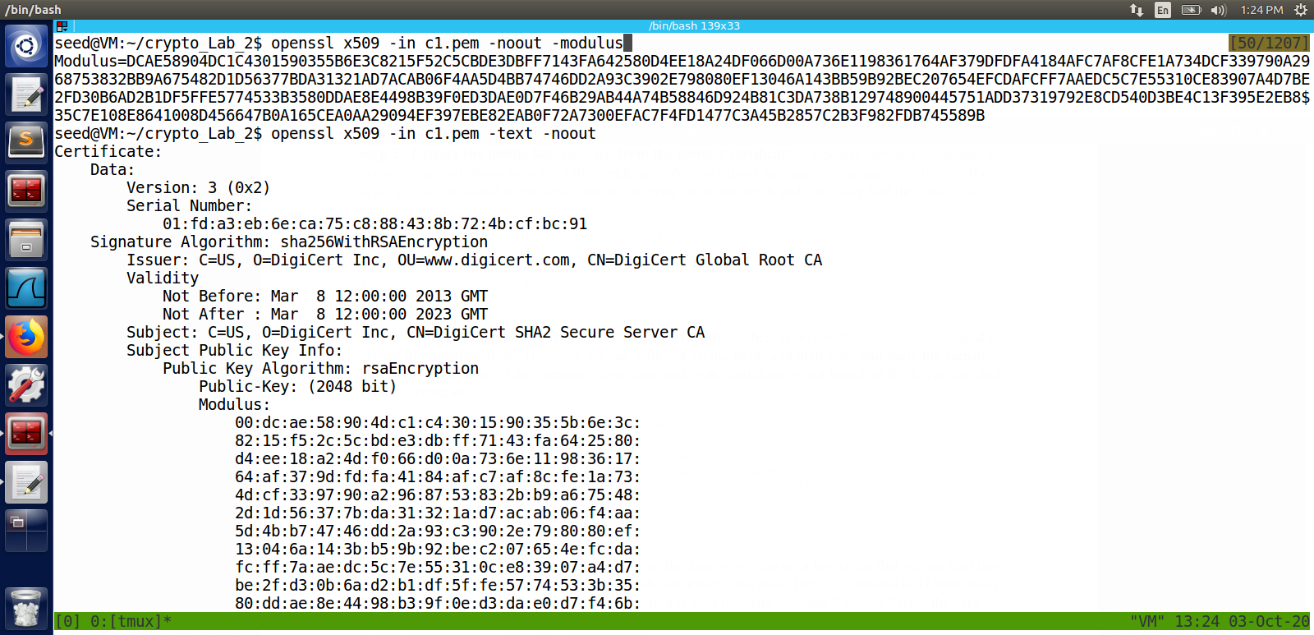
Find Modulus ie n

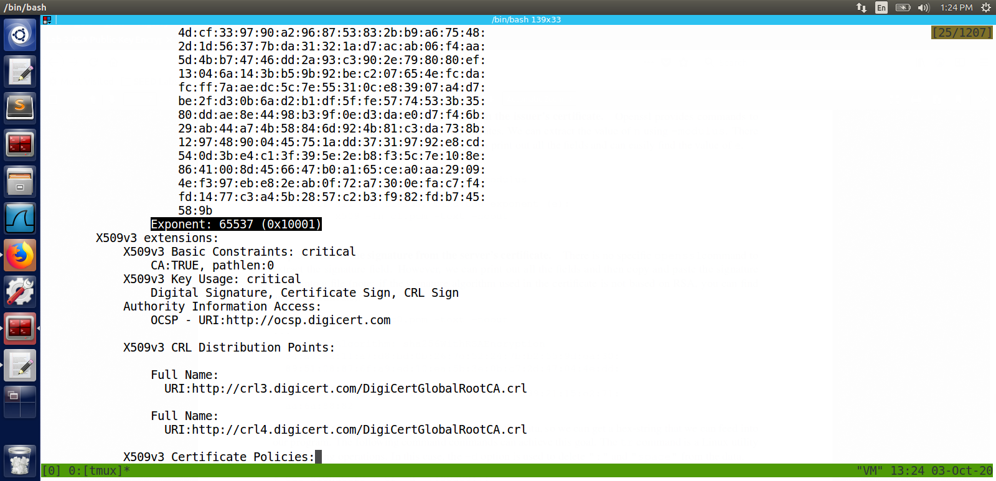
Finding Exponent e

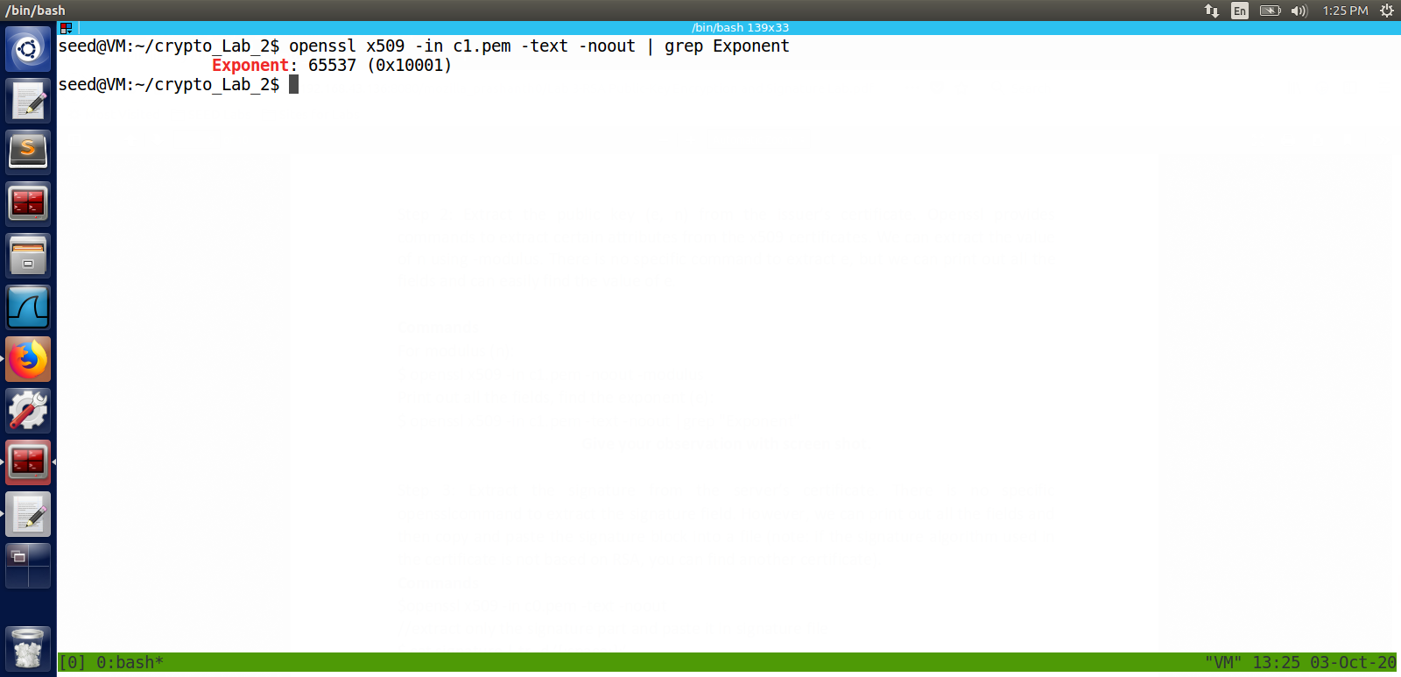

extract signature from server certificate
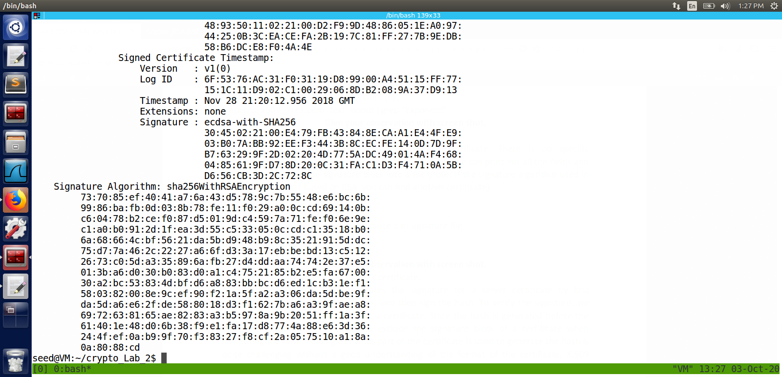
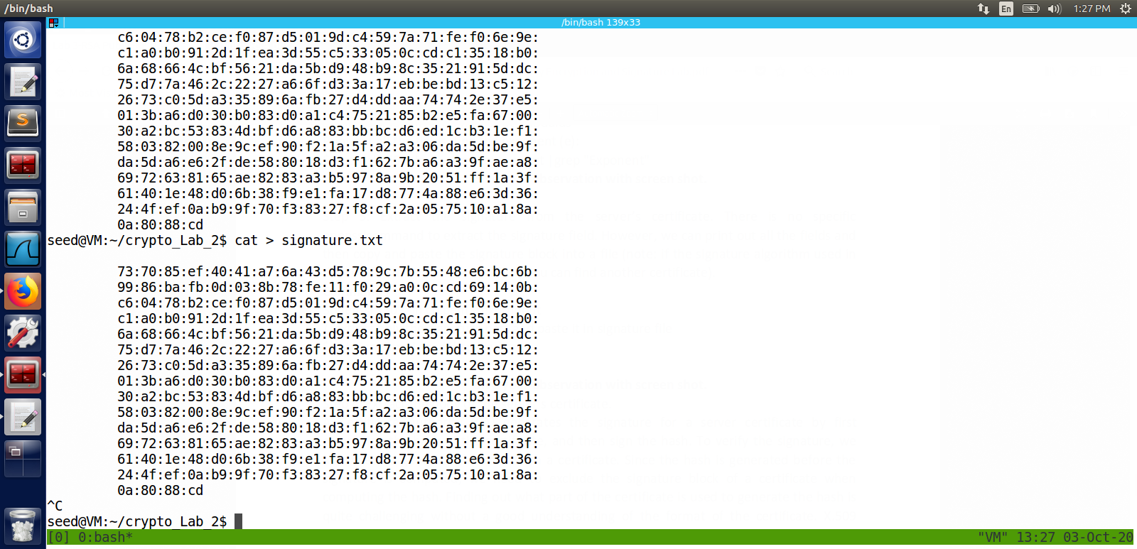
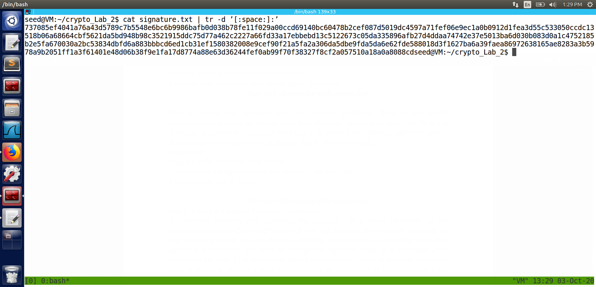
extract signature and find sha256 checksum
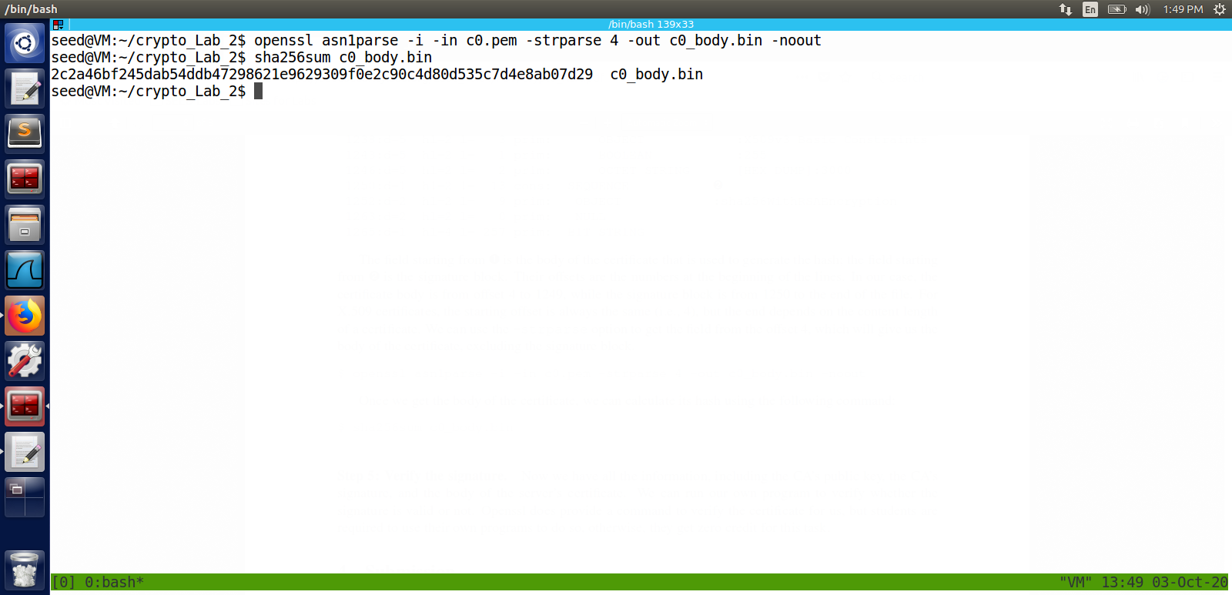
Verify the signature
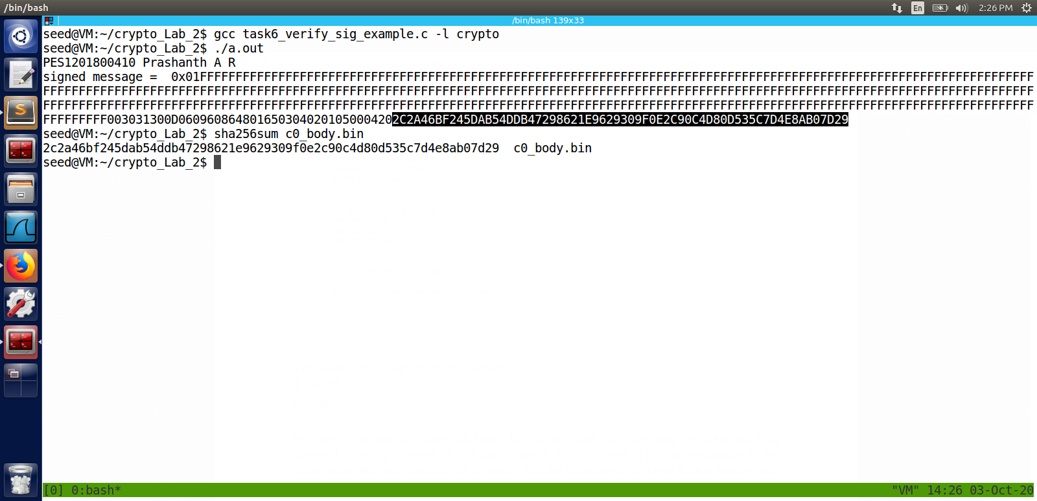
Observation:
The sha256 checksum and the calculated hash matched
hence we can say it is a valid signature .

