DOWNSTREAM PROCESSING
Separation of Cells and Other Solids
MSc Bioprocess Engineering / Biotechnology Assignment

Module: BPE7040 — Advanced Downstream Processing
Word Count: ~4,500 words
Academic Year: 2025–2026

Table of Contents
1. Abstract ....................................................................................................
2. Introduction ..............................................................................................
3. Context: The Fermentation Broth ..........................................................................
4. Centrifugation .............................................................................................
4.1 Principle and Theory (Stokes’ Law, Sigma Factor) .....................................................
4.2 Types of Centrifuges .....................................................................................
4.3 Industrial Applications and Limitations ................................................................
5. Filtration ...............................................................................................
5.1 Dead-End Filtration ......................................................................................
5.2 Crossflow (Tangential Flow) Filtration .................................................................
5.3 Membrane Selection and Fouling ..........................................................................
6. Flocculation and Sedimentation .............................................................................
7. Aqueous Two-Phase Extraction (ATPS) .......................................................................
8. Comparative Analysis of Methods ............................................................................
9. Process Selection Criteria ..................................................................................
10. Emerging Technologies and Future Directions .............................................................
11. Conclusion ..................................................................................................
12. References ..................................................................................................

1. Abstract
The separation of cells and other solid particulates from fermentation broths represents one of the most critical and technically demanding steps in downstream processing (DSP) of biopharmaceuticals and industrial biotechnology products. This assignment provides a comprehensive MSc-level analysis of the principal solid–liquid separation techniques employed in bioprocessing: centrifugation, filtration (dead-end and crossflow), flocculation, and aqueous two-phase extraction (ATPS). Each method is examined in terms of its governing theory, process parameters, equipment configurations, industrial scalability, and inherent limitations. Comparative performance data are presented using quantitative and qualitative criteria including separation efficiency, throughput, shear sensitivity, and capital cost. Furthermore, process selection frameworks and emerging technologies such as acoustic wave separation and integrated continuous processing are discussed. The analysis draws upon current peer-reviewed literature and engineering practice to inform rational selection of separation strategies in industrial bioprocessing contexts.

Keywords: downstream processing, solid–liquid separation, centrifugation, crossflow filtration, flocculation, aqueous two-phase systems, bioprocess engineering

2. Introduction
Downstream processing (DSP) encompasses all unit operations performed after the bioreaction step to isolate and purify a target biological product to the required specification. Typically, DSP accounts for 50–80% of total manufacturing cost in biopharmaceutical production, with the initial solid–liquid separation step constituting a significant fraction of this expenditure (Strathmann, 2011; Harrison et al., 2015). The complexity of this step arises from the highly heterogeneous nature of fermentation broths, which contain intact cells, cell debris, colloidal particulates, nucleic acids, lipids, endotoxins, and the target product — all in an aqueous continuous phase.
Effective separation of biomass and cellular debris is a prerequisite for all downstream purification operations. Residual solids, if not adequately removed, cause fouling of chromatography resins, clogging of ultrafiltration membranes, and contamination of final drug substance (Chon and Zarbis-Papastoitsis, 2011). The consequences extend to product loss, process downtime, and regulatory non-compliance.
This assignment critically evaluates the major categories of solid separation technology as applied in bioprocessing: (i) centrifugation, underpinned by Stokes' law and sigma factor analysis; (ii) filtration, including dead-end and crossflow modes; (iii) flocculation combined with sedimentation; and (iv) aqueous two-phase systems. Figure 1 illustrates the typical position of solid–liquid separation within the overall DSP train.

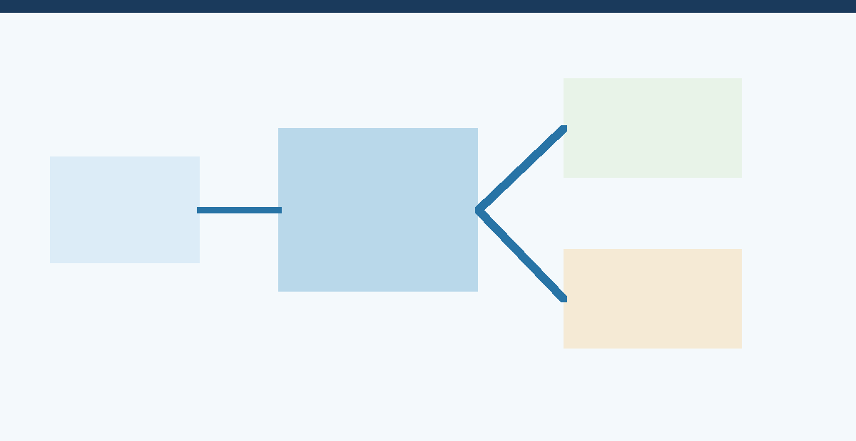
Figure 1: Schematic overview of a typical downstream processing train, highlighting the position of solid–liquid separation. Adapted from Harrison et al. (2015).

3. Context: The Fermentation Broth
To select an appropriate separation strategy, it is essential to characterise the physical and chemical properties of the broth. Key parameters include:
- Biomass concentration: Typically 10–50 g dry cell weight (DCW)/L for bacteria; 1–10 g DCW/L for mammalian cells.
- Cell morphology and size: Bacteria (0.5–5 µm), yeast (5–10 µm), filamentous fungi (fragmented hyphae, 20–100 µm), mammalian cells (10–20 µm). Larger particles sediment more readily per Stokes' law.
- Broth viscosity: Affected by biomass, polysaccharides, and dissolved metabolites. High viscosity (>10 mPa·s) impedes sedimentation and filtration.
- Product location: Extracellular products remain in clarified supernatant; intracellular products require cell disruption prior to separation.
- Particle density differential (Δρ): Drives settling in centrifugation. Bacterial cells typically have Δρ ≈ 100–200 kg/m³ vs. water.

These properties directly influence the choice and design parameters of the separation unit operation. Table 1 summarises the key broth characteristics and their processing implications.

Broth Property | Typical Range | Processing Implication | Preferred Method
Cell diameter | 0.5–20 µm | Small cells harder to centrifuge | High-speed centrifuge or TFF
Biomass concentration | 1–50 g/L DCW | High solids require robust equipment | Disc stack centrifuge or MF
Broth viscosity | 1–50 mPa·s | High μ reduces settling velocity | Centrifuge preferred over filtration
Particle density | 1,050–1,200 kg/m³ | Low Δρ requires high g-force | Ultra-centrifugation
Shear sensitivity | Variable | Mammalian cells rupture easily | Gentle centrifuge or TFF
Compressibility | High (bacteria) | Cake collapses under pressure | Crossflow preferred over dead-end
Table 1: Fermentation broth characteristics and their implications for solid–liquid separation method selection.

4. Centrifugation

4.1 Principle and Theory
Centrifugation accelerates gravity-driven sedimentation by applying a centrifugal force field, characterised by the relative centrifugal force (RCF = ω²r/g), to a heterogeneous liquid–solid mixture. The governing equation for particle settling velocity under centrifugal force is derived from Stokes’ law:
vₛ = d² (ρₚ − ρₑ) ω² r / 18μ
where vₛ is the sedimentation velocity (m/s), d is the particle diameter (m), ρₚ and ρₑ are the particle and fluid densities (kg/m³) respectively, ω is the angular velocity (rad/s), r is the radial distance from the axis (m), and μ is the dynamic viscosity of the medium (Pa·s) (Geankoplis et al., 2018).
To relate bench-scale performance to industrial centrifuges, the sigma (Σ) factor concept, introduced by Ambler (1959), provides a key engineering design parameter:
Q = 2 vₛ · Σ where Σ = Vω² / 2g
Here Q is the volumetric throughput (m³/s) and Σ is the theoretical equivalent settling area (m²). The sigma concept enables scale-up by ensuring that the ratio Q/Σ is maintained constant between pilot and industrial centrifuges (Ambler, 1959; Doran, 2013).

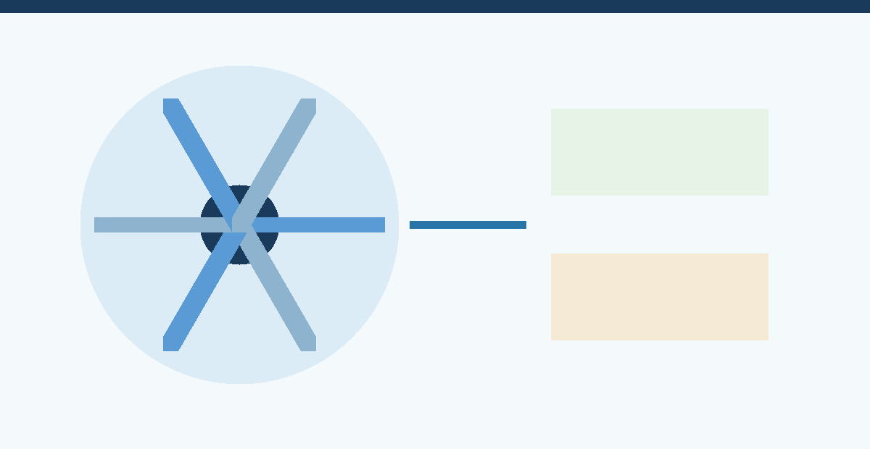
Figure 2: (a) Schematic cross-section of a tubular bowl centrifuge illustrating solid deposition at the bowl wall and clarified centrate. (b) Summary of governing equations and key performance parameters for centrifugation.

4.2 Types of Industrial Centrifuges

4.2.1 Disc Stack Centrifuge
The disc stack centrifuge is the most widely used configuration in the biopharmaceutical industry for continuous cell harvest. A series of conical discs, separated by narrow channels (0.3–1.5 mm), dramatically increases the effective settling area and reduces the settling path length. The sigma factor for a disc centrifuge is expressed as:
Σ = [2πnω² (r²₃ − r²₂)] / [3g·tanθ]
where n is the number of discs, r₂ and r₃ are the inner and outer disc radii, and θ is the disc half-angle (Doran, 2013). Disc stack centrifuges operate at 4,000–12,000 × g with throughputs of 500–20,000 L/h. They are suited to yeast, bacteria, and algae harvesting but are susceptible to nozzle blockage with highly viscous broths.

4.2.2 Tubular Bowl Centrifuge
Tubular bowl centrifuges operate at extremely high g-forces (up to 62,000 × g) and are used for separation of fine particles and clarification of low-density particulates. However, they operate in batch mode with manual solids removal, limiting throughput to 100–500 L/h. They are commonly used for analytical-scale applications or production of high-value products where yield is prioritised over throughput (Harrison et al., 2015).

4.2.3 Decanter (Scroll) Centrifuge
Decanter centrifuges employ a helical scroll conveyor to continuously discharge sedimented solids, making them suitable for high-solids broths such as those produced in fungal fermentations (10–20% solids by volume). Operating at 2,000–6,000 × g, they achieve continuous operation but provide lower clarification efficiency than disc stack centrifuges (Chon and Zarbis-Papastoitsis, 2011).

4.3 Industrial Applications and Limitations
Centrifugation is the dominant solid–liquid separation technique for mammalian cell culture harvest in biopharmaceutical manufacturing (>80% of monoclonal antibody processes). Key advantages include speed, scalability, and ability to handle compressible solids. However, significant disadvantages exist:
- High capital and operating costs due to mechanical complexity and energy consumption (0.5–2 kWh/m³ broth).
- Shear forces generated by disc stack centrifuges can lyse shear-sensitive mammalian cells, releasing intracellular contaminants such as host cell proteins (HCPs) and nucleic acids, increasing downstream purification burden (Chon and Zarbis-Papastoitsis, 2011).
- Incomplete clarification: disc stack centrifuges typically achieve 99% cell removal, leaving residual turbidity of 50–200 NTU, often necessitating a secondary depth filtration step.
- Aerosol generation presents biocontainment concerns for work with pathogenic organisms.

5. Filtration
Filtration-based methods for cell and solid separation exploit size exclusion by driving the broth through a porous medium under a transmembrane pressure (TMP) gradient. Two fundamentally distinct operational modes exist: dead-end filtration and crossflow (tangential flow) filtration (TFF).

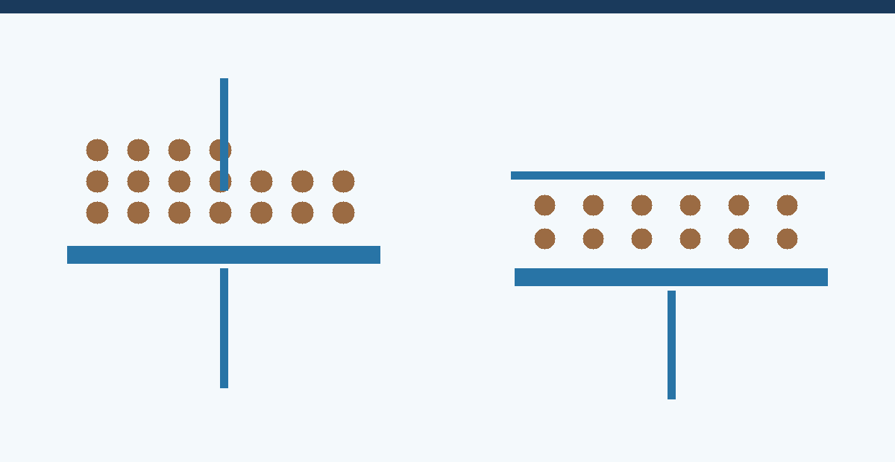
Figure 3: Comparison of (a) dead-end filtration and (b) crossflow filtration configurations for solid–liquid separation, with (c) a comparative property table.

5.1 Dead-End Filtration
In dead-end filtration, the entire feed stream passes perpendicular to the filter medium. Particles accumulate on the surface, forming a filter cake whose increasing resistance (ΔR) progressively reduces filtrate flux (Jᵥ) over time. The governing equation is the Darcy-Ruth equation:
dV/dt = A·ΔP / [μ (Rᵐ + R_cake)]
where V is the total filtrate volume (m³), A is the filter area (m²), ΔP is the pressure drop (Pa), μ is dynamic viscosity, Rᵐ is the membrane resistance, and R_cake is the cake resistance (αcV/A, where α is the specific cake resistance and c is the mass of solids per unit filtrate volume) (Belfort et al., 1994).
Dead-end filtration using rotary vacuum filters (RVFs) or plate-and-frame filter presses is widely applied for separation of fungal mycelia and crystalline solids in antibiotic manufacture. Filter aids such as diatomaceous earth (DE) or perlite are often incorporated to improve cake permeability and prevent blinding. The specific cake resistance α (m/kg) is a key design parameter; highly compressible cakes (e.g., bacterial cells) exhibit α values of 10¹³– 10¹⁵ m/kg, severely limiting throughput (Doran, 2013).

5.2 Crossflow (Tangential Flow) Filtration
In crossflow filtration, the feed stream flows parallel (tangentially) to the membrane surface, generating a wall shear rate that continuously sweeps deposited particles from the membrane, greatly reducing concentration polarisation and cake formation. The permeate flux at steady state is described by the film model:
J = kᵐ · ln(C_w / C_b)
where kᵐ is the mass transfer coefficient, C_w is the wall concentration (gel concentration for severely polarised systems), and C_b is the bulk concentration (Strathmann, 2011).
TFF using hollow fibre or flat-sheet membranes with pore sizes of 0.1–1 µm (microfiltration, MF) is the gold-standard for mammalian cell harvest in monoclonal antibody manufacture. It offers superior clarification efficiency compared to centrifugation, with residual turbidity of <10 NTU achievable. Furthermore, TFF can be operated in perfusion culture mode for continuous cell retention (Shukla and Thommes, 2010).

5.3 Membrane Selection, Fouling, and Flux Enhancement
Membrane material selection critically influences fouling propensity. Hydrophilic membranes (cellulose acetate, polyethersulfone) exhibit lower protein adsorption than hydrophobic membranes (PVDF, polypropylene). Key operational strategies to maximise TFF performance include:
- Maintaining TMP below 0.5 bar to minimise compaction of the gel layer.
- Optimising crossflow velocity (CFV) at 3–7 m/s to maximise wall shear without excessive shear-induced cell lysis.
- Backpulsing or backflushing sequences to periodically dislodge the fouling layer.
- Periodic CIP (clean-in-place) with sodium hydroxide (0.1–0.5 M NaOH) and sodium hypochlorite to restore flux.

Depth filtration, using cellulose-DE composite media, is routinely employed as a polishing step after centrifugation in biopharmaceutical DSP to remove residual fine particles, colloidal matter, lipids, and HCPs. Modern single-use depth filter capsules (e.g., Millistak+ by Merck, Zeta Plus by 3M) have largely replaced reusable stainless-steel filter housings at commercial scale (van Reis and Zydney, 2007).

6. Flocculation and Sedimentation
Flocculation involves the addition of chemical or biological agents (flocculants) to a broth to promote aggregation of fine particles into larger flocs that are more readily separated by sedimentation or centrifugation. The mechanism involves charge neutralisation (coagulation) and/or polymer bridging between particles (Bratby, 2016).
Common flocculants in bioprocessing include: inorganic coagulants (aluminium sulfate, ferric chloride), cationic polyelectrolytes (polyethylenimine, PEI; polyDADMAC), and natural biopolymers (chitosan). PEI is particularly widely used in fermentation broth clarification due to its ability to simultaneously flocculate cells, nucleic acids, and endotoxins via electrostatic interaction with negatively charged cellular surfaces (Roush and Lu, 2008).
The flocculation process can be characterised by the Smoluchowski model for orthokinetic flocculation:
dN/dt = −(4εG/3π)·N²
where N is the number concentration of particles (#/m³), ε is the collision efficiency factor (0–1), and G is the velocity gradient (s⁻¹) imposed by gentle agitation (Bratby, 2016). Post-flocculation, the enlarged aggregates can be removed by low-speed centrifugation (500–2,000 × g) or gravity sedimentation, significantly reducing energy consumption compared to conventional centrifugation of unflocculated broth.
Flocculation is especially valuable for processing difficult-to-centrifuge broths containing Gram-negative bacteria or recombinant E. coli, where the presence of outer membrane vesicles and endotoxins complicates clarification. However, flocculant carry-over into downstream operations and potential product adsorption onto floc represent significant risks requiring careful process optimisation (Roush and Lu, 2008).

7. Aqueous Two-Phase Extraction (ATPS)
Aqueous two-phase systems (ATPS) offer an elegant integration of solid removal and primary isolation into a single unit operation. An ATPS is formed when certain polymers (e.g., polyethylene glycol, PEG) are combined with salts (e.g., potassium phosphate, ammonium sulfate) or with another polymer (e.g., dextran) above critical concentrations, spontaneously forming two immiscible aqueous phases (Albertsson, 1986).

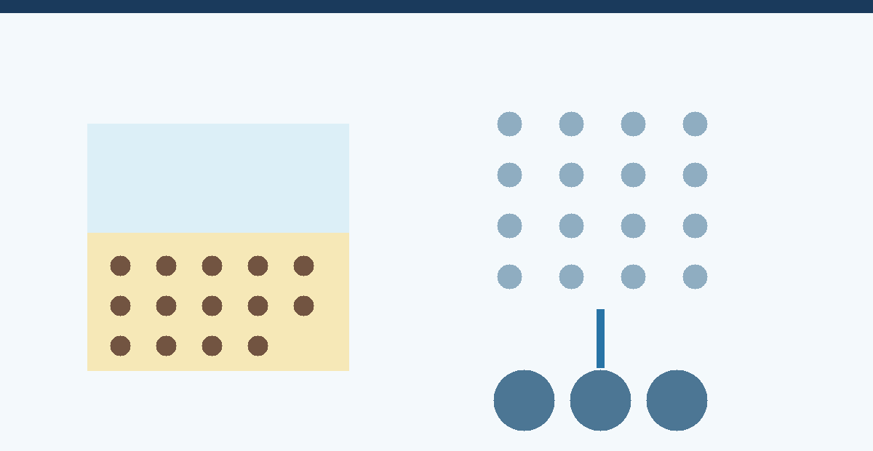
Figure 5: (a) Schematic of an aqueous two-phase system (ATPS) showing phase partitioning of cells, debris, and product. (b) Mechanism of flocculation from dispersed cells to settled floc aggregates.

In a PEG–phosphate ATPS, whole cells and particulate debris partition strongly into the salt-rich bottom phase or the interface, while many proteins selectively partition into the PEG-rich top phase. This allows simultaneous cell removal and initial protein concentration in a single mixing–settling step. The partition coefficient K for a protein is defined as:
K = C_top / C_bottom
K > 1 indicates preferential partitioning to the top (PEG-rich) phase. Manipulation of K can be achieved by varying PEG molecular weight, tie-line length (phase composition), addition of affinity ligands (affinity ATPS), ionic strength, and pH (Albertsson, 1986; Andrews et al., 2005).
ATPS has been implemented industrially for the purification of enzymes and therapeutic proteins. The process is scalable using mixer-settlers or liquid–liquid centrifuges (e.g., Westfalia extractors). A significant advantage is the biocompatible, aqueous environment that maintains protein activity. However, high polymer and salt costs, difficulties in recycling PEG, and high ionic strength in the product phase (necessitating subsequent desalting) remain challenges to widespread adoption (Andrews et al., 2005).

8. Comparative Analysis of Separation Methods
Figure 4 presents a multi-criteria comparative analysis of the major solid–liquid separation methods evaluated in this assignment, scored across six performance dimensions relevant to industrial bioprocessing decision-making.

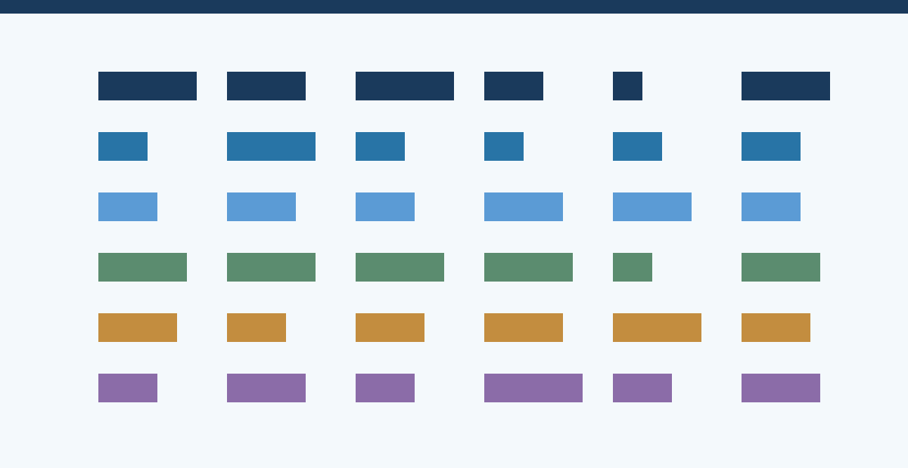
Figure 4: Comparative performance scores (1–10) for six solid–liquid separation methods across key bioprocessing criteria. Higher scores are preferable for all metrics. Capital cost score is inversed (higher score = lower cost).

Method | Throughput | Clarification | Scalability | Shear  Sensitivity | Relative  Cost | Best Application
Disc stack centrifuge | Very high | Good | Excellent | Moderate | High | Yeast/bacterial harvest
Tubular bowl centrifuge | Low–medium | Excellent | Limited | High | Moderate | High-value, low volume
Dead-end filtration | Medium | Good | Moderate | Low | Low | Fungal mycelial separation
Crossflow (TFF/MF) | High | Excellent | Excellent | Low | High | Mammalian cell harvest
Flocculation + sedimentation | High | Moderate | Good | Low | Low | E. coli / primary clarification
ATPS (PEG–salt) | Medium | Good | Moderate | Very low | Moderate | Protein–cell co-separation
Table 2: Qualitative comparison of major solid–liquid separation methods for bioprocessing applications.

9. Process Selection Criteria
The selection of an appropriate solid–liquid separation strategy is governed by a hierarchy of technical, economic, and regulatory considerations. A rational decision framework should address the following factors in sequence:
- Product location: Extracellular products allow direct clarification of intact broth; intracellular products require cell disruption (homogenisation, bead milling) prior to separation, generating a more complex particle size distribution and higher debris load.
- Organism and cell characteristics: Cell size, morphology, density, and shear sensitivity dictate the viable g-force range and preferred equipment type. Mammalian cells require gentle methods (low-shear TFF); robust microbial cells tolerate high-speed centrifugation.
- Broth rheology: High viscosity broths from filamentous fungal fermentations (Aspergillus, Penicillium) require specialised equipment (e.g., rotary vacuum drum filters with filter aids) or pre-treatment by broth dilution or enzyme addition to reduce viscosity.
- Process scale and throughput: At small scale (<100 L), batch centrifuges or tangential flow cassettes are appropriate; at manufacturing scale (>10,000 L), continuous disc stack centrifuges or large-area TFF systems are required for economic viability.
- Product stability and yield: Temperature, shear history, and residence time in the separation unit must be minimised for labile products. ATPS and TFF offer advantages for shear-sensitive biologics.
- Regulatory and quality requirements: GMP compliance demands sterile single-use systems or validated CIP/SIP protocols. Containment requirements (BSL-2/3 organisms) may mandate closed centrifuge systems.
- Economic analysis: Capital expenditure (CAPEX) for centrifugation infrastructure is high but offers low operating cost per unit volume; TFF cassettes have lower CAPEX but higher consumable replacement costs at scale.

10. Emerging Technologies and Future Directions

10.1 Continuous Downstream Processing
The biopharmaceutical industry is undergoing a paradigm shift from batch to continuous manufacturing. Continuous cell harvest using centrifuges equipped with hermetic feed systems or alternating tangential flow (ATF) perfusion systems enables steady-state operation, reduces process volumes, and improves product consistency. Integration of continuous harvest with real-time process analytical technology (PAT) — including in-line turbidity, particle size, and cell viability monitoring — is advancing towards fully integrated continuous biomanufacturing platforms (Konstantinov and Cooney, 2015).

10.2 Acoustic Wave Separation
Ultrasonic standing wave technology applies acoustic radiation force to drive microparticles and cells to pressure nodes within a resonant cavity, enabling label-free, contact-free cell separation without membranes or centrifugal force. Acoustic separators are inherently scalable, operate in a closed system, and have been demonstrated for mammalian cell retention in perfusion bioreactors at flow rates up to 100 L/h (Trampler et al., 1994; Pitt, 2009). However, scale-up to commercial manufacturing throughputs remains a technical challenge.

10.3 Aqueous Two-Phase Expanded Bed Adsorption
The integration of ATPS with expanded bed adsorption chromatography (EBA) or precipitation allows direct capture of the target protein from unclarified broth, collapsing two DSP steps into one. Polymer–salt ATPS combined with thermoresponsive polymers (NIPAM-based) enables triggered phase separation by temperature, facilitating solvent-free product recovery and polymer recycling (Andrews et al., 2005).

10.4 High-Gradient Magnetic Separation (HGMS)
Magnetic nanoparticles functionalised with cell-specific ligands or adsorbent coatings can selectively capture target cells or proteins from complex mixtures, followed by magnetic field-assisted separation. HGMS offers extremely fast separation kinetics and high specificity, with potential applications in cell therapy manufacturing and continuous affinity capture from fermentation broth (Hubbuch and Thomas, 2002).

11. Conclusion
The separation of cells and solid particulates from fermentation broth is a scientifically rich and technically demanding aspect of bioprocess engineering. This assignment has examined the four primary approaches — centrifugation, filtration, flocculation/sedimentation, and ATPS — through the lens of their governing theory, engineering design parameters, industrial applications, and limitations.
Centrifugation remains the dominant industrial technology for high-throughput cell harvest, with disc stack centrifuges offering the best compromise between throughput, scalability, and separation efficiency. Crossflow microfiltration has become the method of choice for shear-sensitive mammalian cell culture harvest in biopharmaceutical manufacturing, offering superior clarification and compatibility with continuous processing. Flocculation provides a cost-effective pre-treatment strategy for difficult-to-centrifuge organisms, while ATPS represents a unique opportunity for simultaneous solid removal and primary protein isolation.
Process selection must be based on a systematic evaluation of broth characteristics, product requirements, regulatory constraints, and economic factors. Increasingly, the optimal solution involves hybrid or sequential application of multiple techniques. Emerging technologies — including acoustic separation, integrated continuous DSP, and thermoresponsive ATPS — promise to further reduce the cost and complexity of solid–liquid separation in next-generation biomanufacturing facilities.

12. References
1. Albertsson, P.-Å. (1986) Partition of Cell Particles and Macromolecules. 3rd edn. New York: Wiley-Interscience.
2. Ambler, C.M. (1959) "The theory of scaling up laboratory data for the sedimentation type centrifuge," Chemical Engineering Progress, 55(6), pp. 55–62.
3. Andrews, B.A., Schmidt, A.S. and Asenjo, J.A. (2005) "Correlation for the partition behavior of proteins in aqueous two-phase systems: Effect of surface hydrophobicity and charge," Biotechnology and Bioengineering, 90(3), pp. 380–390.
4. Belfort, G., Davis, R.H. and Zydney, A.L. (1994) "The behavior of suspensions and macromolecular solutions in crossflow microfiltration," Journal of Membrane Science, 96(1–2), pp. 1–58.
5. Bratby, J. (2016) Coagulation and Flocculation in Water and Wastewater Treatment. 3rd edn. London: IWA Publishing.
6. Chon, J.H. and Zarbis-Papastoitsis, G. (2011) "Advances in the production and downstream processing of antibodies," New Biotechnology, 28(5), pp. 458–463.
7. Doran, P.M. (2013) Bioprocess Engineering Principles. 2nd edn. Oxford: Academic Press.
8. Geankoplis, C.J., Hersel, A.A. and Lepek, D.H. (2018) Transport Processes and Separation Process Principles. 5th edn. Upper Saddle River, NJ: Pearson.
9. Harrison, R.G., Todd, P.W., Rudge, S.R. and Petrides, D.P. (2015) Bioseparations Science and Engineering. 2nd edn. Oxford: Oxford University Press.
10. Hubbuch, J.J. and Thomas, O.R.T. (2002) "High-gradient magnetic affinity separation of trypsin from porcine pancreatin," Biotechnology and Bioengineering, 79(3), pp. 301–313.
11. Konstantinov, K.B. and Cooney, C.L. (2015) "White paper on continuous bioprocessing," Journal of Pharmaceutical Sciences, 104(3), pp. 813–820.
12. Pitt, W.G. (2009) "Ultrasonic separation of cells," in Fretz, M.M. et al. (eds) Methods in Molecular Biology: Cancer Cell Culture. Totowa: Humana Press, pp. 97–110.
13. Roush, D.J. and Lu, Y. (2008) "Advances in primary recovery: centrifugation and membrane technology," Biotechnology Progress, 24(3), pp. 488–495.
14. Shukla, A.A. and Thommes, J. (2010) "Recent advances in large-scale production of monoclonal antibodies and related proteins," Trends in Biotechnology, 28(5), pp. 253–261.
15. Strathmann, H. (2011) Introduction to Membrane Science and Technology. Weinheim: Wiley-VCH.
16. Trampler, F. et al. (1994) "Acoustic cell filter for high density perfusion culture of hybridoma cells," Bio/Technology, 12(3), pp. 281–284.
17. van Reis, R. and Zydney, A.L. (2007) "Bioprocess membrane technology," Journal of Membrane Science, 297(1–2), pp. 16–50.

