CaterPrep
Kannada PDF Rendering Fix - V2
HarfBuzz / OpenType Shaping Implementation Specification
Target  Flutter mobile app | Problem  Kannada glyph shaping | Priority  Release blocker

What changed from the previous fix
The previous recommendation (embed Noto Sans Kannada and use pw.Font.ttf/fontFallback) solves missing glyphs but does NOT solve Kannada shaping. The current PDF proves the font is embedded successfully, yet Kannada vowel signs, conjuncts and marks are still visually malformed. The PDF generation path must use an OpenType shaping engine such as HarfBuzz.

1. Observed problem in the current exported PDF
The latest exported file contains real Kannada Unicode text, and the Kannada font is embedded, but the visual form of several Kannada words is still incorrect. This is a shaping problem, not a missing-font problem.
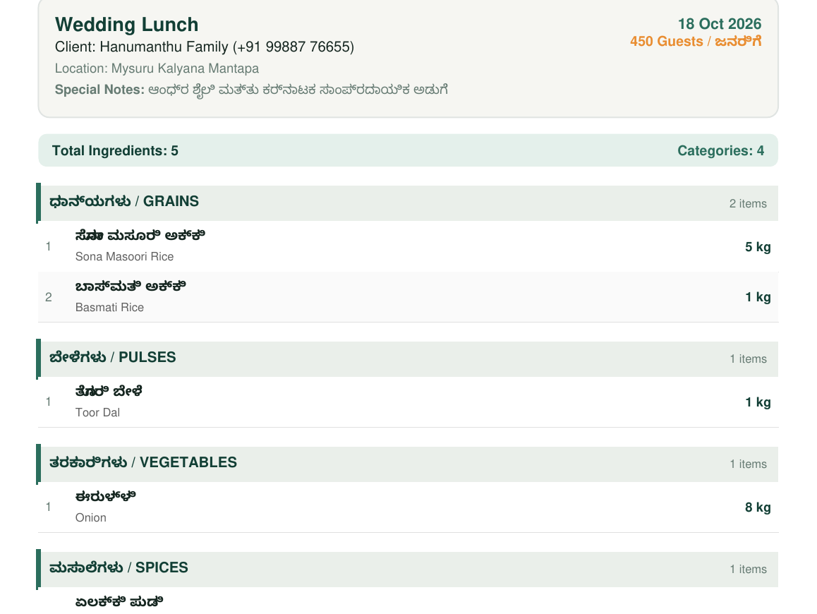
Figure 1. Current CaterPrep export: Kannada is present but the letter shaping/mark positioning is visibly wrong.
2. Diagnostic proof: the Kannada font is already embedded
A font inspection of the uploaded PDF reports the following fonts:
Font | Type | Encoding | Embedded | Unicode
NotoSansKannada-Regular | CID TrueType | Identity-H | Yes | Yes
NotoSansKannada-Bold | CID TrueType | Identity-H | Yes | Yes
Helvetica | Type 1 | WinAnsi | No | No
Conclusion
Do NOT spend more time only changing fonts, fontFallback, or pw.ThemeData.withFont(). The font is already embedded. The remaining defect occurs because package:pdf standard text rendering does not shape complex Indic scripts with GSUB/GPOS.

3. Root cause
Kannada is a complex Indic script. Correct rendering requires more than mapping Unicode characters to glyphs. The renderer must apply OpenType shaping rules:
- GSUB (Glyph Substitution): forms conjuncts and contextual glyph combinations.
- GPOS (Glyph Positioning): positions vowel signs, anusvara/visarga and other marks relative to base letters.
- Indic reordering: some visual components must move relative to the logical Unicode order.
- Cluster shaping: multiple Unicode code points may become one visual glyph cluster.
The Dart package:pdf standard pw.Text path currently does not reliably apply the full OpenType shaping required for Kannada. A correct TTF/OTF font therefore still renders malformed text. The current dart_pdf issue tracker explicitly identifies this gap for Indic scripts, and its HarfBuzz/complex-script support remains an open upstream area as of October 2026.
4. Mandatory implementation decision
Preferred production solution
Use pdf_text_shaper (HarfBuzz-backed) for EVERY Kannada text run in generated PDFs. Continue using package:pdf for page/layout drawing, tables, backgrounds, borders and English text. Do not render Kannada with pw.Text.

Recommended dependency path (native Flutter targets):
dependencies:
pdf: ^3.13.0
pdf_text_shaper: ^1.1.0
printing: <keep the project-compatible version>

Important compatibility note: pdf_text_shaper uses a native HarfBuzz backend. Its current documented targets are Android, iOS, Windows, macOS and Linux. It does not currently advertise Web support. If the CaterPrep PDF is generated on Android/iOS, this is appropriate.
5. Font assets
Keep the Unicode OpenType Kannada fonts in the app. Use full Noto Sans Kannada fonts, not Latin-only fonts and not manually converted/legacy Kannada fonts.
assets/
fonts/
NotoSansKannada-Regular.ttf
NotoSansKannada-Bold.ttf
Inter-Regular.ttf
Inter-SemiBold.ttf

pubspec.yaml:
flutter:
assets:
- assets/fonts/NotoSansKannada-Regular.ttf
- assets/fonts/NotoSansKannada-Bold.ttf
- assets/fonts/Inter-Regular.ttf
- assets/fonts/Inter-SemiBold.ttf

6. Create a dedicated shaped-font loader
The coding implementation must load the font bytes once per PDF generation session, construct HarfBuzz ShapedFont objects, reuse them for the whole document, and dispose them only after document.save().
import 'dart:typed_data';
import 'package:flutter/services.dart';
import 'package:pdf_text_shaper/pdf_text_shaper.dart';
class PdfShapedFonts {
PdfShapedFonts._({
required this.kannadaRegular,
required this.kannadaBold,
});
final ShapedFont kannadaRegular;
final ShapedFont kannadaBold;
static Future<PdfShapedFonts> load() async {
final regular = await rootBundle.load(
'assets/fonts/NotoSansKannada-Regular.ttf',
);
final bold = await rootBundle.load(
'assets/fonts/NotoSansKannada-Bold.ttf',
);
final regularBytes = regular.buffer.asUint8List(
regular.offsetInBytes,
regular.lengthInBytes,
);
final boldBytes = bold.buffer.asUint8List(
bold.offsetInBytes,
bold.lengthInBytes,
);
return PdfShapedFonts._(
kannadaRegular: ShapedFont.fromBytes(
regularBytes,
name: 'NotoSansKannada-Regular',
),
kannadaBold: ShapedFont.fromBytes(
boldBytes,
name: 'NotoSansKannada-Bold',
),
);
}
void dispose() {
kannadaRegular.dispose();
kannadaBold.dispose();
}
}

7. Critical rule: replace pw.Text for Kannada
The following is NOT an acceptable fix, even if NotoSansKannada-Regular.ttf is supplied:
// WRONG for Kannada shaping
pw.Text(
item.nameKannada,
style: pw.TextStyle(font: kannadaPdfFont),
);
// ALSO NOT ENOUGH
pw.ThemeData.withFont(
base: pw.Font.helvetica(),
fontFallback: [kannadaPdfFont],
);

Use ShapedText for Kannada:
ShapedText(
item.nameKannada,
style: ShapedTextStyle(
font: fonts.kannadaBold,
fontSize: 11,
preserveUnicodeText: true,
),
)

8. Required bilingual ingredient row implementation
Kannada and English should be separate widgets. Do not put both scripts into a single pw.TextSpan and expect fontFallback to shape Kannada.
pw.Widget buildIngredientName({
required String kannada,
required String english,
required PdfShapedFonts fonts,
}) {
return pw.Column(
crossAxisAlignment: pw.CrossAxisAlignment.start,
children: [
ShapedText(
kannada,
style: ShapedTextStyle(
font: fonts.kannadaBold,
fontSize: 10.5,
preserveUnicodeText: true,
),
),
pw.SizedBox(height: 2),
pw.Text(
english,
style: const pw.TextStyle(
fontSize: 8.5,
color: PdfColors.grey700,
),
),
],
);
}

9. Category headings
Category headings such as “ಧಾನ್ಯಗಳು / GRAINS” must also shape the Kannada segment independently.
pw.Row(
crossAxisAlignment: pw.CrossAxisAlignment.center,
children: [
ShapedText(
category.nameKannada,
style: ShapedTextStyle(
font: fonts.kannadaBold,
fontSize: 10.5,
preserveUnicodeText: true,
),
),
pw.Text(
' / ${category.nameEnglish.toUpperCase()}',
style: pw.TextStyle(
fontSize: 10.5,
fontWeight: pw.FontWeight.bold,
),
),
],
)

10. Mixed lines: guests, notes, taglines and headers
Do not write mixed English/Kannada strings using ordinary pw.Text if the string contains Kannada. Split the line into shaped and non-shaped widgets.
// Instead of:
// pw.Text('450 Guests / ಜನರಿಗೆ')
pw.Row(
mainAxisSize: pw.MainAxisSize.min,
children: [
pw.Text('450 Guests / '),
ShapedText(
'ಜನರಿಗೆ',
style: ShapedTextStyle(
font: fonts.kannadaRegular,
fontSize: 9,
preserveUnicodeText: true,
),
),
],
);

Apply the same rule to: business tagline, “ಅಡುಗೆಸಾಮಾನುಗಳ ಪಟ್ಟಿ”, special notes, category headings, ingredient names, custom item notes, client/event fields if Kannada is allowed, and the PDF footer.
11. Complete PDF generation lifecycle
Future<Uint8List> generateCateringPdf(CateringList list) async {
final fonts = await PdfShapedFonts.load();
try {
final doc = pw.Document();
doc.addPage(
pw.MultiPage(
pageFormat: PdfPageFormat.a4,
margin: const pw.EdgeInsets.all(24),
build: (context) => [
buildHeader(list, fonts),
pw.SizedBox(height: 12),
buildClientCard(list, fonts),
pw.SizedBox(height: 12),
...buildIngredientSections(list, fonts),
],
),
);
return await doc.save();
} finally {
fonts.dispose();
}
}

12. Do not perform manual Kannada “fixes”
The coding agent must explicitly remove or reject these approaches:
- Do not reverse Kannada strings.
- Do not split Kannada into characters and reorder them manually.
- Do not replace Kannada with transliteration in the PDF.
- Do not preprocess Unicode with custom regex to remove combining marks.
- Do not use legacy non-Unicode Kannada fonts/encodings.
- Do not use fontFallback as the primary shaping solution.
- Do not convert the entire PDF into a screenshot merely to hide the problem.
13. Required regression test strings
Use the exact strings below because they exercise Kannada vowel signs, conjuncts and combining marks. Compare the generated PDF visually against normal Flutter Text rendering.
• ಶುದ್ಧ ಸಾಂಪ್ರದಾಯಿಕ ಅಡುಗೆಸೇವೆ
• ಅಡುಗೆಸಾಮಾನುಗಳ ಪಟ್ಟಿ
• 450 Guests / ಜನರಿಗೆ
• ಆಂಧ್ರ ಶೈಲಿ ಮತ್ತು ಕರ್ನಾಟಕ ಸಾಂಪ್ರದಾಯಿಕ ಅಡುಗೆ
• ಧಾನ್ಯಗಳು
• ಸೋನಾ ಮಸೂರಿ ಅಕ್ಕಿ
• ಬಾಸ್ಮತಿ ಅಕ್ಕಿ
• ಬೇಳೆಗಳು
• ತೊಗರಿ ಬೇಳೆ
• ತರಕಾರಿಗಳು
• ಈರುಳ್ಳಿ
• ಮಸಾಲೆಗಳು
• ಏಲಕ್ಕಿ ಪುಡಿ
• ತಾಜಾ ಪುಡಿ ಮಾತ್ರ ಬಳಸಿ
14. Validation checklist for the coding agent
- Generate a fresh PDF after replacing Kannada pw.Text widgets with ShapedText.
- Visually compare each Kannada word with the same text shown inside the Flutter app.
- Check vowel signs and conjuncts; do not accept merely “readable enough” output.
- Open the same PDF in Chrome/Edge PDF viewer, Adobe Acrobat, and an Android PDF viewer.
- Send the PDF through WhatsApp and reopen the received file.
- Verify English text, quantities and layout remain unchanged.
- Verify PDF search/copy extracts Kannada correctly when preserveUnicodeText is enabled.
- Run pdffonts and confirm relevant fonts/content are embedded as expected.
- Test a multi-page ingredient list, not only the 5-item sample.
15. Acceptance criteria
Check | Pass condition | Mandatory
Kannada appearance | Matches normal Flutter rendering; no broken matras/conjuncts/marks | Yes
Font handling | Unicode Noto Sans Kannada supplied to the shaper | Yes
Rendering path | All Kannada uses HarfBuzz-backed ShapedText | Yes
English/layout | No regression in English text, quantities, cards or page breaks | Yes
PDF portability | Correct in at least 3 viewers and after WhatsApp sharing | Yes
Search/copy | Kannada remains extractable where Unicode preservation is enabled | Preferred
16. Fallback if HarfBuzz package cannot be used
Fallback - Flutter-shaped image text
If project SDK constraints prevent pdf_text_shaper, render Kannada strings with Flutter TextPainter/Paragraph (Flutter itself performs complex shaping) to transparent PNG images and place those images in the PDF. This is visually reliable but produces larger PDFs and makes visible Kannada non-selectable unless a separate invisible Unicode layer is added.

Fallback must only be used when the HarfBuzz solution cannot be integrated. It is not the preferred implementation.
// Conceptual fallback only
// 1. Shape/render Kannada with Flutter TextPainter.
// 2. Paint at 3x or 4x resolution to a transparent image.
// 3. Convert ui.Image -> PNG bytes.
// 4. Insert with pw.Image(pw.MemoryImage(bytes)).
// 5. Keep English as ordinary PDF text.

17. Coding-agent task statement
Copy this task into the coding agent
Fix CaterPrep PDF Kannada rendering. The current generated PDF already embeds NotoSansKannada-Regular and NotoSansKannada-Bold, so do not treat this as a missing-font problem. The defect is complex-script shaping. Replace every Kannada use of package:pdf pw.Text/pw.RichText with HarfBuzz-backed pdf_text_shaper ShapedText. Load Noto Sans Kannada as ShapedFont, keep each ShapedFont alive until document.save() completes, then dispose it. Split mixed Kannada/English lines into separate shaped and ordinary text widgets. Cover business tagline, bilingual heading, client/event fields, categories, ingredient names and notes. Keep current PDF layout/colors/English unchanged. Add regression tests using the Kannada strings listed in this document and verify the resulting PDF in multiple viewers.

18. Why the previous documentation did not fully solve it
The earlier fix correctly identified that default Helvetica cannot render Kannada and recommended embedding Noto Sans Kannada. That was necessary, but it addressed only glyph availability. The newest PDF demonstrates that glyph availability is now fixed: Kannada Unicode is embedded and extractable. However, Kannada still requires OpenType shaping. Therefore the second-stage fix is to change the text rendering engine, not merely the font.
19. References for the coding team
dart_pdf issue #1907 - Add OpenType (HarfBuzz) text shaping support for Indic scripts
https://github.com/DavBfr/dart_pdf/issues/1907
dart_pdf PR #1929 - Universal Complex Script Shaping Engine (still upstream work)
https://github.com/DavBfr/dart_pdf/pull/1929
pdf_text_shaper 1.1.0 - HarfBuzz-powered shaping for Dart pdf
https://pub.dev/packages/pdf_text_shaper
pdf_text_shaper repository
https://github.com/ardevcraft/pdf_text_shaper

