Physical Design of ASICs

Homework-1

Name : J. Prashanth

Roll Number : IMT2019507

System : Windows WSL (Ubuntu), using windows terminal

PDK path : cd "/mnt/c/Users/jonna/Documents/PDK"

Whenever I open my WSL terminal, it generally starts at “mnt/c/Users/jonna” location. As the PDK location is not far away, I have not created the link files. Instead, I found that copy pasting the different library locations with cd commands is much faster for switching between standard cell libraries. I have listed my paths below so that I can copy paste commands from here directly.

Cadence 45 nm .lib files path **:** cd "/mnt/c/Users/jonna/Documents/PDK/Cadence_design_database_45nm/lib"

Nangate_OCL .lib files path : cd “/mnt/c/Users/jonna/Documents/PDK/Nangate_OCL/lib”

NanGate_15nm .lib files path : cd "/mnt/c/Users/jonna/Documents/PDK/NanGate_15nm_OCL_v0.1_2014_06_Apache.A/front_end/timing_power_noise"

Skywater HS .lib files path :

cd "/mnt/c/Users/jonna/Documents/PDK/sky130_fd_sc_hs/Liberty"

**(A) Cell Counts and Types**

|  |  |  |  |  |
| --- | --- | --- | --- | --- |
|  | Cadence | Nangate_OCL | NanGate_15nm | Skywater HS |
| Total no. of cells | 480 | 134 | 76 | 376 |
| **DFFs** |  |  |  |  |
| Total no. of DFFs | 120 | 16 | 4 | 45 |
| No. of DFFs with reset | 16 | 8 | 2 | 12 |
| No. of DFFs with set | 32 | 8 | 2 | 10 |
| No. of negative edge-triggered DFFs | 8 | 0 | 0 | 6 |
| **NAND gates** |  |  |  |  |
| Count of 2-inp NAND gates | 10 | 3 | 2 | 7 |
| Count of 3-inp NAND gates | 10 | 3 | 2 | 6 |
| Count of 4-inp NAND fates | 14 | 3 | 2 | 9 |
| **Muxes** |  |  |  |  |
| Count of 2-inp Muxes | 18 | 2 | 1 | 6 |
| Count of 3-inp Muxes | 8 | 0 | 0 | 0 |
| Count of 4-inp Muxes | 8 | 0 | 0 | 3 |

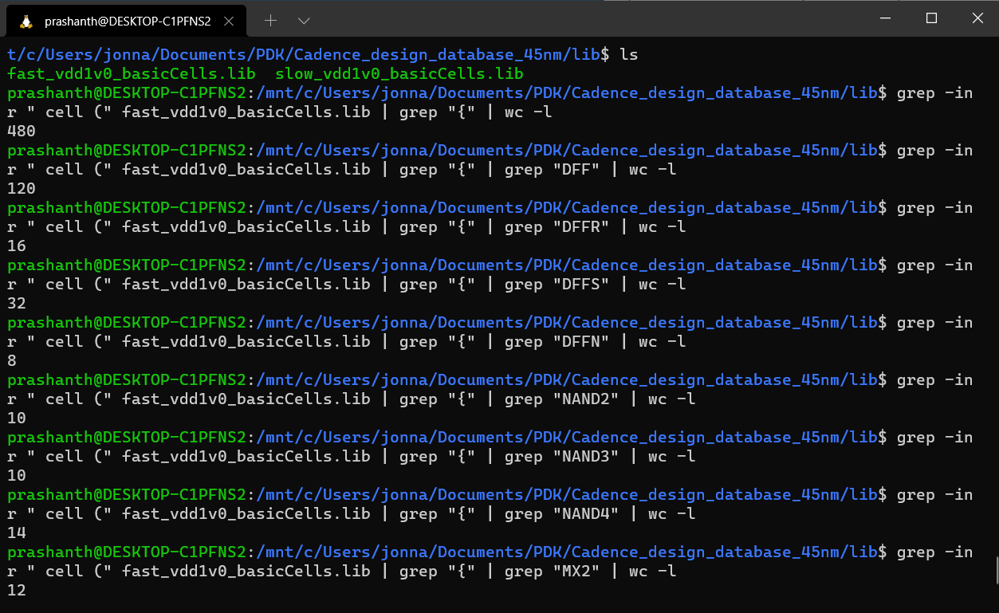Screenshots :

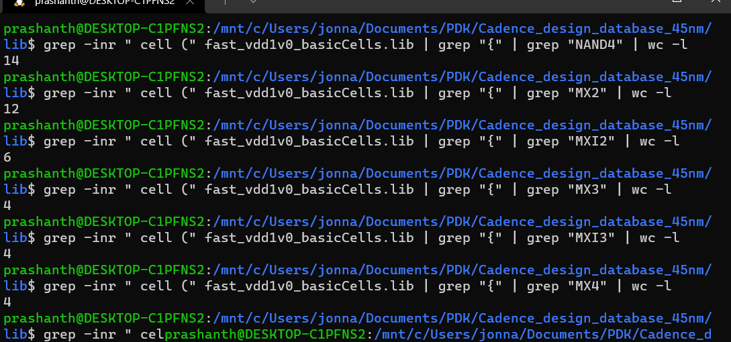

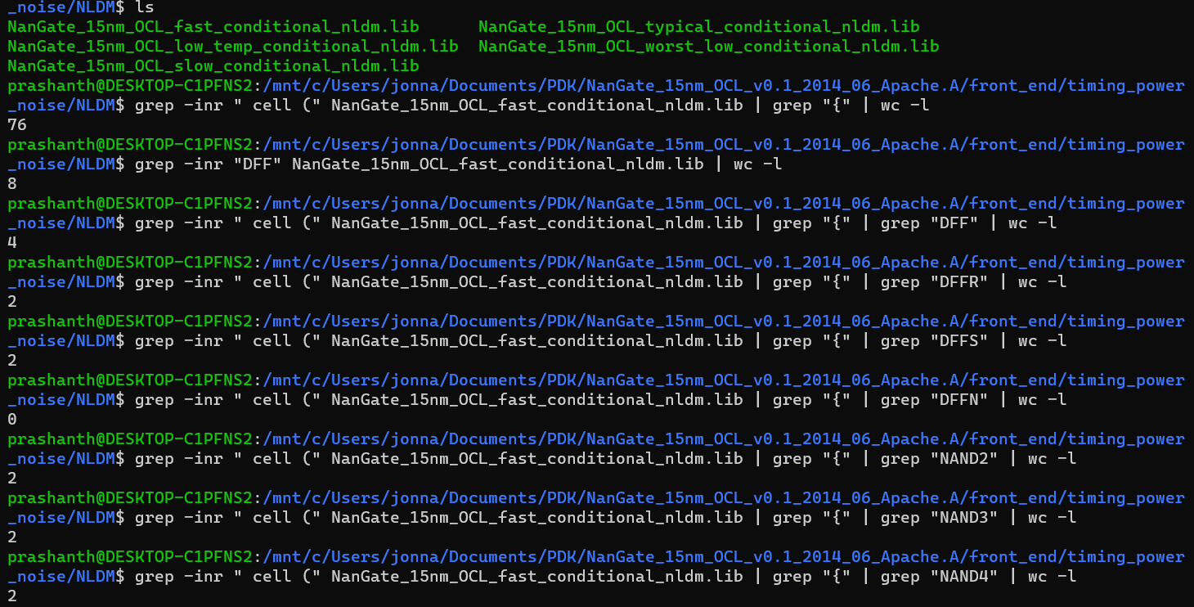

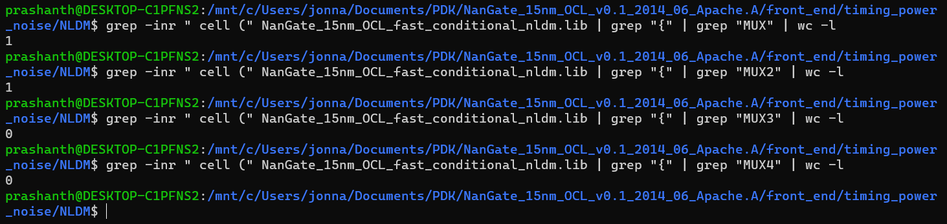

**(B) Cell Drive Strengths**

|  |  |  |  |  |
| --- | --- | --- | --- | --- |
|  | Cadence | NanGate_OCL | Nangate_15nm | Skywater HS |
| **Inverter** |  |  |  |  |
| Total count | 19 | 7 | 6 | 26 |
| Max drive strength | X20 | X32 | X16 | _16 |
| Min drive strength | XL | X1 | X1 | _1 |
| **Buffer** |  |  |  |  |
| Total count | 26 | 14 | 18 | 18 |
| Max drive strength | X20 | X32 | X16 | _16 |
| Min drive strength | XL | X1 | X1 | _1 |
| **NAND2** |  |  |  |  |
| Total count | 10 | 3 | 2 | 7 |
| Max drive strength | X8 | X4 | X2 | _8 |
| Min drive strength | XL | X1 | X1 | _1 |
| **DFFs** |  |  |  |  |
| Total count | 120 | 16 | 4 | 45 |
| Max drive strength | X8 | X2 | X1 | _4 |
| Min drive strength | XL | X1 | X1 | _1 |

Screenshots :

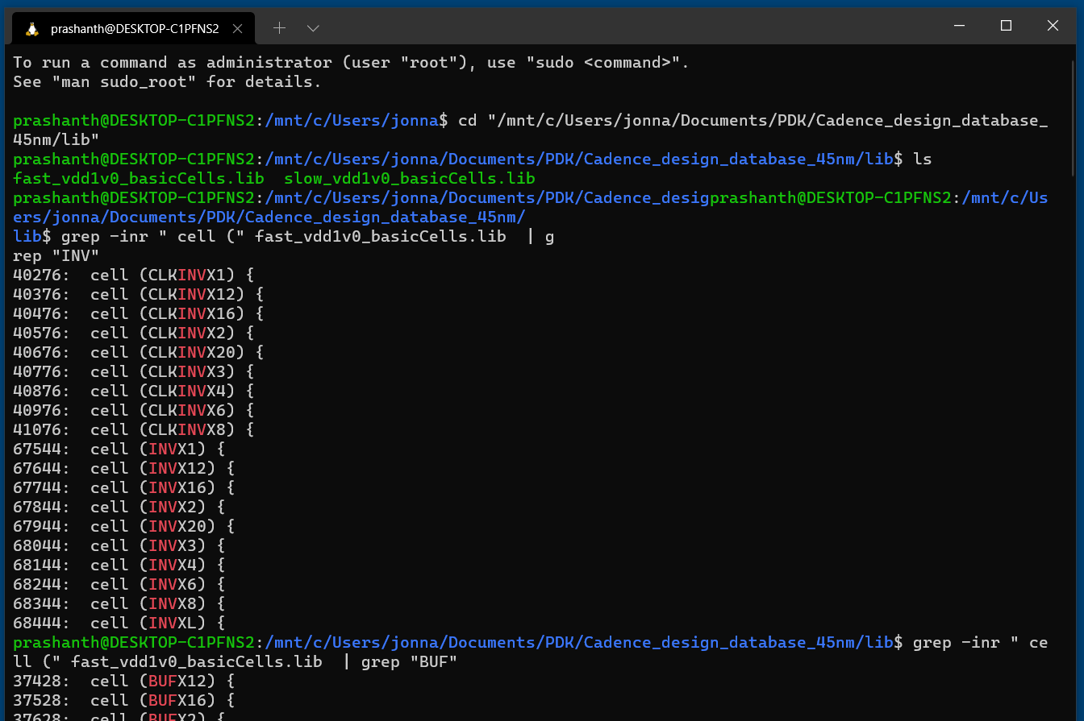

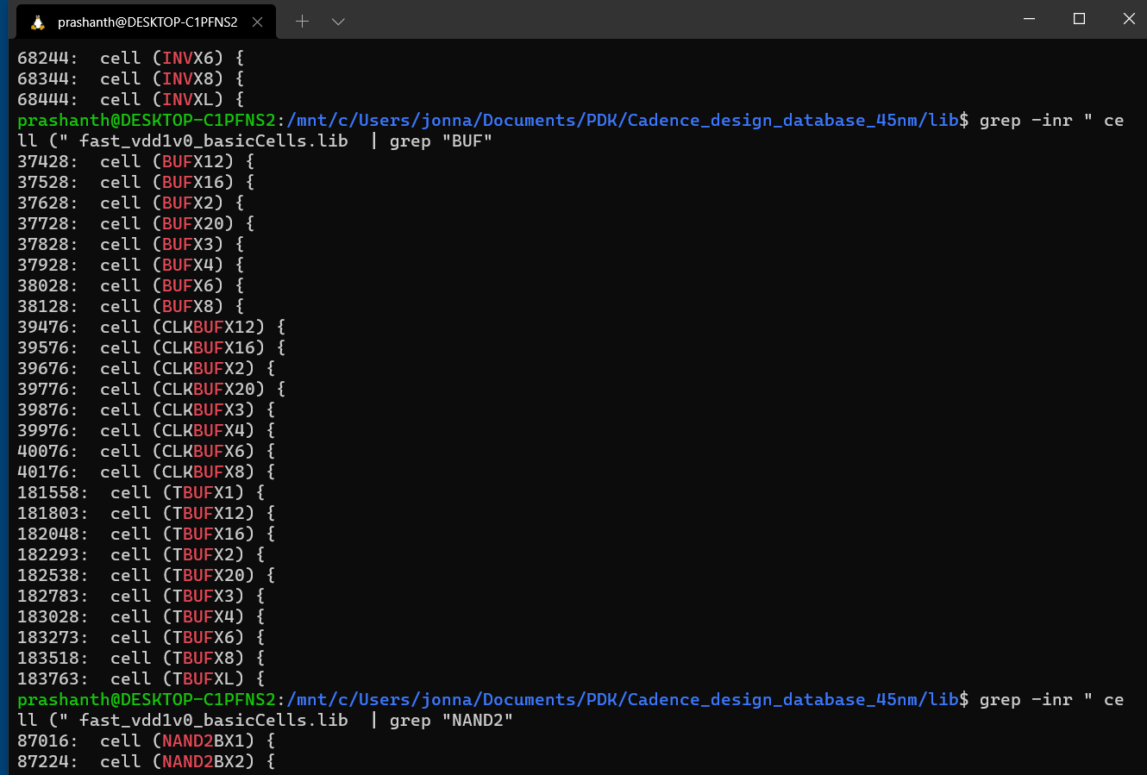

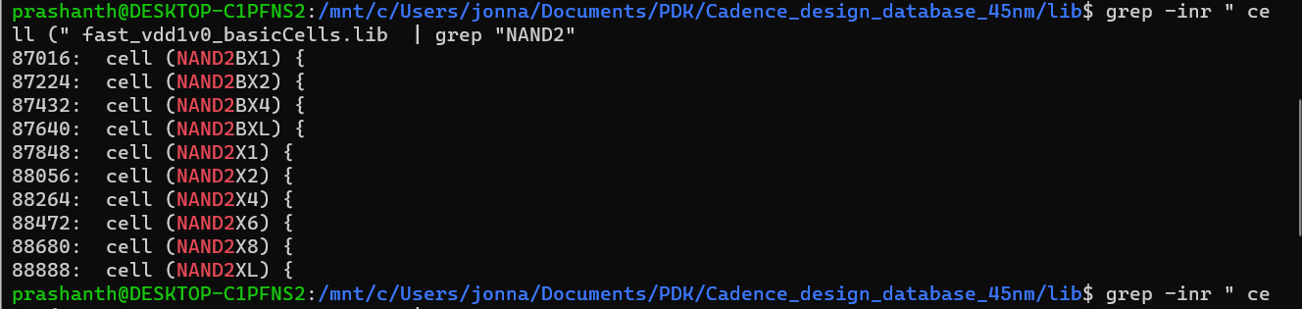

**(C) Cell pin capacitances and area**

I have selected pin (A) inputs for all the cells and have stayed consistent with the input,

|  |  |  |  |
| --- | --- | --- | --- |
| Cadence | INV | BUF | NAND2 |
| Fast | 0.00094 | 0.00027 | 0.000944 |
| Slow | 0.00079 | 0.0002 | 0.000784 |

|  |  |  |  |
| --- | --- | --- | --- |
| NanGate_OCL | INV | BUF | NAND2 |
| Fast | 3.277 | 1.81 | 3.060 |
| Temp | 3.232 | 1.77 | 3.099 |
| Slow | 3.135 | 1.70 | 3.002 |
| Typical | 3.25 | 1.77 | 3.053 |
| Worst Low | 2.99 | 1.626 | 2.890 |

|  |  |  |  |
| --- | --- | --- | --- |
| Nangate_25mm | INV | BUF | NAND2 |
| Fast | 1.702 | 0.866 | 1.408 |
| Temp | 1.693 | 0.860 | 1.402 |
| Slow | 1.639 | 0.839 | 1.358 |
| Typical | 1.649 | 0.839 | 1.371 |
| Worst Low | 1.553 | 0.784 | 1.307 |

|  |  |  |  |
| --- | --- | --- | --- |
| Skywater HS library files | INV | BUF | NAND2 |
| sky130_fd_sc_hs__ff_100C_1v95 | 0.00538 | 0.00274 | 0.0054 |
| sky130_fd_sc_hs__ff_150C_1v95 | 0.00546 | 0.00254 | 0.0055 |
| sky130_fd_sc_hs__ff_n40C_1v56 | 0.00501 | 0.00254 | 0.005 |
| sky130_fd_sc_hs__ff_n40C_1v76 | 0.00494 | 0.00229 | 0.00483 |
| sky130_fd_sc_hs__ff_n40C_1v95 | 0.00494 | 0.00229 | 0.00483 |
| sky130_fd_sc_hs__ss_100C_1v60 | 0.0056 | 0.0029 | 0.00563 |
| sky130_fd_sc_hs__ss_150C_1v60 | 0.00573 | 0.00277 | 0.00576 |
| sky130_fd_sc_hs__ss_n40C_1v28 | 0.00494 | 0.00229 | 0.00483 |
| sky130_fd_sc_hs__ss_n40C_1v44 | 0.00519 | 0.00256 | 0.0049 |
| sky130_fd_sc_hs__ss_n40C_1v60 | 0.00523 | 0.00268 | 0.00513 |
| sky130_fd_sc_hs__tt_025C_1v20 | 0.00491 | 0.00253 | 0.0049 |
| sky130_fd_sc_hs__tt_025C_1v35 | 0.00519 | 0.00277 | 0.0050 |
| sky130_fd_sc_hs__tt_025C_1v44 | 0.00521 | 0.00 | 0.00 |

I have chosen to use VSCode for only this specific problem as I found it much easier to do so,

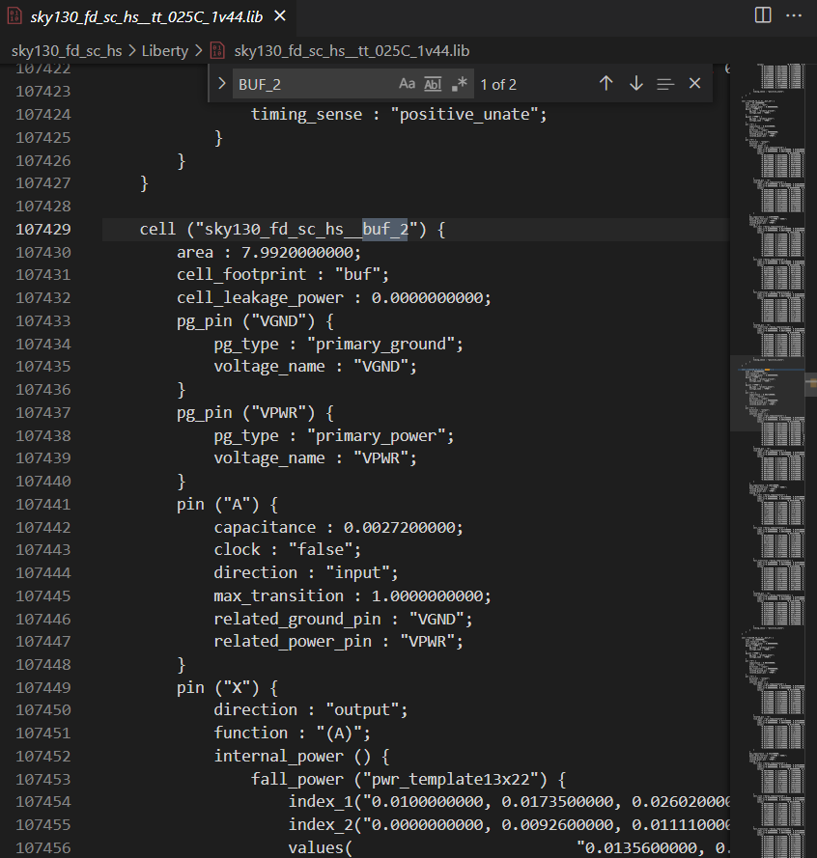

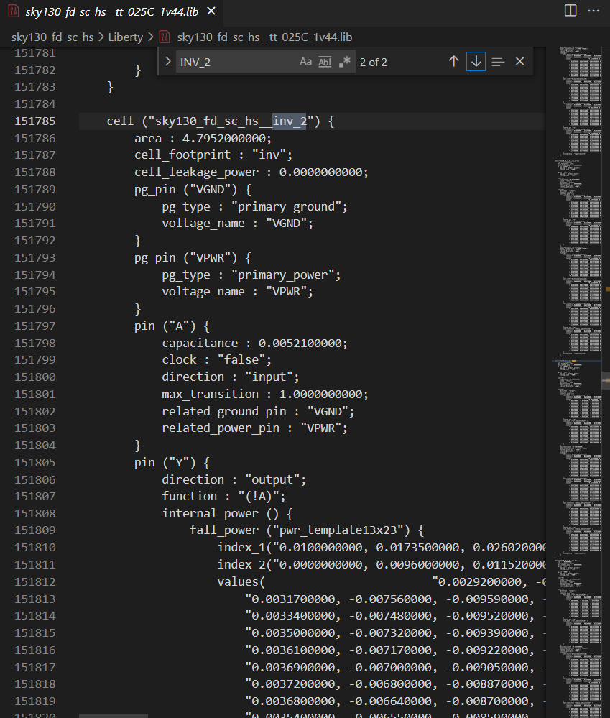

**(D) Operating Conditions (P-V-T)**

|  |  |  |  |
| --- | --- | --- | --- |
| dotlib file name (HS library files) | P | V (volts) | T (oC) |
| sky130_fd_sc_hs__ff_100C_1v95 | ff | 1.95 | 100 |
| sky130_fd_sc_hs__ff_150C_1v95 | ff | 1.95 | 150 |
| sky130_fd_sc_hs__ff_n40C_1v56 | ff | 1.56 | 40 |
| sky130_fd_sc_hs__ff_n40C_1v76 | ff | 1.76 | 40 |
| sky130_fd_sc_hs__ff_n40C_1v95 | ff | 1.95 | 40 |
| sky130_fd_sc_hs__ss_100C_1v60 | ss | 1.60 | 100 |
| sky130_fd_sc_hs__ss_150C_1v60 | ss | 1.60 | 150 |
| sky130_fd_sc_hs__ss_n40C_1v28 | ss | 1.28 | 40 |
| sky130_fd_sc_hs__ss_n40C_1v44 | ss | 1.44 | 40 |
| sky130_fd_sc_hs__ss_n40C_1v60 | ss | 1.60 | 40 |
| sky130_fd_sc_hs__tt_025C_1v20 | tt | 1.20 | 25 |
| sky130_fd_sc_hs__tt_025C_1v35 | tt | 1.35 | 25 |
| sky130_fd_sc_hs__tt_025C_1v44 | tt | 1.44 | 25 |
| sky130_fd_sc_hs__tt_025C_1v50 | tt | 1.50 | 25 |
| sky130_fd_sc_hs__tt_025C_1v62 | tt | 1.62 | 25 |
| sky130_fd_sc_hs__tt_025C_1v68 | tt | 1.68 | 25 |
| sky130_fd_sc_hs__tt_025C_1v80 | tt | 1.8 | 25 |
| sky130_fd_sc_hs__tt_025C_1v89 | tt | 1.89 | 25 |
| sky130_fd_sc_hs__tt_025C_2v10 | tt | 2.1 | 25 |
| sky130_fd_sc_hs__tt_100C_1v80 | tt | 1.8 | 100 |
| sky130_fd_sc_hs__tt_150C_1v80 | tt | 1.8 | 150 |

|  |  |  |  |
| --- | --- | --- | --- |
| dotlib file name (MS library files) | P | V (volts) | T (oC) |
| sky130_fd_sc_ms__ff_085C_1v95_pwrlkg | ff | 1.95 | 85 |
| sky130_fd_sc_ms__ff_100C_1v65 | ff | 1.65 | 100 |
| sky130_fd_sc_ms__ff_100C_1v95 | ff | 1.95 | 100 |
| sky130_fd_sc_ms__ff_100C_1v95_pwrlkg | ff | 1.95 | 100 |
| sky130_fd_sc_ms__ff_150C_1v95 | ff | 1.95 | 40 |
| sky130_fd_sc_ms__ff_n40C_1v56 | ss | 1.60 | 100 |
| sky130_fd_sc_ms__ff_n40C_1v65_ka1v76 | ss | 0.76 | 150 |
| sky130_fd_sc_ms__ff_n40C_1v76 | ss | 1.76 | 40 |
| sky130_fd_sc_ms__ff_n40C_1v95 | ss | 1.95 | 40 |
| sky130_fd_sc_ms__ff_n40C_1v95_ccsnoise | ss | 1.95 | 40 |
| sky130_fd_sc_ms__ff_n40C_1v95_pwrlkg | tt | 1.95 | 40 |
| sky130_fd_sc_ms__ss_100C_1v60 | tt | 1.60 | 100 |
| sky130_fd_sc_ms__ss_150C_1v60 | tt | 1.60 | 150 |
| sky130_fd_sc_ms__ss_n40C_1v28 | tt | 1.28 | 40 |
| sky130_fd_sc_ms__ss_n40C_1v44 | tt | 1.44 | 40 |
| sky130_fd_sc_ms__ss_n40C_1v60 | tt | 1.60 | 40 |
| sky130_fd_sc_ms__ss_n40C_1v60_ccsnoise | tt | 1.60 | 40 |
| sky130_fd_sc_ms__tt_025C_1v80 | tt | 1.80 | 25 |
| sky130_fd_sc_ms__tt_025C_1v80_ccnoise | tt | 1.80 | 25 |
| sky130_fd_sc_ms__tt_100C_1v80 | tt | 1.80 | 100 |

(E) **Physical Design**

|  |  |  |
| --- | --- | --- |
|  | Cadence | Nangate_15nm |
| Cell height | 1.71 | 0.768 |
| No. of metal layers | 11 (Metal1 + Metal2 + … + Metal 11) | 6 (M1 + MINT Layers) |
| Routing pitch | {0.2 , 0.19} + {0.5 , 0.19} + {0.5 , 0.475} | {0.064 , 0.064} |
| Cell height in routing tracks | 2 (Assuming 10 routing tracks) | 0.64 (Assuming 10 routing tracks) |

Screenshots :

