**Post Deployment steps**

This document lists out the post deployment steps to be performed as a part of the Smart Approvals Project

**Adding Remote Site Settings**

1.From Setup, enter Remote Site Settings in the Quick find Box, then Select **Remote Site Settings**.

2.Click **New Remote Site**.

3.Enter a discriptive term for the Remote site Name. (Name and url for different environments are given below).

4. Enter the URL for the remote site.

5. Optionally, enter the description of the site.

6. Click Save.

|  |  |  |
| --- | --- | --- |
| **Environment** | **Name** | **Value** |
| SIT/DEV | CPQDev | [https://cpqdev.paloaltonetworks.com](https://cpqdev.paloaltonetworks.com/) |
| QA | CPQQA | [https://cpqtest.paloaltonetworks.com](https://cpqtest.paloaltonetworks.com/) |
| STAGING | CPQSTG | <https://cpqtest.paloaltonetworks.com/STG> |
| PROD | CPQ | [https://cpq.paloaltonetworks.com](https://cpq.paloaltonetworks.com/) |
|  |  |  |

**Adding Custom Settings Data**

This document lists out the manual steps to be performed for **Adding Custom Settings Data**.

1. From Setup, enter Custom Settings in the Quick Find Box, select **Custom Settings,** then click **Manage** next to “SF Code Parameters” custom setting.

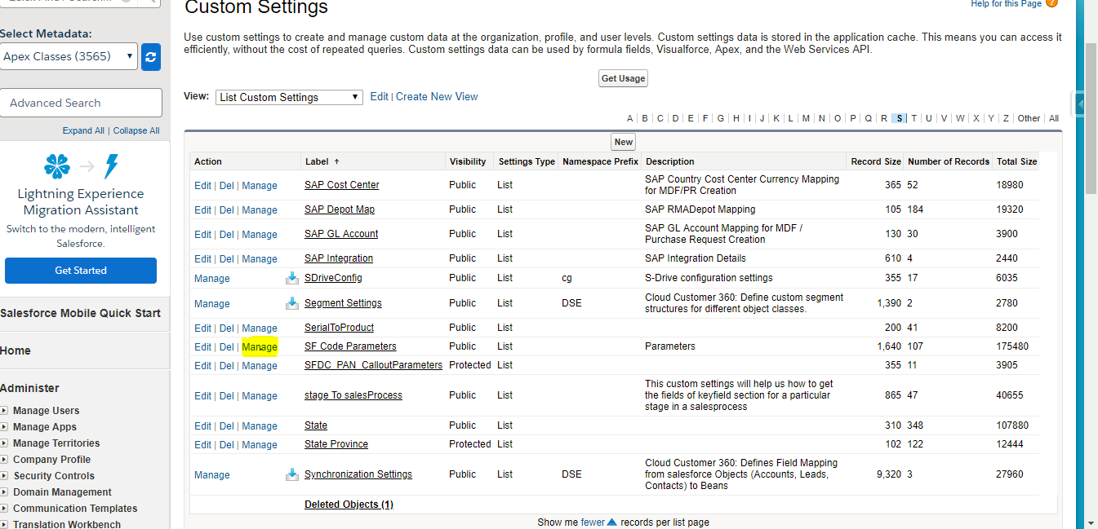

2. Click on **New**.

3. Add the Data.

- Specify a **Name** for the data set.

- Enter the Data for first field named **value**.

- Name and value are given in below table. It is different for different environments.

|  |  |  |
| --- | --- | --- |
| **Environment** | **Name** | **Value** |
| SIT/DEV | COGS_HTTP_ENDPOINT | [https://cpqdev.paloaltonetworks.com](https://cpqdev.paloaltonetworks.com/) /api/Cogs |
| QA | COGS_HTTP_ENDPOINT | [https://cpqtest.paloaltonetworks.com](https://cpqtest.paloaltonetworks.com/)/api/Cogs |
| STAGING | COGS_HTTP_ENDPOINT | <https://cpqtest.paloaltonetworks.com/STG>/api/Cogs |
| PROD | COGS_HTTP_ENDPOINT | [https://cpq.paloaltonetworks.com](https://cpq.paloaltonetworks.com/)/api/Cogs |
|  |  |  |

- Click Save.

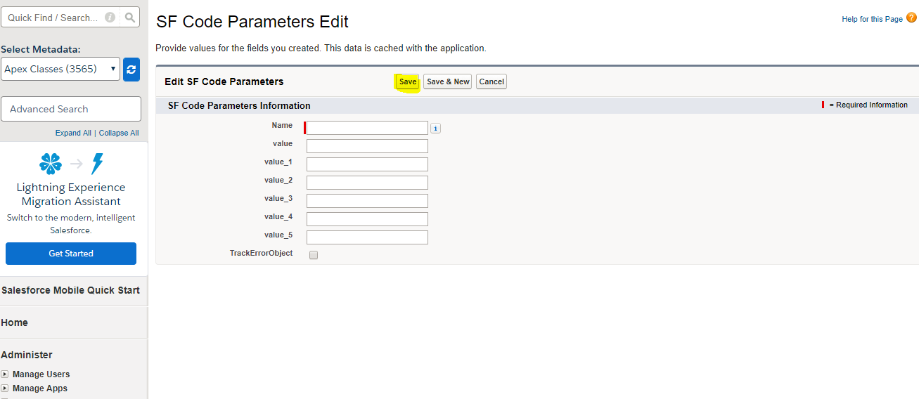

4. Similarly repeat the steps to create another data set with **Name** and **value** as given below. (Note: It is same for all environments)

**Name**: COGS_HTTP_AUTHORIZATION

**Value**: BASIC Q1BRU2VydmljZVVzZXI6SUBkX2NAfHwhRHUkQzBuZiFndXIzUHIhKDNRdTArM19fc2VjcmV0dXNfX19jaWZyYSE7LSk=

5. click save.

6. Again repeat the same steps to create another data set with Name and value as given below.

**Name**: ENABLE_CPQ_QUOTE_SMART_APPROVALS

**Value**: true

7. save

**Scheduling Batch Apex Jobs**

This document lists out the manual steps to be performed for Scheduling the SmartApprovalsBatch.

**Scheduling Batch Apex Weekly Using Apex**

1. From Setup, enter Apex classes in the Quick Find Box, select **Apex Classes,** and then click **Schedule Apex**.

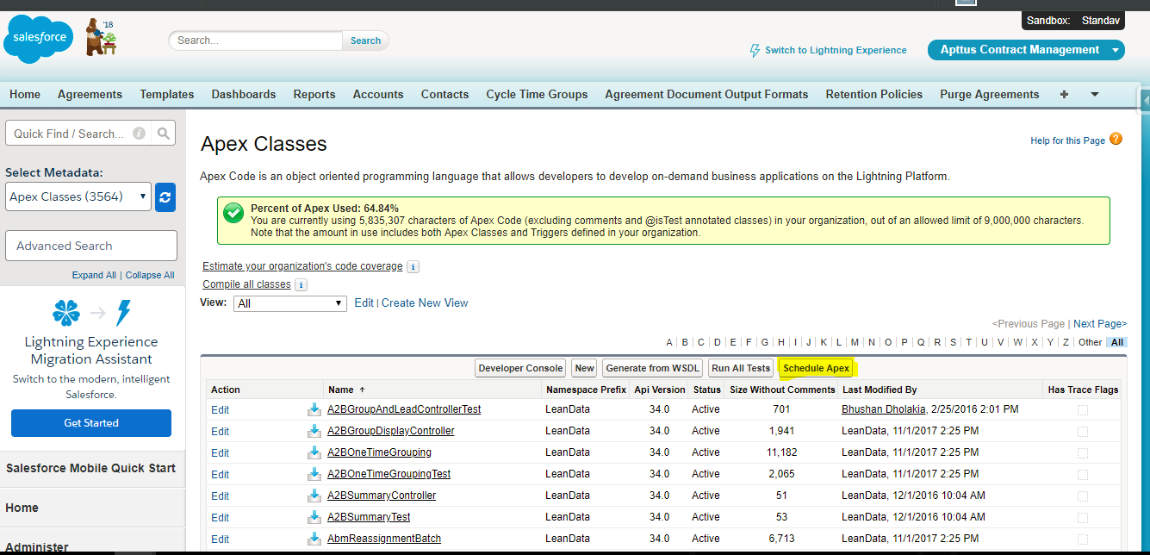

2. Specify the name of the class that you want to schedule. **SmartApprovalsWeeklyScheduler.**

3. Specify how often the Apex class is to run.

- For **weekly** – specify one or more days of the week the job is to run.

- For SmartApprovalsWeeklyScheduler select **Saturday** and for preferred start time select 12:00 AM.

4. schedule **SmartApprovalsWeeklyScheduler** class weekly.

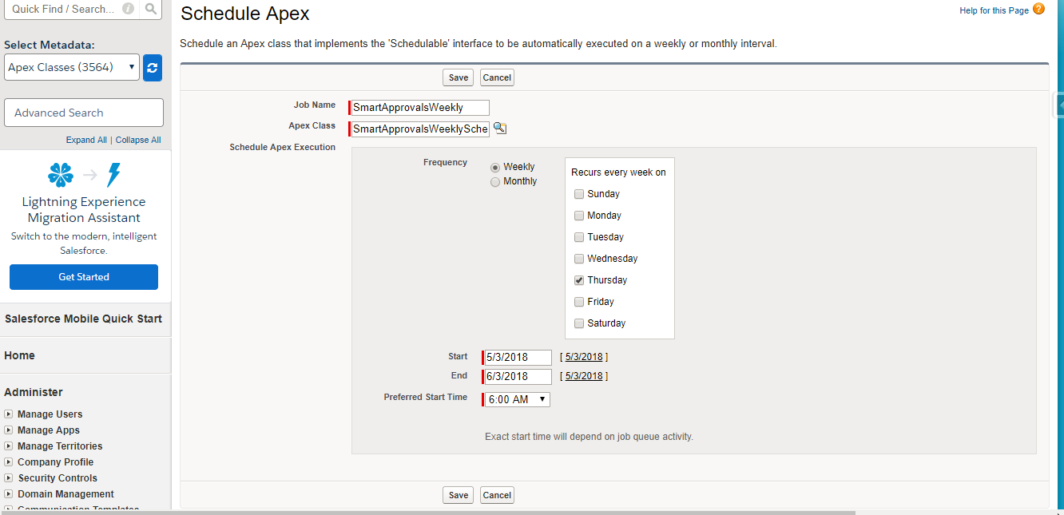

4. Specify the start and end dates for the apex scheduled class. if you specify a single day, the job runs only once. Select present day for start and very long time from now (in years) for end.

5. Specify a preferred start time. The exact time the job starts depends on service availability. select 12:00 AM for scheduling the class.

6. click **save**.

7.

- Go to developer console.

- click on Debug

- select Open Anonymous window.

- execute the command “**Database.executeBatch(new SmartApprovalsBatch(null,null));**”

**Scheduling Batch Apex Hourly Using Apex**

1. For scheduling **SmartApprovalsHourlyScheduler** for every 6 hours daily in week days,

- Go to developer console.

- click on Debug

- select Open Anonymous window.

- execute the command “**SmartApprovalsHourlyScheduler. SchedulerMethod();**”. It will schedule the batch class to run every 6 hours.

