Home Loan Insurance Management System

Technical Design Document

Prepared by

Prashanth K Rama

**Microservices on Azure Containers**​

* By using Domain Driven Design I have used the Microservices Architecture to build this application. The advantages of Microservices are single responsibility, highly scalable, easy to build, reduce the regression testing efforts.​

Technology Stack and its Advantages:​

* UI: UI (Responsive) has been developed using Angular using ASP.NET Core​
* Web API: Web APIs are developed using ASP.NET Core​
* SQL Server: To store the Relational Data​
* Cosmos DB: To store the unstructured data like JSON objects and documents for importing the Banka nd Insurance company data​
* Redis: To store the static data to improve the performance​
* Azure Data Factory: For the ETLs to import the data from Azure Blog Storage​
* Azure Service Bus: Push all the Emails/SMS notifications to Azure Service Bus​
* Function App: Schedule to read and send the notifications form Azure service bus and Check the Borrowers Insurance status and buy automatically.​
* Azure Databricks: To read the data from different sources and Generate the Dashboard for Analytics.​

**System Context:**

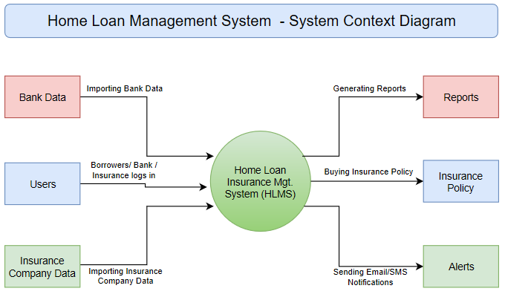

**Conceptual Architecture:**

